Supercritical Emulsion Extraction fabricated PLA/PLGA micro/nano carriers for Growth Factor delivery : release profiles and cytotoxicity

Ida Palazzo^{1§}, Erwin Pavel Lamparelli ^{2§}, Maria Camilla Ciardulli², Pasqualina Scala², Ernesto Reverchon¹, Nicholas Forsyth², Nicola Maffulli³, Antonietta Santoro^{2,4}, Giovanna Della Porta^{2,4*}

¹ Department of Industrial Engineering, University of Salerno, Via Giovanni Paolo II, 84084 Fisciano (SA), IT.
^{2 ..}
³ Department of Medicine, Surgery and Dentistry, “Scuola Medica Salernitana” University of Salerno, Via S. Allende, 84081 Baronissi (SA), IT.
⁴ Interdepartment Centre BIONAM, University of Salerno, via Giovanni Paolo I, 84084 Fisciano (SA), Italy (SA), IT.

Author’s mail address: IP: ipalazzo@unisa.it; EPL: elamparelli@unisa.it; MCC: mciardulli@unisa.it; PS: pscala@unisa.it; NF: NM: nmaffulli@unisa.it; ER: ereverchon@unisa.it; AS: ansantoro@unisa.it; GDP: gdellaporta@unisa.it.

Keywords: nano/micro carriers, poly-lactic-co-glycolic acid (PLGA), poly-lactic acid (PLA), growth factors, emulsion, controlled release, cytotoxicity.

(*) Corresponding Author: Della Porta Giovanna,
Translational Medicine Lab. Department of Medicine, Surgery and Dentistry, University of Salerno, Via S. Allende, Baronissi (SA) 84084, Italy. e-mail: gdellaporta@unisa.it; Tel-fax: +39089965234.

(§) Author’s equally contributed to the work.

ABSTRACT
Controlled delivery of human growth factors is still a challenge in tissue engineering protocols, and poly-lactic acid and poly-lactic-co-glycolic acid carriers have been recently proposed for this purpose. Here, we tested the microencapsulation of two human growth factors, namely Growth Differentiation Factor -5 (hGDF-5) and Transforming Growth Factor β1 (hTGF-β1), by processing different emulsions with Supercritical Emulsion Extraction (SEE) technology. Polymer molecular weight, co-polymer ratio and surfactant amount in aqueous phases as well as phases mixing rate were varied to fabricate carriers with suitable size and loadings.

Carriers with different mean sizes from 0.4 ±0.09 μm up to 3±0.9 μm were obtained by SEE technology when processing emulsions with different formulations; carriers were loaded with 3 μg/g and 7μg/g for hGDF-5 and hTGF-β1 with controlled growth factor release over 25 days. Carriers displayed reduced cytotoxicity when evaluated in Chinese Hamster Ovary cells (CHO-K1). Further, they also exhibited reduced cytotoxicity with respect to carriers obtained by conventional evaporation techniques, and low reactivity on human peripheral blood mononuclear cells (hPBMCs), suggesting their safety and potential use in tissue engineering protocols.

INTRODUCTION
Micro and nano-carriers, with controlled size and suitable encapsulation efficiency, may act as micro-environmental regulators within a 3D bioengineered scaffold, providing a wide range of spatio-temporally controlled bio-molecule delivery (Della Porta et al., 2018; Della Porta et al., 2017). These 3D assembled synthetic matrices can be used for highly predictive in vitro models or to fabricate implantable devices for tissue engineering applications (Ciardulli et al., 2020; Cipollaro et al., 2019; Giordano et al., 2020; Okamoto, 2019). In this context, controlled release systems have recently received extensive attention given their great potential not only in pharmaceutical (Ciaglia et al., 2019; Cricchio et al., 2017; Govoni et al., 2020) but also in biomedical applications within tissue engineering protocols (Della Porta et al., 2015; Govoni et al., 2017; Trucillo et al., 2019). Particularly, growth factors are small biomolecules capable of stimulating cellular growth, proliferation and differentiation (Ren et al., 2020). Therefore, they are largely used in tissue engineering protocols to induce stem cell commitment towards specific phenotype(s). For example, human Growth Differentiation Factor 5 (hGDF-5) induces the expression of genes typically associated to the tendon phenotype (Giordano et al., 2020; Karthik et al., 2014; Tan et al., 2012) and, for this reason, it is used in pharmacological protocols for tendon healing and repair. On the other hand, human Transforming Growth factor β1 (hTGF-β1) has been widely investigated in the process of chondrogenesis for cartilage healing protocols (Danišovič et al., 2012; Madry et al., 2014).

Poly-lactic-co-glycolic acid (PLGA) and poly-lactic acid (PLA) are FDA-approved bioresorbable carriers (Gentile et al., 2014; Makadia and Siegel, 2011) capable of bulk degradation without swelling and with a recognized capacity of ensuring controlled release rates of loaded drugs (Faisant et al., 2006; Faisant et al., 2002; Klose et al., 2006; Siepmann and Siepmann, 2008; Trucillo et al., 2019). Several techniques are available to prepare biopolymer-based micro/nano-carriers, such as spray drying (Miller et al., 2016; Shi et al., 2020) or coacervation (Timilsena et al., 2019), even through, in the specific case of PLA and PLGA processing, the solvent evaporation/extraction of emulsions. This has been described as optimal given its milder processing conditions compared to spray drying, and easier solvent removal compared to coacervation. Indeed, during the evaporation or extraction of emulsion, the oily droplets dispersed in the water external phase are hardened leading to micro/nano-carriers formation (Freitas et al., 2005; Katou et al., 2008; Nag and Nath, 2018). Despite these two technique being largely recommended, evaporation showed batch to batch reproducibility disturbances (Meng et al., 2004; Miyazaki et al., 2006) and extraction uses relatively large amounts of a second solvent producing the problem of solvent mixtures recovery. Both processes require processing time of several hours and, as a consequence, aggregation phenomena may occur between the droplets, producing carriers with a larger poly-dispersity compared to derived droplets (Ozkan et al., 2019). Another disadvantage lies in the poor encapsulation efficiencies of high water-soluble compounds (Freitas et al., 2005). Indeed, these molecules could spread out or diffuse from the dispersed oily phase into the aqueous continuous phase, and their microcrystalline fragments can deposit on the particulate surface and/or outside of the biopolymer matrix (Freitas et al., 2005). It should also be underlined that, despite the widespread use of solvent evaporation/extraction processes to prepare polymer carriers, there are no standard protocols acquired, and each preparation follows its own set.

Dense carbon dioxide technologies have been proposed to produce micro/nano-particles or biopolymer 3D scaffold for tissue engineering applications (Della Porta et al., 2017). Supercritical Emulsion Extraction (SEE) technology operating in a continuous layout using a counter-current packed tower (Falco et al., 2012) was described for PLA/PLGA carriers fabrication. SEE assured improved performances, such as better batch-to-batch reproducibility (Falco et al., 2013), accurate carrier size control thanks to a fixed droplet shrinkage without aggregation phenomena (Campardelli et al., 2013), lower solvent residue (Campardelli et al., 2012) and controlled encapsulation efficiency (Della Porta et al., 2016; Gimenez-Rota et al., 2019; Palazzo et al., 2020).

In contrast to SEE, other supercritical technologies described for particle formation cannot properly work in the case of PLA/PLGA carriers preparation for different reasons: for example, impregnation technology with supercritical fluid cannot be properly applied to PLGA and PLA carriers fabrication because of well-documented polymer foaming (Cabezas et al., 2012). Furthermore, considering particles from Gas Saturated Solution (PGSS) or Supercritical Assisted Atomization (Di Capua et al., 2018; Palazzo et al., 2019) technologies, the supercritical or dense carbon dioxide come in direct contact with the polymer solution before the expansion step and the subsequent particles precipitation. Particles are then recovered in a dried environment that cannot be applied to PLA/PLGA. Indeed, these biopolymers when in contact with dense-CO₂, undergo a reduction of their glass transition temperature that becomes close to the processing temperature of 311-312 K, with consequent particle aggregation or film formation. This behavior prevented the processing of these biopolymers by Supercritical Anti-solvent (SAS) (Chafidz et al., 2018; Franco and De Marco, 2020; Franco et al., 2019); indeed, when PLA/PLGA micronization is attempted by SAS, larger particle aggregates or a continuous film have been always collected (personal communication, data not published).

Furthermore, PGSS, SAA and SAS technologies are not suitable for peptide processing, because of the use of organic solvents to solubilize polymer and peptides which induces their denaturation. This adverse condition is not present when using SEE technology. Indeed, carriers are collected in a liquid environment (water external phase) that prevents the aggregation of any particles and the growth factors are well preserved within the internal water phase before droplet drying (Govoni et al., 2017; Govoni et al., 2020). Moreover, given the Joule-Thomson effect consequent to the expansion of carbon dioxide, the water suspension is always maintained refrigerated in the collection vessel.

However, despite the large investigation on SEE carrier formulation in term of size distributions (Tirado et al., 2019) and drug loading optimization (Gimenez-Rota et al., 2019), to date few investigations described the cytotoxicity of the produced particles. Particularly, in vitro cytotoxicity tests, including cell viability and proliferation studies are considered important screening assays, capable of evaluating the reaction of living cells to the implant and to assess safety characteristics of the produced carriers. Up to now, very few cytotoxicity characterizations have been described for the micro/nano materials fabricated by dense gases, while several assays have been performed for carrier fabrication using conventional technologies (Derman et al., 2017; Grasel et al., 2019; Kang et al., 2008). Different cell models can be used to assess the cytotoxic activity of biomaterials. For example, Chinese Hamster Ovary cells (CHO-K1) are mitotic primary cells and, therefore, they may provide indications on genotoxicity (Santoro et al., 2005). Human-Peripheral Blood Mononuclear Cells (hPBMCs), isolated from human healthy donors can provide indications of the immune reaction to the biopolymer devices and can better mimic in vivo conditions (Di Pietro et al., 2020; Santoro et al., 2008).

Following all these considerations, several emulsion formulation protocols with different surfactant amounts were tested and, then, processed by SEE using both PLA and PLGA with different molecular weights or co-polymer ratios to fix carrier size and distribution. Then, two different human recombinant growth factors (hGDF-5 and hTGFβ1) were added to the formulation to provide data about the drug loading and related release profiles. Cytotoxicity was monitored using two different cell types, from animal and human sources, namely CHO-K1 and hPBMCs, and a comparison was made with carriers obtained by conventional solvent evaporation. These data are extremely important for carrier’s use in in vitro and in vivo protocols and to provide a better characterization of the safety of the SEE fabricated carriers.

MATERIALS
Poly-Lactic-Acid (PLA, RESOMER 203H (Mw 18,000-24,000 Da, indicated as low Mw-PLA), Evonik Industries, Essen, DE) and Poly-lactic-co-Glycolic-Acid (RESOMER 504H, ratio 50:50 Mw 38,000-54,000 Da, indicated as high Mw-PLGA and RESOMER 752H, ratio 75:25, Mw 4,000-15,000 Da, indicated as low Mw-PLGA, Evonik Industries, Essen, DE) were used as received. O₂ (99.9%, Morlando Group, Naples, IT).

Polyvinyl alcohol (PVA, Mol wt: 30,000–55,000, Aldrich Chemical Co., Milan, IT), Bovine Serum Albumin (Sigma-Aldrich, Milan, IT), human Serum Albumin (≥98%, HSA, Aldrich Chemical Co., Milan, IT), Tween 80 (Sigma-Aldrich, Milan, IT), Ethyl Acetate (EA, 99.9%, Aldrich Chemical Co., Milan, IT), recombinant hGDF-5 (PeproTech; UK), recombinant hTGF-β1 (PeproTech; UK), glucose (Sigma-Aldrich, Milan, IT), PBS 1X (Corning Cellgro, Manassas, VA, USA), Minimum Essential Medium Alpha (α-MEM) (Corning Cellgro, Manassas, VA, USA), Enzyme Linked Immunosorbent Assay (ELISA, Cloud-Clone Corp., USA), Ficoll-Hypaque gradient density (Sigma-Aldrich, Milan, IT), Roswell Park Memorial Institute (RPMI, Life Technologies Inc., USA), fetal bovine serum (FBS) (Life Technologies Inc.), L-glutamine (Life Technologies Inc., USA), penicillin/streptomycin (Life Technologies Inc., USA), 3-(4,5-Dimethylthiazol-2-yl)-2,5-diphenyl-tetrazolium bromide (MTT, Sigma-Aldrich, Milan, IT), dimethyl sulfoxide (DMSO, Sigma-Aldrich, Milan, IT).

METHODS

3.1 Emulsions preparation
Emulsions were obtained using a ratio of 1:19:80 water-oil-water (w₁/o/w₂). Oily phase was prepared by solubilizing a given amount of polymer, whereas a variable amount of PBS solution (1X) containing HSA (1% w/v) and PVA (0.06% w/w) was used as water internal phase. Recombinant hTGF-β1 was reconstituted in citric acid (pH 3) to a final concentration of 1 μg/μL, while hGDF-5 was reconstituted in Milli-Q water at the same concentration.
w₁ was mixed with the oily phase to form a primary w₁/o emulsion by sonication with a digital ultrasonic probe operating at 30% of its amplitude (mod. S-450D; Branson Ultrasonic Corp. Danbury, Connecticut, USA). When growth factors were added, the inner water phase was mixed with the oily phase by vortexing (mod. Velp Scientifica, Monza, IT) at maximum speed for 30 sec.

The primary emulsion was then slowly added into EA-saturated aqueous Tween80 solution by high-speed stirring (mod. L4RT, Silverson Machines Ltd., Waterside, Chesham, Bucks, UK). Surfactant amounts in the external water phase varied from 0.1 to 0.6% w/w. In some cases, 15% w/w of glucose was added in the water external phase. Temperature of 10°C was assured during emulsion phase mixing. All emulsions were processed by SEE immediately after their preparation.

3.2 Dense gas technology protocol
SEE is a continuous process which involves the continuous counter-current extraction of solvent in the oily phase of emulsion by supercritical carbon dioxide. The prototype apparatus consists of a packed column with stainless steel pickings (1889 m⁻¹ specific surface and 0.94 voidage; Pro-Pak, Scientific Development Company, State College, PA, USA) where gaseous and liquid phases are in contact counter-current. The main apparatus system is formed by three extraction cascades in which the emulsion is introduced at the top, while CO₂ from the bottom, so counter-current flows are obtained (Della Porta et al., 2011b). The three stages are formed by AISI 316 stainless steel cylindrical sections of 30 cm height, connected by four cross-unions. A refrigerated cyclonic separator is located downstream the top of the column for oily phase recovery through a micrometric valve. Another separator is located at the bottom of the column to collect the water external phase with carriers. The high-pressure diaphragm pump (mod. Milroyal B, Milton Roy, Pont Saint-Pierre, FR) is used to deliver the dense-CO₂ at a selected flow rate; a high pressure piston pump (mod. 305, Gilson, FR) is used to feed the emulsion at a constant flow rate. A rotameter and a dry test meter, located at the exit of the separator, measure the CO₂ flow rate and the total amount delivered, respectively. The column is thermally isolated by ceramic cloths, and temperatures profiles are controlled by six controllers, located at different heights of the column (Della Porta et al., 2011a). The SEE process scheme with a continuous counter-current operation is shown Figure 1c.

To optimize the performance, it is necessary to reach a steady state condition in the apparatus; proper gas/liquid mixing by complete wetting of the packing element of the column. This pre-conditioning operation was performed using a w-o-w emulsion formed by only solvents and surfactant. Finally, a washing step is performed to recover the carriers still retained in the column packing elements. Normally, 70% of the overall polymer used in the emulsion is recovered for each run as a result of the loss of emulsion/suspension caused by dead volumes of SEE apparatus. The organic solvent recovered is less than 50% in weight of the solvent loaded in the emulsion, due to partial loss in the gas stream at the exit of the separator located at the top of the column.

PLA and PLGA carriers are not amenable to conventional sterilization methods such as ethanol washing, gamma irradiation or steam because of biopolymer oxidation (Athanasiou et al., 1996) and further degradation of peptide payload. To overcome these challenges, a specific SEE operational protocol was set. Carriers, collected from each run, were always washed in sterile conditions with a penicillin/streptomycin (1% w/v) and amphotericin (1% w/v) solution to ensure removal of the surfactant and to ensure cell culture-grade preparation, centrifuged for 50 min at 6500 rpm at 4° C (model IEC CL30R Thermo Scientific, Rodano, Milan, IT), recovered by using a membrane filtration (filter 0.2 µm HA Millipore, Sigma Aldrich, Milan, IT). All experiments were repeated twice (N=2).

3.3. Solvent evaporation protocol
Solvent evaporation (SE) was performed to compare the outcomes of conventional and supercritical techniques starting from the same emulsion. In the case of SE, emulsions were stirred at 100 rpm for 3 hours at a temperature of 38°C in a sterile controlled environment, to allow solvent elimination by evaporation. Carriers collected from each assay were washed and centrifuged following the same protocol described above after for SEE process.

3.4. Morphological and size distribution analyses
The droplets of the emulsions were observed using an optical microscope (mod. BX 50 Olympus, Tokyo, JP) equipped with a phase contrast condenser. Droplet size distributions (DSDs) and Particle Size distributions (PSDs) were measured by dynamic light scattering (DLS, mod. Mastersizer S, Malvern Instruments Ltd., Worcestershire, UK). Analyses were performed using several milligrams of each sample (corresponding to more than one million droplets or particles). Size evaluation analyses were performed in triplicate. Mean and standard deviation were calculated for all data. The shrinkage factor percentage (SF%) was calculated as indicated in equation 1:
% Shrinkage = (1-$\frac{carriers mean size}{droplets mean size}$ ) x 100 (eq.1)

Carrier morphology was observed using a Field Emission-Scanning Electron Microscope (FE-SEM mod. LEO 1525, Carl Zeiss SMT AG, Oberkochen, DE). Powder samples of each test were placed on a double-sided adhesive carbon tape previously glued to an aluminum stub and coated with a gold film (250 A thickness) using a sputter coater (mod.108 A; Agar Scientific, Stansted, UK).

3.5. hGDF-5 and hTGF-β1 release study and encapsulation efficiency
Growth factor release profiles were monitored in vitro by suspending approximately 5 (±0.3) mg of carriers in 0.5mL of Minimum Essential Medium Alpha (α-MEM) plus 0.1% w/w Tween 20, which was placed in an incubator at 37°C, and stirred continuously at 100 rpm. Every 24 hours, the samples were centrifuged at 12000 rcf for 10 min and the supernatant completely removed and replaced with fresh media to maintain sink conditions. The concentration of the released peptides were then measured with an Enzyme Linked Immunosorbent Assay (ELISA, Cloud-Clone Corp., USA). Release experiments were performed in duplicate (N=2) and the curve describes the mean profile was calculated as ng of growth factor released from 100mg of polymer versus time.
Encapsulation Efficiency (%) was defined as the ratio between loaded peptides in the emulsion and recovered per g of polymer; this value is expressed as a percentage.

3.6. Cells isolation and harvesting
Chinese Hamster Ovary Cells sub-clone K1 (CHO-K1, ATCC® CCL-61™) were seeded in 96-well plates at a density of 10.000 cells/well and cultured in HAM’s F12 medium supplemented with 10% FBS and 1% penicillin/streptomycin (50 U/mL). Cells were then incubated in a humidified atmosphere containing 5% CO₂ and 95% air.

Human Peripheral Blood Mononuclear Cells (hPBMCs) were obtained from three healthy donors (age 25-40 years) and separated by Ficoll-Hypaque gradient density (Sigma-Aldrich) following standard techniques (Santoro et al., 2008). All donors gave their written informed consent in accordance with the Declaration of Helsinki for the use of their residual blood for research purposes, with approval from the University Hospital of Salerno Institutional Review Board. After isolation, cells were re-suspended in RPMI medium, supplemented with 10% heat-inactivated FBS, 10 mg/mL L-glutamine, and penicillin/streptomycin (50 U/mL). Cells were then seeded in 96-well plates at a density of 10.000 cells/well and incubated in a humidified atmosphere containing 5% CO₂ and 95% air.

3.7. Cytotoxic activity.
Cell metabolic activity was analyzed using the MTT assay. Briefly, cells were treated with decreasing amounts of growth factor loaded and unloaded PLGA and PLA carriers; pure growth factors were also tested at different concentrations for 24 and 48h. All carriers were suspended in culture medium using ultrasound in ice-cold (Elmasonic P, Elma Schmidbauer GmbH, DE).
Following treatment, 3-(4,5-Dimethylthiazol-2-yl)-2,5-diphenyl-tetrazolium bromide (MTT) was added (1 mg/mL) to each well and incubated at 37°C for an additional 4 h. Plates were centrifuged at 300 g for 10 min and the supernatants completely removed. Formazan products were dissolved in 100 μL of dimethyl sulfoxide (DMSO). Absorbance was determined at 490 nm using a microplate reader (Infinite F200 PRO, Tecan Group Ltd., SW). All assays were performed in triplicate (N=3). For the MTT assay on hPBMCs, three independent experiments were performed in triplicate, each one on a single subject (N=3). Cell metabolic activity, a surrogate of viability, was calculated as the percentage of the control group, considered as 100%. The percentage viability of cells was calculated according to equation (2):
% Cell viability =$\frac{Abs of sample-Abs blank}{Abs of control-Abs blank}$ x 100 (eq.2).

4. RESULT AND DISCUSSION

4.1 SEE operative conditions
SEE pressure and temperature operating conditions were selected to extract the solvent from the oily phase, as illustrated in the schematic representation ( Figure 1a). Taking into account the high-pressure vapor-liquid equilibrium of the pseudo-binary system EA/CO₂, pressure and temperature conditions were chosen at 8 MPa and 312K to selectively extract the organic solvent from the oily phase of emulsion (see Figure 1b), adapted from (Chrisochoou et al., 1995). Adopting this operative pressure and temperature, the approximate operative point (in the steady state operation) is indicated as the blue dot in Figure 1b and it is located outside the miscibility hole of the system EA plus CO₂. Therefore, we can assume the complete miscibility of the ethyl acetate in dense carbon dioxide. The approximated operative point position is also defined by Liquid/Gas flow rate ratio fixed at 0.1 (with CO₂ flow rate of 1.4 kg/h), according to the previous optimization (Della Porta et al., 2011b; Falco et al., 2012; Gimenez-Rota et al., 2019). In these condition, the water suspension recovery displayed a solvent residue less than 100 ppm (Della Porta et al., 2011a).

In these conditions, the external water phase of emulsion showed a negligible solubility in dense-CO₂ (Toews et al., 1995) even when water phase pH was lowered to 5.2; this value was taken as acceptable for PLA/PLGA carrier production. Indeed, even if biopolymer degradation is promoted in aqueous medium, it is strongly inhibited by acid pH (Faisant et al., 2006); therefore, the presence of carbonic acid in the water medium would be also useful to ensure the chemical stability of biopolymers.
Operating at 8 MPa and 311 K, CO₂ density is 304 kg/m³ and water density is 993 kg/m³. These conditions assured sufficient difference in density to enable counter-current flows (Don and Robert, 2008; McBride-Wright et al., 2015).

4.2. Emulsion Formulation Optimization
The surfactant of the external water phase was varied to optimize carrier size and distribution. The extremely low amount of growth factor used in the internal water phase was assumed not to exert any influence on carrier’s morphology and size. Two different growth factors were loaded in the emulsion formulations previously optimized, to observe their encapsulation efficiency and release profiles as well as carrier cytotoxicity. A summary of all tested compositions and results in terms of mean diameter, polydispersity, and loading are summarized in Table 1.
Fixing the polymer concentration at 5% w/w in the oily phase, the amount of surfactant in the external phase of the emulsion was varied from 0.1% to 0.6% w/w. These tests were performed using low Mw-PLA or PLGA (75:25) and mixing the secondary emulsions at 2800 rpm for 6 min. In these conditions, PLA emulsions had an average droplet diameter of 1792±254 nm, 1613±335 nm, and 819±110 nm, respectively, and the related particles showed a mean size of 634±88 nm, 285±45 nm, and 220±41 nm, when increased surfactant concentration of 0.1%, 0.3%, and 0.6% w/w, respectively, were used. A similar trend was observed using low Mw-PLGA, obtaining droplets sizes from 5554±555nm to 1388±259 nm at increased Tween 80 concentration values; related carriers had a mean size of 342±90 nm and 205±32 nm, respectively (see carrier size and SEM images in Figure 2 and 3). The average diameter of droplets and carriers decreased when the concentration of surfactant increased. These data are in agreement with those previously reported (Tirado et al., 2019), confirming that higher surfactant concentrations lead to a higher number of micelles, which may stabilize smaller droplets in emulsion, and produce smaller particles. Lowering the surfactant concentration beyond 0.1% w/w of Tween 80, agglomerated droplets/particles were observed especially in the case of PLA, due to emulsion instability probably induced by extremely low amount of micelles. This observation is in agreement with previous reports (Bouissou et al., 2006).

Shrinkage was observed between the droplets and the solid particles in all experiments performed (see also Figure 1a and Table 1). In detail, Shrinkage Factor (SF) ranges between 94-65% were measured when Tween 80 concentration varied from 0.1 to 0.6%. Generally, when fixing the polymer concentration in the oily phase (i.e., oily phase viscosity), a larger shrinkage was observed in the emulsions with a lower surfactant concentration. This observation can be explained by considering that lower amounts of surfactant used in the external water phase allows the formation of a reduced number of micelle and, therefore, larger droplets are formed. Conversely, higher surfactant concentrations stabilized smaller droplets; therefore, despite the lower droplets shrinkage, smaller carrier mean size are obtained (Tirado et al., 2019). The size of carriers (and the related droplet shrinkage) can be influenced by the different molecular weight of polymer used in the oily phase formulation which determines the oily phase viscosity. Therefore, the use of low Mw-PLA can be responsible for the different shrinkage values compared to that of the two PLGA used (co-polymer ratio of 75:25 and 50:50) both with higher molecular weight (Gimenez-Rota et al., 2019).

Following the data on carrier size and distribution, the surfactant concentration of 0.6% w/w was selected for preliminary tests of growth factor encapsulation using both low Mw-PLA and low Mw-PLGA (75:25) biopolymers. In these cases, emulsions with a droplet mean size of 858±47 nm and 1653±63 nm were obtained and related carriers with a mean size of 189±25 nm and 193±19 nm, respectively, were fabricated. The SFs were coherent with previous data, confirming that the presence of hGDF-5, had no effect on emulsions stability and processing (see also Table 1).
Preliminary tests of hGDF-5 encapsulation were performed using the inactive epitope of growth factor (ihGDF-5) given high cost of the active recombinant form. However, the differences between the two epitopes were not relevant from the process point of view.
The explored emulsion formulation conditions delivered anticipated carrier morphology and size control but ensured low encapsulation efficiencies which were of about 20%, with hGDF-5 loading of 2.3 and 2.2 μg/g, respectively (see Table 1).

It is suggested that active peptide encapsulation requires milder conditions in terms of mixing times and velocity during the emulsion formulation. Moreover, the use of vortex (instead of ultrasound) was strongly recommended for emulsion phase mixing to avoid peptide denaturation. Sonication can induce changes in the structural and thermal properties of proteins and increase the enthalpy of denaturation due to protein aggregation (Chandrapala et al., 2011). Following these considerations, the emulsion preparation protocol was modified and the primary emulsion was obtained using vortex at maximum speed for 30 sec. In these conditions, all preliminary runs led to encapsulation efficiency lower than 20% (data not shown).

To improve encapsulation performance, fabricated larger particles and to reduce the osmotic gradient switched from external phase to internal water phase. To increase carrier size the surfactant concentration was reduced at 0.1 %w/w in the external water phase and the rotational speed of emulsifier was downgraded to 2000 rpm for 5 min. Furthermore to obtain an osmotic gradient, to improve growth factor entrapment efficiency (Zhang and Zhu, 2004), PBS 1X solution was adopted as inner water phase (Nihant et al., 1994), whereas, external water phase was prepared using 0.1% w/w of Tween 80 plus glucose (15% w/w). Additionally, a PLGA co-polymer ratio of 50:50 with higher molecular weight (3,8000-54,000 Da) was selected, to increase oily phase dynamic viscosity, that may also help the encapsulation efficiency (Tirado et al., 2019). Adopting these new conditions, larger droplet mean sizes were obtained with a consequent increase of derived carriers that showed a size of 2073±94 and 3287±1002 nm, respectively. However, the encapsulation efficiency was increased to 70%, with carrier loading of 3.2 μg/g for hGDF-5 and 7 μg/g for hTGF-β1 (see Table 1 and Figure4), respectively.

4.3. Comparison between SEE and SE
Using high Mw-PLGA (50:50) and fixing the emulsion composition (see Table 2), the same system was processed by both SEE and SE techniques. SEE technology allowed the formation of carriers with a smaller size (843±226 nm) and distribution, when compared to the ones obtained by SE (1780±1001 nm), as also illustrated in Figure 5. The results confirmed previous data (Falco et al., 2012, 2013) and are explained by droplet aggregation (Ostwald maturation) during SE, which lead to larger carrier size. This phenomenon is prevented by the SEE process due to the fast elimination of the solvent in the oily phase and consequent rapidly polymer hardening.

4.4. Release Profile study
The release profiles are related to the amounts of peptide (ng) released from 100 mg of carriers. In the case of PLGA/hTGF-β1 (Figure 6a), a typical biphasic delivery profile was observed, with an initial burst release followed by a more controlled secondary release phase. The burst release of 35 ng was followed by a sustained release of about 40/50 ng/day for the following 9/10 days; the first asymptote was reached at about day 11 and 12, then, a further drug release of about 20 ng/day was observed for the following 25 days. The initial burst effect could represent the release of the growth factor entrapped on the surface of the carrier, while the drug delivery during the second phase of release (after Day 13) likely results from polymer degradation, a typical characteristic of these PLGA systems (Siepmann and Siepmann, 2008).

In the case of hGDF-5 loaded carriers, loading of 3.2 μg/g (high-MW PLGA 50:50) and 2.3 μg/g (low MW PLA), respectively, provided similar release profile over 25 days into α-MEM medium at 37°C (Figure 6b), ensuring about 1.5 ng/mL released each day for the first 25 days. This linear release profile with the absence of burst effect may result from the different nature of growth factor or its lower amount loaded (about 1/3 with respect to the loaded hTGF-β1). Moreover, despite the larger hydrophobicity of PLA/hGDF-5 carriers with respect to the PLGA/hGDF-5 ones, they showed a similar profile; this behavior likely due to the different carrier sizes of about 2 μm for PLGA and of 0.2 μm for PLA. It is also worth of note that the inactive hGDF-5 epitope loaded in the PLA carriers has no effect with regards the release study. .

4.5. Cytotoxicity studies
The cytotoxicity of carriers was determined using CHO-K1 cells. Cells were incubated for 24 and 48h using 10μg/uL, 5μg/uL, 2.50μg/uL and 1.25μg/uL concentrations of carriers (unloaded and loaded with growth factors, Figure 7) and their viability was analyzed using MTT. Carriers were designed with different loadings to be enclosed within a 3D environment and commit stem cells towards a specific phenotype, the concentrations were selected according to the amounts required within the 3D environment (Trucillo et al., 2019).

At 24h, in the lowest concentrations, cell viability decreased up to a maximum of 50% with PLGA unloaded treatments, while PLA treatments displayed less toxicity. Furthermore, the higher concentrations of both carriers seem to be less toxic with the highest (but not statistically significant) cell viability at 10μg/uL, where cell viability reached about 60% at 48h. Similarly, PLGA carriers seemed to affect cell viability at lower, but not higher, concentrations (Figure 7a). Moreover, at all-time points explored, PLGA carriers fabricated with conventional SE seemed to exhibit more cytotoxicity than SEE PLGA carriers, originating from the same emulsion, as illustrated in Figure 7b. This effect may result from the reduced presence of organic solvent residue in the carriers fabricated with the SEE technique (Della Porta et al., 2011a). On the other hand, treatment with pure growth factors, at the concentrations of 0.8 μg/uL; 0.6 μg/uL; 0.1 μg/uL, did not affect cell viability, stimulating cell viability and proliferation, (Figure7c-d). At 24 and 48h, all hTGFβ-1 treatments increased cell viability compared to untreated cells. The treatment of proliferating CHO-K1 cells with hTGFβ-1/PLGA carriers exhibited a cytotoxic effect which did not exceed the effect observed for the empty carriers used at the same concentrations (Figure 7c). This suggests that the effect probably resulted from PLGA and not the hTGFβ-1 loaded carriers. Similar results were obtained by treating cells with pure hGDF-5 where at 24h, 0.1 μg/uL induced the highest percentage of cell viability. At 48h, the highest percentage of cell viability was obtained after pure hGDF-5 treatment at a concentration of 0.8 μg/uL. The concentration of pure growth factors were chosen based on loading efficiency of carriers.

Higher cytotoxicity was induced by lower concentrations of carriers. This was potentially a result of an interference of carrier material with specific cellular receptors and/or internal proteins involved in cell viability and proliferation together with a better internalization of carriers, when diluted. Efficient internalization of carriers by cells has been already reported by Ciaglia et al. where the increasing granular appearance of gated monocytes supports the uptake of carriers. We hypothesize that CHO-K1 cells might phagocyte carriers, affecting the relative viability (Ciaglia et al., 2019).

The cytotoxicity of low-Mw-PLA and high-Mw-PLGA carriers loaded with hGDF-5 was also explored with hPBMCs isolated from healthy donors to provide further evidence on toxicity of the encapsulated carriers directly on human primary cells. To this aim, cells were incubated for 24 and 48h with decreasing concentrations of unloaded and hGDF5-loaded carriers, and viability analyzed by MTT assay as in the CHO cell system. No cytotoxicity was detected in hPBMCs versus controls at either 24 or 48 h of treatment with empty carriers (see Figure 8a), though PLA carriers seemed to induce a greater increases in viability than PLGA carriers. However, for both materials, lower concentrations significantly improved cell viability suggesting a better uptake of the carriers with a significant enhancement of cell metabolism consistent with previous reports (Prota et al., 2011). Comparable results were found by treating hPBMCs with hGDF-5 loaded PLGA or PLA carriers (see Figure 8b). However, in contrast to CHO cells, neither PLGA nor PLA carriers negatively affected cell survival but instead resulted in modest increases. This suggests that both empty and loaded carriers, especially at lower concentrations, could stimulate cell proliferation by acting as mitogens or at a minimum improving mitochondrial metabolism. Therefore, the observed effects could be explained by either a stimulating effect on mitochondrial activity of the carriers and hGDF-5 or by a more general action of these compounds on hPBMCs survival, ultimately leading to an improvement of hPBMCs metabolism. These data are in agreement with those already reported by Da Silva et al. who investigated PLA carriers cytotoxicity on hPBMCs, and showed an increase of cell viability of about 70% (Da Silva et al., 2019).

CONCLUSION AND PERSPECTIVES
SEE technology can successfully encapsulate peptides, such as growth factors, into PLGA or PLA carriers providing advanced control of carrier size and morphology, ensuring sustained growth factor release over 25 days.
SEE-fabricated carriers do not present intrinsic toxicity, they can be safely introduced within biomedical device structures as they are unlikely to pose a risk for human health. The present investigation opens new perspectives for the use of SEE fabricated carriers for the development of 3D bioengineered microenvironments where biological molecules can be released under controlled conditions stimulating tissue regeneration and healing.

ACNOWLEDGMENTS
The authors acknowledge: MiUR within the framework of PON-RI 2014/2020. Action I.1–“Innovative PhDs with industrial characterization” Cycle XXXIV (D.D. 1090 del 04.05.2018additional PhD fellowships). PhD project: “Development of a 3D scaffold for local growth factor delivery to improve cartilage tissue engineering”. The authors acknowledge Marianna Marino for the support in cells culture during her laboratory internship.

FUNDING
Research contract with Istituto di Ricovero e Cura a Carattere Scientifico di diritto pubblico “Galeazzi” Milan (IT) entitled “The design and implementation of an experimental model of multifaceted 3D bioengineered construct for the regeneration of cartilage systems”. Year 2019-20.

CREDIT AUTHORSHIP CONTRIBUTION STATEMENT
Ida Palazzo: Methodology, Data curation, Formal analysis, Writing - original draft,; Erwin Pavel Lamparelli: Methodology, Data curation, Formal analysis, Writing - original draft; Maria Camilla Ciardulli: Methodology, Investigation; Pasqualina Scala: Investigation, Ernesto Reverchon: Conceptualization, Nicholas Forsyth: Supervision & review, Nicola Maffulli: Conceptualization, Supervision, Antonietta Santoro: Supervision, Methodology, Resources, Writing - review & editing; Giovanna Della Porta: Project administration, Conceptualization, Methodology, Supervision, Writing - review & editing, Funding acquisition.

REFERENCES
Athanasiou, K.A., Niederauer, G.G., Agrawal, C.M., 1996. Sterilization, toxicity, biocompatibility and clinical applications of polylactic acid/ polyglycolic acid copolymers. Biomaterials 17, 93-102.
Bouissou, C., Rouse, J.J., Price, R., van der Walle, C.F., 2006. The Influence of Surfactant on PLGA Microsphere Glass Transition and Water Sorption: Remodeling the Surface Morphology to Attenuate the Burst Release. Pharmaceutical Research 23, 1295-1305.
Cabezas, L.I., Fernández, V., Mazarro, R., Gracia, I., de Lucas, A., Rodríguez, J.F., 2012. Production of biodegradable porous scaffolds impregnated with indomethacin in supercritical CO2. The Journal of Supercritical Fluids 63, 155-160.
Campardelli, R., Della Porta, G., Gomez, V., Irusta, S., Reverchon, E., Santamaria, J., 2013. Encapsulation of titanium dioxide nanoparticles in PLA microspheres using supercritical emulsion extraction to produce bactericidal nanocomposites. Journal of Nanoparticle Research 15, 1987.
Campardelli, R., Della Porta, G., Reverchon, E., 2012. Solvent elimination from polymer nanoparticle suspensions by continuous supercritical extraction. The Journal of Supercritical Fluids 70, 100-105.
Chafidz, A., Jauhary, T., Kaavessina, M., Sumarno, S., Latief, F., 2018. Formation of fine particles using supercritical fluid (SCF) process: Short review. Communication in Science and Technology 3, 57-63.
Chandrapala, J., Zisu, B., Palmer, M., Kentish, S., Ashokkumar, M., 2011. Effects of ultrasound on the thermal and structural characteristics of proteins in reconstituted whey protein concentrate. Ultrasonics Sonochemistry 18, 951-957.
Chrisochoou, A., Schaber, K., Bolz, U., 1995. Phase equilibria for enzyme-catalyzed reactions in supercritical carbon dioxide. Fluid Phase Equilibria 108, 1-14.
Ciaglia, E., Montella, F., Trucillo, P., Ciardulli, M.C., Di Pietro, P., Amodio, G., Remondelli, P., Vecchione, C., Reverchon, E., Maffulli, N., Puca, A.A., Della Porta, G., 2019. A bioavailability study on microbeads and nanoliposomes fabricated by dense carbon dioxide technologies using human-primary monocytes and flow cytometry assay. International Journal of Pharmaceutics 570, 118686.
Ciardulli, M.C., Marino, L., Lovecchio, J., Giordano, E., Forsyth, N.R., Selleri, C., Maffulli, N., Porta, G.D., 2020. Tendon and Cytokine Marker Expression by Human Bone Marrow Mesenchymal Stem Cells in a Hyaluronate/Poly-Lactic-Co-Glycolic Acid (PLGA)/Fibrin Three-Dimensional (3D) Scaffold. Cells 9, 1268.
Cipollaro, L., Ciardulli, M.C., Della Porta, G., Peretti, G.M., Maffulli, N., 2019. Biomechanical issues of tissue-engineered constructs for articular cartilage regeneration: in vitro and in vivo approaches. British Medical Bulletin 132, 53-80.
Cricchio, V., Best, M., Reverchon, E., Maffulli, N., Phillips, G., Santin, M., Della Porta, G., 2017. Novel Superparamagnetic Microdevices Based on Magnetized PLGA/PLA Microparticles Obtained by Supercritical Fluid Emulsion and Coating by Carboxybetaine-Functionalized Chitosan Allowing the Tuneable Release of Therapeutics. Journal of Pharmaceutical Sciences 106, 2097-2105.
Da Silva, J., Jesus, S., Bernardi, N., Colaço, M., Borges, O., 2019. Poly(D,L-Lactic Acid) Nanoparticle Size Reduction Increases Its Immunotoxicity. Frontiers in Bioengineering and Biotechnology 7.
Danišovič, Ľ., Varga, I., Polák, Š., 2012. Growth factors and chondrogenic differentiation of mesenchymal stem cells. Tissue and Cell 44, 69-73.
Della Porta, G., Campardelli, R., Cricchio, V., Oliva, F., Maffulli, N., Reverchon, E., 2016. Injectable PLGA/Hydroxyapatite/Chitosan Microcapsules Produced by Supercritical Emulsion Extraction Technology: An In-Vitro Study on Teriparatide/Gentamicin Controlled Release. Journal of pharmaceutical sciences 105, 2164-2172.
Della Porta, G., Campardelli, R., Falco, N., Reverchon, E., 2011a. PLGA microdevices for retinoids sustained release produced by supercritical emulsion extraction: Continuous versus batch operation layouts. Journal of Pharmaceutical Sciences 100, 4357-4367.
Della Porta, G., Ciardulli, M.C., Maffulli, N., 2018. Microcapsule Technology for Controlled Growth Factor Release in Musculoskeletal Tissue Engineering. Sports Medicine and Arthroscopy Review 26.
Della Porta, G., Falco, N., Reverchon, E., 2011b. Continuous supercritical emulsions extraction: A new technology for biopolymer microparticles production. Biotechnology and Bioengineering 108, 676-686.
Della Porta, G., Nguyen, B.-N.B., Campardelli, R., Reverchon, E., Fisher, J.P., 2015. Synergistic effect of sustained release of growth factors and dynamic culture on osteoblastic differentiation of mesenchymal stem cells. Journal of Biomedical Materials Research Part A 103, 2161-2171.
Della Porta, G., Reverchon, E., Maffulli, N., 2017. Biomaterials and Supercritical Fluid Technologies: Which Perspectives to Fabricate Artificial Extracellular Matrix? Current Pharmaceutical Design 23, 3759-3771.
Derman, S., Z, M., Canim Ates, S., Mansuroglu, B., Kizilbey, K., M, B., A, A., 2017. The Study Of Synthetic Peptide Loaded PLGA Nanoparticles Cytotoxicity In Vitro. Fresenius Environmental Bulletin 26, 8.
Di Capua, A., Bejarano, A., Adami, R., Reverchon, E., 2018. Preparation and characterization of Chilean propolis coprecipitates using Supercritical Assisted Atomization. Chemical Engineering Research and Design 136, 776-785.
Di Pietro, P., D'Auria, R., Viggiano, A., Ciaglia, E., Meccariello, R., Russo, R.D., Puca, A.A., Vecchione, C., Nori, S.L., Santoro, A., 2020. Bisphenol A induces DNA damage in cells exerting immune surveillance functions at peripheral and central level. Chemosphere 254, 126819.
Don, W.G., Robert, H.P., 2008. Perry's Chemical Engineers' Handbook, Eighth Edition, 8th ed. / ed. McGraw-Hill Education, New York.
Faisant, N., Akiki, J., Siepmann, F., Benoit, J.P., Siepmann, J., 2006. Effects of the type of release medium on drug release from PLGA-based microparticles: Experiment and theory. International Journal of Pharmaceutics 314, 189-197.
Faisant, N., Siepmann, J., Benoit, J.P., 2002. PLGA-based microparticles: elucidation of mechanisms and a new, simple mathematical model quantifying drug release. European Journal of Pharmaceutical Sciences 15, 355-366.
Falco, N., Reverchon, E., Della Porta, G., 2012. Continuous Supercritical Emulsions Extraction: Packed Tower Characterization and Application to Poly(lactic-co-glycolic Acid) + Insulin Microspheres Production. Industrial & Engineering Chemistry Research 51, 8616-8623.
Falco, N., Reverchon, E., Della Porta, G., 2013. Injectable PLGA/hydrocortisone formulation produced by continuous supercritical emulsion extraction. International Journal of Pharmaceutics 441, 589-597.
Franco, P., De Marco, I., 2020. Supercritical antisolvent coprecipitation in the pharmaceutical field: Different polymeric carriers for different drug releases. The Canadian Journal of Chemical Engineering n/a.
Franco, P., Reverchon, E., De Marco, I., 2019. Production of zein/antibiotic microparticles by supercritical antisolvent coprecipitation. The Journal of Supercritical Fluids 145, 31-38.
Freitas, S., Merkle, H.P., Gander, B., 2005. Microencapsulation by solvent extraction/evaporation: reviewing the state of the art of microsphere preparation process technology. Journal of Controlled Release 102, 313-332.
Gentile, P., Chiono, V., Carmagnola, I., Hatton, P.V., 2014. An overview of poly(lactic-co-glycolic) acid (PLGA)-based biomaterials for bone tissue engineering. Int J Mol Sci 15, 3640-3659.
Gimenez-Rota, C., Palazzo, I., Scognamiglio, M.R., Mainar, A., Reverchon, E., Della Porta, G., 2019. β-Carotene, α-tocoferol and rosmarinic acid encapsulated within PLA/PLGA microcarriers by supercritical emulsion extraction: Encapsulation efficiency, drugs shelf-life and antioxidant activity. The Journal of Supercritical Fluids 146, 199-207.
Giordano, L., Della Porta, G., Peretti, G.M., Maffulli, N., 2020. Therapeutic potential of microRNA in tendon injuries. British Medical Bulletin.
Govoni, M., Berardi, A.C., Muscari, C., Campardelli, R., Bonafè, F., Guarnieri, C., Reverchon, E., Giordano, E., Maffulli, N., Della Porta, G., 2017. An Engineered Multiphase Three-Dimensional Microenvironment to Ensure the Controlled Delivery of Cyclic Strain and Human Growth Differentiation Factor 5 for the Tenogenic Commitment of Human Bone Marrow Mesenchymal Stem Cells. Tissue Engineering Part A 23, 811-822.
Govoni, M., Lamparelli, E.P., Ciardulli, M.C., Santoro, A., Oliviero, A., Palazzo, I., Reverchon, E., Vivarelli, L., Maso, A., Storni, E., Donati, M.E., Ruspaggiari, G., Maffulli, N., Fini, M., Della Porta, G., Dallari, D., 2020. Demineralized bone matrix paste formulated with biomimetic PLGA microcarriers for the vancomycin hydrochloride controlled delivery: Release profile, citotoxicity and efficacy against S. aureus. International Journal of Pharmaceutics 582, 119322.
Grasel, F.d.S., Behrens, M.C., Strassburger, D., Einloft, S., Diz, F.M., Morrone, F.B., Wolf, C.R., Ligabue, R.A., 2019. Synthesis, characterization and in vitro cytotoxicity of acacia mearnsii proanthocyanidin loaded PLGA microparticles. Brazilian Journal of Chemical Engineering 36, 239-250.
Kang, Y., Wu, J., Yin, G., Huang, Z., Yao, Y., Liao, X., Chen, A., Pu, X., Liao, L., 2008. Preparation, characterization and in vitro cytotoxicity of indomethacin-loaded PLLA/PLGA microparticles using supercritical CO2 technique. European Journal of Pharmaceutics and Biopharmaceutics 70, 85-97.
Karthik, L., Kumar, G., Keswani, T., Bhattacharyya, A., Chandar, S.S., Rao, K.B., 2014. Protease inhibitors from marine actinobacteria as a potential source for antimalarial compound. PloS one 9.
Katou, H., Wandrey, A., Gander, B., 2008. Kinetics of solvent extraction/evaporation process for PLGA microparticle fabrication. International journal of pharmaceutics 364, 45-53.
Klose, D., Siepmann, F., Elkharraz, K., Krenzlin, S., Siepmann, J., 2006. How porosity and size affect the drug release mechanisms from PLGA-based microparticles. International Journal of Pharmaceutics 314, 198-206.
Madry, H., Rey-Rico, A., Venkatesan, J.K., Johnstone, B., Cucchiarini, M., 2014. Transforming growth factor beta-releasing scaffolds for cartilage tissue engineering. Tissue Engineering Part B: Reviews 20, 106-125.
Makadia, H.K., Siegel, S.J., 2011. Poly Lactic-co-Glycolic Acid (PLGA) as Biodegradable Controlled Drug Delivery Carrier. Polymers (Basel) 3, 1377-1397.
McBride-Wright, M., Maitland, G.C., Trusler, J.M., 2015. Viscosity and density of aqueous solutions of carbon dioxide at temperatures from (274 to 449) K and at pressures up to 100 MPa. Journal of Chemical & Engineering Data 60, 171-180.
Meng, F.T., Ma, G.H., Liu, Y.D., Qiu, W., Su, Z.G., 2004. Microencapsulation of bovine hemoglobin with high bio-activity and high entrapment efficiency using a W/O/W double emulsion technique. Colloids and Surfaces B: Biointerfaces 33, 177-183.
Miller, D.A., Ellenberger, D., Gil, M., 2016. Spray-Drying Technology, in: Williams Iii, R.O., Watts, A.B., Miller, D.A. (Eds.), Formulating Poorly Water Soluble Drugs. Springer International Publishing, Cham, pp. 437-525.
Miyazaki, Y., Onuki, Y., Yakou, S., Takayama, K., 2006. Effect of temperature-increase rate on drug release characteristics of dextran microspheres prepared by emulsion solvent evaporation process. International Journal of Pharmaceutics 324, 144-151.
Nag, D., Nath, B., 2018. Review on solvent evaporation technique: A promising method for microencapsulation.
Nihant, N., Schugens, C., Grandfils, C., Jérôme, R., Teyssié, P., 1994. Polylactide Microparticles Prepared by Double Emulsion/Evaporation Technique. I. Effect of Primary Emulsion Stability. Pharmaceutical Research 11, 1479-1484.
Okamoto, M., 2019. The role of scaffolds in tissue engineering, Handbook of Tissue Engineering Scaffolds: Volume One. Elsevier, pp. 23-49.
Ozkan, G., Franco, P., De Marco, I., Xiao, J., Capanoglu, E., 2019. A review of microencapsulation methods for food antioxidants: Principles, advantages, drawbacks and applications. Food Chemistry 272, 494-506.
Palazzo, I., Campardelli, R., Scognamiglio, M., Reverchon, E., 2019. Zein/luteolin microparticles formation using a supercritical fluids assisted technique. Powder Technology 356, 899-908.
Palazzo, I., Raimondo, M., Della Porta, G., Guadagno, L., Reverchon, E., 2020. Encapsulation of health-monitoring agent in poly-methyl-methacrylate microcapsules using supercritical emulsion extraction. Journal of Industrial and Engineering Chemistry 90, 287-299.
Prota, L., Santoro, A., Bifulco, M., Aquino, R., Mencherini, T., Russo, P., 2011. Leucine enhances aerosol performance of Naringin dry powder and its activity on cystic fibrosis airway epithelial cells. International journal of pharmaceutics 412, 8-19.
Ren, X., Zhao, M., Lash, B., Martino, M.M., Julier, Z., 2020. Growth factor engineering strategies for regenerative medicine applications. Frontiers in Bioengineering and Biotechnology 7, 469.
Santoro, A., Bianco, G., Picerno, P., Aquino, R.P., Autore, G., Marzocco, S., Gazzerro, P., Lioi, M.B., Bifulco, M., 2008. Verminoside- and verbascoside-induced genotoxicity on human lymphocytes: Involvement of PARP-1 and p53 proteins. Toxicology Letters 178, 71-76.
Shi, N.-Q., Zhou, J., Walker, J., Li, L., Hong, J.K.Y., Olsen, K.F., Tang, J., Ackermann, R., Wang, Y., Qin, B., Schwendeman, A., Schwendeman, S.P., 2020. Microencapsulation of luteinizing hormone-releasing hormone agonist in poly (lactic-co-glycolic acid) microspheres by spray-drying. Journal of Controlled Release 321, 756-772.
Siepmann, J., Siepmann, F., 2008. Mathematical modeling of drug delivery. International Journal of Pharmaceutics 364, 328-343.
Tan, S.-L., Ahmad, R.E., Ahmad, T.S., Merican, A.M., Abbas, A.A., Ng, W.M., Kamarul, T., 2012. Effect of growth differentiation factor 5 on the proliferation and tenogenic differentiation potential of human mesenchymal stem cells in vitro. Cells Tissues Organs 196, 325-338.
Timilsena, Y.P., Akanbi, T.O., Khalid, N., Adhikari, B., Barrow, C.J., 2019. Complex coacervation: Principles, mechanisms and applications in microencapsulation. International Journal of Biological Macromolecules 121, 1276-1286.
Tirado, D.F., Palazzo, I., Scognamiglio, M., Calvo, L., Della Porta, G., Reverchon, E., 2019. Astaxanthin encapsulation in ethyl cellulose carriers by continuous supercritical emulsions extraction: A study on particle size, encapsulation efficiency, release profile and antioxidant activity. The Journal of Supercritical Fluids 150, 128-136.
Toews, K.L., Shroll, R.M., Wai, C.M., Smart, N.G., 1995. pH-Defining Equilibrium between Water and Supercritical CO2. Influence on SFE of Organics and Metal Chelates. Analytical Chemistry 67, 4040-4043.
Trucillo, E., Bisceglia, B., Valdrè, G., Giordano, E., Reverchon, E., Maffulli, N., Della Porta, G., 2019. Growth factor sustained delivery from poly-lactic-co-glycolic acid microcarriers and its mass transfer modeling by finite element in a dynamic and static three-dimensional environment bioengineered with stem cells. Biotechnology and Bioengineering 116, 1777-1794.
Zhang, J.X., Zhu, K.J., 2004. An improvement of double emulsion technique for preparing bovine serum albumin-loaded PLGA microspheres. Journal of Microencapsulation 21, 775-785.

FIGURE LEGENDS
Figure 1. Schematic illustration of SEE with the representation of droplet (in emulsion) shrinkage and polymer particle formation after the oily phase extraction by dense-CO₂ (a). Vapour Liquid Equilibrium (VLE) at high pressure for the system EA-CO₂ at 312 K adapted by Chrisochoou et al., (1995); the blue dot indicates the operative point, neglecting the water phase that is immiscible in CO₂ in the same conditions (b). SEE apparatus layout with the packed column operating in counter-current mode; other legends: CO₂ supply; chiller used for CO₂ cooling; diaphragm pump used for high pressure CO₂; heater used for SC-CO₂ heating; emulsion supply; piston pump used for the emulsion; TT-TIC, temperature control; FT-FIC, flow rate control; BPR, back pressure regulator; separator used for CO₂ and solvent recovery; suspension recovery (c).

Figure 2: Influence of the surfactant content in the water external phase on carrier size distribution obtained using low Mw-PLA (a) and low Mw-PLGA (75:25) (b). Fixing the polymer concentration in the oily phase and other emulsion formulation parameters, a reduction of carriers mean size was observed with the increase of surfactant concentration in the external water phase.

Figure 3. FE-SEM images of carriers fabricated using emulsion formulated at increasing surfactant concentrations in the external water phase from 0.1 to 0.6% w/w. Low Mw-PLA (a) and low Mw-PLGA (75:25) (b). Increasing the surfactant concentration, while fixing all other parameters, results in a general reduction of mean droplet size in emulsion assuring carriers mean size reduction.

Figure 4: Optical images of emulsions and SEM images of related carriers loaded with growth factors; high Mw-PLGA (50:50) loaded with Active hGDF-5 (a) and hTGFβ1 (b).

Figure 5: SEM images and Particle Size Distribution of high Mw-PLGA (50:50) empty carriers fabricated using the same emulsion processed with different technologies: Supercritical Emulsion Extraction (SEE) and traditional solvent evaporation (SE) techniques, respectively. Larger carriers size and distribution was observed in the case of particles obtained by SE.

Figure 6. Release profiles of growth factors measured in α-MEM at 37°C up to 25 days. Data are expressed as amounts (ng) released from 100 mg of carriers: hTGF-β1 from high-Mw PLGA (50:50) carriers (a); ihGDF-5 and hGDF-5, respectively, from high-MW PLGA (50:50) and low-MW PLA carriers (b).

Figure 7. Carrier cytotoxicity evaluated using Chinese Hamster Ovary cell line (CHO-K1) were treated with empty and loaded PLA and PLGA carriers for 24h and 48h: (a) empty PLA and PLGA carriers; (b) empty high-Mw PLGA carriers, fabricated with SEE and SE techniques; (c) free hTGF-β1 and hTGF-β1 loaded high-Mw PLGA carriers; (d) free hGDF-5 and hGDF-5 loaded PLGA carriers. Histograms report the mean percentage of viable cells compared to controls (untreated cells, 100%). The experiments were analyzed by two-tailed Student’s t-test, * p ≤ 0.05, **p < 0.01, ***p < 0.001 and **** p ≤ 0.0001; n=3.

Figure 8. Carrier cytotoxicity was evaluated using human peripheral blood mononuclear cells (hPBMCs) treated with decreasing amounts of empty and loaded low-Mw PLA and high-Mw PLGA carriers for 24h and 48h: (a) empty low-Mw PLA and high-Mw PLGA carriers; (b) free hGDF-5 and hGDF-5 loaded carriers. Histograms report the mean percentage of viable cells compared to controls (untreated cells, 100%). The experiments were analyzed by two-tailed Student’s t-test * p ≤ 0.05, **p < 0.01, ***p < 0.001 and **** p ≤ 0.0001; n=3.

Table 1: A summary of emulsion formulations processed with SEE technology. Internal water phase was always added with human Serum Albumin (1 % w/w); the proteins was used as growth factors stabilizer.
Polymer | Tween80  % w/w | Emulsion composition | DSD (±SD)  nm | PSD (±SD)  nm | SF  % | Load  μg/g | EE  %
low Mw-PLA | 0.1% | w1: 0.5mL water plus 0.06% PVA  o: 1 g PLA in 19.5 mL EA.  w2: 80 mL of EA_{sat}-W + Tween80 | 1792±254 | 634±88 | 65 | -- | --
 | 0.3% |  | 1613±335 | 285±45 | 82 | -- | --
 | 0.6% |  | 819±110 | 220±41 | 73 | -- | --
low Mw-PLGA, 75:25 | 0.1% | w1: 0.5mL water plus 0.06% PVA  o: 1 g PLGA in 19.5 mL EA.  w2: 80 mL of EA_{sat}-W plus Tween80 | 5554±555 | 342±90 | 94 | -- | --
 | 0.3% |  | 2417±283 | 261±39 | 89 | -- | --
 | 0.6% |  | 1388±259 | 205±32 | 85 | -- | --
low Mw-PLA plus ihGDF-5 | 0.6% | w1: 0.5mL W plus 0.06% PVA plus 10 μg ihGDF-5  o: 1 g PLA in 19.5 mL EA.  w2: 80 mL of EAsat-W plus Tween80 | 858±47 | 189±25 | 78 | 2.3 | 23%
low Mw-PLGA 75:25  plus ihGDF-5 | 0.6% | w1: 0.5mL W plus 0.06% PVA plus 10 μg ihGDF-5  o: 1 g PLGA in 19.5 mL EA.  w2: 80 mL of EA sat-W plus Tween80 | 1653±63 | 193±19 | 88 | 2.2 | 22%
Mixing by sonicated plus mixing 2800 rpm for 6 m
high Mw-PLGA 50:50  plus hGDF-5 | 0.1% | w₁: 250 uL PBS plus 0.06% w/w PVA plus 5 μg hGDF-5  o: 500 mg polymer in 5 mL EA.  w₂: 50 mL of EAsat-W plus 15% w/w glucose | 3391±1196 | 2073±94 | 84 | 3.2 | 64
high Mw-PLGA 50:50  plus hTGF-β1 | 0.1% | w₁: 250 uL PBS plus 0.06% w/w PVA plus 10 μg hTGF-β1  o: 500 mg polymer in 5 mL EA.  w₂: 50 mL of EAsat-W plus 15% w/w glucose | 4736±2368 | 3287±1002 | 93 | 7 | 70
Mixing by vortex and emulsifier 2000 rpm for 5 m

Table 2: Emulsion formulation processed by both SEE and Solvent Evaporation (SE) technique.
Polymer | Tween80  % w/w | Emulsion composition | DSD (±SD)  nm | PSD(±SD)  nm | Shrinkage  %
high Mw-PLGA  50:50 | 0.3% | w₁: 250 PBS plus 0.06% w/w PVA and human Serum Albumin (1 % w/w)  o: 500 mg polymer in 5 mL EA.  w₂: 50 mL of EAsat-W plus 15% w/w glucose | 8729±273 | SE  1780±1001 | 80
 |  |  |  | SEE 843±226 | 90
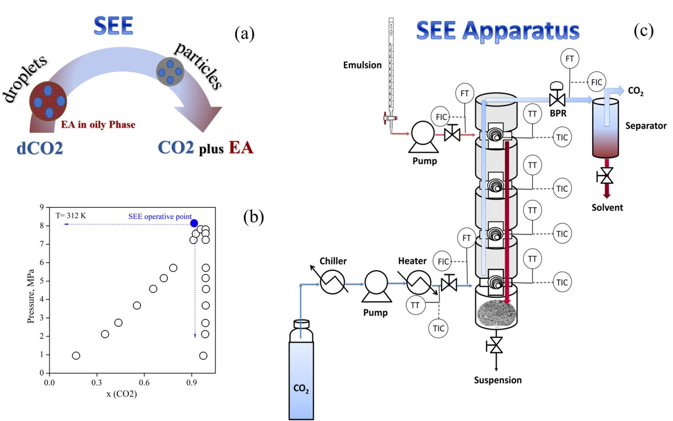

Figure 1. Schematic illustration of SEE process with the representation of droplet (in emulsion) shrinkage and polymer particle formation after the oily phase extraction by dense-CO₂ (a). Vapour Liquid Equilibrium (VLE) at high pressure for the system EA-CO₂ at 312 K adapted by Chrisochoou et al., (1995); the blue dot approximatively indicates the operative point, neglecting the water phase that is immiscible in CO₂ in the same conditions (b). SEE apparatus layout with the packed column operating in counter-current mode; other legends: CO₂ supply; chiller used for CO₂ cooling; diaphragm pump used for high pressure CO₂; heater used for SC-CO₂ heating; emulsion supply; piston pump used for the emulsion; TT-TIC, temperature control; FT-FIC, flow rate control; BPR, back pressure regulator; separator used for CO₂ and solvent recovery; suspension recovery (c).

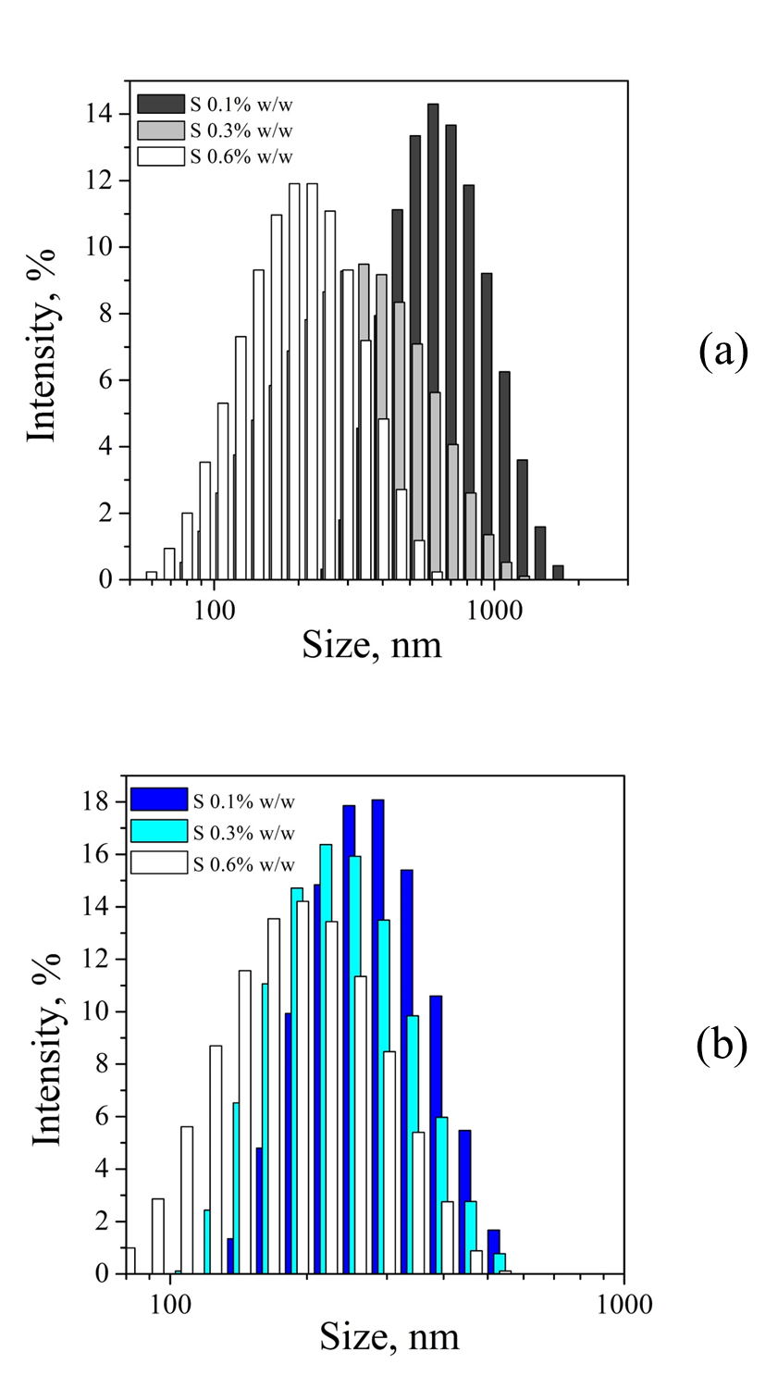
Figure 2: Influence of the surfactant content in the water external phase on carrier size distribution obtained using low Mw-PLA (a) and low Mw-PLGA (75:25) (b). Fixing the polymer concentration in the oily phase and other emulsion formulation parameters, a reduction of carriers mean size was observed with the increase of surfactant concentration in the external water phase.
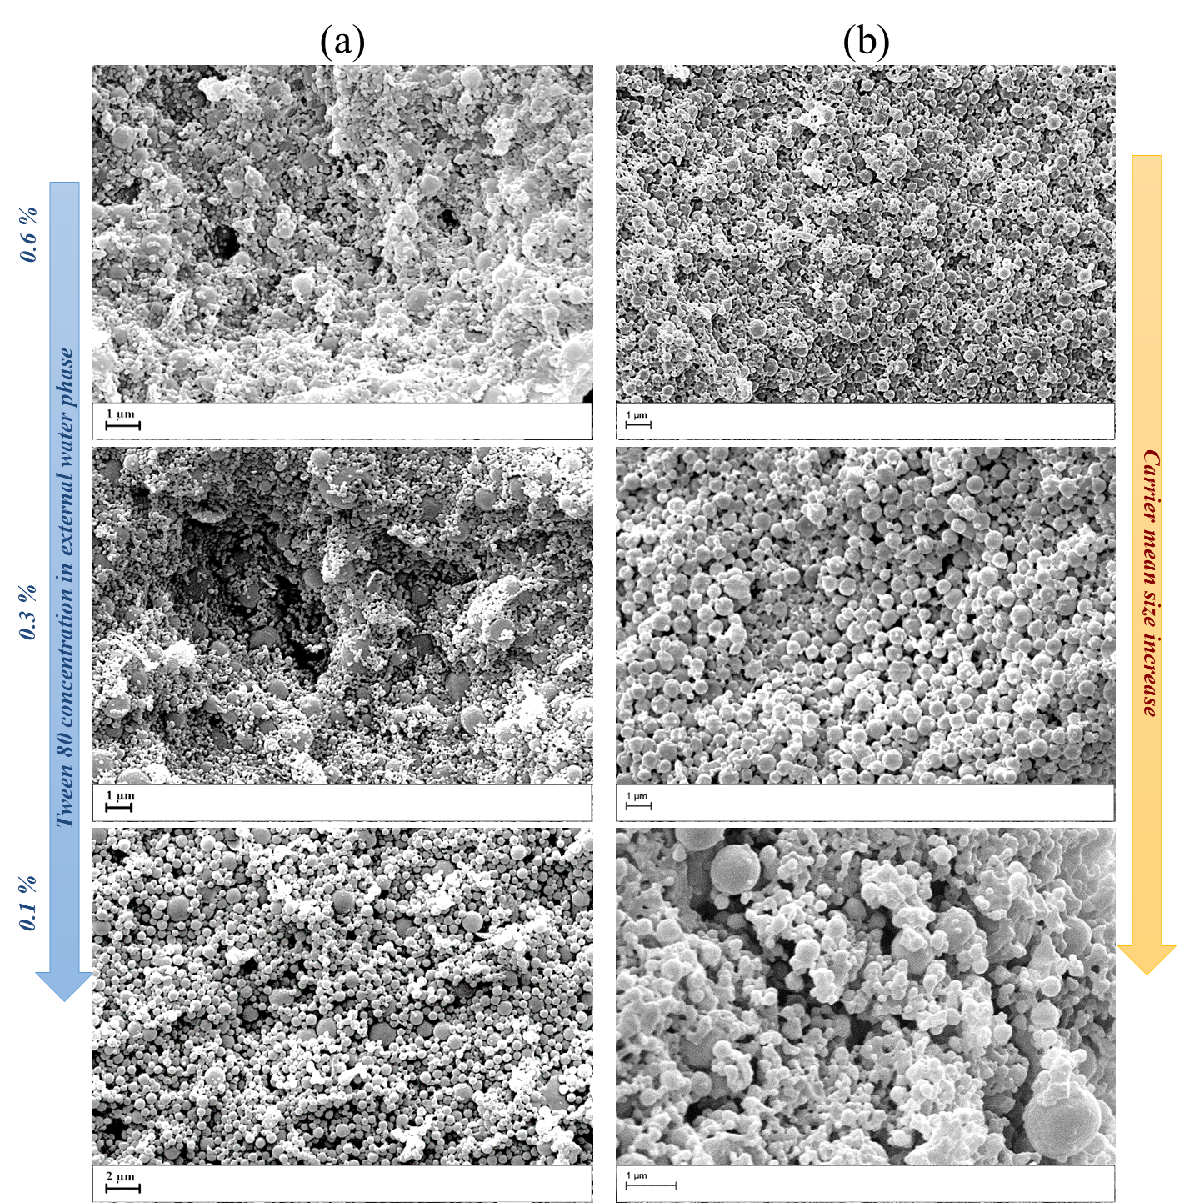

Figure 3. FE-SEM images of carriers fabricated using emulsion formulated at increasing surfactant concentrations in the external water phase from 0.1 to 0.6% w/w. Low Mw-PLA (a) and low Mw-PLGA (75:25) (b). Fixing the all other parameters, increasing the surfactant concentration a general reduction of mean droplets size was obtained in emulsion assuring carriers mean size reduction.

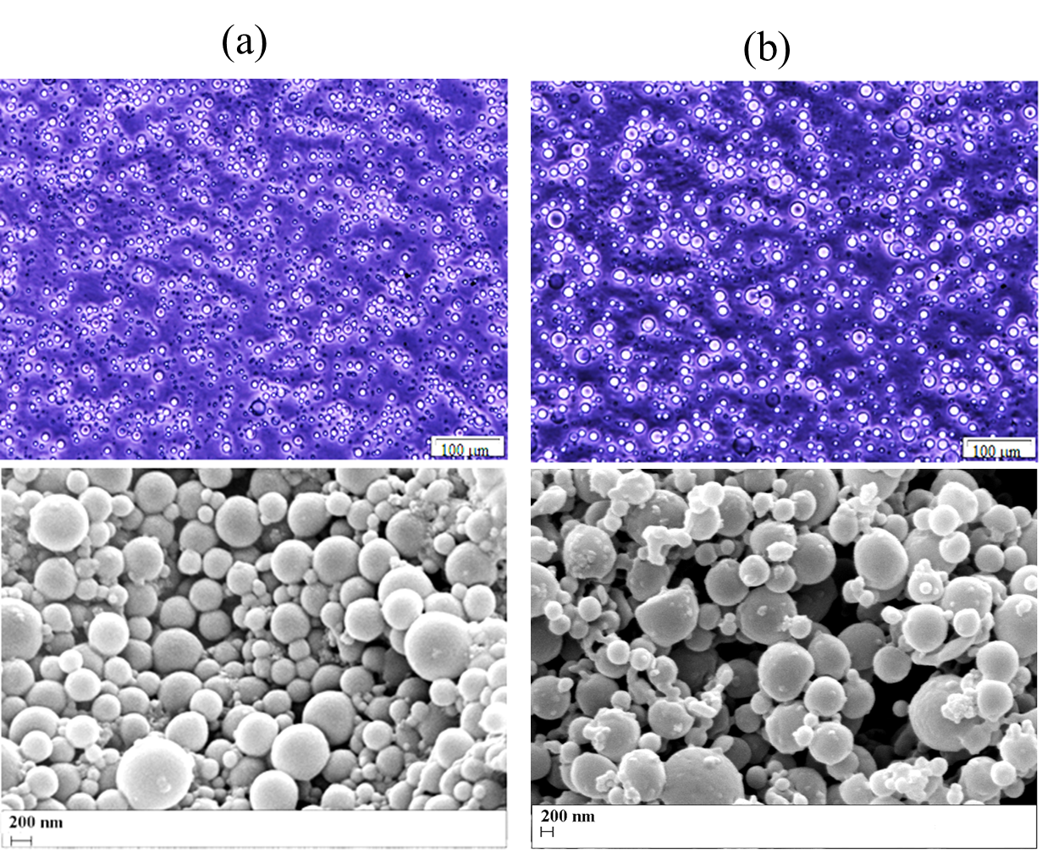
Figure 4: Optical images of emulsions and SEM images of related carriers loaded with growth factors; high Mw-PLGA (50:50) loaded with Active hGDF-5 (a) and hTGFβ1 (b).

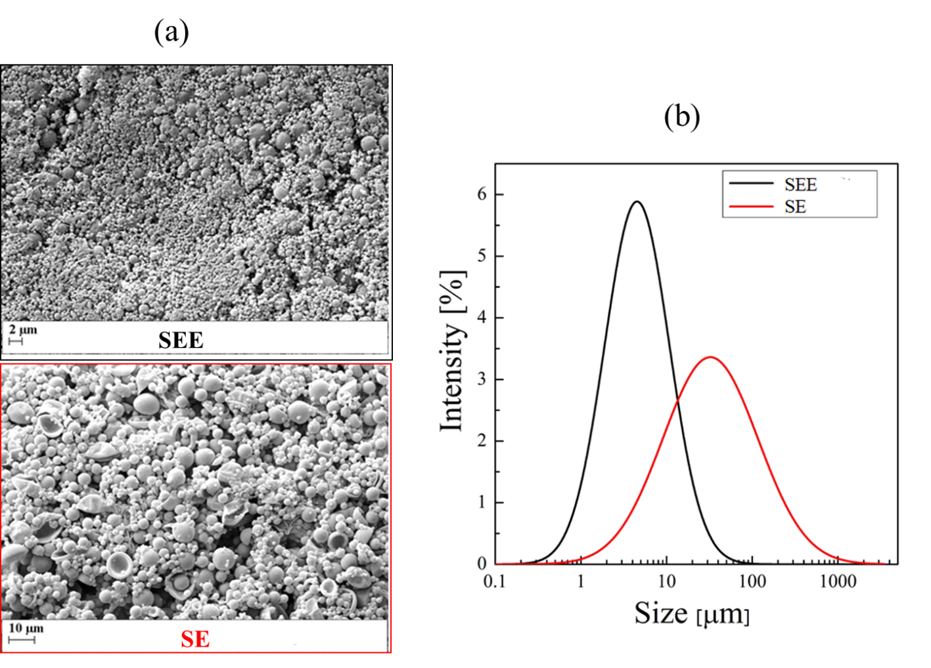
Figure 5: SEM images and Particle Size Distributions of high Mw-PLGA (50:50) empty carriers fabricated using the same emulsion processed with different technologies: Supercritical Emulsion Extraction (SEE) and traditional solvent evaporation (SE) techniques, respectively. Larger carriers size and distribution was observed in the case of particles obtained by SE.

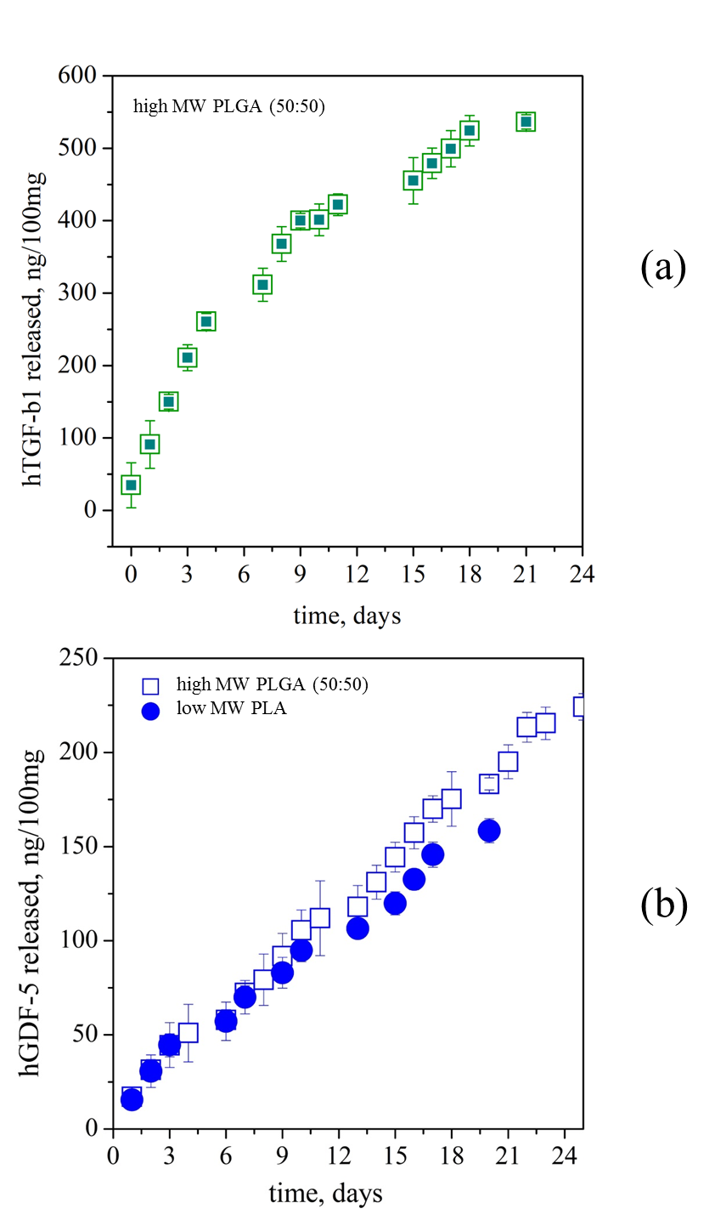

Figure 6. Release profiles of growth factors measured in α-MEM at 37°C up to 25 days. The data are expressed as amounts (ng) released from 100 mg of carriers: hTGF-β1 from high-Mw PLGA (50:50) carriers (a); ihGDF-5 and hGDF-5, respectively, from high-MW PLGA (50:50) and low-MW PLA carriers (b).
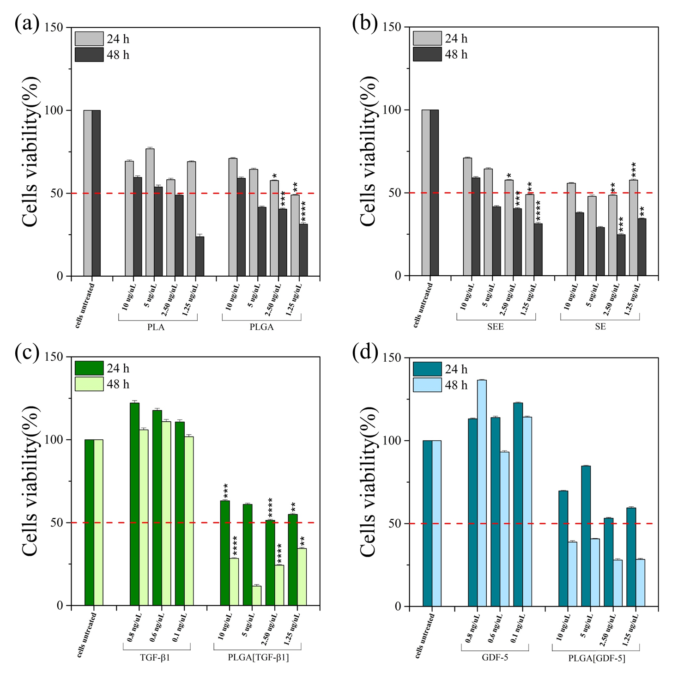
Figure 7. Carriers cytotoxicity evaluated using Chinese Hamster Ovary cell line (CHO-K1) that were treated with empty and loaded PLA and PLGA carriers for 24h and 48h: (a) empty PLA and PLGA carriers; (b) empty high-Mw PLGA carriers, fabricated with SEE and SE techniques; (c) free hTGF-β1 and hTGF-β1 loaded high-Mw PLGA carriers; (d) free hGDF-5 and hGDF-5 loaded PLGA carriers. The histograms report the mean percentage of viable cells compared to controls (untreated cells, 100%). The experiments were analyzed by two-tailed Student’s t-test, * p ≤ 0.05, **p < 0.01, ***p < 0.001 and **** p ≤ 0.0001; n=3.

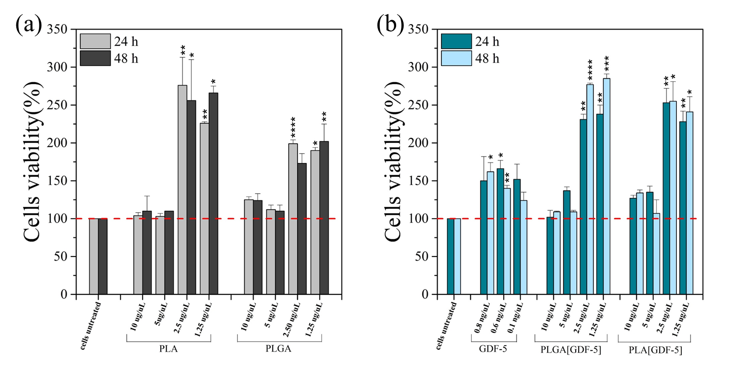
Figure 8. Carrier cytotoxicity was evaluated using human peripheral blood mononuclear cells (hPBMCs) that were treated with decreasing amounts of empty and loaded low-Mw PLA and high-Mw PLGA carriers for 24h and 48h: (a) empty low-Mw PLA and high-Mw PLGA carriers; (b) free hGDF-5 and hGDF-5 loaded carriers. The histograms report the mean percentage of viable cells compared to controls (untreated cells, 100%). The experiments were analyzed by two-tailed Student’s t-test * p ≤ 0.05, **p < 0.01, ***p < 0.001 and **** p ≤ 0.0001; n=3.

