Enhancing the regenerative potential of stem cell-laden, clinical-grade implants through laminin engineering
Aina Mogas Barconsª, Prof. Divya M. Chari^{b}, Dr. Chris Adamsª.

ªSchool of Life Sciences, Keele University, Staffordshire, ST5 5BG, United Kingdom.
^{b}School of Medicine, Keele University, ST5 5BG, United Kingdom.

Aina Mogas Barcons: a.mogas.barcons@keele.ac.uk
Prof. Divya M. Chari: d.chari@keele.ac.uk
Dr. Chris Adams: c.adams@keele.ac.uk

Corresponding author:
Dr. Chris Adams
School of Life Sciences (Huxley Building: 226)
Keele University
Staffordshire, ST5 5BG
United Kingdom

Phone: +44 (0)1782 733943
Fax: +44 (0)1782 73423
ABSTRACT
Protected delivery of neural stem cells (NSCs; a major transplant population) within bioscaffolds has the potential to improve regenerative outcomes in sites of spinal cord injury. Emergent research has indicated clinical grade bioscaffolds (e.g. those used as surgical sealants) may be repurposed for this strategy, bypassing the long approval processes and difficulties in scale-up faced by laboratory grade materials. Whilst promising, clinical scaffolds are often benign and not inherently regenerative. Extracellular molecule biofunctionalisation of scaffolds can enhance regenerative features such as encapsulated cell survival/distribution, cell differentiation into desired cell types and nerve fibre growth. However, this strategy is yet to be tested for clinical grade scaffolds. Here, we show for the first time that HemopatchTM, a widely used, clinically approved surgical matrix, supports NSC growth. Further, functionalisation of HemopatchTM with laminin promoted even distribution of NSCs and their daughter cells within the matrix, a key regenerative criterion for transplant cells.
KEY WORDS
Spinal cord injury; tissue engineering; neural stem cell; HemopatchTM; surgical materials; extracellular matrix.

- BACKGROUND
Spinal cord injury (SCI) affects between 250,000 and 500,000 people every year [1], often with severe and debilitating consequences. Repairing the multifaceted pathology of SCI is a major challenge requiring breakdown of the glial scar, removal of inhibitory myelin fragments and restoration of complex circuitry [2]. Numerous pre-clinical studies have demonstrated neural stem cell (NSC) transplantation offers promise in this regard, providing cell replacement and trophic factor release and enhancing functional outcomes [2–5]. Clinical trials are also in progress [6]. For example, following intramedullary injections of human foetal-derived NSCs to chronic phase SCI in human patients at 3, 6, 9 and 12 month periods, all subjects showed an increase in their total GRASSP (Graded Redefined Assessment of Strength, Sensibility and Prehension) score [6], demonstrating the clinical promise of this approach.
However, multiple studies have demonstrated that low numbers of cells are retained at the injury site following injection. For example, only ca. 30% of cells transplanted into a rat model of SCI persisted at the injury site 7 days post-grafting, with an associated decline in motor function [7]. Cell survival when injected with cerebrospinal fluid (CSF) + Chondroitinase ABC into the injured spinal cord of rats was 2.44 ± 1.04%, 8 weeks post-transplant [8]. In mice, NSCs injected into the spinal cord and tracked through bioluminescence, retained 20% of the initial signal one week after injection [9], suggesting a possible cell loss. Such cell attrition may be due to the combination of a robust host immune response, insufficient vascularisation leading to poor oxygen supply to the implanted cells, the presence of cytotoxic free radicals at the injury site and environmental shock during transplantation (i.e. extrusion of cells through a thin needle and associated mechanical trauma) which, ultimately, can lead to cell death [10]. Moreover, attachment of cells in the subarachnoid space or cell washout due to CSF flow may contribute to the low cell numbers found in the injury site [11]. Clearly, this is a critical issue to overcome, as higher numbers of viable cells reaching injury sites correlates directly with functional efficacy [12].
To address this, encapsulation of transplant cell populations within implantable, biocompatible matrices may offer several translational advantages [13] . These materials offer (i) a porous structure mimicking the extracellular matrix (ECM) to facilitate cell attachment and tissue ingrowth; (ii) ‘soft’ mechanical properties to match the stiffness of the native CNS (important for implant acceptance) [14] and allow surgical moulding into diverse injury sites and; (iii) improved cell survival and distribution in injury sites after implantation. For example, ca. 85% mice retained NSCs 7 days after injection within a hyaluronan-based hydrogel compared to ca. 55% of mice when NSCs were injected in CSF [15]. Further, hydrogel injected cells were dispersed throughout the injection site with cell clumping observed after injection in CSF. Führmann et al. [7] showed an increase in cell retention from ca. 30% to 45% when cells were implanted within a hydrogel. This was associated with increases in motor functionality at 6 weeks post-injury, compared to medium-injected cells. Similarly, Vacanti et al. [15] demonstrated cells delivered by encapsulation in a polyglycolic acid (PGA) matrix to sites of SCI in rats resulted in higher measures of limb functionality 4 weeks post-surgery compared to media-injected cells.
Despite this promise, none of the hydrogels tested for therapeutic cell encapsulation and delivery to SCI are clinically approved or manufactured under good manufacturing practice (GMP). This is a major barrier to clinical use as it takes an average of seven years for a new device to be approved by the American Food and Drug Administration (FDA) [17]. In addition, any major changes in the manufacturing process (e.g. through scale-up) necessitate further biological tests to ensure that the safety and functionality of the material have not changed, increasing the time to clinic and costs of development.
As a potential alternative, numerous polymeric implants are already routinely used within the clinic and approved for uses such as tissue sealants, sutures and wound dressings [18]. In the majority of cases, these have not been tested for potential cell transplant applications. One study has demonstrated DuragenTM, a surgical sealant manufactured from clinical grade, bovine collagen can support NSC growth, including genetically engineered populations [19]. Here, highly viable populations of cells could be grown throughout the material with no effect on key regenerative properties of the stem cells including proliferation, stemness and differentiation [19]. Given the positive findings from this study, it is vital other clinical materials are tested for the creation of a ‘bank’ of suitable, clinically used materials with potential for cell transplant applications. Further, it is well-established that biofunctionalisation of scaffolds can add significant regenerative potential to the material. For example, engineering extracellular matrix molecules or epitopes into scaffold design has been shown to improve cell survival and distribution throughout injury sites [20], enhance neuronal differentiation of encapsulated stem cells and enhance nerve fibre and neural cell infiltration into the scaffold [21]. However, ECM modification of clinically approved biomaterials for neural cell transplantation has not yet been tested.
One clinically approved material with a number of potential translational advantages for use in cell transplantation is HemopatchTM. HemopatchTM is a sealing hemostat approved for medical use during surgical procedures to reduce bleeding and induce hemostasis. Within the CNS, it has been safely used to close dural defects and avoid post-operative CSF leakage in humans [22]. It is a porous structure made from ultrapure bovine collagen, with a 200 µm coating of polyethylene glycol (PEG) on one surface, to improve tissue adhesiveness. HemopatchTM is flexible, allowing for easy handling by surgeons with potential for moulding into sites of injury, and is naturally degraded within 6 to 8 weeks [23]. This material is approved as a CE-marked medical device and is already manufactured for a global market.
The two objectives of this study were therefore to (1) test whether Hemopatch TM can support NSC growth and differentiation and (2) examine the feasibility and effect on encapsulated NSC populations of biofunctionalisation of HemopatchTM with the ECM molecule laminin.
- METHODOLOGY
Expanded methodology is available as Supplementary Information.
  - HemopatchTM preparation
HemopatchTM was kindly donated by Baxter Healthcare Technologies. Under sterile conditions, a 0.5 cm² piece of HemopatchTM was cut with a scalpel and then chopped with a McIlwain Tissue Chopper set to 250 µm. Some pieces of HemopatchTM were rinsed with ethanol and then incubated at 37ᵒC with poly-ornithine (1:5) (Sigma P4957) for 1 hour. Then, the slices were washed with water and incubated again with laminin (1:200) (Sigma L2020) for 1 hour. Finally, they were washed three times with water and stored in the incubator until use. Alternatively, some slices were left uncoated and kept in water until use.
The laminin isotype, laminin-111, was chosen as its active peptides have been previously used in conjugation with 3D biomaterials and to promote regenerative behaviour of encapsulated cells. For example, conjugation of laminin-111 active peptides with a chitosan biomaterial resulted in potent neuronal attachment and promoted axonal extension of primary cultured rat cortical neurons in comparison to uncoated samples [24].
It should be noted that HemopatchTM is also equipped with a 250 µm thick layer of NHS-PEG bound to one side of the material, designed to enhance its tissue adherance properties. However, we consider the impact of this PEG layer on cellular function to be negligible in these experiments due to the following reasons: the material was cut vertically (to fit the culture well), perpendicular to the PEGylated layer to generate a piece of HemopatchTM approximately 5000 (length) x 1000 (width) x 250 (depth) µm. The 250 µm thick PEGylated layer was therefore solely situated along one of the widths of the final piece. Moreover, during culture, the material was orientated sideways (with the thin PEGylated side as one of the lateral walls) so as to minimise PEG interaction with cells. Further, it is likely the PEG layer was dissolved in water during the preparation steps prior to seeding the cells on the material (personal communication, Baxter), so would not have affected the outcomes.
  - Cell culture
Mouse brains were dissected from postnatal day 1 (P1) to P3 mice and kept in phosphate buffered saline (PBS) on ice until use. Under a dissection microscope, the subventricular zone was isolated from all brains using a scalpel and kept in 1 mL of neurosphere medium (NSM) (Supplementary Table 1). The cells were dissociated with DNAse I (Sigma Aldrich 10104159001) and cultured in T25 flasks in 5 mL of NSM at a density of 1x10⁵ cells/mL. These were incubated at 5% CO₂ and 37ᵒC. NSCs were allowed to proliferate as neurospheres and after 5 to 7 days, dissociated into single cells with a DNAse I /Accutase mix (1:9) for the experiments. The experimental conditions included: (i) laminin and poly-ornithine coated coverslips, (ii) laminin and poly-ornithine coated HemopatchTM and (iii) uncoated HemopatchTM. The coverslips (i) were placed at the bottom of 24 well plates and the cells were seeded on top suspended in 600 µL of medium at a density of 1.5x10⁵ cells/mL. Each piece of HemopatchTM (ii, iii) was placed in a different well from the same plate and the cells were seeded on top of the biomaterial in a 10 µL drop at a density of 1x10⁷cells/mL. The cells were allowed to settle for 30 minutes in the incubator and then 600 µL of medium was added in each well.
Cells were grown in monolayer medium (MLM) (Supplementary Table 1) (designed to retain NSCs) for 4-5 days, with feeding every other day. Once the cells on the coverslips were confluent, they were either fixed with 4% PFA for 1 hour (for assessment of NSC growth and health) or were allowed to differentiate for 7 days by swapping the MLM to differentiation medium (DiffM) (Supplementary Table 1) (for assessing any effects of materials on differentiation). All plates were fed every other day with a 50% medium change. Prior to fixing, some cells were stained for survival (Live/Dead) and proliferation (Edu) assays (See Supplementary Information for protocols and Supplementary Table 2 for a list of antibodies).
  - Image and statistical analysis
The cells were imaged with a x5 or x40 magnification objective using fluorescence microscopy and scanning electron microscopy (SEM) at x1.5k and x3k magnification and cell counts were performed (See Supplementary Information). All statistical analyses were carried out using GraphPad Prism. All values are expressed as the mean ± standard deviation. A one-way ANOVA test (with Bonferroni’s multiple comparison test) was carried out to test if there were any statistical differences between groups, assuming a normal distribution, without matching. A p-value of below 0.05 was determined to indicate a significant difference between experimental groups (n ≥ 3). “n” is the number of biological repeats for each experiment, with each mouse litter counted as one biological repeat.
  - Ethics statement
All animal use was in accordance with the Animals (Scientific Procedures) Act of 1985 (UK). This material has not been published in whole or in part elsewhere. All authors have been personally and actively involved in substantive work leading to the manuscript, and will hold themselves jointly and individually responsible for its content.
- RESULTS
  - HemopatchTM supports NSC survival and proliferation
Five days after cell seeding, NSCs had dispersed through the biomaterial and distributed three-dimensionally, as seen by the presence of cells out of the plane of focus and in Supplementary Figure 1. NSCs were evenly distributed and present as individual cells over the surface of the coverslips and the coated HemopatchTM, while cells within uncoated HemopatchTM consistently appeared to form spheres dispersed in the gel (Fig 1, A-C). Cell survival was high across experimental groups (Fig 1, D-F) and the number of EDU⁺ cells, an indicator of proliferation, also remained similar in all groups (Fig 1, G-I). After quantification, it was found that between 1 and 3 neurospheres/field and between 0 and 1 neurospheres/field were counted for the glass and coated HemopatchTM conditions respectively compared to 15-19 neurospheres/field in uncoated HemopatchTM (Fig 1, J). NSCs in all conditions displayed over 80% viability, with no statistical differences between experimental groups (Fig 1, K). Finally, the numbers of proliferating cells remained at approximately 20% in all experimental groups after 6 hours of incubation with EduA (Fig 1, L).
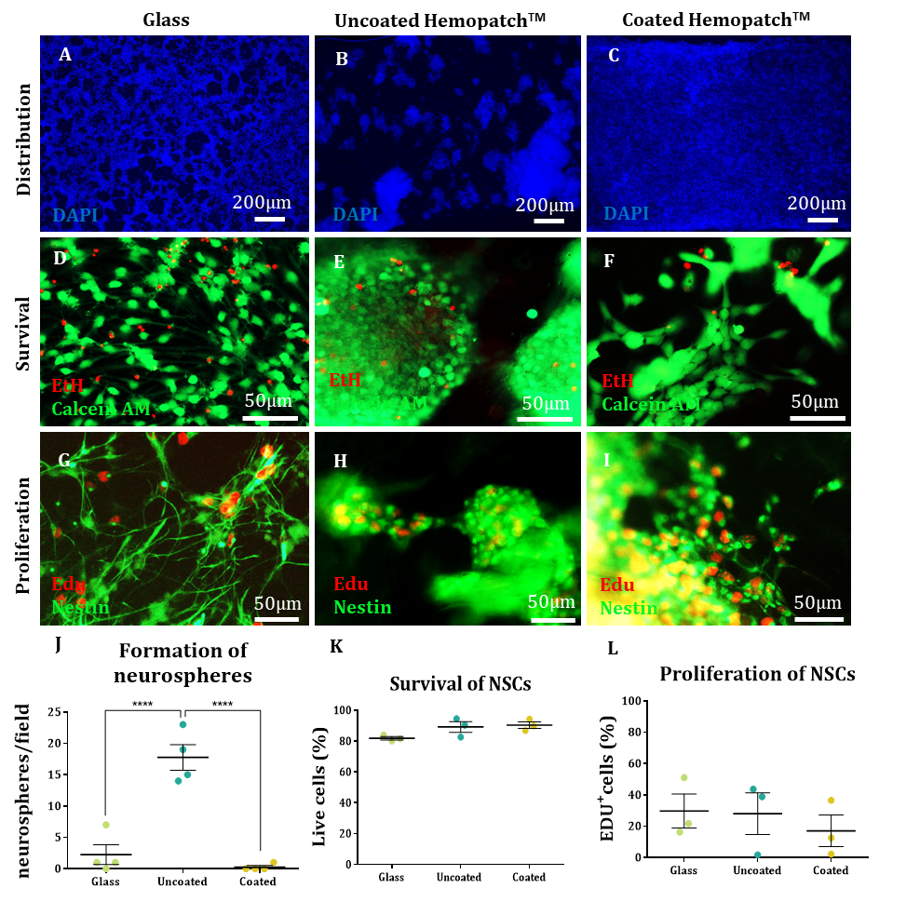
Figure 1. NSCs display high survival rates and proliferate in HemopatchTM. (A-C): Nuclei distribution in low magnification images on glass (A), uncoated HemopatchTM (B) and coated HemopatchTM (C). (D-F): Live/Dead assay of NSCs on glass (D), uncoated HemopatchTM (E) and coated HemopatchTM (F). Live cells (Calcein AM) are green and dead cells (Ethidium homodimer) are red. (G-I): Proliferation assay for NSCs on glass (G), uncoated HemopatchTM (H) and coated HemopatchTM (I). (J-K): Scatter plot representations of cell distribution (p<0.0001, n=4) (J), proportion of live cells (p=0.101; n=3) (K) and proportion of proliferating cells (p=0.713; n=3) (K).

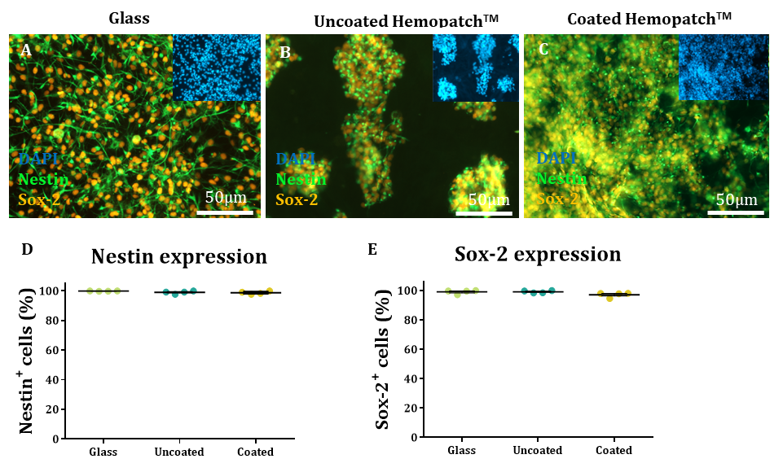
NSCs displayed similar proportions of cells positive for the NSC marker Nestin with >98% of cells recorded as positive across all experimental groups (Fig 2, A-D). Cells generally displayed classical bipolar morphologies associated with the NSC phenotype on glass with some evidence for this seen within the coated HemopatchTM samples. NSC morphology was harder to discern in the uncoated HemopatchTM where cells tended to form into neurospheres (Fig 2, A-C). NSCs also showed comparable expression of Sox-2, a nuclear stem cell marker, across all experimental conditions (Fig 2, A-C, E).
Figure 2. NSCs were successfully cultured in HemopatchTM. Nestin and Sox-2 stained NSCs in glass (A), uncoated HemopatchTM (B) and coated HemopatchTM (C); insets are DAPI stained counterparts. Scatter plots showing the proportions of cells expressing Nestin (D) (p=0.181, n=4) or Sox-2 (E) (p=0.111, n=4) under each experimental condition.

  - HemopatchTM could support the differentiation of NSCs into their daughter cells
After seven days in differentiation conditions, cell viability remained high (Fig 3, A-C) and the presence of EDU⁺ cells in HemopatchTM was similar to coverslips (Fig 3, D-F). In detail, the proportion of viable cells was higher than 80% in all groups as judged by live/dead staining (Fig 3, G). Moreover, daughter cells retained their proliferative capability, with ca. 5% staining positive for Edu incorporation in each condition (Fig 3, H). No statistical differences were found between experimental groups.

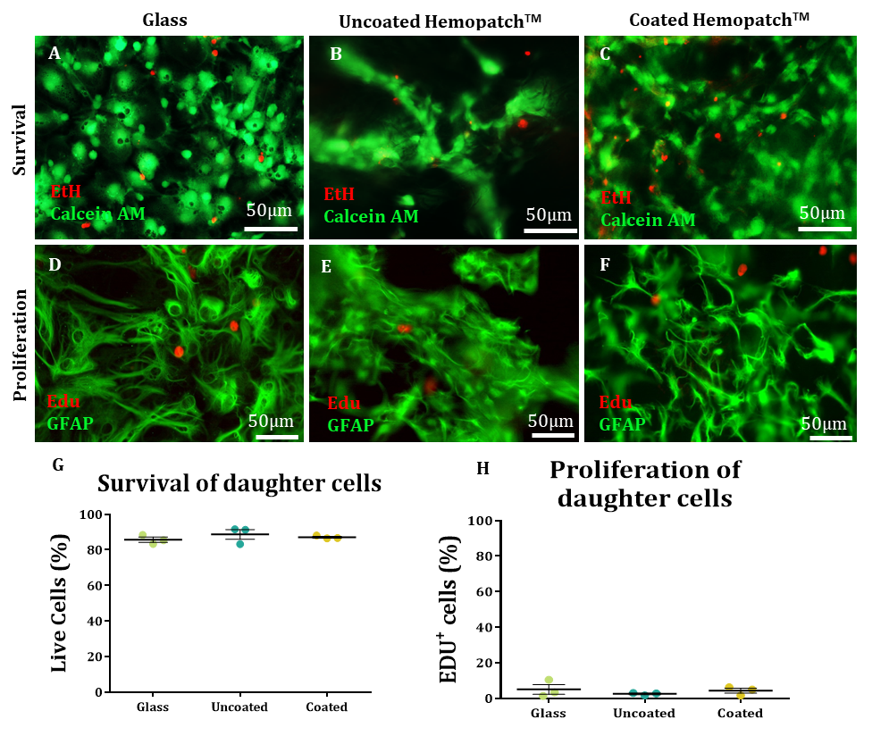
Figure 3. Survival and proliferation of daughter cells in HemopatchTM. (A-C): Live/Dead assay of daughter cells in glass (A), uncoated HemopatchTM (B) and coated HemopatchTM (C). Live cells are green and dead cells are red. (D-F): Proliferation assay for daughter cells in glass (D), uncoated HemopatchTM (E) and coated HemopatchTM (F). (G-H): Scatter plot representations of the proportion of live cells (p=0.810; n=3) (G) and the proportion of proliferating cells (p=0.612; n=3) (H).

Immunocytochemistry revealed that the NSCs had differentiated in all conditions into the expected phenotypes, namely astrocytes (Fig 4, A-C), neurons (Fig 4, D-F) and oligodendrocytes (Fig 4, G-I). Overall, more than 60% of the cells differentiated into astrocytes (Fig 4, J), >18% into neurons (Fig 4, K) and >3% into oligodendrocytes (Fig 4, L) in a consistent manner across the experimental groups with no statistically significant differences observed. The rest of the cells remained unidentified and were possibly undifferentiated stem cells. The daughter cells appeared to retain the pattern of distribution seen for the NSCs, with cells in the uncoated samples remaining in groups and an even distribution noted in the coated samples. In general, daughter cells displayed normal morphologies as expected in in vitro culture conditions.

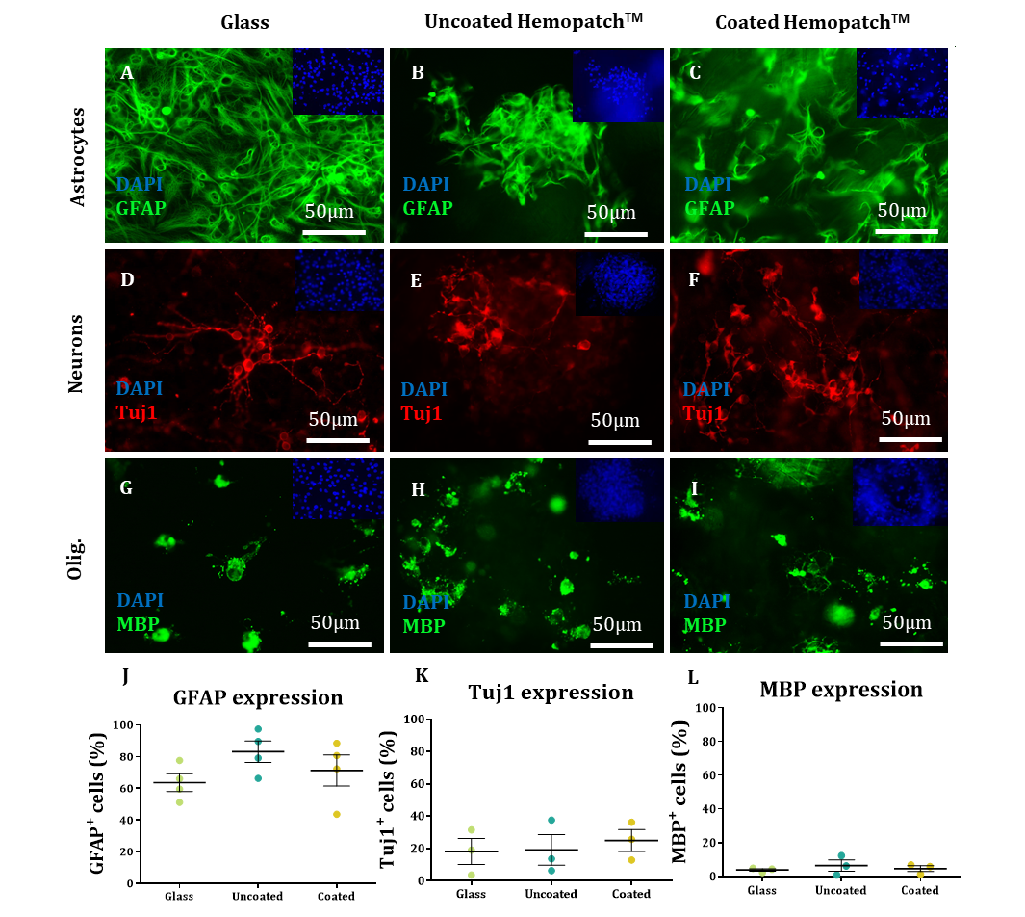
Figure 4. NSCs could generate their daughter cells in HemopatchTM. (A-C): GFAP stained astrocytes in glass (A), uncoated HemopatchTM (B) and coated HemopatchTM (C). (D-F): Tuj-1 stained neurons in glass (D), uncoated HemopatchTM (E) and coated HemopatchTM (F). (G-I): MBP stained oligodendrocytes in glass (G), uncoated HemopatchTM (H) and coated HemopatchTM (I). (J-L): Scatter plots show the proportions of each cell type: astrocytes (p=0.234, n=4) (J), neurons (p=0.821, n=3) (K) and oligodendrocytes (p=0.700, n=3) (L). Image insets show DAPI stained counterparts.
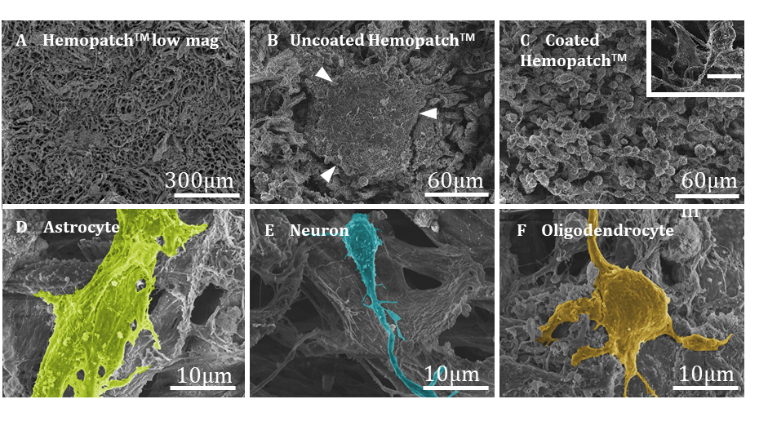
However, astrocytes grown in HemopatchTM did appear more ramified compared to the broad, flattened appearance of astrocytes grown on glass coverslips. In general, cell projections were observed extending throughout the construct and travelled in and out of the plane of focus, highlighting the 3D nature of the culture as compared to glass coverslips. Finally, we showed the feasibility of processing these constructs for imaging via SEM. Here, we were able to visualise the porosity of the material (Fig 5, A) and the presence of neurospheres on uncoated HemopatchTM but not on the coated HemopatchTM (Fig 5, B-C). Moreover, we were able to identify differentiated NSCs on the collagen fibres (Fig 5, D-F). Putative cell subtypes are highlighted in Figure 5, although these need to be confirmed through combinatorial techniques such as immunogold labelling (See Supplementary Fig 2 in SI for original images). Finally, this technique also allowed for pore size quantification, showing the average pore diameter was 10.0 ± 3.2 µm.
Figure 5. Daughter cell morphology on SEM images. (A-C): Low magnification image of coated HemopatchTM depicting the porosity of the construct (A), cells in a neurosphere formation on uncoated HemopatchTM (B) and single cells on coated HemopatchTM (C) Inset showing a single cell on the material. Scale bar: 10µm. Arrows indicate edges of the neurosphere. (D-F): Differentiated NSCs on coated HemopatchTM: astrocyte (D), neuron (E) and oligodendrocyte (F). Colour indicates our interpretation of the cell bodies.
- DISCUSSION
Our data show for the first time that the neurosurgical grade biomaterial HemopatchTM can support the clinical transplant population of NSCs. Further, we have provided the first data indicating clinical grade materials can be modified using laminin with associated improvements in NSC and daughter cell distribution throughout the material. This finding has implications in reducing cell aggregation after transplantation which can lead to uneven repair. Survival, proliferation and differentiation rates were similar to glass coverslips (the gold standard substrate for NSC growth), suggesting that the material does not adversely impact key NSC properties that underpin their regenerative potential. We believe the findings support in vivo testing of HemopatchTM as an implantable plug containing healthy NSCs for SCI repair. Further, alongside other reports in the literature, the data can provide manufacturers a framework (identifying suitable material physiochemical properties and biofunctionalisation strategies) to develop their own materials and protocols for repurposing existing medically approved scaffolds for neural cell transplantation.
We found that a simple coating step of the HemopatchTM with laminin promoted an even pattern of cell distribution through the material instead of the sphere formation observed in uncoated samples, without affecting survival, proliferation or differentiation of cells.
The cellular mechanism underpinning these differences is not yet clear, but it could be that the presence of ECM molecules facilitates migration of the cells through the material whereas in their absence the cells remain in place and divide to become neurospheres [25]. Both systems may have advantages. On one hand, improving cell distribution by coating the material with ECM molecules could avoid the issue of cell aggregation and ultimately enhance even repair throughout injury sites. On the other hand, higher survival rates have been observed after transplantation of NSCs as neurospheres compared to dissociated cells in sites of SCI in rats [26], potentially providing additional protective benefit to the encapsulated cells. Both formats would need to be tested in sites of in vivo SCI to examine which could lead to the greatest functional recovery. As far as we are aware, laminin is not yet used clinically and ECM coating would require additional safety testing steps for CE-marking approval. However, a number of companies already produce chemically defined and animal component-free, human laminin isoforms using commercially scalable processes adaptable to producing clinical grade laminin. Alongside the expansion in biofunctionalisation of scaffolds designed to support cell transplant populations and further enhance regenerative responses, tuning cellular and tissue responses to the scaffold in this manner appears feasible for clinical production and warrants investigation [21].
In terms of physicochemical properties, HemopatchTM is a porous, sponge-like structure mainly fabricated using collagen type I, a material with several benefits for implantation into site of SCI. Collagen is neurocompatible and alongside our study has previously been shown to support neuronal and NSC growth in vitro [27,28]. Implantation of collagen hydrogels in a transected spinal cord has been shown to promote axonal growth 5 days post-injury and functional recovery 12 days post-injury in rats [29], as well as cell infiltration and vascularization within the implanted hydrogel [30]. Therefore, collagen appears to be well-tolerated in the nervous system but may also be able to impart additional regenerative benefit alongside the encapsulated therapeutic cells, a feature that will have to be tested in future work.
The porosity of the material may also facilitate nerve fibre in-growth and cellular infiltration. The infiltration of macrophages and lymphocytes within HemopatchTM has been previously reported in the rat liver [31]. Currently, the pores in HemopatchTM, which are approximately 10µm in diameter, are randomly ordered but the spinal cord displays highly ordered, aligned structures such as the corticospinal tracts. It may therefore be desirable to enhance cell alignment within the construct to aid repair of these structures. Application of an 80 mV/mm alternating current to neurons cultured in a 3D silk protein matrix resulted in axons growing in parallel to the electrical field. [32]. Given the porous, open nature of HemopatchTM, it seems feasible that this strategy could be employed here to influence encapsulated cell behaviour.
Besides its physicochemical properties, HemopatchTM is currently manufactured as a 2 mm thick sheet of flexible collagen, in approximately 15 x 4 cm dimensions. This can be simply cut to a desired shape and is conformable allowing ease of handling. An average intramedullary lesion length size for cervical injuries was reported to be ca 7 cm [33], suggesting the patches in their current form could cover most injuries (although the largest lesions were up to 19 cm in length). It can be envisaged that these could be cut to size, seeded with NSCs, cultured for up to 5 days then implanted into the site of injury. Taken together, development of bioscaffolds fabricated and functionalised with clinical grade materials appears feasible, offers potential for controlled cell delivery strategies and warrants further testing.
- ACKNOWLEDGEMENTS
We would like to thank Karen Walker and the Keele Electron Microscopy unit for their assistance with processing and imaging samples for SEM.

- FUNDING SOURCES
This research did not receive any specific grant from funding agencies in the public, commercial, or not-for-profit sectors.
- REFERENCES
[1] WHO, World Health Organisation, (2018). http://www.who.int/mediacentre/factsheets/fs384/en/ (accessed March 17, 2018).
[2] C.S. Ahuja, S. Nori, L. Tetreault, J. Wilson, B. Kwon, J. Harrop, D. Choi, M.G. Fehlings, Traumatic Spinal Cord Injury-Repair and Regeneration, Neurosurgery. 80 (2017) S9–S22. https://doi.org/10.1093/neuros/nyw080.
[3] J.F. Bonner, T.M. Connors, W.F. Silverman, D.P. Kowalski, M.A. Lemay, Grafted Neural Progenitors Integrate and Restore Synaptic Connectivity across the Injured Spinal Cord, J. Neurosci. 31 (2011) 4675–4686. https://doi.org/10.1523/JNEUROSCI.4130-10.2011.
[4] Y. Ogawa, K. Sawamoto, T. Miyata, S. Miyao, M. Watanabe, M. Nakamura, B.S. Bregman, M. Koike, Y. Uchiyama, Y. Toyama, H. Okano, Transplantation of in vitro-expanded fetal neural progenitor cells results in neurogenesis and functional recovery after spinal cord contusion injury in adult rats, J. Neurosci. Res. 69 (2002) 925–933. https://doi.org/10.1002/jnr.10341.
[5] S. Nemati, R. Jabbari, M. Hajinasrollah, N. Zare Mehrjerdi, H. Azizi, K. Hemmesi, Z. Azhdari, A. Talebi, S. Mohitmafi, A. Vosough Dizaj, G. Sharifi, H. Baharvand, S. Kiani, O. Rezaee, Transplantation of Adult Monkey Neural Stem Cells into A Contusion Spinal Cord Injury Model in Rhesus Macaque Monkeys., Cell J. 16 (2013) 117–130. http://www.ncbi.nlm.nih.gov/pubmed/24567941.
[6] K.D. Anderson, J. Martinez-barrizonte, G.H. Sunn, K.L. Gant, A.D. Levi, Human Neural Stem Cell Transplantation in Chronic Cervical Spinal Cord Injury : Functional Outcomes at 12 Months in a Phase II Clinical Trial, Clin. Neurosurg. 64 (2017) 87–91. https://doi.org/10.1093/neuros/nyx242.
[7] T. Führmann, R.Y. Tam, B. Ballarin, B. Coles, I. Elliott Donaghue, D. van der Kooy, A. Nagy, C.H. Tator, C.M. Morshead, M.S. Shoichet, Injectable hydrogel promotes early survival of induced pluripotent stem cell-derived oligodendrocytes and attenuates longterm teratoma formation in a spinal cord injury model, Biomaterials. 83 (2016) 23–36. https://doi.org/10.1016/j.biomaterials.2015.12.032.
[8] H. Suzuki, C.S. Ahuja, R.P. Salewski, L. Li, K. Satkunendrarajah, N. Nagoshi, S. Shibata, M.G. Fehlings, Neural stem cell mediated recovery is enhanced by Chondroitinase ABC pretreatment in chronic cervical spinal cord injury, PLoS One. 12 (2017) 1–23. https://doi.org/10.1371/journal.pone.0182339.
[9] A. Yasuda, O. Tsuji, S. Shibata, S. Nori, M. Takano, Y. Kobayashi, Y. Takahashi, K. Fujiyoshi, C.M. Hara, A. Miyawaki, H.J. Okano, Y. Toyama, M. Nakamura, H. Okano, Significance of remyelination by neural stem/progenitor cells transplanted into the injured spinal cord, Stem Cells. 29 (2011) 1983–1994. https://doi.org/10.1002/stem.767.
[10] D.D. Pearse, A.R. Sanchez, F.C. Pereira, C.M. Andrade, R. Puzis, Y. Pressman, K. Golden, B.M. Kitay, B.A.S. Blits, P.M. Wood, M.B. Bunge, Schwann Cell Transplantation Improves Reticulospinal Axon Growth and Transplantation of Schwann Cells and / or Olfactory Ensheathing Glia into the Contused Spinal Cord : Survival , Migration , Axon Association , and Functional Recovery, Glia. 55 (2007) 976–1000. https://doi.org/10.1002/glia.20490.
[11] S.K. Oh, S.R. Jeon, Current Concept of Stem Cell Therapy for Spinal Cord Injury : A Review, Korean J Neurotrauma. 12 (2016) 40–46. doi: 10.13004/kjnt.2016.12.2.40.
[12] M. Yousefifard, V. Rahimi-movaghar, NEURAL STEM / PROGENITOR CELL TRANSPLANTATION FOR SPINAL CORD INJURY TREATMENT ; A SYSTEMATIC REVIEW AND META-ANALYSIS, Neuroscience. 322 (2016) 377–397. https://doi.org/10.1016/j.neuroscience.2016.02.034.
[13] R.C. Assuncao-Silva, E.D. Gomes, N. Sousa, N.A. Silva, A.J. Salgado, Hydrogels and Cell Based Therapies in Spinal Cord Injury Regeneration., Stem Cells Int. 2015 (2015) 948040. https://doi.org/10.1155/2015/948040.
[14] M.M. Pakulska, B.G. Ballios, M.S. Shoichet, Injectable hydrogels for central nervous system therapy, Biomed. Mater. 7 (2012) 024101. https://doi.org/10.1088/1748-6041/7/2/024101.
[15] B.G. Ballios, M.J. Cooke, L. Donaldson, B.L.K. Coles, C.M. Morshead, D. Van Der Kooy, M.S. Shoichet, A Hyaluronan-Based Injectable Hydrogel Improves the Survival and Integration of Stem Cell Progeny following Transplantation, Stem Cell Reports. 4 (2015) 1031–1045. https://doi.org/10.1016/j.stemcr.2015.04.008.
[16] M.P. Vacanti, J.L. Leonard, B. Dore, L.J. Bonassar, Y. Cao, S.J. Stachelek, J.P. Vacanti, F.O. Connell, C.S. Yu, A.P. Farwell, C.A. Vacanti, Tissue-Engineered Spinal Cord, 598 (2001) 592–598.
[17] G.A. Van Norman, Drugs, Devices, and the FDA: Part 1: An Overview of Approval Processes for Drugs, JACC Basic to Transl. Sci. 1 (2016) 170–179. https://doi.org/10.1016/j.jacbts.2016.03.002.
[18] M.F. Maitz, Applications of synthetic polymers in clinical medicine, Biosurface and Biotribology. 1 (2015) 161–176. https://doi.org/10.1016/j.bsbt.2015.08.002.
[19] L. Finch, S. Harris, G. Solomou, J. Sen, N. Tzerakis, R.D. Emes, C.S. Lane, S.R. Hart, C.F. Adams, D.M. Chari, Safe nanoengineering and incorporation of transplant populations in a neurosurgical grade biomaterial, DuraGen PlusTM, for protected cell therapy applications, J. Control. Release. 321 (2020) 553–563. https://doi.org/10.1016/j.jconrel.2020.02.028.
[20] C.C. Tate, D.A. Shear, M.C. Tate, D.R. Archer, D.G. Stein, M.C. La Placa, Laminin and fibronectin scaffolds enhance neural stem cell transplantation into the injured brain, J Tissue Eng Regen Med. 3 (2009) 208–217. https://doi.org/10.1002/term.
[21] D. Barros, I.F. Amaral, A.P. Pêgo, Laminin-Inspired Cell-Instructive Microenvironments for Neural Stem Cells, Biomacromolecules. 21 (2019) 276–293. https://doi.org/10.1021/acs.biomac.9b01319.
[22] S. Nowak, H.W.S. Schroeder, S. Fleck, Hemopatch® as a new dural sealant: A clinical observation, Clin. Neurol. Neurosurg. 176 (2019) 133–137. https://doi.org/10.1016/j.clineuro.2018.12.009.
[23] Baxter Healthcare Corporation, Hemopatch Sealing Hemostat, (2019). http://www.hemopatch.com/int/index.html (accessed March 18, 2018).
[24] H. Hayashi, M. Yamada, J. Kumai, N. Takagi, M. Nomizu, Biological activities of laminin-111-derived peptide-chitosan matrices in a primary culture of rat cortical neurons, Arch. Biochem. Biophys. 648 (2018) 53–59. https://doi.org/10.1016/j.abb.2018.04.010.
[25] L.A. Flanagan, L.M. Rebaza, S. Derzic, P.H. Schwartz, E.S. Monuki, Regulation of human neural precursor cells by laminin and integrins, J. Neurosci. Res. 83 (2006) 845–856. https://doi.org/10.1002/jnr.20778.
[26] A.J. Mothe, I. Kulbatski, A. Parr, M. Mohareb, C.H. Tator, Adult spinal cord stem/progenitor cells transplanted as neurospheres preferentially differentiate into oligodendrocytes in the adult rat spinal cord, Cell Transplant. 17 (2008) 735–751. https://doi.org/10.3727/096368908786516756.
[27] J.L. Drury, D.J. Mooney, Hydrogels for tissue engineering: Scaffold design variables and applications, Biomaterials. 24 (2003) 4337–4351. https://doi.org/10.1016/S0142-9612(03)00340-5.
[28] W. Ma, S. Chen, W. Fitzgerald, D. Maric, H.J. Lin, T.J. O’Shaughnessy, J. Kelly, X.-H.H. Liu, J.L. Barker, Three-dimensional collagen gel networks for neural stem cell-based neural tissue engineering, Macromol. Symp. 227 (2005) 327–333. https://doi.org/DOI 10.1002/masy.200550933.
[29] S. Yoshii, M. Oka, M. Shima, A. Taniguchi, Y. Taki, M. Akagi, Restoration of function after spinal cord transection using a collagen bridge., J. Biomed. Mater. Res. A. 70 (2004) 569–75. https://doi.org/10.1002/jbm.a.30120.
[30] J.C. de la Torre, Catecholamine fiber regeneration across a collagen bioimplant after spinal cord transection, Brain Res. Bull. 9 (1982) 545–552. https://doi.org/10.1016/0361-9230(82)90162-9.
[31] L. Nissen, J. Hunter, H. Schrøder, K. Rütz, P. Bollen, Adhesions, infl ammatory response and foreign body giant cells infi ltration of the topical hemostats TachoSil®, HemopatchTM and VerisetTM – An Animal Study, J. Surg. Surg. Res. 3 (2017) 038–041. https://doi.org/10.17352/2455-2968.000043.
[32] M.D. Tang-schomer, 3D axon growth by exogenous electrical stimulus and soluble factors, Brain Res. 1678 (2018) 288–296. https://doi.org/10.1016/j.brainres.2017.10.032.
[33] B. Aarabi, C.A. Sansur, D.M. Ibrahimi, J.M. Simard, D.S. Hersh, E. Le, C. Diaz, J. Massetti, N. Akhtar-Danesh, Intramedullary lesion length on postoperative magnetic resonance imaging is a strong predictor of ASIA impairment scale grade conversion following decompressive surgery in cervical spinal cord injury, Clin. Neurosurg. 80 (2017) 610–620. https://doi.org/10.1093/neuros/nyw053.

