Supplemental Material

Oxygen desaturation and adverse outcome in acute stroke: secondary analyses of the HeadPoST study
Menglu Ouyang MPH,^{1,2} Christine Roffe,³ Laurent Billot MRes,¹ Lili Song MD PhD,^{1,2} Xia Wang PhD,¹ Paula Muñoz Venturelli MD PhD,^{1,4,5} Pablo M. Lavados MD MPH,⁴ Thompson Robinson MD,⁶ Sandy Middleton PhD,⁷ Verónica V. Olavarría MD MSc.,⁴ Caroline L. Watkins PhD,⁸ Tsong-Hai Lee MD PhD,⁹ Alejandro M Brunser MD, ⁴ Octavio M. Pontes-Neto MD PhD,¹⁰ Maree L. Hackett PhD,^{1,8} Craig S. Anderson MD PhD^{1,2,6,11,12}

Appendix 1. Summary of definitions of serious adverse events (SAEs)
Item | Definition
Acute stroke | Cerebral ischemia, cerebral haemorrhage, cerebral edema, brain herniation, raised intracranial pressure
Cardiac/ other vascular disease | Myocardial infarction, heart failure, arrhythmia, sudden death (cardiac, cardiogenic shock), pulmonary embolism, death of unknown cardiac origin, acute pulmonary edema, epilepsy or seizures, carotid endarterectomy (CEA), hypertension, collapse, carotid angioplasty stenting (CAS) or other cardiac origin SAEs
Pneumonia | Pneumonia
Other infection | Urinary tract, septicemia, other type of infection in body, septic shock
Other SAE | Fall, renal failure, death (non-cardiovascular), ulcers, tumor or cancer, depression, anxiety, uncertain death, deep vein thrombosis (DVT), confusion, limb ischemia, meningitis and other undefined

Appendix 2. Propensity score matching approach
The propensity score was generated from all the baseline characteristics listed in Table 1. The propensity matching cohort for the two groups of oxygen desaturation (SaO₂ <93%) and normal group (SaO₂ 93-100%) was generated by balanced, parallel (1:1) nearest available neighbour matching with a maximum permitted difference of 0.1 (caliper: 0.1) approach. Absolute standardized difference (ASD) was calculated between the two groups and unbalanced covariates (ASD more than 0.10) were identified. All unbalanced covariates were then adjusted into the multivariable analysis using the generalised linear mixed (GLM) models to obtain the associations of oxygen desaturation and clinical outcomes of (i) death or dependency and (ii) any serious adverse events (SAEs).

Table S1. Baseline characteristics of stroke patients by missing data on arterial oxygen saturation (SaO₂)
Variable | Available  (n=8067, 73%) | Missing  (n=3026, 27%) | P value*
Age | 69.0 (13.96) | 65.1 (12.81) | 0.496
Male | 4726 (58.6) | 1983 (64.4) | 0.357
Region
Australia/UK | 4376 (54.3) | 385 (12.7) | <0.001
China/Taiwan | 2370 (29.4) | 2282 (75.4)
India/Sri Lanka | 501 (6.2) | 269 (8.9)
South America | 820 (10.2) | 90 (3.0)
Premorbid mRS scores 2-5 | 1597 (19.8) | 739 (24.5) | <0.001
NIHSS score at baseline | 4.0 (2.0-9.0) | 4.0 (2.0-7.0) | 0.134
≥15 | 1011 (12.8) | 196 (6.5) | 0.596
Systolic BP | 152 (135-173) | 150 (138-170) | 0.438
Blood glucose level | 6.1 (5.3-7.7) | 6.0 (5.1-7.7) | 0.677
Heart rate | 76 (68-86) | 76 (68-81) | 0.009
Time from symptom onset to hospital arrival | 6.0 (2.1-22.6) | 17.6 (4.5-51.4) | 0.444
Heart failure | 328 (4.1) | 85 (2.8) | 0.054
COPD/emphysema | 334 (4.2) | 72 (2.4) | 0.047
Hypertension | 5162 (64.2) | 1989 (65.9) | 0.649
Atrial fibrillation | 992 (12.4) | 197 (6.6) | 0.309
Coronary heart disease | 1141 (14.2) | 399 (13.3) | 0.291
Diabetes mellitus | 1907 (23.7) | 745 (24.7) | 0.870
Hyperlipidemia | 2296 (28.6) | 436 (14.5) | 0.308
Previous stroke | 1776 (23.7) | 831 (27.5) | 0.113
Other major health conditions | 1502 (18.9) | 267 (9.0) | 0.166
Current smoker | 1402 (17.6) | 723 (24.1) | 0.809
Antiplatelet use in AIS | 3410 (50.2) | 1773 (66.3) | 0.631
Anticoagulant use in AIS | 611 (9.0) | 112 (4.2) | 0.328
Dysphagia | 1634 (20.4) | 411 (13.7) | 0.375
Final diagnosis
Acute ischemic stroke | 6807 (84.5) | 2678 (88.6) | 0.006
Large vessel occlusion | 2064 (30.3) | 884 (33.0) | 0.145
Cardioembolic | 1068 (15.7) | 167 (6.2)
Lacunar | 1756 (25.8) | 1107 (41.3)
Other | 1919 (28.1) | 520 (19.4)
Intracerebral hemorrhage | 703 (8.7) | 228 (7.5)
Presence of intraventricular blood | 204 (29.3) | 66 (29.0) | 0.339
Haematoma volume | 10 (3-15) | 9 (4-15) | 0.275
Not AIS/ICH | 550 (6.8) | 116 (3.8)
Hospitalisation management
Reperfusion therapy† for AIS | 1181 (17.4) | 160 (6.0) | <0.001
Surgical procedures‡ for ICH | 7 (1.0) | 5 (2.2) | 0.623
Withdraw active care | 92 (1.2) | 21 (0.7) | 0.657
Endotracheal intubation | 81 (1.0) | 20 (0.7) | 0.198
Data are mean (SD), median (IQR), and n (%)
AIS denotes acute ischemic stroke, COPD chronic obstructive pulmonary disease, ICH intracerebral haemorrhage, mRS modified Rankin scale, NIHSS National Institutes of Health Stroke Scale, UK United Kingdom
*P value from univariate analyses using generalized linear mixed models with adjustment for study design (fixed effects of head position and cross-over period, random effects of cluster, and random interaction effects between cluster and crossover period)
†Reperfusion therapy includes recombinant tissue-type plasminogen activator (rt-PA) treatment (intravenous or intra-arterial) or endovascular clot retrieval
‡ICH surgical procedures include decompressive hemicranectormy, open craniotomy surgical evacuation, minimally invasive surgery or intraventricular drainage

Table S2. Desaturation (<92%) and clinical outcomes at 90 days
 | SaO₂ |  | Model 1 |  | Model 2 |  |  |  | Model 3
Outcome | <92% | 92-100% | aOR (95% CI) | P value | aOR (95% CI) | P value | aOR (95% CI) |  |  | P value
Death or dependency | 214/365* (58.6) | 2669/6584* (40.5) | 1.31 (0.98-1.76) | 0.069 | 1.28 (0.95-1.73) | 0.105 | 1.21 (0.94-1.56) |  |  | 0.136
Any SAEs | 122/414† (29.5) | 1160/7653† (15.2) | 1.76 (1.33-2.32) | <0.001 | 1.62 (1.21-2.17) | 0.001 | 1.46 (1.14-1.88) |  |  | 0.004
Acute stroke | 42/414 (10.1) | 392/7653 (5.1) | 1.73 (1.16-2.57) | 0.007 | 1.42 (0.92-2.19) | 0.110
Cardiac/other vascular disease | 16/414 (3.9) | 179/7653 (2.3) | 1.14 (0.63-2.08) | 0.660 | 1.17 (0.64-2.14) | 0.602
Pneumonia | 34/414 (8.2) | 227/7653 (3.0) | 1.58 (0.98-2.54) | 0.059 | 1.51 (0.93-2.46) | 0.093
Other infection | 7/414 (1.7) | 91/7653 (1.2) | 1.13 (0.49-2.26) | 0.773 | 1.11 (0.47-2.59) | 0.815
Other SAE | 22/414 (5.3) | 268/7653 (3.5) | 1.40 (0.86-2.29) | 0.178 | 1.42 (0.87-2.32) | 0.164
Data are n/N (%).
CI denotes confidence interval, SAEs serious adverse events, aOR adjusted odds ratio
*Denominators represent the total number of patients with follow-up to 90-days
†Denominators represent the total number of randomized patients

Model 1: aOR obtained from generalized linear mixed models with adjustment for study design (fixed effects of head position and cross-over period, random effects of cluster, and random interaction effects between cluster and crossover period) and baseline variables of age, sex, region, history of diabetes mellitus, hypertension, heart failure, atrial fibrillation, National Institutes of Health Stroke Scale score, pre-morbid score 0-1 on the modified Rankin scale, dysphagia, hyperlipidemia, other major health conditions, chronic obstructive pulmonary disease, stroke type, antithrombotic treatment, and time from symptom onset to hospital arrival

Model 2: further adjusted management variables include withdraw active care, endotracheal intubation and reperfusion therapy for ischemic stroke during hospitalisation and surgical procedures for intracerebral haemorrhage during hospitalisation

Model 3: imputation dataset analysis based on the variables adjusted in Model 2 with additional adjustment of imputed blood glucose level

Table S3. Propensity score matching of baseline characteristics by lowest level of arterial oxygen saturation (SaO₂)
Variables | Lowest SaO₂ |  |  | Lowest SaO₂
 | <93%  (n=784) | 93-100%  (n=7283) | ASD | <93%  (n=784) | 93-100%  (n=784) | ASD
Age | 72.7 (13.00) | 68.6 (14.00) | 0.30 | 72.7 (13.00) | 71.0 (13.39) | 0.13
Female | 354 (45.2) | 2987 (41.0) | 0.08 | 354 (45.2) | 345 (44.0) | 0.02
Region |  |  | 0.29 |  |  | 0.44
Australia/UK | 418 (53.3) | 3958 (54.5) |  | 418 (53.3) | 455 (58.0)
China/Taiwan | 176 (22.5) | 2194 (30.1) |  | 176 (22.5) | 247 (31.5)
India/Sri Lanka | 44 (5.6) | 457 (6.3) |  | 44 (5.6) | 30 (3.8)
South America | 146 (18.6) | 674 (9.3) |  | 146 (18.6) | 52 (6.6)
Premorbid mRS scores 2-5 | 196 (25.1) | 1401 (19.3) | 0.14 | 196 (25.1) | 177 (22.6) | 0.06
NIHSS score | 6 (3-13) | 4 (2-9) | 0.32 | 6 (3-13) | 5 (2-10) | 0.20
Systolic blood pressure, mmHg | 152 (135-176) | 152 (135-172) | <0.01 | 152 (135-176) | 151 (137-170) | <0.01
Blood glucose level, mmol/L | 6.5 (5.6-8.5) | 6.1 (5.3-7.7) | 0.16 | 6.5 (5.6-8.5) | 6.3 (5.4-8.3) | 0.07
Time from symptom onset to hospital arrival, hrs | 4.1 (1.8-14.1) | 6.2 (2.1-23.5) | 0.20 | 4.1 (1.8-14.1) | 5.1 (2.0-19.6) | 0.14
Medical history and medications
Heart failure | 49 (6.3) | 279 (3.9) | 0.11 | 49 (6.3) | 41 (5.3) | 0.05
COPD/emphysema | 72 (9.3) | 262 (3.6) | 0.23 | 72 (9.3) | 54 (6.9) | 0.09
Hypertension | 541 (69.2) | 4621 (63.6) | 0.12 | 541 (69.2) | 502 (64.3) | 0.10
Atrial fibrillation | 117 (15.0) | 875 (12.1) | 0.09 | 117 (15.0) | 108 (13.9) | 0.04
Coronary heart disease | 114 (14.7) | 1027 (14.2) | 0.01 | 114 (14.7) | 119 (15.2) | 0.02
Diabetes mellitus | 202 (25.8) | 1705 (23.5) | 0.05 | 202 (25.8) | 181 (23.2) | 0.06
Hyperlipidemia | 245 (31.5) | 2051 (28.3) | 0.07 | 245 (31.5) | 248 (31.7) | <0.01
Previous stroke | 178 (22.8) | 1598 (22.0) | 0.02 | 178 (22.8) | 186 (23.8) | 0.02
Other major health conditions | 184 (23.8) | 1318 (18.3) | 0.13 | 184 (23.8) | 159 (20.4) | 0.08
Current smoker | 127 (16.4) | 1275 (17.7) | 0.04 | 127 (16.4) | 139 (17.9) | 0.04
Antiplatelet use in AIS | 318 (48.1) | 3092 (50.4) | 0.04 | 318 (48.1) | 368 (47.1) | 0.04
Anticoagulant use in AIS | 82 (12.4) | 529 (8.7) | 0.01 | 82 (12.4) | 80 (10.2) | <0.01
Dysphagia | 264 (34.2) | 1370 (19.0) | 0.35 | 264 (34.2) | 206 (26.4) | 0.17
Final diagnosis |  |  | 0.04 |  |  | 0.08
AIS | 664 (84.7) | 6143 (84.4) |  | 664 (84.7) | 671 (85.8)
ICH | 74 (9.4) | 629 (8.6) |  | 74 (9.4) | 58 (7.4)
Not AIS/ICH* | 46 (5.9) | 504 (6.9) |  | 46 (5.9) | 53 (6.8)
Data are mean (SD), median (IQR), and n (%)
Analyses were T-test for normally distributed variables, Wilcoxon rank sum test for skewed continuous variables, and Chi-squared test for categorical variables.
AIS denotes acute ischemic stroke, ASD absolute standardized difference, COPD chronic obstructive pulmonary disease, ICH intracerebral hemorrhage, mRS modified Rankin scale, NIHSS National Institutes of Health Stroke Scale, UK United Kingdom
*includes transient ischemic attack, migraine, seizure, functional weakness, syncope, transient global amnesia, metabolic disorder, tumor or other sources

Table S4. Association of arterial oxygen saturation (SaO₂) and clinical outcomes at 90 days after acute stroke using propensity matching dataset
 | SaO₂ |  | Model 1 |  | Model 2
Outcome | <93% | 93-100% | aOR (95% CI) | P value | aOR (95% CI) | P value
Death or dependency | 380/683* (55.6) | 298/692* (43.1) | 1.27 (0.97-1.68) | 0.088 | Didn’t converge | -
Any SAEs | 197/784† (25.1) | 1355/784† (17.2) | 1.38 (1.03-1.85) | 0.030 | 1.40 (1.02-1.90) | 0.035
Data are n/N (%)
aOR adjusted odds ratio, CI denotes confidence interval, SAEs serious adverse event
*Denominators represent total number of patients with follow-up to 90-days
†Denominators represent total number of randomized patients

Model 1: aOR obtained from generalized linear mixed models with adjustment for study design (fixed effects of head position and cross-over period, random effects of cluster, and random interaction effects between cluster and crossover period) and baseline variables of age, region, hypertension, National Institutes of Health Stroke Scale score, dysphagia, and time from symptom onset to hospital arrival
Model 2: further adjusted management variables include withdraw active care, endotracheal intubation and reperfusion therapy for ischemic stroke and surgical procedural intervention for intracerebral hemorrhage during hospitalization

Table S5 Post-hoc power calculations
Outcome | Lowest Oxygen Saturation |  | Power
 | <93% | 93-100%
Death or dependency | 380/683* (55.6) | 2503/6266* (40.0) | >99.9%
Any SAEs | 197/784† (25.1) | 1085/7283† (14.9) | >99.9%
Acute stroke | 70/784 (8.9) | 364/7283 (5.0) | 99.2%
Cardiac/other vascular disease | 27/784 (3.4) | 168/7283 (2.3) | 50.6%
Pneumonia | 49/784 (5.1) | 212/7283 (2.9) | 90.0%
Other infection | 12/784 (1.5) | 86/7283 (1.2) | 13.3%
Other SAEs | 38/784 (4.5) | 252/7283 (3.4) | 40.9%

Figure S1. Flow chart
11093 randomized patients in HeadPoST
8076 had record of lowest SaO₂ in first 24 hours
Respiratory comorbidity N=356

Respiratory comorbidity N=261
N=3810
Sitting up
N=4257
Lying flat
N=3810
3017 missing record on lowest SaO₂
*SaO₂ denotes arterial oxygen saturation
Figure S2. Distribution of the arterial oxygen saturation
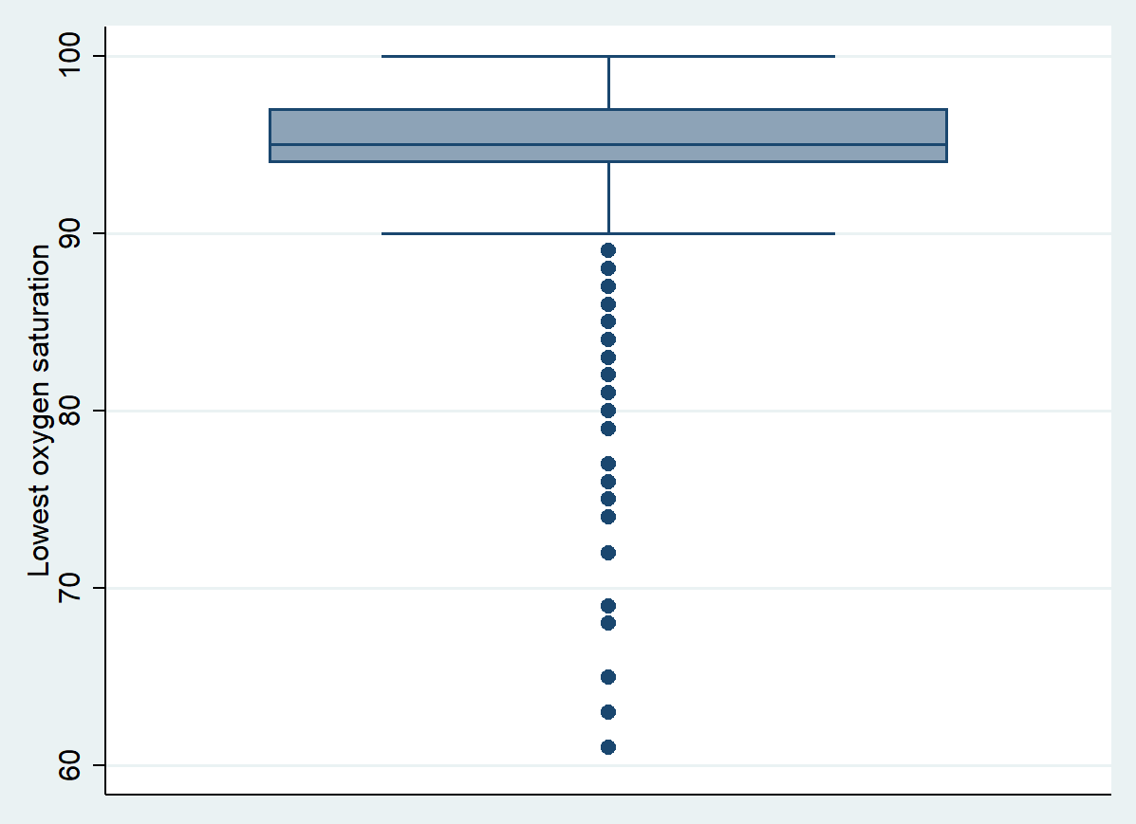
Boxes indicate first quartile (Q1) to third quartile (Q3); inner line indicates median; dots indicate outliers.

Figure S3. Subgroup analysis of association of arterial oxygen saturation and death or dependency at 90 days
Death or dependency
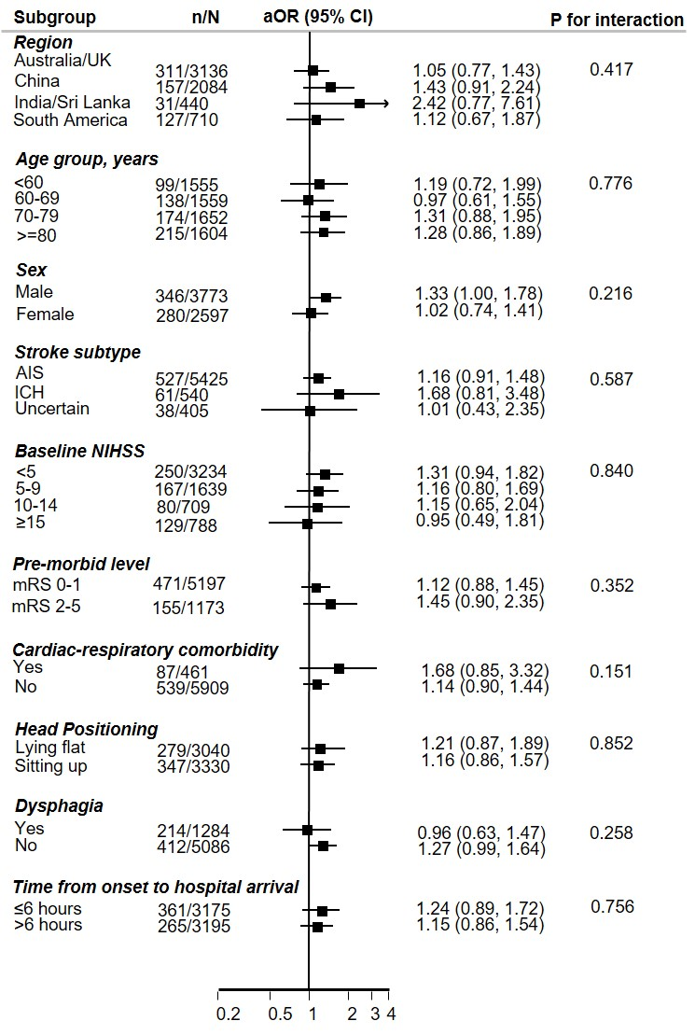
Footnote: AIS denotes acute ischemic stroke, aOR adjusted odds ratio, CI confidence interval, ICH intracerebral haemorrhage, NIHSS National Institutes of Health Stroke Scale

aOR obtained from generalized linear mixed models with adjustment for study design (fixed effects of head position and cross-over period, random effects of cluster, and random interaction effects between cluster and crossover period) and baseline variables of age, sex, region, history of diabetes mellitus, hypertension, heart failure, atrial fibrillation, National Institutes of Health Stroke Scale score, pre-morbid score 0-1 on the modified Rankin scale, dysphagia, hyperlipidemia, other major health conditions, chronic obstructive pulmonary disease, stroke type, antithrombotic treatment, and time from symptom onset to hospital arrival, withdraw active care, endotracheal intubation and reperfusion therapy for ischemic stroke and surgical procedures for intracerebral haemorrhage during hospitalisation
Figure S4. Subgroup analysis of the association between arterial oxygen saturation and serious adverse events at 90 days
SAE
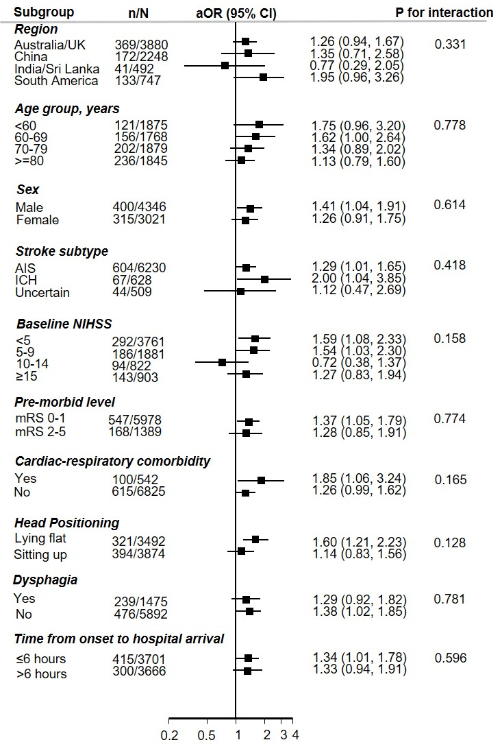
Footnote: AIS denotes acute ischemic stroke, aOR adjusted odds ratio, CI confidence interval, ICH intracerebral haemorrhage, NIHSS National Institutes of Health Stroke Scale

aOR obtained from generalized linear mixed models with adjustment for study design (fixed effects of head position and cross-over period, random effects of cluster, and random interaction effects between cluster and crossover period) and baseline variables of age, sex, region, history of diabetes mellitus, hypertension, heart failure, atrial fibrillation, National Institutes of Health Stroke Scale score, pre-morbid score 0-1 on the modified Rankin scale, dysphagia, hyperlipidemia, other major health conditions, chronic obstructive pulmonary disease, stroke type, antithrombotic treatment, and time from symptom onset to hospital arrival, withdraw active care, endotracheal intubation and reperfusion therapy for ischemic stroke and surgical procedures for intracerebral haemorrhage during hospitalisation

Figure S5. Spline of lowest oxygen saturation and death or dependency at 90 days by stroke subtype
A. Ischemic stroke
B. Haemorrhagic stroke
Footnote: Generalized linear mixed models with adjustment for study design (fixed effects of head position and cross-over period, random effects of cluster, and random interaction effects between cluster and crossover period) and baseline variables of age, sex, region groups, history of coronary heart disease, diabetes mellitus, hypertension, heart failure, atrial fibrillation, National Institutes of Health Stroke Scale score, pre-morbid score 0-1 on the modified Rankin scale, dysphagia, hyperlipidemia, other major health conditions, chronic obstructive pulmonary disease, antithrombotic treatment, and time from symptom onset to hospital arrival, withdraw active care, endotracheal intubation with A. further adjusted reperfusion therapy and stroke subtype for ischemic stroke and B. further adjusted surgical procedures for haemorrhagic stroke
Spline fitted with 4 knots (percentiles 5th, 35th, 65th, 95th) for oxygen saturation, with lowest point as reference; solid line indicates adjusted odds ratio; dotted lines indicates 95% confidence intervals.

Figure S6. Spline of lowest oxygen saturation and death or dependency at 90 days by region
A. Australia and UK
B. China

C. India and Sri Lanka
D. South America
Footnote: Generalized linear mixed models with adjustment for study design (fixed effects of head position and cross-over period, random effects of cluster, and random interaction effects between cluster and crossover period) and baseline variables of age, sex, history of coronary heart disease, diabetes mellitus, hypertension, heart failure, atrial fibrillation, National Institutes of Health Stroke Scale score, pre-morbid score 0-1 on the modified Rankin scale, dysphagia, hyperlipidemia, other major health conditions, chronic obstructive pulmonary disease, stroke subtype, antithrombotic treatment, and time from symptom onset to hospital arrival, withdraw active care, endotracheal intubation, reperfusion therapy for ischemic stroke and surgical procedures for haemorrhagic stroke
Spline fitted with 4 knots (percentiles 5th, 35th, 65th, 95th) for oxygen saturation, with lowest point as reference; solid line indicates adjusted odds ratio; dotted lines indicates 95% confidence intervals.

