**Figure 1: STROBE diagram of patient inclusion/exclusion criterion**

Total number of NSTEMI patients in MINAP data from 2010 – 2017

(n= 369,435)

Records excluded for missing mortality data (n = 12,666)

Records excluded for missing ethnicity (n = 30,609)

Number of patients for Inclusion

(n= 326,160)

White patients

(n= 299,184)

Ethnic minorities

(n= 26,976)

NSTEMI; non-ST-segment elevation myocardial infarction, MINAP; myocardial Infarction national audit project

**Figure 2: Overlaid kernel density plot to show predicted in-hospital mortality of each racial group**

GRACE; global registry of acute coronary events

**Figure 3: Discrimination of GRACE risk model for in-hospital mortality stratified by ethnicity (White vs Ethnic Minorities)**

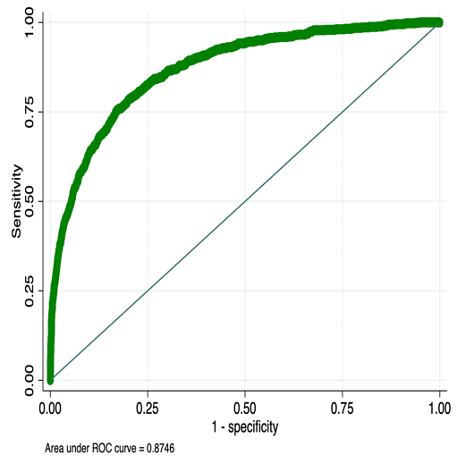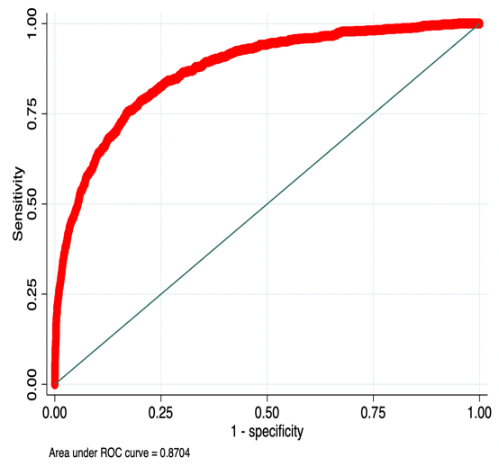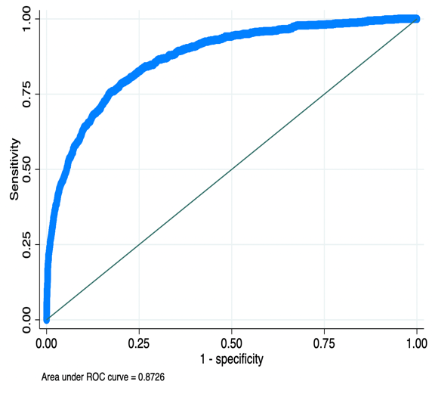

Overall

White

Ethnic minorities

GRACE; global registry of acute coronary events, ROC: receiver operator curve

**Figure 4: Calibration GRACE risk model for in-hospital mortality stratified by ethnicity**

White

Ethnic minorities

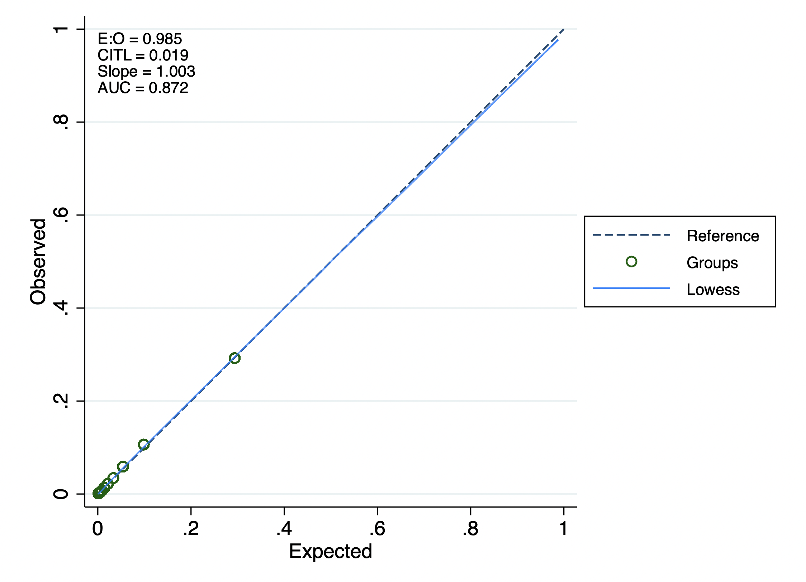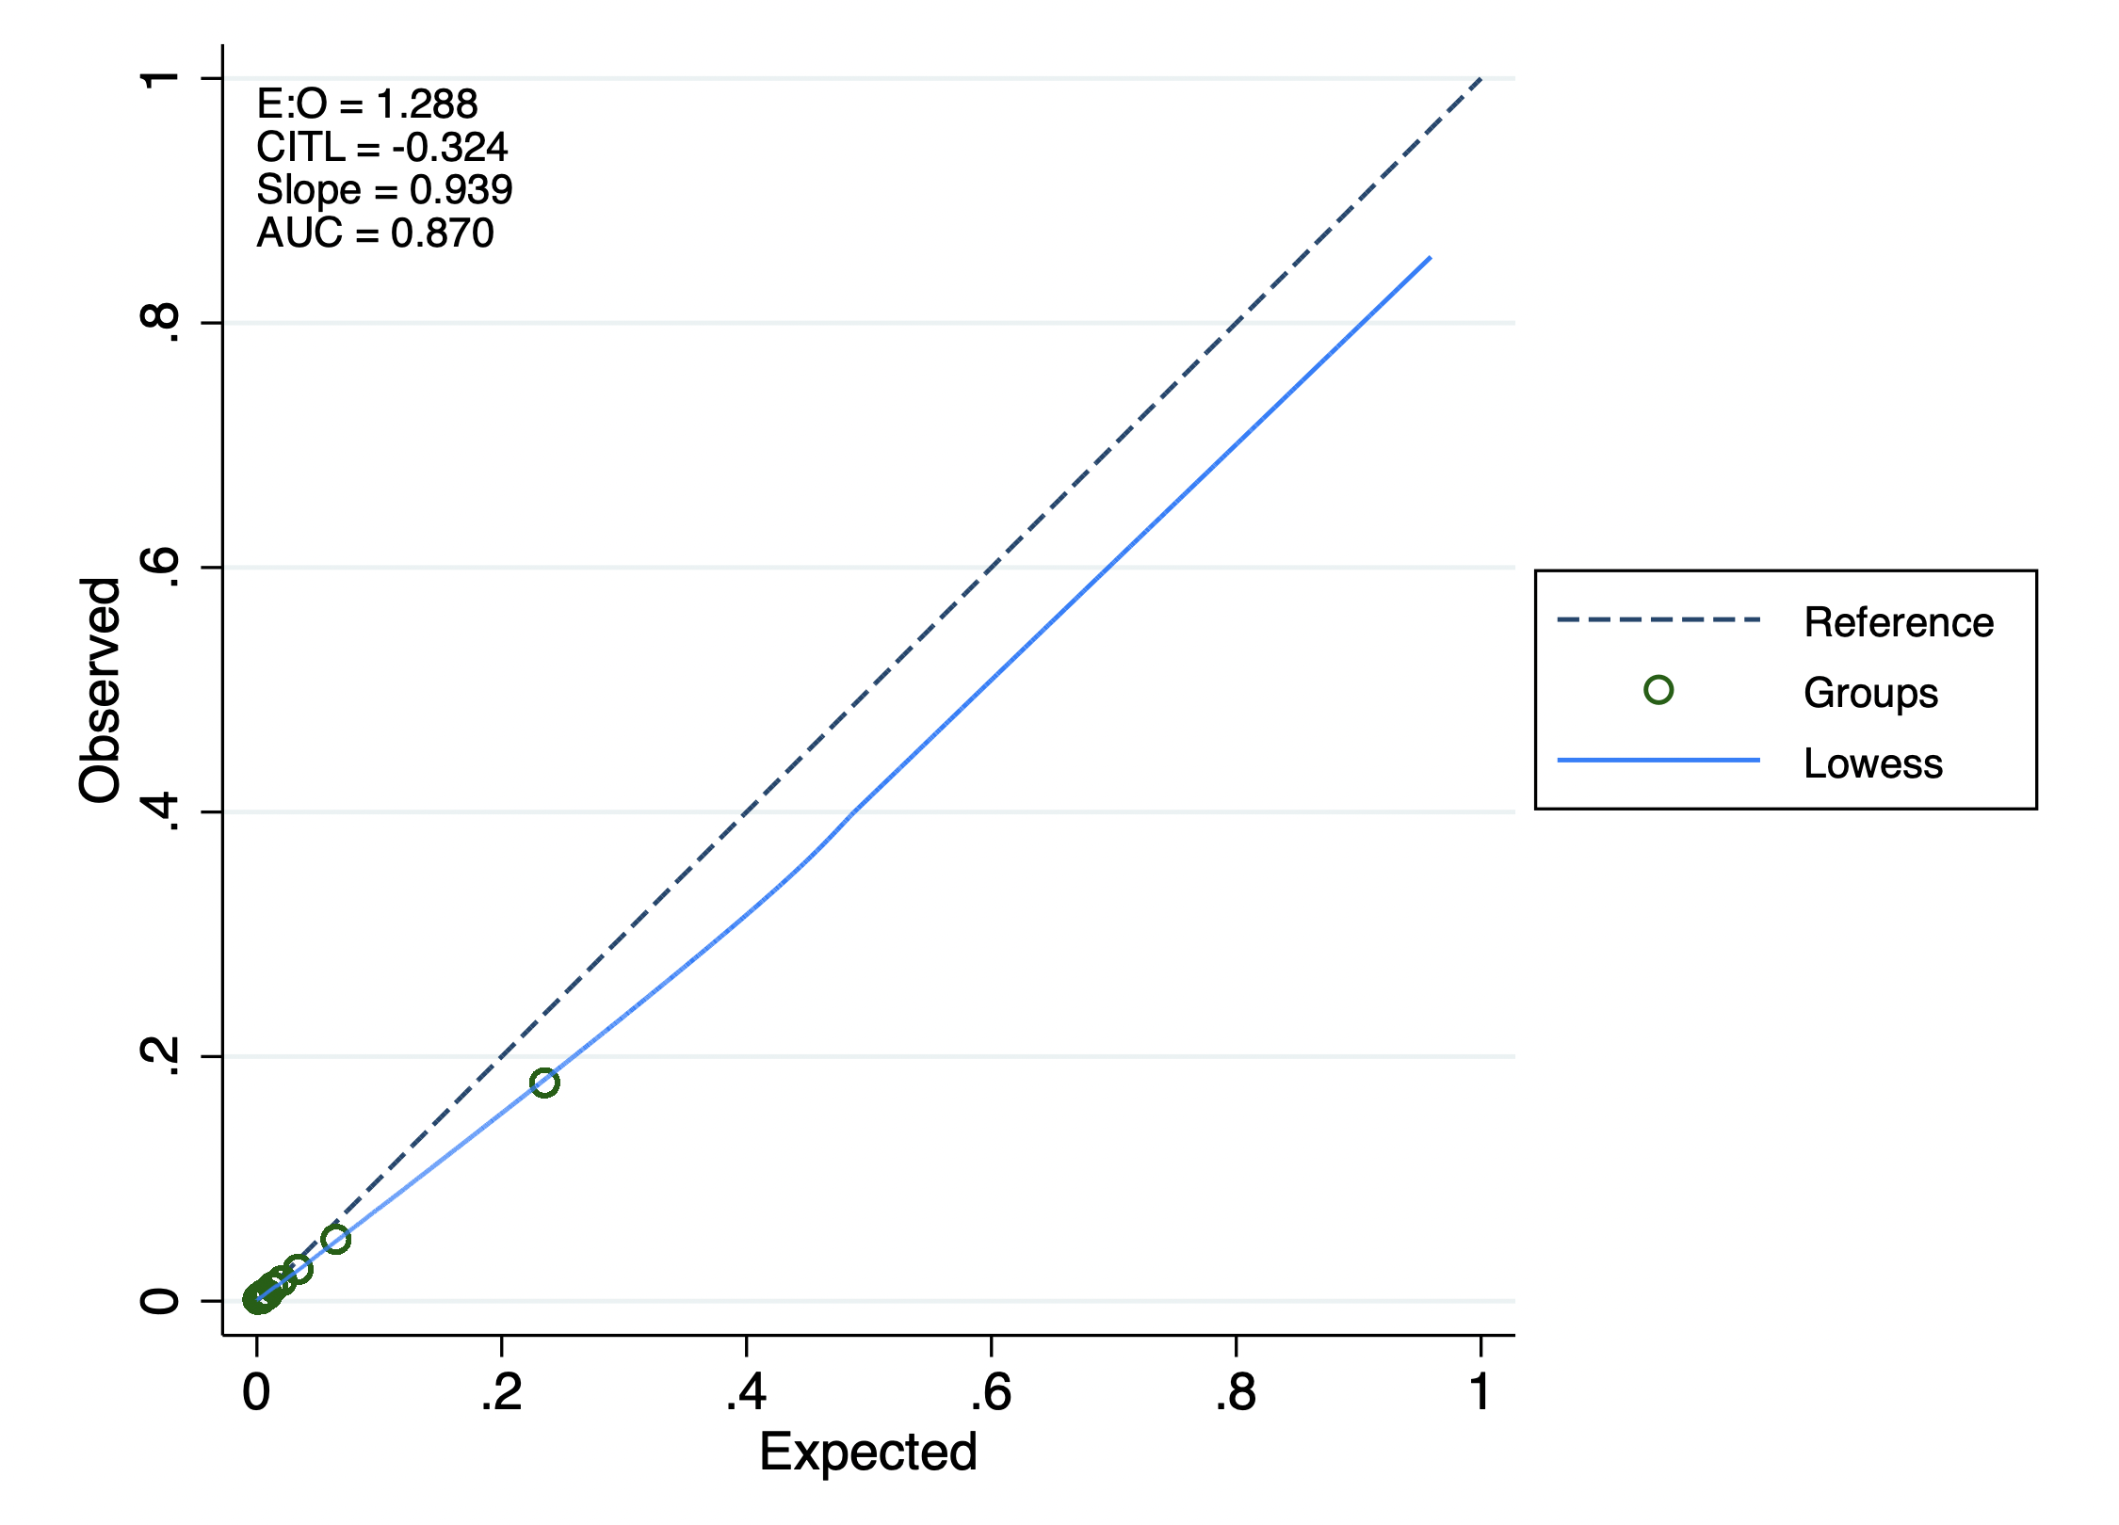

GRACE; global registry of acute coronary events, E:O; estimated to observed ratio, CITL; calibration in the large, AUC: area under receiver operator curve

**Figure 5: Recalibration of GRACE risk model for in-hospital mortality stratified by ethnicity**

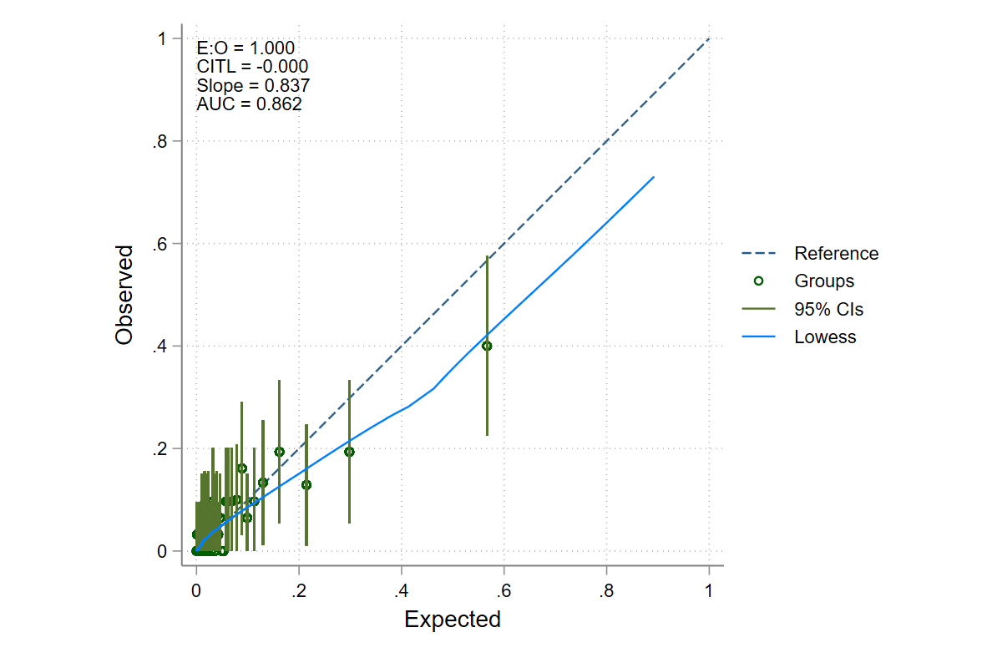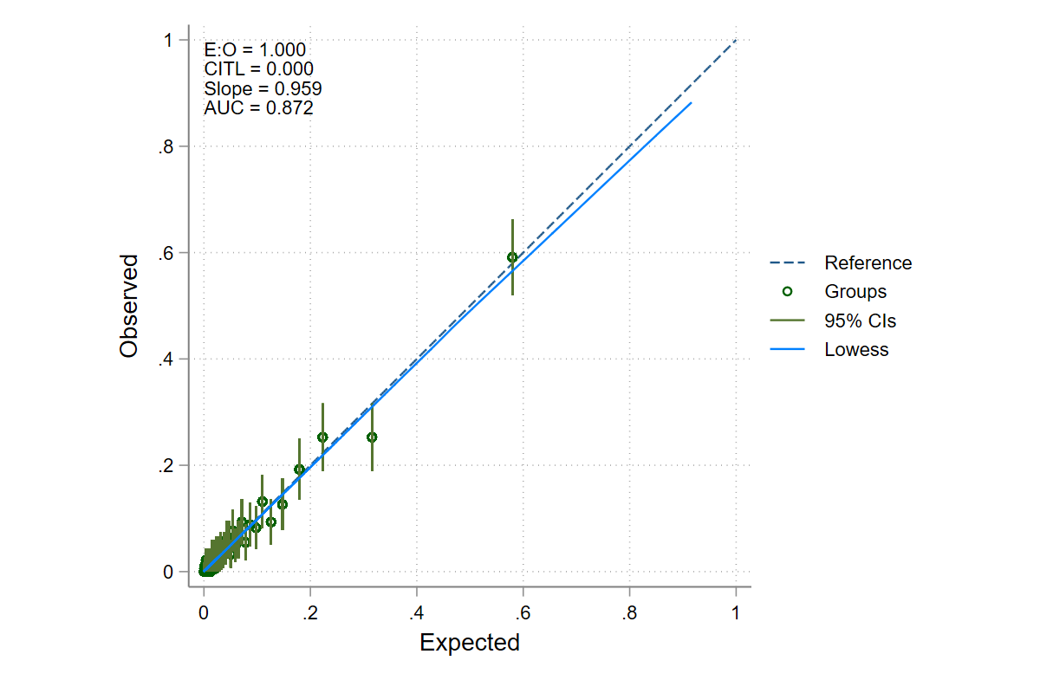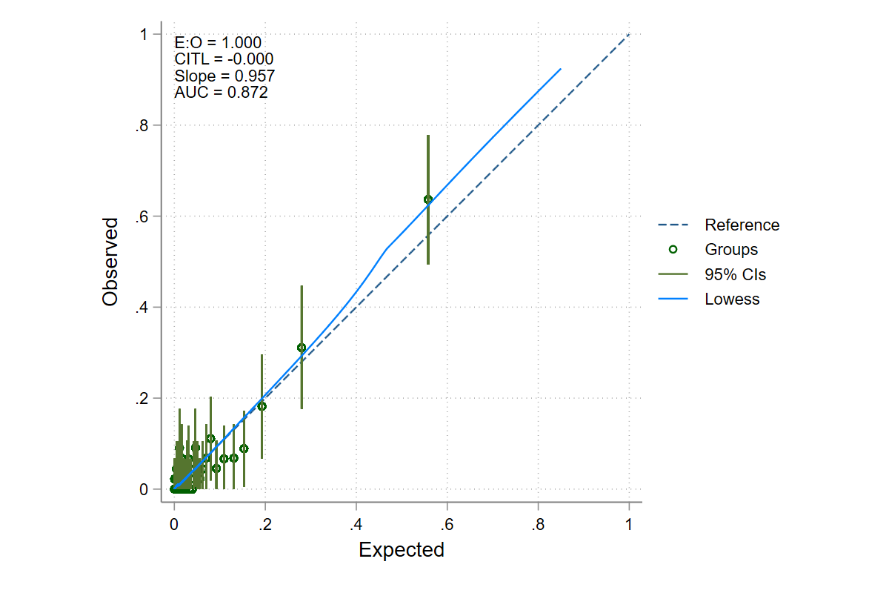

Black

Asian

Other Non-White ethnic minorities

GRACE; global registry of acute coronary events, E:O; estimated to observed ratio, CITL; calibration in the large, AUC: area under receiver operator curve.

**Table 1a: Clinical characteristics and management strategy for high-risk GRACE score.**

|  |  |  |  |
| --- | --- | --- | --- |
|  | **High risk GRACE (v2.0) score (>140)** | | |
| **Variables** | **White patients (142,403)** | **Ethnic minorities**  **(12,504)** | **P-value** |
| **Clinical Characteristics** | | | |
| Age (years), median [IQR] | 77 (69-84) | 72 (62-79) | <0.001 |
| Women (%) | 54,877/139,104 (39%) | 4,133/12,379 (33%) | <0.001 |
| BMI median [IQR] | 27 (24-30) | 26 (23-30) | 0.63 |
| Previous smoker (%) | 54,718/132,287 (41%) | 2,761/11,789 (23%) | <0.001 |
| Current smoker (%) | 22,122/132,287 (17%) | 1,713/11,789 (15%) | <0.001 |
| Chronic renal failure (%) | 14,867/133,340 (11%) | 2,015/11,980 (17%) | <0.001 |
| Prior percutaneous coronary intervention (%) | 19,167/132,665 (14%) | 2,920/11,990 (24%) | <0.001 |
| Prior CABG surgery (%) | 14,214/132,913 (11%) | 1,798/12,020 (15%) | <0.001 |
| Diabetes (%) | 37,402/138,036 (27%) | 6,875/12,285 (56%) | <0.001 |
| CCF (%) | 13,283/133,463 (10%) | 1,429/12,001 (12%) | <0.001 |
| Hypercholesterolemia (%) | 46,948/132,401 (36%) | 6,120/11,987 (51%) | <0.001 |
| Previous MI (%) | 43,966/133,825 (33%) | 4,564/12,027 (38%) | <0.001 |
| Angina (%) | 45,958/133,428 (34%) | 4,376/12,003 (36%) | <0.001 |
| Cerebrovascular disease (%) | 16,328/133,567 (12%) | 1,401/11,991 (12%) | 0.08 |
| Peripheral vascular disease (%) | 9,300/133,264 (7%) | 629/11,961 (5%) | <0.001 |
| Hypertension (%) | 78,069/133,887 (58%) | 8,765/12,113 (72%) | <0.001 |
| Asthma / COPD (%) | 26,482/133,681 (20%) | 2,054/12,018 (17%) | <0.001 |
| Family history of CAD (%) | 24,775/109,259 (23%) | 2, 355/10,134 (23%) | 0.23 |
| Moderate LVSD (%) | 23,551/117,842 (20%) | 2,440/10,393 (23%) | <0.001 |
| Severe LVSD (%) | 11,079/117,842 (9%) | 1,015/10,393 (10%) | <0.001 |
| **Management Strategy** | | | |
| Coronary Angiography (%) | 84,166/133,522 (63%) | 8,859/11,591 (76%) | <0.001 |
| CABG surgery (%) | 14,213/132,913 (11%) | 1,798/12,020 (15%) | <0.001 |
| PCI (%) | 42,955/102,742 (42%) | 5,176/10,475 (49%) | <0.001 |
| Coronary Angiography received within 72 hours (%) | 35,723/55,490 (64%) | 4,136/6,490 (64%) | 0.30 |
| LV Function recorded in notes (%) | 76,703/117,842 (65%) | 7,659/10,393 (74%) | <0.001 |
| Adequate P2Y12 Inhibition on discharge (%) | 126,456/138,810 (91%) | 11,591/12,357 (94%) | <0.001 |
| Fondaparinux or LMWH received (%) | 104,797/124,759 (84%) | 8,037/10,756 (74%) | <0.001 |
| DAPT received on discharge (%) | 122,934/138,717 (89%) | 11,411/12,354 (92%) | <0.001 |
| Statin on discharge (%) | 114,364/138,887 (82%) | 111,046/12,362 (89%) | <0.001 |
| ACEi or ARB on discharge for those with moderate and severe LVSD (%) | 29,010/34,597 (84%) | 2,955/3,452 (86%) | 0.007 |
| Beta Blocker on discharge for those for those with moderate and severe LVSD (%) | 29,479/34,511 (85%) | 2,905/3,442 (84%) | 0.10 |

CABG surgery; coronary artery bypass grafting surgery, PCI; percutaneous coronary intervention, MI; myocardial infarction, BMI; body mass index, GRACE: global registry of acute coronary events, ECG; electrocardiograph, CCF; congestive cardiac failure, COPD; chronic obstructive pulmonary disease, CAD; coronary artery disease, IQR; interquartile range, EF; ejection fraction, LV; left ventricle, EF; ejection fraction, LMWH; low molecular weight heparin, DAPT; dual antiplatelet therapy, ACEi/ARB; angiotensin converting enzyme inhibitor/angiotensin receptor blockers, LVSD; left ventricular systolic dysfunction

**Table 1b: Clinical characteristics and management strategy for intermediate risk GRACE score.**

|  |  |  |  |
| --- | --- | --- | --- |
|  | **Intermediate risk GRACE (v2.0) score (109-140)** | | |
| **Variables** | **White patients (31,165)** | **Ethnic minorities (4,055)** | **P-value** |
| **Clinical Characteristics** | | | |
| Age (years), median [IQR] | 60 (53-67) | 55 (48-62) | <0.001 |
| Women (%) | 9,025/33,355 (27%) | 960/4,029 (24%) | <0.001 |
| BMI median [IQR] | 28 (25-32) | 27 (25-31) | <0.001 |
| Previous smoker (%) | 10,715/32,669 (33%) | 750/3,929 (19%) | <0.001 |
| Current smoker (%) | 11,581/32,669 (35%) | 1,200/3,929 (31%) | <0.001 |
| Chronic renal failure (%) | 1,172/32,154 (3.6%) | 272/3,901 (7.0%) | <0.001 |
| Prior percutaneous coronary intervention (%) | 5,204/32,118 (16%) | 871/3,909 (22%) | <0.001 |
| Prior CABG surgery (%) | 1,998/32,117 (6%) | 310/3,912 (8%) | <0.001 |
| Diabetes (%) | 6,782/33,175 (20%) | 1,577/3,997 (39%) | <0.001 |
| CCF (%) | 7770/32,166 (2.4%) | 99/3,903 (2.5%) | 0.06 |
| Hypercholesterolemia (%) | 11,879/31,978 (37%) | 1,887/3,890 (49%) | <0.001 |
| Previous MI (%) | 7,477/32,217 (23%) | 1,041/3,914 (27%) | <0.001 |
| Angina (%) | 7,787/32,155 (24%) | 1.034/3,891 (27%) | <0.001 |
| Cerebrovascular disease (%) | 1,837/32,150 (6%) | 198/3,902 (5%) | 0.10 |
| Peripheral vascular disease (%) | 1,270/32,099 (4%) | 99/3,894 (3%) | <0.001 |
| Hypertension (%) | 15,493/32,230 (48%) | 2,323/3,925 (59%) | <0.001 |
| Asthma / COPD (%) | 4,529/32,171 (14%) | 414/3,907 (11%) | <0.001 |
| Family history of CAD (%) | 11,687/28,751 (41%) | 1,327/3,437 (39%) | 0.02 |
| Moderate LVSD (%) | 3,245/28,226 (12%) | 430/3,257 (13%) | 0.09 |
| Severe LVSD (%) | 619/28,226 (2.2%) | 84/3,527 (2.6%) | 0.13 |
|  | | | |
| Coronary Angiography (%) | 28,889/31,823 (91%) | 3,471/3,790 (92%) | 0.10 |
| CABG surgery (%) | 1,998/32,117 (6%) | 310/3,912 (8%) | <0.001 |
| PCI (%) | 16,436/26,838 (62%) | 2,238/18,674 (61%) | 0.15 |
| Coronary Angiography received within 72 hours (%) | 13,804/19,156 (72%) | 1,899/2,552 (74%) | 0.01 |
| LV Function recorded in notes (%) | 17,701/28,226 (63%) | 2,228/3,257 (68%) | 0.03 |
| Adequate P2Y12 Inhibition on discharge (%) | 31,300/33,304 (94%) | 3,845/4,025 (96%) | <0.001 |
| Fondaparinux or LMWH received (%) | 26,676/30,353 (88%) | 2,820/3,455 (82%) | <0.001 |
| DAPT received on discharge (%) | 30,847/33,276 (93%) | 3,811/4,022 (95%) | <0.001 |
| Statin on discharge (%) | 27,629/33,306 (83%) | 3,590/4,027 (89%) | <0.001 |
| ACEi or ARB on discharge for those with moderate and severe LVSD (%) | 3,484/3,861 (90%) | 469/514 (91%) | 0.47 |
| Beta Blocker on discharge for those for those with moderate and severe LVSD (%) | 3,495/3,855 (91%) | 460/513 (90%) | 0.47 |

CABG surgery; coronary artery bypass grafting surgery, PCI; percutaneous coronary intervention, MI; myocardial infarction, BMI; body mass index, GRACE: global registry of acute coronary events, ECG; electrocardiograph, CCF; congestive cardiac failure, COPD; chronic obstructive pulmonary disease, CAD; coronary artery disease, IQR; interquartile range, LVSD; left ventricular systolic dysfunction, EF; ejection fraction, LV; left ventricle, EF; ejection fraction, LMWH; low molecular weight heparin, DAPT; dual antiplatelet therapy, ACEi/ARB; angiotensin converting enzyme inhibitor/angiotensin receptor blockers, LVSD; left ventricular systolic dysfunction

**Table 1c: Clinical characteristics and management strategy for low-risk GRACE score.**

|  |  |  |  |
| --- | --- | --- | --- |
|  | **Low Risk GRACE (v2.0) score (<109)** | | |
| **Variables** | **White patients (7,976)** | **Ethnic minorities (1,194)** | **P-value** |
| **Clinical Characteristics** | | | |
| Age (years), median [IQR] | 51 (45-57) | 47 (41-53) | <0.001 |
| Women (%) | 2,475/10,591(23%) | 266/1,580 (17%) | <0.001 |
| BMI median [IQR] | 29 (26-33) | 28 (25-31) | <0.001 |
| Previous smoker (%) | 2,503/10,408 (24%) | 270/1,552 (17%) | <0.001 |
| Current smoker (%) | 5,021/10,408 (48%) | 618/1,552 (40%) | <0.001 |
| Chronic renal failure (%) | 172/10,264 (1.7%) | 61/1,562 (3.9%) | <0.001 |
| Prior percutaneous coronary intervention (%) | 1,384/10,261 (13%) | 309/1,558 (20%) | <0.001 |
| Prior CABG surgery (%) | 298/10,260 (2.9%) | 70/1,560 (4.5%) | <0.001 |
| Diabetes (%) | 1,657/10,537 (16%) | 500/1,573 (32%) | <0.001 |
| CCF (%) | 109/10,258 (1.1%) | 25/1,558 (1.6%) | 0.58 |
| Hypercholesterolemia (%) | 3,407/10,157 (34%) | 683/1,542 (44%) | <0.001 |
| Previous MI (%) | 1,834/10,271 (18%) | 364/1,558 (23%) | <0.001 |
| Angina (%) | 1,850/10,247 (18%) | 322/1,554 (21%) | 0.01 |
| Cerebrovascular disease (%) | 340/10,262 (3.3%) | 51/1,561 (3.3%) | 0.92 |
| Peripheral vascular disease (%) | 219/10,244 (2.1%) | 26/1,553 (1.7%) | 0.23 |
| Hypertension (%) | 4,297/10,262 (42%) | 763/1,557 (49%) | <0.001 |
| Asthma / COPD (%) | 1,170/10,259 (11%) | 128/1,558 (8%) | <0.001 |
| Family history of CAD (%) | 4,452/9,358 (47%) | 644/1,409 (46%) | 0.20 |
| Moderate LVSD (%) | 763/8,909 (9%) | 110/1,237 (9%) | 0.73 |
| Severe LVSD (%) | 82/8,909 (0.9%) | 19/1,237 (1.5%) | 0.04 |
|  | | | |
| Coronary Angiography (%) | 9,551/10,108 (95%) | 1,419/1,516 (94%) | 0.16 |
| CABG surgery (%) | 298/10,260 (3%) | 70/1,560 (4%) | 0.001 |
| PCI (%) | 5,440/8,503 (64%) | 905/1,420 (65%) | 0.86 |
| Coronary Angiography received within 72 hours (%) | 4,617/6,291 (73%) | 774/1,069 (72%) | 0.50 |
| LV Function recorded in notes (%) | 5,411/8,909 (61%) | 794/1,237 (64%) | 0.03 |
| Adequate P2Y12 Inhibition on discharge (%) | 9,860/10,575 (93%) | 1,526/1,573 (97%) | <0.001 |
| Fondaparinux or LMWH received (%) | 8,863/9,793 (91%) | 1,185/1,366 (87%) | <0.001 |
| DAPT received on discharge (%) | 9,725/10,560 (92%) | 1,514/1,571 (96%) | <0.001 |
| Statin on discharge (%) | 8,369/10,572 (79%) | 1,369/1,579 (87%) | <0.001 |
| ACEi or ARB on discharge for those with moderate and severe LVSD (%) | 761/845 (90%) | 117/129 (91%) | 0.82 |
| Beta Blocker on discharge for those for those with moderate and severe LVSD (%) | 778/845 (92%) | 118/128 (92%) | 0.96 |

CABG surgery; coronary artery bypass grafting surgery, PCI; percutaneous coronary intervention, MI; myocardial infarction, BMI; body mass index, GRACE: global registry of acute coronary events, ECG; electrocardiograph, CCF; congestive cardiac failure, COPD; chronic obstructive pulmonary disease, CAD; coronary artery disease, IQR; interquartile range, LVSD; left ventricular systolic dysfunction, EF; ejection fraction, LV; left ventricle, EF; ejection fraction, LMWH; low molecular weight heparin, DAPT; dual antiplatelet therapy, ACEi/ARB; angiotensin converting enzyme inhibitor/angiotensin receptor blockers, LVSD; left ventricular systolic dysfunction

**Table 2: Components of GRACE score**

|  |  |  |  |  |
| --- | --- | --- | --- | --- |
|  | Overall | White | Ethnic minorities | P-Value |
| Age | 72 | 73 (62-82) | 66 (55-76) | <0.001 |
| Heart rate (bpm) | 78 (66-92) | 78 (66-92) | 78(66-92) | 0.02 |
| Systolic blood pressure (mmHg) | 140 (121-158) | 140 (121-158) | 139 (122-158) | 0.34 |
| Creatinine | 91 (75-116) | 91(75-116) | 89 (74-115) | <0.001 |
| Killip Class (%) |  | | |  |
| I | 158,246/206,850 (77%) | 144,208/188,384 (77%) | 14,038/18,466 (76%) | <0.001 |
| II | 34,263/206,850 (17%) | 31,555/188,384 (17%) | 2,708/18,466 (15%) | <0.001 |
| III | 13,111/206,850 (6%) | 11,540/188,384 (6%) | 1,571/18,466 (9%) | <0.001 |
| IV | 1,230/206,850 (0.6%) | 1,081/188,384 (0.6%) | 149/18,466 (0.8%) | <0.001 |
| Cardiac Arrest (%) | 10,132/318,524 (3.2%) | 9,440/292,139 (3.2%) | 692/26,385 (2.6%) | <0.001 |
| Raised Troponin | 318,380/320,725 (99%) | 292,267/294,228 (99%) | 26,113/26,497 (99%) | <0.001 |
| ECG Ischaemia (%) | 247,070/317,033 (78%) | 226,868/290,684 (78%) | 20,202/26,349 (77%) | <0.001 |
| In-hospital mortality (%) | 16,314/326,160 (5.0%) | 15,534/299,184 (5.2%) | 780/26,976 (2.9%) | <0.001 |
| In-hospital cardiac mortality (%) | 12,807/326,160 (3.9%) | 12,185/299,184 (4.1%) | 622/26,976 (2.3%) | <0.001 |
| In-hospital non-cardiac mortality (%) | 3,507/326,160 (1.1%) | 3,349/299,184 (1.1%) | 158/26,976 (0.6%) | <0.001 |
| Reinfarction (%) | 2,802/305,381 (0.9%) | 2,555/280,097 (0.9%) | 247/25,285 (1.0%) | 0.30 |
| MACE (%) | 18,497/326,160 (5.7%) | 17,517/299,184 (5.9%) | 980/26,976 (3.6%) | <0.001 |

GRACE; global registry of acute coronary events, ECG; electrocardiograph

**Supplement Figure 1: Discrimination of GRACE risk model for in-hospital mortality stratified by ethnicity (White vs Black vs Asian vs Other Non-White ethnic minorities)**

GRACE; global registry of acute coronary events.

**Supplement Figure 2: Calibration GRACE risk model for in-hospital mortality stratified by ethnicity (Black vs Asian vs Other Non-White ethnic minorities)**

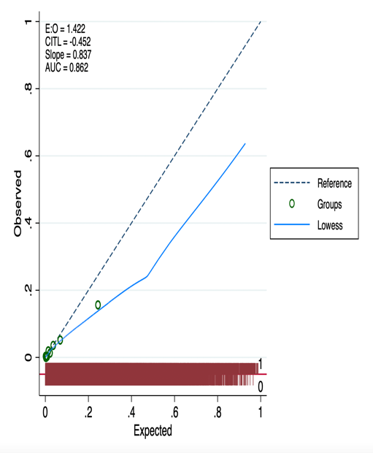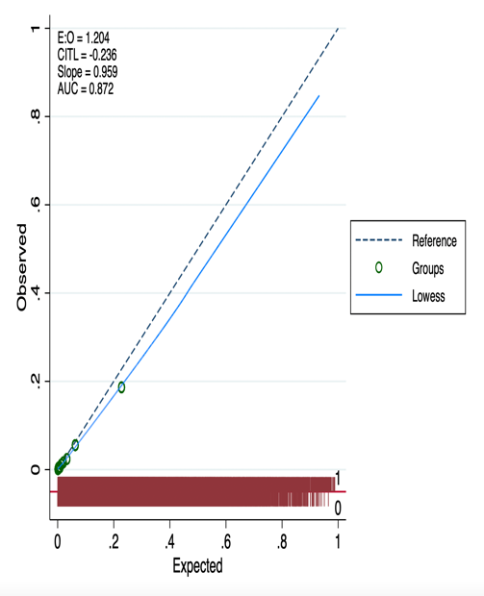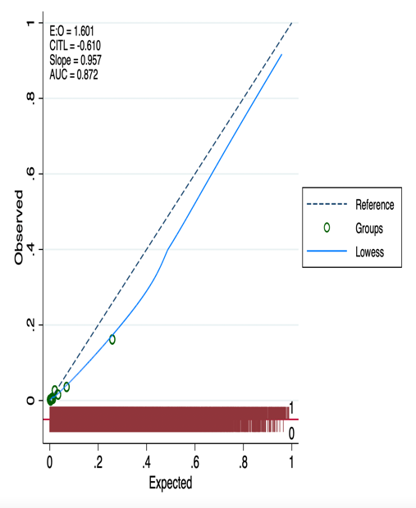

Black

Asian

Other Non-White ethnic minorities

GRACE; global registry of acute coronary events, E:O; estimated to observed ratio, CITL; calibration in the large, AUC: area under receiver operator curve

**Supplement Figure 3: Calibration of GRACE risk model for in-hospital mortality for ethnic minorities stratified by sex**

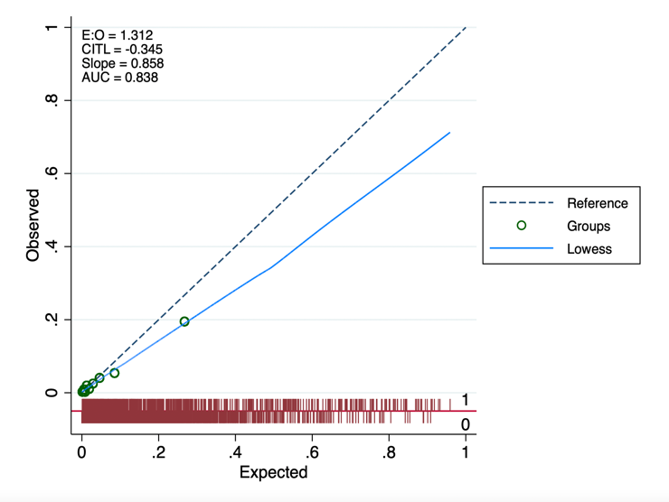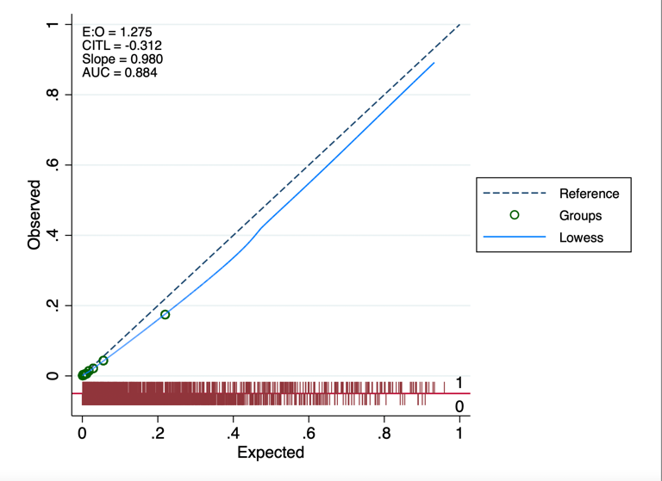

Ethnic minorities (male)

Ethnic minorities (female)

GRACE; global registry of acute coronary events, E:O; estimated to observed ratio, CITL; calibration in the large, AUC: area under receiver operator curve