Abstract

An estimated 500,000 people died from all causes during the Spanish Civil War between 1936 and 1939, with a further 135,000 killed after the war ended. There are currently over 2,000 known mass burial locations throughout Spain but many more are unknown. This study details the successful search for an unmarked mass grave in mountainous terrain in the Asturias region of Northern Spain. Two approximate locations were known due to eyewitness accounts. A phased site investigation approach was undertaken, which included ground penetrating radar. Results showed a clear geophysical anomaly on 2D GPR profiles. The identified area was subsequently intrusively investigated by forensic archaeologists and human remains were successfully discovered. Careful and sensitive investigations are essential in these approaches where living relatives are involved.

- Introduction

In April 2014, the Cienfuegos family contacted the research team to assist with their longstanding efforts to locate the grave of their grandfather, shot and buried together with probably 10 other victims, in a mass grave in Parasimón on the mountains of Lena, in Asturias in the North of Spain.

Around 500,000 people died from all causes during the Spanish Civil War between 1936 and 1939, with a further estimated 135,000 killed throughout Spain for years after the war ended [1-3]. There are currently known to be over 2,000 mass burials throughout Spain (Fig. 1) with many victims being exhumed, identified where possible and reburied, a lot in the Valle de los Caídos “Valley of the Fallen” [4-5]. This has meant developing forensic techniques to identify remains to a high degree of certainty to minimize effects on the affected families [3,6].

However many mass graves remain whose location are unknown. Successful mass grave detection has been undertaken globally, for example, in 19th Century Irish mass burials [7], USA race riot victims [8], World War Two burials [9-10], in post-WW2 Polish repression mass burials [11], the Northern Ireland ‘Troubles’ mostly isolated burials [12], the 1990s Balkan wars mass burials [13-14], and sadly in active civil wars with both isolated and mass burials [15].
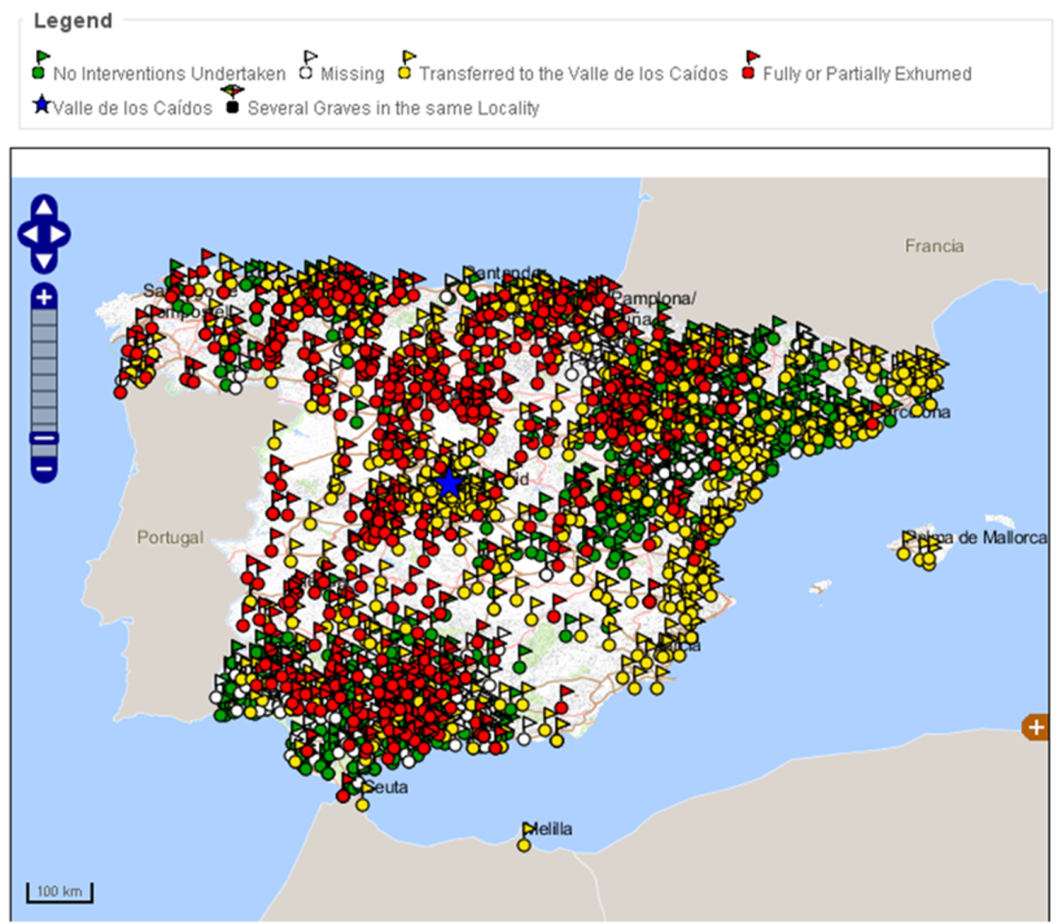
Fig. 1. Map of Spain showing current known positions of ~2,000 mass graves (see key and text for details). Modified from [16].

Mass grave geometries are known to be highly varied, taking the forms of a trench, pit, organized or sectioned with variable body densities (see [4-5,17]).

Current forensic search methods to detect both isolated and mass clandestine burials of murder victims are highly varied and have been reviewed elsewhere [18], with best practice suggesting a phased approach, moving from large-scale remote sensing methods [19] to ground reconnaissance and control studies before full searches are initiated [20]. These full searches have involved a variety of methods, including forensic geomorphology [21], forensic botany [22] and entomology [23], scent-trained search dogs [24-25], physical probing [26-28], thanatochemistry [29] and near-surface geophysics [30-37].

Geophysical surveys in mountainous terrain are difficult logistically, collecting data and covering significant survey areas as [37] discovered. This paper aims are to firstly detail the geoforensic search for an unmarked Spanish Civil War mass grave in the mountains in Asturias in Northern Spain, secondly to document the resulting forensic archaeological excavation and thirdly to compare results to other mass grave search studies in similar environments.

- Materials and methods

2.1 Desk study and site description

The proposed search area was in the Parasimón area in the mountains of Lena, in Asturias, in the North of Spain (Fig. 2). Two contemporary witnesses stated the approximate location of a mass grave, although not with certainty. Previous archaeological investigations had been performed on site in 2013 and they allowed identify the execution spot, the crime scene, by recovering the cartridge elements (cartridge cases, cartridges and few projectiles) of the execution firing line, rather than the burial site [38].

The search for the mass burial site was prioritised in two areas identified by contemporary witnesses, designated zone A and zone B in Fig. 2. Zone A was considered to be more probable based on previous archaeological investigations [38]. Recovered cartridge elements had also been anecdotally reported in this area, although initial surface and botanical investigations did not reveal any obvious potential burial sites and it was relatively common for burials to be re-buried in other places during this time [4-5]. Zone B is included because other oral testimonies mentioned it as a potential location. However, witnesses statements were of events more than seventy years ago, they were also positioned more than 500 metres away from the study sites and the surface terrain has undergone suffered major changes since those times.

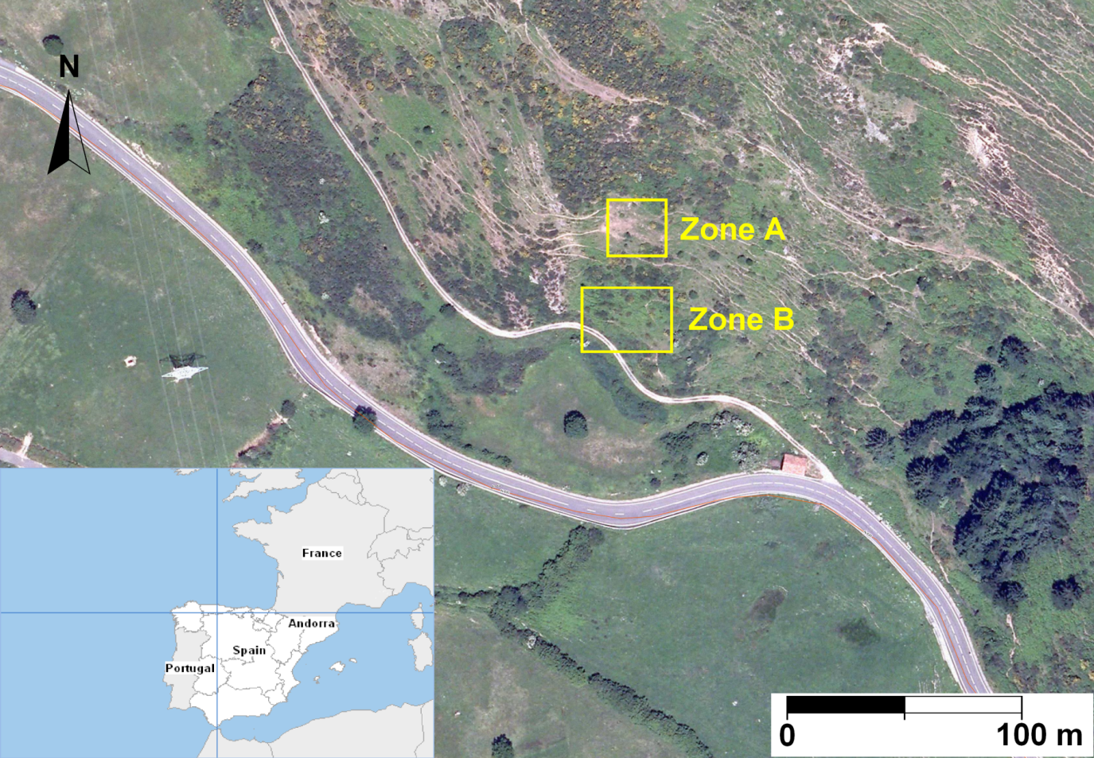
Fig. 2. Aerial photograph showing the mountainous search areas A and B in their surroundings with location map (inset). Modified from [39].

The bedrock geology in this area consists of a calcareous formation of Carboniferous age. Areas A and B are situated on colluvium materials filling a hollow between two limestone outcrops to the west and east. The colluvial deposits found here are unconsolidated sediments with abundant presence of angular heterolithic rock fragments interspersed in a silty matrix. The thickness of the soil ranges from 10 cm to 30 cm below ground level (bgl), with sparse bushes and grassy vegetation present.

2.2 Geophysical data acquisition

Once the main search zones had been identified, trial geophysical surveys were then undertaken to determine which techniques would be appropriate and their respective equipment configurations following best practise (see [18]). From contemporary witness accounts it was not expected that any metallic items would be buried along with the human remains, and this, together with the presence of high voltage cables and a nearby road (Fig. 2) precluded the use of magnetic and electro-magnetic surveys in this study.

A GPR MALÅ™ ProEx System was used to collect 2D trial profiles (Fig. 3). Whilst other authors in similar mountainous terrains (e.g. [37]) had determined 250 MHz frequency antennae to be optimal, the 500 MHz antennae was determined to be optimal here due to better quality data, when compared to 250 MHz data, and for data acquisition logistics in such mountainous terrain and steep slopes. Lower frequency antennae had also been suggested for detection by control simulated clandestine grave studies (e.g. see [40-41]), but the 500 MHz frequency was judged here to be a good compromise between data quality, acquisition time and successful chance of detection due to adequate resolution.

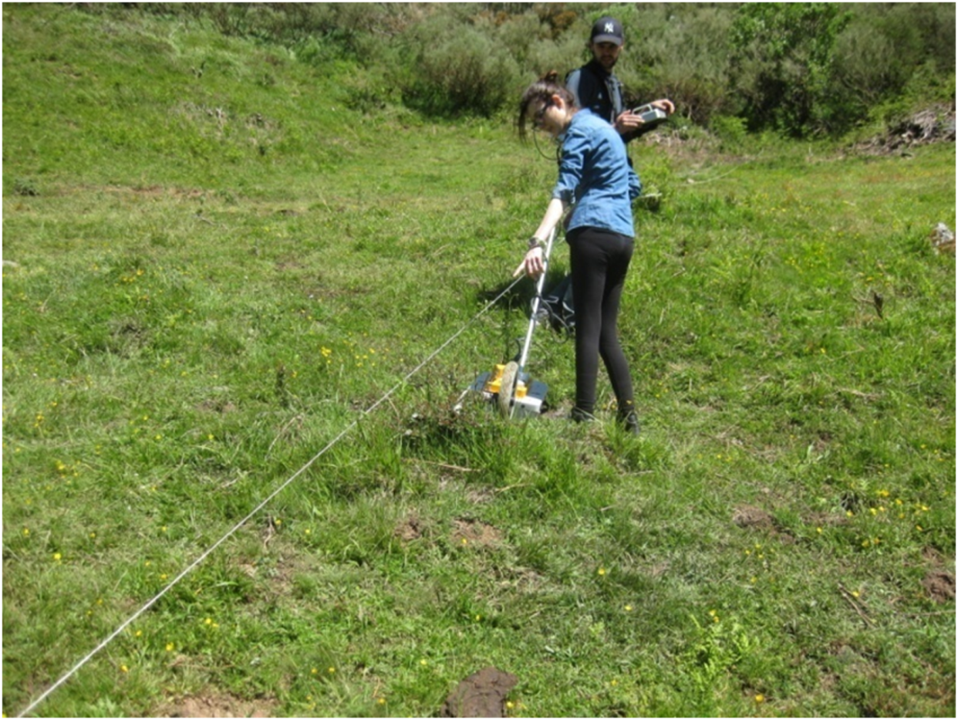
Fig. 3. Zone A photograph (looking north) showing the mountainous terrain and the GPR MALÅ™ ProEx system with 500 MHz frequency antennae acquiring data on 2D Profile 3 (see Fig.4 for location).

Full GPR survey grids were then acquired in both zones A and B. No geophysical anomalies were identified in zone B so only zone A results are discussed here. Zone A had nine local grid survey lines (P1-P9) marked and staked, of approximately 27 m at 2 m spacing, orientated Northeast-Southwest (Fig. 4). Four (additional perpendicular profiles P10-P13) of around 13 m were also marked and staked, (Fig.4). GPR trace spacing on each 2D profile was 2 cm with automatic stack mode, and a time window of 100 ns throughout. Standard triangular positioning was employed to ensure accuracy (see [38]).

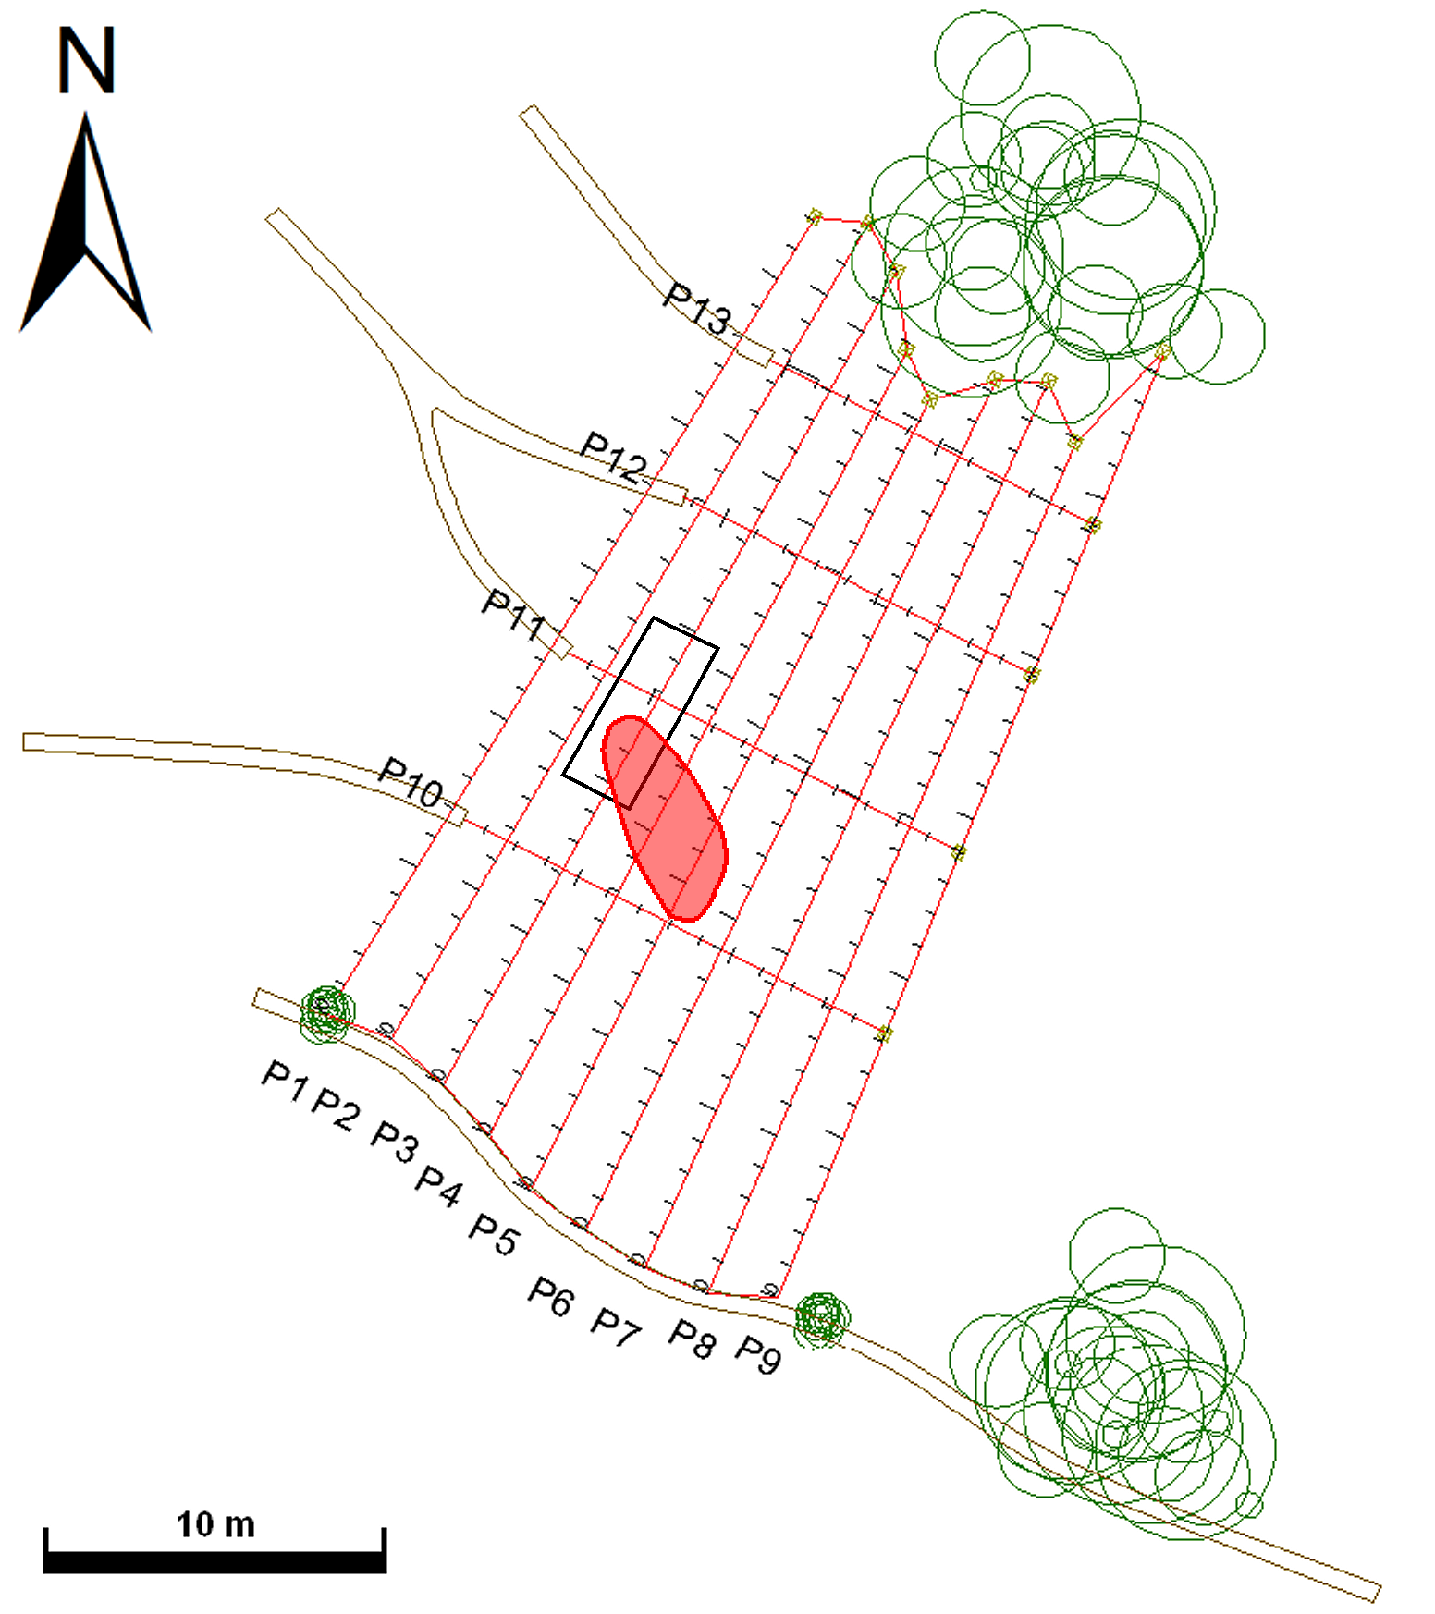
Fig. 4. Zone A sitemap showing key geophysical GPR 2D profiles acquired (P1-P13) with access tracks and bushes/shrub locations also marked. The suggested mass burial site identified from the geophysical survey is marked (red area) together with the archaeological excavation (black rectangle).

Once the 2D GPR profiles were acquired, they were downloaded and imported into REFLEX-Win™ v.6.0 processing software (Sandmeier Scientific Software, Karlsruhe, Germany). For each 2D profile, the first arrival wavelets were first picked and shifted to ensure consistent arrival times at 0 ns. Processing steps were then applied to filter out non-target ‘‘noise’’. The filtering sequence included the following steps: (i) subtracting the mean from traces (‘‘dewowing’’); (ii) picking first arrivals; (iii) applying static correction and moving the start times for traces in all profiles to 0 ns; (iv) applying a 1D Butterworth bandpass filter; (v) using background removal to reduce any ‘‘ringing’’ effect, and finally; (vi) the gain function was manually adjusted to improve the visualization in each profile.

3. Results

3.1 GPR dataset

In the GPR 2D profiles collected from South to North (P1-P10), two types of information could be extracted: a) geomorphological information revealing the internal structure of the colluvial sediments, and; b) in three profiles (P3-P5) anomalous geophysical features were detected.

The observed background geomorphological pattern (P8 example shown in Fig. 5b), was:
- Firstly, a “quiet” band of smooth, parallel reflection events from 0-10 ns. This “quiet” band could be correlated with the first 10 cm bgl of fine grained, top soil.
- Secondly, a sharp contact with underlying “chaotic” reflectors which was horizontal (~10 ns) throughout, except for the north (right) part of profiles where it dips down slightly (Fig.5).
- Thirdly, below the contact, 2D profiles had discontinuous “chaotic” reflection events down to 60 ns in places, which could be correlated with the 2 m - 3 m thick random accommodation of gravity-driven debris material formed by heterolithic limestone fragments with a silty sedimentary matrix.
- Fourthly, an abrupt loss of signal amplitude was then observed below this “chaotic” band across the whole area (Fig.5) which was most probably due to the bottom of the colluvium.
- Fifthly, blue marks correspond to rocks known to be near the surface.

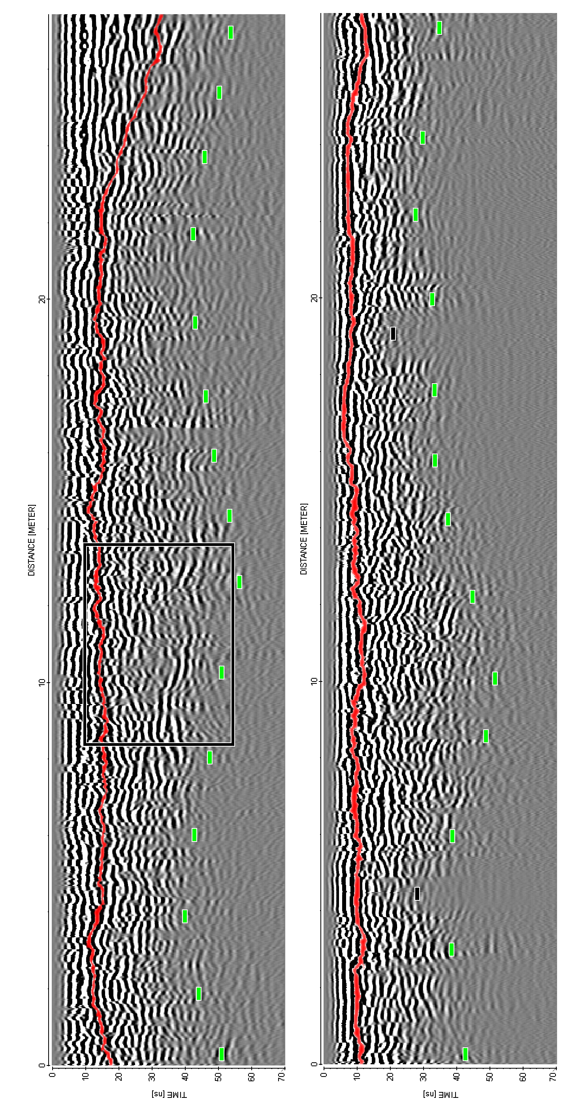
Fig. 5. GPR 2D profiles. a) Geophysical anomaly examples observed in P3-5, P4 shown here. Observe the significant signal attenuation inside the blue rectangle that was observed on P3-5, the spatial positions being marked on Fig.4. b) Typical background features shown in P8. Red line indicates contact between soil and colluvium materials, dashed green line indicates the approximate colluvium bottom position and blue dots indicates known large, isolated rock boulders.

In contrast to the background geomorphological features, the observed geophysical anomalies in P3-P5 (Fig. 5a) 2D profiles show quite different characteristics:
- Firstly, the interpreted contact between the topsoil and colluvial sediments (red line in Fig.5) dips down in the right part of profiles, but this is an artefact of the topographic slope that increases in angle.
- Secondly, there was a clear and significant radar signal attenuation loss about 5 m long along P3-P5 profiles (example shown in Fig. 5a), compared to the areas either side of this position, which will be due to this area having quite different material properties to the background material. This is also shown in Fig. 6.

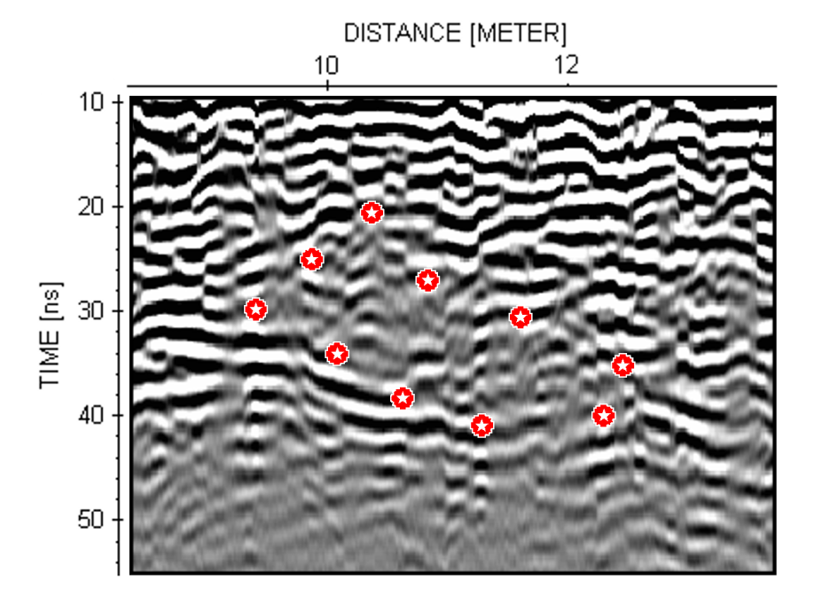
Fig. 6. Detail of the radar signal attenuation that was observed in P3-P5 2D profiles.

3.2 Forensic archaeological excavation

An initial forensic archaeological excavation was undertaken over the geophysical survey anomalous area identified in Zone A (see Fig. 4 for location). This was ~1 m by ~5 m and with the purpose of confirming whether or not human remains were present on site. If so, then the procedure in Spain is to report them and then undergo official excavation protocols. Standard logging of the stratigraphic units was undertaken (see [38, 42]).

The trial excavation was successful. A complete left human femur was found in anatomical connection with a pelvis and some phalanges at an approximate depth of 50 cm bgl (see Figs. 7 and 8). The forensic excavation confirmed the existence of the two stratigraphical units identified on the 2D radar profiles: the topsoil with vegetation cover and the underlying continuous yellow-brown, sandy matrix colluvial sediments. The excavation was then halted and the authorities notified for follow-up archaeological excavations.
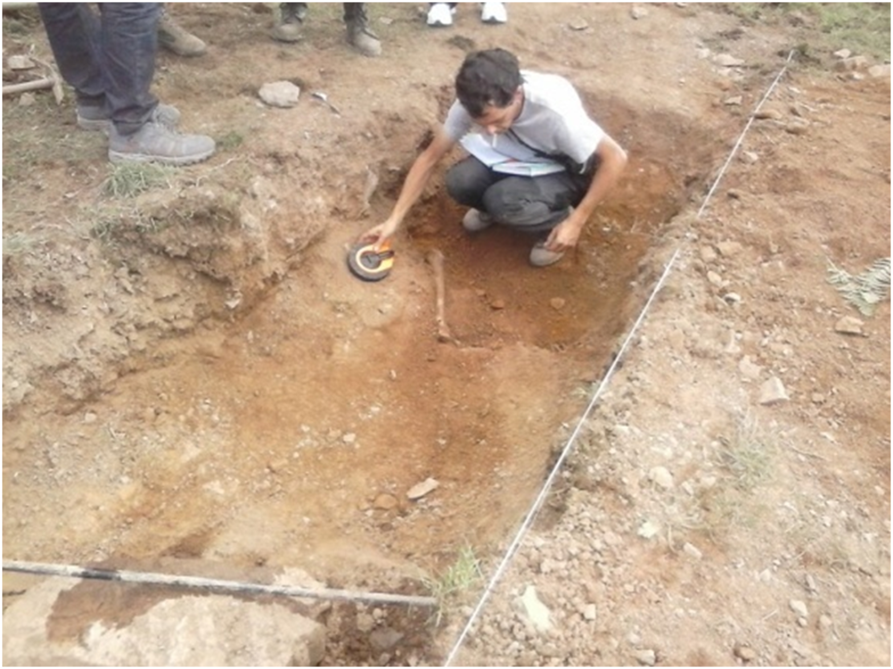
Fig. 7. Photograph of the trial excavation in zone A (Fig. 3 for location) showing the successful detection of buried human remains, note the femur position (source: Cienfuegos family).

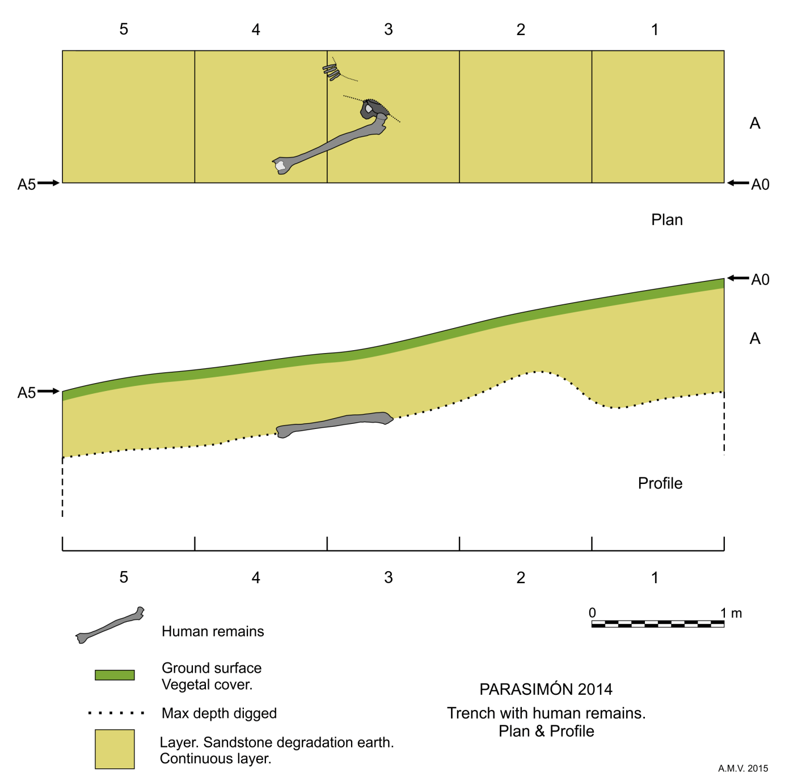
Fig. 8. Planview and vertical cross-section of the trial forensic archaeological excavation, showing the discovered position of the femur, pelvis and phalanges human remains.

4. Discussion

This forensic search study for a mass grave from the Spanish Civil War has been successfully undertaken, showing the importance of a careful desk study, including sensitive collection of contemporary witness statements, analysis of relevant modern remote sensing data, then followed by a phased geophysical site investigation approach that worked in difficult, mountainous terrain in Northern Spain. This was in contrast to the unsuccessful similar search study in mountainous terrain for Spanish Civil War mass burials [37]. Although the mountainous terrain in this study necessitated a mid-range GPR frequency antennae to be employed, which would normally decrease the likely penetration depths below ground level, when compared to lower frequency antennae (see [41]), and also resolve other non-target anomalies in the study area, the significant radar signal attenuation loss observed in similar spatial positions in three 2D profiles allowed this anomalous area to be identified, targeted and a successful forensic archaeological excavation to be employed. It also did not need a 3D GPR datacube to be created in contrast to the [37] study. Whilst contemporary witness statements can be of critical importance, the passage of time, changing landscape and the uncertainty of the exact burial position make a non-invasive site investigation, such as the use of forensic geophysical surveys, an important tool to verify potential grave positions before intrusive site investigations are initiated, even in such difficult mountainous terrain.

It is relatively rare that identified anomalous areas in forensic geophysical surveys are subsequently ground-truthed and the searched-for human remains successfully identified. This study is therefore important to provide important survey information and search considerations for other forensic search teams, either working in Spain or in other similar mountainous terrain environments elsewhere, to improve their successful forensic search detection rates. Whilst the searched-for victims were buried over 70 years ago, the initial trial forensic archaeological excavations documented in this study still recovered human remains that look to be relatively well preserved albeit in a skeletonised state. The forensic archaeology recovery results therefore give hope that other mass graves of similar burial age could still hold important forensic evidence and hopefully victim identification. The site shown in this study will hopefully be revisited, following the necessary Spanish permissions, to allow careful exhumation and identification of the human remains before reburial by the victim’s families.

There are few published studies to forensically search for mass graves, and fewer still in such difficult mountainous terrain search areas. [13] has documented a successful search for a mass grave located in wooded hilly terrain in Bosnia, Eastern Europe, but using 2D Electrical Resistivity Imaging (ERI) geophysical methods rather than GPR. ERI 2D profiles take comparatively longer to acquire than GPR 2D profiles, and can also be affected by varying soil moisture percentages that can give non-target geophysical anomalies, but they can penetrate relatively deeply in ideal ground conditions down to 50 m bgl that is significantly more than typical GPR penetration depths of 10 m (see [43]). Electrical resistivity surveys can also work much better in clay-rich soils than GPR surveys for example [18]. [7] successfully used a combination of geomorphological and GPR techniques to locate and characterise a 19th Century Irish human mass burial, albeit these were closely-spaced individual burials and the relatively flat surface nature of the site topography did reveal most of the burial locations which were significantly different to the mountainous terrain of this study. [8] used a combination of magnetic and GPR surveys to characterise a 1920s mass burial site in the US, but again the site specifics of flat topography and sandy soil made the magnetic and GPR methods optimal in this investigation. Finally [44] used low-frequency GPR to both locate and characterise modern animal mass burial sites in the Republic of Ireland in a peatland soil environment with relatively flat topography. This study therefore provides important information to add to published literature about optimal search methods, techniques and equipment configurations for search teams in difficult mountainous terrain.

5. Conclusions

A forensic search for a mass grave from the Spanish Civil War was undertaken in mountainous terrain in the Asturias region of Northern Spain. Following a desk study, analysis of contemporary witness accounts, initial site reconnaissance and archaeological work, two areas or zones were identified for further investigation. A GPR survey using 500 MHz frequency antennae was undertaken on 2 m spaced survey lines. Significant loss in radar signal attenuation was observed in specific areas in 3 adjacent 2D profiles. Subsequent trial forensic archaeological intrusive investigations were undertaken and the first human remains were successfully located and described. It is now important for the victim’s family that the discovered human remains are carefully and sensitively exhumed, correctly identified and properly reburied.

7. Role of the funding source
The funding sources for the geophysical work have been provided privately by the Cienfuegos Family.

8. References

[1] A. Beevor, The Spanish Civil War. London: Castell, 2002.

[2] E. Betancor, R. Fregel, M. Almeida, N.M. Suárez, J. Pestano, DNA typing for the identification of eight victims of Spanish Civil War reprisals in the Canary Islands: the case of “the Fuencaliente thirteen” mass graves (Fuencaliente, La Palma). For. Sci. Int. Gen. Suppl. Series 3 (2011) e301-302.

[3] J. Gelonch-Solé, Mass graves from the Civil War and the Franco Era in Spain: once forgotten, now at the heart of the public debate. European Rev. 21 (2013) 507-522.

[4] L. Ríos, J.I.C. Overjero, J.P. Prieto, Identification process in mass graves from the Spanish Civil War I. For. Sci. Int. 199 (2010) e27-e36.

[5] L. Ríos, A.García-Rubio, B. Martínez, A. Alonso, J. Puente, Identification process in mass graves from the Spanish Civil War II. For. Sci. Int. 219 (2012) e4-e9.

[6] F. Ferrándiz, Exhuming the defeated: Civil War mass graves in 21st-century Spain. Am. Ethno. 40 (2013), 38-54.

[7] A. Ruffell, A. McCabe, C. Donnelly, B. Sloan, Location and assessment of an historic (150–160 years old) mass grave using geographic and ground penetrating radar investigation, NW Ireland, J. Forensic Sci. 54 (2009) 382–394.

[8] A. Witten, R. Brooks, T. Fenner, The Tulsa race riot of 1921: a geophysical study to locate a mass grave, Leading Edge 20 (2000) 655–660.

[9] S. Fiedler, J.Berger, K. Stahr, M. Graw, Localisation of a mass grave from the Nazi era—a case study. in: K. Ritz, L. Dawson, D. Miller, (Eds.), Springer Pub, 2009, pp. 303–314.

[10] A. Ossokoswki, M. Kuś, P. Brzeziński, J. Prüffer, J. Piatek, G. Zielińska, et al., Example of human individual identification from World War II gravesite. For. Sci. Int. 233 (2013) 179-192.

[11] L. Szleszkowski, A. Thannhäuser, K. Szwagrzyk, P. Konczewski, J. Kawecki, B. Światek, Exhumation research concerning the victims of political repressions in 1945-1956 in Poland: a new direction in forensic medicine. For. Sci. Int. 235 (2014) e1-e6.

[12] Independent Commission for the Location of Victims Remains, Accessible online at: http://www.iclvr.ie/ Last Accessed: 11th March 2015.

[13] A.G. Brown, The use of forensic botany and geology in war crimes investigations in NE Bosnia. For. Sci. Int. 163 (2006) 204-210.

[14] M. Dajuric, D. Dunjic, D. Djonic, M. Skinner, Identification of victims from two mass-graves in Serbia: a critical evaluation of classical markers of identity. For. Sci. Int. 172 (2007) 125-129.

[15] Syrian Observatory for Human Rights, Available online at www.syriahr.com, Last accessed: 21st May 2015.

[16] Ministerio de Justicia. Map of Graves. Available Online: http://mapadefosas.mjusticia.es/exovi_externo/CargarMapaFosas.htm [Last Accessed 21st May, 2015].

[17] W.D. Haglund, M.H. Sorg, Advances in forensic taphonomy: method, theory and archaeological perspectives. FL: CRC Press, 2011.

[18] J.K. Pringle, A. Ruffell, J.R. Jervis, J.D. Donnelly, J. McKinley, J.D. Hansen, R. Morgan, D. Pirrie, M. Harrison, The use of geoscience methods for terrestrial forensic searches. Earth Sci. Rev. 114 (2012a) 108-123.

[19] M. Kalacska, L.S. Bell, G.A. Sanchez-Azofeifa, T. Caelli, The application of remote sensing for detecting mass graves: an experimental animal case study from Costa Rica. J. For. Sci. 54 (2009) 159-166.

[20] M. Harrison, L.J. Donnelly, Locating concealed homicide victims: developing the role of geoforensics, in: K. Ritz, L. Dawson, D. Miller, (Eds.), Crim. and Env. Soil For., Springer, 2009, pp. 197–219.

[21] A. Ruffell, J. McKinley, Forensic geomorphology. Geomorph. 206 (2014) 14-22.

[22] Aquila, F. Ausania, C. Di Nunzio, A. Serra, S. Boca, A. Capelli, et al.. The role of forensic botany in crime scene investigation: case report and review of literature. J. For. Sci. 59 (2014) 820-824.

[23] J. Amendt, C.P. Campobasso, E. Gaudry, C. Reiter, H.N. LeBlanc, M.J.R. Hall, Best practice in forensic entomology: standards and guidelines, Int. J. Legal Med. 121 (2007) 90-104.

[24] A. Lasseter, K.P. Jacobi, R. Farley, L. Hensel, Cadaver dog and handler team capabilities in the recovery of buried human remains in the Southeastern United States. J. For. Sci. 48 (2003) 1–5.

[25] T.L. Dupras, J.J. Schultz, S.M. Wheeler, L.J. Williams, Forensic recovery of human remains, 2nd ed. CRC Press, 2011.

[26] E.W. Killam, The detection of human remains. Charles C Thomas Pubs., Springfield, USA, 2004.

[27] A. Ruffell, Burial location using cheap and reliable quantitative probe measurements, For. Sci. Int. 151 (2005a) 207–211.

[28] D.W. Owsley, Techniques for locating burials, with emphasis on the probe, J. For. Sci. 40 (1995) 735–740.

[29] A.A. Vass, R.R. Smith, C.V. Thompson, M.N. Burnett, N. Dulgerian, B.A. Eckenrode, Odor analysis of decomposing human remains, J. For. Sci. 53 (2008) 384–391.

[30] D.L. France, T.J. Griffin, J.G. Swanburg, J.W. Lindemann, G.C. Davenport, V. Trammell et al., A multidisciplinary approach to the detection of clandestine graves, J. For. Sci. 37 (1992) 1445–1458.

[31] K. Powell, Detecting human remains using near-surface geophysical instruments, Expl. Geophys. 35 (2004) 88-92.

[32] D.C. Nobes, The search for ‘‘Yvonne’’: a case example of the delineation of a grave using near-surface geophysical methods, J. For. Sci. 45 (2000) 715–721.

[33] P. Cheetham, Forensic geophysical survey, in: J. Hunter, M. Cox, (Eds.) Forensic archaeology: advances in theory and practice, Routledge, 2005, pp. 62–95.

[34] A. Ruffell, Searching for the IRA ‘‘disappeared’’: ground penetrating radar investigation of a churchyard burial site, J. For. Sci. 50 (2005b) 1430–1435.

[35] J.J. Schultz, Using ground-penetrating radar to locate clandestine graves of homicide victims: forming forensic archaeology partnerships with law enforcement, Homicide Stud. 11 (2007) 15-29.

[36] J.K. Pringle, J.R. Jervis, Electrical resistivity survey to search for a recent clandestine burial of a homicide victim, UK, For. Sci. Int. 202 (2010) e1-e7.

[37] A. Novo, H. Lorenzo, F. Ria, M. Solla, 3D GPR in forensics: finding a clandestine grave in a mountainous environment, For. Sci. Int. 204 (2011) 134-138.

[38] J. F. Torres-Martínez, A. Martínez. Loose it all. The location of the place of a war crime. I International Congress on Archaeology of Spanish Civil War. UPV-EHU. Vitoria-Gasteiz (2014) (in press).

[39] Sistema de información geográfica nacional de España, Available online at signa.ign.es/signa/, Last accessed: 29th May 2015.

[40] J.J. Schultz, M.M. Martin, Controlled GPR grave research: Comparison of reflection profiles between 500 and 250 MHz antennae, For. Sci. Int. 209 (2011) 64-69.

[41] J.K. Pringle, J.R. Jervis, J.D. Hansen, N.J. Cassidy, G.M. Jones, J.P. Cassella, Geophysical monitoring of simulated clandestine graves using electrical and Ground Penetrating Radar methods: 0-3 years, J. For. Sci. 57 (2012b) 1467-1486.

[42] Andrea Carandini, Storie dalla terra. Manuale di scavo archeologico, Einaudi, Torino, Italy, 1991.

[43] J.M. Reynolds, An introduction to applied and environmental geophysics, 2nd ed., Wiley, 2011.

[44] A. Ruffell, B. Kulessa. Application of geophysical techniques in identifying illegally buried toxic waste. Environ. For. 10 (2009), 196–207.

