(a) | (b)
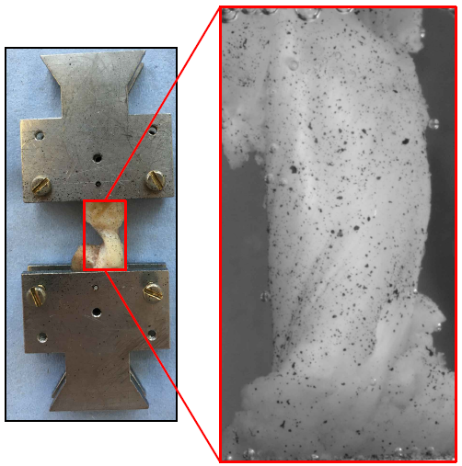
(c)
Fig. 1. (a) Anterior and (b) posterior views of an anterior cruciate ligament. (c) The ligament with speckle patterns.

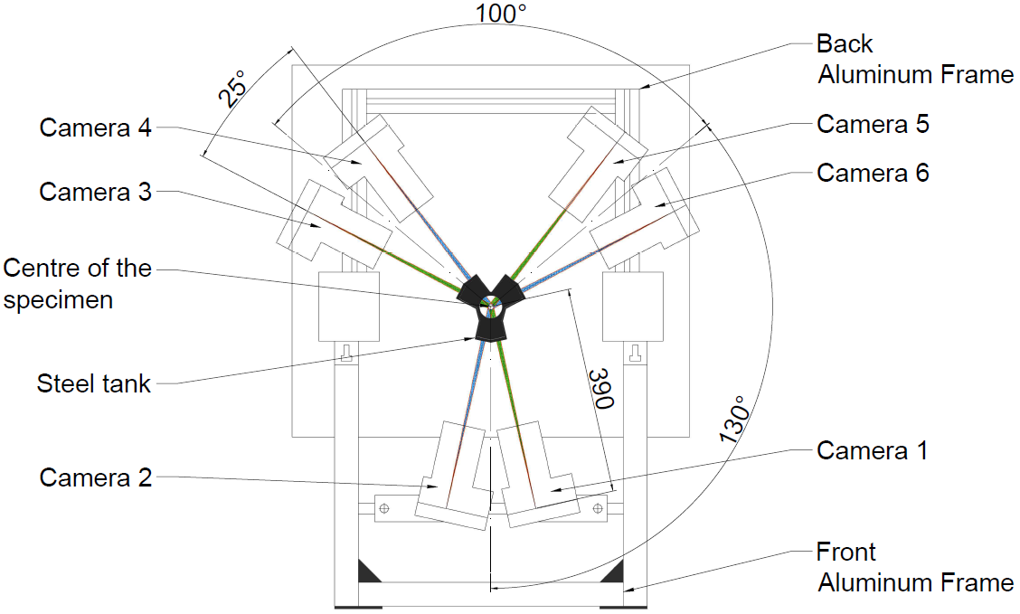
(a)

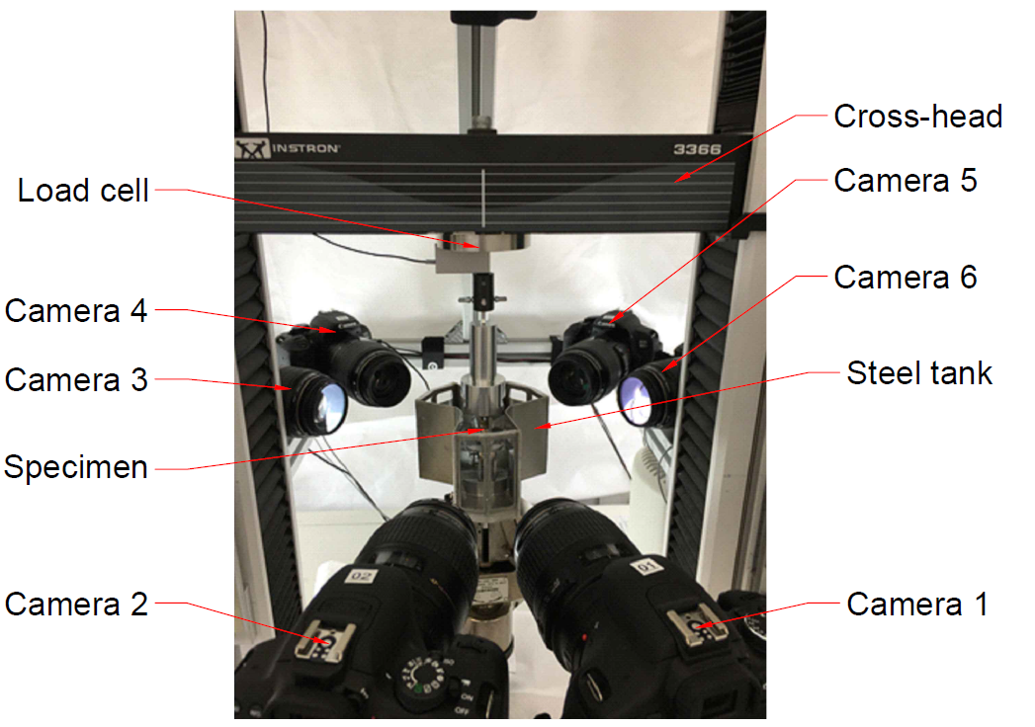
(b)
Fig. 2. The digital image correlation (DIC) setup for testing an anterior cruciate ligament. (a) Schematic view of the DIC setup around the tensile testing machine. (b) Complete built of the DIC setup showing all six cameras, stainless-steel tank and the specimen submerged in 20 ml buffer solution (15ml of 20mM Tris pH 7.5, 150 mM NaCl, 5 mM CaCl₂) with protease inhibitors (1 tablet of mini-cOmplete per 10 ml of buffer, SIGMA-ALDRICH/Roche, USA).

Fig. 3. Representative average load-displacement curves at different regions across the surface of the anterior cruciate ligament during a tensile test. Curves for the top, middle (mid) and lower regions obtained from the image correlations using 3D digital image correlation setup and the tensile test on the material testing machine curve obtained from the moving crosshead of the material testing machine. The error bars represent specimen variations (n=5), the maximum

 | Total Displacement (resultant value) | True Strain (longitudinal direction)
Camera pair 1 and 2 | 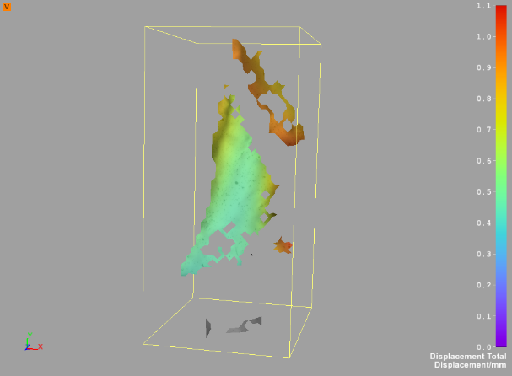 | 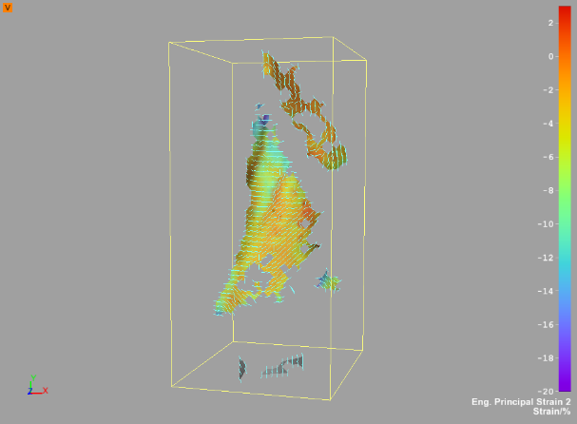
Camera pair 3 and 4 | 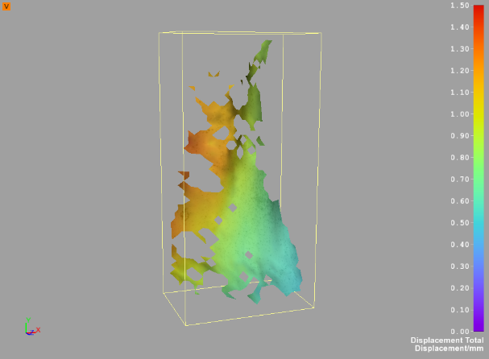 | 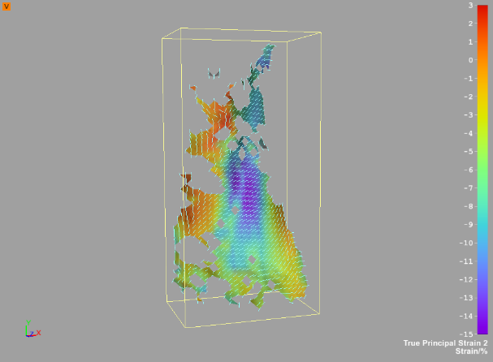
Camera pair 5 and 6 | 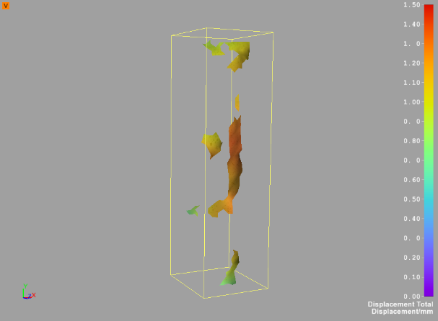 | 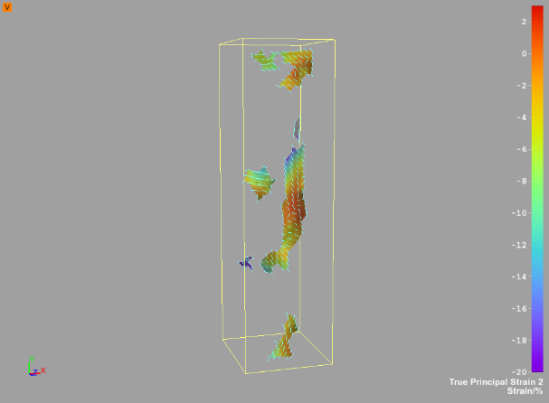
Fig. 4. Total displacement and true strain across the surface of an ACL at maximum load from all three camera pairs. Additional images showing load-displacement distribution can be found in Supplementary Material (Supplementary Materials Fig. S4).

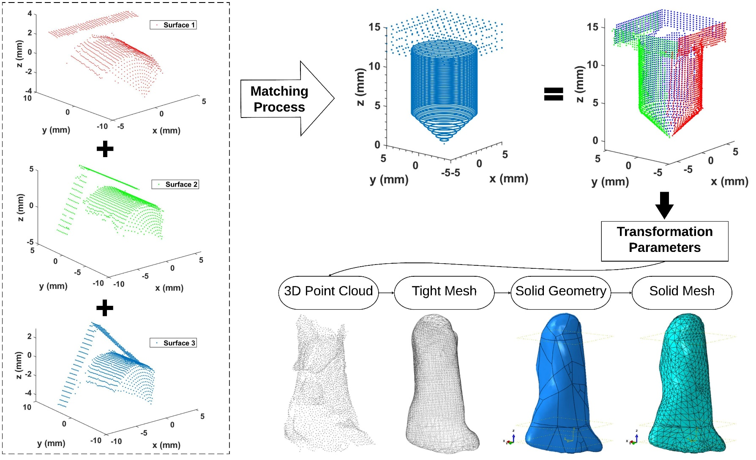
Fig. 5. Schematics showing the process of mapping the three surfaces of the reference object (red, green and blue) on the virtual surface in order to obtain transformation parameters for the 3D digital image correlation test setup. Subsequently, the parameters were applied on to the 3D surfaces of the ligaments to construct 3D point clouds, which were then converted to tight mesh, solid geometry and finally continuous solid finite element models.
(a)
(b)
Fig. 6. Finite element models of an ACL with hyperelastic material properties showing (a) von Mises stress (S, Mises) and (b) maximum principal logarithmic strain (LE, Max, Principal) across the surface at different views.

Fig. 7. The box plot shows nominal stress and strain calculated from the Ogden material model parameters for the current study. The scattered dots in magenta, blue and red are nominal stress and strain values obtained from previous literature. Although sample deviations appear to be large, the median nominal stresses (the line in the middle of the boxes) agree with the values in the literature.

