Localized bank collapse or regional event? A study of distinct contorted heterolithic facies observed in the Lower Jurassic Kayenta Formation, Utah and Arizona

Charlotte L. Priddy¹, Amy V. Regis¹, Stuart M. Clarke^{1 & 2}, A. Graham Leslie^{2 & 1} and Thomas J. H. Dodd ^{2 & 1}.
¹ Basin Dynamics Research Group, School of Geography, Geology and the Environment, Keele University, Keele, ST5 5BG, UK.
² British Geological Survey, The Lyell Centre, Research Avenue South, Edinburgh, EH14 4AP, UK.

Abstract
This study presents a detailed synopsis of the sedimentological and structural features displayed within an under-described enigmatic facies observed in the basal Lower Jurassic Kayenta Formation of the Colorado Plateau. The facies comprises pebble to cobble-sized clasts of fine to medium-grained cross-bedded sandstone with mud-draped and deformed foresets, as well as clasts of parallel-laminated but highly contorted siltstone and mudstone, supported in a silty to sandy matrix. The deposits are internally deformed and show both ductile and brittle structures in close spatial proximity, with a consistent and pervasive west-directed sense of shear. The facies occurs consistently within the same approximate stratigraphic interval, at or near the base of the Kayenta Formation. It is, however, observed only at four localities, distributed in a crudely linear arrangement parallel to the Utah-Idaho trough, despite extensive studies of outcrops of the same stratigraphic interval widely distributed across both Utah and Arizona. This study interprets the depositional process as that of a partially sub-aerial debris flow with depositional events perhaps taking place during the waning period after ephemeral stream activity. The clast morphology and composition suggests a local source for the sediment entrained within the flow, and a limited transport distance. All of these observations are difficult to reconcile with the consistency of the stratigraphic interval in which the facies occur, or with the regional distribution of preserved examples. Consequently, this study discusses the potential for a common and time-equivalent triggering mechanism across all examples, which may have regional significance in the Jurassic evolution of the region.
Key words: Contorted heterolithic facies, debris flow, Kayenta Formation, Utah-Idaho trough

Introduction
During the Early to Middle Jurassic Period, compressional tectonic activity to the west of the Colorado Plateau resulted in asymmetrical subsidence along the Wasatch line that formed the Utah-Idaho trough (figure 1). Associated subsidence in the foreland of the Cordilleran magmatic arc formed the Zuni sag (figure 1) (Bjerrum and Dorsey, 1995; Blakey, 2008; Blakey and Ranney, 2018; Hassan and others, 2018). Evidence for both paleotopographic lows is provided by abrupt westward thickening of the Jurassic-aged strata across the Colorado Plateau (figure 2) (Blakey, 1994; Kirkland and others, 2014).
Sediments of the late Sinemurian to early Toarcian Kayenta Formation were funnelled through the southeast–northwest-trending Zuni sag and into the southwest–northeast-trending Utah-Idaho trough (Olsen, 1989; Blakey, 1994; Kirkland and Milner, 2006). These deposits are of dominantly ephemeral braided fluvial origin (Bromley, 1991; North and Taylor, 1996; Martin, 2000; Priddy and Clarke, 2020), deposited onto a broad arid alluvial plain. Sediment transport was by both southwestward to westward-flowing rivers that sourced sediment from the Uncompahgre uplift of the Ancestral Rocky Mountains (North and Taylor, 1996), and northwestward-flowing rivers that sourced sediment from the Mogollon highlands of the Cordilleran magmatic arc. The initial deposits of the formation overlay a marked unconformity termed the ‘J-sub-K’ unconformity (Marzolf, 1994; Blakey, 1994; Lucas and Tanner, 2006; 2014). By contrast, the upper boundary with the succeeding eolian deposits of the Navajo Sandstone is gradational and interfingering.
Extensive fieldwork that examined regional patterns in the sedimentology of the Kayenta Formation has revealed a distinctive contorted heterolithic facies, observed within proximal sediments of the Uncompahgre-sourced fluvial system (Priddy and Clarke, 2020). The facies comprises contorted intraformational mudstone and sandstone clasts, with internal mud-draped and deformed foresets, as well as contorted and buckled beds and laminations. These deposits were previously interpreted as the deposits of localized debris flows that formed as a result of bank collapse of active river channels into highly sediment-laden flows (Priddy and Clarke, 2020). However, subsequent fieldwork, discussed herein, has revealed further examples that display brittle structures related to sediment transport and deposition, as well as distal examples with a siltier composition. All identified examples occur near the base of the Kayenta Formation, within approximately the same stratigraphic interval, and form a constrained “belt” oriented approximately parallel to the trend of the Utah-Idaho trough.
This study examines the contorted heterolithic facies with the specific objectives of: (1) describing their sedimentology in detail, (2) identifying the possible depositional processes and mechanisms, and (3) discussing possible hypotheses for their formation. Are they (a) localized occurrences controlled by isolated process-scale events that are somewhat “typical” of the fluvial system, or (b) may they relate to a regionally-significant event linked to the J-sub-K unconformity, and to the Utah-Idaho trough?

Geological Setting
The Colorado Plateau is a large high-standing block that spans approximately 360,000 km² across southeastern Utah, northeastern Arizona, southwestern Colorado, and northwestern New Mexico (figure 1) (Gilfillan and others, 2008). From the Early Jurassic to Early Cretaceous, the plateau was influenced profoundly by several orogenic events. The 160 to 150 Ma Elko Orogeny (Thorman and others 1990; Thorman and Peterson, 2004; Thorman, 2011) resulted in raised uplands to the west of the Colorado Plateau (Lawton, 1994), and asymmetrical subsidence along the Wasatch line that formed the northeast–southwest-trending Utah-Idaho trough (figure 1) (Bjerrum and Dorsey, 1995; Blakey, 2008; Blakey and Ranney, 2018). Associated subsidence, caused by loading and contraction of the Cordilleran magmatic arc and Mogollon highlands, resulted in the formation of a northwest to southeast retro-arc foreland basin, referred to as the Zuni sag (figure 1) (Blakey, 2008; Hassan and others, 2018). Subsidence of both depocenters began during the Lower Jurassic, accelerated rapidly throughout the Middle Jurassic, and ceased during the Upper Jurassic (Bjerrum and Dorsey, 1995).

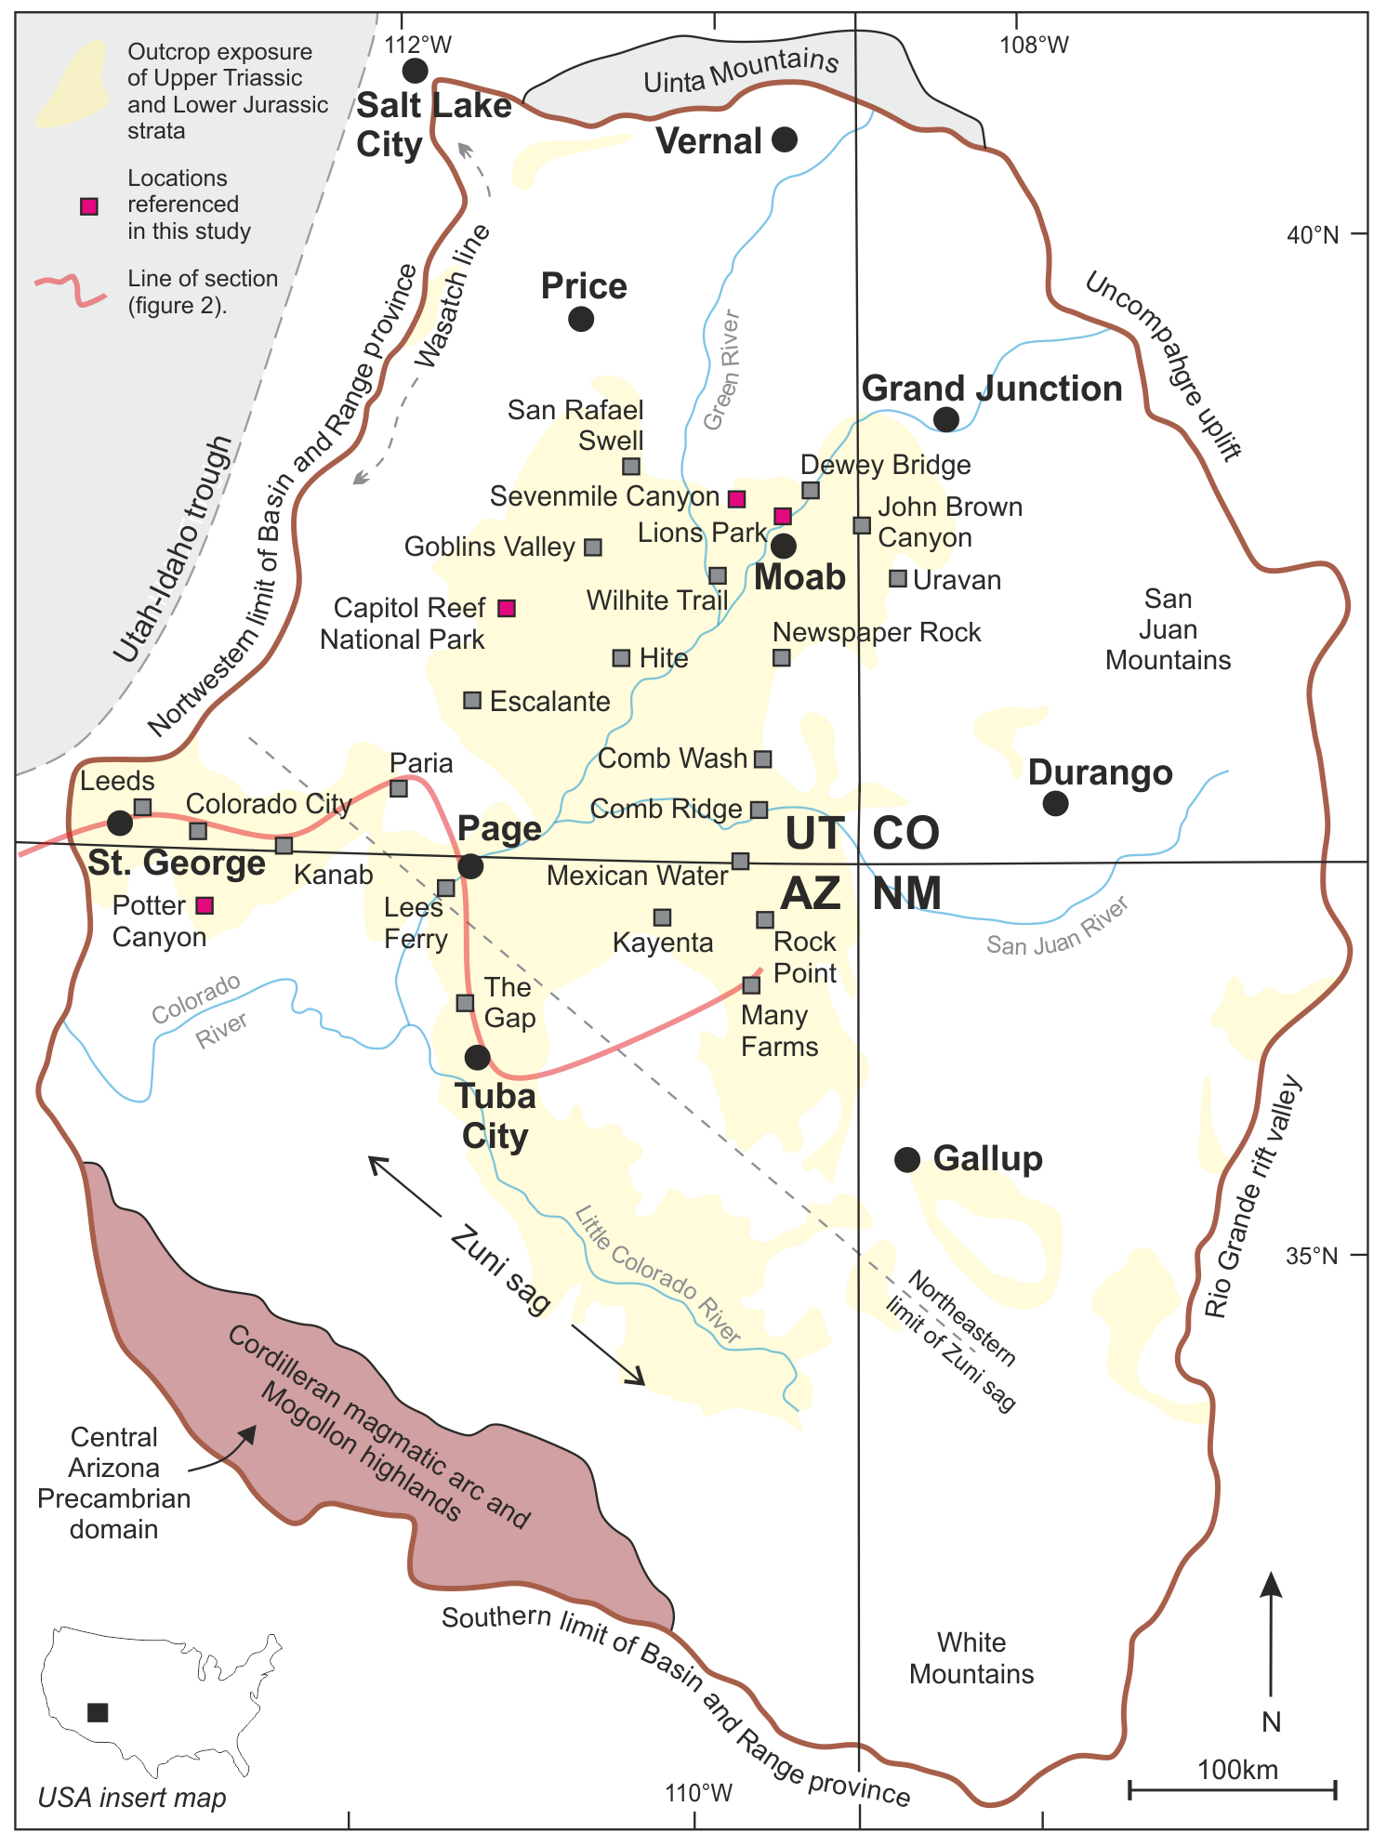
Figure 1. Outline of the Colorado Plateau (brown line), southwestern USA, and within it the exposure of Upper Triassic to Lower Jurassic deposits (yellow), and structural features active during deposition of these sediments, including the Zuni sag and Utah-Idaho trough (modified from Dickinson, 2018). Locations from regional studies of the Kayenta Formation (Priddy and Clarke, 2020; 2021) are highlighted in gray, with the four locations discussed within this study (Sevenmile Canyon, Lions Park, Capitol Reef National Park, and Potter Canyon) highlighted in pink.
The Zuni sag formed a southeast–northwest-trending palaeotopographic low on the western edge of the North American Craton that extended through present day central Arizona, and into southwestern Utah (figure 1) (Tanner and Lucas, 2009; Antonietto and others, 2018). It is somewhat poorly-constrained geographically, but its northeastern limit follows a northwest–southeast-trending line between Page and Tuba City, Arizona (figure 1) (Blakey, 1994). By contrast, the Utah-Idaho trough is a northeast–southwest-trending feature that extends from north-central Utah to the state’s southwestern corner and on into southeastern Nevada (figure 1) (Peterson, 1988). The trough was bound to the north by a submerged barrier coinciding with the western continuation of the Uinta Mountains (Sprinkel, 1994), but its western edge is poorly constrained due to erosion of Lower to Middle Jurassic strata; it probably lies close to the present-day Nevada-Utah border (Peterson, 1988).

Stratigraphy
The presence of the Zuni sag and Utah-Idaho trough resulted in westward thickening of sedimentary successions into these paleotopographic lows, and a system of sedimentary reworking between coeval depositional regimes (Blakey, 1994; Kirkland and others, 2014). The deposited successions belong to the Upper Triassic to Lower Jurassic Glen Canyon Group (figure 2) (Lewis and others, 1961; Lucas and others, 2005; 2006; Sprinkel and others, 2011b; Martz and others, 2014; 2017; Irmis and others, 2015). The group is exposed across southern Utah, northern Arizona, northwest New Mexico, and western Colorado, and comprises four stratigraphic units: the Wingate Sandstone and coeval Moenave Formation, the Kayenta Formation, and Navajo Sandstone (figure 2). The sediments were deposited in eolian, fluvial, and lacustrine settings, and facies from each environment interfinger numerous times to suggest relatively continuous deposition under shifting climatic conditions (Middleton and Blakey, 1983).
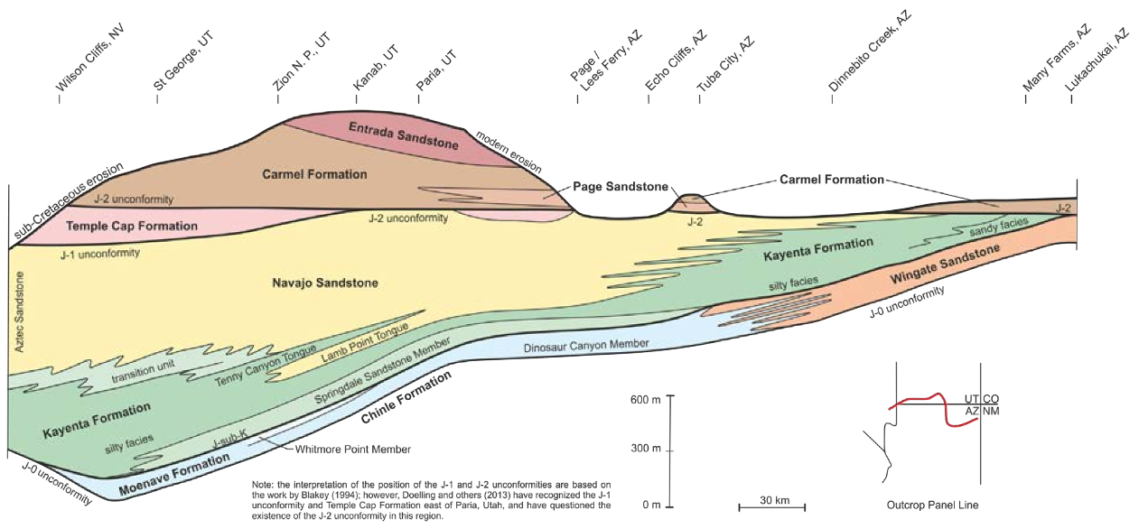
Figure 2. Schematic cross-section through the Lower and Middle Jurassic stratigraphy, highlighting the unconformities that bound the Glen Canyon Group (Moenave Formation/Wingate Sandstone, Kayenta Formation, and Navajo Sandstone). The orientation of the schematic cross-section is shown by the red line of the inset map (modified from Blakey, 1994).
The strata of the Glen Canyon Group are truncated by several unconformities, the stratigraphic locations of which have long been contentious. The J-0 regional unconformity, at the base of the Glen Canyon Group was thought to be the basal bounding surface of the Jurassic strata (Pipiringos and O’Sullivan, 1978; Blakey, 1994; Kirkland and Milner, 2006). However, recent work suggests the Triassic-Jurassic boundary may sit within the Wingate Sandstone or coeval Moenave Formation and, as such, the J-0 regional unconformity may be conflated with the TR-5 unconformity (Lockley and others, 2004; Lucas and others, 2005; 2006; Sprinkel and others, 2011b; Martz and others, 2014; 2017; Irmis and others, 2015). The Glen Canyon Group is capped by either the J-1 unconformity which truncates the top of the Navajo Sandstone in the west, towards Nevada, or by the J-2 unconformity that truncates the top of the Middle Jurassic Temple Cap Formation (as well as the Navajo Sandstone and Kayenta Formation) in the east, towards Colorado and New Mexico (figure 2) (Dickinson, 2018). However, and similarly to the J-0 unconformity, there is debate over the veracity of the J-2 regional unconformity (Sprinkel and others, 2011a; Doelling and others, 2013).
A disconformity — termed the ‘J-sub-K disconformity’ (Riggs and Blakey, 1993; Lucas and Tanner, 2006) — is located between the J-0 and J-1 unconformity and marks the base of the Springdale Sandstone Member of the Kayenta Formation. The J-sub-K disconformity is an erosional surface with between 1 and 15 m of relief that is identified by clasts of lacustrine sediment derived from the Whitmore Point Member of the Moenave Formation below (Kirkland and Milner, 2006). The feature marks a two-million-year-long depositional hiatus in parts of the plateau (Marzolf, 1994; Blakey, 1994; Lucas and Tanner, 2006; 2014). These varying unconformities have been linked to the initiation of the Cordilleran Magmatic Arc and associated thrusting along the western continental margin (Reynolds and others, 1989; Marzolf, 1991).
The laterally equivalent Moenave Formation and Wingate Sandstone overly the J-0 unconformity and together comprise the oldest deposits of the Glen Canyon Group. The Moenave Formation, of Rhaetian to Hettangian age (208–199 Ma), consists of a succession of terrestrial red-bed sediments, including units of fine-grained sandstone, siltstone, and mudstone, which were deposited by fluvial, lacustrine, and eolian processes (Tanner and Lucas, 2007). Sediments were derived from the Mogollon highlands and transported by fluvial systems northwestward along the Zuni sag into west-central Utah (figure 1) (Blakey, 1994). They were then transported back to the east by prevailing westerly winds, into the eolian erg system of the Wingate Sandstone that covered 110,000 km² across present day northeastern Arizona and central Utah (Harshbarger and others, 1957; Clemmensen and others, 1989; Tanner and Lucas, 2009). Because of contemporaneous sedimentation, the Moenave Formation and the Wingate Sandstone interfinger frequently across a 150-km-wide northwest-trending section near Tuba City, Arizona (Tanner and Lucas, 2007; Blakey, 2008). The Wingate Sandstone consists of very fine to fine-grained, well-sorted, sub to well-rounded, quartz-rich sandstone. The sediments are typically preserved in stratigraphic sections of cross-bedded sets and cosets that form sheer, vertical cliffs (Harshbarger and others, 1957) and represent deposition by migrating eolian duneforms.
The upper Sinemurian to lower Toarcian continental red-bed assemblage of the Kayenta Formation overlies the Moenave Formation and the Wingate Sandstone. The formation comprises units of fine-grained sandstone, siltstone, and occasional intraformational conglomerates (Harshbarger and others, 1957; Peterson and Pipiringos, 1979; Luttrell, 1993), which were deposited on a broad alluvial plain by southwestward to westward-flowing rivers from the Uncompahgre uplift of the Ancestral Rocky Mountains (North and Taylor, 1996), and by northwestward-flowing rivers from the Mogollon highlands in the Cordilleran magmatic arc (Luttrell, 1993). In southwest and south-central Utah and northern Arizona, the Kayenta Formation includes the Springdale Sandstone Member and the overlying main body of the Kayenta (figure 2). However, in south-central and parts of southwestern Utah, the Lamb Point Tongue of the Navajo Sandstone is present and separates the main body of the Kayenta (below) from the Tenney Canyon Tongue of the Kayenta (above) (Doelling, 2008; Biek, 2010). The lowermost Springdale Sandstone Member was originally described as part of the Moenave Formation due to lithological similarities with the Dinosaur Canyon Member of that formation around Tuba City, Arizona (Wilson, 1967; Wilson and Stewart, 1967; Pipiringos and O’Sullivan, 1978), but has since been re-assigned on the basis of the identification of the J-sub-K disconformity and the member’s relationship to that surface (Marzolf, 1994; Lucas and Heckert, 2001; Lucas and others, 2005). The member is mostly pale yellow-brown and comprises approximately 30 m of medium to coarse-grained, planar and trough-cross-stratified units of sandstone, with discontinuous lenses of conglomerate and subsidiary lenses of mudstone (Lucas and Tanner, 2007). The basal part of the Springdale Sandstone is often conglomeratic, with pebbles of chert and limestone, as well as angular clasts of siltstone and mudstone derived from the underlying Whitmore Point Member (Kirkland and others, 2014). The main body of the Kayenta Formation conformably and gradationally overlies the Springdale Sandstone Member and comprises 28 to 460 m of red-brown, fine to coarse-grained sandstone, siltstone, and subordinate claystone (Luttrell, 1993). Limestone beds and nodules, as well as conglomeratic beds, are also present locally within the main body of the formation (North and Taylor, 1996; Fillmore, 2011). Towards the top of the Kayenta Formation, the Tenney Canyon Tongue comprises up to 98 m of pale reddish-brown lenticular fine-grained sandstone, siltstone, and mudstone, with subordinate limestone and claystone, all deposited in a distal river and playa system (Luttrell, 1993).

Methods
This study draws upon extensive regional fieldwork that examined the sedimentology of the Moenave and Kayenta formations during four field campaigns between 2016 and 2019. Throughout these studies, a total of 30 detailed vertical sections (centimetre-scale resolution) were logged at 25 separate locations (figure 1), with a cumulative measured length of over 2000 m. Each of the 30 sedimentary logs includes the upper strata of the Wingate Sandstone or the Moenave Formation and extend through the full thickness of the Kayenta Formation to include the lowermost strata of the overlying Navajo Sandstone. From the 25 locations, the distinctive contorted heterolithic facies was observed in four of the measured sections, the locations of which form a northeast to southwest transect (figure 3). Traditional sedimentological methods of facies analysis, augmented by photographic interpretations, were applied to field data in order to interpret depositional processes and sub-environments (sensu Walker, 1992).
The four localities (figure 3) have been separated into proximal and distal settings in this study, with respect to the dominant sediment source for the Kayenta Formation (Priddy and Clarke 2020; 2021). Proximal localities include exposures at Sevenmile Canyon and Lions Park, to the northwest, and at Capitol Reef National Park, approximately 150 km to the southwest of Moab, Utah (figure 1). The distal locality occurs within a series of cliffs and valleys at Potter Canyon, near Colorado City, Arizona, approximately 33 km west of Kanab, Utah.
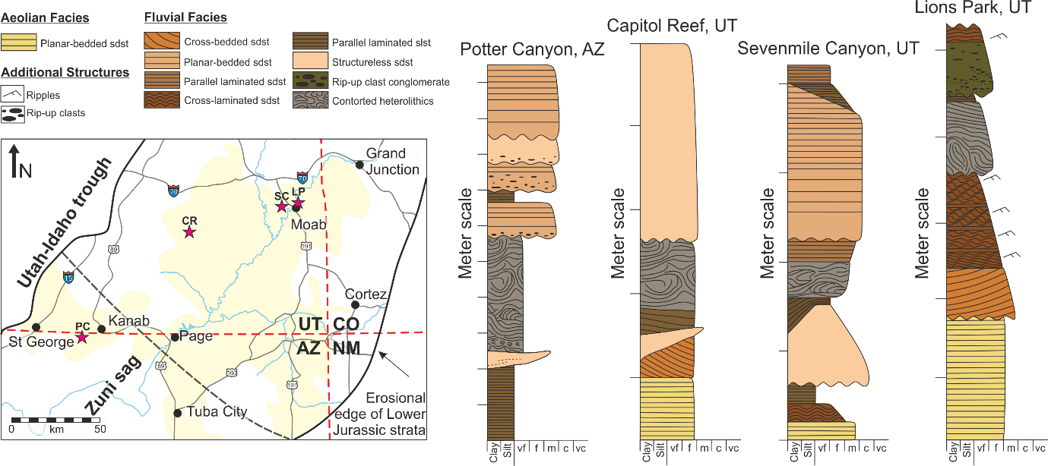
Figure 3. Schematic vertical sedimentary sections of the study localities (pink stars on the insert map) that expose examples of the contorted heterolithic facies, highlighted in gray. Insert map modified from Harshbarger and others (1957); Middleton and Blakey (1983); Blakey (1994). PC = Potter Canyon, CR = Capitol Reef, SC = Sevenmile Canyon, LP = Lions Park, sdst = sandstone, slst = siltstone.

The Deposits
In each of the four locations where contorted heterolithic units are present, examples occur at approximately the same stratigraphic interval of the Kayenta Formation. In the proximal localities of Sevenmile Canyon, Lions Park and Capitol Reef, the boundary between the Kayenta Formation and the underlying Wingate Sandstone is challenging to identify because of the gradational nature of the contact. However, the contorted heterolithic facies occurs within the first fluvial incursion, which is
1–2 m above the underlying aeolian sediments of the Wingate Sandstone. In the distally located Potter Canyon locality, the contorted heterolithic facies marks the boundary between the underlying Moenave Formation and the Kayenta Formation. All examples occur along the western limit of exposure of Jurassic strata, in a northeast to southwest-trending belt.
Proximal examples (Sevenmile Canyon, Lions Park and Capitol Reef) comprise moderately to poorly sorted, sub-rounded clasts that are up to 30 cm in diameter, and comprise plastically deformed and contorted cross-stratified sandstone with mud-draped foresets. The clasts are supported within a purple to brown, siltstone to fine-grained sandstone matrix (figures 4 and 5). Smaller, bladed to prolate clasts display depositional imbrication, with the long axis parallel to the dip of the clasts (figure 4D and 4F). The facies form sedimentary units, 1–3 m thick, with a flat to slightly concave upwards base and an erosive upper bounding surface (figure 4). The units overlay 0.7–1.2 m of purple to dark-brown parallel-laminated siltstone to very fine-grained sandstone, which are then overlain by 0.8–2.1 m thick, pale orange to brown, medium-grained, structureless to crudely cross-bedded sandstone, each with erosive bases and basal rip-up clasts that are distributed along the foresets of crude cross-bedding (figures 4, 5, and 6).
The distal example (Potter Canyon) is composed of a purple-brown, siltstone to very fine-grained sandstone matrix that supports sub-rounded, poorly to moderately sorted clasts of highly contorted parallel-laminated siltstone, with inter-laminae of mudstone (figure 7). Gray-green diagenetic features in the form of either mottling or haloes surround some clasts. Clasts are less than 10 cm in diameter and lack consistent orientation, but are distributed to give the units a bi-partite structure in which an upper clast-rich interval overlays a lower clast-poor interval dominated by contorted laminations. The units are 3 m thick in total, and occur as localized, lens-shaped scours, with erosional lower and upper bounding surfaces. They overlay 1 m of brown-purple, parallel-laminated siltstone and mudstone of the underlying Whitmore Point Member, or a 50 cm thick, channelized, pale orange to brown medium-grained structureless sandstone with muddy laminations, that pinches-out beneath the contorted heterolithic facies, and is replaced by the brown-purple siltstone. The contorted heterolithic facies is capped by a 0.5–2 m thick units of pale orange to brown, medium-grained structureless to planar-bedded sandstone, each with erosive bases, and containing rip-up clasts of mudstone, and 5–30 cm thick interbeds of red-brown mudstone between ‘U-shaped’ sandstone bodies.
In both proximal and distal examples, internally-layered clasts are observed to have been folded; the fold style is distinctive such that fold hinges are thickened and the fold limbs are thinned and attenuated. Structural imbrication and antiformal stacking of packages of clasts (figure 4B and 4F), and the enclosing matrix sediment, is also consistently developed (figure 4B and 5F), typically towards the base of individual units. The fold hinges in some examples are markedly curvilinear and individual sheath fold geometries are evident locally (figure 4A and 4B); the orientations of these fold axes are highly variable but are, in general terms, broadly perpendicular to the stacking-direction indicated in the spatially associated imbricate structures. In all examples, the observed sense of shear is consistently oriented between top-to-the-west, and top-to-the-southwest. Where individual fold axes are more curvilinear in aspect, they appear to have been attenuated in a direction approximately parallel to the structural transport that created the observed imbricate stacking. Extensional structures (e.g. figure 6) indicate that extensional collapse occurred in the same general direction as shown by the other sense of shear criteria described above. In some examples, depositionally imbricated deformed clasts appear caught up within the packages defining structurally imbricated stacks (e.g. figure 4F).
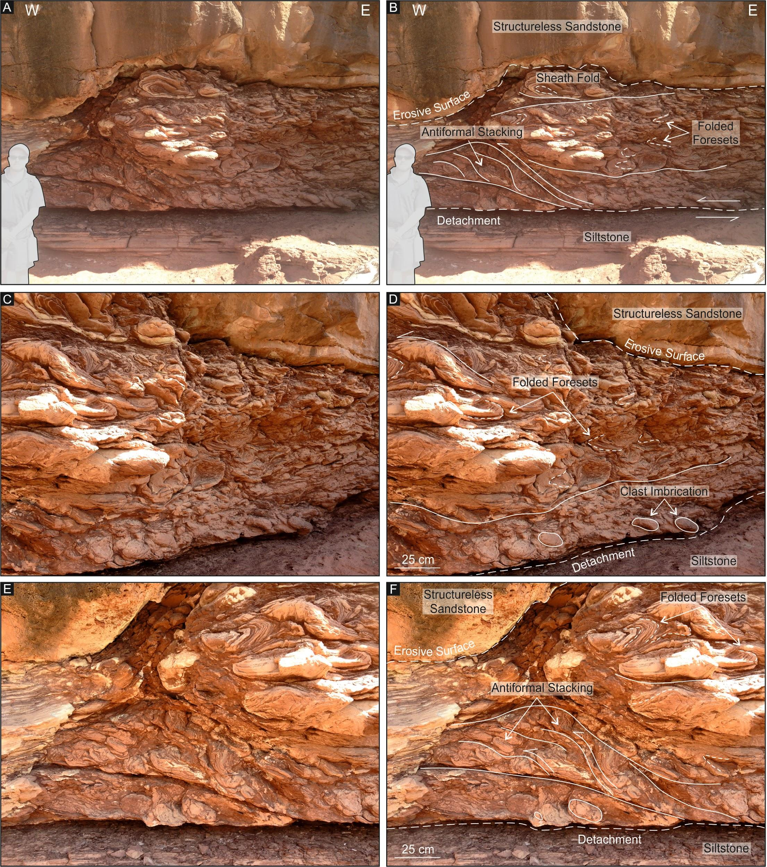
Figure 4. Examples of the proximal contorted heterolithic facies observed at Sevenmile Canyon, Utah (unannotated on left, annotated on right). (A–B) Overview of the geometry, bounding surfaces, and internal structure of the contorted heterolithic facies, highlighting the basal detachment zone and erosional upper bounding surface. (C–D) Close-up of the internally contorted, locally-derived clasts with mud-draping along the folded foresets, and depositional imbrication of clasts near the basal boundary. (E–F) Western edge of the contorted heterolithic facies where clasts display antiformal stacking at the base of the unit.
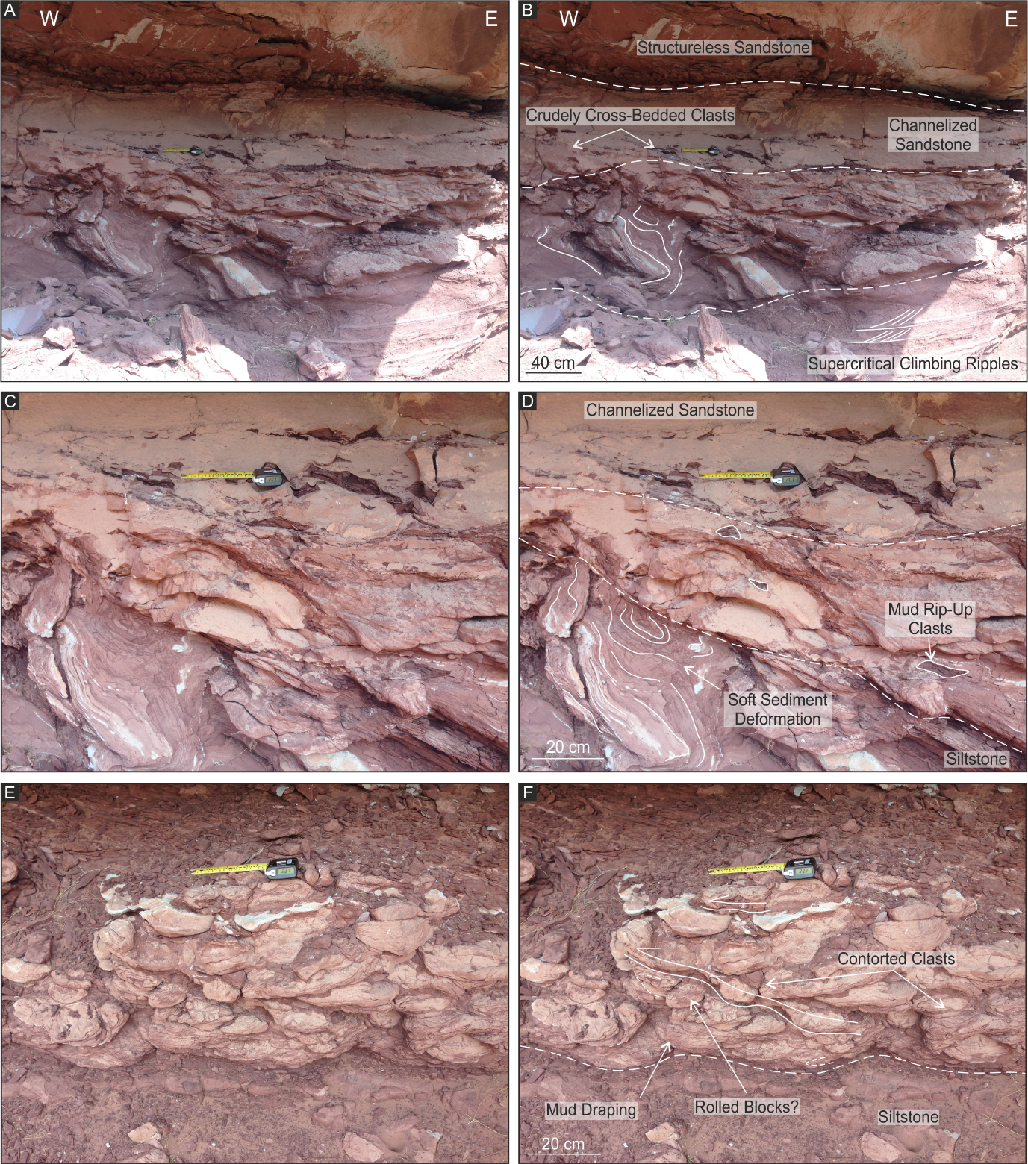
Figure 5. Examples of the proximal contorted heterolithic facies observed at Lions Park, Utah (unannotated on left, annotated on right). (A–B) Overview of the geometry, bounding surfaces, and internal structure of the contorted heterolithic facies. (C–D) Close-up of the upper bounding surface to the unit of contorted heterolithic facies, with soft sediment deformation and mud rip-up clasts within the deformed sandstone layer. (E–F) Deformed sandstone clasts with mud draping along folded foresets and imbrication of clasts.
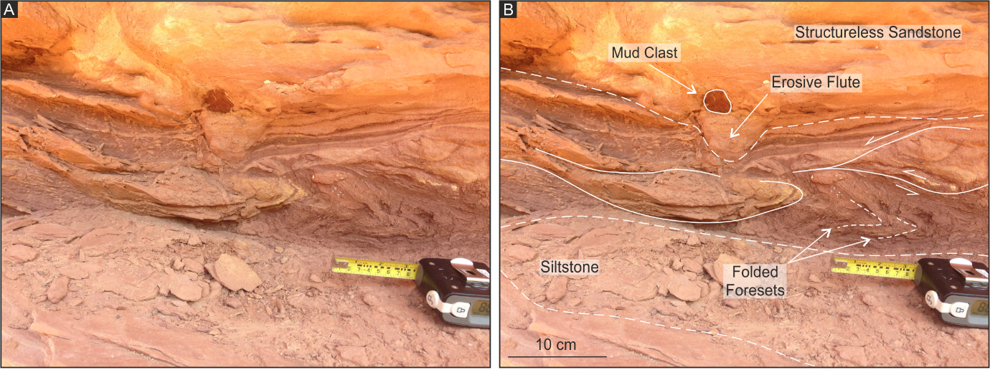
Figure 6. Examples of the proximal contorted heterolithic facies observed at Capitol Reef, Utah, with folded foresets and evidence of collapsed deformation packages in the direction of shear (unannotated on left, annotated on right).

Process of Formation
The presence of units of parallel-laminated siltstone and mudstone that preserve mud-draped sandy foresets within clasts, suggests original subaqueous deposition. Within the distal region of the Kayenta depositional system, the sediments were deposited dominantly through suspension settling, whereas in the proximal region, deposition occurred within migrating bedforms and barforms during highly sediment-laden, episodic and irregular flow (Owen, 1996; Rana and others, 2016; Van Den Berg and others, 2017; Carling and Leclair, 2019). In the proximal setting, the fine fraction may be deposited at times of near-stagnant water, or after the flow reaches its maximum carrying capacity (Olsen, 1987; Nwajide, 1988; Priddy and Clarke, 2020).
Distortion and folding of individual clasts, and structural imbrication of packages of clasts, suggest remobilization of the sediments within a sufficiently short time after initial deposition, such that the sediments were not fully lithified and therefore able to deform (Scholz and others, 2011) in a ductile or brittle-ductile manner. The muddy matrix-supported nature of the resultant deposit, coupled with the style of depositional imbrication of the prolate clasts, suggests a non-Newtonian plastic or pseudo plastic nature to the remobilizing flow. This is perhaps a consequence of a high sediment concentrations, which prevented disaggregation of the sandy clasts through attrition, and allowed them to deform (Shanmugam, 1996; Wozniak and Pisarska-Jamrozy, 2018). The distinctive fold style observed, with thickened fold hinges and thinned attenuated fold limbs, gives a clear indication of non-coaxial plastic deformation under translational shear within the flow (Parrish and others, 1976; Mies, 1993). The consistent overall top-to-the-west or top-to-the-southwest sense of shear indicated by these deformational features is aligned with the local paleoslope.
The markedly curvilinear sheath-fold axes were probably formed as a result of intense non-coaxial deformation with the fold hinges progressively rotated into the transport direction (sensu Alsop and Carreras, 2007). The variable orientations of the fold axes suggest that folds may actually have initiated in a range of orientations prior to more pervasive internal shearing and rotation within the flow. Non-coaxial flow would have been the principal influence constraining the overall fold shape (sensu Adamuszek and Dabrowski, 2017), with the development of curvilinear fold hinge lines as a result of individual fold hinges being dragged out in the overall shear (flow) direction (Alsop and Carreras, 2007).
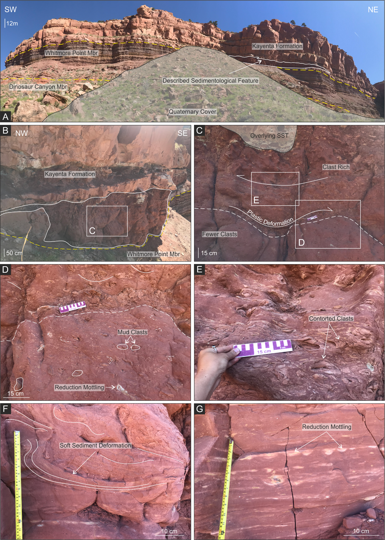
Figure 7. Examples of the distal contorted heterolithic facies observed at Potter Canyon, Arizona. (A) Panel photograph highlighting the contorted heterolithic facies relative to the surrounding sediments. (B) Overview of the geometry and bounding surfaces of the distal contorted heterolithic facies. White box highlights approximate location of Image C. (C) Overview of the structure of the contorted heterolithic facies including the clast-poor lower interval, and clast-rich upper interval. White boxes highlight approximate locations of images D and E. (D) Detailed view of image C. (E) Contorted mud-clasts and silt lenses within the upper interval of the contorted heterolithic facies. (F) Deformed bedding planes and soft sediment deformation within the lower interval of the contorted heterolithic facies. (G) Gray-green diagenetic reduction mottling observed towards the base of the contorted heterolithic facies.
Despite evidence for plastic flow, the structural imbrication and antiformal stacking of sheared packages of clasts and their enclosing matrix suggest sufficient cohesion at times, and in places, to promote brittle deformation. Deformation was dominantly compressional to build-up structurally-thickened packages that overall suggest a sense of shear comparable, at least locally, to the paleocurrent indicated by depositional imbrication. Sporadically, brittle structures that are clearly superimposed upon the more ductile and/or brittle-ductile deformation features, indicate collapse and extension in the same (forward) direction and overall sense of shear (figure 6B). Deformation was progressive, becoming more brittle in style where cohesion in the deforming package increased, for example by thickening and stacking, or perhaps by localized de-watering.
The local juxtaposition of brittle-ductile and ductile deformation suggests a depositional process for these sediments that is capable of supporting both styles, either contemporaneously or consecutively within the time frame of the event. Some evidence for depositionally imbricated clasts caught up in structural imbricated packages suggests a temporal link whereby a plastically deforming flow evolves to become more cohesive through time (Enos, 1977).
The general sedimentology suggests a debris flow in which deformation is predominantly by laminar shear; the composition and orientation of the contorted heterolithic clasts suggest that they were derived locally (from the substrate), and then deformed within the flow. Non-coaxial deformation suggests many contorted heterolithic clasts may have contained pre-existing folds that were subsequently modified by the debris flow, or the sediments may have been deformed under localized stress fields during clast development, to form structures that were later modified by the overriding shear of the flow. Through time, the flow becomes more cohesive, particularly along its basal surface.

Discussion
Examples of the contorted heterolithic facies were first identified within the basal units of the Kayenta Formation to the northwest of Moab, Utah (Priddy and Clarke, 2020). Those examples were in locations proximal to the dominant sediment source for the Kayenta Formation, namely the Uncompahgre uplift. From their locations, internal sedimentology, and localized associations, the facies was interpreted as ‘debris-flow deposits’ formed by the collapse of river banks into the flow (Priddy and Clarke, 2020). That interpretation is supported by previously published descriptions and interpretations of the fluvial sedimentology and depositional processes of the Kayenta Formation, which indicate sporadic, high-discharge events (Stephens, 1994; North and Taylor, 1996; Priddy and Clarke, 2020).
The observations and interpretations of this study (which includes additional localities to those of Priddy and Clarke, 2020) are consistent with the interpretation of a debris flow as the depositional mechanism for their emplacement (sensu Priddy and Clarke, 2020). The facies and depositional imbrication, along with the ductile structures developed within the contorted clasts, are consistent with a high sediment to fluid ratio, and they indicate a plastic flow in which deformation is predominantly by laminar shear rather than fluid turbulence.
The close spatial association of ductile and brittle-ductile structures within the deposits, and the temporal relationships implied by the depositionally imbricated clasts that are subsequently caught up in structurally imbricated packages, suggest flows became more cohesive through time (Enos, 1977). Plausible situations under which this scenario could occur are loss of water from the flow though time, a sharp reduction in basal slope angle over which the flows travel, and/or a reduction in flow velocity. The scenario favours subaerial deposition as the loss of water from more coherent flow types into ambient waters of subaqueous environments is more difficult (Talling, 2013). Additionally, gradually reducing flow velocity over progressive transport distances is known to be more typical for sub-aerial debris flows than compared with their subaqueous counterparts (see Breien and others, 2007). A loss of water from the flows, as well as reduced flow velocities over prolonged transport distances, possibly enhanced by a change in gradient (decrease in slope angle), would easily explain the increase in cohesion and progression from ductile, through ductile-brittle, to brittle deformation as observed in these examples.
Based on our observations and previous studies, we interpret the contorted heterolithic facies as the products of debris flows that took place sub-aerially. As the Kayenta Formation represented a high-energy ephemeral fluvial system (Priddy and Clarke, 2020), and there are fluvial channel deposits formed above these deposits (e.g. figure 4), it is likely these contorted heterolithic facies initiated by collapse of material into empty channels, or into channels with low flow conditions. Once initiated, the debris flows lose water to become cohesive and deform in a brittle fashion in the later stages of flow.
The formation of debris flows requires destabilization of deposited sediment, usually following some form of triggering mechanism or event (i.e., seismicity, oversteepening or changes in base level). In a fluvial setting the most probable triggers are sudden input of water to the system (rainfall) (Bookhagen and others, 2005; Aguilar and others, 2020), over-steepening of a sediment pile (Keaton and others, 1991), or changes in base level (Scherler and others, 2016). The channel cut surface at the base of the contorted heterolithic deposits suggest a sudden input of water or rise in the water table as the dominant triggers, as does the nature of the flow itself, but oversteepening cannot be discounted as a contributing factor. Indeed, it may provide some explanation for the curvilinear fold axes/folds developed within clasts, as localized slumping may deform clasts to generate folding as they enter the flow.
Equally, the cross-bedded and mud-draped sedimentary architecture of many sandstone clasts within the proximal examples, coupled with evidence of pre-existing ductile deformation, may suggest clasts were derived from recently deposited barforms of the ephemeral system. In-situ plastic deformation of foresets within barform sediments (so called recumbent cross-bedding or rip-back curls) have been observed elsewhere within the Kayenta Formation by the present authors (Priddy and Clarke, 2020). These deformational features have a sandstone composition, and contorted foresets that define similar sheath fold geometries with curvilinear fold axes, and in some cases have been observed up to metre scale in size.
Consequently, a scenario can be envisaged in which localized ephemeral stream activity may cut channels through recently deposited barforms. Following the flood event, the saturated and potentially over-steepened channel banks fail, resulting in debris flows. Both partially ductile failure in the failing sediments, as well as any pre-existing folded fabrics, may contribute to the preserved folding of the sediments within clasts. The folds are later reworked by laminar shear within the flow. As the debris flows develop, they lose water rapidly to the sandy substrate, which promotes brittle deformation within the lower parts of the flows under the shear of the overriding, and still plastic, upper flows. The sub-aerial debris flows were most probably localized, with progressively reducing flow velocities, leading to relatively short transport paths (up to tens of meters), which may go some way to explaining the intraformational nature of the clasts, the localized and sporadic occurrences of the facies, and the differences in sedimentary texture between proximal and distal examples.
Despite the fit of the observations across all sites examined with this interpretation, it is difficult to explain the regional distribution of the contorted heterolithic facies by that process of formation alone. Interestingly, units of the contorted heterolithic facies occur within the same narrow stratigraphic interval just above the boundary of the Kayenta Formation with the underlying Moenave and Wingate formations. Thus, it is tempting to hypothesize that their occurrences may be linked, and this could suggest that examples of the facies were deposited coevally as a result of a regional event, possibly linked also to formation of the J-sub-K unconformity.
Furthermore, examples of the contorted heterolithic facies occur in a northeast to southwest transect, near the northwesterly limit of exposure for Triassic–Jurassic strata. Notwithstanding the constraints of exposure, this facies has not been found elsewhere despite an extensive, regular, and grid-based logging strategy (where outcrop exposure allowed) to support regional studies of the Kayenta and Moenave formations (Priddy and Clarke 2020; 2021). The alignment of the localities discovered and reported here is parallel to the consistent paleoflow indicated by internal deformation and shearing within the flow, and parallel to the axis of the Utah-Idaho trough (Peterson, 1988; Bjerrum and Dorsey, 1995). Therefore, this facies may be constrained to a narrow belt, possibly reflecting funnelling of mass-transport debris-flow deposits towards the Zuni Sag (figure 1).
Despite regional and temporal distributions of the contorted heterolithic facies that could imply a physical link between all four examples; such an interpretation is inconsistent with sedimentological observations. It is difficult to conceive of a single mass flow event capable of sustaining the physical characteristics indicated by the sedimentology of these deposits over distances indicated by the spread of localities. The most likely explanation for the spatial distribution of the localities, is one in which the mass flows are separate occurrences, with sediment derived locally. Their consistent paleocurrent simply indicates the general trend of the depositional system in which they reside. However, it is inescapable from the studies presented herein that mass flows with the same style are occurring regionally (although sourced locally) within a somewhat similar stratigraphic position. This suggests potential for a shared and significant triggering mechanism. It is conceivable that this could be a climatic trigger that promoted a period of widespread but episodic flash flooding, or a rise in the water table, but further studies are required to draw full conclusions. It is also possible that the region was influenced by tectonic instability linked to the initiation of the Cordilleran Magmatic Arc and any associated thrusting (Reynolds and others, 1989; Marzolf, 1991). Therefore, the significance of these enigmatic contorted heterolithic deposits to the evolution of the region during the Jurassic Period requires and deserves further detailed investigation.

Conclusions
The contorted heterolithic facies of the Lower Jurassic Kayenta Formation described within this study were first identified in the proximal localities of Sevenmile Canyon and Lions Park, northwest of Moab, and at Capitol Reef National Park, Utah.
Detailed analysis of the sedimentology and the brittle structures developed within these deposits suggests transport and deposition via debris flows that became more cohesive through time. This interpretation is inconsistent with subaqueous deposition in a highly energetic ephemeral flow. Consequently, we suggest a model in which collapse and debris flow takes place at least in part sub-aerially to transport locally-derived sediment over short distances. Such a situation could be conceived during and following episodic flash flooding.
This model explains the sedimentological observations and the spatial distribution of the outcrops, but it does not explain their occurrence within approximately the same stratigraphic level within the strata, near the basal boundary of the Kayenta Formation. Despite being locally sourced, their stratigraphic coincidence may suggest initiation was triggered by some regional-scale autogenic event, perhaps of a climatic nature, and potentially related to the J-sub-K unconformity and evolution of the environment. However, in this context, the interpretation presented may be considered very much of a preliminary nature, and extensive additional work is required to better understand the depositional processes behind these examples of the contorted heterolithic facies, and to constrain their significance in a regional context.

Acknowledgements
This research was conducted during a study undertaken as part of the Natural Environment Research Council (NERC) Centre for Doctoral Training (CDT) in Oil & Gas under its Extending the Life of Mature Basins theme [grant number: NEM00578X/1]. It is sponsored by Keele University, NERC and the British Geological Survey (BGS) via the British University Funding Initiative (BUFI) whose support is gratefully acknowledged. This paper is published by permission of the Executive Director, British Geological Survey (UKRI). We are also grateful to the United States National Park Service for permitting this research and granting scientific research permits for Arches and Capitol Reef National Parks. We are very grateful to Ranie Lynds (Wyoming State Geological Survey) and Doug Sprinkel (Azteca Geosolutions) for their constructive and useful comments that have greatly improved this work. The authors declare that they have no conflicts of interest and the data that support the findings of this study are available from the corresponding author upon reasonable request.

References
Adamuszek, M., and Dabrowski, M., 2017, Sheath fold development in monoclinic shear zones: Terra Nova, v. 29, p. 356–362.
Aguilar, G. Cabré, A. Fredes, V. and Villela, B., 2020, Erosion after an extreme storm event in an arid fluvial system of the southern Atacama Desert: an assessment of the magnitude, return time, and conditioning factors of erosion and debris flow generation: Natural Hazards and Earth System Sciences, v. 20, p. 1247–1265.
Alsop, G.I., and Carreras, J., 2007, The structural evolution of sheath folds—a case study from Cap de Creus: Journal of Structural Geology, v. 29, no. 12, p. 1915–1930.
Antonietto, L.S., Park Boush, L.E., Suarez, C.A., Milner, A.R.C., and Kirkland, J.I., 2018, The ‘last hurrah of the reigning Darwinulocopines’? Ostracoda (Arthropoda, Crustacea) from the Lower Jurassic Moenave Formation, Arizona and Utah, USA: Journal of Paleontology, v. 92, no. 4, p. 648–660.
Armstrong, R.L., 1968, Sevier orogenic belt in Nevada and Utah: Geological Society of America Bulletin, v. 79, no. 4, p. 429–458.
Baars, D.L., and Doelling, H.H., 1987, Moab salt-intruded anticline, east-central Utah: Geological Society of America Centennial Field Guide—Rocky Mountain Section, p. 275–280.
Beitler, B., Chan, M.A., and Parry, W.T., 2003, Bleaching of Jurassic Navajo sandstone on Colorado Plateau Laramide highs—evidence of exhumed hydrocarbon supergiants?: Geology, v. 31, no. 12, p. 1041–1044.
Bjerrum, C.J., and Dorsey, R.J., 1995, Tectonic controls on deposition of Middle Jurassic strata in a retroarc foreland basin, Utah-Idaho trough, Western Interior, United States: Tectonics, v. 14, no. 4, p. 962–978.
Blakey, R.C., 1994, Paleogeographic and tectonic controls on some Lower and Middle Jurassic erg deposits, Colorado Plateau, in Caputo, M.V. Peterson, J.A., and Franczyk, K.J., editors, Mesozoic systems of the Rocky Mountain region, USA. Rocky Mountain Section. SEPM (Society for Sedimentary Geology), p. 273–298.
Blakey, R.C., 2008, Chapter 7—Pennsylvanian–Jurassic sedimentary basins of the Colorado Plateau and southern Rocky Mountains, in Miall, A.D., editor, The sedimentary basins of the United States and Canada: Sedimentary Basins of the World, Amsterdam, Elsevier, v. 5, p. 245–296.
Blakey, R.C., Peterson, F., and Kocurek, G., 1988, Synthesis of late Paleozoic and Mesozoic eolian deposits of the Western Interior of the United States: Sedimentary Geology, v. 56, p. 3–125.
Blakey, R., and Ranney, W., 2018, Chapter 7—The Arrival of Wrangellia and the Nevadan orogeny—Late Triassic to Late Jurassic—Ca. 240–145 Ma, in, Ancient landscapes of Western North America—a geologic history with paleogeographic maps, Switzerland, Springer, 228 p.
Bookhagen, B. Thiede, R.C. and Strecker, M.R., 2005, Abnormal monsoon years and their control on erosion and sediment flux in the high, arid northwest Himalaya: Earth and Planetary Science Letters, v. 231, p. 131–146.
Breien, H., Pagliardi, M., De Blasio, F.V. and Issler, D., 2007, Experimental studies of subaqeous vs. subaerial debris flows – velocity characteristics as a function of the ambient fluid. In: V. Lykousis, D. Sakellariou and J. Locat (eds.), Submarine Mass Movements and their Consequences III, p. 101-110, Springer.
Bromley, M.H., 1991, Architectural features of the Kayenta Formation (Lower Jurassic), Colorado Plateau, USA—relationship to salt tectonics in the Paradox Basin: Sedimentary Geology, v. 73, p. 77–99.
Carling, P.A., and Leclair, S.F., 2019, Alluvial stratification styles in a large, flash‐flood influenced dryland river—the Luni River, Thar Desert, north‐west India: Sedimentology, v. 66, no. 1, p. 102–128.
Clemmensen, L.B., Olsen, H., and Blakey, R.C., 1989, Erg-margin deposits in the Lower Jurassic Moenave Formation and Wingate Sandstone, southern Utah: Geological Society of America Bulletin, v. 101, p. 759–773.
Dickinson, W.R., 2018, Tectonosedimentary relations of Pennsylvanian to Jurassic strata on the Colorado Plateau: Geological Society of America Special Paper, no. 533, 184 p.
Doelling, H.H., 2010, Geology of Arches National Park, Utah, in Sprinkel, D.A., Chidsey, T.C., Jr., and Anderson, P.B., editors, Geology of Utah’s parks and monuments: Utah Geological Association Publication 28, p. 11–36.
Doelling, H.H., Sprinkel, D.A., Kowallis, B.J., and Kuehne, P.A., 2013, Temple Cap and Carmel Formations in the Henry Mountains Basin, Wayne and Garfield Counties, Utah, in Morris, T.H., and Ressetar, R., editors, The San Rafael Swell and Henry Mountains Basin−geologic centerpiece of Utah: Utah Geological Association Publication 42, p. 279–318.
Enos, P., 1977, Flow regimes in debris flow: Sedimentology, v. 24, p. 133–142.
Fillmore, R., 2011, Geological evolution of the Colorado Plateau of eastern Utah and western Colorado, including the San Juan River, Natural Bridges, Canyonlands, Arches and the Book Cliffs. University of Utah Press, Salt Lake City, 495 p.
Gilfillan, S.M.V., Ballentine, C.J., Holland, G., Blagburn, D., Lollar, B.S., Stevens, S., Schoell, M., and Cassidy, M., 2008, The noble gas geochemistry of natural CO₂ gas reservoirs from the Colorado Plateau and Rocky Mountain Provinces, USA: Geochimica et Cosmochimica Acta, v. 72, p. 1174–1198.
Hassan, M.S., Venetikidis, A., Bryant, D., and Miall, A.D., 2018, The sedimentology of an ERG Margin—The Kayenta-Navajo transition (Lower Jurassic), Kanab, Utah, USA: Journal of Sedimentary Research, v. 88, no. 5, p. 613–640.
Harshbarger, J.W., Repenning, C.A., and Irwin, J.H., 1957, Stratigraphy of the uppermost Triassic and the Jurassic rocks of the Navajo Country (Colorado Plateau): U.S. Geological Survey Professional Paper 291, 74 p.
Heller, P.L., Bowdler, S.S., Chambers, H.P., Coogan, J.C., Hagen, E.S., Shuster, M.W., Winslow, N.S., and Lawton, T.F., 1986, Time of initial thrusting in the Sevier orogenic belt, Idaho-Wyoming and Utah: Geology, v. 14, no. 5, p. 388–391.
Irmis, R.B., Chure, D.J., Engelmann, G.F., Wiersma, J.P., and Lindström, S., 2015, The alluvial to eolian transition of the Chinle and Nugget Formations in the southern Uinta Mountains, northeastern Utah, in Vanden Berg, M.D., Ressetar, R., and Birgenheier, L.P., editors, The Uinta Basin and Uinta Mountains: Utah Geological Association Publication 44, p. 13–48.
Keaton, J.R., Anderson, L.R. and Mathewson, C.C., 1991, Assessing debris flow hazards on alluvial fans in Davis County, Utah: Utah Geological Survey Report, p. 1–157.

Kirkland, J.I., and Milner, A.R.C., 2006, The Moenave Formation at the St. George Dinosaur Discovery Site at Johnson Farm, St. George, southwestern Utah, in Harris, J.D., Lucas, S.G., Spielmann, J.A., Lockley, M.G., Milner, A.R.C., and Kirkland, J.I., editors, The Triassic-Jurassic terrestrial transition: New Mexico Museum of Natural History and Science Bulletin 37, p. 289–309.
Kirkland, J.I., Milner, A.R.C., Olsen, P.E., and Hargrave, J.E., 2014, The Whitmore Point Member of the Moenave Formation in its type area in Northern Arizona and its age and correlation with the section in St. George, Utah—evidence for two major lacustrine sequences, in MacLean, J.S., Biek, R.F. and Huntoon, J.E., editors, Geology of Utah’s far south: Utah Geological Association Publication 43, p. 321–355.
Lawton, T. F., 1994, Tectonic setting of Mesozoic sedimentary basins, Rocky Mountain region, United States, in Caputo, M. V., Peterson, J. A. and Franczyk, K. J., editors, Mesozoic systems of the Rocky Mountain region, USA: Rocky Mountain Section SEPM (Society for Sedimentary Geology) Special Publication, p. 1–25.
Lewis, G.E., Irwin, J.H., and Wilson, R.F., 1961, Age of the Glen Canyon Group (Triassic and Jurassic) on the Colorado Plateau: Geological Society of America Bulletin, v. 71, no. 9, p. 1437–1440.
Liu, L., Gurnis, M., Seton, M., Saleeby, J., Muller, R.D., and Jackson, J.M., 2010, The role of oceanic plateau subduction in the Laramide orogeny: Nature Geoscience, v. 3, p. 353–357.
Lockley, M.G., Lucas, S.G., Hunt, A.P., and Gaston, R., 2004, Ichnofaunas from the Triassic-Jurassic boundary sequences of the Gateway area, western Colorado: implications for faunal composition and correlations with other areas: Ichnos, v. 11, no. 1, p. 89–102
Lucas, S.G., and Heckert, A.B., 2001, Theropod dinosaurs and the Early Jurassic age of the Moenave Formation, Arizona-Utah, USA: Neues Jahrbuch fur Geologie und Palaontologie Monatshefte, v. 7, p. 435–448.
Lucas, S.G., Heckert, A.B., and Tanner, L.H., 2005, Arizona's Jurassic vertebrates and the age of the Glen Canyon Group, in Heckert, A.B., and Lucas, S.G., editors, Vertebrate paleontology in Arizona: New Mexico Museum of Natural History and Science Bulletin 29, p. 94–103.

Lucas, S.G., and Tanner, L.H., 2006, The Springdale Member of the Kayenta Formation, Lower Jurassic of Utah-Arizona, in Harris, J.D., Lucas, S.G., Spielmann, J.A., Lockley, M.G., Milner, A.R.C., and Kirkland, J.I., editors, The Triassic-Jurassic terrestrial transition: New Mexico Museum of Natural History and Science Bulletin 37, p. 71–76.
Lucas, S.G., Lockley, M.G., Hunt, A.P., and Tanner, L.H., 2006, Biostratigraphic significance of tetrapod footprints from the Triassic-Jurassic Wingate Sandstone on the Colorado Plateau, in Harris, J.D., Lucas, S.G., Spielmann, J.A., Lockley, M.G., Milner, A.R.C., and Kirkland, J.I., editors, The Triassic-Jurassic terrestrial transition: New Mexico Museum of Natural History and Science Bulletin 37, p. 109–117.

Lucas, S.G., and Tanner, L.H., 2007, Tetrapod biostratigraphy and biochronology of the Triassic-Jurassic transition on the southern Colorado Plateau, USA: Palaeogeography, Palaeoclimatology, Palaeoecology, v. 244, p. 242–256.
Lucas, S.G., and Tanner, L.H., 2014, Unconformable contact of the Lower Jurassic Wingate and Kayenta Formations, southeastern Utah, in MacLean, J.S., Biek, R.F., and Huntoon, J.E., editors, Geology of Utah’s far south: Utah Geological Association Publication 43, p. 311–319
Luttrell, P.R., 1993, Basinwide sedimentation and the continuum of paleoflow in an ancient river system: Kayenta Formation (Lower Jurassic), central portion Colorado Plateau: Sedimentary Geology, v. 85, no. 1-4, p. 411–434.
Martin, A.J., 2000, Flaser and wavy bedding in ephemeral streams: A modern and an ancient example: Sedimentary Geology, v. 136, no. 1-2, p. 1-5.
Martz, J.W., Irmis, R.B., and Milner, A.R.C., 2014, Lithostratigraphy and biostratigraphy of the Chinle Formation (Upper Triassic) in southern Lisbon Valley, southeastern Utah, in MacLean, J.S., Biek, R.F., and Huntoon, J.E., editors, Geology of Utah's far south: Utah Geological Association Publication 43, p. 397–448.

Martz, J.W., Kirkland, J.I., Milner, A.R.C., Parker, J.W., and Santucci, V.L., 2017, Upper Triassic lithostratigraphy, depositional systems, and vertebrate paleontology across southern Utah: Geology of the Intermountain West, v. 4, p. 99–180.

Marzolf, J.E., 1991, Lower Jurassic unconformity (J-0) from the Colorado Plateau to the eastern Mojave Desert—evidence of a major tectonic event at the close of the Triassic: Geology, v. 19, p. 320–323.
Marzolf, J.E., 1994, Reconstruction of the early Mesozoic Cordilleran cratonic margin adjacent to the Colorado Plateau, in Caputo, M.V., Peterson, J.A. and Franczyk, K.J., editors, Mesozoic Systems of the Rocky Mountain Region, USA: Rocky Mountain Section SEPM (Society for Sedimentary Geology), p. 181–215.
Middleton, L.T., and Blakey, R.C., 1983, Processes and controls on the intertonguing of the Kayenta and Navajo Formations, Northern Arizona—eolian-fluvial interactions: Developments in Sedimentology, v. 38, p. 613–634.
Mies, J.W., 1993, Structural analysis of sheath folds in the Sylacauga Marble Group, Talladega salt belt, southern Appalachians: Journal of Structural Geology, v. 15, no. 8, p. 983–993.
Morris, T.H., Manning, V.W., and Ritter, S.M., 2010, Geology of Capitol Reef National Park, Utah, in Sprinkel, D.A., Chidsey, T.C., Jr., and Anderson, P.B., editors, Geology of Utah’s Parks and monuments: Utah Geological Association 28, p. 85–108.
North, C.P., and Taylor, K.S., 1996, Ephemeral-fluvial deposits—integrated outcrop and simulation studies reveal complexity: American Association of Petroleum Geologists Bulletin, v. 80, no. 6, p. 811–830.
Nwajide, C.S., 1988, Convergent mud drapes on some planar cross-beds in the fluvial Turonian
sandstones of the Makurdi formation, Benue Trough, Nigeria: Journal of African Earth Sciences (and the Middle East), v. 7, p. 113–120.

Olsen, H., 1987, Ancient ephemeral stream deposits—a local terminal fan model from the Bunter Sandstone Formation (L. Triassic) in the Tønder-3,-4 and-5 wells, Denmark: in Frostick, L. and Reid, I., editors, Desert Sediments: Ancient and Modern: Geological Society Special Publication No. 35, p. 69–86.
Olsen, H., 1989, Sandstone-body structures and ephemeral stream processes in the Dinosaur Canyon Member, Moenave Formation (Lower Jurassic), Utah, USA: Sedimentary Geology, v. 61, p. 207–221.
Owen, G., 1996, Experimental soft‐sediment deformation—structures formed by liquefaction of unconsolidated sands and some ancient examples: Sedimentology, v. 43, p. 279–293.
Parrish, D.K., Krivz, A.L., and Carter, N.L., 1976, Finite-element folds of similar geometry: Tectonophysics, v. 32, no. 3-4, p. 183–207.
Peterson, F., 1988, A synthesis of the Jurassic System in the southern Rocky Mountain region, in Sloss, L.L., editor, Sedimentary cover of the North American craton: Geology of North America, v. D-2, p. 65–76.
Peterson, F., and Pipiringos, G.N., 1979, Stratigraphic relations of the Navajo Sandstone to Middle Jurassic formations, southern Utah and northern Arizona: U.S. Geological Survey Professional Paper 1035-B, 43 p.
Pipiringos, G.N., and O'Sullivan, R.B., 1978, Principal unconformities in Triassic and Jurassic rocks, western interior United States—a preliminary survey: U.S. Geological Survey Professional Paper 1035-A, 29 p.
Priddy, C.L., and Clarke, S.M., 2020, The sedimentology of an ephemeral fluvial–aeolian succession: Sedimentology, v. 67, no. 5, p. 2392–2425.
Priddy, C.L., and Clarke, S.M., 2021, Spatial variation in the sedimentary architecture of a dryland fluvial system. Sedimentology, v. 68, no. 6, p. 2887–2917.
Rana, N., Sati, S.P., Sundriyal, Y., and Juyal, N., 2016, Genesis and implication of soft‐sediment deformation structures in high‐energy fluvial deposits of the Alaknanda Valley, Garhwal Himalaya, India: Sedimentary Geology, v. 344, p. 263–276.
Renne, P.R., and Turrin, B.D., 1987, Constraints on timing of deformation in the Benton Range, southeastern California, and implications to Nevadan orogenesis: Geology, v. 15, p. 1031–1034.
Reynolds, S.E., Spencer, J.E., Asmerom, Y., DeWitt, E., and Laubach, S.E., 1989, Early Mesozoic uplift in west-central Arizona and southeastern California: Geology, v. 17, p. 207–211.
Riggs, N.R., and Blakey, R.C., 1993, Early and Middle Jurassic paleogeography and volcanology of Arizona and adjacent areas, in Dunne, G. and McDougall, K., editors, Mesozoic Paleogeography of The Western United States, II: Pacific Section SEPM (Society for Sedimentary Geology) Book 71, p. 347–373.
Schanmugam, G., 1996, High-density turbidity currents: are they debris flows?: Journal of Sedimentary Research, v. 66, p. 2–10.
Scherler, D., Lamb, M.P., Rhodes, E.J. and Avouac, J-P., 2016, Climate-change versus landslide origin of fill terraces in a rapidly eroding bedrock landscape: San Gabriel River, CA: Geological Society of America Bulletin, v. 128(7-8), p. 1228–1248.
Scholz, H., Frieling, D., and Aehnelt, M., 2011, Synsedimentary deformational structures caused by tectonics and seismic events—examples from the Cambrian of Sweden, Permian and Cenozoic of Germany, in Sharkov, E.V., editor, New frontiers in tectonic research—general problems, sedimentary basins and island arcs, v. 9, p. 183–218.
Spencer, J.E., 1996, Uplift of the Colorado Plateau due to lithospheric attenuation during Laramide low-angle subduction: Journal of Geophysical Research: Solid Earth, v. 101, no. B6, p. 13595–13609.
Sprinkel, D.A., 1994, Stratigraphic and time-stratigraphic cross sections of Phanerozoic rocks along line D-D1—a north-south transect from near the Uinta Mountain axis across the Basin and Range transition zone to the western margin of the San Rafael Swell (Summit, Wasatch, Utah, Juab, Sanpete, and Emery Counties), Utah: U.S. Geological Survey Miscellaneous Investigations Map I-2184-D, 31 p, 2 plates, scale 1:500,000.
Sprinkel, D.A., Doelling, H.H., Kowallis, B.J., Waanders, G., and Kuehne, P.A., 2011a, Early results of a study of Middle Jurassic strata in the Sevier fold and thrust belt, Utah, in Sprinkel, D.A., Yonkee, W.A., and Chidsey, T.C., Jr., editors, Sevier thrust belt—northern and central Utah and adjacent areas: Utah Geological Association Publication 40, p. 151–172.
Sprinkel, D.A., Kowallis, B.J., and Jensen, P.H., 2011b, Correlation and age of the Nugget Sandstone and Glen Canyon Group, Utah, in Sprinkel, D.A., Yonkee, W.A., and Chidsey, T.C., Jr., editors, Sevier thrust belt—northern and central Utah and adjacent areas: Utah Geological Association Publication 40, p. 131–149.
Stephens, M., 1994, Architectural element analysis within the Kayenta Formation (Lower Jurassic) using ground-probing radar and sedimentological profiling, southwestern Colorado: Sedimentary Geology, v. 90, no. 3-4, p. 179–211.
Talling, P.J., 2013, Hybrid submarine flows comprising turbidity current and cohesive debris flow: Deposits, theoretical and experimental analyses, and generalized models. Geosphere, v. 9, no. 3, p. 460–488.
Tanner, L.H., and Lucas, S.G., 2007, The Moenave Formation—sedimentologic and stratigraphic context of the Triassic-Jurassic boundary in the Four Corners area, southwestern USA: Palaeogeography, Palaeoclimatology, Palaeoecology, v. 244, p. 111–125.
Tanner, L.H., and Lucas, S.G., 2009, The Whitmore Point Member of the Moenave Formation: Early Jurassic Dryland Lakes on the Colorado Plateau, Southwestern USA: Volumina Jurassica, v. 6, p. 11–21.
Thorman, C.H., Ketner, K.B. and Peterson, F., 1990, The Elko orogeny–Late Jurassic orogenesis in the Cordilleran miogeocline [abs.]: Geological Society of America Abstract and Program, v. 22, no. 3, p. 88.
Thorman, C.H., and Peterson, F., 2004, The Middle Jurassic Elko orogeny—a major tectonic event in Nevada-Utah [abs.], American Association of Petroleum Geologists Search and Discovery Article #30022, 7 p.
Thorman, C.H., 2011, The Elko orogeny—a major tectonic event in eastern Nevada-western Utah, in Sprinkel, D.A., Yonkee, W.A., and Chidsey, T.C., Jr., editors, Sevier thrust belt: northern and central Utah and adjacent areas: Utah Geological Association Publication 40, p. 117–129.
Van den Berg, J.H., Martinus, A.W., and Houthuys, R., 2017, Breaching‐related turbidites in fluvial and estuarine channels—examples from outcrop and core and implications to reservoir models: Marine and Petroleum Geology, v. 82, p. 178-205.
Walker, R.G. , 1992, Facies, facies models and modern stratigraphic concepts in Walker, R.G. and James, N.P., editors, Facies models: Geological Association of Canada, St Johns, Newfoundland., p. 1-14.
Wilson, R.F., 1958, The stratigraphy and sedimentology of the (Jurassic) Kayenta and (?Triassic) Moenave Formations, Vermilion Cliffs region, Utah and Arizona. Stanford, California, Stanford University, Ph.D. dissertation, 337 p.
Wilson, R.F, 1967, Whitmore Point, a new member of the Moenave Formation in Utah and Arizona: Plateau, v. 40, p. 29–40.
Wilson, R.F., and Stewart, J.H., 1967, Correlation of Upper Triassic and Triassic (?) Formations Between Southwestern Utah and Southern Nevada: U.S. Geological Survey Bulletin 1244-D, 20 p.
Wozniak, P.P., and Pisarska-Jamrozy, M., 2018, Debris flows with soft-sediment clasts in a Pleistocene glaciolacustrine fan (Gdansk Bay, Poland): CATENA, v. 165, p. 178–191.
Yonkee, W.A., and Weil, A.B., 2015, Tectonic evolution of the Sevier and Laramide belts within the North American Cordillera orogenic system: Earth Science Reviews, v. 150, p. 531–593.

