Geophysical monitoring of simulated graves with resistivity, magnetic susceptibility, conductivity and GPR in Colombia, South America.

Carlos Martin Molina^{a*}, Jamie K. Pringle^{b}, Miguel Saumett^{c}, Orlando Hernández^{d}, Gethin T. Evans^{b}

ªDepartamento de Geociencias, Universidad Nacional de Colombia y Laboratorio de Evidencia Traza, Instituto Nacional de Medicina Legal y Ciencias Forenses, Bogotá, Colombia

^{b}School of Physical Sciences & Geography, Keele University, Staffordshire, ST5 5BG, UK

^{c}GeoSense, Carrera 7 # 127-48 Of. 1007. Bogotá, Colombia

^{d}Departamento de Geociencias, Universidad Nacional de Colombia. Bogotá, Colombia

E-mail addresses; cmmolinaga@unal.edu.co (C. Molina); j.k.pringle@keele.ac.uk (J. Pringle); miguel.saumett@geosenservices.com (M. Saumett); ohernandezh@unal.edu.co (O. Hernandez); gtevans2000@yahoo.co.uk (G. Evans)

*corresponding author. Tel: +57 3002 121736 Email: cmmolinaga@unal.edu.co
Abstract

In most Latin American countries there are significant numbers of both missing people and forced disappearances, ~71,000 alone in Colombia. Successful detection of buried human remains by forensic search teams can be difficult in varying terrain and climates. Three clandestine burials were simulated at two different depths commonly encountered in Latin America. In order to gain critical knowledge of optimum geophysical detection techniques, burials were monitored using: ground penetrating radar, magnetic susceptibility, bulk ground conductivity and electrical resistivity up to twenty-two months post-burial. Radar survey results showed good detection of modern ½ clothed pig cadavers throughout the survey period on 2D profiles, with the 250 MHz antennae judged optimal. Both skeletonised and decapitated and burnt human remains were poorly imaged on 2D profiles with loss in signal continuity observed throughout the survey period. Horizontal radar time slices showed good anomalies observed over all targets, but these decreased in amplitude over the post-burial time. These were judged due to detecting disturbed grave soil rather than just the buried targets. Magnetic susceptibility and electrical resistivity were successful at target detection in contrast to bulk ground conductivity surveys which were unsuccessful. Deeper burials were all harder to image than shallower ones. Forensic geophysical surveys should be undertaken at suspected burial sites.

Highlights

- Geophysical monitoring of simulated graves in Colombia, South America
- GPR 2D profiles good at modern target detection and reasonable for historic graves
- GPR horizontal time-slices all showed grave soil detection
- Magnetic susceptibility and electrical resistivity surveys showed good target detection
- Other depositional environments and real forensic searches suggested

1. Introduction

In many South American countries there are significant numbers of people both missing and those who have been subjected to forced disappearances [1]. In Colombia there are currently ~71,000 people missing, of whom it has been estimated that ~21,000 are forced disappearances [2]. Clandestine grave victims discovered in South America have been reported to be isolated [3,4], co-mingled and mass burial styles [5], at different burial depths below ground level and in a variety of depositional environments [3-5]. Other relevant published case studies of atrocity victims have been reported, for example, in 19th Century Irish mass burials [6], USA race riot victims [7], Spanish Civil War mass burials [8-10], World War Two burials [11,12], in post-WW2 Polish repression mass burials [13], the Northern Ireland ‘Troubles’ albeit mostly isolated burials [14], the 1990s Balkan wars mass burials [15,16], and sadly in current civil wars with both isolated and mass burials [17].

Current forensic search methods to detect both isolated and mass clandestine burials of murder victims are highly varied and have been reviewed elsewhere [18,19], with best practice suggesting a phased approach, moving from large-scale remote sensing methods [20] to initial site reconnaissance [21] and control studies before full ground searches are initiated [22,23). These full searches have also involved a variety of methods, including forensic geomorphology [21], forensic botany [24,25] and entomology [26, 27], scent-trained search dogs [28,29], physical probing [30-32], thanatochemistry from soil samples [33-35] and near-surface geophysical investigations [36-43].

Recent forensic geophysical research has used simulated clandestine graves to work out optimal detection method(s) and equipment configuration(s). Results have been found to be highly variable, depending upon a host of factors, the most important determined are time since burial, burial style, local soil type, vegetation and climate [36, 44-56]. There has been little research in South America using controlled test experiments, with [57] reporting ground penetrating radar (GPR) results from monitoring controlled burials over a period of nine months. This paper presents results of GPR, surface magnetic susceptibility, bulk ground conductivity and electrical resistivity datasets from ten months to twenty-two months post-burial. Brief discussions on these techniques in forensic searches are now given.

GPR is one of the most popularly employed pieces of geophysical equipment being used in searches by professional search teams and practitioners [18]. GPR has been successful in detecting forensic targets in numerous controlled experiments [36, 44-55, 57] and criminal cases [40,41,46,55]. However it may not be optimal in all depositional conditions [8,47,48], which include saline soils [51], wet clay [42] or burial style [53].

Magnetic susceptibility is an emerging technique and measures material that are susceptible to being magnetized, with measurements generating an AC magnetic field of low intensity, making both positive and negative susceptibilities [54]. This reading usually increases by combining magnetic minerals such as magnetite and ferromagnetic materials with manmade material [58]. The use of magnetic susceptibility for forensic purposes has been successful in buried target detection [59] in simulated environments [46,54, 60], and to differentiate soil samples [61-62].

Bulk ground conductivity is a relatively quick field technique to measure relative changes in ground conductivity between targets and background readings by inducing an electro-magnetic current [18,63]. Although more widely used in environmental forensics [18,63], it has had mixed results in criminal searches [18,38,64,65]; controlled studies have determined that the depositional environments have been deemed to be very important, with searches in urban environments found to be particularly problematic for successful target detection [61,66]. Decompositional fluids have also been found to be detectable with this method but are temporally variable [56]. Electrical resistivity is the reciprocal of conductivity and has been widely used in environmental forensics [18,63], detection of clandestine graves [42], ancient burials [66-68] and in controlled experiments [36,39,46,48,51,53], however, major depositional environment variables can affect target detection, including soil moisture [69-70] ,soil type [18,70] and salinity [51].

This paper presents results of GPR, surface magnetic susceptibility, bulk ground conductivity and electrical resistivity surveys over controlled burials in Colombia, South America in a rural depositional environment, from ten months to twenty-two months post-burial. GPR results from zero to nine months post-burial were reported in [57]. The research aims were: firstly, to assess whether these methods could detect the simulated graves, secondly, to determine if there was an optimal time for surveying post-burial and thirdly, to compare results to other studies.

2. Material and Methods

2.1 Study site

The experimental site is located in a rural area of the Marengo Agricultural Center of the National University of Colombia ~ 14 km north of the capital Bogota (Fig. 1a). The study site was in a rural neo-tropical environment with dense vegetation that was cleared, typical of those encountered away from coastal areas in Colombia (Fig. 1b). The site was situated ~ 2,500 m above sea level. Geologically the site is underlain by fluvial-lacustrine deposits of the Sabana Formation of Middle and Late Pleistocene age. The local soil type is a red clay-rich andisol loam, formed from lacustrine sediments and volcanic ash (Fig 1c.), with an organic topsoil horizon ~ 5 cm to ~60 cm thick.

The Tibaitatá Centre for Agricultural research had a meteorological weather observation station ~1 km from the test site, which continually recorded rainfall and temperature data. The site was observed to have an average temperature of 14 ºC and annual rainfall rates of between 500 mm – 1,000 mm per year [71] with little seasonal variation as would be expected in this latitude.

2.2 Simulated graves

It was decided to use freshly dispatched domestic pig cadavers to simulate clandestine graves of murder victims as they are commonly used in such monitoring experiments [45-50], comprising similar chemical compositions, body size, tissue:body fat ratios and skin/hair types to humans [53]. The National Charter for the Protection of Animals (1989) covers biomedical use of animals in Colombia (Ministry of Health, 1993). For this study it was also able to use human remains using Resolution 8430 of the Colombian Ministry of Health Act (1993). Donated skeletonised remains were used to represent historic clandestine graves after a historical archaeological rescue by the Colombian Association of Forensic Anthropology (ACAF), as the time frame that modern human remains would take to skeletonise would be too long for this study, typically months to years post-burial. The National University of Colombia Faculty of Science ethics committee had also approved the project.

Eight simulated clandestine graves were excavated on 19th June 2013 (see Table 1). For each grave, the overlying vegetation was removed and c. 2 m x 2 m holes were dug in a regular pattern (Fig. 2a). Four graves were dug to ~0.8 m below ground level (bgl) and four dug to ~1.2 m bgl respectively, these depths have been commonly encountered in discovered clandestine graves in Colombia [57]. Two simulated graves (Pig1/2) at 0.8 m and 1.2 m bgl had humanely dispatched (electrocuted and bled <6 h before burial) ~70 kg domestic pig carcasses procured from a local butcher emplaced in the centre, with them both having their lower half wrapped with cloth as discovery of half-naked remains are a common burial scenario in Colombia [72]. Best practice was followed on the use of animals, namely non-conscious, minimal numbers and also minimizing any pain and/or discomfort [73]. It was unfortunate that animals were bled prior to burial as the lack of blood may reduce any subsequent leachate plume from developing and results would, most likely, be different to an intact cadaver. A further two graves (Cont1/2) were empty acting as control and were refilled by the excavated soil. The next two graves (Skel1/2) contained the simulated historic skeletonised human remains together with various small arms shell casings and the final two graves (Burnt1/2) contained the simulated historic beheaded and burnt skeletonised human remains, these burial style scenarios sadly are also common in Colombia [74]. Note that obviously the soil will be freshly disturbed, will most probably have higher porosities and will not contain decompositional products as might be expected from true historic graves but these were deemed important to provide a variety of burial targets in the time frame of the study. All graves were then refilled with excavated soil back to ground level. Surface botanical changes documented in [57].

2.3 Ground penetrating radar data collection and processing

Repeat GPR survey datasets were collected within the survey area (Fig. 2a) by a Mala™ ProEx model at c. 1-monthly intervals after burial (Table 2) continuing the surveys shown in [57]. In addition to the reported 250 MHz frequency data, 500 MHz frequency antennae datasets were also collected from nine months post-burial as the equipment became available. The 20 m x 10 m survey grid was GPR surveyed on both north-south and east-west oriented, 0.25 m spaced, parallel survey lines with 0.02 m radar trace spacings throughout, using a 30 ns time window.

Once the 2D GPR profiles were acquired by the Mala RadExplorer™ data collection software, they were downloaded and imported into GSSI‘s RADAN™ v6.6 data processing software. For each profile, standard sequential processing steps were undertaken as in [57] to optimize image quality. These were; (i) DC removal; (ii) time-zero adjustment to make all traces consistent, this adjustment eliminates the time zero; (iii) 2D spatial filtering; (iv) bandpass filtering to reduce noise; (v) amplitude correction to boost deeper reflection amplitudes, and; (vi) deconvolution. Once completed and with all GPR 2D profiles having their known spatial position added, horizontal time-slices of the GPR data were generated for each repeat GPR survey.

2.4 Magnetic susceptibility/conductivity data collection and processing

The Slingram method, in which both the primary field (transmitter coil) as the (receiving coil) move together at a constant separation (see [64, 75]) was used to simultaneously obtain magnetic susceptibility and conductivity measurements with GSSI’s 400 Profiler™ equipment. Data collection began after a year post-burial up until 21 months post-burial, with some monthly gaps in data collection due to equipment availability and the tropical rainy season making data collection impossible (Table 2). A 7 m x 17 m grid was collected for each survey, composed of north-south parallel lines separated every 0.5 m, with sample intervals of 0.5 m and 1 s sample position time. After initial trials and equipment calibration following best practice [18, 22,23, 63], the vertical component (VMD) and frequencies of 11,000 Hz, 13,000 Hz and 15,000 Hz were chosen to be optimal at the test site.

Once the data was collected onto a hand-held portable logging device and downloaded, data was input into Microsoft Excel and was (i) despiked to eliminate anomalous data outliers before exporting into Generic Mapping Tools (GMT) software to (ii) undertake detrending to remove long wavelength site trends before (iii) digital gridded, colour contoured surfaces of magnetic susceptibilities and bulk ground conductivity were both generated.

2.5 Electrical resistivity data collection and processing

Electrical resistivity surface datasets were acquired in the same 7 x 17 m survey grid as described in section 2.4, using a Geoelectric Abem™ Terrameter in a pole-pole mobile equipment configuration, with remote probes spaced 1 m apart and ~15 m away from the survey area following standard practice [63,69]. Datasets were collected from 12 to 21 months post-burial following equipment availability, and comprised of fifteen east-west parallel lines of 17 m in length, separated every 0.5 m, with sample intervals of 0.25 m along survey lines.

Once the data was downloaded, it was input into Microsoft Excel and (i) was despiked to eliminate anomalous data outliers before being exported into Generic Mapping Tools (GMT) software to be (ii) detrended to remove long wavelength site trends and a (iii) digital gridded, colour contoured surface was generated. Finally (iv) R statistical software was used to create boxplot summary data graphs over the simulated grave positions by summing the 10 measurements over them (Fig.2) and for the respective control lines.

3. Results

3.1. Ground penetrating radar

Selected GPR 250 MHz (Fig. 3a) and 500 MHz (Fig. 3b) 2D profiles acquired through the survey period are shown (see Fig. 2a for respective profile locations).

The simulated modern clandestine graves with pigs as murder victims (Pigs1/2) continued (see [57]) to be detected by the 250 MHz 2D profiles throughout the survey period, with either ½ hyperbolic reflection events imaged and/or strong horizontal reflection events that may be due to the disturbed grave contents rather than the target itself (Fig.3a). For the 500 MHz data, however, any ½ hyperbolic reflection events on 2D profiles were only imaged over the 0.8 m bgl buried pig, with the 1.2 m bgl buried pig was poorly detected with just weak horizontal reflection events being observed, presumably due to the significantly reduced penetration depth only imaging the disturbed grave soil (Fig. 3b). For both frequency horizontal time-slice data, all of the grave locations were imaged as high amplitude, square-shaped anomalies but the shallow buried (0.8 m bgl) ones were more clearly defined, probably due to the grave soil being imaged (Fig. 4).

The empty control graves were not able to be imaged by both the 250 MHz and 500 MHz 2D profiles, with only loss of radar signal continuity areas being observed over target positions (Fig. 3). However, the horizontal time-slices did show reasonably high amplitude, square-shaped anomalies over the control grave positions which were also probably imaging the disturbed grave soil (Fig. 4).

The simulated historic clandestine graves with skeletonized remains at both 0.8 m bgl (Skel1) and 1.2 m bgl (Skel2) depths showed variable, low amplitude ½ hyperbolic reflection events in the 2D profiles, with both the 250 MHz and 500 MHz datasets showing a loss in radar signal continuity, with the 500 MHz 2D profiles again being poorly detectable compared to the 250 MHz 2D profiles (Fig.3). The horizontal time-slices from both frequencies showed reasonably high amplitude, square-shaped anomalies over target positions with again the shallow buried (0.8m bgl) ones being more clearly defined (Fig. 4).

The simulated historic clandestine graves with beheaded and burnt skeletonized remains at both 0.8 m bgl (Burnt1) and 1.2 m bgl (Burnt2) depths did not show any ½ hyperbolic reflection events in the 2D profiles, rather a radar signal loss in continuity were observed over target positions in both frequencies (Fig. 3). The horizontal time-slices from both frequencies showed reasonably high amplitude, square-shaped anomalies over target positions, with again the shallow buried (0.8m bgl) ones being more clearly defined when compared to the deeper (1.2 m bgl) buried ones (Fig. 4).

3.2 Magnetic Susceptibility

All simulated burial targets were detected by the magnetic susceptibility inphase component processed survey datasets as relatively low anomalies, when compared to background values (cf. Fig. 5). However, these were temporarily variable and all the skeletonised (Skel1/2) and decapitated and burnt (Burnt 1/2) human remains were relatively harder to define when compared to the other buried targets (Pigs1/2 and Cont1/2), see Fig. 5. These surveys were most probably picking up the disturbed grave soil as [60] also suggests. The simulated shallow buried (0.8m bgl) graves were also generally better resolved when compared to the deeper buried (1.2 m bgl) graves (Fig. 5).

3.3 Bulk ground Conductivity

In contrast to the magnetic susceptibility and electrical resistivity results, the bulk ground conductivity processed results were relatively poorly detectable with individual anomalies over target positions not being resolved (cf. Fig.5). A large and relatively low anomaly, compared to background values, was present in the centre of the survey area and was consistently observed throughout the survey period, which was still present even after de-trending the datasets, which was not observed in the processed magnetic susceptibility and electrical resistivity datasets. The conductivity anomaly was most probably due to either a site effect or the data collection equipment not recording correctly, and thus not due to the presence of the simulated clandestine graves.

3.4 Electrical resistivity

The electrical resistivity survey processed datasets had mostly relatively high anomalous values, with respect to background values, over target positions throughout the survey period (Fig. 5). This was true of all resistivity datasets over the simulated modern clandestine graves (Pig1/2), although the control graves (Cont1/2) were both high/low anomalies with respect to background values depending upon the survey date (Fig. 5). The simulated historic clandestine graves with skeletonised remains (Skel1.2) were mostly low anomalies, with respect to background values, with the exception of the survey undertaken at 15 months post-burial which had a strong, high anomaly with respect to background values (Fig. 5). The simulated historic clandestine graves with beheaded and burnt skeletonized remains were all high anomalies over target positions, with respect to background values (Fig. 5). Clearly, anomalies present over target positions were variable in both character and strength, although all simulated graves (and indeed the control graves) were imaged. The variability was most probably due to differing grave soil porosities, soil moisture percentages and variable rainfall effects as discussed in [46,48,69].

4. Discussion

Whilst the main clandestine graves typically encountered by forensic search teams in Latin America were discussed in [57], this is the first published forensic geophysical research using a combination of geophysical techniques conducted over simulated clandestine graves for a significant time post-burial in Latin America. This has therefore allowed some basic questions posed by forensic search teams to be addressed and indeed compared to other published forensic research and case studies.

The research aims were “firstly to assess whether these methods could detect the simulated graves”. GPR was successful in identifying grave positions using the 250 MHz frequency antennae on 2D profiles, with the simulated modern clandestine graves (Pig1/2) imaged best, followed by the simulated historic clandestine graves with skeletonized remains (Skel1/2), the control empty graves (Cont1/2) and finally the simulated historic clandestine graves with burnt remains (Skel1/2). However some target locations were imaged as radar signal loss in continuity rather than an object which may be due to imaging the disturbed grave soil. The 500 MHz frequency datasets were all less successful at imaging the buried targets when compared to the 250 MHz antennae, as other authors have noted [50,52,53]. In contrast to the GPR 2D profile results, the horizontal time-slices for all surveys using both frequencies were much better, resolving the target locations throughout. This was most probably due to this data imaging the disturbed grave soil, showing the importance of collecting multiple 2D survey lines over suspect burial positions in forensic geophysics searches so that time-slices can be generated. Both magnetic susceptibility and electrical resistivity were good at resolving target burials as other authors have begun to find [54, 59, 60]. The bulk ground conductivity surveys were not able to detect the buried targets, mirroring the results of other forensic geophysical surveys to detect individual burials (see [64,65]), in contrast to one successful study [66]. Of course it should be noted that ‘grave soil’ on the simulated historic graves would not be the same as true historic graves as they were only re-instated and thus this study results for such targets should be used with caution when preparing for such surveys. .

The second paper’s aim was to determine if there was an optimal time for surveying post-burial. GPR 2D profiles were generally good at detecting the simulated burials during the early weeks of monitoring but saw a progressive lessening of signal amplitudes up until the end of the survey period (Fig. 3). This has also been shown in other control studies due to both target skeletonization and grave soil compaction to background levels (see, e.g. [45,47,52,53]). The GPR horizontal time-slices generated from both frequencies all showed good target detection, especially so in the case of the shallower (0.8 m bgl) buried ones, which is thus deemed crucial to undertake regardless of post-burial age. The 12 months summer magnetic susceptibility and electrical resistivity surveys were not optimal (Fig. 5), rather it was the 15 and 18 month autumn and winter months which produced better results; if therefore forensic search surveys in such depositional environments could be timed to coincide with these seasonal months, then their results should then be optimal for target detection. It should also be stated that the disturbed grave soil was detected more than the burial targets themselves. From this study’s results it was determined that bulk ground conductivity surveys should not be used in this depositional environment, in contrast to the [46] simulated urban clandestine grave study.

The third paper’s aim was to compare this study’s results to other studies. Although this has been partially answered in the first two sections, clearly there are similarities with this study’s results when compared with other controlled studies, albeit there have not been any others published in South America. Controlled studies in both North America [45,47,50,52] and Europe [46,53] have shown forensic GPR surveys to be an effective near-surface geophysical detection technique for both clandestine graves and historic burials, with electrical resistivity surveys also found to be promising. Magnetic susceptibility surveys are beginning to be used for forensic applications [51,60], and here has also shown to be promising. Electrical resistivity surveys were found to be successful, mirroring European control studies [46,48,49,53]. Bulk ground conductivity surveys were not that successful here, similar to a UK urban control grave study [46], although this does contrast with a successful conductivity survey to detect a clandestine grave in woodland in New Zealand [38]. Interestingly, the control graves in this study were detectable, in contrast to the [53] semi-rural environment control study.

5. Conclusions

Simulated clandestine graves commonly encountered in Latin America were created on a control test site near Bogota, Colombia. The clandestine graves included ½ clothed pig cadavers to simulated modern clandestine graves of murder victims, and simulated historic graves using both donated skeletonised human remains and beheaded and burnt donated skeletonised human remains. These were buried at both relatively shallow (0.8 m bgl) and deep (1.2 m bgl) depths with control empty graves also created.

Sequential monitoring of the simulated clandestine graves over 21 months post-burial evidenced that the simulated modern clandestine burials could be imaged throughout the survey period using GPR, electrical resistivity and magnetic susceptibility. The simulated historic skeletonised remains were reasonably well imaged but the beheaded and burnt skeletonised remains were relatively poorly detected throughout the survey period. Most probably the disturbed grave soil provided a geophysical contrast with surrounding targets, which was especially important when viewing the GPR horizontal time-slice data. The 500 MHz datasets were all consistently poorer when compared with to 250 MHz datasets with reduced signal amplitudes throughout. Interestingly the control graves were imaged as reduced signal amplitude areas when compared to background values. Bulk ground conductivity surveys were not successful at detecting the simulated targets.

Further work should continue to geophysically monitor these surveys until the simulated clandestine graves can no longer be detected which will provide an important time-line for forensic search teams undertaking searches. In addition, perhaps other techniques (e.g. Electrical Resistivity Imaging or ERI) may also need to be investigated as potential complementary near-surface geophysical search techniques. These simulated graves should also be created in other soil types and depositional environments in Latin America. Simulated mass human burials should also be created and be geophysically monitored over time as this is also sadly a common burial scenario encountered in South America. The detection techniques used in this study should also be used in real forensic search scenarios in Latin America to investigate their effectiveness at burial target detection.

6. Role of the funding source

There was no involvement of any funding sources with this project.

7. Acknowledgements

The authors would like to thank the Universidad Nacional de Colombia for permission to undertake the study, especially to Centro Agropecuario Marengo. GeoSense for loan of the GPR equipment and Sandox for loan EMI equipment. A Santander fellowship in collaboration with Keele University funded a short research exchange programme for the lead author. The Instituto Geográfico Agustín Codazzi is acknowledged for doing soil analysis and the Centro de Investigación Tibaitatá-IDEAM is thanked for providing meteorological datasets. Finally the authors would like to thank two anonymous reviewers who have greatly improved the manuscript.

8. References

[1] Proyecto Desaparecidos. Por la Memoria, la Verdad y la Justicia. Available online at http://www.desaparecidos.org Last accessed: 24th May 2014.

[2] National Institute of Legal Medicine and Forensic Sciences, Colombia. Available online at www.medicinalegal.gov.co Last accessed: 14th April 2014.

[3] H.E. Solla, M.Y. Işcan, Skeletal remains of Dr. Eugenio Berrios Sagredo, Forensic Sci. Int. 116 (2001) 201-211.

[4] M.Y. Işcan, H.E. Solla, B.Q. McCabe, Victim of a dictatorial regime: identification of Mr. Roberto Gomensoro Josman, Forensic Sci. Int. 151 (2005) 213-220.

[5] C.G. Varas, M.I. Leiva, Managing comingled remains from mass graves: considerations, implications and recommendations from a human rights case in Chile, Forensic Sci. Int. 219 (2012), e19-e24.

[6] A. Ruffell, A. McCabe, C. Donnelly, B. Sloan, Location and assessment of an historic (150–160 years old) mass grave using geographic and ground penetrating radar investigation, NW Ireland, J. Forensic Sci. 54 (2009) 382–394.

[7] A. Witten, R. Brooks, T. Fenner, The Tulsa race riot of 1921: a geophysical study to locate a mass grave, Leading Edge 20 (2000) 655–660.

[8] L. Ríoz, J.I.C. Overjero, J.P. Prieto, Identification process in mass graves from the Spanish Civil War I, Forensic Sci. Int. 199 (2010) e27-e36.

[9] L. Ríoz, A.García-Rubio, B. Martínez, A. Alonso, J. Puente, Identification process in mass graves from the Spanish Civil War II, Forensic Sci. Int. 219 (2012) e4-e9.

[10] J-P Fernandez-Alvarez, D. Rubio-Melendi, A. Martinez-Velasco, J.K. Pringle, D. Aguilera, In press. Discovery of a mass grave from the Spanish Civil War using GPR and forensic archaeology. Forensic Sci. Int.

[11] S. Fiedler, J.Berger, K. Stahr, M. Graw, Localisation of a mass grave from the Nazi era—a case study, in: K. Ritz, L. Dawson, D. Miller, (Eds.), Springer Pub, 2009, pp. 303–314.

[12] A. Ossokoswki, M. Kuś, P. Brzeziński, J. Prüffer, J. Piatek, G. Zielińska, et al. Example of human individual identification from World War II gravesite, Forensic Sci. Int. 233 (2013) 179-192.

[13] L. Szleszkowski, A. Thannhäuser, K. Szwagrzyk, P. Konczewski, J. Kawecki, B. Światek, Exhumation research concerning the victims of political repressions in 1945-1956 in Poland: a new direction in forensic medicine, Forensic Sci. Int. 235 (2014) e1-e6.

[14] Independent Commission for the Location of Victims Remains, Accessible online at: http://www.iclvr.ie/ Last Accessed: 26th April 2014.

[15] A.G. Brown, The use of forensic botany and geology in war crimes investigations in NE Bosnia, Forensic Sci. Int. 163 (2006) 204-210.

[16] M. Dajuric, D. Dunjic, D. Djonic, M. Skinner, Identification of victims from two mass-graves in Serbia: a critical evaluation of classical markers of identity, Forensic Sci. Int. 172 (2007) 125-129.

[17] Syrian Observatory for Human Rights, Available online at www.syriahr.com, Last accessed: 8th June 2015.

[18] J.K. Pringle, A. Ruffell, J.R. Jervis, J.D. Donnelly, J. McKinley, J.D. Hansen, R. Morgan, D. Pirrie, M. Harrison, The use of geoscience methods for terrestrial forensic searches, Earth Sci. Rev. 114 (2012) 108-123.

[19] R. Parker, A. Ruffell, D. Hughes, J. Pringle, Geophysics and the search of freshwater bodies: a review, Sci. Justice 50 (2010) 141-149.

[20] M. Kalacska, L.S. Bell, G.A. Sanchez-Azofeifa, T. Caelli, The application of remote sensing for detecting mass graves: an experimental animal case study from Costa Rica, J. Forensic Sci. 54 (2009) 159-166.

[21] A. Ruffell, J. McKinley, Forensic geomorphology, Geomorphology 206 (2014) 14-22.

[22] M. Harrison, L.J. Donnelly, Locating concealed homicide victims: developing the role of geoforensics, in: K. Ritz, L. Dawson, D. Miller, (Eds.), Criminal and Environmental Soil Forensics, Springer, 2009, pp. 197–219.

[23] D.O. Larson, A.A. Vass, M. Wise, Advanced scientific methods and procedures in the forensic investigation of clandestine graves, J. Contemp. Crim. Justice 27 (2011) 149–182.

[24] I. Aquila, F. Ausania, C. Di Nunzio, A. Serra, S. Boca, A. Capelli, et al.. The role of forensic botany in crime scene investigation: case report and review of literature, J. Forensic Sci. 59 (2014) 820-824.

[25] H.M. Coyle, Forensic botany: principles and applications to criminal casework, CRC Press, 2005.

[26] D. Gennard, Forensic entomology: an introduction, 2nd ed,, Wiley-Blackwell, 2012.

[27] J. Amendt, C.P. Campobasso, E. Gaudry, C. Reiter, H.N. LeBlanc, M.J.R. Hall, Best practice in forensic entomology: standards and guidelines, Int. J. Legal Medicine 121 (2007) 90-104.

[28] A. Lasseter, K.P. Jacobi, R. Farley, L. Hensel, Cadaver dog and handler team capabilities in the recovery of buried human remains in the Southeastern United States, J Forensic Sci. 48 (2003) 1–5.

[29] T.L. Dupras, J.J. Schultz, S.M. Wheeler, L.J. Williams, Forensic recovery of human remains, CRC Press, 2006.

[30] E.W. Killam, The detection of human remains. Charles C Thomas Pubs., Springfield, USA, 2004.

[31] A. Ruffell, Burial location using cheap and reliable quantitative probe measurements, Forensic Sci. Int. 151 (2005) 207–211.

[32] D.W. Owsley, Techniques for locating burials, with emphasis on the probe, J. Forensic Sci. 40 (1995) 735–740.

[33] A.A. Vass, R.R. Smith, C.V. Thompson, M.N. Burnett, N. Dulgerian, B.A. Eckenrode, Odor analysis of decomposing human remains, J. Forensic Sci. 53 (2008) 384–391.

[34] D.O. Carter, D. Yellowlees, M. Tibbett, Using ninhydrin to detect gravesoil, J. Forensic Sci. 53 (2008), 397–400.

[35] J. Dekeirsschieter, F.J. Verheggen, M. Gohy, F. Hubrecht, L. Bourguignon, G. Lognay, et al., Cadaveric volatile organic compounds released by decaying pig carcasses (Sus domesticus) in different biotopes, For. Forensic Int. 189 (2009) 46–53.

[36] D.L. France, T.J. Griffin, J.G. Swanburg, J.W. Lindemann, G.C. Davenport, V. Trammell et al., A multidisciplinary approach to the detection of clandestine graves, J. Forensic Sci. 37 (1992) 1445–1458.

[37] K. Powell, Detecting human remains using near-surface geophysical instruments, Expl. Geophysics 35 (2004) 88-92.

[38] D.C. Nobes, The search for ‘‘Yvonne’’: a case example of the delineation of a grave using near-surface geophysical methods, J. Forensic Sci. 45 (2000) 715–721.

[39] P. Cheetham, Forensic geophysical survey, in: J. Hunter, M. Cox, (Eds.) Forensic archaeology: advances in theory and practice, Routledge, 2005, pp. 62–95.

[40] A. Ruffell, Searching for the IRA ‘‘disappeared’’: ground penetrating radar investigation of a churchyard burial site, J. Forensic Sci. 50 (2005) 1430–1435.

[41] J.J. Schultz, Using ground-penetrating radar to locate clandestine graves of homicide victims: forming forensic archaeology partnerships with law enforcement, Homicide Studies. 11 (2007) 15-29.

[42] J.K. Pringle, J.R. Jervis, Electrical resistivity survey to search for a recent clandestine burial of a homicide victim, UK, Forensic Sci. Int. 202 (2010) e1-e7.

[43] A. Novo, H. Lorenzo, F. Ria, M. Solla, 3D GPR in forensics: finding a clandestine grave in a mountainous environment, Forensic Sci. Int. 204 (2011) 134-138.

[44] K.B. Strongman, Forensic applications of ground penetrating radar, in: J. Pilon (Ed.) Ground penetrating radar, Geol. Survey Canada Paper 90-4 (1992) 203–211.

[45] J.J. Schultz, M.E. Collins, A.B. Falsetti, Sequential monitoring of burials containing large pig cadavers using ground-penetrating radar, J. Forensic Sci. 51 (2006) 607–616.

[46] J.K. Pringle, J.R. Jervis, J.P. Cassella, N.J. Cassidy, Time-lapse geophysical investigations over a simulated urban clandestine grave, J. Forensic Sci. 53 (2008) 1405–1417.

[47] J.J. Schultz, Sequential monitoring of burials containing small pig cadavers using ground-penetrating radar, J. Forensic Sci. 53 (2008) 279–287.

[48] J.R. Jervis, J.K. Pringle, G.W. Tuckwell, Time-lapse resistivity surveys over simulated clandestine graves, Forensic Sci. Int. 192 (2009) 7–13.

[49] A. Juerges, J.K. Pringle, J.R. Jervis P. Masters, Comparisons of magnetic and electrical resistivity surveys over simulated clandestine graves in contrasting burial environments, Near Surf. Geophys. 8 (2010) 529–539.

[50] J.J. Schultz, M.M. Martin, Controlled GPR grave research: comparison of reflection profiles between 500- and 250-MHz antennae, Forensic Sci. Int. 209 (2011) 64–69.

[51] J.K. Pringle, C. Holland, K. Szkornik, M. Harrison, Establishing forensic search methodologies and geophysical surveying for the detection of clandestine graves in coastal beach environments, Forensic Sci. Int. 219 (2012) e29-e36.

[52] J.J. Schultz, M.M. Martin, Monitoring controlled graves representing common burial scenarios with ground penetrating radar, J. Applied Geophys. 83 (2012) 74–89.

[53] J.K. Pringle, J.R. Jervis, J.D. Hansen, N.J. Cassidy, G.M. Jones, J.P. Cassella, Geophysical monitoring of simulated clandestine graves using electrical and Ground Penetrating Radar methods: 0-3 years, J. Forensic Sci. 57 (2012) 1467-1486.

[54] J.D. Hansen, J.K. Pringle, Comparison of magnetic, electrical and GPR surveys to detect buried forensic objects in semi-urban and domestic patio environments, in: D. Pirrie, A. Ruffell, L.A. Dawson, (Eds.), Environmental & Criminal Geoforensics, Geol. Soc. London Spec. Pub., 384, 2013, pp. 229-251.

[55] A. Ruffell, J.K. Pringle, S. Forbes, Search protocols for hidden forensic objects beneath floors and within walls, Forensic Sci. Int. 237 (2014) 137-145.

[56] J.K. Pringle, J.P. Cassella, J.R. Jervis, A. Williams, P. Cross, N.J. Cassidy, Soilwater conductivity analysis to date and locate clandestine graves of homicide victims, J. For. Sci. (2015) 60, 1052-1060.

[57] C.M. Molina, J.K. Pringle, M. Saumett, O. Hernandez, Preliminary results of sequential monitoring of simulated clandestine graves in Colombia, South America, using ground penetrating radar and botany, Forensic Sci. Int. (2015) 248, 61-70.

[58] P.S. Miller, Disturbances in the soil: finding buried bodies and other evidence using ground penetrating radar, J. Forensic Sci. 41 (1996), 648–652.

[59] N. Linford, Magnetic ghosts: Mineral magnetic measurements on Roman and Anglo-Saxon graves, Arch. Prosp.11 (2004) 167–180.

[60] J.K. Pringle, M. Giubertoni, N.J. Cassidy, K. Wisniewski, J.D. Hansen, N. Linford, R. Daniels, The use of magnetic susceptibility as a forensic search tool, Forensic Sci. Int. 246 (2015) 31–42.

[61] A. Guedes, R. Murray, H. Ribeiro, H. Sant'Ovaia, B. Valentim, A. Rodrigues, S. Leal, F. Noronha, The potential application of magnetic susceptibility as a technique for soil forensic examinations. Geol. Soc. London Spec. Pub. 384 (2013), pp. 75-83.

[62] C. Manrong, Y. Lizhong, N. Xiangfeng, C. Bin, Application of environmental magnetism on crime detection in a highway traffic accident from Yangzhou to Guazhou, Jiansu Province, China, Forensic Sci. Int. 187 (2009) 29–33.

[63] J.M. Reynolds, An introduction to applied and environmental geophysics, 2nd ed., Wiley, 2011.

[64] D.C. Nobes, Geophysical surveys of burial sites: a case study of the Oaro Urupa site, Geophys. 64 (1999) 357–367.

[65] D.P. Bigman, The use of electromagnetic induction in locating graves and mapping cemeteries: an example from Native North America, Arch. Prospect. 19 (2012) 31-39.

[66] H.C. Dick, J.K. Pringle, B. Sloane, J. Carver, A. Haffenden, S. Porter, et al. Detecting and characterising of Black Death burials by multi-proxy geophysical methods, J. Arch. Sci. 59 (2015) 132-141.

[67] B.B. Ellwood, Electrical resistivity surveys in two historical cemeteries in northeast Texas: a method for delineating unidentified burial shafts, Hist. Arch. 24 (199) 91–98.

[68] H.C. Matias, F.A. Monteiro Santos, F.E. Rodruiges Ferreira, C. Machado, R. Luzio, Detection of graves using the micro-resistivity method. Ann. Geophys. 49 (2006) 1235–1244.

[69] J.R. Jervis, J.K. Pringle, A study of the affect of seasonal climatic factors on the electrical resistivity response of three experimental graves. J. App. Geophys. 108 (2014) 53-60.

[70] J.D. Hansen, J.K. Pringle, J. Goodwin, J. GPR and bulk ground resistivity surveys in graveyards: locating unmarked burials in contrasting soil types, Forensic Sci. Int. 237 (2014) e14-e29.

[71] Centro Agropecuario Marengo at the Universidad Nacional de Colombia. Available online at: http://www.marengo.unal.edu.co Last accessed: 7th October 2015.

[72] Fiscalía General de la Nación. Available online at http://www.fiscalia.gov.co Last Accessed: 09/06/2015.

[73] M. de Osorio, Ética en la investigación con modelos animales experimentales, Alternativas y las 3 RS de Russel, Una responsabilidad y un compromiso ético que nos compete a todos, 2006, 163-183.

[74] Centro Nacional de Memoria Histórica. Available online at http://www.centrodememoriahistorica.gov.co Last Accessed: 9th June 2015.

[75] J. Thiesson, G. Rousselle, F. Simon, A. Tabbagh. Slingram EMI prospection: Are vertical orientated devices a suitable solution in archaeological and pedological prospection? J. App. Geophys. 75 (2011) 731-737.

[78] A.J. Clark, Seeing beneath the soil: prospecting methods in archaeology. Batsford, 2nd ed., 1996.

9. Figure Captions:
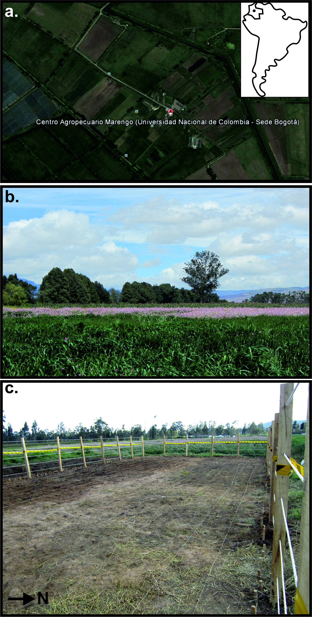
Fig.1. (a) Aerial photograph of the Marengo Agricultural Center of the National University of Colombia with location (inset). (b) General site photograph. (c) Fenced test site with cleared vegetation photograph. Modified from [57].
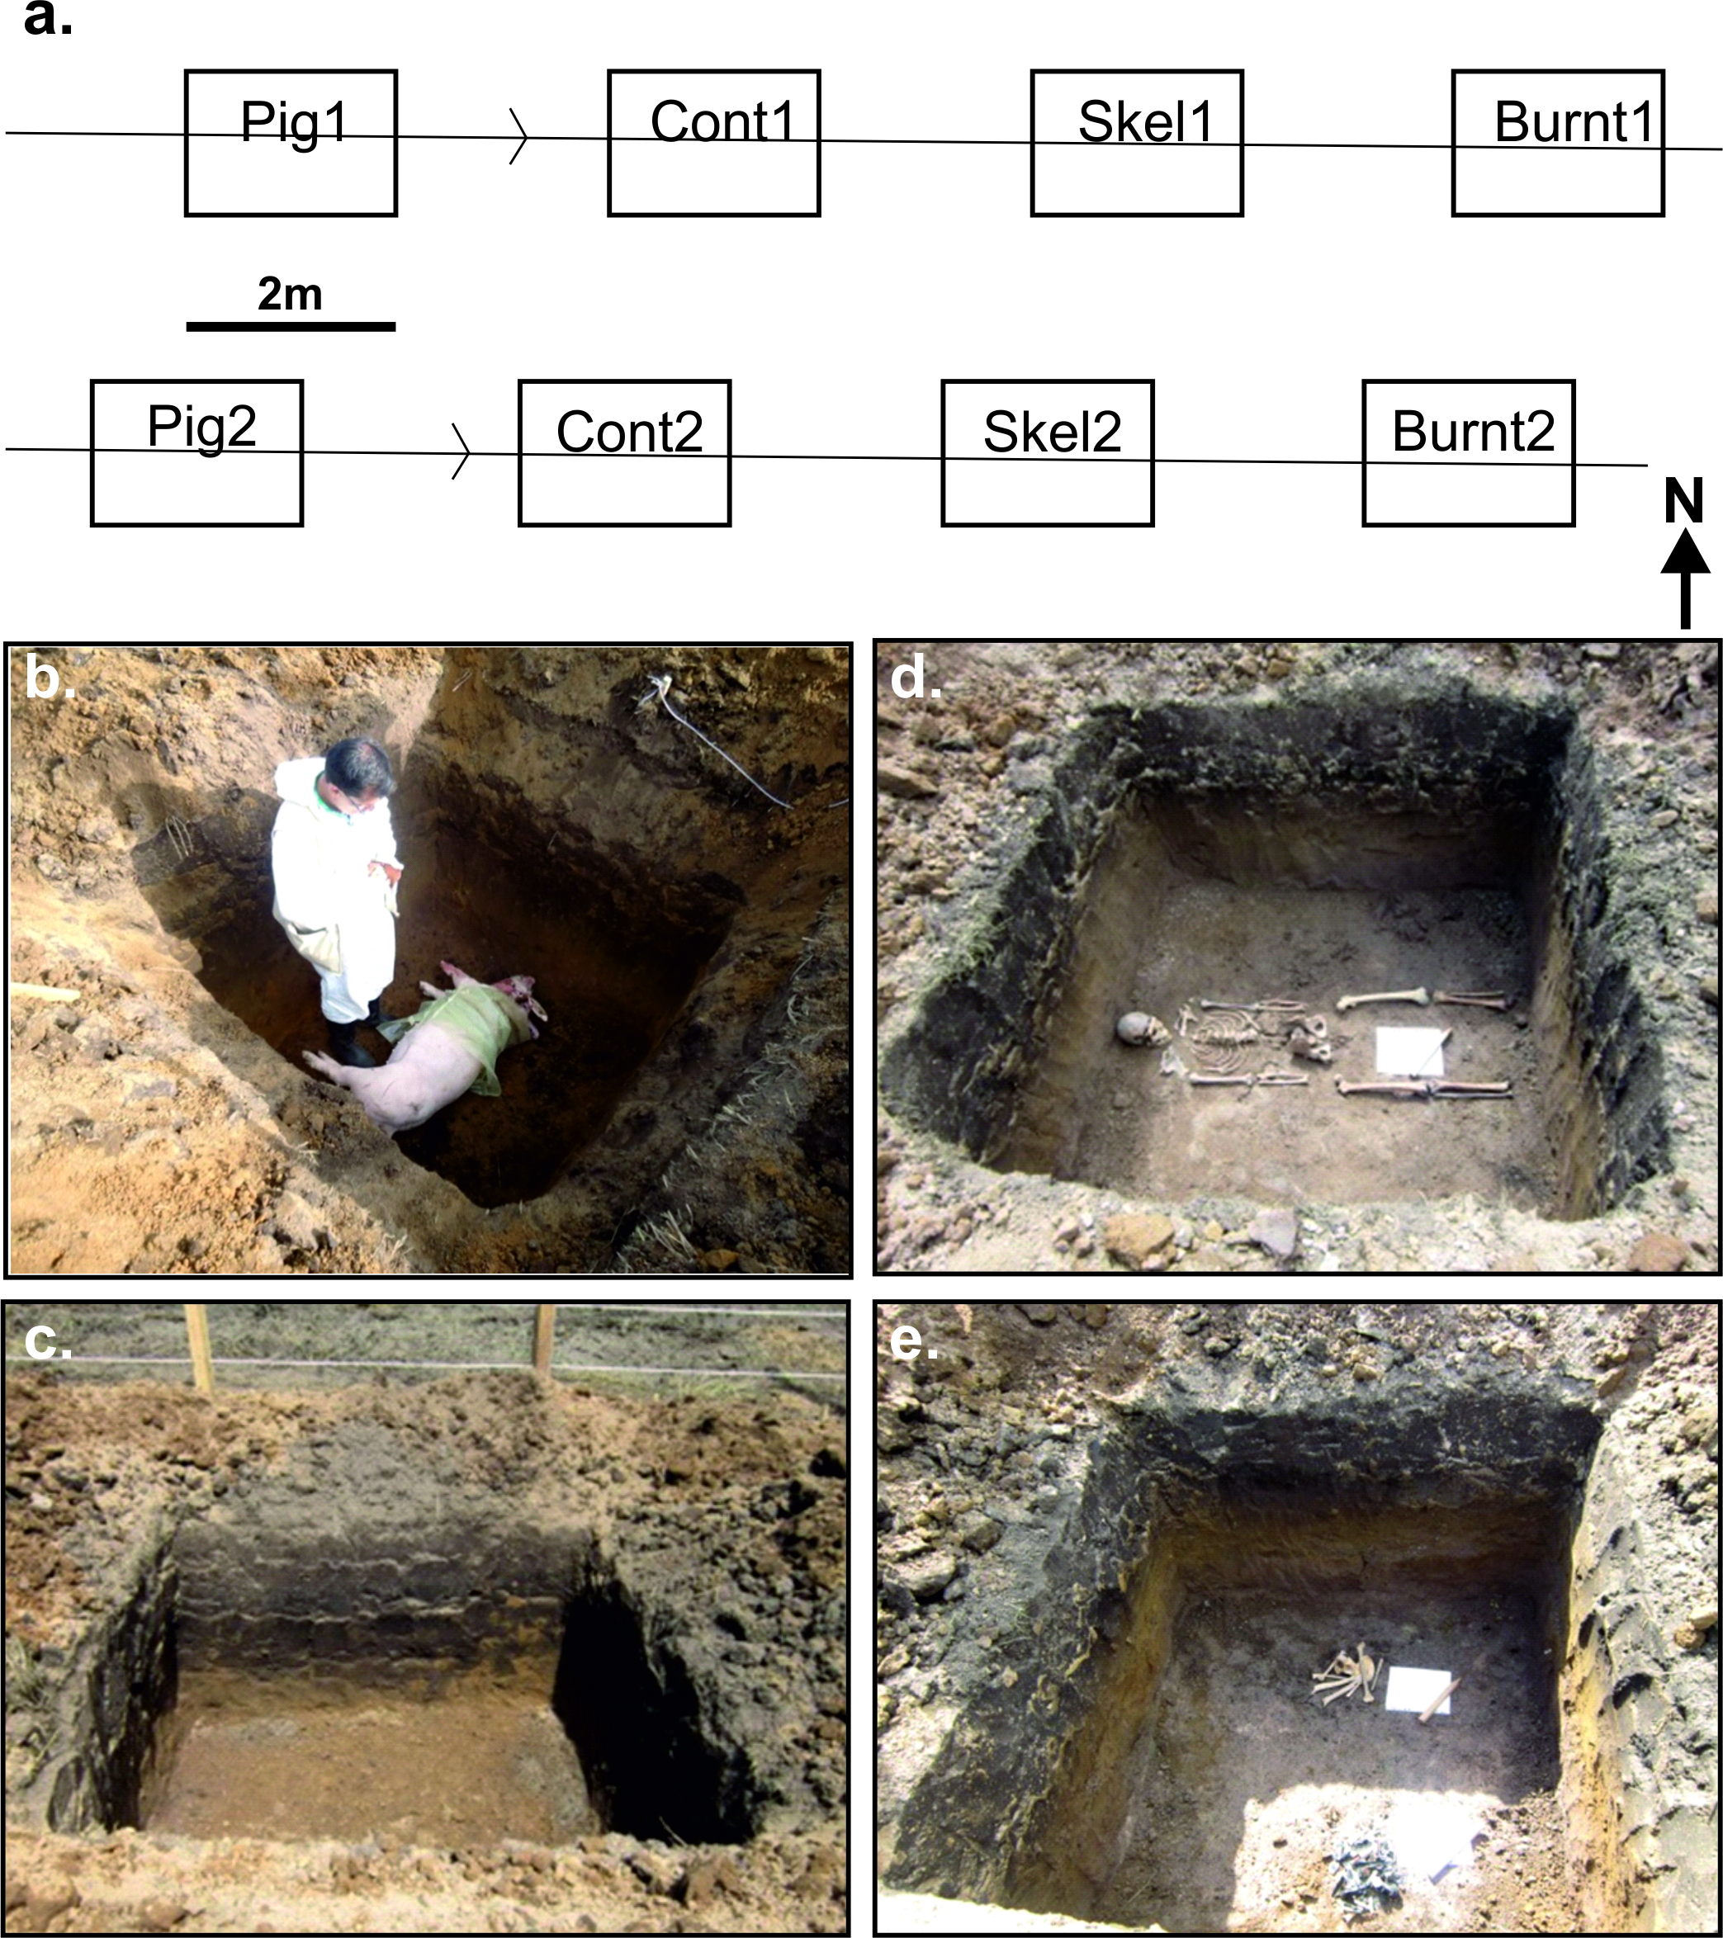
Fig. 2. (a) Plan-view of control test site showing positions of eight simulated clandestine graves (annotated) with top row depths 0.8 m and bottom row 1.2 m below ground level (bgl). (b) Simulated clandestine grave with ½ clothed domestic pig cadaver. (c) simulated clandestine empty grave for control. (d) Simulated historic clandestine grave with skeletonized human remains and bullet casings. (e) Simulated historic clandestine grave with beheaded and burnt skeletonized human remains. Modified from [57].
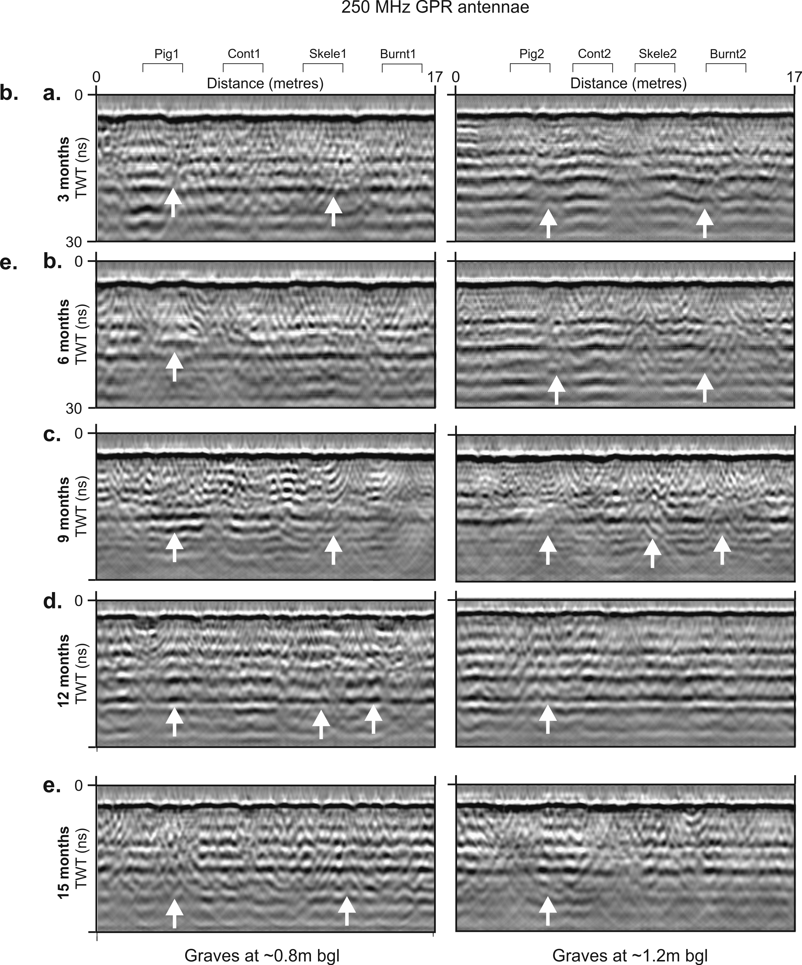
Fig. 3a. Sequential selected GPR 250 MHz 2D profiles taken over the simulated clandestine grave sites, showing; (a) 15 weeks, (b) 32 weeks, (c) 42 weeks, (d) 52 weeks, (e) 66 weeks post-burial respectively. Buried simulated named grave (see Table 1 for detail) positions, burial depths bgl and any resulting ½ hyperbolic reflection events (arrows) are marked (see text for details and Fig. 2a for location).
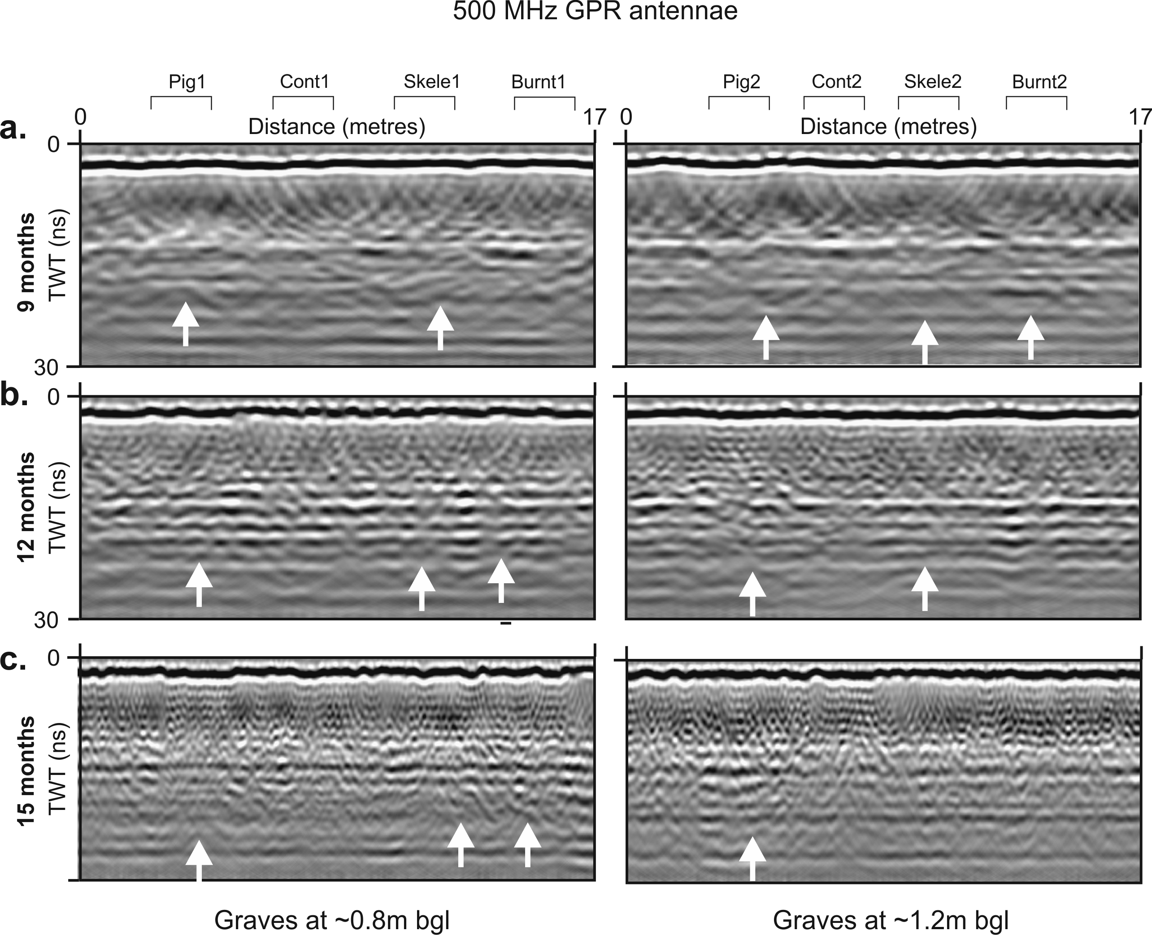
Fig. 3b. Sequential selected GPR 500 MHz time-slices taken over the simulated clandestine grave sites, showing; (a) 42 weeks, (b) 52 weeks, (c) 66 weeks post-burial respectively. Buried simulated named grave (see Table 1 for detail) positions, burial depths bgl and any resulting ½ hyperbolic reflection events (arrows) are marked (see text for details and Fig. 2a for location).
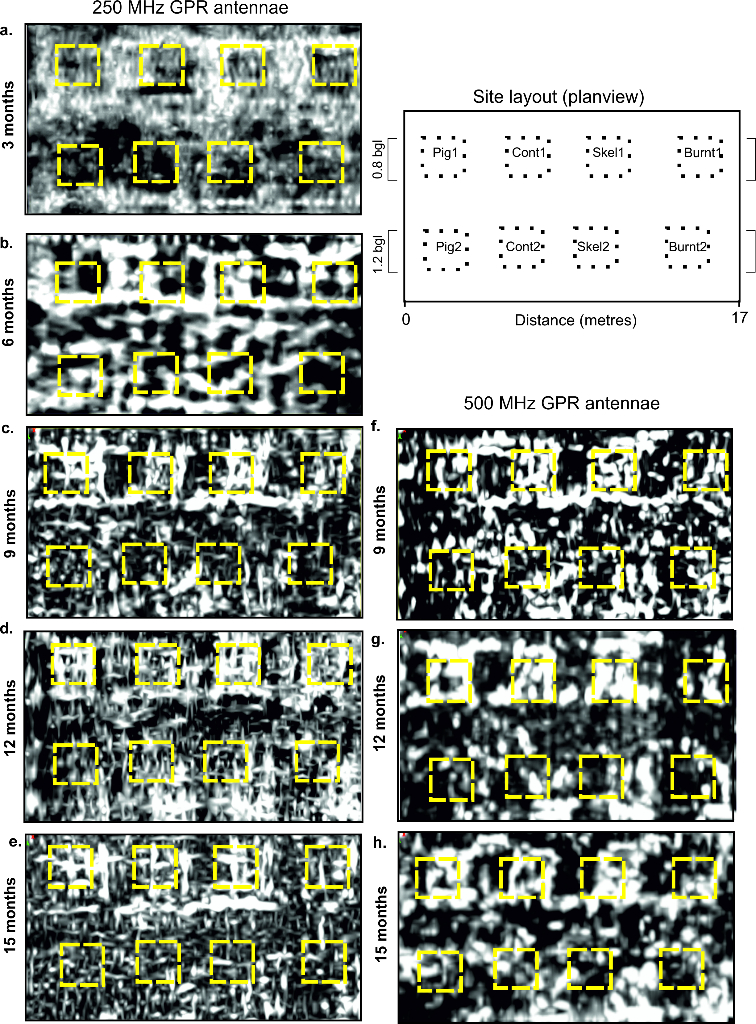
Fig. 4. Sequential GPR 2D horizontal time slice taken over the simulated clandestine grave sites, showing 225 MHz datasets for; a. 15 weeks, b. 32 weeks, c. 42 weeks, d. 52 weeks, e. 66 weeks and for 450 MHz datasets, f. 42 weeks, g. 52 weeks, h. 66 weeks post-burial respectively. Buried simulated named grave (see Table 1 for detail) positions and depths bgl shown (see text for details and Fig. 2a for location).
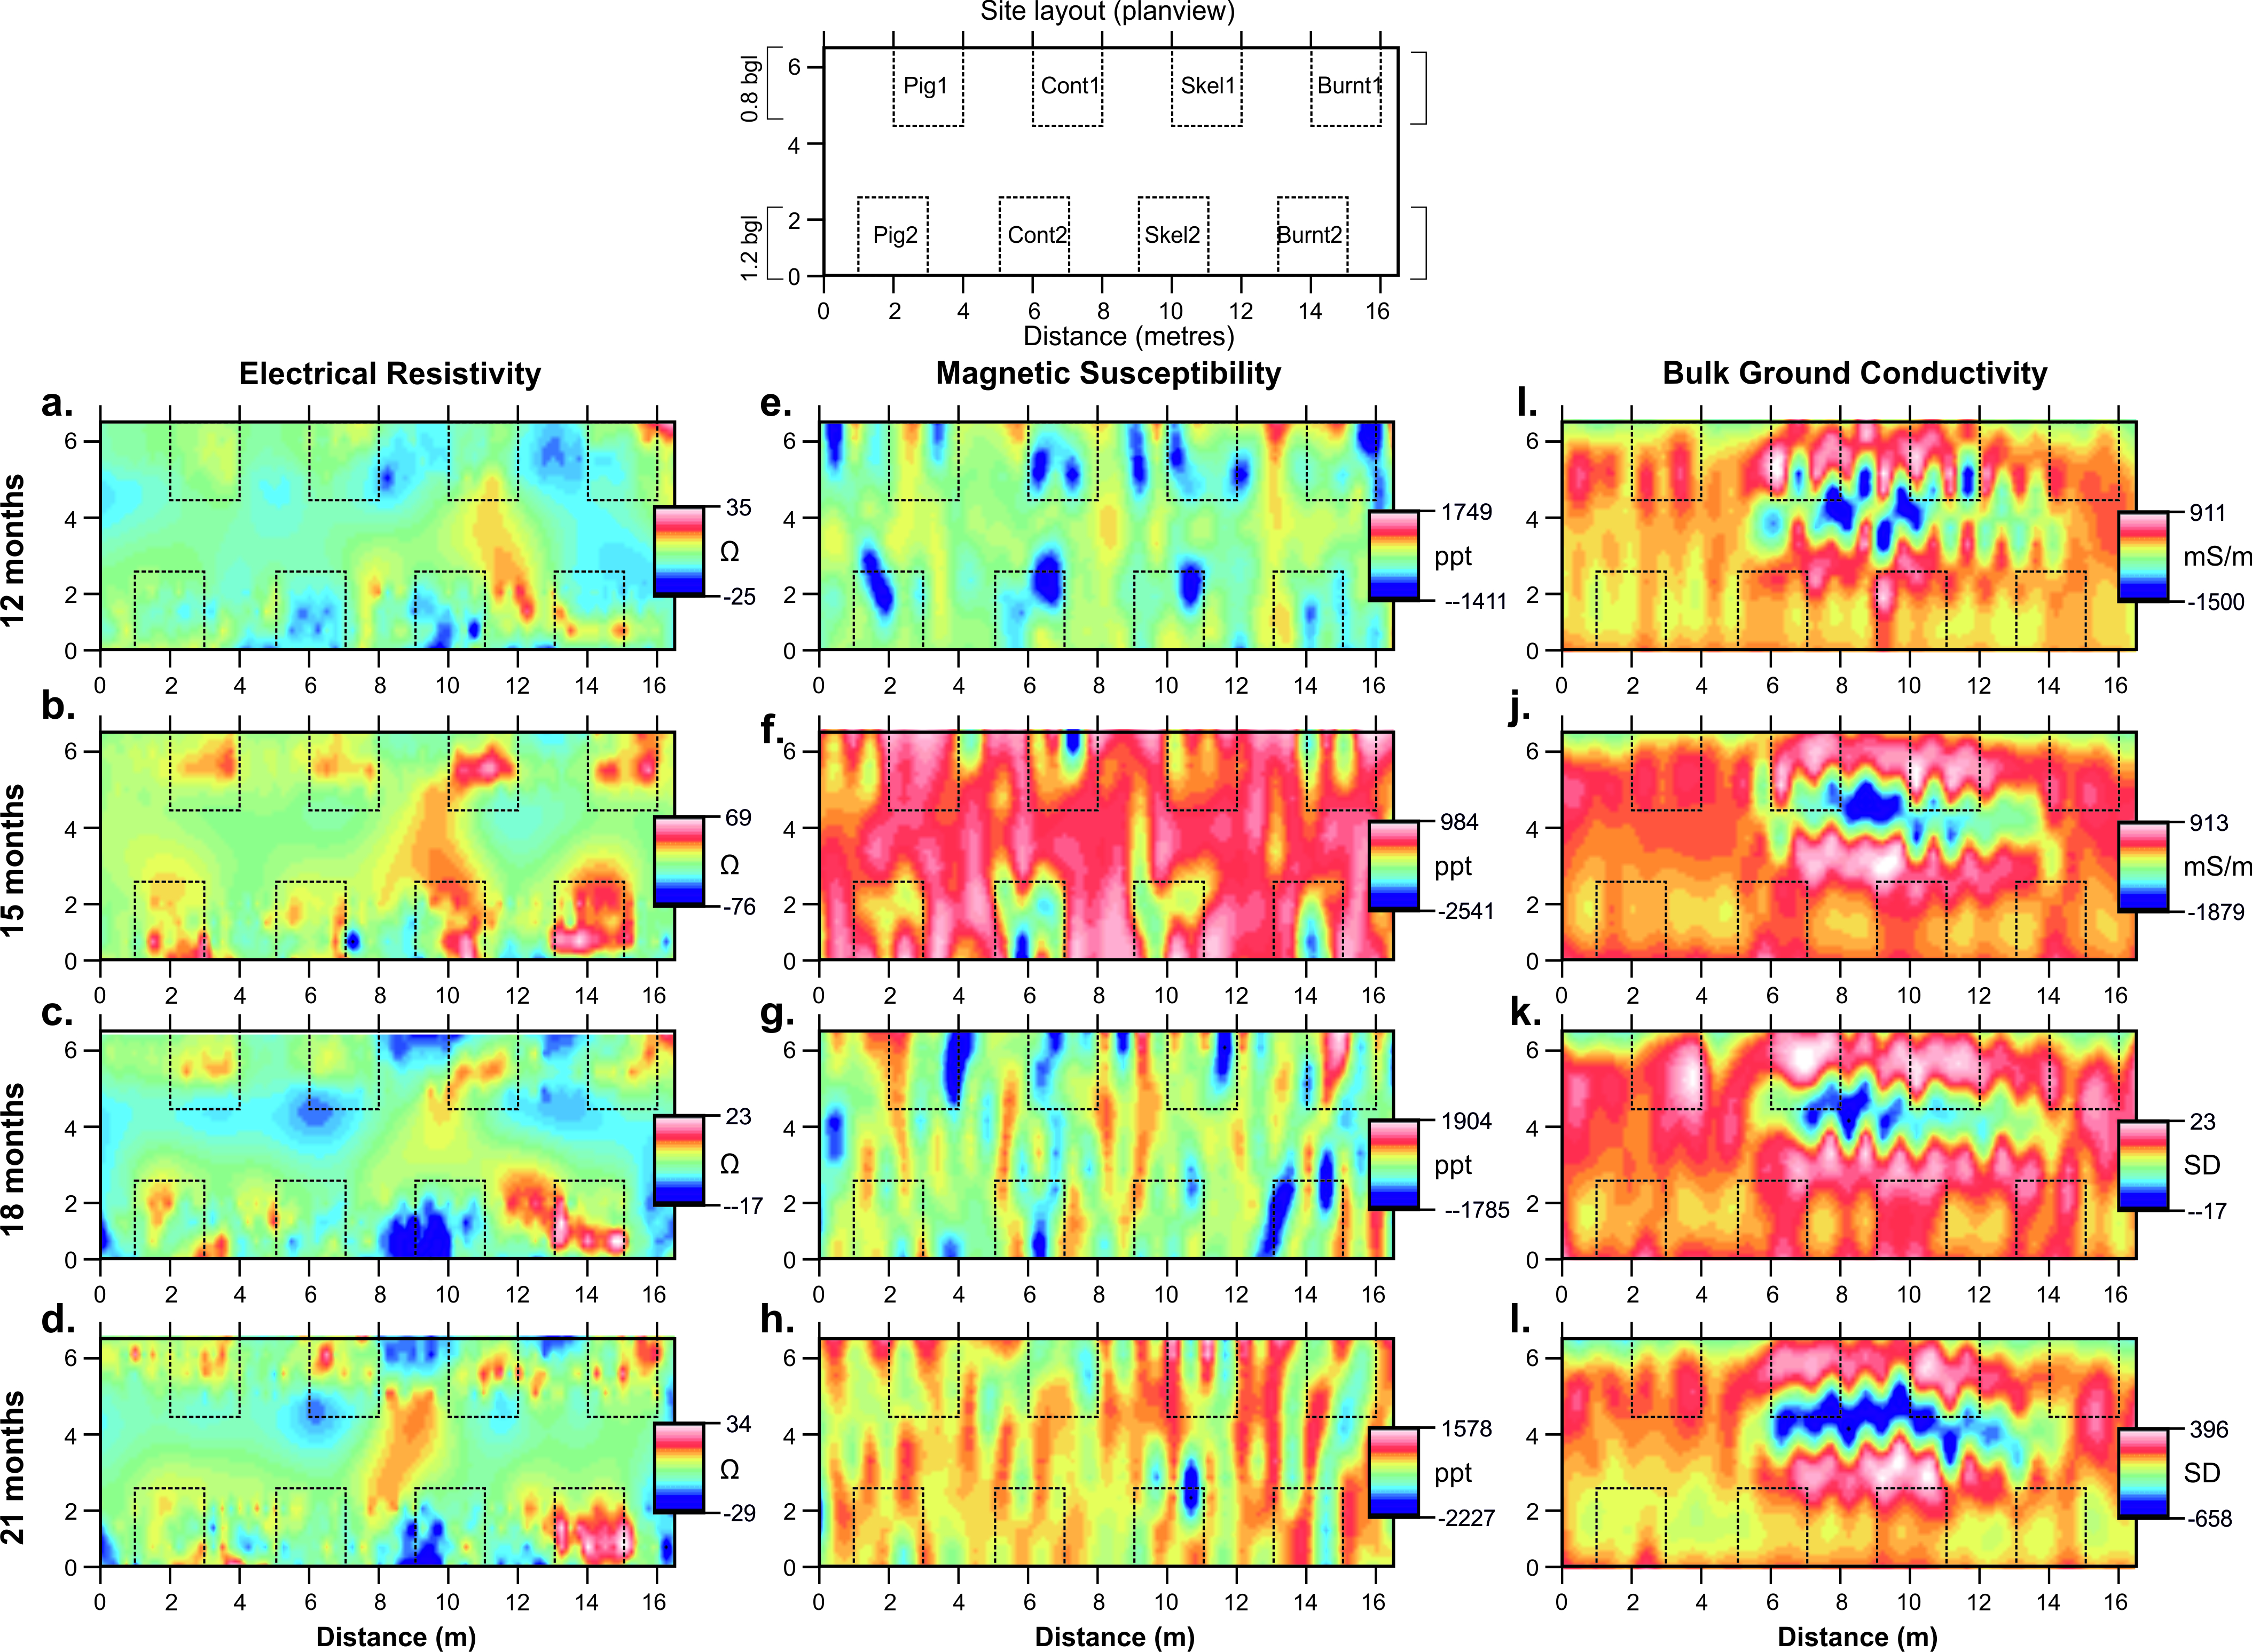
Fig. 5. Sequential electrical resistivity, magnetic susceptibility and bulk ground conductivity mapview datasets at: (a,e,l) 52 weeks, (b,f,j) 68 weeks, (c,g,k) 78 weeks, and (d,h,l) 90 weeks post-burial respectively. Buried simulated grave positions shown at top and dotted lines throughout (see text for details).

Fig. 6. Dataset boxplot (min/av./max.) measurements over the simulated clandestine grave sites, showing; (a) 52 weeks, (b) 55 weeks, (c) 59 weeks, (d). 63 weeks, (e) 68 weeks, (f) 78 weeks, (g) 82 weeks, (h)86 weeks, (i) 90 weeks and (j) 94 weeks post-burial respectively. Buried simulated grave positions shown at top and dotted line throughout (see text for details).
10. Tables

Grave no. | Dimensions | Contents | Description | Justification
A1/A2 | 2 m x 2 m x 0.8 m / 1.2 m | 70kg domestic pig carcass freshly dispatched | Bottom half wrapped in cloth | Represents ½ clothed common scenario
B1/B2 | 2 m x 2 m x 0.8 m / 1.2 m | None | Dug and re-filled | Acted as control
C1/C2 | 2 m x 2 m x 0.8 m / 1.2 m | Skeletonised human remains with 6 x 9mm & 4 x 38mm bullet casings | Skeleton placed in dorsal extended position | Common homicide scenario
D1/D2 | 2 m x 2 m x 0.8 m / 1.2 m | Beheaded skeletonised and burnt human remains | Bones laid out anatomically correct | Common homicide scenario

Table 1. Details of simulated clandestine graves emplaced at the test site with dimensions, contents and justifications all given. A1-D1 were emplaced ~0.8 m below ground level (bgl) and A2-D2 were emplaced at ~1.2 m bgl respectively (see Fig. 2 for location). Modified from [57].

Survey date | Survey day after burial* | Survey week after burial | Accumulated degree day (ADD) | Data acquired
26/09/2013 | 100 | 15 | 1,303 | 225MHz GPR
28/01/2014 | 224 | 32 | 3,002 | 225MHz GPR
08/04/2014 | 294 | 42 | 3,951 | 225/450MHz GPR
14/06/2014 | 351 | 52 | 4,662 | 225/450MHz GPR, Res, MS & cond
24/09/2014 | 463 | 66 | 6075 | Res, MS & Cond
16/12/2014 | 546 | 78 | 7135 | Res, MS & Cond
10/04/2015 | 661 |  | 8754 | Res, MS & Cond
Table 2. Summary of geophysical data presented in this study. *Burial date was 19th June 2013. Accumulated degree day calculated from average daily temperature information (see text for details) but note is not relevant for skeletonised remains as this are not in situ. Res = Electrical resistivity, MS =- Magnetic susceptibility and Cond = Bulk ground conductivity surveys respectively.

