The geology of the Blue Lagoon
Andrew Mitten, Basin Dynamics Research Group, Geography, Geology and the Environment, William Smith Building, Keele University, Keele, Staffordshire, ST5 5BG, UK. a.j.mitten@keele.ac.uk

Summary
The geology of the Blue Lagoon, Abereiddy Bay, South Wales, has been studied for over a hundred years, and is the type locality for the Abereiddian sub-stage of the Darriwilian (Ordovician), due to its outstanding fossil assemblages. Despite the work done on the Blue Lagoon, its geological significance has not yet been examined. The strata preserved at the Blue Lagoon is comprised of Avalonian volcanics and marine sedimentation. The following discusses: Avalonia’s paleogeography, the structure and stratigraphy of Abereiddy Bay and the global correlatable significance of the geology at the Blue Lagoon and Abereiddy Bay.

Main text
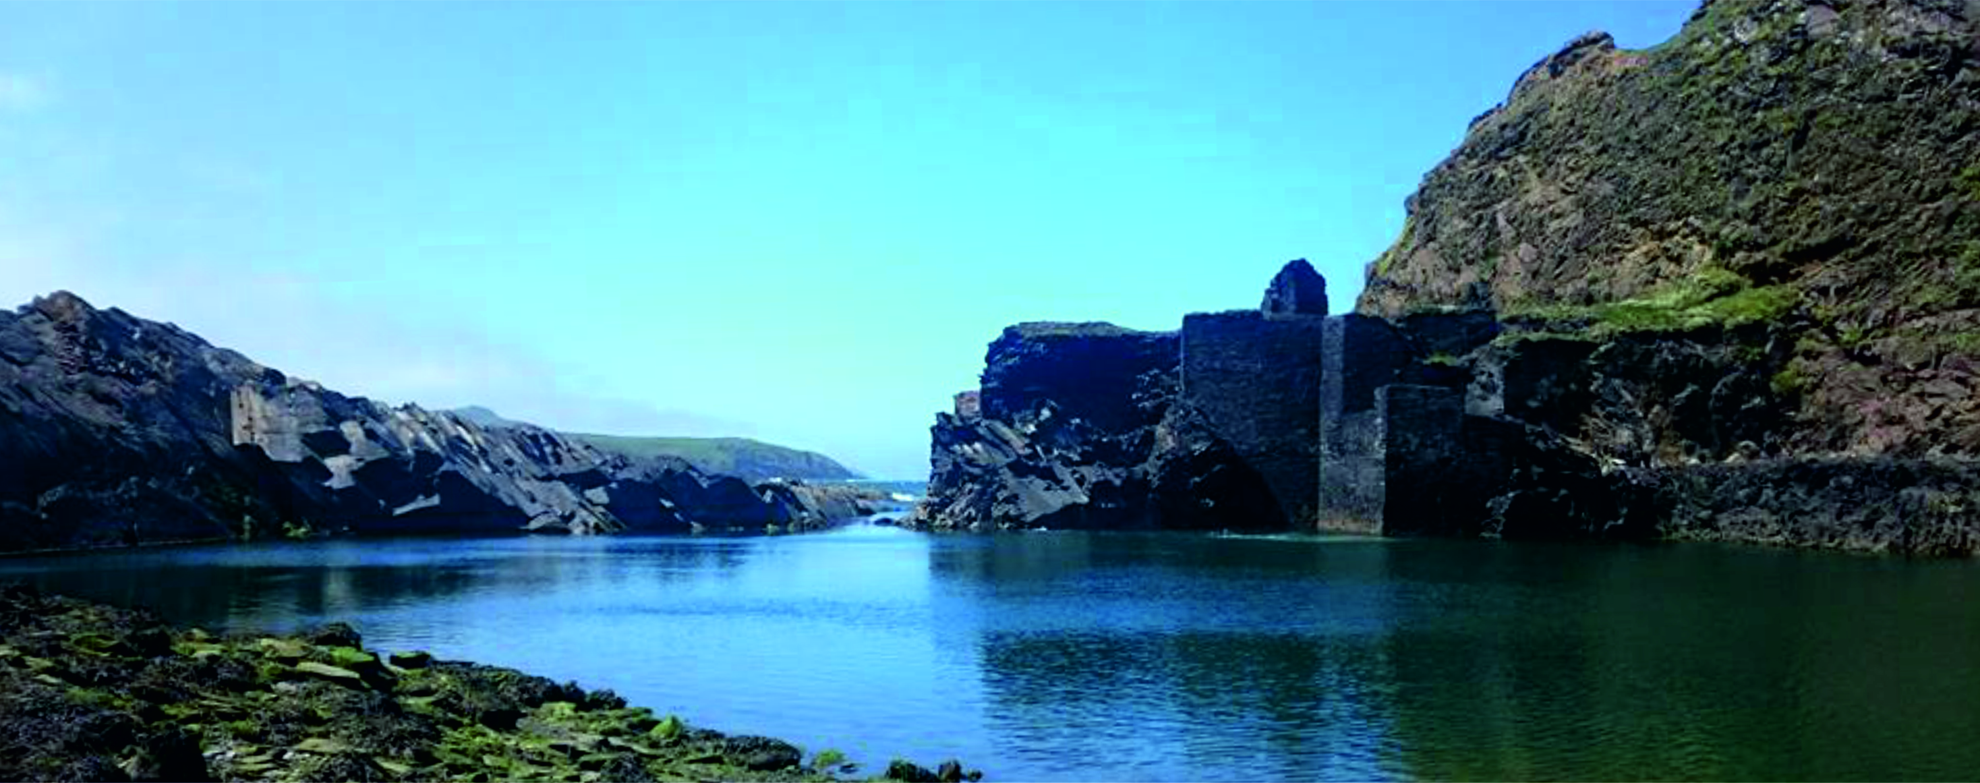
Figure 1 – Looking west into the ‘Blue Lagoon’. The buildings visible are part of disused slate quarry workings preserved by the National Trust.
The Blue Lagoon at Abereiddy Bay is a relict coastal slate quarry on the north coast of Pembrokeshire, South Wales. The bay has become a popular tourist destination for surfing, kayaking and coasteering. The quarry itself is now a SSSI (site of special scientific interest) for its fossil assemblages and is a National Trust Site for its industrial ancestry (Fig. 1). The geology of the Blue Lagoon is of stratigraphical importance as the site is the type locality for the Abereiddian sub-stage of the Lower Darriwilian, upper Middle Ordovician (467.3±1.1 to 458.4±0.9 Ma). The area was first examined for its paleontological and petrographic significance by Cox (1915), who examined the Ordovician strata from Abereiddy to Abercastle along the North coast of St. David’s Head. Later, Waltham (1971) developed a stratigraphical and structural interpretation from such work combined with his own field work.
During the Early Palaeozoic the geology of the Welsh Basin was heavily affected by the separation of Avalonia from Gondwana, this began during the Cambrian Period, evidence of which can be seen in the formation of the Welsh Basin and the subsidence of the Midland Platform. Further evidence can be seen in the onset of the Tremadocian arc volcanics, as Avalonia finally separated from Gondwana and the Rheic Ocean opened. Avalonia migrated north towards Laurentia by marginal subduction. During the middle Upper Ordovician Avalonia was approaching the supercontinent of Baltica and the Torquist Sea. Amalgamation of the two continents resulted from a collision at the end of the Ordovician, this new larger continent then moved west toward Laurentia. Avalonia and Baltica’s accretion created Laurussia in the middle Silurian to the Middle Devonian during the Caladonian Orogeny.

Regional metamorphism of the Welsh Basin and the St. David’s Head area
The end Ordovician to Wenlockian regional metamorphism in the area is attributed to the paratectonic Caledonides that are seen throughout the British Isles; these same orogenic processes produced the East to West trending folding seen within the area. The tectonostratigraphic terrane of the St. David’s Head area is comprised of the following photoliths: basic volcanics, dolerite and marine sedimentation (Darriwillian to middle Katian); producing progradational prehnite-pumpellyite to greenschist facies metamorphism by sedimentary burial.

The geology of St. David’s Head
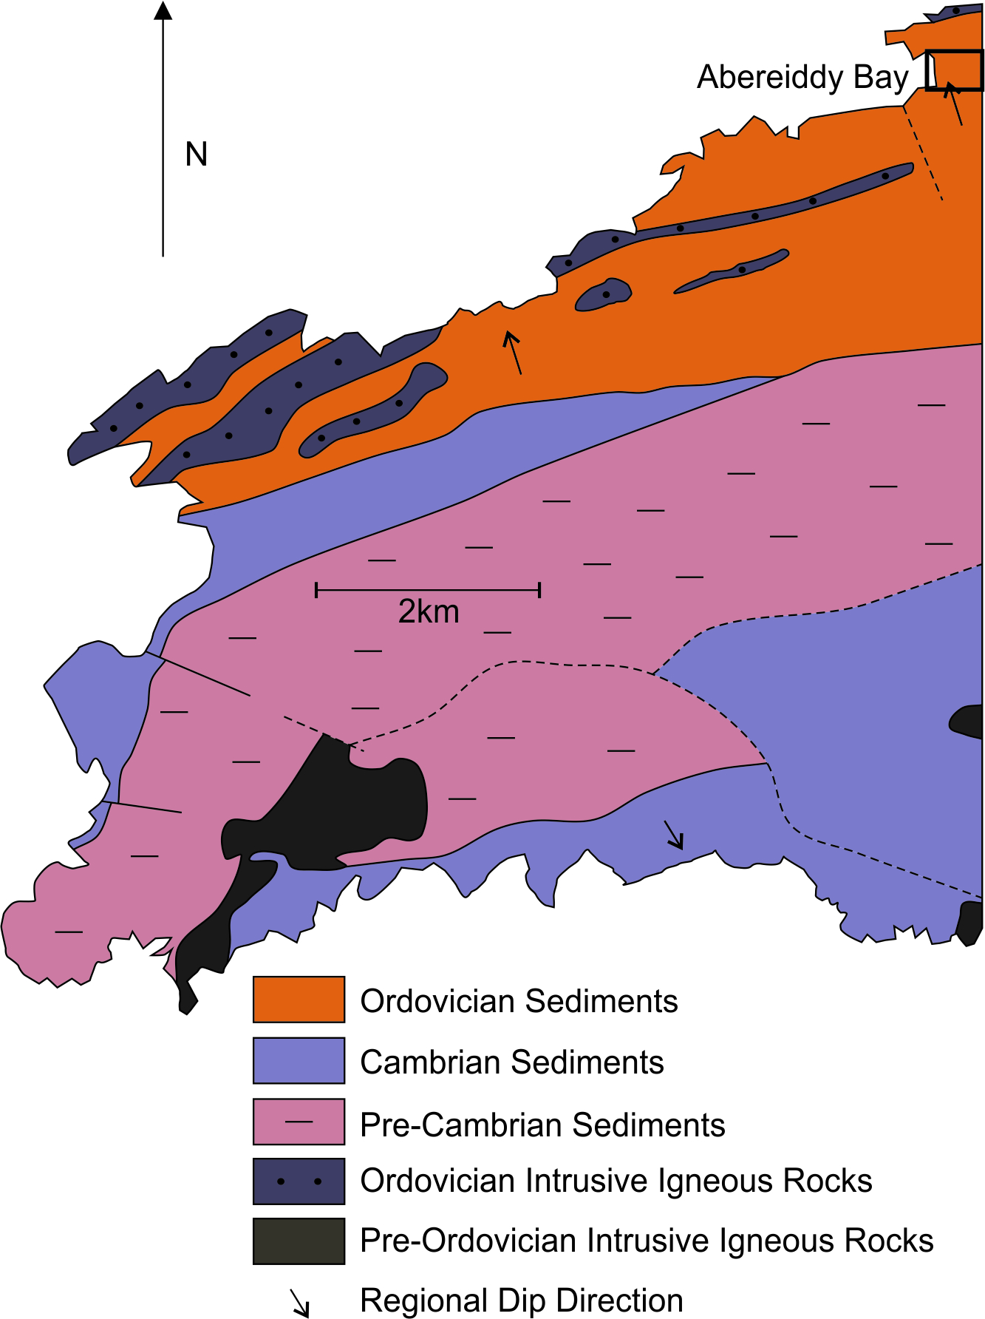
Figure 2 – The geological map of St. David’s Head.
Arc related volcanism ended during the late Tremadocian (c.480Ma). Following this, during the early Floian (477.7 Ma) there was a large transgression which created an unconformity marking the megasequence boundary of the Gwynedd Super Group. Post transgressional back arc volcanism peaked during the late Darriwilian and Upper Ordovician. These Darriwilian volcanics are best preserved in north Pembrokeshire, and are attributed to Avalonia’s northward migration. In the Welsh Basin these volcanics are interbedded with marine sediments, with the end of volcanic activity marked by the deposition of welded tuffs and thick rhyolite lavas, known as the Goodwick Volcanic Formation; volcanic debris is reworked in debris flows and turbidites along with tufficeous sedimentation. This succession is also contaminated by siltstone and mudstone background sedimentation as the sequence becomes more distal (Fig. 2).

The structure of Abbereiddy Bay
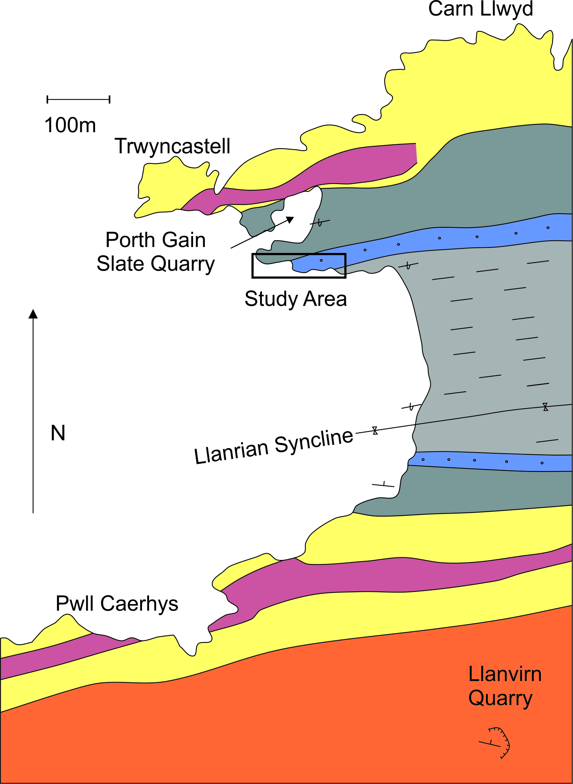
Figure 3 – A geological sketch map of Abereiddy Bay, (the formation colours correspond to the GVS in figure 4, for the maps location see figure 2.
The predominant structure at Abbereiddy Bay is the Llanrian Syncline, with an east-west trending axis, this syncline can be traced from Gorth Gain to St. David’s. The northern limb of this fold is overturned with cleavage having a steeper dip angle than that of bedding. Beds consistently dip at high angles ranging from 60⁰ to 85⁰, with shallower dipping axial planar cleavage dipping 5⁰ less than bedding north of the axial trace, and shallowing by up to 12⁰ to 14⁰ less than bedding moving to the north. The structure of Abereiddy Bay is argued by various authors.
There are currently two major theories with regards to synclinal magnitude and faulting. The first model was developed by Waltham (1971), who suggested that the syncline was of high amplitude and that there was such a structural hiatus on the northern limb (as stated above). Such a hiatus removes the top of the Caerhys Shale Formation and the base of the Castell Limestone Formation.
Alternatively, the Rickards (1973) model suggests that the magnitude of the syncline is much lower than previously suggested. This model also suggests that the southern limb of the fold is faulted and that the syncline axis should be placed within this faulted zone rather than in the centre of the bay. This debate may never be resolved as the centre of the bay (where the Waltham model places the synclines’ axial trace) is covered by dense alluvium.

The Stratigraphy of Abbereiddy Bay
The Abereiddian deposition starts with c. 180m of Didymograptus bifidus Shale, which is interrupted by the Llanrian Volcanics (c. 90m), during the middle Lower Llanvirnian (Fig. 4). The remaining Llanvirnian succession is conformable. The Didymograptus (D.) bifidus Shale is topped by the D. murchisoni Ash, which is overlain by the D. murchisoni Shale (Fig. 5) (c. 2m - 43m). The top of the D. murchisoni Shale represents the Llanvirnian / Llandeilan boundary. This boundary marks the discordantly unconformable deposition of the Castell Limestone Formation and the Dicranograptus Shale. Through the remainder of the succession (through into the Sandbian) there is only the uniform deposition of the Dicranograptus Shale (c. 120m). Such fossil assemblages found within the bay provide strong biostratigraphical markers to date the formations accurately. Accurate dating of formations can provide basinal or even global correlation, aiding a larger scale palaeogeographical interpretation.
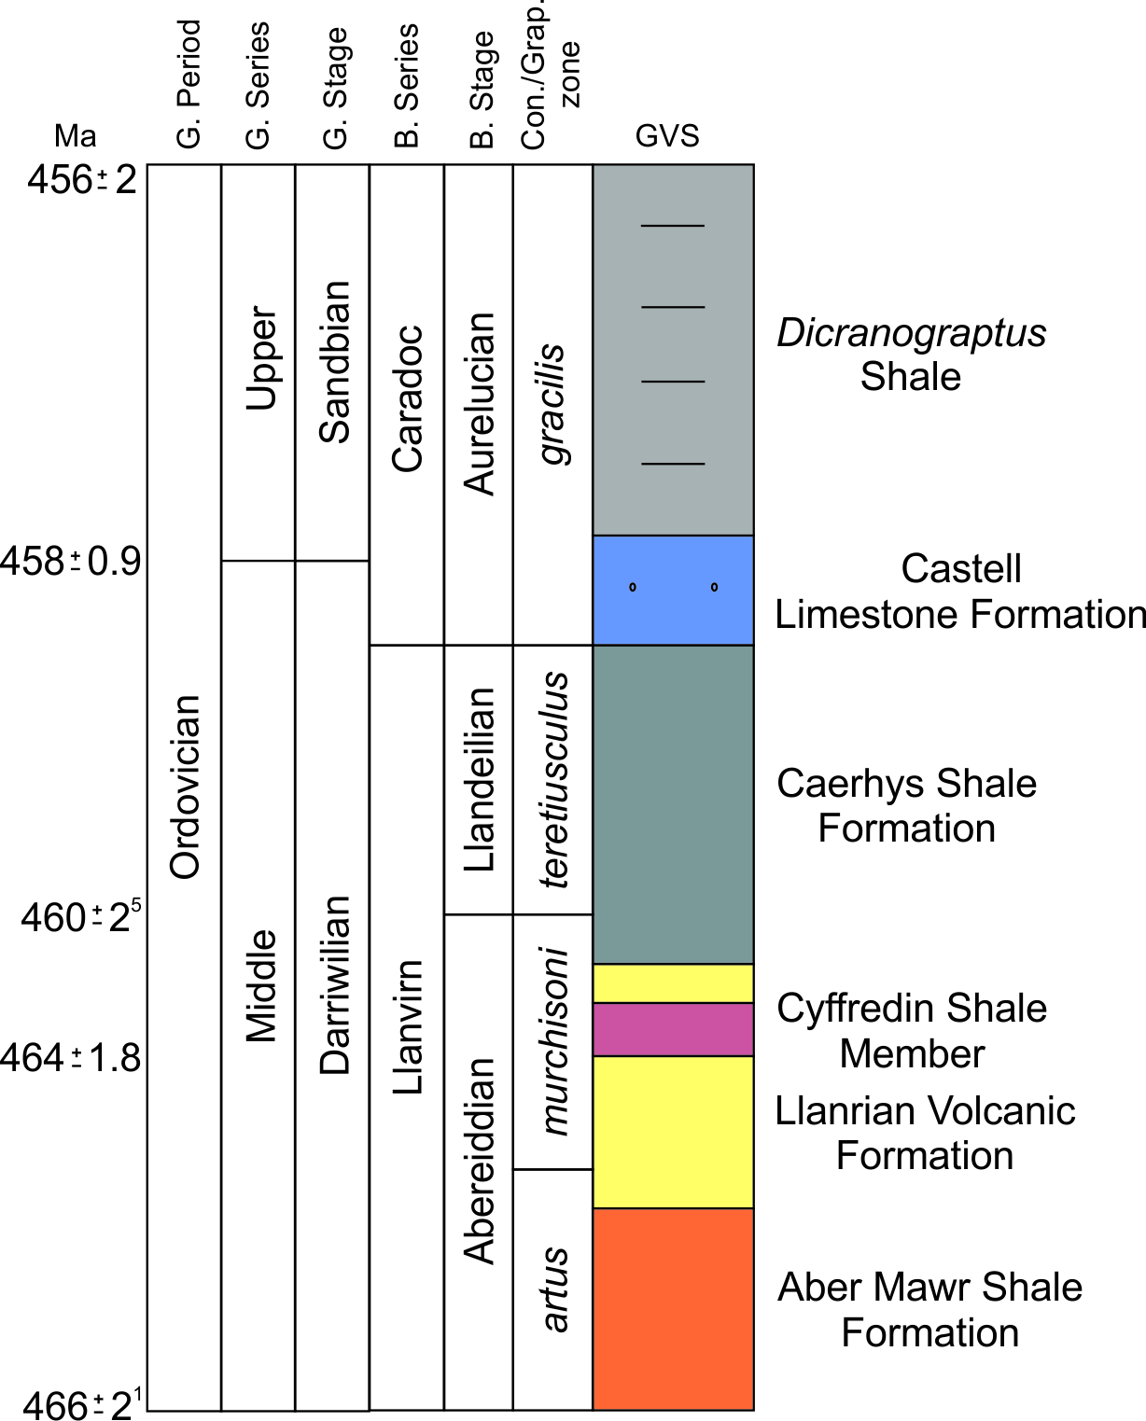
Figure 4 – The generalised vertical section and bio- chemo- lithostratigraphy for Abereiddy Bay. The formation colours correspond to those in figure 3. G. – Global; B. – British; Con. Conodont; Grap. – Graptolite
Moving south from the centre of the syncline, the Didymograptus murchisoni Ash (c. 60m) is spilt into two sequences. The lower sequence is c. 52m and the upper c. 8m thick. The lower sequence is comprised of a lapilli tuff at the base which is poorly sorted and crudely normally graded with no distinguishable bedding. Moving upwards through the sequence the succession’s tuffaceous bedding becomes more well-defined and thins upwards. The upper sequence is marked by a lapilli tuff at its base and thinly bedded coarse and lapilli tuffs. This is overlain by turbiditic tuffs, containing mudstone intraclasts and mass flows. Finally, the southern limb of the syncline yields a c. 2m thick black bed of typical D. muchisoni shale.
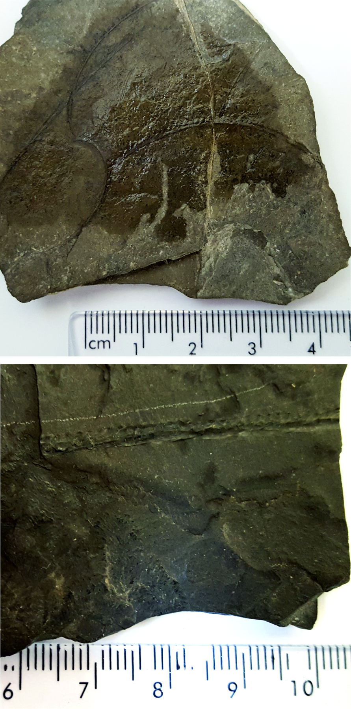
Figure 5 – (Top) Graptolite Didymograptus murchisoni of the Caerhys Shale Formation (international biozone for the upper Abereiddian); (Base) Graptolite Didymograptus bifidus (British biozone for the lower Abereiddian); both found at Abereiddy Bay.
Moving north from the syncline axis (into overturned stratigraphy), the sequence begins with 12m bedded succession of the Castell Limestone Formation. Within this succession there are sparse abundances of trilobites. The Castell Limestone Formation consists of brecciated limestone and moderately calcareous shale interbeds (Fig. 6). These were previously uninterrupted until recently, when a depositional model for the formation was developed. This limestone sequence has been interpreted to be a mass flow system of material shedding from a carbonate factory into the more distal portion of the basin.
Figure 6 – (Top) Brecciated limestone of the Castell Limestone Formation; (Base) Laminated mudstones of the Castell Limestone Formation; note – each image is 10cm wide.
Unconformably underlying the Castell Limestone Formation, is the graptolite rich (D. murchisoni) Caerhys Shale Formation. The succession has a series of thin tuffs interbedding the major mudstone lithology; the Caerhys Shales are the equivalent of the Hendre Shales of Carmarthen which are described by Williams et al., (2003) as "anoxic graptolite bearing mudstones".

Geochemical significance of the Darriwilian
There is a general decrease in the ⁸⁷Sr/⁸⁶Sr ratio during the Ordovician, with values decreasing from ~0.7090 (the Late Cambrian maximum) to 0.7078. The Late Cambrian maximum has been attributed to the uplift of the Pan African orogenesis during the Cambrian Period. This trend through the Ordovician is due to the decreasing supply of radiogenic strontium from such an orogenic belt. There is a rapid decrease within the isotopic ratio at the Darriwilian/Sandbian boundary, making areas such as Abereiddy Bay very important for stratigraphic correlation. This drop can be attributed to three factors: 1, decreasing weathering rates of continental material (the major factor influencing the overall Ordovician trend); 2, a major transgression; 3, the erosion of juvenile volcanic rock associated with the extensive volcanism during Avalonia’s marginal subduction.
Several strong positive excursions exist in the δ¹³C data for the Ordovician, during the Darriwilian and early Sandbian there is a strong, correlatable excursion known as the Middle Darriwilian Isotopic Carbon Excursion (MDICE). The MDICE has been discovered across various paleocontinental terranes, making it a globally correlatable, chemostratigraphical tool. The cause of the MDICE is unknown, however, Ainsaar et al. (2007) suggested that it may be due to a transgressive event drowning carbonate platforms. This interpretation seems more than plausible as there is a known massive transgression that concludes at a similar time to the end of the MDICE.

Suggestions for Further Reading
Black, W. W., Bulman, O. M. B., Hey, R. W. & Hughes, C. P., 1971. Ordovician Stratigraphy of Abereiddy Bay, Pembrokeshire. Geological Magazine, v.108, pp. 546-548.
Brenchley, P. J., Rushton, A. W. A., Howells, M. & Cave, R., 2006. Cambrian and Ordovician: the early Paleozoic tectonostratigraphic evolution of the Welsh Basin, Midland and Monian Terranes of Eastern Avalonia. In: The Geology of England and Wales. London: The Geological Society, pp. 25-74.
Cox, A., 1915. The geology of the district between Abereiddy and Abercastle (Pembrokeshire). Quaterly Journal of the Geological Society, London, v.71, pp. 273.
Fortey, R. A. & Rushton, A. W. A., 2000. A revised correlation of Ordovician rocks in the British Isles, London: Geological Society of London, pp.18.
Howells, M., 2007. British Regional Geology: Wales. Nottingham: British Geological Survey.
Rushton, A. W. A., Owen, A. W. & Owens, R. M. a. P. J. K., 2000. British Cambrian to Ordovician Stratigraphy. Peterborough: Joint Nature Conservation Committee.
Waltham, A., 1971. A note on the structure and succession At Abereiddy Bay, Pembrokeshire. Geological Magazine, v.108, pp. 49-52.
Williams, M., Davies, J. R., Waters, R. A. & Rushton, A. W. A., Wilby, P. R., 2003. Stratigraphic and palaeoecological importance of Caradoc (Upper Ordovician) graptolites from the Cardigan area, southwest Wales. Geological Magazine, v.140, pp. 549-71.
Woodcock, N., 2012. Ordovician Volcanism and Sedimentation on Eastern Avalonia. In: Geological History of Britain and Ireland, John Wiley and Sons, pp. 162-176.
Wookcock, N. H., 1990. Sequence Stratigraphy of the Welsh Basin. Journal of the Geological Society, London, v.147, pp. 537-547.

