The sedimentology of an ephemeral fluvial–aeolian succession

Charlotte L. Priddy* & Stuart M. Clarke
Basin Dynamics Research Group, School of Geography, Geology and the Environment, Keele University, Keele, Staffordshire, ST5 5BG, UK (*E-mail: c.priddy@keele.ac.uk)

Associate Editor – Christopher Fielding
Short Title – Ephemeral fluvial–aeolian systems

ABSTRACT
Ephemeral fluvial systems are commonly associated with arid to semi-arid climates. Although their complex sedimentology and depositional settings have been described in much detail, depositional models depicting detailed lateral and vertical relationships, and interactions with coeval depositional environments, are lacking compared to well-recognized meandering and braided fluvial systems. This study critically evaluates the applicability of current models for ephemeral fluvial systems to an ancient arid fluvial example of the Lower Jurassic Kayenta Formation of the Colorado Plateau, USA. The study employs detailed sedimentary logging, palaeocurrent analysis and photogrammetric panels across the regional extent of the Kayenta. A generic model that accounts for the detailed sedimentology of a sandy arid ephemeral fluvial system (drawing upon both ancient and geomorphological studies) is developed, along with analysis of the spatial and temporal interactions with the aeolian setting. Results show that the ephemeral system is dominated by laterally and vertically amalgamated, poorly channelized to sheet-like elements, with abundant upper flow regime flat beds and high sediment load structures formed between periods of lower flow regime conditions. Through interaction with a coeval aeolian system, most of the fluvial deposits are dominated by sand-grade sediment, unlike many modern ephemeral fluvial systems that contain a high proportion of conglomeratic and/or finer grained mudstone and siltstone deposits. During dominantly fluvial deposition, high width to thickness ratios are observed for channelized and sheet-like elements. However, with increasing aridity, the aeolian environment becomes dominant and fluvial deposition is restricted to interdune corridors, resulting in lower width to thickness ratio channels dominated by flash-flood and debris-flow facies. The data presented here, coupled with modern examples of ephemeral systems and flood regimes, suggest that ephemeral flow produces and preserves distinctive sedimentological traits that can not only be recognized in outcrops, but also within core.
Keywords: Aeolian, depositional models, ephemeral fluvial, flash-flood, fluvial architecture, Kayenta Formation

INTRODUCTION
Many arid continental basins comprise a sedimentary fill that records the activity of both fluvial and aeolian environments. The preserved deposits from each individual environment have been studied in great depth, along with the sedimentary interactions between the deposits of coeval depositional systems (e.g. Langford, 1989; Langford & Chan, 1989; Herries, 1993; Veiga et al., 2002; Al-Masrahy & Mountney, 2015; Reis et al., 2019; Formolo Ferronatto et al., 2019). In many cases, these relationships can be related to a cyclo-stratigraphical framework based upon a climatic control (Howell & Mountney, 1997; Mountney & Jagger, 2004; Hassan et al., 2018; Soares et al., 2018; Xu et al., 2019).
The fluvial components of arid continental basins may be either ephemeral or perennial in nature, and can be influenced strongly by climate (Mather, 2007; Hooke, 2016) amongst a number of other factors. Depositional facies models have long been used to aid our understanding of these sedimentary systems and processes by combining data from both ancient and modern systems (Reading, 1978, Walker, 1979; 1984). Recent advancements have focused on quantifying such models in terms of statistics pertaining to physical dimensions and distributions of elements they contain, and therefore the distribution of sediments and sediment properties, at multiple scales (Colombera et al., 2013; Colombera & Mountney, 2019), to provide valuable data for subsurface prediction (Walker, 1984; 2006).
However, despite detailed studies of ephemeral fluvial systems from within the rock record (e.g. Bromley,1991; North & Taylor,1996; Gulliford et al., 2014; Bachmann & Wang, 2014; Lowe & Arnott, 2016; Bartz et al., 2017; Horn et al., 2018) and from present-day settings (e.g. Thomas et al., 1997; Tooth, 2005; 2013; Sutfin et al., 2014; Goudie & Viles, 2015; Jaeger et al., 2017; Billi et al., 2018; Carling & Leclair, 2019; Lima & Lupinacci, 2019; Colombera & Mountney, 2019), detailed three-dimensional facies models for ephemeral systems are appreciably fewer in number and are less developed compared to those of their meandering and braided fluvial counterparts. In particular, comparatively fewer models depict detailed lateral and vertical variations in architectural elements and the nature of interactions with sediments of competing and coeval dispositional systems compared to models for other fluvial settings.
This study critically evaluates the applicability of current sedimentary models for ephemeral fluvial systems to an ancient dryland fluvial example, and demonstrates the impact of aeolian interactions upon sedimentary architecture of the preserved deposits. The Lower Jurassic Kayenta Formation of the Colorado Plateau, USA, (Fig. 1), is used as a field case study, because it comprises the preserved deposits of an ephemeral fluvial system with minor perennial influxes and interactions with deposits of an aeolian system. Comparisons can be drawn with modern dryland systems [for example, the Luni River (Carling & Leclair, 2019)], ancient systems [for example, the Tacuarembó Formation (Amarante et al., 2019)] and the Kayenta can be considered analogous to several North Sea reservoirs [for example, the Leman Sandstone (Glennie & Provan, 1990)]. Consequently, the study has the potential to illustrate generic concepts in the understanding of ephemeral fluvio–aeolian systems. To that end, the work will: (i) document in detail the sedimentary architecture of the ephemeral fluvial–aeolian Kayenta Formation, from its proximal setting in south-eastern Utah to its distal setting in north-western Arizona; (ii) describe the characteristic spatial interactions between the ephemeral-fluvial and aeolian deposits at multiple scales; (iii) develop a generic facies model that illustrates the detailed sedimentology of an ephemeral fluvial system (drawing upon both ancient and geomorphological studies), along with the spatial and temporal interactions with aeolian settings; and (iv) compare the detailed sedimentology of the Kayenta to core from the Leman Sandstone of the Southern North Sea Gas Basin to illustrate generic applicability of the developed model.
BACKGROUND
Ephemeral fluvial systems are commonly associated with arid to semi-arid climates (Tunbridge, 1981; 1984; Billi et al., 2018; Colombera & Mountney, 2019), are characterized typically by seasonal to strongly intermittent discharge (Tunbridge, 1984; Horn et al., 2018; Billi et al., 2018), and are highly dependent on climatic and seasonal variations in rainfall (Mather, 2007; Hooke, 2016; Billi et al., 2018). Their large-scale architecture typically comprises unconfined sheets and low-sinuosity channels (Williams, 1971; Tunbridge, 1984; Tooth, 2000; Al-Masrahy & Mountney, 2015) with large width to depth ratios (Billi et al., 2018), that decrease in size and discharge downstream, as substantial water is lost due to evapotranspiration and infiltration into the dry, sandy substrate (Lane et al., 1971; Picard & High, 1973; Tunbridge; 1984, Sutfin et al., 2014). Most sandy ephemeral fluvial systems are endorheic and terminate within muddy flood plains or ephemeral lakes (Tunbridge, 1981; Tunbridge, 1984) in the centres of continental basins, in a similar way to distributive fluvial systems (Weissmann et al., 2010; Gulliford et al., 2014; Reis et al., 2019) or terminal fluvial fans (Cain & Mountney, 2009).
Deposition in ephemeral systems is dominated by unconfined sheet-like flows and large, single, flood-driven ‘scour and fill’ sedimentation, as large volumes of sediment are deposited in short periods of time (Picard & High, 1973; Jaeger et al., 2017). In addition to typical channelized Newtonian flow and its associated sedimentary deposits, periodically high concentrations of sediment result in non-Newtonian to pseudo-plastic flows, both channel-confined and unconfined in nature, that deposit dominantly structureless debris flows (Reid & Laronne, 1995; Tooth, 2000; Billi, 2011; Miall, 2013). The sediment deposited has a bimodal grain-size distribution, with a dominance of fine-grained mud/silt and coarser sediment that ranges from very coarse-grained sand to large pebbles (Dreyer, 1993; Reid et al., 1995; Billi, 2007). The conglomeratic sediment is typically poorly sorted, sub-angular to sub-rounded, contains both intra-formational and extra-formational clasts, and ranges from matrix to clast supported (Dreyer, 1993; Batezelli et al., 2019).
With normal sediment concentrations, brief periods of supercritical flow deposit antidune cross-strata and upper flow regime plane beds, along with some rarer features including overturned cross-strata (recumbent cross-bedding) (Allen & Banks, 1972) and mudballs (Karcz, 1972; Foley, 1978). These features are typically described as the product of intermediate to high discharge variance (Fielding et al., 2018). Rapid variations in both discharge and sediment load promote preservation of these features by comparison to non-ephemeral systems where they are typically reworked into lower flow regime structures as the flow wanes.
Interactions between ephemeral-fluvial and aeolian systems can be observed in both modern environments such as the Mojave River, California (Langford, 1989), the Kuiseb River, Namibia (Thomas et al., 1997) and the Luni River, India (Carling & Leclair, 2019), and in the stratigraphical record, including the De La Cuesta Formation of north-western Argentina (Spalletti et al., 2010), the Swanshaw Sandstone Formation of Scotland (Smith et al., 2006) and the Organ Rock Formation of Utah (Cain & Mountney, 2011). In mixed fluvial and aeolian settings, a dominance of fluvial processes can affect the development of the aeolian system by: (i) eroding dunes to cause over-steepening of dune flanks and eventual collapse, resulting in transport and deposition of aeolian sediment in the fluvial system (Langford, 1989; Liu & Coulthard, 2015); (ii) reducing the sediment available for wind-blown transport during periods of high water table or episodic flooding (Fryberger & Schenk, 1988; Mountney & Jagger, 2004); and/or (iii) by completely blocking aeolian dune movement by intercepting transported sediment (Sweet et al., 1988; Muhs et al., 2003; Liu & Coulthard, 2015). By contrast, a dominance of aeolian processes inhibits development of the fluvial system by: (i) diverting or damming fluvial pathways, resulting in dried-up relic channels in ephemeral systems (Langford, 1989; Loope et al., 1995; Jones & Blakey, 1997); (ii) changing the pattern and behaviour of the river system, for example from a single-channel river to a braided system (Smith & Smith, 1984); and/or (iii) providing sediment from dried-up river systems for aeolian transportation (Roskin, et al., 2011; Draut, 2012). Within mixed fluvial and aeolian settings, sediment calibre varies from that of a typical ephemeral system. Typically, sand-grade sediment dominates with minor siltstone and conglomeratic deposits (Marra et al., 2014; Mehl et al., 2018).
GEOLOGICAL SETTING
The late Sinemurian to early Toarcian Kayenta Formation of the Four Corners area of the USA (Figs 1 and 2) comprises a continental red bed assemblage of fine to coarse-grained sandstones, siltstones and occasional intra-formational conglomerates (Harshbarger et al., 1957; Peterson & Pipiringos, 1979; Luttrell, 1993), deposited in a dominantly ephemeral-fluvial system, with minor perennial influxes and aeolian interactions. Deposition occurred on a broad alluvial plain, from south-westward to westward flowing rivers, sourced from the Ancestral Rocky Mountains (North & Taylor, 1996), along with north-westward flowing rivers sourced from the Mogollon Highlands in the Cordilleran Magmatic Arc (Luttrell, 1993).
Harshbarger et al. (1957) described two distinct lithofacies within the Kayenta Formation, the so-called ‘sandy’ and ‘silty’ facies, which resulted from the downstream variation of the fluvial system across the Colorado Plateau. In the proximal region of south-eastern Utah and western Colorado, the ‘sandy’ Kayenta is characterized by grey to reddish orange, fine to coarse-grained, well sorted, well to sub-rounded sandstones, with minor reddish-purple siltstones and matrix-supported conglomerates. In north-western Arizona, the ‘silty’ Kayenta is characterized by reddish purple siltstones/mudstones and minor sandstones. The transition from predominately sandy facies to predominately silty facies is gradational and can be observed from US highway 89 along several miles of the Echo Cliffs, from Page to Tuba City, Arizona, (Fig. 1).
Lithostratigraphically, the Kayenta comprises two members – the Springdale Sandstone and the Tenny Canyon Tongue members – separated by the ‘main body’ of the Kayenta (Fig. 2). The basal Springdale Sandstone Member comprises up to 32 m of medium to coarse-grained sandstones, with occasional discontinuous conglomerates and minor mudstone lenses (Lucas & Tanner, 2007), deposited in a northward flowing braided-fluvial system, with small floodplains (Clemmensen & Blakey, 1989; Blakey, 1994). The main body of the Kayenta conformably and gradationally overlies the Springdale Sandstone, and comprises between 28 m and 460 m of reddish-brown fine to coarse-grained sandstones, siltstones and minor claystones (Luttrell, 1993). Occasional limestones and conglomeratic beds are present, derived from flooding events that ripped up the overbank and floodplain deposits (North & Taylor, 1996; Fillmore, 2011). The Tenny Canyon Tongue comprises up to 98 m of pale reddish-brown, lenticular, fine-grained sandstones, siltstones and mudstones, with minor limestones and claystones, deposited in a distal river and playa system (Luttrell, 1993).
The Kayenta Formation is bound by two aeolian formations – the underlying Wingate and overlying Navajo formations (Fig. 2) – except for in south-western Utah and north-eastern Arizona where the Kayenta overlies the lacustrine Moenave Formation: the lateral equivalent to the Wingate. The boundary of the Kayenta Formation with the overlying aeolian Navajo Formation is generally considered to be conformable, with a gradational contact and frequent interfingering between deposits of the two formations (Bromley, 1991; Luttrell, 1993; Blakey, 1994; Hassan et al., 2018). However, the lower boundary with the underlying aeolian Wingate Formation is locally unconformable (the J-sub-K unconformity), with a 2 Myr hiatus in parts of the plateau (for example, Comb Wash, Comb Ridge, UT) (Marzolf, 1994; Blakey, 1994; Lucas & Tanner, 2006; 2014) but elsewhere it is conformable and gradational (Bromley, 1991; Doelling, 2010; Morris et al., 2010). The aforementioned formations constitute the Glen Canyon Group, which is bound by the underlying J-0 unconformity and the overlying J-1 (west Utah) and J-2 (east Utah) unconformities (Pipiringos & Sullivan, 1978).
The interfingering between the Kayenta and overlying Navajo Formation has been attributed to Milankovitch-style climatic cyclicity (Hassan et al., 2018). Three ‘large-scale’ drying upward cycles have been observed within the distal setting, and 13 ‘medium-scale’ cycles have been identified in the medial setting that relate to long-eccentricity cycles, each of approximately 400 kyr (Middleton & Blakey, 1983; Herries, 1993; Hassan et al., 2018).
STUDY AREA AND METHODS
This study uses extensive regional sedimentological fieldwork in conjunction with three-dimensional photogrammetry techniques to examine the sedimentary detail and interactions of fluvial and aeolian deposits of the Kayenta Formation across the Colorado Plateau, from proximal to distal settings. To investigate sedimentary interactions, 25 detailed vertical sections were logged, with a total measured length over 1700 m, spaced within a grid pattern, each section approximately 25 km apart, over an area of approximately 200 km² (Figs 1 and 3). Sedimentary logs were combined with detailed photogrammetric panels through key sections within proximal, medial and distal fluvial settings (Figs 1, 4, 5 and 6), to create digital outcrop models totalling a combined length of 5 km. The outcrop models depict: (i) the lateral and vertical relationships between fluvial and aeolian architectural elements; (ii) the geometry and dimensions of the elements; (iii) the nature of the interactions between the elements; (iv) the changes in architecture and sedimentology from proximal to distal settings; and (v) the vertical changes within the formation that represent the temporal evolution of the system.
Detailed sedimentological analysis of these datasets has identified 21 facies and nine architectural elements. Facies proportions within each architectural element have been calculated from the measured sections, and facies relationships in fluvial channels, sheets and accretionary elements have been analysed using Markov Chain Analysis to determine idealized successions for each element (Miall, 1973).
A total of 362 palaeocurrent measurements were collected across the study area, of which 235 are measured from planar and trough cross-bedded foresets, ripple-cross laminated foresets and primary current lineations within fluvial sediments (Fig. 3). The remainder are measured from planar and trough cross-bedded foresets within aeolian sediments.
Palaeocurrent measurements provided a means of determining the local direction of palaeoflow from the mean azimuth of cross-bedded foresets within channel-fill elements, and for assessing the accretionary nature of adjacent elements. The nature of element accretion was inferred from the angle between the dip-azimuth of accretionary surfaces within the element and the direction of local palaeoflow. Angles of less than 60° indicate downstream accretion; angles between 60 and 120° indicate mixed downstream/lateral accretion; and angles of 120 to 180° indicate up-flow element accretion (cf. Miall, 1994; Long, 2006, 2011; Ielpi & Rainbird, 2015; Lebeau & Ielpi, 2017).
The limits of architectural elements were mapped onto digital outcrop models to determine apparent dimensions of elements in the plane of the model. Palaeocurrent measurements were used to correct for the orientation of the model and to calculate true element dimensions in a direction perpendicular to flow (Visser & Chessa, 2000; Pringle et al., 2010; Rarity et al., 2013). The dimensions of partial or incomplete elements within models have been approximated using methods outlined in Geehan & Underwood (1993). For further detail on the methods of photogrammetric analysis, the reader is referred to Priddy et al., 2019.
All datasets were combined and distilled to produce generic models for ephemeral fluvial systems within arid sandy settings with competing aeolian environments.
SEDIMENTOLOGY OF THE KAYENTA FORMATION
Twenty-one facies have been identified within the Kayenta Formation and they are summarized in Table 1. Sixteen facies relate to sub-aqueous processes and the remainder relate to wind-blown processes. Analogous facies have been recognized previously by many workers to typify deposition in aeolian or fluvial settings (Hunter, 1977; Miall, 1988; Langford & Chan, 1989; Kocurek, 1991; North & Taylor, 1996; Hassan et al., 2018). The 21 facies form nine architectural elements. Each element is detailed below, and its key characteristics are summarized in Fig. 7.
Fluvial channel elements
In sections perpendicular to flow, elements of this type have a concave upward ‘U’-shaped geometry. They can occur as isolated entities within overbank elements or stacked with repeated examples laterally and vertically amalgamated giving a sheet-like or ribbon bodies at the larger scale. Elements of this type have erosional fifth-order basal bounding surfaces (sensu Miall, 1996) and comprise eight facies: matrix-supported (Cms), clast-supported (Ccs) and rip-up clast dominated (Cru) conglomerates, which line the basal bounding surface with occasional very coarse to granule sized clasts lining crudely developed foresets and comprise 5% of the element. Planar cross-bedded sandstones (Sxb) that overlie the basal conglomerate and contain sets approximately 0.2 to 2.0 m thick with foresets occasionally lined with siltstone comprise most of the element (75%). Rarer trough cross-bedded (Stxb) and recumbent cross-bedded (Srb) sandstones comprise 5% of the element in more or less equal proportions and occur as sets in between sets of planar cross-bedded sandstones. Parallel-laminated (Spl), and structureless (Smf) sandstones form the upper units of the succession and comprise the remainder of the element. The palaeocurrent data indicate a unimodal palaeoflow with an average azimuth to the west/south-west (240°), and a high dispersion ranging from south-west to north-west (Fig. 7). Preservation of the full element is rare (approximately 15% of examples) with most examples truncated and eroded by basal fifth-order surfaces from either other elements of this type or from sheet-like elements. However, where fully preserved, examples of the element have a thickness to width ratio of approximately 1:50 (Priddy et al., 2019).
Interpretation
Elements with this geometry are interpreted as fluvial channels of a multi-storey, low-sinuosity, braided to ephemeral system (Miall, 1985). The approximate 1:50 thickness to width ratio suggests channels belonging to an ephemeral fluvial system within an arid environment with little vegetation cover (North & Taylor, 1996; Billi et al., 2018). Conglomeratic basal units with clasts lining crude foreset development represent channel lag deposits formed with high flow velocities and dominantly bedload transport where the large sediment grain size prevents the mixed-load transport required for bedform formation. Structureless sands with crude foreset development suggest flows with a high sediment load which lead to rapid deposition and suppressed bedform development (Bridge & Best, 1988; Todd, 1996). Sets of planar cross-bedding and trough cross-bedding represent the migration of straight-crested and sinuous-crested dune-scale bedform trains along the bases of channels during times of lower sediment load. However, the evidence of mud-draping along foresets indicates either fluctuations in discharge (Miall, 1983) giving rise to alternations in coarse and fine clastic sediments (Puigdefabregas & Vliet, 1978), or deposition of silt derived from flow at maximum carrying capacity (Olsen, 1987; Nwajide, 1988). Sets of recumbent cross-bedding initially form in a similar manner; however, the tops of the foresets are ripped back in the direction of flow during periods of high sediment load (Allen & Banks, 1972). Palaeocurrent measurements indicate a strong west/south-westerly transport direction with a low degree of sinuosity to the channel plan-form. The arrangement of facies in a vertical section with no clear fining upward trend suggests deposition in a flow with fluctuating sediment load, with only minor evidence of waning flow preserved.
Fluvial sheet-like elements
Elements of this type consist of thin, tabular, laterally extensive bodies with flat to very slightly concave upward and erosional fifth-order basal bounding surfaces. Rip-up clast conglomerates (Cru) comprise 5% of the element, and overlie the basal bounding surface with sporadic very coarse to granule-sized clasts (up to 30 cm along the long axis) forming crudely developed foresets. These sediments are overlain by planar bedded sandstones (Spb) with primary current lineation, that comprise the majority of the element (75%), and then by sigmoidal bedded (Sma), structureless (Smf) and parallel-laminated (Spl) sandstones, which comprise 15% of the total element in more or less equal proportions. Ripple-cross-laminated (Sfrl) sandstones, and flaser-laminated siltstones (Sfl) form the upper units of the succession and comprise the remaining 10% of the element. Units of sigmoidal-bedded sandstone have a symmetrical convex upward geometry, mimicked by the internal structure of the bedding. Palaeocurrent data for the element indicate a unimodal distribution with an average azimuth to the west/south-west (242°), and a high degree of dispersion ranging from south-west to north-west (Fig. 7). Preservation of the full, fining upward element is rare and examples are typically truncated and eroded by basal fourth-order surfaces from either other elements of this type, or from fluvial channel elements. The lateral extents of these elements can range between 250 m and 400 m, with thicknesses of no more than 5 m, giving a thickness to width ratio of approximately 1:100 (Priddy et al., 2019) when the full lateral and vertical extent of the element was preserved.
Interpretation
Elements of this type, with thin laterally extensive geometries and sedimentary fill from both upper and lower flow regime structures, are interpreted as unconfined sheet-like deposits (Miall, 1985; North & Davidson, 2012). The approximate 1:100 thickness to width ratios suggest unconfined sheets belonging to an ephemeral fluvial system within an arid environment with little vegetation cover (North & Taylor, 1996; Billi et al., 2018). Each individual fining upward succession with an erosive base represents an individual flood event (Miall, 2014). The basal conglomeratic unit suggests that the flood events had high enough energy to rip up underlying elements and transport up to boulder-sized clasts. The sigmoidal-bedded sandstones (Sma) are interpreted as humpback cross-bedding of antidunes with a symmetrical geometry and preservation of the stoss and lee slope of the bedform (Fielding, 2006; Lang & Winsemann, 2013). These structures represent the transition from conditions of lower flow regime dune formation to upper flow regime plane bed formation, and they were probably formed under high rates of sediment deposition (Fielding, 2006; Lang & Winsemann, 2013). The abundance of flat beds (Spb) with primary current lineation and sigmoidal-bedded sandstone (Sma) suggest that upper flow regime conditions dominated, with even the parallel-laminated sandstones most probably reflecting upper flow regime plane-bed conditions (Arnott & Hand, 1989; Carling, 2013; Guan et al., 2016). Structureless sandstones indicate deposition from hyper-concentrated flows where rapid deposition supressed bedform development (Olsen, 1987). Ripple-laminated sandstones suggest that flow waned enough for bedform development and migration; however, sediment supply was significant enough to promote supercritical climb. Palaeocurrent measurements indicate a strong west/south-westerly transport direction with a low degree of sinuosity. The arrangement of facies in a vertical section with dominant upper flow regime structures and evident fining upward trend, suggests deposition within a high velocity flow that waned quickly in a dominantly aggradational setting.
Lateral accretion element
Elements of this type have a lensoidal to wedge-like geometry, internal second-order and third-order bounding surfaces and are bound typically by second-order surfaces or sporadically by basal fifth-order bounding surfaces that extend laterally and merge with the basal fifth-order bounding surfaces of examples of the fluvial channel element (Miall, 1996). Trough cross-bedded sandstones (Stxb), typically with clasts lining the foresets, form the basal 5% of this element and are overlain by low-angle cross-bedded sandstones (Slxb) with sporadic examples of mud draped foresets. Low-angle cross-bedded sandstones (Slxb), comprise approximately 85% of the element and are overlain by parallel-laminated (Spl) and ripple-cross-laminated (Sfrl) sandstones, which comprise the remaining upper units of the element in roughly equal proportions. Palaeocurrent data indicate a slightly bimodal distribution with a dominant azimuth to the south-east (139°), which has a moderate degree of dispersion, ranging from east to SSW, and subordinate azimuth towards the north (009°) (Fig. 7). Preserved examples of the full, fining upward element are rare, and most examples of the element are typically truncated and eroded by basal fourth-order or fifth-order surfaces from sheet-like or channel elements. Lateral extents of the element range from 2 m to 15 m, with thicknesses no greater than 3 m.
Interpretation
Elements with sets of low-angle cross-bedding dominating the sedimentary fill and lensoidal to wedge-like geometries with internal second-order and third-order bounding surfaces (sensu Miall, 1996) dipping approximately perpendicular to the average channel palaeoflow are interpreted as laterally accreting barforms (Miall, 1985; Simon & Gibling, 2017). Silt draped on foresets suggests a high sediment load within the flow with the finer sediment deposited after the flow reaches its full carrying capacity for fine material (Olsen, 1987). Subcritically climbing trough cross-bedded sets of sandstone represent the migration of sinuous crested dune-scale bedforms in a flow with a normal sediment load. The presence of parallel laminated and ripple-cross-laminated sandstones towards the top of the element, as well as the presence of slight fining upward trend, indicate a reduction in flow depth as the barform builds towards the surface (Miall, 1985).
Downstream accretion element
Elements of this type have lensoidal geometries with internal convex-up, erosional third-order bounding surfaces (sensu Miall, 1996). A relatively flat fourth-order surface forms the upper bounding surface to the element, and a relatively flat to slight concave fourth-order or fifth-order bounding surface forms the basal surface and extends sporadically to merge with a basal fifth-order bounding surface of the fluvial channel element. Matrix-supported conglomerates (Cms) comprise 5% of the element and immediately overlie the basal fourth-order or fifth-order bounding surface. These deposits are overlain by planar cross-bedded (Sxb), low-angle cross-bedded (Slxb) and recumbent cross-bedded (Srb) sandstones in sets ranging from 0.3 m to 1.2 m, that together comprise most of the element (approximately 80%), and parallel-laminated (Spl) and ripple-cross-laminated (Sfrl) sandstones that comprise the remainder of the element in more or less equal proportions. Palaeocurrent data indicate a unimodal distribution with an average azimuth to the west (265°), and a low dispersion from south-west to north-west (Fig. 7). Preserved examples of the full, fining upward element are rare, and the element is often truncated and eroded by basal fourth-order or fifth-order surfaces from sheet-like or channel elements.
Interpretation
Elements of this geometry and fill with internal erosional third-order bounding surfaces (sensu Miall, 1996) dipping approximately parallel to the average channel palaeoflow are interpreted as the incremental growth and downstream migration of simple or compound in-channel barforms (Miall, 1985; Ghinassi & Ielpi, 2018). Where the basal surfaces are fourth-order, barforms developed on top of existing barforms, without significant erosion, to form compound barforms (Jackson, 1975; Miall, 1977; Almeida et al., 2016). Planar cross-bedding represents the downstream migration of straight crested dune-scale bedforms, and the occasional bi-directionality to some of the foresets may indicate a degree of lateral accretion on the outside margins of a downstream accreting bar (Rust, 1972; Miall, 1977). Recumbent cross-bedding represents possible fluctuations within flow conditions and sediment load, causing the overriding flow to overturn the underlying saturated beds (Stikes, 2007). The presence of parallel laminated and ripple-cross-laminated sandstones towards the top of the element and the presence of a slight fining upward trend indicates a reduction in flow depth as the barform builds towards the surface.
Bank collapse element
Elements of this type have flat erosive basal bounding surfaces that merge laterally with basal fifth-order bounding surfaces of the fluvial channel elements. Examples of the element contain two facies: soft-sediment deformed sandstone (Sssd), which comprises the majority of the element (90%) and brown parallel-laminated siltstone (Stpl), which comprises the remainder. Units of soft-sediment deformed sandstone are present as contorted intra-formational clasts with mud-draping along the folded foresets, all held within a brown, parallel laminated siltstone matrix (Stpl). Elements of this type range from 1 to 3 m in thickness and have lateral extents up to 20 m.
Interpretation
Elements of this geometry and fill are interpreted as mass transport debris-flow deposits formed by the collapse of the river banks into high sediment load flow (Owen, 1996, 2017; Rana et al., 2016; Van den Berg et al., 2017; Carling & Leclair, 2019). The abundance of siltstone and silt/mud draping on foresets of the contorted clasts suggests a high sediment load within the flow with the finer sediment deposited after the flow reaches its maximum carrying capacity (Olsen, 1987).
Overbank/floodplain elements
Elements of this type have a laterally extensive tabular geometry and are bound by basal fourth-order surfaces (sensu Miall, 1996) and comprise three facies: parallel-laminated to faintly rippled siltstone (Stpl) and parallel-laminated sandstone (Spl), which together comprise most of the element (95%); and structureless to undulose laminated, siliciclastic-rich, carbonate wackestones (Lm), which comprise the remainder. Mottling, bioturbation, rhizoliths and desiccation cracks are common features within the siliciclastic facies, whereas the carbonate wackestones occur as structureless to undulose laminated isolated lenses, with thicknesses of 5 to 20 cm and widths of 2 m, or as very thin laterally extensive sheets. This element is very poorly preserved and regularly occurs as clasts within other fluvial elements.
Interpretation
Elements of this type are interpreted as overbank or floodplain deposits (Miall, 1985). Laminated siltstones and sandstones represent deposition from suspension in standing water after flooding (Eberth & Miall, 1991). The sporadic mottling and bioturbation indicate pedogenesis and stabilization of the floodplain (Eberth & Miall, 1991). Preserved examples of this element are extremely rare due to reworking and erosion by other elements. Atypically thick deposits occur near the top of the formation where they contain desiccation cracks and rhizoliths that indicate stabilization and drying of the floodplain (Miall, 1988), and within the distal region, where they represent waning of flow and channel abandonment. Isolated siliciclastic-rich carbonate wackestone lenses result from entrapment of water in small depressions for relatively long periods after the fluvial system wanes (Allen, 1974).
Compound aeolian dune element
Elements of this type comprise cross-stratified tabular bodies with sharp planar upper and lower bounding surfaces, and are composed of four facies: planar cross-bedded (Smxb) and trough cross-bedded (Smtxb) sandstones, which together comprise 85% of the element; planar bedded sandstones (Smpb), which comprise approximately 10%; and undulose to rippled (Smwb) sandstones, which comprise the remainder of the element. The lateral extents of these elements range from 2 to 100 m, and elements often intertongue with overbank or sandsheet and interdunal elements. Individual sets of cross-strata range from 1 to 5 m in thickness and comprise couplets of alternating inversely graded medium-grained and finer grained sandstone exhibiting sweeping, sporadically deformed, asymptotic foresets with truncated tops and climbing ripple-cross-lamination (Smwb) at bases of toesets. The average dip directions of the foresets are towards the east (095°) with a distribution between 57° and 150° (Fig. 7). The set-bounding surfaces range from planar where sets comprise dominantly planar cross-bedded sandstones (Smxb), to slightly concave upward where sets comprise dominantly trough cross-bedded sandstones (Smtxb). Planar bedded sandstones (Smpb) are typically observed between sets of planar cross-bedded sandstone (Smxb).
Interpretation
Large-scale cross-bedded sandstones with couplets of medium-grained and fine-grained sandstone, with sporadic inverse grading, represent dune-scale, wind-blown bedforms migrating by the combined processes of grainfall and grainflow (Hunter, 1977; Kocurek, 1981; 1991; 1996; Langford & Chan, 1989). Subcritically climbing planar cross-bedded sets (Smxb) with planar bounding surfaces represent the migration of straight crested dunes, whereas trough cross-bedded sets (Smtxb) with slightly concave set bounding surfaces represent the migration of sinuous-crested dunes. The presence of both planar cross-bedded sets (Smpb) and trough cross-bedded sets (Smtxb) indicate compound dunes of sufficient size to affect sediment supply and wind direction locally. Palaeocurrent measurements indicate a dominantly eastward sediment transport direction and the dispersion of the measurements suggest either a degree of sinuosity to the migrating dunes or more localized changes of the wind direction. The undulose to ripple-laminated facies (Smwb) represent the superimposition of ripple-scale bedforms onto dune-scale bedforms (Sharp, 1963; Fryberger & Schenk, 1988). Soft-sediment deformation of the cross-bedding indicates fluctuation of the water table at or shortly after the time of deposition, before the cross-bedded sets were fully lithified (Doe & Dott, 1980; Mckee et al., 1971, Bryant et al., 2013; 2016).
Aeolian sandsheet element
Elements of this type comprise tabular bodies with large lateral extents over hundreds of metres and comprise three facies: planar bedded sandstone (Smpb) that comprises approximately 75% of the element; and undulose to ripple-laminated (Smwb) sandstones and structureless (Sm) sandstones that comprise the remainder of the element in approximately equal proportions. This element has an almost uniform grain size, making individual facies hard to distinguish. The upper and lower contacts have sharp planar bounding surfaces, with element thicknesses ranging from 0.1 to 3.0 m. Many examples of the element display gradual thinning and pinching out on a regional scale, with lateral extents of up to 100 m.
Interpretation
Planar bedded tabular bodies of well-sorted sandstone, with occasional undulose to ripple-laminated beds are indicative of sandsheet depositional settings, where dune development is inhibited. Sediment supply available for dune development is limited because of either a high water table (Fryberger & Schenk, 1988; Mountney & Jagger, 2004) or episodic flooding (Kocurek & Nielson, 1986). Undulose to ripple-laminated strata are interpreted as ballistic or translatent wind ripples formed by the migration of ripple-scale bedforms through the process of saltation of fine-grained sand, which accumulate along the saltation wavelength, then reptation of coarser grains over the accumulated grains (Sharp, 1963; Fryberger & Schenk, 1988).
Interdune elements
Elements of this type occur as either isolated lenses or continuous sheets that separate tabular aeolian deposits. They comprise four facies: massive (Sm) to parallel-laminated (Spl) sandstones, ripple-laminated sandstones (Sfrl) and parallel-laminated siltstones (Stpl). The upper and lower contacts can be either sharp or interfinger with aeolian dune and sandsheet elements. Two sub-types of elements are recognized: (i) lens-shaped to continuous sheets, approximately 0.2 to 0.5 m thick, comprising predominately structureless (Sm) and parallel-laminated (Spl) sandstones, that typically occur gradational with aeolian dune elements, and have evidence of desiccation cracks and bioturbation; and (ii) lens-shaped to continuous sheets, approximately 0.5 to 1.0 m thick, comprising ripple-laminated sandstones (Sfrl) and parallel-laminated siltstones (Stpl) with evidence of rhizoliths, bioturbation and desiccation cracks.
Interpretation
Continuous sheets or lens-shaped elements composed predominately of massive (Sm) to parallel-laminated (Spl) well-sorted sandstone suggest deposition in a dry interdune environment where the water table has had very little to no influence on the depositional processes because it lies significantly below the depositional surface. The massive to parallel-laminated appearance is due to the lack of defined translatent strata caused by a uniform grain-size (Kocurek, 1981). Continuous sheets to lens-shaped elements composed of ripple-cross-laminated sandstones (Sfrl) and parallel-laminated siltstones (Stpl) suggest deposition in a damp interdune environment where the water table is within the capillary fringe of the surface (Mountney, 2006) resulting in the adhesion of grains, bioturbation and rhizolith development.
FACIES ASSOCIATIONS
The nine architectural elements can be grouped into three broad associations related to aeolian, braided-fluvial and ephemeral-fluvial depositional settings.
Association 1: Dominantly aeolian deposition
The association comprises three architectural elements: aeolian dunes, sandsheets and interdunes. Most of the association (75%) is dominated by sets of grainfall and grainflow strata deposited by the migration of dune-scale bedforms. Most foresets within the aeolian sets exhibit soft sediment deformation. Sandsheet elements of planar to undulose laminated sandstone are typically preserved between aeolian dune and fluvial elements. Interdune sediments constitute a minor proportion of the association and are typically observed between sets of aeolian dunes.
This association represents the deposits of damp to wet aeolian environment that often interfingers with fluvial associations. The switch to aeolian dominated deposition is interpreted as a slight change in climatic regime, representing more arid conditions (Howell & Mountney, 1997).
Association 2: Dominantly braided fluvial deposition
The association comprises five architectural elements: fluvial channels, lateral accretion, downstream accretion and minor sheet-like and overbank/floodplain elements. The association is dominated by channel and accretionary elements composed of fine to medium-grained sandstone. The channels are typically stacked and amalgamated. They display conglomeratic bases and progressively fining upward fill that is interpreted as the progressive abandonment of channels with fairly steady flow (Bromley, 1991). The lateral accretionary elements have a lensoidal to wedge-like geometry, with internal second-order and third-order bounding surfaces. The internal cross-bedding foresets dip approximately parallel to the strike of the higher order accretionary surfaces (Miall, 1988). This element is interpreted as a bank-attached macroforms/point-bar deposited on the inside bends of channels, indicating a moderate level of sinuosity (Miall, 1988). The downstream accretionary elements have a lensoidal geometry with internal convex up erosional third-order bounding surfaces. The internal cross-bedding foresets dip approximately parallel to the dip of the higher order accretionary surfaces (Miall, 1988). This element is interpreted as the deposits of mid-channel bars within channels of indeterminate sinuosity (Miall, 1988). The occasional interfingering of the accretionary and channel elements is interpreted as mutually active deposition (i.e. the channel was active during the deposition of the accretionary elements) (Bromley, 1991). Sandy sheet-like elements constitute a minor proportion of the association and represent deposits of unconfined flow. Overbank/floodplain deposits also constitute a minor proportion, especially within the proximal region and become more prevalent and laterally extensive within the distal region.
Overall this association represents the build-up of a channel belt during the migration and deposition of low-amplitude compound braid bars. Discharge was relatively steady with minor more localized scours. Channel incision and abandonment as well as overbank/floodplain deposition followed periods of avulsion (Lowe & Arnott, 2016).
Association 3: Dominantly ephemeral fluvial deposition.
The association comprises three architectural elements: fluvial channels, sheet-like elements and overbank/floodplain. This association is dominated by laterally extensive sheet-like elements (80%) composed of dominantly upper flow regime structures such as antidunes and parallel-laminations (with parting lineation), often topped with climbing ripple cross-stratified structures. These elements are often stacked and amalgamated and are the result of unconfined, high-energy, waning flows. Within the distal setting, these sheet-like elements are isolated within overbank/floodplain deposits and are interpreted as terminal splays deposited by unconfined flows downstream of poorly/shallowly confined channels (Nichols & Fisher, 2007). Fluvial channels are less common features and are typically composed of scour and fill sedimentation. The channels either comprise laterally extensive, gravel-dominated, clast-supported, structureless to crudely cross-bedded conglomerates with clasts of intraformational sediment, or confined channels dominated by structureless sandstones within minor basal rip-up clast, matrix-supported conglomerates. The laterally extensive gravel-dominated conglomerates are interpreted as highly erosive fluvial discharge events that occasionally traversed into the distal alluvial plain (Cain & Mountney, 2009). Whereas, the structureless channels are interpreted as deposits from a heavy-laden flow with a rapid waning stage and the inclusion of rip-up clasts suggest that the flows were highly erosive and ripped up the previously deposited overbank/floodplain elements (Horn et al., 2018).
Overall, this association represents the build-up of a distributive channel belt by deposition of high energy sheet-like terminal splays fed by distributary fluvial networks with episodic discharge (Lowe & Arnott, 2016).
DEPOSITIONAL SETTING AND GENERIC MODELS
From the data and analysis presented in this work, the Kayenta Formation is interpreted as the preserved deposits of an ephemeral braided fluvial system with minor perennial and aeolian influxes within an arid to semi-arid climate. The dominance of sandy, bedload-dominated, multi-lateral sheet-like elements with minor channelized scours and minimal floodplain/overbank elements provides evidence of an ephemeral nature (Fig. 8), with little variation in palaeocurrent direction (Hassan et al., 2018).
The fluvial system was highly cannibalistic as very little overbank/floodplain is preserved, although clasts composed of overbank facies are common features within channel, sheet-like and lateral accretion elements (Fig. 8), and provide evidence of stabilized overbank being reworked (North & Taylor, 1996; Hassan et al., 2018).
The dominance of upper flow regime deposits implies that high discharge events were most abundant but preservation of many of these features implies highly variable discharge; conditions attested to by frequent alternations in preserved strata between deposits of upper and lower flow regime conditions. Fluctuations in sediment supply and the interaction with the aeolian system plays an important role in the preserved sedimentology. Very coarse to granule size grains lining foresets and suppressing bedform development prove the only major grain-size change, with the majority of the fluvial sediment being composed of fine to medium-grained, aeolian sourced sediment (Fig. 9). Consequently, in some channel elements, bedforms are rare due to the high concentration of sediment within the flow. Other examples of high sediment load structures include recumbent cross-bedding (Figs 8 and 9) that are formed when the tops of bedforms are ripped over in the direction of flow in a concentrated solute that preserves the foresets in a relatively coherent state (Allen & Banks, 1972).
Spatial variations
Architectural element analysis across the expanse of Kayenta deposition shows a generally consistent percentage of fluvial channel and sheet-like elements, with an increase in the proportion of overbank sediments and decrease in accretionary elements towards the south-west (Figs 10 and 11). The proximal region around Moab, UT, consists of a series of laterally and vertically amalgamated channel-fill complexes with abundant stacked sandy sheet-like deposits and very little overbank (Figs 4 and 10). The medial region around Comb Ridge, UT, illustrates a decrease in the lateral and vertical amalgamation of channels, but continues to display an abundance of stacked sheet-like deposits and minimal overbank fines (Figs 5 and 10). The decreasing trend in the amalgamation of channels continues into the distal region around Kanab, UT, where the amalgamation of sheet-like deposits also decreases, as they become more isolated within overbank fines (Figs 6 and 10). The regional sedimentology indicates a normal waning trend from proximal to distal settings with a decrease in flow velocity and grain-size distribution that is similar to that of a distributive fluvial system (Blakey, 1994; North & Taylor, 1996). Palaeocurrent analysis shows a general palaeoflow to the south-west/west and towards the Utah–Idaho Trough, where sediment accumulation also thickens to over 300 m. However, within the distal setting of this fluvial system large beds of polymictic conglomerates have been observed with palaeocurrents indicating flow towards the west and north-west, suggesting that a second fluvial system was also present (Luttrell, 1993). Palaeocurrent measurements within this region are also comparatively more dispersed, with the average palaeoflow towards the north-west and a dispersion from WSW to north.
The distributions of aeolian architectural elements remain fairly constant across the plateau (Fig. 11). Within the proximal region, smaller isolated dune elements (between 0.5 to 1.0 m in thickness) occur in abundance. The aeolian dunes generally increase in size but decrease in abundance with proximity to the distal setting, eventually resulting in two large aeolian tongues reaching up to 100 m in thickness within the distal region around Kanab. The fluctuations in aeolian dune sizes and abundance suggests possible expansion and contraction of a dune field located to the south-west of the Colorado Plateau, perhaps as a consequence of the developing fluvial system.
Temporal variations
Climatic variations play a key role within arid continental settings, controlling the preserved architecture, facies distributions and stratigraphy of successions. The temporal interactions between the fluvial and aeolian systems occur as a result of climatic variations, and depict the sedimentological change across the systems as the climate becomes wetter to establish a fluvial system, or dries to promote expansion of the aeolian dune field.
On a system-scale, an overall switch between depositional settings can be observed across the expanse of the Kayenta Formation. The underlying Wingate Formation represents aeolian deposition, the lower Kayenta is first dominantly ephemeral in nature with most deposition the result of high-energy unconfined flows and minor large scour events from flash-flood discharge. In the middle section of the Kayenta, a transition from dominantly ephemeral to dominantly braided fluvial deposits is observed, marked by the onset of large laterally extensive accretionary elements, before sedimentation switches back to dominantly ephemeral deposition. However, within the upper section of the Kayenta, sediments of the ephemeral system intertongue with the aeolian deposits of the transitional units of the Navajo Formation. This interaction alters the sedimentology observed within the ephemeral system as the ephemeral fluvial deposition now becomes confined to interdunal corridors within the aeolian dune field. Eventually, the aeolian system dominates and the fluvial system dries out.
On an architectural element-scale, wetting trends are characterized by either a gradual or, more typically, a sharp erosive contact between the underlying aeolian and overlying fluvial elements (Fig. 12). For example, the most common transition between architectural elements occurs as aeolian dune fields are deflated into sandsheet elements before the encroachment of the fluvial system by erosive channel and sheet-like elements (Fig. 12). Moreover, during times of higher erosion in wetting upward trends, sandsheet elements are often not observed. Instead, a sharp erosive contact is typically observed between the aeolian dune and the overlying channel/sheet-like elements (Fig. 12). The local provenance of sediment from the aeolian system is evident from the well-rounded sand of uniform grade that comprises the sediments of fluvial channels and sheet-like elements.
Conversely, drying trends are characterized by a more gradual transition from underlying fluvial to overlying aeolian architectural elements. This results from the stabilization of the fluvial system before the encroachment of aeolian dune fields. For example, the most typical transition between architectural elements occurs as the overbank stabilizes and dries – evidenced by desiccation cracks and rhizoliths – before the development of aeolian dunes that typically contain soft-sediment deformation features at the base. Other elemental transitions occur as sandy channel, sheet-like, downstream and lateral accretion elements are reworked by aeolian processes to form dunes.
DISCUSSION
Despite several detailed studies of ephemeral fluvial systems and their sedimentology, 3D depositional facies models depicting their complex sedimentology, their lateral and vertical variations of architectural elements, and the nature of their interactions with competing depositional settings are less well documented compared with those for their meandering and braided fluvial counterparts. Typically, published models depict a braid plain in a distal setting with shallow, poorly defined, intercalated channels, laminated sandsheets and rare to no preservation of overbank sediments (e.g. Miall, 1985). Some models depict an abundance of downstream accretion (Colombera et al., 2013; Batezelli et al., 2019) in addition to those features outlined above, and recent advancements have focused more on quantification of models at multiple scales (Colombera et al., 2013; Colombera & Mountney, 2019), rather than upon their sedimentology
In the study presented here, the sediments of laterally and vertically amalgamated, poorly channelized sheets and fluvial channels dominate the preserved deposits (36% and 26%, respectively) with corresponding element thickness to width ratios of 1:100 and 1:50. In proximal and medial settings, overbank sediments comprise less than 4% of the succession, but comprise up to 32% within the distal setting. Channel architectures range from poorly defined sheet-like bodies, dominated by planar cross-bedding (Spxb) and parallel laminations (Spl) to channels with steeply dipping sides, dominated by features of debris-driven flow [matrix-supported conglomerates (Cms) and structureless sandstones (Smf)]. Upper flow regime flat beds and high sediment load structures form the most dominant features, and typically occur between sediments representing periods of lower flow regime conditions. The fluctuation in flow regime, and the geometry and architecture of the fluvial system, indicate highly variable discharge, often with high velocity flows dominating. Architectural element analysis across the expanse of deposition shows a generally consistent percentage of fluvial channel and sheet-like elements within the system, but a decrease in amalgamation of these elements downstream. An increase in the proportion of overbank sediments is also observed, from isolated pockets preserved within the proximal setting to laterally extensive sheets of overbank preserved within the distal setting. Vertical variations in the strata depict temporal changes within the system depict a large-scale drying upward trend from the establishment of the fluvial system to the encroachment of an aeolian dune field. Smaller scale cycles can also be recognized within the system, relating to the intertonguing of the fluvial and aeolian environments.
By comparison, modern ephemeral fluvial systems tend to display large proportions of mud or silt grade and/or gravel grade facies (e.g. Reid et al., 1995; Billi, 2007; Tooth et al, 2013), and studies of preserved ancient examples show a similar dominance (e.g. Olsen, 1989; Dreyer, 1993; Long, 2017). Published quantitative arid to semi-arid ephemeral braided fluvial models (Colombera et al., (2013) tend to show a dominance of channel (approximately 55%) and accretionary (approximately 40%) elements with comparatively low preservation of sheets (less than 5%). The channel elements have a thickness to width ratio of approximately 1:25, whereas the sheets have a thickness to width ratio of approximately 1:70. On a facies-scale, channel elements are dominated by trough cross-bedded sandstone (approximately 50%), followed by low-angle cross-bedded sandstone (approximately 12%) and horizontally-laminated sandstone (approximately 12%). However, authors of the models acknowledge a general lack of input data on ephemeral systems and typically propose an arid to semi-arid braided fluvial system model as a more appropriate quantitative representation of sand-dominated ephemeral fluvial systems like that depicted by sediments of the Kayenta Formation (Colombera et al., 2013). Braided models of this type typically comprise approximately 45% channel elements, approximately 30% accretionary elements, approximately 15% sheets and approximately 8% overbank deposits. On a facies-scale, channel complexes are dominated by trough cross-bedded (approximately 20%), planar cross-bedded (approximately 15%), horizontally-laminated (approximately 12%) and structureless to faintly laminated sandstone (approximately 12%).
Both of these models depict a larger proportion of channel and accretionary elements with a lower proportion of sheets, as well as much smaller thickness to width ratios of both channel and sheet elements when compared to the data and analysis of this study of the Kayenta Formation. On a facies-scale these models also depict a much lower percentage of upper flow regime and high sediment load facies such as parallel-laminated and structureless sandstones than observed within the Kayenta. However, when compared with quantitative studies of modern ephemeral fluvial systems (Colombera & Mountney, 2019), a dominance of upper flow regime flat beds and structureless sandstones is observed, similar to that of the preserved deposits of the Kayenta Formation.
Compositional and geometric differences between previously published examples of modern and ancient ephemeral fluvial systems and the study of the Kayenta Formation presented here may relate to the dominantly arid and aeolian-influenced setting of the Kayenta fluvial system at the time of deposition. At the facies level, a dominance of ‘sandy’ fluvial facies within the Kayenta that are composed of well-sorted and well-rounded aeolian-derived sediment is most likely a direct result of a dominance of sediment from local aeolian provenance within the system that would not be present without a coeval and competing aeolian setting (Dickinson & Gehrels, 2009). Furthermore, the high volume of sediment available for transport from the aeolian system may account for the high proportion of fluvial facies that indicate a high sediment load as well as spatial and temporal variations in sediment load that promote their preservation.
During dominantly fluvial deposition, high width to depth ratios are observed for channel and sheet-like elements as a result of both the high sediment concentrations and the high erosion rates within the fluvial system (Tunbridge, 1984; Dam & Andreasen, 1990; Bull & Kirkby, 2002). However, as the system dries and the aeolian environment dominates and restricts fluvial deposition to within interdunal corridors, channels with lower width to depth ratios dominated by flash-flood and debris-flow facies developed. These are spatio-temporal relationships between architectural elements within an ephemeral fluvial system that are the consequence of the coeval and competing aeolian system that may not be present in other settings. Consequently, the model presented represents a sandy ephemeral system influenced strongly by aeolian deposition.
Sandy ephemeral fluvial sandstones constitute a significant component of reservoirs within many oil and gas fields, including the Permian Leman Sandstone of the Southern Gas Basin (Glennie & Provan, 1990) and the Upper Triassic Lunde Formation of the Snorre Field within the Tampen Spur of the Norwegian North Sea (Nystuen et al., 1989). Correctly characterizing sedimentary architecture of ephemeral fluvial systems from outcrops is vital in aiding the understanding of subsurface reservoirs.
To demonstrate applicability of the sandy ephemeral models presented here, comparisons can be drawn with the Leman Sandstone of the Southern North Sea. Sand to silt ratios, channel thicknesses, aeolian set thicknesses and the percentage of fluvial sediments versus aeolian sediments have been measured from core data from the Leman Sandstone, and direct comparisons between the two systems can be observed (Fig. 13). Key characteristic sedimentary structures of the ephemeral fluvial model presented here can also be identified directly within core from the Leman Sandstone, including mud-draping along foresets of fluvial channel elements, upper flow regime structures such as parallel laminated flat beds, and debris-driven, matrix-supported conglomerates (Fig. 14). Equally, similarities between the aeolian–fluvial interactions can be observed, including the recycling of aeolian sediment within the fluvial system evidenced by the dominantly well-rounded and well-sorted sand grains of fine to medium-grained distribution. Recycling of the fluvial sediment within the aeolian system is also observed, picked out by the gradual change in sediment colour, with dominantly red fluvial sandstones and grey aeolian sandstones.
The data presented here, coupled with modern studies (e.g. Tooth & Nanson, 2011; Tooth, 2013; Sutfin et al., 2014; Jaeger et al., 2017; Colombera & Mountney, 2019) and ancient studies (Colombera et al., 2013; Gulliford et al., 2014; Lowe & Arnott, 2016; Bartz et al., 2017; Horn et al., 2018) of ephemeral systems and flood regimes, suggest that ephemeral flow produces and preserves sufficiently distinctive sedimentology that these systems can be classified as such and distinctly from other types of fluvial system. However, ephemeral fluvial systems are sedimentologically variable and strongly influenced by their specific setting and by coeval sedimentary systems. Consequently, a standard or ‘all encompassing’ model for ephemeral fluvial systems may be insufficient and inappropriate for many scenarios. Ephemeral systems may be better represented by a suite of generic facies models, not all of which contain significant sandy sediments, and with the characteristics of each model determined principally by the coeval environments to the fluvial system.
The model derived from the Kayenta Formation presented here represents an ephemeral sandy braided fluvial model for an arid to semi-arid, aeolian-influenced setting. It describes an ephemeral fluvial setting that lacks significant fines and in which typical fluvial facies, comprising well-rounded, well-sorted, reworked aeolian sediment, stack into vertically and horizontally amalgamated extensive sandstone bodies with high reservoir or aquifer potential. The proposed model shows differences in architecture and composition from previously published models. It provides useful generic geometrical and compositional details for the characterization of analogous settings in the subsurface where the key sedimentary detail can be extracted from only 1D core, and it provides a means of extrapolating 3D geometries of architectural elements to characterize the subsurface beyond and between well control.

CONCLUSIONS
Ephemeral fluvial systems within arid to semi-arid climates are dominated by fluctuations in discharge and sediment supply. The fluvial style is highly cannibalistic and dominated by vertically and laterally amalgamated channel and sheet-like elements, and comprises sediment of aeolian source. Little overbank is preserved, and the regional-scale depositional system shows waning flow and a decrease in stacking of fluvial channels and sheet-like elements, similar to that of a distributive fluvial system or terminal fluvial fan. Ephemeral systems preserve unique deposits that are dominated by upper flow regime structures such as upper plane beds and antidunes, and high sediment load structures such as recumbent cross bedding and mud-draped foresets.
The interaction of the fluvial system with neighbouring aeolian environments impacts greatly upon the sedimentology observed within the ephemeral fluvial setting. Fluvial architectural elements are dominated by fine to medium-grained aeolian-sourced sandstone, providing an almost uniform grain-size distribution, with the exception of very coarse-grained to granule conglomeratic basal units. High width to depth ratios are observed for channel and sheet-like elements as a result of high sediment concentrations and minimal vegetation during the dominance of the ephemeral fluvial system; however, during more arid times when the whole system is drying and the aeolian dune field expands, fluvial channels are confined to interdunal corridors resulting in lower width to depth ratios and channel sedimentology dominated by flash-flood and debris facies.
Consequently, characterization of ephemeral fluvial systems requires specific facies models that are strongly influenced by coeval sedimentary systems. The model presented here represents sandy ephemeral fluvial deposition in an arid setting influenced by aeolian deposition. It differs from published ephemeral models in the proportion of fine-grained and gravel-grade sediment, percentage of architectural elements and their width to depth ratios, as well as dominant facies type. Consequently, it describes a subsurface sedimentary body with good reservoir or aquifer potential that may be applicable to similar subsurface settings.
ACKNOWLEDGEMENTS
This research was conducted during a PhD study undertaken as part of the Natural Environment Research Council (NERC) Centre for Doctoral Training (CDT) in Oil & Gas under its Extending the Life of Mature Basins theme [grant number: NEM00578X/1]. It is sponsored by NERC and the British Geological Survey (BGS) via the British University Funding Initiative (BUFI) whose support is gratefully acknowledged. We are also grateful to the United States National Park Service for permitting this research and granting scientific research permits for Arches, Canyonlands, Capitol Reef and Zion National Parks, and to the Navajo Nation for granting access to conduct research within their land. Ross Pettigrew, David Cousins and Andrew Mitten are acknowledged for providing valuable field support and assisting with observations and interpretations. We are very grateful to Luis Spalletti, José Matildo Paredes and one anonymous reviewer for their constructive and extremely useful comments that have greatly improved this work. The authors declare that they have no conflict of interests and the data that support the findings of this study are available from the corresponding author upon reasonable request.
REFERENCES
Allen, J.R.L. (1974). Studies in fluviatile sedimentation: implications of pedogenic carbonate units, Lower Old Red Sandstone, Anglo-Welsh outcrop. Geological Journal, 9(2), 181-208.
Allen, J.R.L. and Banks, N.L. (1972). An interpretation and analysis of recumbent‐folded deformed cross‐bedding. Sedimentology, 19(3‐4), 257-283.
Al-Masrahy, M.A. and Mountney, N.P. (2015). A classification scheme for fluvial–aeolian system interaction in desert-margin settings. Aeolian Research, 17, 67-88.
Almeida, R.P., Freitas, B.T., Turra, B.B., Figueiredo, F.T., Marconato, A. and Janikian, L. (2016). Reconstructing fluvial bar surfaces from compound cross‐strata and the interpretation of bar accretion direction in large river deposits. Sedimentology, 63(3), 609-628.
Amarante, F. B. D., Scherer, C. M. S., Goso Aguilar, C. A., Reis, A. D. D., Mesa, V. and Soto, M. (2019). Fluvial-eolian deposits of the Tacuarembó formation (Norte Basin – Uruguay): Depositional models and stratigraphic succession. Journal of South American Earth Sciences, 90, 355-376.
Arnott, R.W.C. and Hand, B.M. (1989). Bedforms, primary structures and grain fabric in the presence of suspended sediment rain. Journal of Sedimentary Research, 59(6), 1062-1069.
Bachmann, G.H. and Wang, Y. (2014). Armoured mud balls as a result of ephemeral fluvial flood in a humid climate: Modern example from Guizhou Province, South China. Journal of Palaeogeography, 3(4), 410-418.
Bartz, M., Rixhon, G., Kehl, M., El Ouahabi, M., Klasen, N., Brill, D., Weniger, G.C., Mikdad, A. and Brückner, H. (2017). Unravelling fluvial deposition and pedogenesis in ephemeral stream deposits in the vicinity of the prehistoric rock shelter of Ifri n'Ammar (NE Morocco) during the last 100 ka. Catena, 152, 115-134.
Batezelli, A., Ladeira, F.S.B., Nascimento, D.L.D., and DA Silva, M.L. (2019). Facies and palaeosol analysis in a progradational distributive fluvial system from the Campanian–Maastrichtian Bauru Group, Brazil. Sedimentology, 66 (2), 699-735.
Billi, P. (2007). Morphology and sediment dynamics of ephemeral stream terminal distributary systems in the Kobo Basin (northern Welo, Ethiopia). Geomorphology, 85(1-2), 98-113.
Billi, P. (2011). Flash flood sediment transport in a steep sand-bed ephemeral stream. International Journal of Sediment Research, 26(2), 193-209.
Billi, P., Demissie, B., Nyssen, J., Moges, G., and Fazzini, M. (2018). Meander hydromorphology of ephemeral streams: Similarities and differences with perennial rivers. Geomorphology, 319, 35-46.
Blakey, R.C. (1994). Paleogeographic and tectonic controls on some Lower and Middle Jurassic erg deposits, Colorado Plateau. In: Mesozoic Systems of the Rocky Mountain Region, USA, (Eds. M.V. Caputo, J.A. Peterson and K.J. Franczyk), Rocky Mountain Section (SEPM), Denver, 273-298.
Bridge, J.S. and Best, J.L. (1988). Flow, sediment transport and bedform dynamics over the transition from dunes to upper‐stage plane beds: implications for the formation of planar laminae. Sedimentology, 35(5), 753-763.
Bromley, M.H. (1991). Architectural features of the Kayenta Formation (Lower Jurassic), Colorado Plateau, USA: relationship to salt tectonics in the Paradox Basin. Sedimentary Geology, 73, 77-99.
Bryant, G., Cushman, R., Nick, K. and Miall, A. (2016). Paleohydrologic controls on soft-sediment deformation in the Navajo Sandstone. Sedimentary Geology, 344, 205-221.
Bryant, G., Monegato, G. and Miall, A. (2013). An example of liquefaction-induced interdune sedimentation from the early Jurassic Navajo Sandstone, USA. Sedimentary Geology, 297, 50-62.
Bull, L.J. and Kirkby, M.J. (2002). Dryland river characteristics and concepts. In: Dryland Rivers: Hydrology and Geomorphology of Semi-arid Channels, (Eds. L.J. Bull and M.J. Kirkby) 1st edn., pp. 3-16. John Wiley & Sons, Chichester.
Cain S.A. and Mountney, N.P. (2009). Spatial and temporal evolution of a terminal fluvial fan system: the Permian Organ Rock Formation, South-east Utah, USA. Sedimentology, 56, 1774-1800.
Cain, S.A. and Mountney, N.P. (2011). Downstream changes and associated fluvial-aeolian interactions in an ancient terminal fluvial fan system: the Permian Organ Rock Formation, SE Utah. In: From River to Rock Record (Eds. Davidson, S, Leleu, S. and North, C.) SEPM Special Publication, 97, 165-187.
Carling, P. A. (2013). Freshwater megaflood sedimentation: what can we learn about generic processes? Earth-Science Reviews, 125, 87-113.
Carling, P. A. and Leclair, S. F. (2019). Alluvial stratification styles in a large, flash‐flood influenced dryland river: The Luni River, Thar Desert, north‐west India. Sedimentology, 66(1), 102-128.
Clemmensen, L.B. and Blakey, R.C. (1989). Erg deposits in the Lower Jurassic Wingate Sandstone, northeastern Arizona: oblique dune sedimentation. Sedimentology, 36, 449-470.
Colombera, L. and Mountney, N.P. (2019). The lithofacies organization of fluvial channel deposits: A metaanalysis of modern rivers. Sedimentary Geology, 383, 16-40.
Colombera, L., Mountney, N.P. and McCaffrey, W.D. (2013). A quantitative approach to fluvial facies models: methods and example results. Sedimentology, 60, 1526-1558.
Dam, G. and Andreasen, F. (1990). High-energy ephemeral stream deltas; an example from the Upper Silurian Holmestrand Formation of the Oslo Region, Norway. Sedimentary Geology, 66, 197-225.
Dickinson, W.R. and Gehrels, G.E. (2009). U-Pb ages of detrital zircons in Jurassic eolian and associated sandstones of the Colorado Plateau: Evidence for transcontinental dispersal and intraregional recycling of sediment. GSA Bulletin, 121(3-4), 408–433.
Doe, T.W. and Dott JR, R.H. (1980). Genetic significance of deformed cross bedding - with examples from the Navajo and Weber Sandstones of Utah. Journal of Sedimentary Research, 50(3).
Doelling, H.H. (2010). Geology of Arches National Park, Utah. In: Geology of Utah’s Parks and Monuments (Eds. D.A. Sprinkel, T.C. Chidsey Jr. and P.B. Anderson) Utah Geological Association Publication, 28, 11-36.
Draut, A.E. (2012). Effects of river regulation on aeolian landscapes, Colorado River, southwestern USA. Journal of Geophysical Research: Earth Surface, 117, F02022, 1-22.
Dreyer, T. (1993). Quantified fluvial architecture in ephemeral stream deposits of the Esplugafreda Formation (Palaeocene), Tremp‐Graus Basin, northern Spain. Alluvial sedimentation, 337-362.
Eberth, D.A. and Miall, A.D. (1991). Stratigraphy, sedimentology and evolution of a vertebrate-bearing, braided to anastomosed fluvial system, Cutler Formation (Permian-Pennsylvanian), north-central New Mexico. Sedimentary Geology, 72(3-4), 225-252.
Fielding, C.R. (2006). Upper flow regime sheets, lenses and scour fills: extending the range of architectural elements for fluvial sediment bodies. Sedimentary Geology, 190, 227-240.
Fielding, C.R., Alexander, J. and Allen, J.P. (2018). The role of discharge variability in the formation and preservation of alluvial sediment bodies. Sedimentary Geology, 365, 1-20.
Fillmore, R. (2010). Geological evolution of the Colorado Plateau of Eastern Utah and Western Colorado, including the San Juan River, Natural Bridges, Canyonlands, Arches, and the Book Cliffs. University of Utah Press, Salt Lake City.
Foley, M.G. (1978). Scour and fill in steep, sand-bed ephemeral streams. Geological Society of America Bulletin, 89, 559-570.
Formolo Ferronatto, J.P., Scherer, C.M.D.S., de Souza, E.G., Domingos dos Reis, A., and de Mello, R.G. (2019). Genetic units and facies architecture of a Lower Cretaceous fluvial-aeolian succession, São Sebastião Formation, Jatobá Basin, Brazil. Journal of South American Earth Sciences, 89, 158-172.
Fryberger, S.G. and Schenk, C.J. (1988). Pin stripe lamination: a distinctive feature of modern and ancient eolian sediments. Sedimentary Geology, 55(1-2), 1-15.
Geehan, G. and Underwood, J. (1993). The use of length distributions in geological modeling. In: The Geologic Modelling of Hydrocarbon Reservoirs and Outcrop Analogs (Eds S.S. Flint and I.D. Bryant), Int. Assoc. Sedimentol. Spec. Publ., 15, 205–212.
Ghinassi, M. and Ielpi, A. (2018). Precambrian snapshots: Morphodynamics of Torridonian fluvial braid bars revealed by three‐dimensional photogrammetry and outcrop sedimentology. Sedimentology, 65(2), 492-516.
Glennie, K.W. and Provan, D.M.J. (1990). Lower Permian Rotliegend reservoir of the southern North Sea gas province. In: Classic Petroleum Provinces (Ed. J. Brooks) Geological Society, London, Special Publications, 50(1), 399-416.
Goudie, A., and Viles, H. (2015). The Ephemeral Rivers and Dunes of the Skeleton Coast. World Geomorphological Landscapes, 69-71.
Guan, Q., Wang, L., Wang, F., Pan, B., Song, N., Li, F. and Lu, M. (2016). Phosphorus in the catchment of high sediment load river: A case of the Yellow River, China. Science of The Total Environment, 572, 660-670.
Gulliford, A.R., Flint, S.S. and Hodgson, D.M. (2014). Testing applicability of models of distributive fluvial systems or trunk rivers in ephemeral systems: reconstructing 3-D fluvial architecture in the Beaufort Group, South Africa. Journal of Sedimentary Research, 84(12), 1147-1169.
Harshbarger, J.W., Repenning, C.A. and Irwin, J.H. (1957). Stratigraphy of the uppermost Triassic and the Jurassic rocks of the Navajo Country (Colorado Plateau). Professional Paper. US Geological Survey, 291, 74.
Hassan, M.S., Venetikidis, A., Bryant, G. and Miall, A.D. (2018). The Sedimentology of an erg Margin: The Kayenta–Navajo Transition (Lower Jurassic), Kanab, Utah, USA. Journal of Sedimentary Research, 88(5), 613-640.
Herries, R.D. (1993). Contrasting styles of fluvial-eolian interaction at a downwind erg margin: Jurassic Kayenta-Navajo transition, northeastern Arizona, USA. In: Characterization of Fluvial and Aeolian Reservoirs (Eds. C.P. North and D.J. Prosser), Geological Society Special Publication, 73, 199-218.
Hooke, J.M. (2016). Morphological impacts of flow events of varying magnitude on ephemeral channels in a semiarid region. Geomorphology, 252, 128-143.
Horn, B.L.D., Goldberg, K. and Schultz, C.L. (2018). Interpretation of massive sandstones in ephemeral fluvial settings: A case study from the Upper Candelária Sequence (Upper Triassic, Paraná Basin, Brazil). Journal of South American Earth Sciences, 81, 108-121.
Howell, J. and Mountney, N. (1997). Climatic cyclicity and accommodation space in arid to semi-arid depositional systems: an example from the Rotliegend Group of the UK southern North Sea. In: Petroleum Geology of the Southern North Sea: Future Potential (Ed. A.J. Fleet) Geological Society, London, Special Publications, 123(1), 63-86.
Hunter, R.E. (1977). Basic types of stratification in small eolian dunes. Sedimentology, 24(3), 361-387.
Ielpi, A., and Rainbird, R. H. (2015). Architecture and morphodynamics of a 1· 6 Ga fluvial sandstone: Ellice Formation of Elu Basin, Arctic Canada. Sedimentology, 62(7), 1950-1977.
Jackson, R.G. (1975). Hierarchical attributes and a unifying model of bedforms composed of cohesionless material and produced by shearing flow. Bull. geol. Soc. Am., 86, 1523- 1533.
Jaeger, K.L., Sutfin, N.A., Tooth, S., Michaelides, K. and Singer, M. (2017). Geomorphology and sediment regimes of intermittent rivers and ephemeral streams. In: Intermittent Rivers and Ephemeral Streams: Ecology and Management (Eds. T. Datry, N. Bonada, and A. Boulton) 1st Edn., pp 21-49. Elsevier, London.
Jones, L.S., and Blakey, R.C. (1997). Eolian–fluvial interaction in the Page Sandstone (Middle Jurassic) in south-central Utah, USA—a case study of erg-margin processes. Sedimentary Geology, 109 (1–2), 181–198.
Karcz, I. (1972). Sedimentary structures formed by flash floods in southern Israel. Sedimentary Geology, 7, 161–182.
Kocurek, G. (1981). Significance of interdune deposits and bounding surfaces in aeolian dune sands. Sedimentology, 28(6), 753-780.
Kocurek, G. (1991). Interpretation of ancient eolian sand dunes. Annual Review of Earth and Planetary Sciences, 19(1), 43-75.
Kocurek, G. and Nielson, J. (1986). Conditions favorable for the formation of warm‐climate aeolian sand sheets. Sedimentology, 33(6), 795-816.
Kocurek, G.A. (1996). Desert aeolian systems, In: Sedimentary environments: Processes, facies and stratigraphy (Ed. H.G. Reading) 3rd Edn., pp. 125-153. Blackwell Science Ltd, Cambridge.
Lane, L.J., Diskin, M.H. and Renard, K.G. (1971). Input-output relationships for an ephemeral stream channel system. Journal of Hydrology, 13, 22-40.
Lang, J., and Winsemann, J. (2013). Lateral and vertical facies relationships of bedforms deposited by aggrading supercritical flows: from cyclic steps to humpback dunes. Sedimentary Geology, 296, 36-54.
Langford, R. P. (1989). Fluvial‐aeolian interactions: Part I, modern systems. Sedimentology, 36(6), 1023-1035.
Langford, R. P. and Chan, M. A. (1989). Fluvial‐aeolian interactions: Part II, ancient systems. Sedimentology, 36(6), 1037-1051.
Lebeau, L. E. and Ielpi, A. (2017). Fluvial channel-belts, floodbasins, and aeolian ergs in the Precambrian Meall Dearg Formation (Torridonian of Scotland): Inferring climate regimes from pre-vegetation clastic rock records. Sedimentary Geology, 357, 53-71.
Lima, K.C., and Lupinacci, C.M. (2019). Fluvial morphologies in semiarid environment: Theoretical issues applied to a case study. Revista Brasileira de Geomorfologia, 20 (3), 475-490.
Liu, B. and Coulthard, T.J. (2015). Mapping the interactions between rivers and sand dunes: Implications for fluvial and aeolian geomorphology. Geomorphology, 231, 246-257.
Long, D. G. (2006). Architecture of pre-vegetation sandy-braided perennial and ephemeral river deposits in the Paleoproterozoic Athabasca Group, northern Saskatchewan, Canada as indicators of Precambrian fluvial style. Sedimentary Geology, 190(1-4), 71-95.
Long, D. G. (2011). Architecture and depositional style of fluvial systems before land plants: a comparison of Precambrian, early Paleozoic and modern river deposits. In: From river to rock record: The preservation of fluvial sediments and their subsequent interpretation (Eds. SK Davidson, S. Leleu, & CP North), SEPM (Society for Sedimentary Geology), 97, 37-61.
Long, D.G.F. (2017). Evidence of flash floods in Precambrian gravel dominated ephemeral river deposits. Sedimentary Geology, 347, 53-66.
Loope, D.B., Swinehart, J.B. and Mason, J.P. (1995). Dune-dammed paleovalleys of the Nebraska Sand Hills: intrinsic versus climatic controls on the accumulation of lake and marsh sediments. Geological Society of America Bulletin, 107(4), 396–406.
Lowe, D. G., and Arnott, R. W. C. (2016). Composition and architecture of braided and sheetflood-dominated ephemeral fluvial strata in the Cambrian–Ordovician Potsdam Group: a case example of the morphodynamics of Early Phanerozoic fluvial systems and climate change. Journal of Sedimentary Research, 86(6), 587-612.
Lucas, S.G. and Tanner, L.H. (2006). The Springdale Member of the Kayenta Formation, Lower Jurassic of Utah-Arizona, New Mexico Museum of Natural History and Science, Bulletin, 37, 71-76.
Lucas, S.G. and Tanner, L.H. (2007). Tetrapod biostratigraphy and biochronology of the Triassic-Jurassic transition on the southern Colorado Plateau, USA. Palaeogrography, Palaeoclimatology, Palaeoecology, 244, 242-256.
Lucas, S.G. and Tanner, L.H. (2014). Unconformable contact of the lower Jurassic Wingate and Kayenta Formations, southeastern Utah. In: Geology of Utah’s Far South (Eds. J.S. MacLean, R.F. Biek and J.E. Huntoon), Utah Geological Association Publication, 43, 311-320.
Luttrell, P.R. (1993). Basinwide sedimentation and the continuum of paleoflow in an ancient river system: Kayenta Formation (Lower Jurassic), central portion Colorado Plateau. Sedimentary Geology, 85(1-4), 411-434.
Marra, K.R., Soreghan, G.S., Madden, M.E.E., Keiser, L.J. and Hall, B.L. (2014). Trends in grain size and BET surface area in cold–arid versus warm–semiarid fluvial systems. Geomorphology, 206, 483-491.
Marzolf, J.E. (1994). Reconstruction of the early Mesozoic Cordilleran cratonal margin adjacent to the Colorado Plateau. In: Mesozoic Systems of the Rocky Mountain Region, USA, (Eds. M.V. Caputo, J.A. Peterson and K.J. Franczyk). Rocky Mountain Section SEPM, Denver, 181-216.
Mather, A. (2007). Arid Environments. In: Environmental Sedimentology (Eds. C. Perry and K. Taylor) 1st Edn., pp. 144-189. Blackwell Publishing, Oxford.
Mckee, E.D., Douglass, J.R. and Rittenhouse, S. (1971). Deformation of lee-side laminae in eolian dunes. Geological Society of America Bulletin, 82(2), 359-378.
Mehl, A., Tripaldi, A. and Zárate, M. (2018). Late Quaternary aeolian and fluvial-aeolian deposits from southwestern Pampas of Argentina, southern South America. Palaeogeography, Palaeoclimatology, Palaeoecology, 511, 280-297.
Miall, A. D. (1973). Markov chain analysis applied to an ancient alluvial plain succession. Sedimentology, 20(3), 347-364.
Miall, A.D. (1977). A review of the braided-river depositional environment. Earth-Science Reviews, 13(1), 1-62.
Miall, A. D. (1983). Basin analysis of fluvial sediments. In: Modern and Ancient Fluvial Systems (Eds. J.D. Collinson and J. Lewin) IAS Special Publication, 6, 279-286.
Miall, A.D. (1985). A new method of facies analysis applied to fluvial deposits. Earth-Science Review, 22, 261-308.
Miall, A.D. (1988). Architectural elements and bounding surfaces in fluvial deposits: anatomy of the Kayenta Formation (Lower Jurassic), southwest Colorado. Sedimentary Geology, 55(3-4), 233-262.
Miall, A. D. (1994). Reconstructing fluvial macroform architecture from two-dimensional outcrops; examples from the Castlegate Sandstone, Book Cliffs, Utah. Journal of Sedimentary Research, 64(2b), 146-158.
Miall, A.D. (1996). The Geology of Fluvial Deposits, Sedimentary Facies, Basin Analysis and Petroleum Geology. 1st Edn. Springer-Verlag, Berlin. Miall, A.D. (2013). The geology of fluvial deposits: sedimentary facies, basin analysis, and petroleum geology. 4th Edn. pp. 5-55. Springer, Berlin.
Miall, A.D. (2014). The facies and architecture of fluvial systems. In: Fluvial Depositional Systems (Ed. A.D. Miall) 1st Edn., pp. 9-68. Springer, Cham.
Middleton, L.T. and Blakey, R.C. (1983). Processes and controls on the intertonguing of the Kayenta and Navajo Formations, northern Arizona: eolian-fluvial interactions. In: Eolian Sediments and Processes (Ed. M. E. Brookfield and T. S. Ahlbrandt). Dev. Sediment., 38, 613-634. Elsevier, Amsterdam.
Morris, T.H., Manning, V.W. and Ritter, S.M. (2010). Geology of Capital Reef National Park, Utah. In: Geology of Utah’s Parks and Monuments (Eds. D.A. Sprinkel, T.C. Chidsey Jr. and P.B. Anderson) Utah Geological Association, 28, 85-108.
Mountney, N.P. (2006). Periodic accumulation and destruction of aeolian erg sequences in the Permian Cedar Mesa Sandstone, White Canyon, southern Utah, USA. Sedimentology, 53(4), 789-823.
Mountney, N.P. and Jagger, A. (2004). Stratigraphic evolution of an aeolian erg margin system: the Permian Cedar Mesa Sandstone, SE Utah, USA. Sedimentology, 51(4), 713-743.
Muhs, D.R., Reynolds, R.L., Been, J. and Skipp, G. (2003). Eolian sand transport pathways in the southwestern United States: importance of the Colorado River and local sources. Quaternary International, 104(1), 3–18.
Nichols, G.J. and Fisher, J.A. (2007). Processes, facies and architecture of fluvial distributary system deposits. Sedimentary Geology, 195, 75–90.
North, C.P. and Davidson, S.K. (2012). Unconfined alluvial flow processes: recognition and interpretation of their deposits, and the significance for palaeogeographic reconstruction. Earth Science Reviews, 111(1-2), 199-223.
North, C.P. and Taylor, K.S. (1996). Ephemeral-fluvial deposits: integrated outcrop and simulation studies reveal complexity. AAPG bulletin, 80(6), 811-830.
Nwajide, C.S. (1988). Convergent mud drapes on some planar cross-beds in the fluvial Turonian sandstones of the Makurdi formation, Benue Trough, Nigeria. Journal of African Earth Sciences (and the Middle East), 7, 113-120.
Nystuen, J.P., Knarud, R., Jorde, K. and Stanley, K.O. (1989). Correlation of Triassic to Lower Jurassic sequences, Snorre field and adjacent areas, northern North Sea. In: Correlation in Hydrocarbon Exploration (Ed. J. Collinson) pp. 273-289. Springer, Dordrecht.
Olsen, H. (1987). Ancient ephemeral stream deposits: a local terminal fan model from the Bunter Sandstone Formation (L. Triassic) in the Tønder-3,-4 and-5 wells, Denmark. In: Desert Sediments: Ancient and Modern (Eds. L. Frostick and I. Reid), Geological Society Special Publications, London, 35, 69-86.
Olsen, H. (1989). Sandstone-body structures and ephemeral stream processes in the Dinosaur Canyon Member, Moenave Formation (Lower Jurassic), Utah, USA. Sedimentary Geology, 61(3-4), 207-221.
Owen, G. (1996) Experimental soft‐sediment deformation: structures formed by liquefaction of unconsolidated sands and some ancient examples. Sedimentology, 43, 279-293.
Owen, G. (2017) Origin and significance of soft‐sediment deformation in the Old Red Sandstone of central South Wales, UK. Proc. Geol. Assoc., 128, 422-430.
Peterson, F. and Pipiringos, G.N. (1979). Stratigraphic relations of the Navajo Sandstone to Middle Jurassic formations, southern Utah and northern Arizona. Professional Paper. US Geological Survey 1035-B, 1-43.
Picard, M.D. and High, L.R. (1973). Sedimentary Structures of Ephemeral Streams. Developments in Sedimentology, 17, Elsevier.
Pipiringos, G. N., and O'Sullivan, R. B. (1978). Principal unconformities in Triassic and Jurassic rocks, western interior United States; a preliminary survey (No. 1035-A). United States Government Printing Office.
Priddy, C.L., Pringle, J.K., Clarke, S.M., and Pettigrew, R.P. (2019). Application of photogrammetry to generate quantitative geobody data in ephemeral fluvial systems. The Photogrammetric Record VGC2018 Special pub. (In press)
Pringle, J.K., Brunt, R.L., Hodgson, D.M., and Flint, S.S. (2010). Capturing stratigraphic and sedimentological complexity in 3D digital outcrop models of submarine channel complexes, Karoo Basin, South Africa. Petroleum Geoscience, 16(4), 307-330.
Puigdefabregas, C. and Vliet, A. Van (1978). Meandering stream deposits from the Tertiary of the Southern Pyrenees. In: Fluvial Sedimentology (Ed. A. D. Miall). Mem. Can. Soc. Petrol. Geol. 5, 469-486.
Rana, N., Sati, S.P., Sundriyal, Y. and Juyal, N. (2016) Genesis and implication of soft‐sediment deformation structures in high‐energy fluvial deposits of the Alaknanda Valley, Garhwal Himalaya, India. Sed. Geol., 344, 263-276.
Rarity, F., Van Lanen, X. M. T., Hodgetts, D., Gawthorpe, R. L., Wilson, P., Fabuel-Perez, I. and Redfern, J. (2014). LiDAR-based digital outcrops for sedimentological analysis: workflows and techniques. Geological Society, London, Special Publications, 387(1), 153-183.
Reading, H.G. (1978). Sedimentary environments and facies. Blackwell Scientific Publications, London.
Reid, I. and Laronne, J. B. (1995). Bed load sediment transport in an ephemeral stream and a comparison with seasonal and perennial counterparts. Water Resources Research, 31(3), 773-781.
Reid, I., Laronne, J.B. and Powell, D.M. (1995). The Nahal Yatir bedload database: Sediment dynamics in a gravel‐bed ephemeral stream. Earth Surface Processes and Landforms, 20(9), 845-857.
Reis, A.D.D., Scherer, C.M.D.S., Amarante, F.B.D., Rossetti, M.D.M.M., Kifumbi, C., Souza, E.G.D., Ferronatto, J.P.F. and Owen, A. (2019). Sedimentology of the proximal portion of a large-scale, Upper Jurassic fluvial-aeolian system in Paraná Basin, southwestern Gondwana. Journal of South American Earth Sciences, 95, 102248.
Roskin, J., Porat, N., Tsoar, H., Blumberg, D.G. and Zander, A.M. (2011). Age, origin and climatic controls on vegetated linear dunes in the northwestern Negev Desert (Israel). Quaternary Science Review, 30(13–14), 1649–1674.
Rust, B.R. (1972). Pebble orientation in fluvial sediments. Journal of Sedimentary Research, 42(2), 348-388.
Sharp, R.P. (1963). Wind ripples. The Journal of Geology, 71(5), 617-636.
Simon, S.S. and Gibling, M.R. (2017). Fine‐grained meandering systems of the Lower Permian Clear Fork Formation of north‐central Texas, USA: Lateral and oblique accretion on an arid plain. Sedimentology, 64(3), 714-746.
Smith, N.D. and Smith, D.G. (1984). William River: an outstanding example of channel widening and braiding caused by bed-load addition. Geology, 12(2), 78–82.
Smith, R.A., Jones, N.S., Monaghan, A.A. and Arkley, S. (2006). Fluvial and aeolian deposition in the Siluro-Devonian Swanshaw Sandstone Formation, SW Scotland. Scottish Journal of Geology, 42, 161-177.
Soares, M.V.T., Basilici, G., Dal’Bó, P.F., da Silva Marinho, T., Mountney, N.P., Colombera, L., de Oliveira, E.F. and da Silva, K.E.B. (2018). Climatic and geomorphologic cycles in a semiarid distributive fluvial system, Upper Cretaceous, Bauru Group, SE Brazil. Sedimentary Geology, 372, 75-95.
Spalletti, L.A., Limarino, C.O. and Colombo Piñol, F. (2010). Internal anatomy of an erg sequence from the aeolian-fluvial system of the De La Cuesta Formation (Paganzo Basin, northwestern Argentina). Geologica Acta, 8(4), 431-447.
Stikes, M.W. (2007). Fluvial Facies and Architecture of the Poison Strip Sandstone Lower Cretaceous Cedar Mountain Formation, Grand County, Utah. Utah Geological Survey, 6(2), 1-60.
Sutfin, N.A., Shaw, J.R., Wohl, E.E. and Cooper, D.J. (2014). A geomorphic classification of ephemeral channels in a mountainous, arid region, southwestern Arizona, USA. Geomorphology, 221, 164-175.
Sweet, M.L., Nielson, J., Havholm, K. and Farrelley, J. (1988). Algodones dune field of Southeastern California—case-history of a migrating modern dune field. Sedimentology, 35(6), 939–952.
Tanner, L.H. and Lucas, S.G. (2007). The Moenave Formation: Sedimentologic and stratigraphic context of the Triassic-Jurassic boundary in the Four Corners area, southwestern USA. Palaeogeography, Palaeoclimatology, Palaeoecology, 244, 111-125.
Thomas, D.S.G., Stokes, S. and Shaw, P.A. (1997). Holocene aeolian activity in the southwestern Kalahari Desert, southern Africa: significance and relationships to late-Pleistocene dune-building events, The Holocene, 7(3), 273–281.
Todd, S.P. (1996). Process deduction from fluvial sedimentary structures, In: Advances in Fluvial Dynamics and Stratigraphy (Eds. P.A. Carling and M.R. Dawson), pp. 299-350. Wiley, Chichester.
Tooth, S. (2000). Process, form and change in dryland rivers: a review of recent research. Earth-Science Reviews, 51(1-4), 67-107.
Tooth, S. (2005). Splay formation along the lower reaches of ephemeral rivers on the northern plains of arid central Australia. Journal of Sedimentary Research, 75 (4), 636-649.
Tooth, S.S. and Nanson, G.C. (2011). Distinctiveness and Diversity of Arid Zone River Systems. Arid Zone Geomorphology: Process, Form and Change in Drylands, 269-300.
Tooth, S. (2013). Dryland Fluvial Environments: Assessing Distinctiveness and Diversity from a Global Perspective. Treatise on Geomorphology, 9, 612-644.
Tooth, S., John Hancox, P., Brandt, D., McCarthy, T.S., Jacobs, Z. and Woodborne, S. (2013). Controls on the genesis, sedimentary architecture, and preservation potential of dryland alluvial successions in stable continental interiors: Insights from the incising Modder River, South Africa. Journal of Sedimentary Research, 83 (7), 541-561.
Tunbridge, I.P. (1981). Sandy high-energy flood sedimentation—some criteria for recognition, with an example from the Devonian of SW England. Sedimentary Geology, 28(2), 79-95.
Tunbridge, I.P. (1984). Facies model for a sandy ephemeral stream and clay playa complex; the Middle Devonian Trentishoe Formation of North Devon, UK. Sedimentology, 31(5), 697-715.
Van den Berg, J.H., Martinus, A.W. and Houthuys, R. (2017) Breaching‐related turbidites in fluvial and estuarine channels: Examples from outcrop and core and implications to reservoir models. Mar. Pet. Geol., 82, 178-205.
Veiga, G.D., Spalletti, L.A. and Flint, S. (2002). Aeolian/fluvial interactions and high‐resolution sequence stratigraphy of a non‐marine lowstand wedge: the Avilé Member of the Agrio Formation (Lower Cretaceous), central Neuquén Basin, Argentina. Sedimentology, 49(5), 1001-1019.
Visser, C. A. and Chessa, A. G. (2000). A new method for estimating lengths for partially exposed features. Mathematical Geology, 32(1), 109-126.
Walker, R.G. (1979). Facies models. Geological Association of Canada.
Walker, R.G. (1984). Facies models. 2nd Edition. Geological Association of Canada.
Walker, R.G. (2006). Facies models revisited. SEPM special publication, 84, 1-17.
Weissmann, G.S., Hartley, A.J., Nichols, G.J., Scuderi, L.A., Olson, M., Buehler, H. and Banteah, R. (2010). Fluvial form in modern continental sedimentary basins: distributive fluvial systems. Geology, 38(1) 39-42.
Williams, G.E. (1971). Flood deposits of the sand‐bed ephemeral streams of central Australia. Sedimentology, 17(1‐2), 1-40.
Xu, H., Liu, Y., Kuang, H., and Peng, N. (2019). Late Jurassic fluvial–eolian deposits from the Tianchihe Formation, Ningwu–Jingle Basin, Shanxi Province, China. Journal of Asian Earth Sciences, 174, 245-262.

FIGURES/TABLE
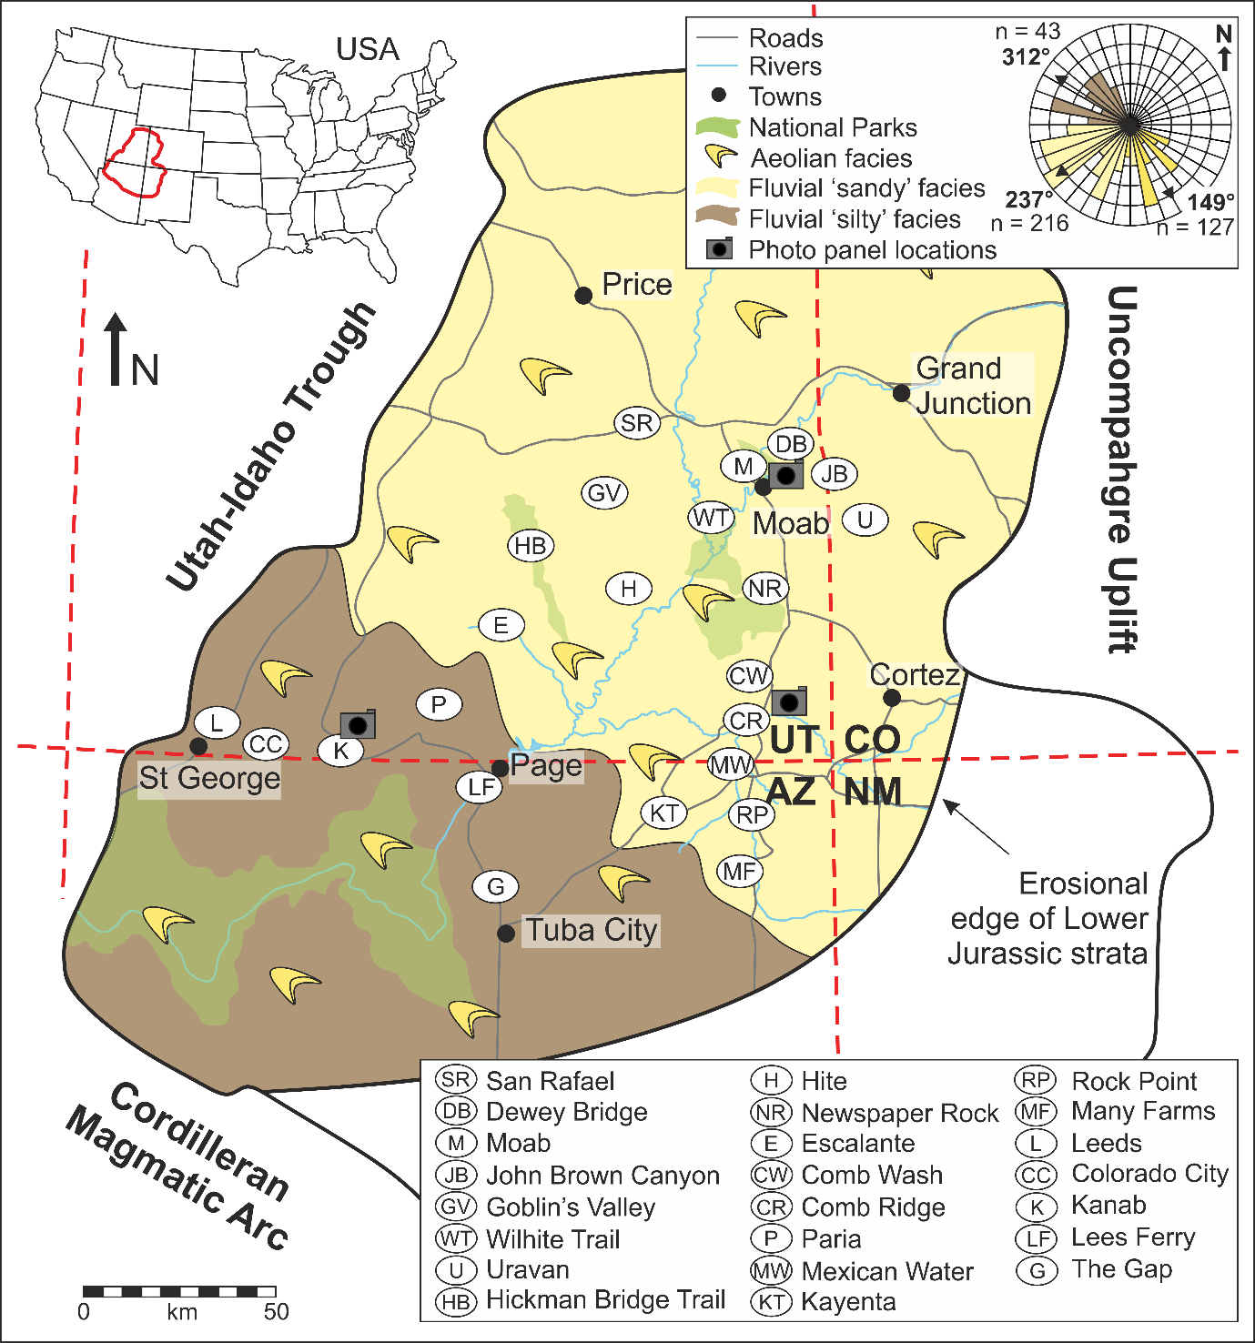
Figure 1. The Colorado Plateau, situated in the Four Corner states, USA, showing the extent of the Kayenta Formation deposition. The Kayenta fluvial systems deposited sediment across the Colorado Plateau sourced from the Ancestral Rocky Mountains (Uncompahgre Uplift) to the north-east and the Cordilleran Magmatic Arc to the south-west, locations of logged sections are indicated in white ellipses (see key) (modified after Harshbarger et al., 1957; Middleton & Blakey, 1983; Blakey 1994). The rose diagram depicts palaeocurrent measurements from the ‘silty’ (brown) and ‘sandy’ (light yellow) fluvial system and the aeolian system (yellow), along with their arithmetic averages (arrows); ‘n’ gives the number of measurements in each set.
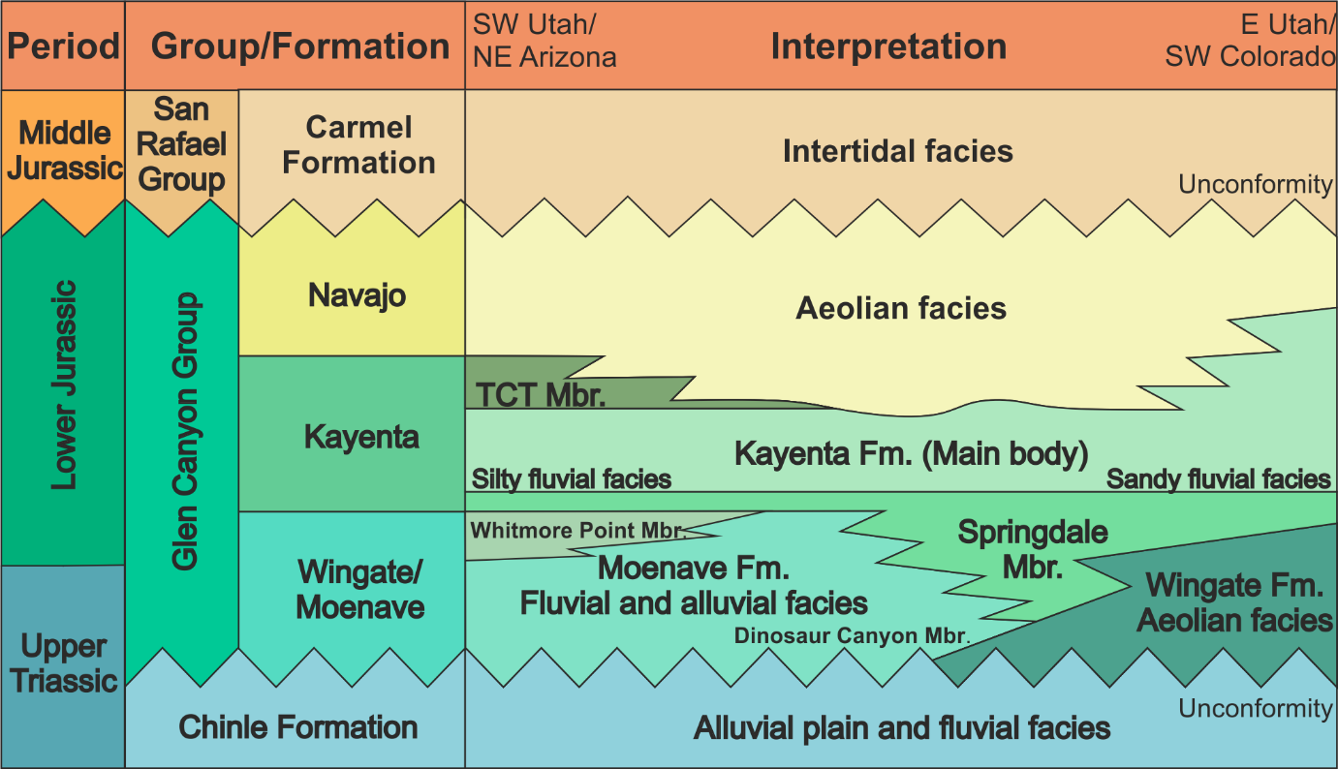
Figure 2. The stratigraphy of the Glen Canyon Group including members, facies and spatial distribution of facies across the Colorado Plateau. The focus of this study is the Kayenta Formation that, along with the underlying Wingate and overlying Navajo formations, form the Glen Canyon Group. Modified after North & Taylor (1996); Tanner & Lucas (2007). TCT = Tenny Canyon Tongue.

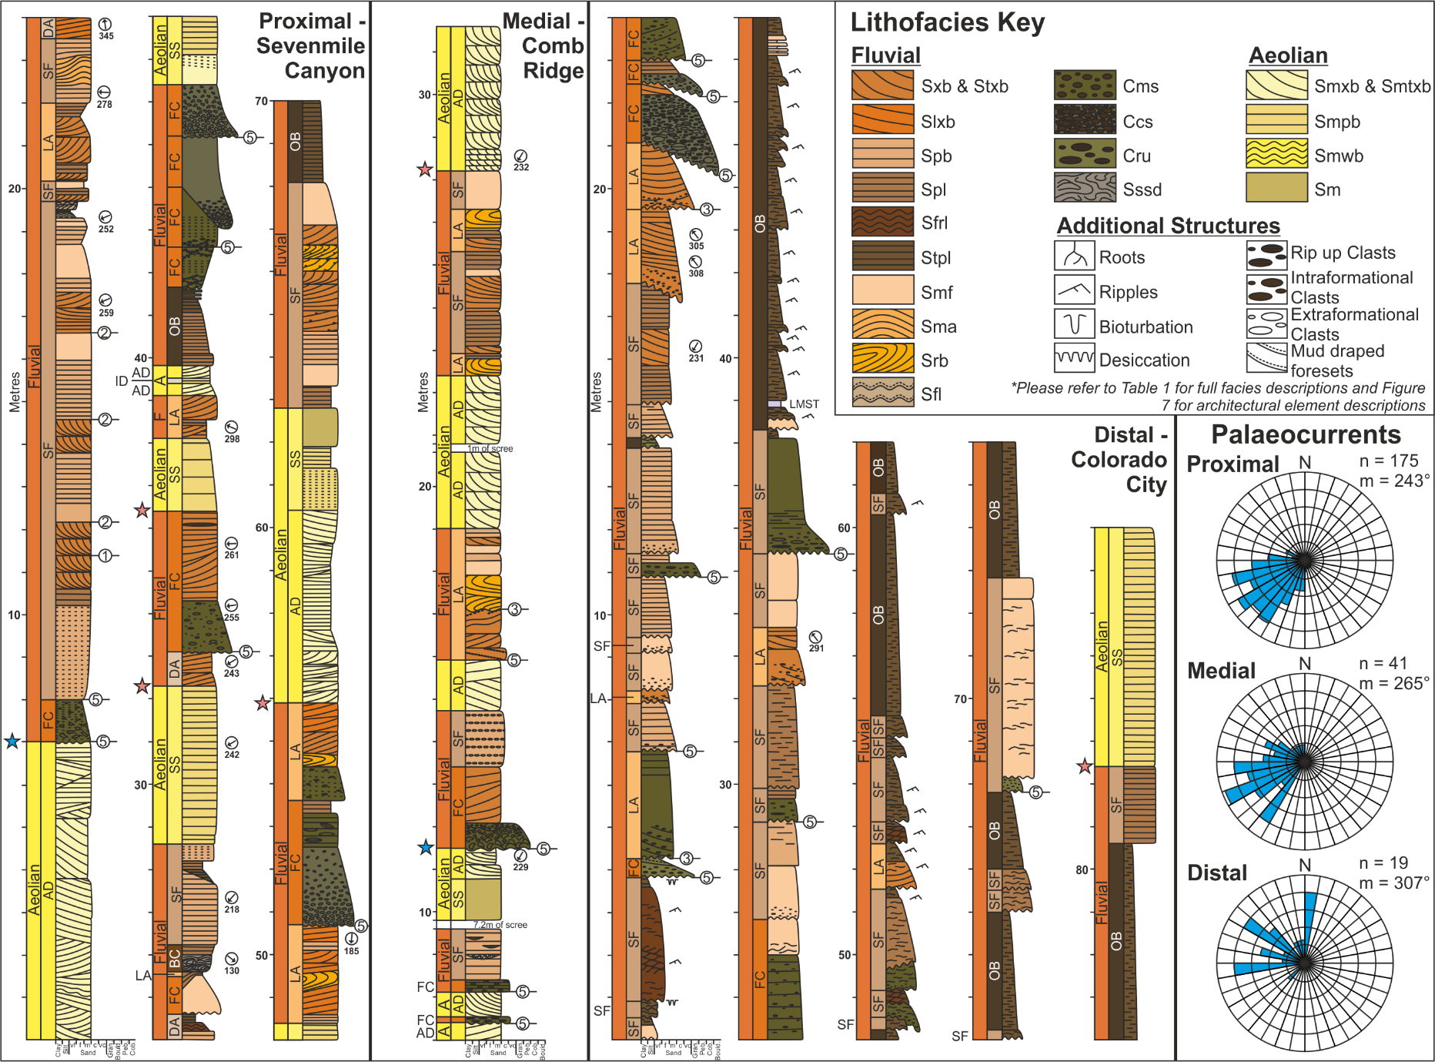
Figure 3. Representative sedimentary logs showing the downstream lithofacies and palaeocurrent variations observed in the Kayenta Formation. Proximal succession – Sevenmile Canyon (north-west of Moab); Medial succession – Comb Ridge (west of Bluff); Distal succession – Hildale (north of Colorado City). Sedimentary logs are coloured by lithofacies (see key) with architectural element codes listed down the side. Examples of bounding surfaces are highlighted by hierarchical numbers (see Figs 4, 5 and 6 for codes). Stars represent changes in gross depositional environment (blue = sharp contacts between underlying aeolian and overlying fluvial sediments, pink = gradual contacts between underlying fluvial and over lying aeolian sediments.) See Fig. 1 for locations.
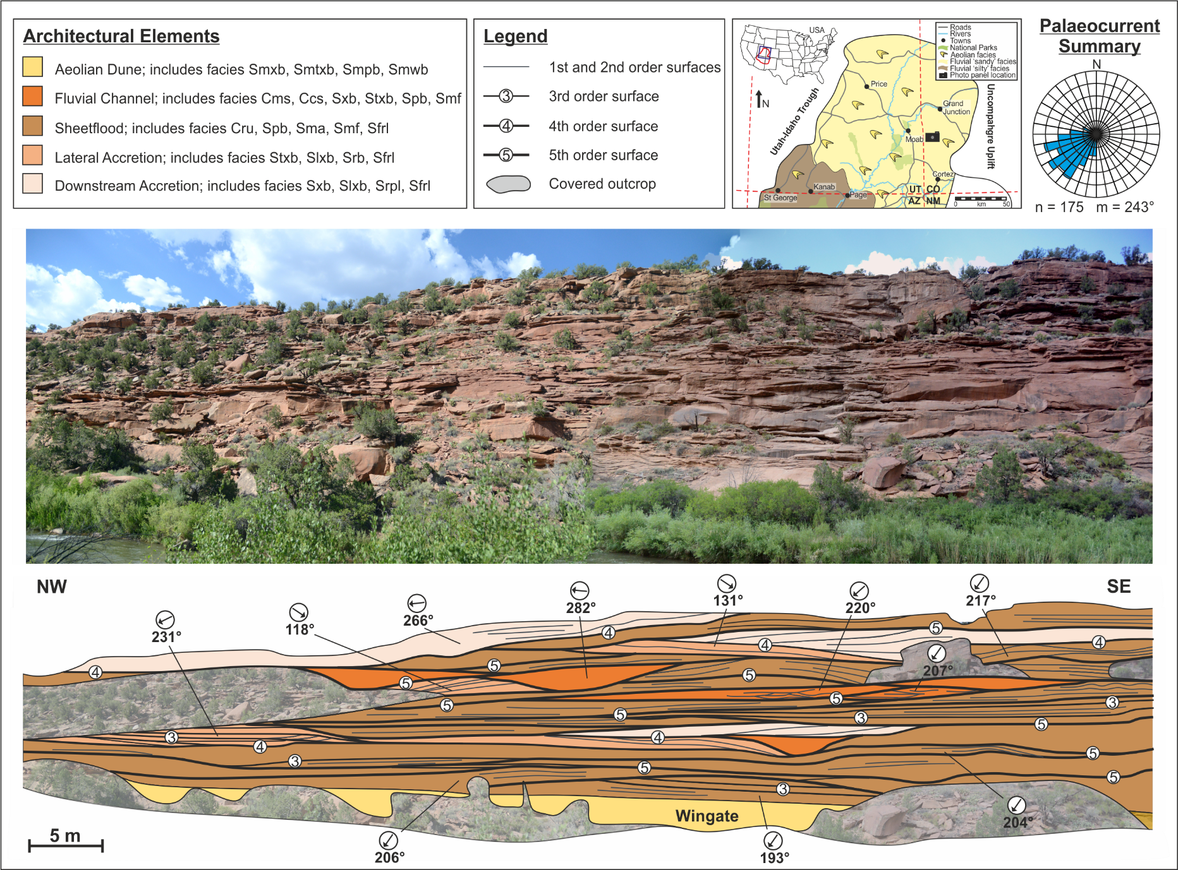
Figure 4. Architectural element outcrop panel for the proximal Kayenta Formation with hierarchical bounding surface analysis and palaeocurrent measurements. The proximal region is dominated by vertically and laterally amalgamated fluvial channel, sheets and accretionary elements with sporadic small isolated pockets of overbank.
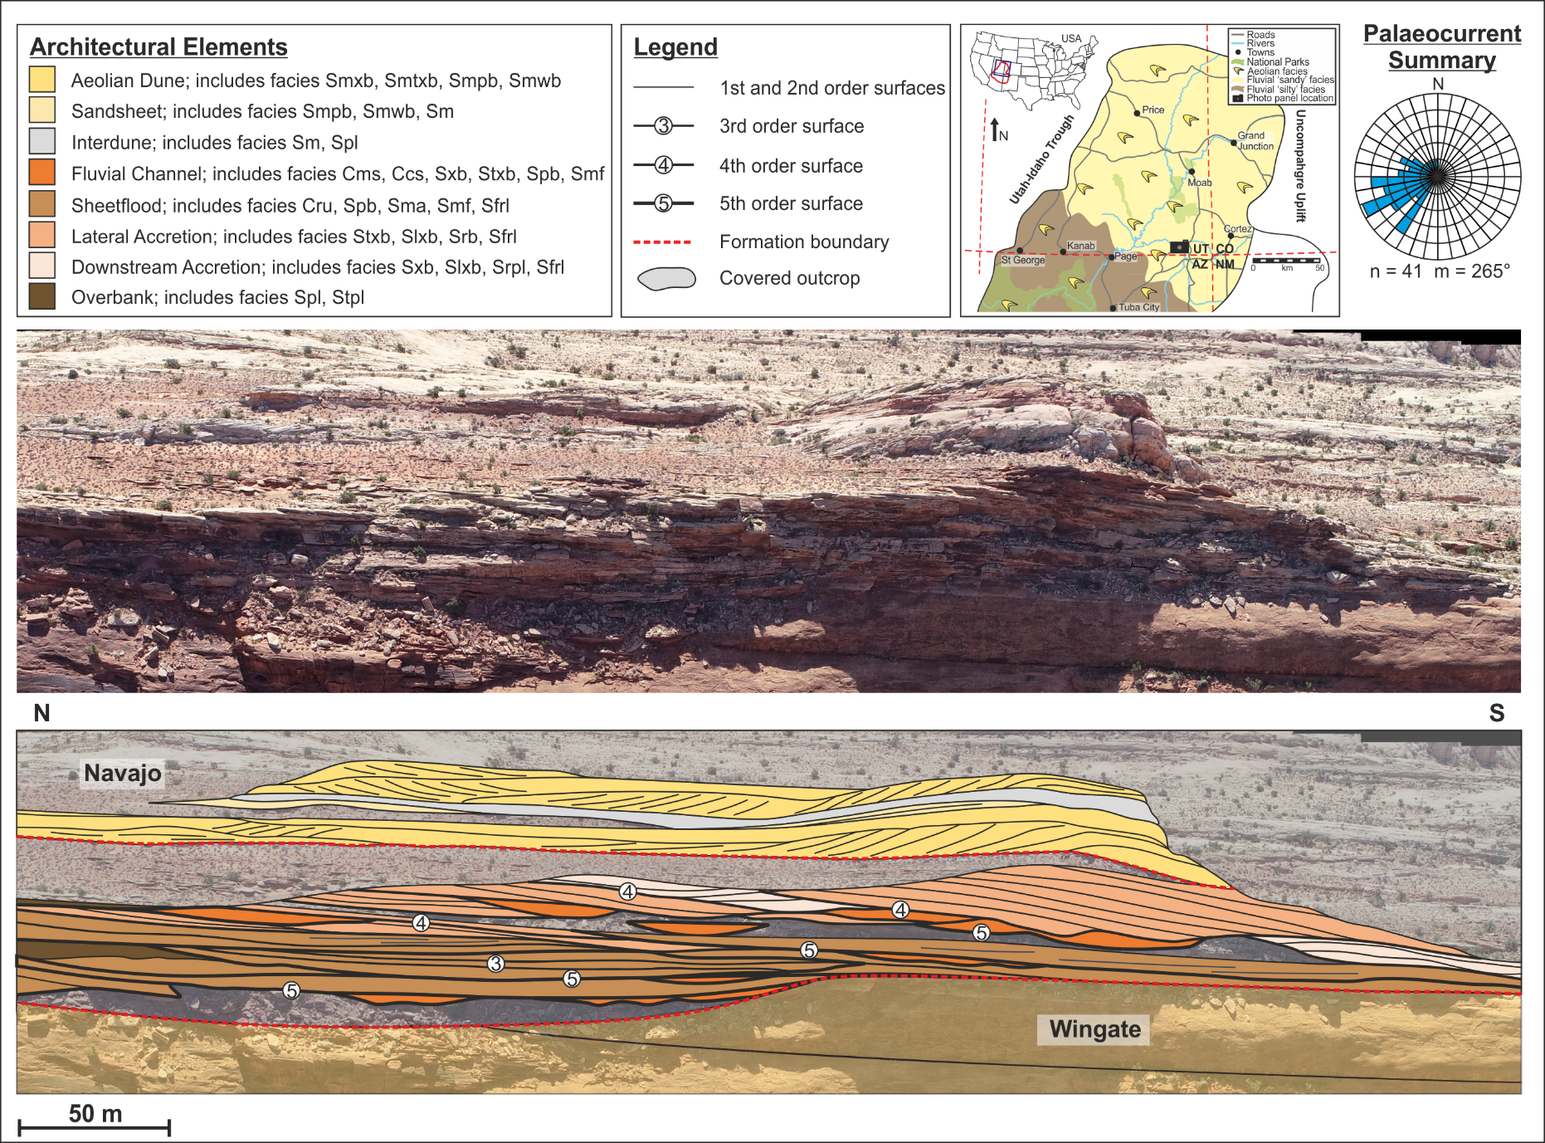
Figure 5. Architectural element outcrop panel for the medial Kayenta Formation with hierarchical bounding surface analysis and palaeocurrent measurements. The medial region is dominated by vertically and laterally amalgamated fluvial channel, sheets and accretionary elements; however, channels are more isolated and overbank elements are thicker and more laterally extensive.
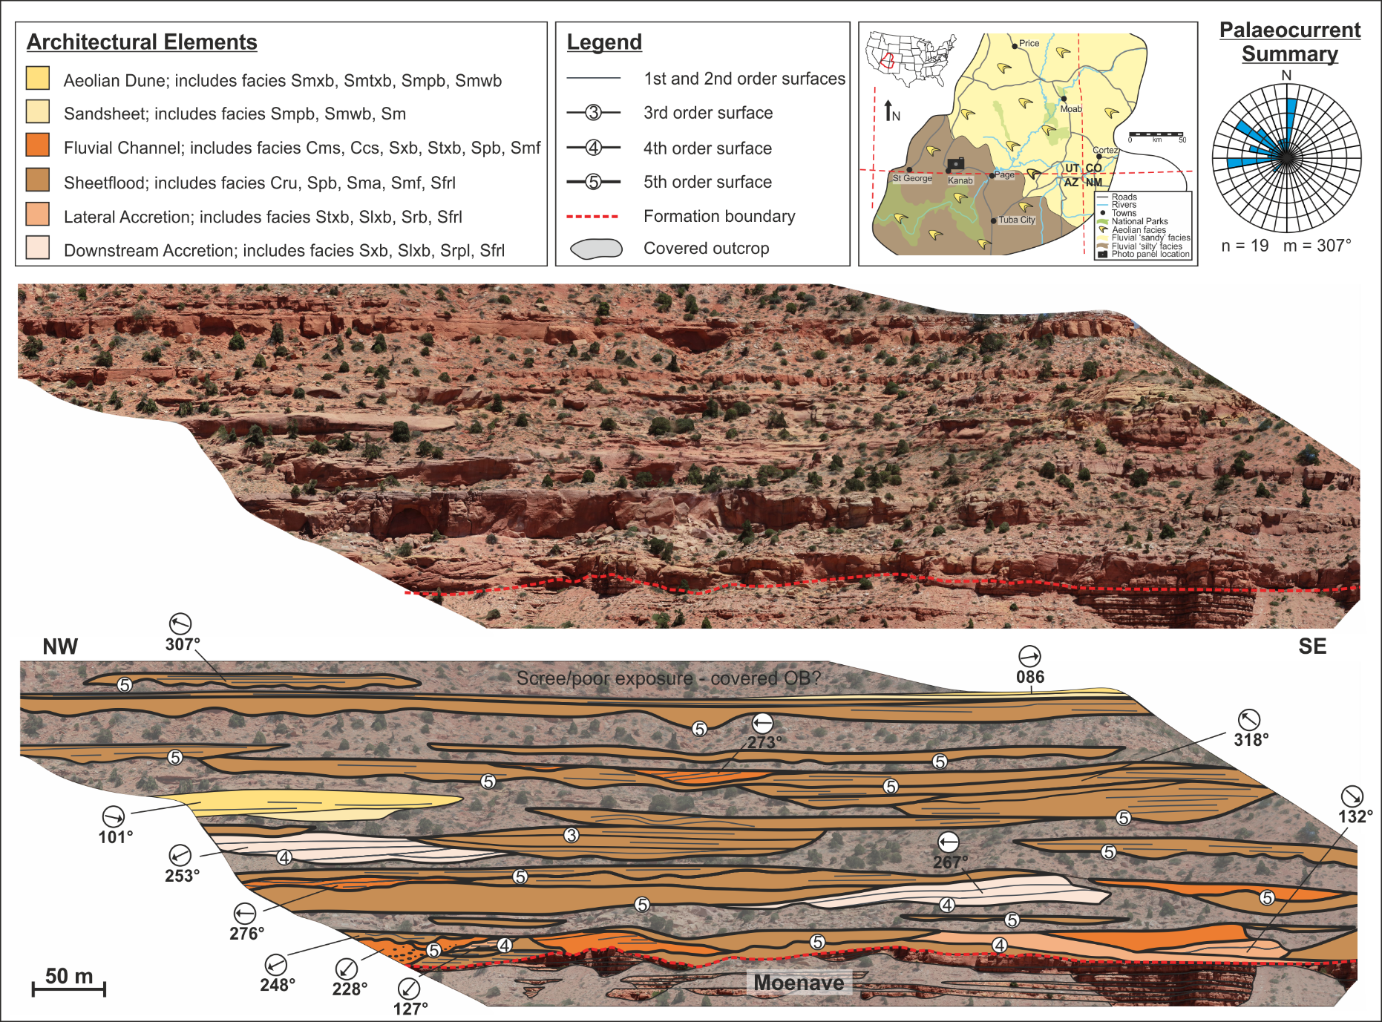
Figure 6. Architectural element outcrop panel for the distal Kayenta Formation with hierarchical bounding surface analysis and palaeocurrent measurements. In the distal region the degree of stacking between channel, sheets and accretionary elements is significantly reduced, with several channel and sheet-like elements being isolated within laterally extensive overbank deposits.

Code | Lithofacies | Log | Lithology & Texture | Sedimentary Structures | Interpretation
Smxb | 1 m | 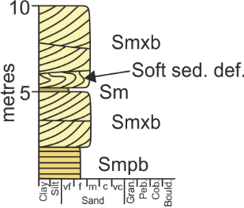 | Grey to orange, fine to medium-grained quartz arenite, well sorted & well rounded. | Planar cross-bedding with mm/cm scale alternations in grainsize in single or multiple sets, sporadic soft sediment deformation. | Migration of wind-blown straight-crested dune-scale bedforms and dune trains. Soft sediment deformation formed as a result of loading on a damp substrate.
Smtxb | 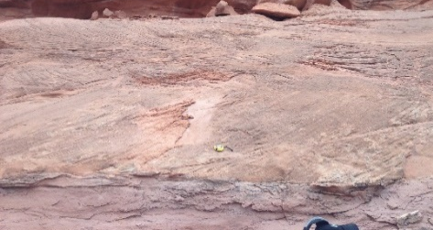  10 cm | 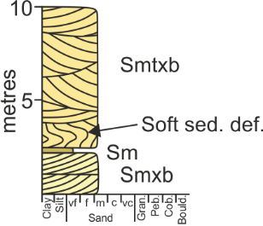 | Grey to orange, fine to medium-grained quartz arenite, well sorted & well rounded. | Trough cross-bedding with mm/cm scale alternations in grainsize in single or multiple sets, sporadic soft sediment deformation. | Migration of wind-blown sinuous-crested dune-scale bedforms and dune trains. Soft sediment deformation formed as a result of loading on a damp substrate.
Smpb |  | 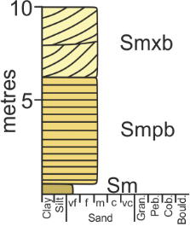 | Grey to orange, fine to medium-grained quartz arenite, well sorted & well rounded. | Planar-bedding with millimetre scale alternations in grainsize. | Wind-blown deposits formed by the deflation of dune-scale bedforms.
Smwb |  | 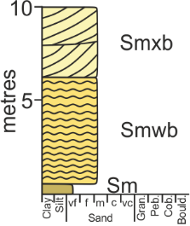 | Grey to orange, fine to medium-grained quartz arenite, well sorted & well rounded. | Undulose-laminations with millimetre scale alternations in grainsize. | Migration of wind-blown ripple-scale bedforms, producing pinstripe laminae.
Sm | 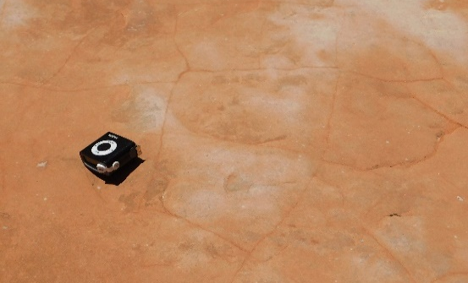 | 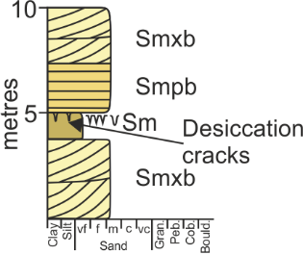 | Grey to orange, very fine to medium-grained quartz arenite, well sorted & well rounded. | Structureless, sporadic desiccation cracks and bioturbation. | Suspension settling of wind-blown sediment in areas affected by surface water, followed by drying.
Sxb | 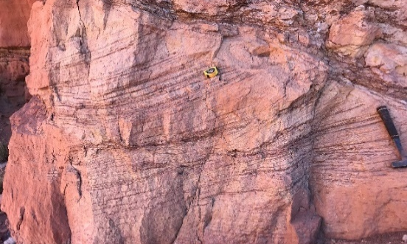 | 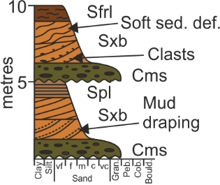 | Brown medium-grained sub-arkosic arenite to quartz arenite, moderate/well sorted & sub-rounded/well rounded. | Planar cross-bedding with normal grading, in single or multiple sets, sporadic clasts, mud draping and soft sediment deformation. | Migration of straight-crested dune-scale bedforms and dune trains sub-aqueously under lower flow regime conditions with high sediment load.
Stxb | 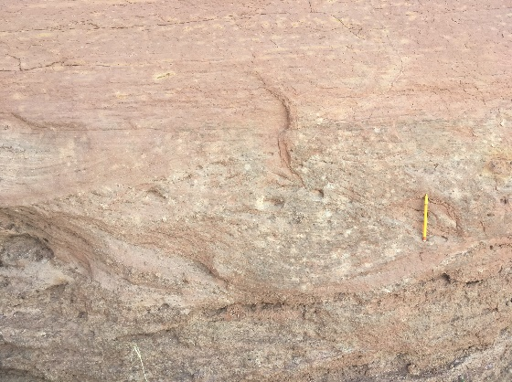 | 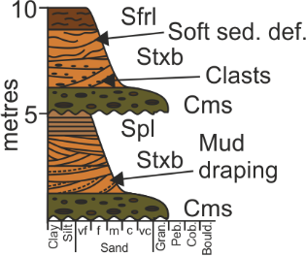 | Brown medium-grained sub-arkosic arenite to quartz arenite, moderate/well sorted & sub-rounded/well rounded. | Trough cross-bedding with normal grading, in single or multiple sets, sporadic clasts and soft sediment deformation. | Migration of sinuous-crested dune-scale bedforms and dune trains sub-aqueously under lower flow regime conditions.
Slxb | 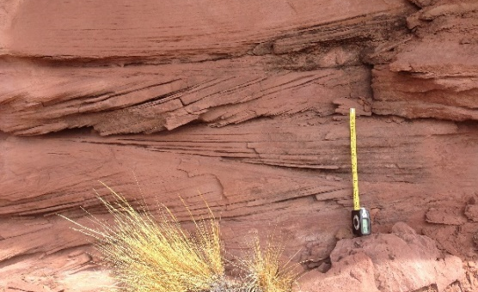 | 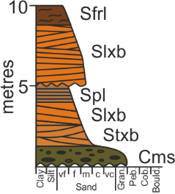 | Brown medium-grained sub-arkosic arenite to quartz arenite, moderate/well sorted & sub-rounded/well rounded. | Low-angle cross-bedding in single or multiple lenticular sets and sporadic reactivation surfaces. | Lateral migration of macro-forms in lower flow regime conditions.
Spb | 50 cm | 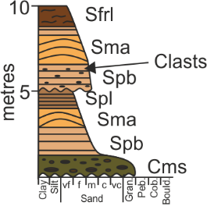 | Brown medium-grained sub-arkosic arenite to quartz arenite, moderate/well sorted & sub-rounded/well rounded. | Planar-bedding, sporadic clasts. | Sub-aqueous upper flow regime flat beds.
Spl |  | 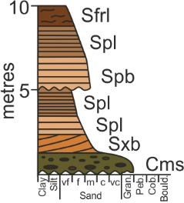 | Brown fine to medium-grained sub-arkosic arenite to quartz arenite, moderate/well sorted & sub-rounded/well rounded. | Parallel laminations. | Sub-aqueous upper flow regime flat beds.
Sfrl |  | 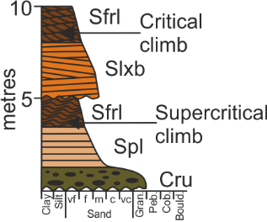 | Brown siltstone to medium-grained sub-arkosic arenite, moderate/well sorted & sub-rounded/well rounded. | Ripple-cross-laminations, with sub-critically to super-critically climbing multiple sets which form cosets. | Migration of ripple-scale bedforms in lower flow regime.
Smf | 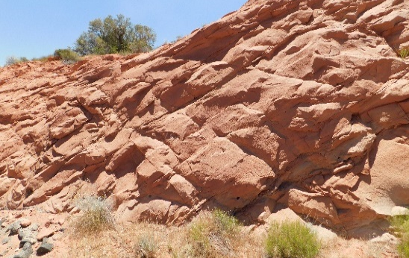  1 m | 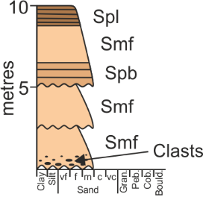 | Orange to brown medium-grained sub-arkosic arenite to quartz arenite, moderate/well sorted & sub-rounded/well rounded. | Structureless, sporadic clasts concentrated in basal sections. | Rapid deposition in high sediment load suppressing bedform development.
Sma | 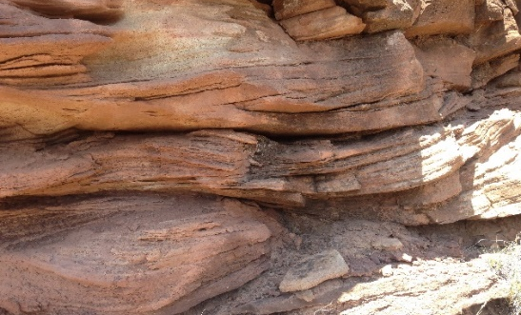  20 cm | 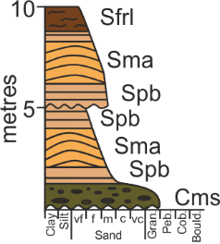 | Orange to brown medium-grained sub-arkosic arenite to quartz arenite, moderate/well sorted & sub-rounded/well rounded. | Sigmoidal-bedding with normally graded foresets in single or multiple sets. | Upper flow regime- antidune development.
Srb | 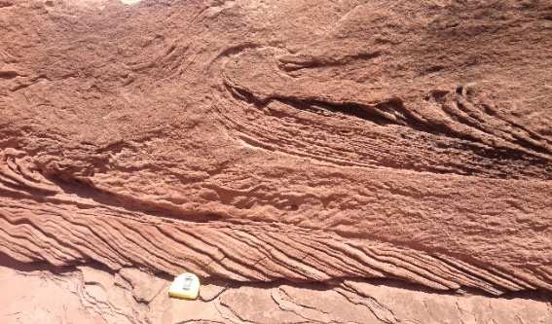 | 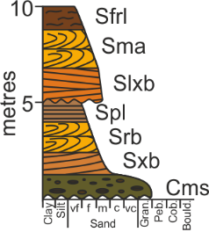 | Orange to grey medium-grained sub-arkosic arenite to quartz arenite, moderate/well sorted & sub-rounded/well rounded. | Recumbent cross-bedding, sporadic mud draping on foresets in single or multiple sets, with slightly concave set bounding surfaces. | Migration of sinuous-crested dune-scale bedforms in lower flow regime with high sediment load.
Sfl | 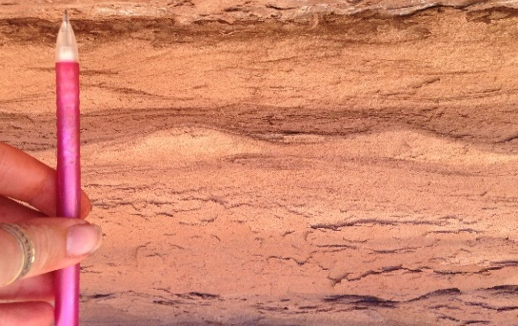 | 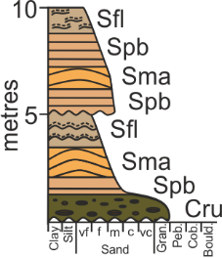 | Brown siltstone to fine-grained sub-arkosic arenite. | Flaser laminations with silt lining foreset and set bounding surfaces. | Migration of ripple-scale bedforms in lower flow regime/waning flow conditions.
Sssd | 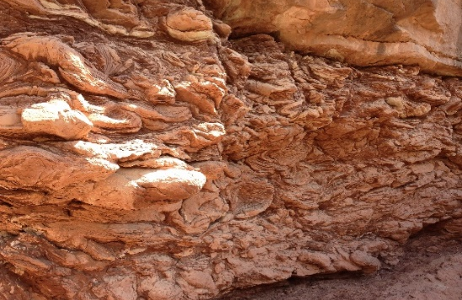  50 cm | 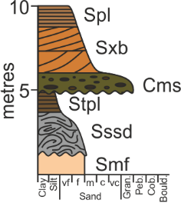 | Purple to brown siltstone to fine-grained sub-arkosic arenite matrix, with locally derived sediment, forming moderate/poorly sorted & sub-rounded clasts. | Soft sediment deformed clasts with silt lining the contorted foresets and between the deformed clasts. | Sub-aqueous mass transport deposits: debris flow/slumping/ sliding into a high sediment load flow.
Stpl | 50 cm | 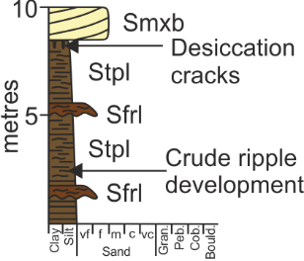 | Dark brown siltstone, sporadic mottling. | Parallel to faint undulose laminations, sporadic rhizoliths, desiccation cracks and bioturbation. | Suspension fall out from stationary waters. Stabilization for vegetation to develop.
Cms | 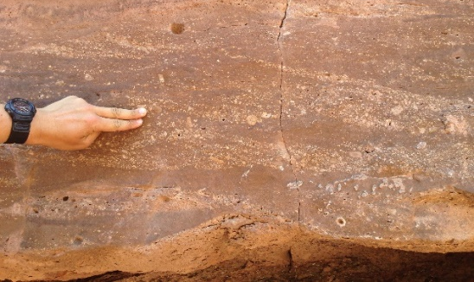 | 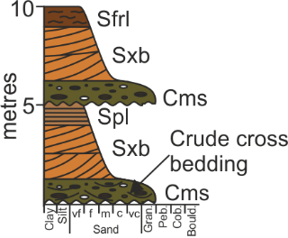 | Grey to brown medium-grained sand to pebble-grade, polymictic conglomerate, poorly sorted, sub-rounded, matrix-supported. | Structureless to sporadic crude trough cross-bedding, with abundant clasts lining foresets. | Sub-aqueous lower flow regime conditions with high sediment load, intermittent development and migration of dune-forms.
Ccs | 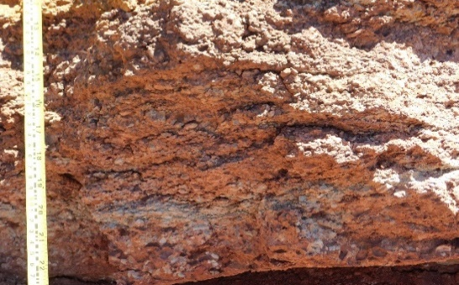 | 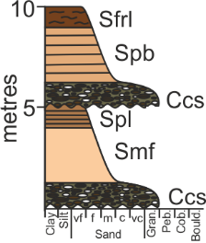 | Grey to brown coarse-grained sand to pebble-grade, polymictic conglomerate, poorly sorted, sub-rounded, clast-supported. | Structureless to very crude cross-bedding, abundant clasts throughout. | Sub-aqueous, high energy Newtonian flow under high sediment load conditions, with suppressed bedform development.
Cru |  | 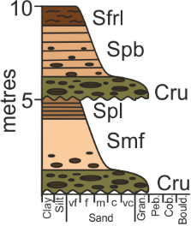 | Grey to orange medium-grained, poorly sorted, sub-rounded/sub-angular, matrix-supported. Rip up clasts ranging from granule to cobble grade. | Structureless to very sporadically crudely cross-bedded, rip up clasts at base. | Sub-aqueous high energy flow under high sediment load conditions and reworking of locally derived sediment.
Lm | 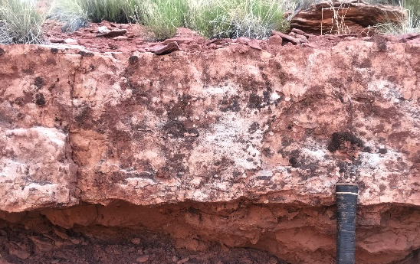 | 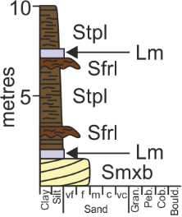 | Grey siliciclastic rich, carbonate wackestone with sporadic red chert. | Structureless to undulose laminated. | Sub-aqueous precipitation of allochthomous carbonate with siliciclastic input.

Table 1. Summary of lithofacies observed in the Kayenta Formation. Smpb: Sub-aerial planar cross-bedded sandstone; Smtxb: Sub-aerial trough cross-bedded sandstone; Smpb: Sub-aerial planar-bedded sandstone; Smwb: Sub-aerial undulose laminated sandstone; Sm: Sub-aerial structureless sandstone; Sxb: Sub-aqueous planar cross-bedded sandstone; Stxb: Sub-aqueous trough cross-bedded sandstone; Slxb: Sub-aqueous low-angle cross-bedded sandstone; Spb: Sub-aqueous planar-bedded sandstone; Spl: Sub-aqueous parallel laminated sandstone; Sfrl: Sub-aqueous ripple cross-laminated sandstone; Smf: Sub-aqueous structureless sandstone; Sma: Sub-aqueous sigmoidal bedded sandstone; Srb: Sub-aqueous recumbent cross-bedded sandstone; Sfl: Sub-aqueous flaser laminated sandstone; Sssd: Sub-aqueous soft sediment deformed sandstone; Stpl: Sub-aqueous parallel-laminated siltstone; Cms: Sub-aqueous matrix-supported conglomerate; Ccs: Sub-aqueous clast-supported conglomerate; Cru: Sub-aqueous rip-up clast conglomerate; Lm: Sub-aqueous siliciclastic-rich limestone.

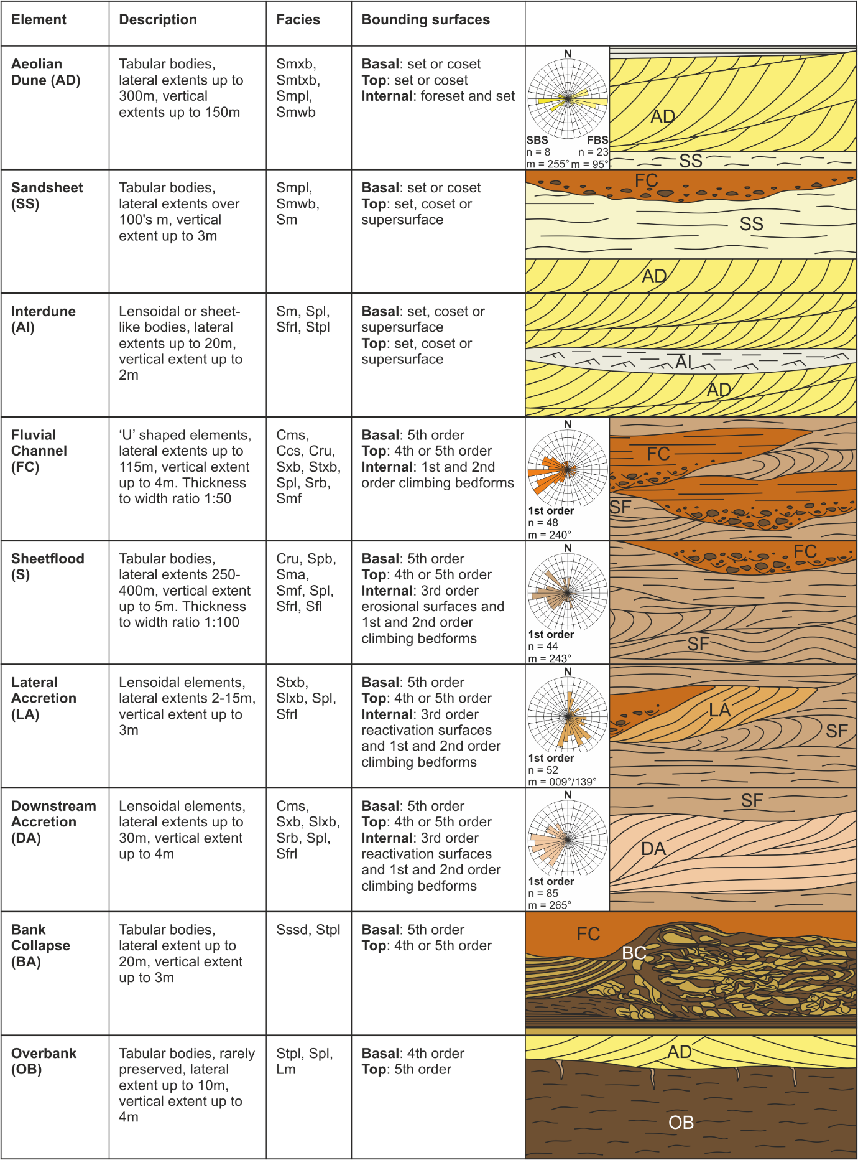
Figure 7. Summary table of architectural elements with brief description and geometry, their contained facies (see Table 1 for detailed facies descriptions), and bounding surface analysis. Two-dimensional illustrations of commonly occurring relationships with overlying and underlying elements are indicated along with their respective palaeocurrent measurements; n = number of measurements, m = mean palaeocurrent direction.

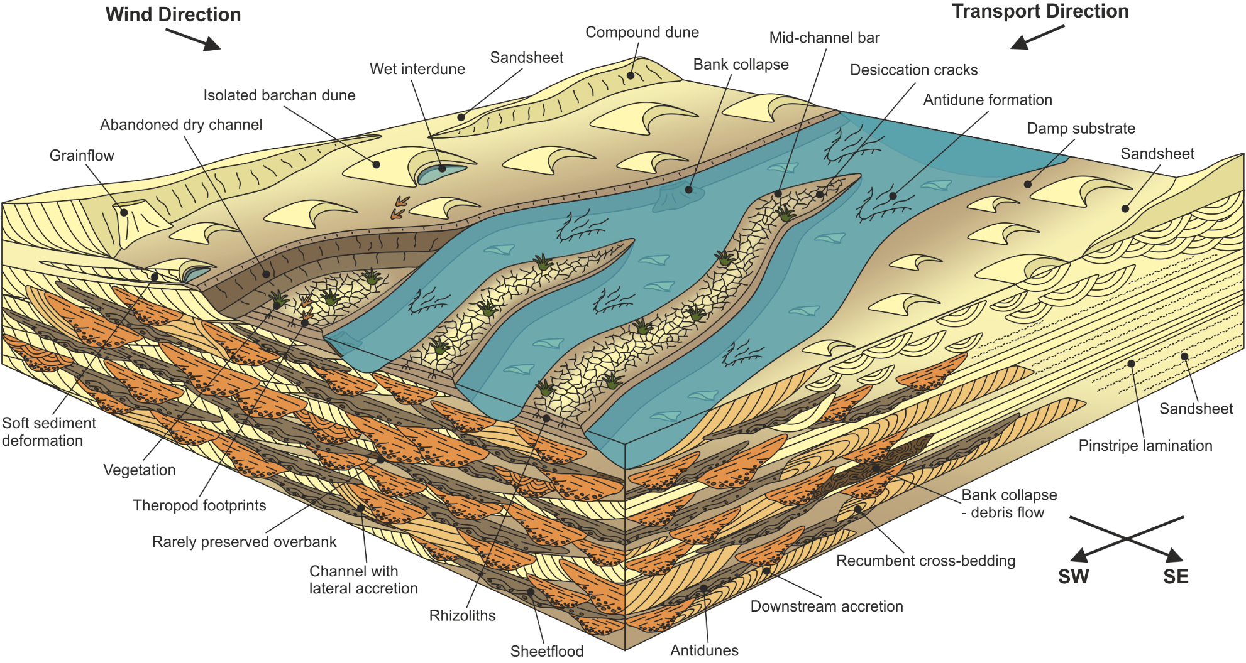
Figure 8. Depositional model of an ephemeral fluvial system based upon field data from the Kayenta Formation. The model highlights the interaction between the aeolian and fluvial environments, and the dominance of upper flow regime and high sediment load structures within the fluvial environment.

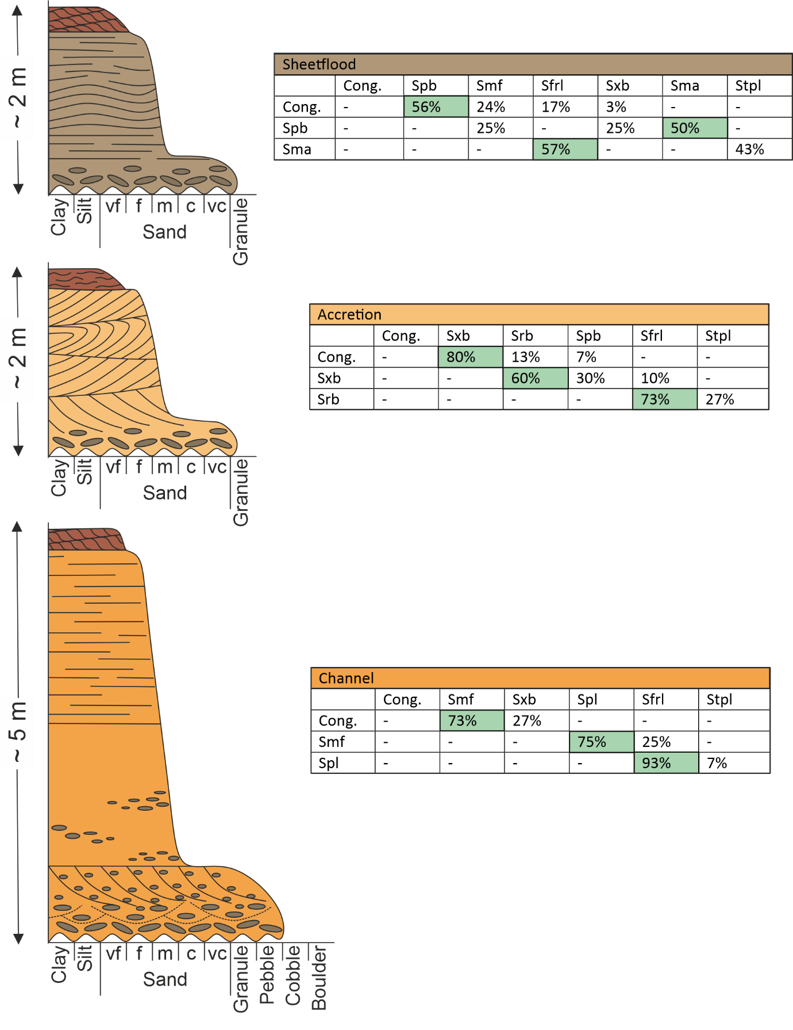
Figure 9. Idealized succession highlighting the typical sedimentology observed in an ephemeral fluvial environment. Channel element (orange) with conglomeratic base, crude cross-bedding with clasts lining foresets, a sharp grain-size change to massive to intermittent parallel laminated sandstone, topped by climbing ripples. Downstream accretion element (pale orange) with conglomeratic base and low-angle and recumbent cross-bedding, topped by wavy to ripple cross-laminated siltstone. Sheet-like element (brown) with conglomeratic base, upper flow regime plane beds and antidunes, topped by supercritical climbing ripples. Markov chain analysis for each architectural element was conducted highlighting the probability of each facies occurring in succession.
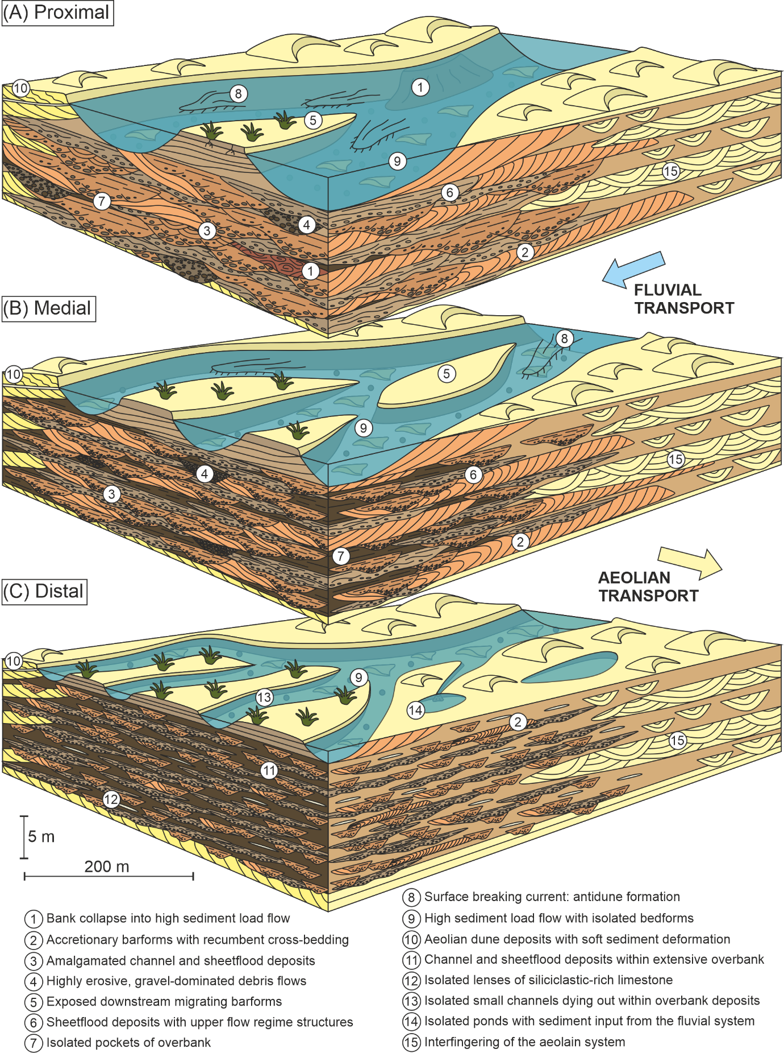
Figure 10. Depositional models of an arid ephemeral fluvial system from (A) proximal to (B) medial to (C) distal, based upon field data from the Kayenta Formation. The models show the detailed sedimentology and key characteristics observed, as along with the interaction between the aeolian and fluvial environment. See Fig. 8 for key.
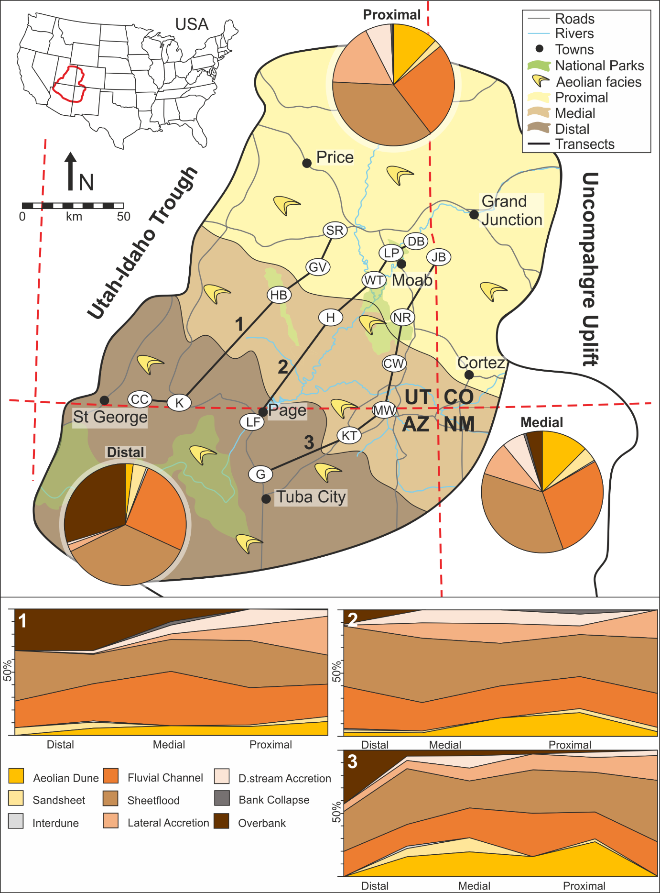
Figure 11. Spatial distribution of architectural elements across proximal, medial and distal settings within Kayenta Formation, with three transects through logged localities (see Fig. 1 for locality names). Fluvial channel and sheet-like elements remain fairly constant across the system, accretionary elements are most prevalent within the proximal and medial regions, whereas overbank elements are most prevalent within the distal region.
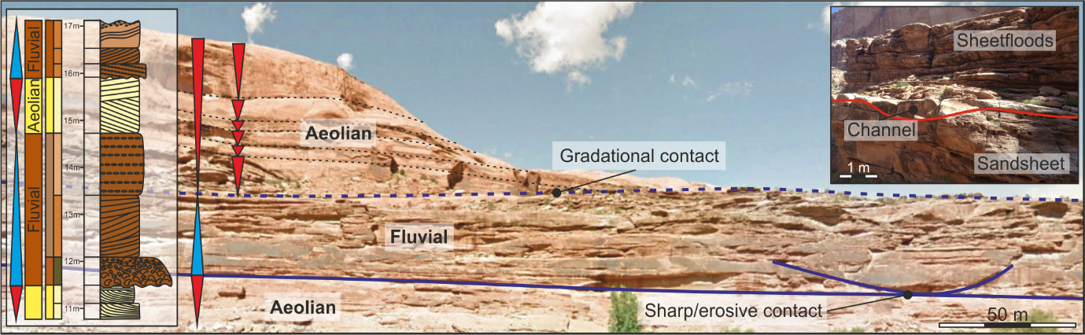
Figure 12. Temporal variations in sediments of the Kayenta Formation, highlighting the wetting (blue arrow) and drying (red arrow) trends within the system. Wetting trends are characterized by a sharp or erosive contact between the underlying aeolian and overlying fluvial sediments, whereas drying trends are characterized by a more gradational contact between the underlying fluvial and overlying aeolian sediments. Smaller scale drying trends are also observed, particularly within the aeolian deposits.
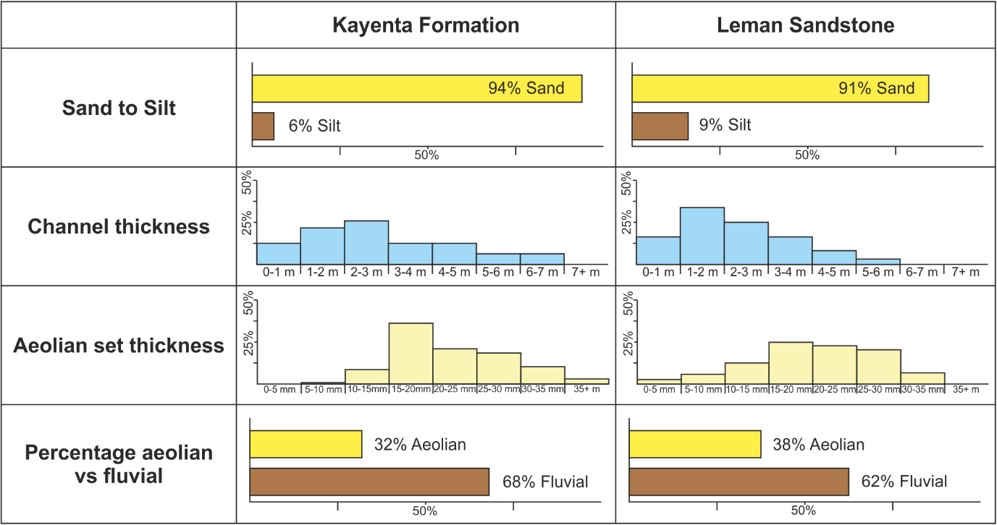
Figure 13. Comparison of data from the Kayenta Formation and Leman Sandstone including percentage of sand versus silt, fluvial channel thicknesses, aeolian dune set thicknesses and percentage of fluvial versus aeolian elements.
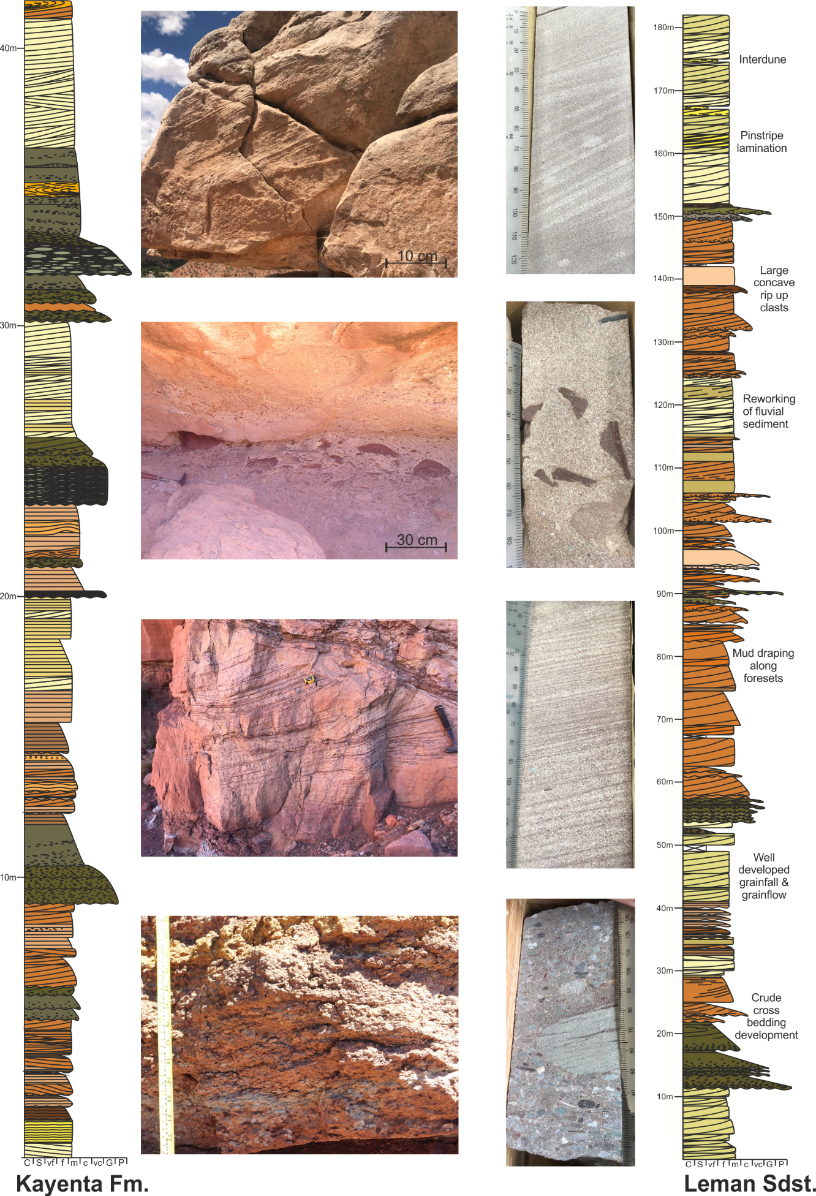
Figure 14. Comparison of sedimentary logs from the Kayenta Formation and Leman Sandstone including photographs of key sedimentary structures.

