An Anatomy of the Blood Eagle: The Practicalities of Viking Torture
By Luke John Murphy, Heidi R. Fuller, Peter L.T. Willan, and Monte A. Gates

Abstract
The infamous blood eagle ritual has long been controversial: did Viking-Age Nordic people really torture one another to death by severing their ribs from their spine and removing their lungs, or is it all a misunderstanding of some complicated poetry? Previous scholarship on the topic has tended to focus on the details and reliability of extant medieval descriptions of the blood eagle, arguing for or against the ritual’s historicity. What has not yet been considered are the anatomical and sociocultural limitations within which any Viking-Age blood eagle would have had to have been performed. In this article, we analyse medieval descriptions of the ritual with modern anatomical knowledge, and contextualise these accounts with up-to-date archaeological and historical scholarship concerning elite culture and the ritualised peri- and post-mortem mutilation of the human body in the Viking Age. We argue that even the fullest form of the blood eagle outlined in our textual sources would have been possible, though difficult, to perform, but would have resulted in the victim’s death early in proceedings. Given the context of the ritual depicted in medieval discourse, we also argue that any historical blood eagle would have existed as part of a wider continuum of cultural praxis, and been employed to reclaim or secure the social status of the ritual’s commissioner following the “bad death” of a male relative at the hands of the ritual’s eventual victim.

Keywords: Early medieval Scandinavia, Old Norse literature, torture, execution, ritual, anatomy, deviant burial, bad death
Introduction
Few aspects of Viking and Medieval Scandinavian history have been as contentious as
the blóðǫrn (“blood eagle”), a process of ritualised torture and execution allegedly carried out during the Viking Age (c. 750–1050), and said to involve the breaking of a victim’s ribs and the withdrawal of the lungs from the chest cavity, whereupon their fluttering would (allegedly) resemble an eagle’s wings. Accounts of the blood eagle appear in a range of medieval texts, the reliability of which has been the subject of some debate. Our aim in this article, however, is not to argue that the blood eagle did (or did not) take place during the Viking Age. Instead, we seek to offer a fresh perspective on the issue, employing an interdisciplinary approach in an attempt to establish whether or not the blood eagle could have taken place during the Viking Age. That is, would the performance of a blood eagle as outlined in medieval discourse have contravened anatomical or Viking-Age sociocultural limitations, and can a greater understanding of physiological and cultural contexts help us better understand Viking-Age torture practices?,

The Medieval Discourse of the Blood Eagle
Before we consider the anatomical practicalities and sociocultural context of any potential Viking-Age blood eagle, we must first establish what we – and other scholars – understand by the term. Seven prose and two poetic accounts in Old Norse and Latin from the eleventh, twelfth, and thirteenth centuries record the torture and execution of four powerful male individuals – Halfdán háleggr, King Ælla of Northumbria, Lyngvi Hundingsson, and Brúsi of Sauðey – via the blood eagle. The eight Old Norse texts explicitly refer to the practice as “[to] carve/cut/mark a [blood] eagle”, a sentiment also expressed in the Gesta Danorum, our lone Latin source, which describes how the ritual’s perpetrators “commanded that the likeness of an eagle should be put onto his [the victim’s] back”.
Despite this initial similarity, there is no consensus between our sources as to what precisely constituted the blood eagle. All nine extant accounts begin with the victim being captured following armed conflict, and having an eagle carved or cut into their back. Three sources – Knútsdrápa, Ragnars saga loðbrókar, and Reginsmál – offer no further anatomical details, suggesting only that the victim died shortly thereafter. For example, a short prose section and strophe 27 of Reginsmál describe the death of Lyngvi Hundingsson thus:

Sigurðr átti orrostu mikla við Lyngva Hundingsson ok bræðr hans. Þar fell Lyngvi ok þeir þrír bræðr. Eptir orrostu kvað Reginn:
“Nú er blóðugr ǫrn
bitrum hjǫrvi
bana Sigmundar
á baki ristinn.”

Sigurðr won a great battle against Lyngvi Hundingsson and his brothers. Lyngvi and those three brothers died there. After the battle, Reginn declared: “Now a bloody eagle is carved into the back of Sigmundr’s killer [Lyngvi] with a bloody sword.”

Similarly, the Gesta Danorum makes it clear that the eagle carved was only a superficial “likeness” of the bird, and adds that the victim’s wounds were salted thereafter. None of these four texts describe the opening of the thoracic cavity, the breaking of ribs, or the removal of lungs.
In contrast, the remaining five sources – Haralds saga ins hárfagra, Orkneyinga saga, Orms þáttr Stórólfssonar, Norna-Gests þáttr, and Ragnarssona þáttr – go further, detailing that the victim’s ribs were cut loose from their spine, and that their lungs were subsequently removed. Haralds saga, for example, provides the following description:
Þá gekk Einarr jarl til Hálfdanar. Hann reist ǫrn á baki homum þeima hætti, at hann lagði sverði á hol við hrygginn ok reist rifinn ǫll ofan á lendar, dró þar út lungun. Var þat bani Hálfdanar.
Then Einar Jarl went to Hálfdan. He carved an eagle on his back in such a way, that he put a sword into the chest cavity at the spine, and cut down along all the ribs to the loins, and pulled out the lungs through the cut. That was the death of Hálfdan.
Such accounts imply that this complicated procedure was the cutting of a blood eagle, and that the bird’s shape was formed not by artistically placed cuts to the skin, but by the arrangement of the victim’s body parts.
This raises the question of how to align what appear to be two textual traditions. One possibility is that medieval writers assumed their audiences would be familiar with the concept of a blood eagle, and either felt no need to detail the whole process or were prevented from doing so by the generic constraints of their writing, leading to brief descriptions of the type found in Knútsdrápa, Ragnars saga loðbrókar, Reginsmál, and the Gesta Danorum. Such an abridgement would be entirely in keeping with the terse style of medieval Old Norse prose. Alternately, it is entirely plausible that the longer, more detailed descriptions are the result of later sensationalism or misunderstanding of older texts, or even outright fabrications.
Most previous scholarship on the blood eagle has focused on this dilemma, seeking to either prove or disprove the historicity of the ritual. This debate is further complicated by the dating of the extant sources, which typically survive only in copies decades or centuries younger than the text’s earliest written form – which were themselves produced some centuries after the events they describe. Only the early eleventh-century Knútsdrápa can be securely dated to the Viking Age, although the verse in question describes events other sources date to the late ninth century. There is thus at least a century between any potentially-historical blood eagle and the source that describes it, leaving significant room for confusion and authorial agenda to work on the tradition. Perhaps due to its early dating, the account of Viking leaders capturing and torturing the Northumbrian King Ælla to death in first stanza of Knútsdrápa has been the focus of particular controversy:

Ok Ellu bak,
at, lét, hinns sat,
Ívarr ara,
Jórvík, skorit.

And Ívarr, who ruled [lit. sat] at York, had Ælla’s back cut with an eagle.

Roberta Frank famously rejected the idea that this text records a genuine ritualised torture, arguing that ara (“eagle”) should be read as an instrumental – that is, the agent performing the cutting – albeit one that lacks the preposition typical for such constructions in Old West Norse skaldic poetry. Frank convincingly pointed to three further examples of instrumental datives employing past participles in later stanzas of Knútsdrápa, which is highly suggestive that the construction in the first stanza should be read in the same way.
In a long-running exchange with Bjarni Einarsson, who defended the traditional reading of Sigvatr’s poetry on the basis of the verse’s vocabulary, Frank made it clear that, for her, the best reading of the extant text is therefore “Ívarr… had Ælla’s back cut by an eagle”, and that the poem therefore employs the stock trope of carrion eaters consuming the bodies of defeated foes. For Frank, then, Knútsdrápa simply does not witness the blood eagle, a position that could find support in the silence of the Old English and Anglo-Latin sources that record Ælla’s defeat. Frank went still further, arguing that if Knútsdrápa cannot support the ritual, then it probably never happened at all, with the whole idea resulting from a misunderstanding of Sigvatr’s complex Anglo-Scandinavian poetic diction by later prose writers who took the poem literally, propagating the idea in a form of literary Chinese Whispers: “Deprived of its skaldic stanza, the rite of the blood-eagle has no viking-age support”. Ragnarssona þáttr even quotes Knútsdrápa in its account of Ælla’s execution, making it a good candidate for precisely this sort of confusion, and it is possible to see lack of anatomical detail in terse sources like Ragnars saga and Gesta Danorum as evidence that a misunderstood literary tradition accreted imaginative but ultimately fictitious gory details over time. It certainly appears that ideas similar to the blood eagle had become established in literary discourse by the late medieval period, when the chivalric romance Sigurðar saga þǫgla includes the carving of an uglu (“owl”) into the backs of two prisoners, alongside other humiliating tortures including the shaving of their heads, being beaten by slaves, and eventually being released without having to swear that they will not seek vengeance.
We wholeheartedly agree with Frank that the other uses of prepositionless instrumental datives in Knútsdrápa enables the eagle in the first stanza to be read as an agent. However, we are unconvinced that it must be read thus. Frank herself called the syntax of the poem “skewed” and “ambiguous”, and we find it highly likely, even probable, that such ambiguity was deliberate on Sigvatr’s part, and well in keeping with the cryptic and periphrastic style of skaldic poetry. Such equivocation would have allowed Sigvatr to use the same words to conjure two separate images: in one, Ælla’s back is cut by an eagle in a standard Beasts of Battle motif; in the other his back is cut with an eagle, invoking the blood eagle. We therefore see no reason to argue, on the basis of Knútsdrápa, against the historicity of the blood eagle. Even if one were to reject the poem as too uncertain a source, leaving no Viking-Age witnesses to the ritual, it must be acknowledged that there are huge parts of embodied and enacted culture in the prehistoric Nordic region – from rites of passage like namings, comings of age, and weddings, to seasonal events marking calendrical occasions like solstices, the changing of the seasons, or the start of new years – for which we have no contemporary descriptions. In essence, we agree with Frank’s reading of the poem, but not her conclusions.
That said, we are similarly sceptical of a body of scholarship that, like Bjarni Einarsson, defends the historicity of the blood eagle, but which goes beyond Bjarni’s position to argue it was a ritual performed as part of an Óðinnic cult. This line of reasoning is primarily based on the understanding that the blood eagle was performed as a form of human sacrifice, which is admittedly the case in Orkneyinga saga’s account:

Þar fundu þeir Hálfdan hálegg, ok lét Einarr rísta ǫrn á baki honum með sverði ok skera rifin ǫll frá hrygginum ok draga þar út lungun ok gaf hann Óðni til sigrs sér.

They found Hálfdan háleggr there, and Einarr had an eagle carved onto his back with a sword, and had all the ribs cut from the spine and pulled out the lungs through the cut, and gave him to Óðinn [as a sacrifice] for his victory.

While there can be no doubt that the blood eagle, if it was ever historically practiced, was a highly ritualised event (a topic we will revisit below), it is noteworthy that none of the other eight accounts from the from the eleventh, twelfth, and thirteenth centuries make any link to pre-Christian religion explicit. Given the willingness of medieval texts to link Óðinn to alleged rituals of dubious historicity – such as Gautreks saga’s famously comic account of ritual suicide, the so-called Ætternistapi (“family crag”) – we are reluctant to take this lone witness at face value. This is not to say that a historical blood eagle could not have been seen as human sacrifice, but Viking-Age evidence for such sacrifices are scanty at best, and efforts to link the blood eagle to such a contested body of evidence do nothing to prove – or refute – the ritual was genuinely part of Viking-Age cultural praxis.
One possible solution to the quandary of the blood eagle’s historicity may lie in giving due consideration to the limitations of performing the elaborate ritual laid out in fuller textual accounts: it may be that the “full” blood eagle is anatomically impossible, or would have been prevented by Viking-Age sociocultural mores. We will therefore apply our expertise in human anatomy to determine whether it would have been practically possible to carry out a blood eagle. In this exercise, we are seeking to establish not whether or not the blood eagle ever did take place in the Viking Age, but whether or not it could have taken place as described in the extant source material. In doing so, we have chosen to consider the fullest, most elaborate possible form of the ritual, based on our reading of the texts noted above. We have also decided to discuss two features commonly included in modern descriptions of the blood eagle, but which are not made explicit in any medieval witnesses: the manipulation of the victim’s broken ribs to form the “wings” of the eagle, and the alleged “fluttering” of the removed lungs. While the spreading of the ribs outwards from the spine may be inferred as an anatomical necessity for the removal of the lungs, which is recorded in many of our medieval sources, the continued inflation and deflation of the lungs as the victim breathes their last appears to be a misconstruction of early scholarship that makes no mention of it. Given the pervasive popularity of the blood eagle motif today, it is nonetheless worth addressing this feature.

The Anatomical Practicalities of the Blood Eagle
There are three major anatomical challenges that would have made it difficult to complete a blood eagle as we understand it, particularly while the victim remained alive. The first is the difficulty in rapidly removing the skin and muscles of the back, which would have been necessary because these obstruct the cutting and manipulation of the underlying ribs to allow the removal of the lungs (and the formation of “wings”). The second is the negative effects that opening the thoracic cavity would have had on the integrity of major arteries of the body, and the negative intrapleural pressures that keep the lungs inflated. Finally, the formation of the shape of an eagle’s wings from the posterior rib cage, and the mobilization of the lungs through the posterior openings in the thoracic wall, would have been anatomically challenging.
The first important step in conducting the blood eagle execution would have been to remove the skin, muscles and shoulder blades from the victim’s back (Figure 1). [Figure 1 and caption near here] These structures obscure the ribs, making it impossible to cut them while maintaining the integrity of the lungs, and would subsequently prevent the manipulation of the ribs into the shape of an eagle’s wings. Removing the skin and other superficial structures could have been achieved by holding a sharpened blade parallel to the underlying muscle layer, while making long cutting incisions just superficial to the muscles. It is, of course, possible that the procedure stopped at this stage if the blood eagle were understood as carving the outline of an eagle into the skin (as implied by Reginsmál, Ragnars saga, and the Gesta Danorum), or if these large flaps of skin and muscle were draped to each side of the body while the victim was in a prone position – forming the appearance of “wings”. If the ritual continued, however, the superficial and deeper muscles of the victim’s back (Figure 1), particularly those that help stabilise the shoulder blades (scapulae) in position, would (in combination with the shoulder blades themselves) present obstructions to the fuller blood eagle procedure. Due to this obstruction, a vertical incision would need to extend downwards from the base of the skull and follow a line between the medial margins of the shoulder blades and the spine (see black incision line Figure 1). This cut would sever the fibres of the trapezius (the largest muscle around the shoulder blade), and if deep enough, also include the underlying levator scapulae muscle. Though such an incision is not mentioned in medieval texts, it would have been a necessary step because both muscles, if left intact, would have prevented the executioner from moving the shoulder blades to each side of the body in order to expose the ribs. This would also have made it impossible to spread the rib cage and gain access to the lungs in subsequent steps of the procedure. If this incision into muscle were continued so that it cut “down to the loins” as described in Haralds saga, then the latissimus dorsi muscle in the lower part of the back would also have been cut (Figure 1). Once cut, however, this muscle could have been readily folded out laterally from the back, as is done in some reconstructive operations today, forming a flap of fleshy tissue to the side of the victim.
The deepest anatomical structures preventing access to the victim’s lungs (when approached from the back) would have been the ribs, intercostal muscles, and the erector spinae muscle group running down the spine (Figure 2). [Figure 2 and caption near here] Though several of our medieval sources (Orkneyinga saga, Ragnarssona þáttr, Norna-Gests þáttr, and Orms þáttr) suggest that the procedure involved cutting the victim’s “ribs from the spine”, it would have been very difficult to actually separate the ribs from the vertebrae. The joints between the ribs and vertebrae are stabilised by several very strong ligaments, and it would have been impossible to cut each of these within any reasonable amount of time to conduct the ritual on a living person. Instead, the ribs would need to have been fractured using blunt trauma (such as a sword would provide). One potential point of fracture is suggested from research which indicates that the neck of the rib (near the spine) readily breaks in instances of force trauma. Alternatively, a short portion of the rib just lateral to the midline (the angle of the rib) is relatively narrow and could readily break via blunt trauma from behind. Though it is impossible to know exactly where ribs might fracture if they had received blows from a sword, this matters, as, if the ribs were fractured near their angles, what remained of the ribs in situ would have obstructed access to the lungs. There would also be little rib cage remaining with which to fold out and form “wings” on the victim.
At this stage, another major complication of the blood eagle is the possible exsanguination of the victim. Clinical analyses of signs and symptoms of blood loss in humans indicate that it takes an approximately 30-40% (1.5-2.0 litres) loss of blood before an individual enters a state of confusion. After more than 40% blood loss, a person becomes lethargic and consciousness is difficult to maintain, and after 50% (2.5 litres) loss of blood an individual would likely die. Anatomically, the skin and muscles of the back receive blood through several arteries, each of which would be severed when the soft tissues were dissected during the initial phase of the blood eagle. Though none of these arteries is particularly large individually, collectively they supply a large volume of tissue, and their cutting would probably result in a rapid and significant loss of blood. More importantly, fracturing ribs would sever intercostal arteries which emerge directly from the aorta. This would result in significant and rapid loss of blood, a dramatic fall in blood pressure, and a substantially reduced blood supply to the brain. Perhaps most significant, however, is the real risk of damaging the aorta itself during the procedure. The aorta courses from the heart down the left side of the thoracic vertebral column and lies immediately under where a blade would have penetrated the back on the left side of the spine during the blood eagle. Because the integrity of the aorta would have already been compromised by severing the intercostal arteries that emerge from it on both sides, and the real possibility of directly cutting the aorta while the ribs were being fractured, it is likely that the great vessel could have been damaged at this stage. This would certainly have resulted in the near-immediate death of the victim. Finally, it is perhaps important to mention that positioning the victim facedown would have made damaging the aorta and other internal structures more likely. Though having the victim prostrate on a horizontally-oriented surface would have made dissecting the soft tissues away from the back easier in the early phase of the procedure, using a sword or other long blade to fracture the ribs in a prone position could mean the weapon would have been projecting directly into the body, and that there would have been many individual blows to fracture or detach the ribs from the vertebral column. Along with the likelihood of damaging the aorta, repeated blows would also have made it highly likely that the weapon would significantly damage the lungs and even the heart of the victim.
Another difficulty at this stage is the collapsing of the lungs that would have resulted from opening the back of the chest. This would have been extreme even in relation to that seen in modern day warfare. Though there is some debate concerning how to estimate the severity of a puncture wound to the back in emergency situations, it is certain that cutting ribs and intercostal muscles would have resulted in complete collapse of both lungs. A complete lung collapse would have meant that the victim would not have been able to breathe at all. Also, in cases of complete collapse of the lung, the actual size of the lungs themselves becomes significantly reduced, which would have made it difficult to mobilise them externally. Furthermore, the severing of the arteries and nerve supply during the fracturing of the ribs would have completely disabled major groups of respiratory muscles, and the spreading of the ribs to form a “full” blood eagle would have necessitated cutting the diaphragm from its attachments. Though these are somewhat academic points in terms of the possible viability of the victim, they are important to mention since the victim would not have been able to expand or make the lungs move in any meaningful way, and would not have been able to scream.
In the final stages of the blood eagle, the executioner is said to have removed the victim’s lungs through the cuts made along the spine. This would presumably have included mobilising the ribs to some degree to allow the withdrawal of the lungs, and it is possible that the ribs were folded outwards from the victim’s back like the wings of a bird – which may have been a contributing factor in the naming of the procedure (Figure 3). [Figure 3 and caption near here] Though not impossible from an anatomical perspective, there would have been significant difficulties associated with this. Firstly, the mobilisation of the ribs would have been cumbersome because they act as a single unit across the back and then around the side of the body, and along the anterior wall of the chest. This means that merely lifting the ribs at the point of their fracture along the spine would have changed the shape of the victim’s thorax, causing the ribcage to displace in a forward direction at the front. The ribs would therefore have likely needed to be fractured again somewhere on the victim’s side (perhaps near the midaxillary line; Figure 3) so that they could spread outwards from the back without distorting the anterior part of the thorax. Though this could have been accomplished by physical force, it would take considerable strength and coordination, and possibly more than one executioner. (It would not necessarily require tools or equipment, however – a good grip and regular body strength would suffice.) An additional anatomical difficulty would be the attachment of the ribs to the muscles of the lower back (serratus posterior inferior; Figure 1) and the diaphragm (Figure 2). These muscles connect the lower ribs to the vertebrae and would have anchored the ribs inferiorly, preventing them from being spread and moved collectively. It would have been necessary, therefore, to sever these muscles to free the inferior parts of the ribs to be spread open.
Lastly, removing the lungs through the openings of the back, and laying them on the “spread” ribs would not have been possible without first detaching the lungs from internal structures. Leaving aside the fact that each lung would be an entirely collapsed, compact tissue mass about the size of a fist, none of our medieval sources mention the possible removal of part of the vertebral column from the victim, and this would present a significant physical obstacle to removing the lungs. Each lung is attached internally to its primary bronchus that is then attached to the single trachea near the midline. Each lung is also attached to the pulmonary veins and arteries which serve as conduits for blood travelling to and from the heart. Due to these attachments, the primary bronchi and pulmonary veins and arteries would have to be long enough for each lung to be removed through the opening on each side of the vertebral column (spine). Measurements of the lengths of the left and right bronchus and pulmonary vessels have indicated that this would not have been possible. While the pulmonary arteries are ~9.05 cm in length on average, the primary bronchi would only allow 0.0-2.9cm (right) and 2.0-5.0 cm (left) displacement of either lung independently. This means that one lung could not have been mobilised any significant distance without displacing the other towards it. The length of these structures might allow for some mobilisation of both lungs if the thoracic part of the vertebral column of the victim were removed, but the connections of the lungs to the heart would still have resisted even this movement. The only possibility for mobilising the lungs (particularly lungs collapsed into a compact tissue mass) through an opening in the back would have been to sever their connections to the trachea, vascular system and the heart, a manoeuvre not recorded in any medieval text. Apart from the fact that there would be no possible means for the victim to remain viable if this were to occur, the display of the remaining lungs would have been less than spectacular.
Assuming that the victim of a blood eagle did not succumb early on, there are two probable causes of death of a victim undergoing the procedure – exsanguination and suffocation – and both would have begun when a blade was thrust into the victim’s back to cut the ribs. Both are likely to have caused death within a matter of seconds, not minutes. Firstly, though it is impossible to estimate the accumulated blood loss at each stage of the blood eagle, it seems possible that an individual could have survived the initial stages of removal of the soft tissues (skin and muscles) from their back. This assumes a rather quick dissection procedure that would have been possible for anyone with skills in animal butchery and knowledge of human anatomy. (A topic to which we will return below.) Significant (likely fatal) blood loss would have occurred, however, the moment an instrument (such as a sword) was used to fracture ribs near the thoracic spine. The severing of several major arteries would have led to a significant and rapid drop in blood volume and blood pressure throughout the body, including the brain. Whether through traumatic shock or blood loss, therefore, it is highly unlikely that an individual could have remained conscious beyond the fracturing of the ribs. If the aorta itself were also compromised at this stage (which is likely due to the position where a sword would penetrate the back of the chest) then this would have resulted in the immediate death of the victim.
Secondly, once the executioner began to open the thorax there would have been a complete collapse of both lungs, rendering ventilation impossible. It is also important to note that all muscles that help with ventilation would have been disabled, meaning the victim could not even attempt to breathe. When considering the intense state of stress that the victim must have been in, the demand for oxygen would have been very high. This means that the total cessation of oxygen supply from the lungs would have led to loss of consciousness much more quickly than would be seen in a more controlled situation (such as holding one’s breath). It is therefore unlikely that the victim would have remained conscious for more than a few seconds after the executioner first “put a sword into the chest cavity at the spine” due to the lack of oxygen alone.
From this, it is clear that a victim undergoing a “full” blood eagle would have died long before their ribs could have been formed into the shape of a bird’s “wings” and their lungs externalised. From an anatomical perspective, it would have been possible to fracture the ribs and spread them on a dead body, particularly if there was no regard for the viability of the victim. The complete collapse of the lungs, however, would have meant that they could only have been externalised if they were completely cut free from their internal attachments. There is no possibility that a victim would have remained alive throughout the procedure.
Before moving on to consider any sociocultural constraints within which a putative blood eagle would have been performed in the Viking Age, we will first offer comment on what tools would have been necessary to accomplish such a ritual. In the first stages of the described procedure, removal of large amounts of soft tissues (i.e., skin and muscle) from the back would have been possible with a long knife with a rigid blade. A sword, as described in several sources (Haralds saga, Orkneyinga saga, Ragnarssona þáttr, and Norna-Gests þáttr) would have been less than ideal due to the length of the blade and double edge, although a shorter weapon, particularly if single-edged (like the sax – a type of Iron Age fighting knife – used in Orms þáttr) would have been ideal, and possibly not too dissimilar to large knives used in autopsy today. Single-edged knives of various sizes are also common in Viking-Age grave goods (Figure 4), [Figure 4 and caption near here] and it is entirely possible that a suitable blade could be found in the personal equipment of many of the ritual’s participants.
What is particularly difficult to imagine, however, is a tool that could be used to detach the ribs quickly from both sides of the spine without damaging the underlying lungs, a manipulation that has no modern equivalent or use. As mentioned above, hacking at the ribs with a sword, or even a small axe, would have caused large-scale damage to the lungs, as it would have forced the broken end of the ribs into the lungs, even if the blade did not directly damage the lungs itself – which seems unlikely. Cutting each rib individually from the top-down with a serrated blade would involve the tip of the blade being constantly inserted into and pulled out of the thoracic cavity, causing undesirable damage to underlying structures. Furthermore, attempting to cut through all the ribs at once with a serrated blade positioned parallel to the curvature of the back is not a possibility due to the unevenness of the body’s surface. In this scenario, the blade would penetrate some areas of the back very deeply in order to cut all the ribs. None of these offer the potential to detach the ribs from the spine quickly (to subsequently use them as “wings”) while preserving the integrity of the lungs.
The only method we can conceive of to quickly separate the ribs from the spine while minimizing damage to the thoracic contents would be to use an implement with a shallow hook that could be placed over the top of the first rib and then pulled parallel to the body surface in order to draw cut the ribs from the vertebral column in a singular motion. This could be best achieved with the victim in a prone position. We are not aware of any tools witnessed in the archaeological record that would allow this. That said, it is not impossible that a tool or weapon could be repurposed on an ad hoc basis to attempt such an operation, particularly if there was sufficient time to prepare for the ritual. In particular, we observe that such “unzipping” could potentially be achieved by using a barbed or lugged spearhead. Small barbed (or “arrowhead”) spearheads, Type L in Petersen’s typology (Figure 5a), would have been ideal, and a similar result may have been possible with heavier spears if they featured lugs (or “wings”). [Figure 5 and caption near here] These were common on Viking-Age spearheads, although there remains debate on whether their intended function was in warfare or hunting, and they took a range of different forms. (Figure 5b) Most lug ends lack the necessary angle to hook under the ribs, although if their terminal extended below the bottom side of the wing, even a decorative example like the bronze socket from York might have been effective for placing over an upper rib, (Figure 5c) and the long shaft of the pole-arm would have been useful for pulling the hook quickly toward the user. Textual studies of saga literature have attempted to identify other Viking-Age polearms, some of which (e.g. the krókspjót, “hooked spear”) sound promising for our context, but we are reluctant to commit to whether any historical examples of such weapons would be appropriate for a blood eagle, as the medieval texts rarely describe these weapons explicitly, making their reconstruction by modern scholars deeply uncertain.
Interestingly, one potential iconographic representation of the blood eagle does seem to feature a spear: Panel 3 of the Lärbro St. Hammars I picture stone from Viking-Age Gotland presently currently presents two bearded figures, one of them seemingly grasping a spear near its head, bending a smaller figure face-down over a dais, piece of furniture, or other small structure (Figure 6). [Figure 6 and caption near here] For all that this scene is widely accepted to represent human sacrifice, it must be noted that the iconography of the Gotland stones can be very hard to identify, even with sophisticated photogrammetric methods. The stones are generally heavily weathered, and modern paintings (as reproduced here as Figure 6a) can obscure fine details and ambiguities. In the case of Lärbro St. Hammars I, there is doubt over what – if anything – might be being sacrificed: a photograph published in 1941–42 shows only a blurred form between the righthand man and the small structure (Lindqivst 1941–42, vol. 1, fig. 81), the subsequent repainting of the stone (Figure 6a) clearly depicts a small humanoid, while in Karl Hauck’s interpretation (Figure 6c), based on a latex mould, a horned goat is the victim. Thus even if we accept that Lärbro St. Hammars I did originally portray human sacrifice performed with a spear, the highly formalised style and poor preservation of the Gotlandic picture stones makes it extremely risky to attempt to identify a particular typologically-defined form of spearhead – for all the modern repainting certainly suggests it is possible it is intended to depict a barbed or lugged spearhead. We would therefore not go so far as definitively identifying this panel as a representation of the blood eagle, as the application of labels from medieval textual accounts to Viking-Age archaeology is a practice fraught with unconscious bias and assumptions.
In sum, though it is impossible to identify specific actions and implements that could have been used to quickly cut through the ribs without damaging the underlying lungs, we see no reason to conclude that a blood eagle as depicted in our textual sources could not have been attempted with the tools available during the Viking Age. This is, of necessity, a speculative conclusion, and we believe that a future dedicated study of Iron Age tools and weaponry could shed significant light on the Viking Age butchery, body modification, and ritual procedures generally, and the blood eagle in particular.

The Sociocultural Context of the Blood Eagle
Having established that even the fullest form of the blood eagle outlined in medieval descriptions is anatomically possible – albeit that much of the procedure would have been performed on a corpse – we will now consider evidence for whether or not similar practices occurred during the Viking Age. As with our above study of the physiological practicalities of the ritual, we must begin by establishing what our extant sources tell us about why, when, by and on whom the blood eagle was performed.
Let us start by considering who our sources describe as performing a blood eagle. All nine accounts depict both the perpetrator and victim of the ritual as socially powerful males, the majority of whom were rulers. King Ælla of Northumbria is killed by Viking war-leaders portrayed as the sons of Ragnarr loðbrók (a figure of dubious historicity often presented by medieval texts as a legendary king) in Ragnars saga, Ragnarssona þáttr, and the Gesta Danorum, while Knútsdrápa appears to reference the same events. Halfdán háleggr, a son of King Haraldr hárfagri of Norway, was subjected to the blood eagle by his rival for rule of the Orkney, Torf-Einarr Jarl, in Orkneyinga saga and Haralds saga. The legendary Lyngvi Hundingsson appears as a king or war leader in a range of Vǫlsung cycle texts, and his death by blood eagle at the hands of the famous hero and king Sigurðr Fáfnisbani is described in both Reginsmál and Norna-Gests þáttr. The only exception to the exalted rank of blood eagle perpetrators and victims occurs in Orms þáttr, where the cowardly jǫtunn Brúsi – a supernatural being – first tortures a sympathetic Dane named Ásbjörn to death via a “fatal walk”, only to later suffer the blood eagle at the hands of Ásbjörn’s blood brother and protagonist of the narrative Ormr. Nonetheless, Ormr – a heroic Icelander abroad – and Brúsi – the antagonistic ruler of an isolated island – may be regarded as the generic equivalent of the magnates found in other accounts, particularly given the constraints of their fantastic saga context. The blood eagle is thus firmly situated in the elite layer of Viking Age society – at least in the minds of the medieval writers responsible for our extant sources.
It also emerges from extant descriptions that the blood eagle was not necessarily a straightforward binary exchange between the ritual’s instigator and the victim. Notably, Orms þáttr and Haralds saga describe their protagonists performing the ritual themselves, as is also the case in two of the four manuscripts preserving the blood eagle episode in Orkneyinga saga. All the remaining sources appear to have the commissioner of their blood eagles arranging for its performance on their behalf. Ragnarssona þáttr, for example, describes how Ívarr and his brothers “then had an eagle carved into Ælla’s back”. Similar sentiments are recorded in Reginsmál, Knútsdrápa, and the Gesta Danorum. Such delegation appears entirely in keeping with the portrayal of socially powerful figures in Old Norse texts, who appear to have attempted to surround themselves with loyal and capable followers. This social organisation is corroborated by toponymic evidence, which suggests that successful magnates rewarded their followers – particularly those with specialist skills in warfare, metalwork, and religion – with eponymous settlements near the magnate’s own home.
Furthermore, both Norna-Gests þáttr and Ragnars saga suggest that the delegation of the blood eagle to a skilled retainer might have served a practical purpose. As we noted above, the performance of the ritual would require at least some specialist knowledge of butchery or human anatomy. Norna-Gests þáttr has the ritual performed by Reginn, a famous smith. While smiths might not be the obvious specialist to call on for an anatomical procedure, the creative abilities and long training of metalworkers is generally accepted to have accorded them a special status during the Viking-Age. Finds of human bone in metalwork furnaces from Bronze and Iron Age Scandinavia indicate their responsibilities included the creation of funerary pyres hot enough to cremate the dead – and it has been argued that the cremation of human or animal bodies was one practical way to attain temperatures high enough to smelt bronze and iron – which would provide a link to ritualised mortuary practices like the blood eagle. (Their skills in metalwork may also have been relevant if a tool or weapon were to be adjusted – or even created – for a blood eagle.) Similarly, in Ragnars saga Ívarr declares that “now should the ‘most point-skilled’ man outline an eagle on his [Ælla’s] back as precisely as possible”. The key term here is oddhagstr, the superlative form of the adjective oddhagr (lit. “skilled with a point”), which Old Norse texts typically apply to woodworkers. Considering the many links between the human body and timber in early medieval Germanic culture, it may be that little difference was perceived between using metal tools to manipulate wood and flesh. Another, more speculative, prospect is that the term might also have been applied to craftsmen who were involved in body modifications like tattooing and tooth filing, which would make the involvement of an anatomically-skilled craftsman in the blood eagle ritual logical. Notably, the only other instance of the superlative form oddhagstr occurs in the early thirteenth-century Páls saga byskups, where it is used to describe an artisan commissioned to make an archbishop’s crozier from ivory (presumably walrus tusk), and who thus falls somewhere between the human tooth-filing witnessed by the archaeological record and the carving of wood recorded in other textual sources. Granted, this episode is set firmly in a medieval Christian milieu, but its actors are undoubtedly the cream of Icelandic society. The medieval evidence for who was involved in the performance of a blood eagle therefore suggests that it falls broadly in line with elite Viking-Age culture. Thus if the blood eagle was ever performed in the Viking Age, it likely took place within a very specific social setting. Let us now consider why, and in what circumstances, the ritual may have been performed.
Previous scholarship arguing that the blood eagle was a historical practice has tended to focus on Orkneyinga saga’s assertion that the rite constituted a human sacrifice to the deity Óðinn. We agree that the blood eagle is portrayed as heavily ritualised behaviour that included impractical or stylised elements such as the use of a sword for the incisions and the breaking of the ribs, for which a shorter blade would presumably have been better suited. Similarly, our medieval texts set the blood eagle in pre-Christian contexts, at a safe remove from the perceived restraint of later Christian eras. As part of the same panel as its potential blood eagle scene, the Lärbro St. Hammars I picture stone also features figures with warrior iconography, at least two birds, and an interlocked triangular symbol known variously as hrungnishjarta and valknútr. Taken together, these might suggest an Óðinnic context, particularly if the birds were intended to be read as ravens or theriomorphic valkyrjur. Nonetheless, we would not go so far as definitively identifying this panel as a representation of the blood eagle – as we observed above, attempting to apply Old Norse labels from medieval textual sources to Viking-Age archaeological sources is at best highly speculative, and at worst ideologically problematic. What is more, for all that it may have been more common earlier in the Iron Age, evidence for human sacrifice in the Viking Age is highly contested, and only one of our nine extant accounts of the blood eagle makes any sort of link to pagan religious praxis explicit. We are therefore sceptical that the blood eagle was primarily a religious ritual, and it seems likely that Óðinn worship (with or without human sacrifice) and the blood eagle (if it ever took place) were only tenuously connected aspects of elite Viking-Age culture.
Instead, we would highlight another common element preserved in the various medieval accounts, and suggest that the ritual was instead performed in revenge for the death of a family member previously killed by the blood eagle’s victim. This is the wider context of events in Haralds saga, Orkneyinga saga, Norna-Gests þáttr, Reginsmál and the Gesta Danorum, and such killings are explicitly cited as the reason for the employment of the blood eagle in Orms þáttr, Ragnars saga, and Ragnarssona þáttr. The latter says that:

Ívarr ok þeir bræðr minntust nú, hversu faðir þeira var píndr. Létu þeir nú rista örn á baki Ellu…

Ívarr and his brothers remembered then how their father was tortured, and they then had an eagle carved into Ælla’s back…

Only Knútsdrápa does not offer even implicit support for such a reading, which might well be explained by the short length of the relevant strophe. Indeed, the ritual has previously been described as “father-revenge”.
What has not previously drawn comment is that these trigger killings are repeatedly depicted as bad deaths. “Good” and “bad” death is an anthropological construction wherein “‘good’ deaths are those that demonstrate some kind of control over events” – control which must necessarily be exercised and evaluated in the terms of the society within which the death occurs. The extant descriptions of the killings which allegedly triggered the performance of a blood eagle are clearly ones in which the victim had little control over the situation, not even the opportunity of a (more-or-less) “fair fight”. The Gesta Danorum, for example, portrays Ælla’s killers as the sons of Regnerus (Ragnar lóðbrók), whom the Northumbrian king had put to death in a pit of snakes, events also recorded in Ragnars saga and Ragnarssona þáttr. Haralds saga describes how Hálfdan háleggr had not only driven Torf-Einarr from the Orkneys, but had previously burnt his father Rǫgnvaldr to death in Norway. In Orms þáttr, Brúsi tortures Ormr’s blood-brother Ásbjörn to death before suffering the blood eagle. Only Norna-Gests þáttr portrays the trigger of its blood eagle, the death of Sigmundr, in more straightforward martial terms. As such, the blood eagle preserved in our medieval sources appears to have been a method to redress a social balance, performing one “bad death” in return for an earlier deviant, dishonourable, or otherwise culturally-condemned death. In this, the blood eagle clearly acted as a communicative medium – as do most rituals – allowing the commissioner to broadcast his rectification of the earlier situation, thereby signalling his continued (or reclaimed) high social status.
We would also suggest that the blood eagle could have communicated information regarding not only its commissioner, but also its victim. As the ritual’s use appears restricted to the male, martial elite of the Viking Age, suffering a blood eagle would presumably have affirmed a victim’s membership of that group despite any other loss of status they suffered as a result of their defeat and torture. Notably, our sources clearly prefer the use of a weapon for the blood eagle, which cements its location in the elite layer of society. If, as we have speculated above, a barbed spearhead were used to “unzip” the victim's ribs, the use of a hunting implement (rather than a more martial spear) would presumably complicate this, recasting the victim as something between human opponent and non-human prey. Some of our sources further seem to suggest that a victim could affect their post-mortem reputation by their reaction to the ritual: Norna-Gests þáttr says that “Lyngvi died with great valour”, while the highly literary account in Ormrs þáttr contrasts Ásbjörn – who suffers disembowelment with appropriate Viking stoicism – with Brúsi, who “lost his life with little manliness.” It is possible that such outcomes might have reflected on the social standing of the blood eagle’s commissioner, demonstrating the character of his enemies (for good or ill), reassuring his allies of his ability to enforce social structures that support their positions, and intimidating would-be antagonists.
Spectacular displays of social authority are not unknown from elite Viking-Age culture, such as the practice of burning down the hall of a previous ruler during dynastic shifts. For all the blood eagle is clearly presented as a revenge ritual, the death of Hálfdan, depicted as the result of a failed attempt at dynastic displacement, makes us sceptical of Klaus af Edholm’s suggestion that the blood eagle was first and foremost a ritual performed to secure the position of a new ruling family. Nonetheless, our above discussion of the anatomical realities of the blood eagle make it clear that the procedure would be attention-grabbing, with blood, skin, and removed organs distributed over the immediate area, practitioners soaked in gore, and the victim’s screams (particularly during the highly-painful removal of soft tissue from their back) likely audible over a significant distance. If the blood eagle was ever performed, it appears that it would have conformed with the discourse of spectacular demonstrations of elite power in the Viking Age.
Thus far we have established that the blood eagle preserved in medieval sources appears as a socially elite phenomenon that plausibly reflects other aspects of elite Viking Age culture, particularly the employment of skilled retainers and the performative display of social status. What we have not yet considered is the intrinsic brutality of the ritual: Viking funerals and mortuary practices – from pyres and boat burials to grave goods and mounds – could be famously extravagant, but do we have evidence that they could be violent?
Medieval textual sources certainly suggest that violence was not unknown at elite Viking-Age funerals. Descriptions of women being killed (or killing themselves) to “accompany” dead magnates into an afterlife are preserved in texts like ibn Faḍlān’s tenth-century Risāla and Snorri Sturluson’s thirteenth-century Gylfaginning. Furthermore, Viking-Age culture appears to have included conspicuous display of dead and dying humans and animals: Adam of Bremen famously described human sacrifices hung or hanged from branches in eleventh-century Uppsala; texts including the thirteenth-century íslendingasaga Egils saga Skalla-Grímssonar witness the practice of erecting a níðstǫng pole surmounted by a decapitated horse’s head in tenth-century Norway; and Ibrāhīm ibn Ya‘qūb al-Isrā’īlī al-Turṭushi records the mounting of a sacrificed animal’s head on a stake as common practice in Hedeby, Denmark, in 961.
The mutilation and display of human bodies is also reflected in an archaeologically-attested phenomenon from across Europe, so-called “deviant burials”, where excavated remains differ significantly from local burial norms. Identifying deviant burials in the hugely varied burial record of the Nordic Viking Age is not straightforward, but at least one is particularly relevant to the blood eagle: grave Bj. 959 at Birka, Sweden, which contains the remains of a woman who appears to have been beheaded. (Figure 7). [Figure 7 and caption near here] While not as brutal as the fullest blood eagle outlined in medieval texts, such a death would doubtless have been a gory spectacle. Despite this, Bj. 959 is well furnished with high-end grave goods, suggesting that the woman was still held in some social regard. In this, Bj. 959 is reminiscent of the way in which blood eagle victims were apparently able to suffer in ways that lead to either positive or negative judgements of their character but remain demonstrably part of the social elite. While there is not (to our knowledge) direct archaeological evidence of a burial with the type of bone modification that could result from the fullest blood eagle outlined in medieval sources, we would nonetheless suggest that although the ritual might have been an extreme case of mortuary violence, it could have formed part of a wider social institution of ritualised peri- and post-mortem mutilation.
On the basis of the evidence considered thus far, we would argue that it is plausible that the blood eagle could have been performed within specific parts of Viking-Age culture. It has long been accepted that to speak of a single “Viking culture” in the Late Iron Age is unrealistic, and various models of regional, temporal, and social subcultures have been proposed on the basis of a range of evidence and practices. From our study, it appears clear that medieval writers situated the blood eagle firmly in the elite level of society, which appears to have formed a “supra-regional […] aristocratic community” with its own semi-distinct forms of Viking-Age mortuary practices, religion, language, and building traditions. That this culture-within-a-culture was not uniform may go some way to explaining the discrepancies within medieval blood eagle discourse: in some places, times, or traditions, the blood eagle could have been superficial, or deeply invasive; performed alone by the aggrieved party, or delegated. Of course, some or all of this variation might be attributed to source-critical issues in the transmission of the blood eagle motif through medieval texts. Nonetheless, such a spread of ideas does not preclude the historicity of the ritual, which might also find support in the observation that while early-medieval “judicial violence” in Anglo-Saxon England was tightly controlled by central authority, similar practices in the Nordic region allowed for a far greater expression of local traditions.
Our study of the sociocultural context of the blood eagle thus does not (and has not attempted to) prove the ritual’s historicity, but does suggest that the practice would not have been beyond the realms of possibility during the Viking Age. We also believe that this study has demonstrated the productivity of considering “good” and “bad” deaths in Viking-Age Scandinavia, particularly within socially-elite settings. There is no Old Norse emic term equivalent to the modern English “bad death”, but the concept does appear to explain the contexts within which the blood eagle was purportedly practiced, at least in our medieval sources. As such, the wider application of this etic concept beyond the blood eagle is a logical extension of our work here, and we believe it could prove what Till Mostowlandsky and Andrea Rota call “far-reaching explanatory potential” of emic data, particularly around the selective afterlives of Hel, Valhöll, and Nástrǫnd, the execution of slaves and women as part of elite male funerals, and potentially even the legal status of manslaughter as opposed to murders.

Conclusion
The blood eagle has had a long and complex reception in modern scholarship. We have not sought to contribute to the ongoing debate for or against the ritual’s historicity, but rather to consider the anatomical and sociocultural limitations within which it might have been performed. That is, not did the ritual take place in the Viking Age, but could it have done? Demonstrating the value of interdisciplinary approaches like the one employed in this article, our anatomical analysis suggests that even the fullest form of the blood eagle outlined in extant medieval sources may have been possible, but would quickly have resulted in the victim’s death by exsanguination or suffocation, and that any further steps taken after this point would have been performed on a corpse. In short, the blood eagle is physically possible. It is, however, unclear whether all the steps we have considered were required for a ritualised execution to be regarded as a blood eagle by its practitioners, and any number of “superficial” blood eagles may have been halted with the victim’s death, leaving no archaeological evidence of skeletal manipulation. Our study of the textual and archaeological evidence for the sociocultural setting of the blood eagle as portrayed in medieval texts argues that the ritual is situated firmly in the elite layer of Viking-Age society, intersecting with several aspects of this martial subculture. (Notably the spectacular and performative display of social status, a concern with addressing perceived social imbalances, and the employment of skilled retainers). Furthermore, comparable evidence from Viking-Age Nordic culture more generally suggests that the conspicuous mutilation of peri- and post-mortem human bodies, up to and including violent, spectacular, and ritualised executions, were indeed practiced in the Viking Age. We therefore propose that the blood eagle could have formed an extreme, but not implausible, outlier to such practices. Our work has also suggested several avenues for future research, particularly the application of “bad death” to Viking-Age Nordic culture, and ritualisation and practicality in tool selection during body modification processes. In conclusion: it appears possible that the blood eagle could have taken place in the Viking Age, and that, if it did so, it would have existed as part of a wider continuum of sociocultural praxis, and been employed to reclaim or secure the social status of the ritual’s commissioner following the “bad death” of a male relative at the hands of the ritual’s eventual victim. The blood eagle was thus no mere torture: it had meaning.

Luke John Murphy* is a Post-Doctoral Researcher at the University of Leicester (email: ljm@hi.is)
Heidi R. Fuller is a Senior Lecturer at the School of Pharmacy and Bioengineering, Keele University, and the Wolfson Centre for Inherited Neuromuscular Disease, RJAH Orthopaedic Hospital
Peter L.T. Willan is a former Professor of Anatomy and is currently Teaching Fellow at Keele University
Monte A. Gates* is Senior Lecturer at the School of Medicine, Keele University, and the School of Pharmacy and Bioengineering, Keele University (email: (m.a.gates@keele.ac.uk)
* Corresponding Authors
Figures
Figure 1: A posterior view of the thorax (back), without the skin, illustrating the anatomical structures encountered during the initial phase of cutting the blood eagle. Superficial layers of tissue are shown on the left (L), and deeper layers on the right (R). The most superficial layer of muscles (left) include the superior, transverse and inferior fibers of the trapezius (Sup Trap, Trans Trap, and Inf Trap, respectively) and latissimus dorsi (Lat Dor). These muscles obscure much of the posterior thoracic wall and would impede access to the ribs (either for cutting or manipulating into “wings”). A vertical incision extending parallel, and just lateral to, the vertebral column (black, vertical line on the left side) would be necessary to sever these muscles from their origins and expose the underlying ribs. If the incision was made deep enough, underlying muscles – including the levator scapulae (Lev Scap), rhomboid minor (Rhob Min) and rhomboid major (Rhob Maj) – would also be severed from their origins and allow the displacement of the shoulder blades (scapulae). The deepest layers of muscles include the serratus posterior inferior (Serr Post Inf) and iliocostalis (ILL) muscles, which represent the last layer of soft tissues immediately superficial to the ribs. Orientation is shown in the upper right corner. S = superior, I = inferior, L = left, R = right. (Image generated using 3D4Medical Complete Anatomy software).
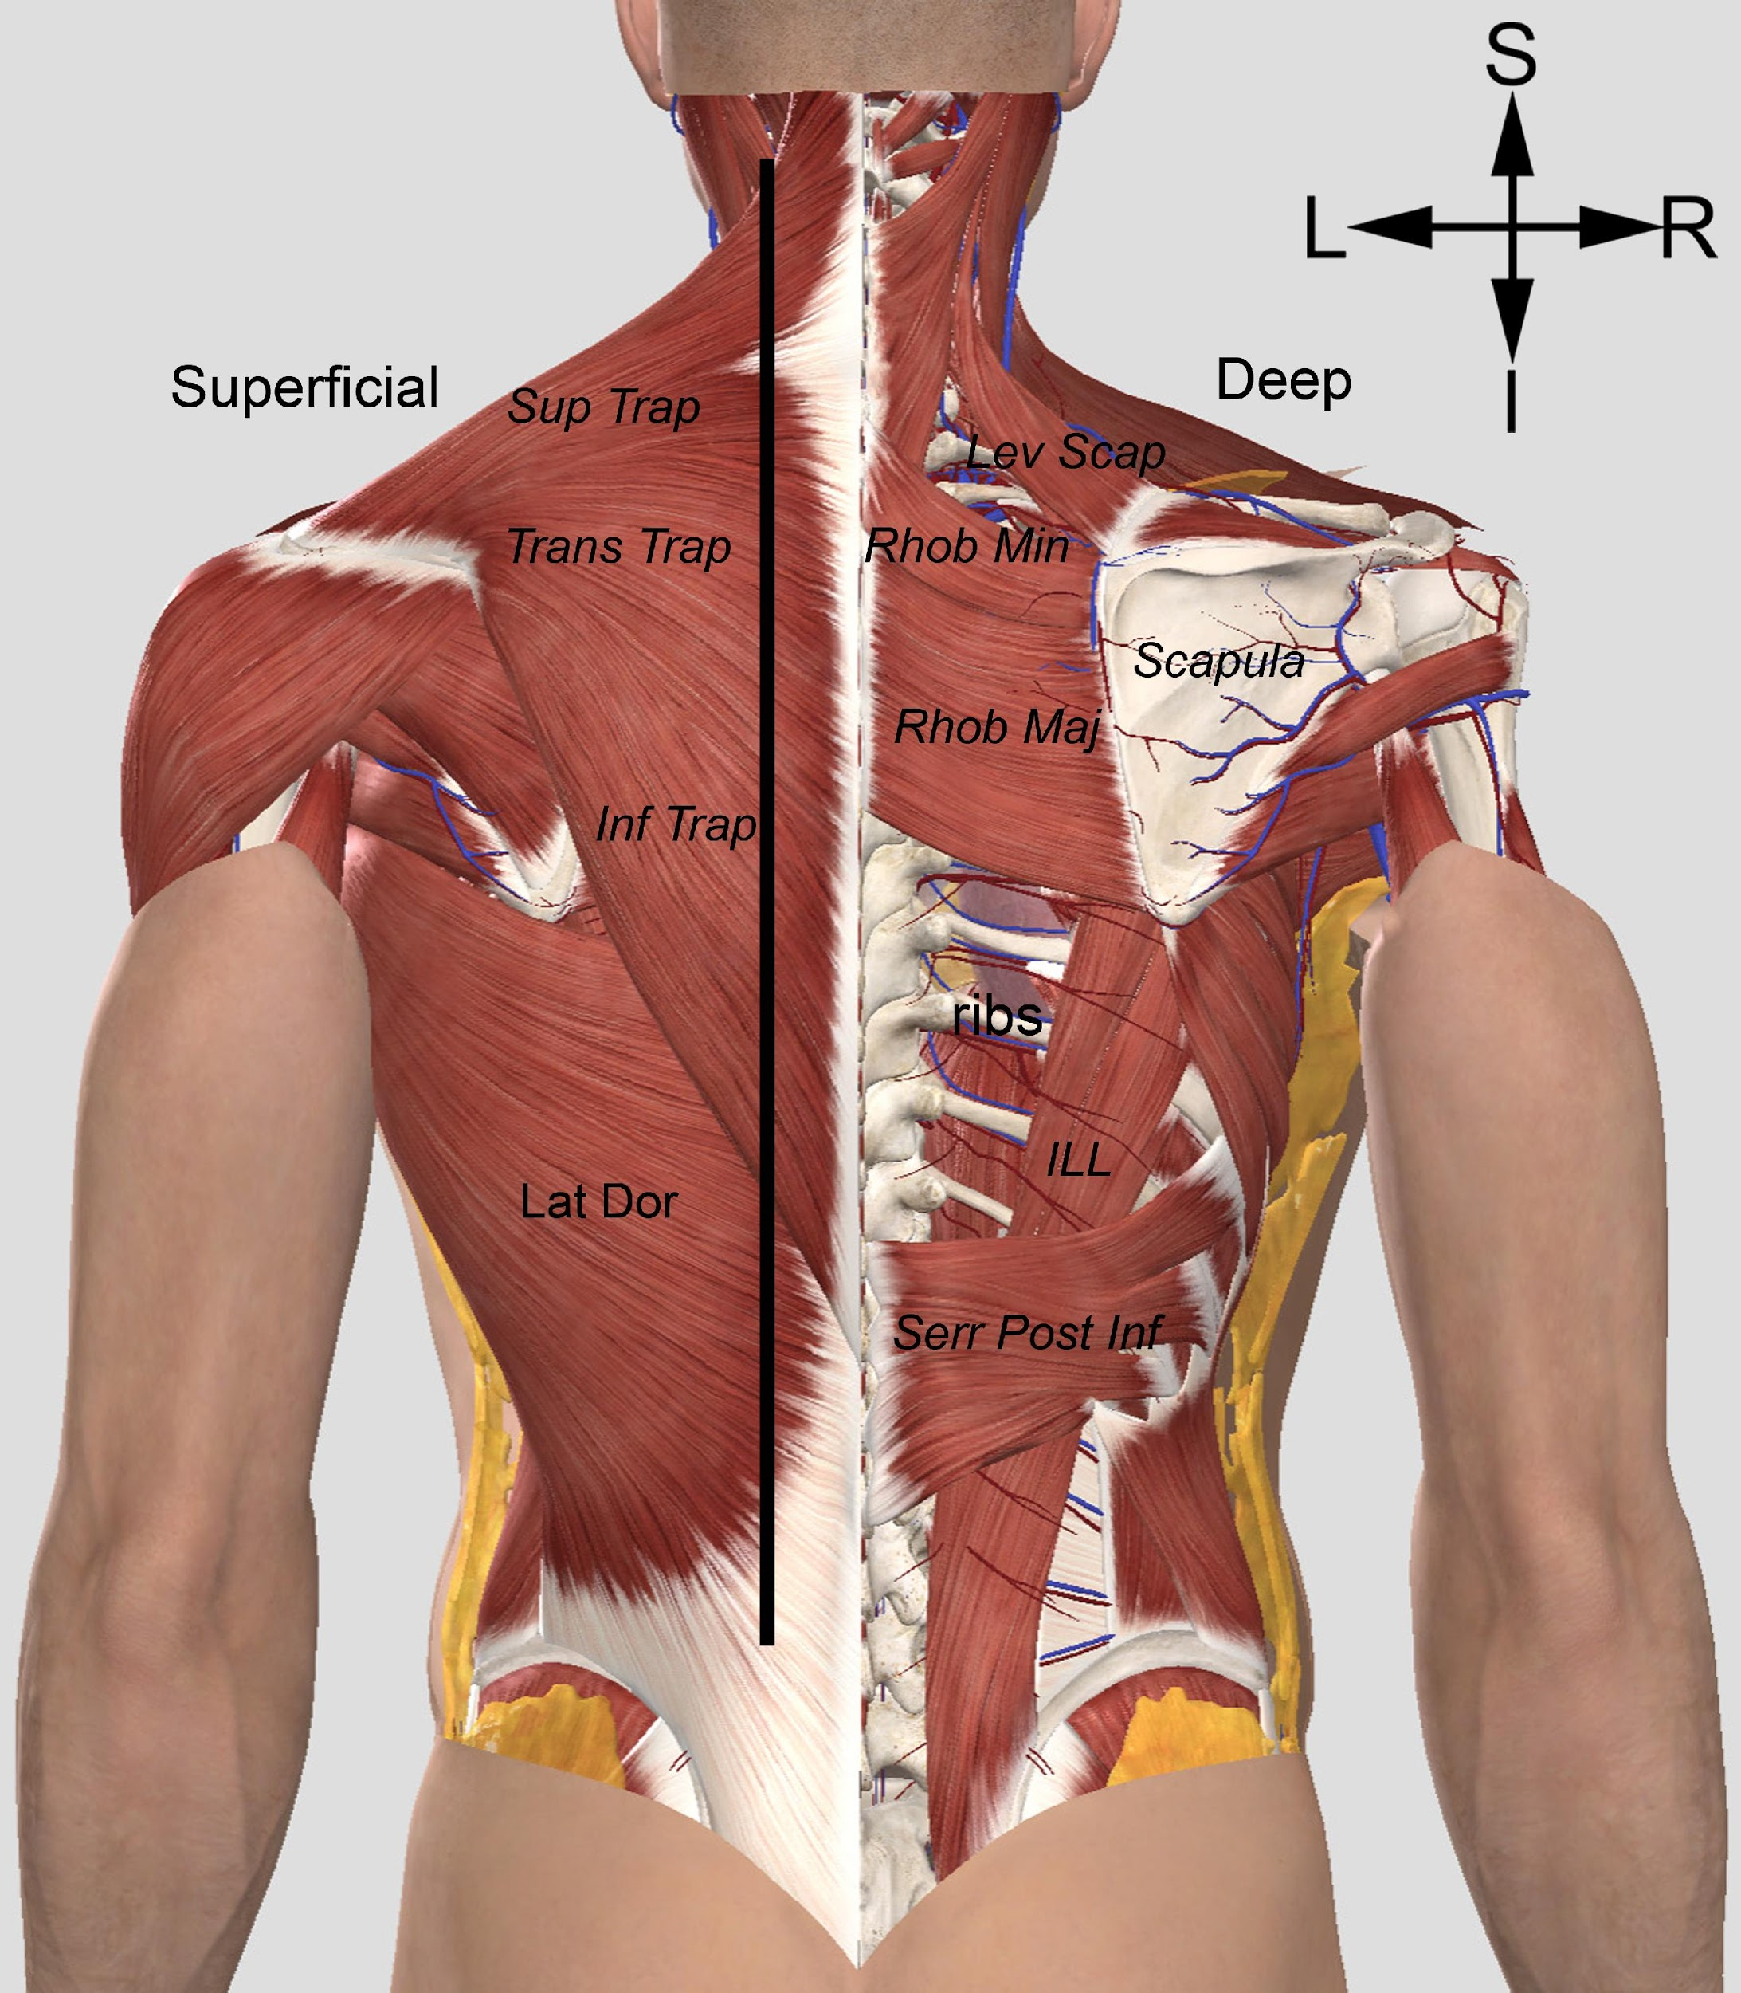

Figure 2: A posterior view of the thorax, illustrating some deeper structures encountered while exposing the ribs. On the left side, the erector spinae muscle group and the intercostal muscles are illustrated. Note how the erector spinae would have obscured access to the ribs at a point where they attach to vertebrae. This would have made it difficult to “cut” the ribs as this point. Also note, that the intact intercostal muscles would have prevented independent movement of each rib, meaning that the rib cage on each side would have to be mobilised as one single unit. The right side illustrates the relationships between the bones of the back and internal structures. The shoulder blade (scapula) lies superficial to the ribs and the lungs (pink structure seen between the ribs and indicated with a *), and covers significant segment of the rib cage. If the shoulder blades had remained in this position, it would have been impossible to spread the ribs laterally to form “wings”. The lungs shown here represent the organs in a normal anatomical position, and not what the lung would look like when collapsed in response to the opening of the thoracic wall. It should also be noted that the lower ribs have significant attachments to the diaphragm (seen here between the lower ribs), making it difficult to spread the rib cage without cutting through this muscle. Orientation is shown in the upper right corner. S = superior, I = inferior, L = left, R = right. (Image generated using 3D4Medical Complete Anatomy software).
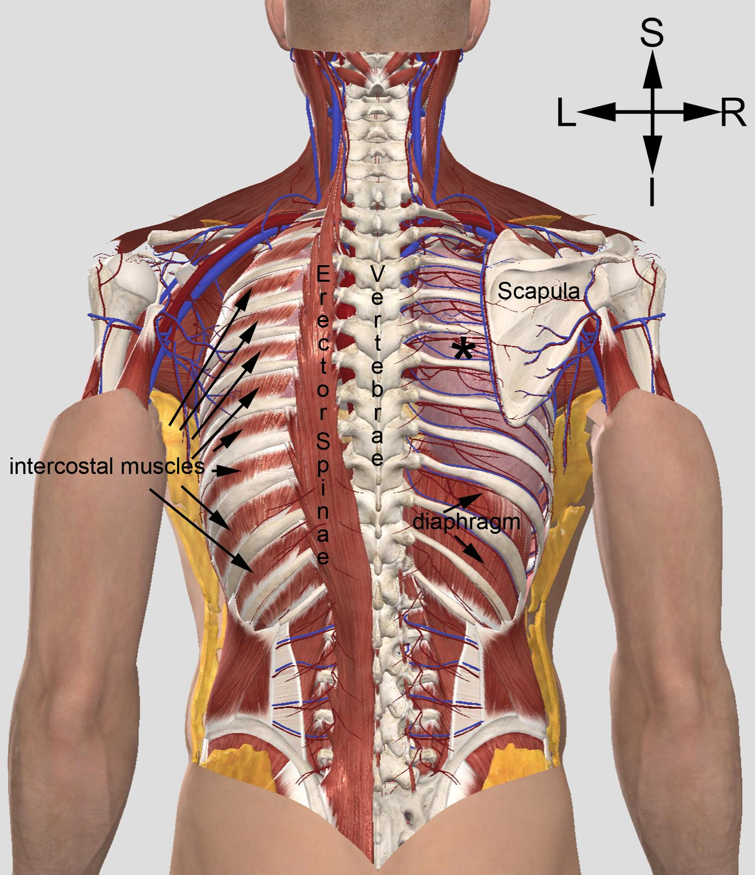

Figure 3: A posterior view of the thorax illustrating the results of detaching or cutting the ribs. The left side illustrates how fracturing the ribs near the angles would make it difficult to mobilise the lungs through the opening made, because the residual attached parts of the ribs (arrows) would have obscured access to the lung. It is important to note, however, that this would be the most likely fracture point of the ribs when using blunt force trauma on the posterior thoracic wall. The lungs would have completely collapsed when the thorax was opened and would have been situated in a very tight mass near the mediastinum. The right side illustrates the opening in the thoracic wall if it were possible to detach the ribs directly from the thoracic vertebrae. Though this would not have been possible, it would have allowed for greater access to the lungs and enabled structuring of more substantial “wings”. To spread the ribs laterally, their attachments to the diaphragm inferiorly would have to be severed. Regardless of where the ribs were cut near the midline, the ribs would have to be fractured again probably near the midaxillary line so that they could be spread laterally without deforming the thorax anteriorly. L. Lung = left lung; R. Lung = right lung; . Orientation is shown in the upper right corner. S = superior, I = inferior, L = left, R = right. (Image generated using 3D4Medical Complete Anatomy software).
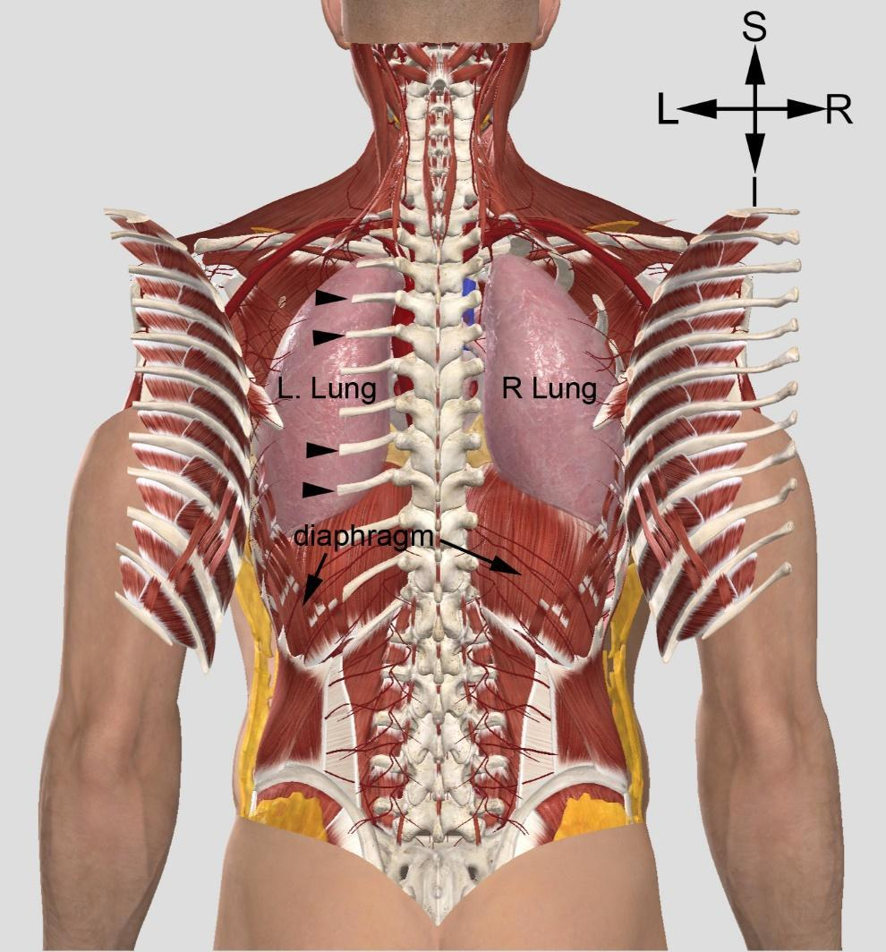

Figure 4: a) a range of Anglo-Scandinavian personal knives from York. After Patrick Ottaway, Anglo-Scandinavian Ironwork from 16-22 Coppergate (London, 1992), plate XLa. Reproduced with permission. b) two broad-bladed Norwegian sverdknivene (‘sword knives’), dated to the sixth or seventh centuries, from Mo, Vestre Slidre, Innlandet (left, blade length c. 22.5cm) and Eltdalen, Trysil, Innlandet (right, blade length c. 40cm). Note that these examples of short fighting blades thus predate the Viking Age by at least half a century, and the composition of the mid-fourteenth century Orms þáttr by around seven centuries After Gudesen, “Merovingertiden i Øst-Norge”, pl. 6, cf. pp. 32–33. Reproduced with permission. c) four sheathed söx from the graves at Valsgärde, Sweden. L-R, they are from Valsgärde 8 (mid-seventh century, blade length c. 39cm), Valsgärde 7 (mid-seventh century, blade length c. 56cm), Valsgärde 7 (mid-seventh century, blade length c. 52.5cm), and Valsgärde 5 (c. 700, blade length c. 40.5cm). After Olsén, Die Saxe von Valsgärde, fig. 103–106, cf. pp. 13–22. Reproduced with permission.
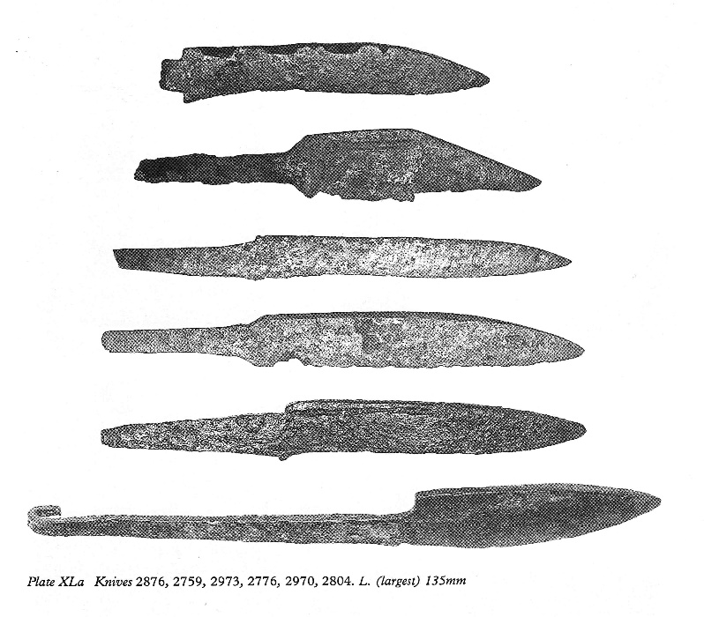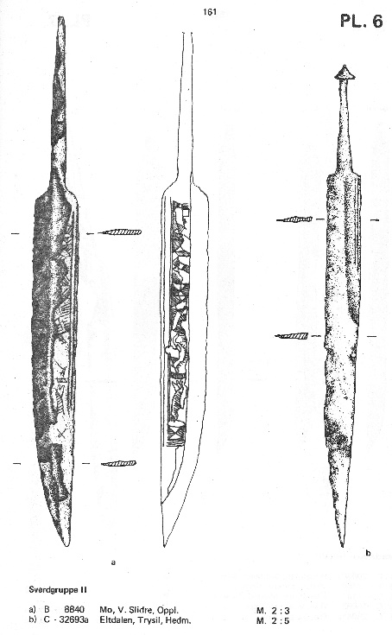
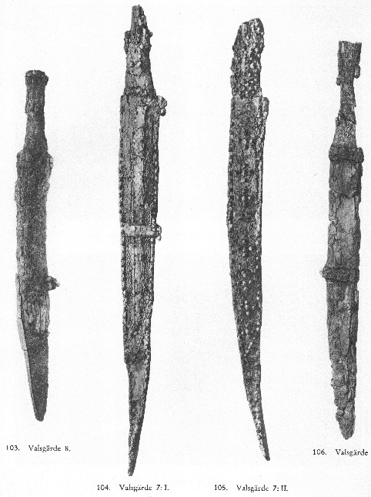

Figure 5: a) Norwegian Type L barbed spearheads from Homerstad, Stange, Innlandet (L) and Strand, Elverum, Innlandet (R). After Petersen, De norske vikingesverd, p. 34, fig. 23–24. b) Norwegian Type C and D lugged spearheads from Asla, Ringsaker, Innlandet (L, Type C), Hamerstad, Stange, Innlandet (C, Type D), and Møli, Tinn, Vestfold & Telemark (R, Type D). After Petersen, De norske vikingesverd, p. 25, fig. 9–10. © Det Norske Videnskaps-Akademi – The Norwegian Academy of Science and Letters. c) A zoomorphic spear socket in the Ringerike style, bronze with the remains of an iron blade, excavated at York in the early nineteenth century. After Lang, “A Viking Age Spear-Socket from York,” pl. XV. Reproduced with permission.
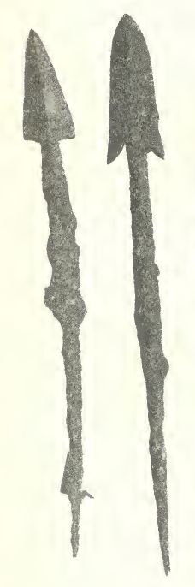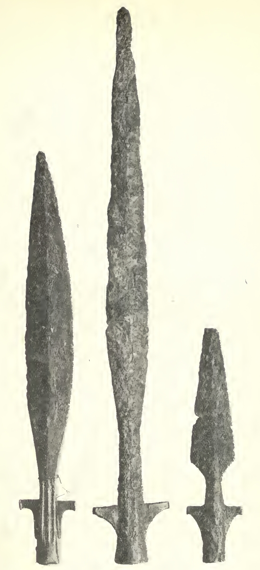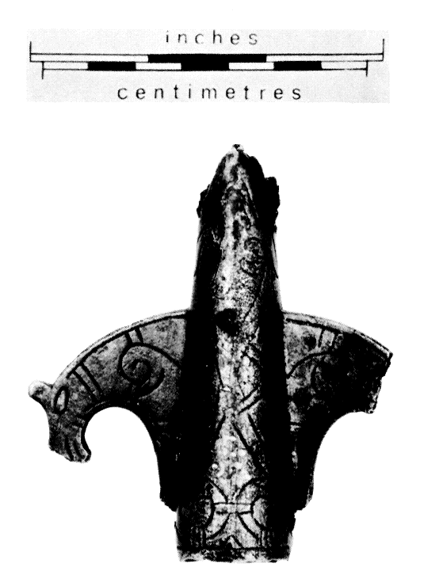

Figure 6: a) The Viking-Age Lärbro St. Hammars I picture stone, Gotland, Sweden. Image Rights: Wikimedia Commons, reproduced under a Creative Commons licence. b) Black and white rendering of the relevant panel, performed by the authors on the basis of the modern painted stone. c) Karl Hauck’s drawing, based on a latex mould of the same panel. Permission pending.
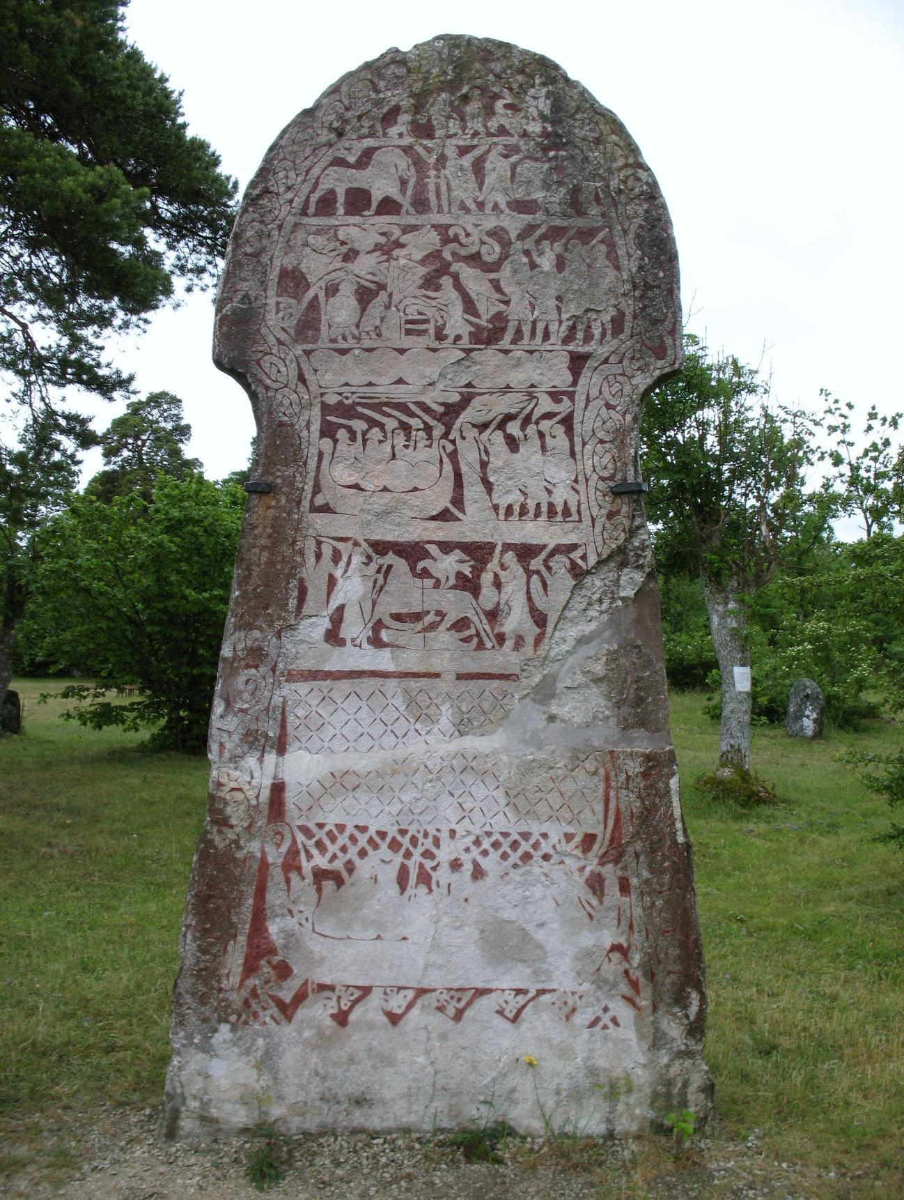
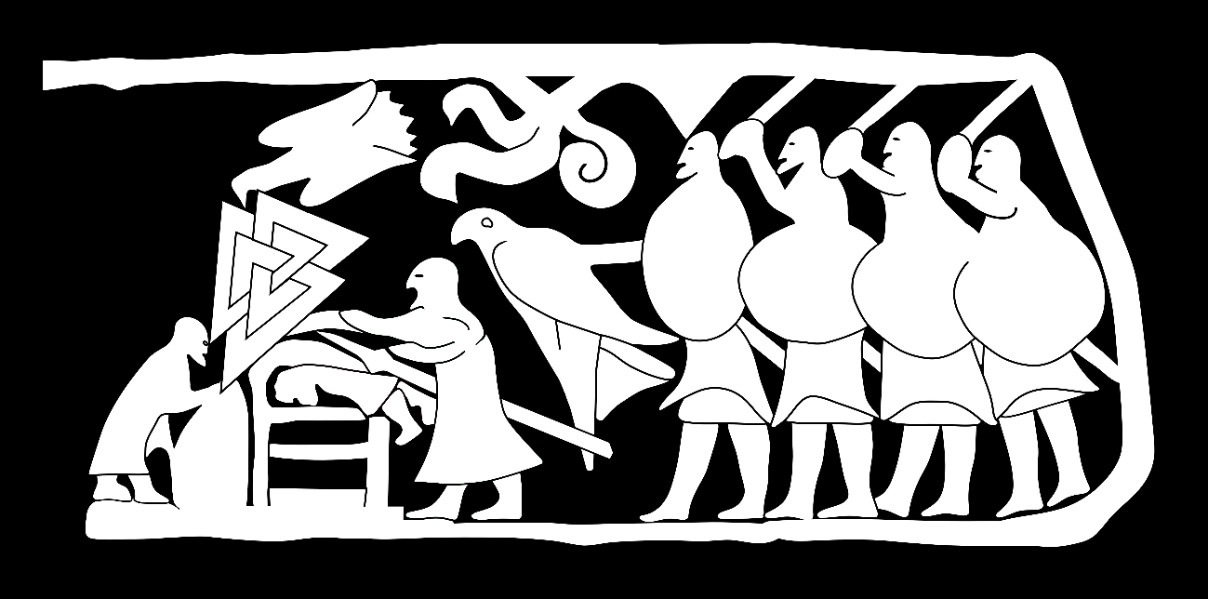
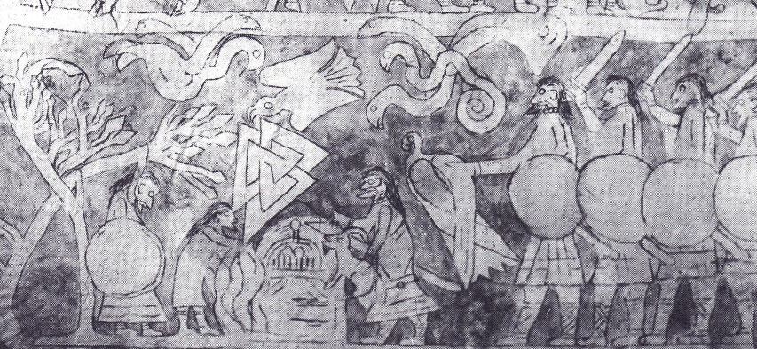

Figure 7: a) Original excavators’ drawing of Brika grave Bj. 595. After Arbman, Birka, vol 1, p. 384, reproduced with permission. b) Reconstruction of Bj. 959 by Mirosław Kuźma. Copyright Leszek Gardeła and Mirosław Kuźma, reproduced with permission.
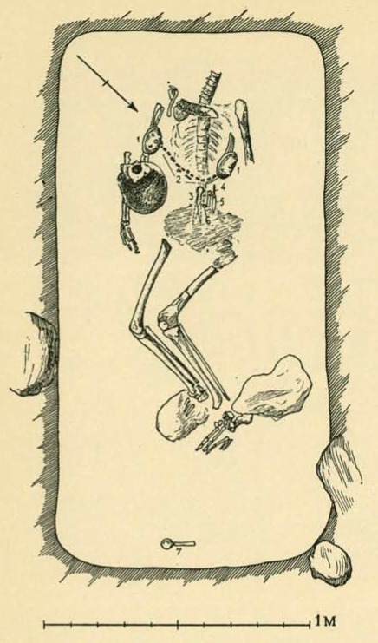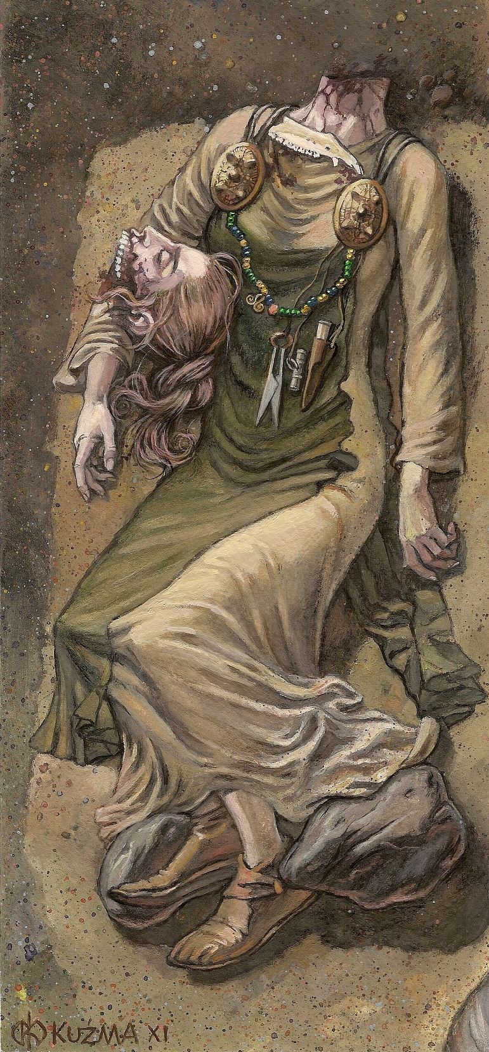

Notes

The authors would like to thank Tom Lovelock for generating digital images to illustrate anatomical structures affected by a blood eagle procedure, and 3D4Medical (https://3d4medical.com/) for permission to use the Complete Anatomy software for the production of images. We also would like to thank Luke Welsh (Keele University) for his helpful discussions on the anatomy of the posterior trunk, and Adam Parsons (Blueaxe Reproductions) for his help with Iron Age tools. We are also deeply grateful for the assistance of many curators, librarians, and publishers – particularly Rebecca Sampson (York Archaeological Trust) and Emilie Myhre (Norges forskningsråd) – in securing the rights to reproduce the images included in this article. Finally, we would like to thank Dr Catherine Holmes (University College, Oxford), Editor of the English Historical Review; Dr Pernille Hermann (Aarhus University), Editor of Viking and Medieval Scandinavia; Prof. Katherine L. Jansen (Catholic University of America), Editor of Speculum, as well as a number of anonymous reviewers for their helpful feedback, advice and encouragement on the early drafts of this manuscript. The Article Processing Free enabling us to make this research Open Access was generously covered by a University of Leicester Open Access grant.
All authors take responsibility for the final form of this text. Luke John Murphy takes primary responsibility for the sections titled “The Medieval Discourse of the Blood Eagle” and “The Sociocultural Context of the Blood Eagle”, and has produced the translations; Heidi R. Fuller and Monte A. Gates share primary responsibility for the section titled “The Anatomical Practicalities of the Blood Eagle”.
The texts use variations of “[at] rísta/skera/marka [blóð]ǫrn”. See discussion of each individual account below.
Saxo Grammaticus, Gesta Danorum: The History of the Danes 9.5.5, ed. Karsten Friis-Jensen, trans. Peter Fisher, 2 vols., (Oxford, 2015), vol. 1, p. 664: “dorsum plaga aquilam figurante affici iuben.” A synoptic history of the Danes, including euhemerised accounts of pre-Christian mythology, the Gesta Danorum was produced in Denmark during the thirteenth century. See further Karsten Friis-Jensen, ed., Saxo Grammaticus: A Medieval Author Between Norse and Latin Culture (Copenhagen, 1981).
Sigvatr Þórðarson, Knútsdrápa, in Poetry from the Kings’ Sagas 1: From Mythical Times to c. 1035, ed. Matthew Townend, Skaldic Poetry of the Scandinavian Middle Ages 1 (Turnhout, 2012), 651. Knútsdrápa is a skaldic poem in praise of Knútr inn ríki, likely composed in the 1020s or 1030s. The poem as a whole celebrates the monarch’s successful subjugation of England in 1016–17 in typically terse skaldic style, with the opening strophe setting the scene by invoking the successful Viking incursion that overthrew – and allegedly inflicted a blood eagle upon – King Ælla of Northumbria in 867 or 868.
Ragnars saga loðbrókar, in Fornaldar sögur Norðurlanda, eds. Guðni Jónsson and Bjarni Vilhjálmsson (Reykjavík, 1943), vol. 1, p. 143; translated in The Saga of the Volsungs: With the Saga of Ragnar Lothbrok, trans. Jackson Crawford (Indianapolis, 2017), 85–133. Ragnars saga recounts the life of the eponymous king, who is believed to have lived in the mid-ninth century, including the death of his (alleged) killer Ælla. However, the thirteenth-century fornaldarsaga blends credible and legendary episodes, and is a highly literary construction reflecting a widespread cultural discourse regarding Ragnar and his family; Elisabeth Ashman Rowe, Vikings in the West: The Legend of Ragnarr Loðbrók and His Sons, Studia Medievalia Septentrionalia 18 (Vienna, 2012), 207–16; cf. Rory McTurk, Studies in Ragnars saga Loðbrókar and Its Major Scandinavian Analogues, Medium Ævum Monographs New Series 15 (Oxford, 1991).
Reginsmál, in Eddukvæði, eds. Jónas Kristjánsson and Vésteinn Ólason, 2 vols. (Reykjavík, 2014), vol. 2, p. 302; translated in The Poetic Edda, trans. Carolyne Larrington (Oxford, 1996), 151–156. Reginsmál is an eddic poem, part of the heroic collection in the second half of the late thirteenth-century Codex Regius. Its dating (and even status as a separate text from adjacent poems) is complicated, but it has been suggested that the poem as it now stands shares a common ancestor with both the main manuscripts of Sorra Edda on the one hand and Vǫlsunga saga and Ragnars saga on the other (Klaus von See et al., eds., Kommentar zu den Liedern der Edda. Heldenlieder: Frá dauða Sinfiǫtla, Grípisspá, Reginsmál, Fáfnismál, Sigrdrífumál, Kommentar zu den Liedern der Edda 5 (Heidelberg, 2006), 264–73). The vocabulary of the prose passages between the verses provides a terminus post quem in the late twelfth century, although it remains possible the poetic verses were recycled from earlier texts (von See et al. Kommentar, 274).
Reginsmál, vol. 2, p. 302
Saxo Grammaticus, Gesta Danorum 9.5.5, vol. 1, p. 664: “figurante”.
Snorri Sturluson, Haralds saga ins hárfagra, in Heimskringla, ed. Bjarni Aðalbjarnarson, 3 vols., Íslenzk Fornrit 26–28 (Reykjavík, 1941), vol. 1, p. 132; translated in Snorri Sturluson, Heimskringla, trans. Alison Finlay and Anthony Faulkes, 3 vols. (London, 2014–2016), vol. 1, pp. 54–87. Haralds saga forms part of Heimskringla, a compilation of konungasögur laying out the history of Norway that is generally accepted to have been compiled by Snorri Sturluson, the Icelandic scholar-statesman, in the first half of the thirteenth century. Snorri may have drawn on Orkneyinga saga for his account of the blood eagle, as Heimskringla and Orkneyinga saga share a complicated textual relationship. Compare the arguments of Finnbogi Guðmundsson ed., Orkneyinga saga, Íslenzk Fornrit 34 (Reykjavík, 1965), xxxi to those presented by Alexander Burt Taylor, trans., The Orkneyinga Saga: A New Translation with Introduction and Notes (Edinburgh, 1938), 59–62. See also Judith Jesch, “Orkneyinga Saga: A Work in Progress?,” in Creating the Medieval Saga: Versions, Variability and Editorial Interpretations of Old Norse Saga Literature, ed. Judy Quinn and Emily Lethbridge (Odense, 2010), 153–73, 289–324, esp. 161–62.
Orkneyinga saga, 13; translated in Orkneyinga Saga: The History of the Earls of Orkney, trans. Hermann Pálsson and Paul Edwards (London, 1981). Recounting the lives of the various rulers of Orkney and the Shetland Isles, Orkneyinga saga is an Icelandic saga that does not conform to any of the major generic groupings employed in modern scholarship. No complete version of the text is extant, and Jesch has demonstrated that even the fullest witness – the late-fourteenth century Flateyjarbók – represents a particular (late) stage in the text’s development; “A Work in Progress?”; cf. Elisabeth Ashman Rowe, The Development of Flateyjarbók: Iceland and the Norwegian Dynastic Crisis of 1389, The Viking Collection 15 (Odense, 2005), 98–104). While the earliest exemplar was likely compiled around 1200, subsequent versions drew on other texts and conventions circulating in the medieval literary milieux, and its blood eagle episode in particular shares a great deal with Snorri’s Haralds saga account of the same events, which might suggest a close – or even intertextual – relationship (Orkneyinga saga, xxxi; Taylor, The Orkneyinga Saga, 59–62).
Orms þáttr Stórólfssonar, in Harðar Saga, eds. Þórhallur Vilmundarson and Bjarni Vilhjálmsson, Íslenzk Fornrit 13 (Reykjavík, 1991), 418; translated in The Complete Sagas of Icelanders with 49 Tales, ed. Viðar Hreinsson et al, trans. Matthew Driscoll (Reykjavík 1997), vol. 3, pp. 455–467. Labelled a fornaldarþáttr by Elisabeth Ashman Rowe and Joseph Harris (“Short Prose Narrative (þáttr),” in A Companion to Old Norse-Icelandic Literature and Culture, ed. Rory McTurk (Oxford, 2007), 462–79, 464), Orms þáttr Stórólfssonar displays an uneasy generic hybrid of íslendingasaga and fornaldarsaga features, and has been tentatively dated to the second or third quarter of the fourteenth century by Þórhallur Vilmundarson and Bjarni Vilhjálmsson, Orms þáttr, cxc. The text is biographical, charting the adventures of its pseudo-historical Icelandic strongman protagonist, and shows interest in the supranatural, albeit at a safe remove from its Icelandic audience in Denmark and Norway, where its blood eagle episode also occurs.
Norna-Gests þáttr, in Fornaldar sögur Norðurlanda, vol. 1, p. 179; translated in Stories and Ballads from the Far Past, trans. Nora Kershaw (Cambridge, 1921), 14–37. The þáttr is one of the so-called “pagan-contact þættir” (Rowe and Harris, “Short Prose Narrative”, 463), where Christian figures are confronted with aspects of Scandinavia’s pagan past. The text consists of a framework narrative set in the court of Óláfr Tryggvason (i.e. late tenth century Norway) and an autobiographical account of Norna-Gestr himself, a pagan who claimed to have been over three centuries old and to have witnessed many of the great events of pre-Christian legend – including the blood eagle performed on Lyngvi. The text is preserved in a number of manuscripts, the oldest of which (Flateyjarbók and AM 62 fol.) date to the late fourteenth century.
Ragnarssona þáttr, in Fornaldar sögur Norðurlanda, vol. 1, p. 158; translated in The Sagas of Ragnar Lodbrok, trans. Ben Waggoner (New Haven, 2009), 63–73. Also known as Þáttr af Ragnars sonum, Ragnarssona þáttr is a fornaldarsaga text covering much the same ground as Ragnars saga. It survives only in the early fourteenth-century Hauksbók manuscript, which may be the collection for which it was first composed; Rowe, Vikings in the West, 228–36. The þáttr’s account of Ragnar’s death and subsequent the killing of Ælla in revenge is less detailed than the saga’s, and would appear to reflect a knowledge of and interest in medieval Norwegian, rather than Icelandic, concerns; Rowe Vikings in the West, 235–36.
Snorri Sturluson, Haralds saga, vol. 1, p. 132.
Sigvatr Þórðarson, Knútsdrápa, 65.
Frank, “Viking Atrocity and Skaldic Verse: The Rite of the Blood-Eagle,” English Historical Review 99 (1984): 332–43, 339.
Frank, “Viking Atrocity and Skaldic Verse”; Bjarni Einarsson, “De Normannorum Atrocitate, Or On the Execution of Royalty by the Aquiline Method,” Saga Book of the Viking Society 22 (1986–89): 79–82; Frank, “The Blood-Eagle Again,” Saga Book of the Viking Society 22 (1986–89): 287–89; Bjarni Einarsson, “Blóðörn – An Observation on the Ornithological Aspect,” Saga Book of the Viking Society 23 (1990–93): 80–81; Frank, “Ornithology and the Interpretation of Skaldic Verse,” Saga Book of the Viking Society 23 (1990–93): 81–83; cf. also McTurk, Studies in Ragnars saga, 230.
Frank, “The Blood-Eagle Again,” 287, our emphasis
The Anglo-Saxon Chronicle, a vernacular chronicle tradition begun in the last thirty years of the ninth century – that is, between three and thirty two years after Ælla’s death – tersely states only that Ælla and his rival Osberht (another Northumbrian magnate) were both killed in the siege of York, with no mention of ritualised torture: ⁊ þa ciningas bægen ofslægene (“and there both kings were struck down”); Susan Irvine, ed., The Anglo-Saxon Chronicle: A Collaborative Edition. Volume 7, MS. E. A Semi-Diplomatic Edition with Introduction and Indicies, The Anglo-Saxon Chronicle: A Collaborative Edition 7 (Cambridge, 2004), 48. Asser’s late ninth century Vita Ælfredi regis Angul Saxonum, the late tenth century Chronicon Æthelweardi, and Symeon of Durham’s early twelfth century Historia Regum all take the same line; Asser, Asser’s Life of King Alfred: Together with the Annals of Saint Neots Erroneously Ascribed to Asser, ed. William Henry Stevenson (Oxford, 1904), 23; Alistair Campbell, ed., Chronicon Æthelweardi: The Chronicle of Æthelweard, Medieval Texts (London, 1962); 36; Symeonis Dunelmensis, Opera et Collectanea, ed. I. Hodgson Hinde, The Publications of the Surtees Society (Durham, 1868), 48. Nonetheless, we are hesitant to regard this as definitive proof that Ælla was not captured and tortured to death by one or more of Ragnar’s sons at York: it might be that for the Old English and subsequent Anglo-Latin texts, “captured in the battle at York and tortured to death shortly afterwards as a direct result” and “killed in the battle at York” were more or less the same thing, and that their terse style favoured the latter expression.
Frank, “Viking Atrocity and Skaldic Verse,” 341.
Sigurðar saga þǫgla is an Icelandic saga conventionally dated to the fourteenth century. It follows the fantastic adventures of the eponymous hero and his two brothers, and has been counted among the lygisögur (lit. “lying sagas”), a genre of late medieval prose fiction characterised by Matthew Driscoll as “an exotic (non-Scandinavian), vaguely chivalric milieu… characterized by an extensive use of foreign motifs and a strong supernatural or fabulous element”; Matthew Driscoll, “Late Prose Fiction (lygisögur),” in A Companion to Old Norse-Icelandic Literature and Culture, ed. Rory McTurk (Oxford 2007), 191. In an episode where the eponymous Sigurðr’s brothers are captured by Sedentiana, a Maiden King, she þa let […] taka suerd og let ʀijsta ugla ꜳ bake þeim med suerdzoddunum (“then had a sword taken, and had an owl carved onto their backs with the swordpoint”); Late Medieval Icelandic Romances II: Saulus saga ok Nikanors, Sigurðar saga þǫgla, ed. Agnete Loth, trans. J.B. Dodsworth, Editiones Arnamagnæanæ, Series B 21 (Copenhagen, 1963), p. 127; see further Henric Bagerius, “Romance and Violence: Aristocratic Sexuality in Late Medieval Iceland,” Mirator 14 (2013): 79–96. On Maiden King sagas more generally, see Erik Wahlgren, The Maiden King in Iceland (Chicago, 1938); Marianne E Kalinke, “The Misogamous Maiden Kings of Icelandic Romance,” Scripta Islandica 37 (1986): 47–71; Bridal-Quest Romance in Medieval Iceland (Ithaca, 1990); Jóhanna Katrín Friðriksdóttir, “From Heroic Legend to ‘Medieval Screwball Comedy’? The Origins, Development and Interpretation of the Maiden-King Narrative,” in The Legendary Sagas: Origins and Development, ed. Ármann Jakobsson, Annette Lassen, and Agneta Ney (Rekjavík, 2012), 229–49.
Frank, “The Blood-Eagle Again,” 287.
That it was Ælla’s back that was cut by the eagle in this reading might be an attempt to suggest the Northumbrian king was killed from behind, implying he cowardly fled from battle. On the Beasts of Battle motif in Old Norse literature, see Judith Jesch “Eagles, Ravens and Wolves: Beasts of Battle, Symbols of Victory and Death,” in The Scandinavians from the Vendel Period to the Tenth Century, ed. Jesch (Woodbridge 2002), 251–280; on the motif in Old English literature, see Francis Patrick Magoun, “The Theme of the Beasts of Battle in Anglo-Saxon Poetry,” in Neuphilologische Mitteilungen 56 (1955): 81–91; Thomas Honegger, “Form and Function: The Beasts of Battle Revisited,” in English Studies 79 (1999): 289–298; Hugo Edward Britt, “The Beasts of Battle: Associative Connections of the Wolf, Raven and Eagle in Old English Poetry” (Melbourne, 2014).
Jan de Vries, Altgermanische Religionsgeschichte, 3rd ed., 2 vols. (Berlin and Leipzig, 1970), vol. 1, p. 411–12; Alfred P. Smyth, Scandinavian Kings in the British Isles, 850–880 (Oxford, 1977), 192; Klaus af Edholm, “Att rista blodörn. Blodörnsriten sedd som offer och ritualiserad våldspraktik i samband med maktskiften i fornnordisk tradition,” Scripta Islandica 69 (2018): 5–40.
Orkneyinga saga, 13.
Gautreks saga, in Fornaldar sögur Norðurlanda, vol. 3, p. 6; translated in Seven Viking Romances, trans. Hermann Pálsson and Paul Edwards (London, 1985), 140–141. On the Ætternisstapi, see further Birgitta Odén, “Ättestupan – myt eller verklighet?” in Scandia. Tidskrift för historisk forskning 62 (1996): 221–234.
Miranda Aldhouse-Green, Dying for the Gods: Human Sacrifice in Iron Age & Roman Europe (Stroud, 2001).
E.g. Mike Dash, “The Vengeance of Ivarr the Boneless: Did He, and Other Vikings, Really Use a Brutal Method of Ritual Execution Called the ‘Blood Eagle’?,” Smithsonian.com, March 18, 2013, https://www.smithsonianmag.com/history/the-vengeance-of-ivarr-the-boneless-4002654/.
E.g. Sharon Turner, History of the Anglo-Saxons, 5th ed., 3 vols. (Paris, 1840), vol. 1, p. 304; Johann Martin Lappenberg, Geschichte von England, 1st ed., 2 vols., Geschichte der Europäischen Staaten (Hamburg, 1834), vol. 1, p. 302; Lappenberg, A History of England Under the Anglo-Saxon Kings, trans. Benjamin Thorpe, 2 vols. (London, 1845), vol. 2, p. 34.
Snorri Sturluson, Haralds saga, vol. 1, p. 132: “ofan á lendar”.
Alexandre Mendonça Munhoz et al., “Periareolar Skin-Sparing Mastectomy and Latissimus Dorsi Flap with Biodimensional Expander Implant Reconstruction: Surgical Planning, Outcome, and Complications,” Plastic and Reconstructive Surgery 119/6 (2007): 1637–49.
E.g. Orkneyinga saga, 13: “rifin […] frá hrygginum”.
Jason Forman et al., “Blunt Impacts to the Back: Biomechanical Response for Model Development,” Journal of Biomechanics 48/12 (2015): 3219–26.
Guillermo Gutierrez, H. David Reines, and Marian E. Wulf-Gutierrez, “Clinical Review: Hemorrhagic Shock,” Critical Care 8/5 (2004): 373–81.
Frank K. Butler et al., “Management of Open Pneumothorax in Tactical Combat Casualty Care: TCCC Guidelines Change 13–02,” Journal of Special Operations Medicine 13/3 (2013): 81–86.
Marc Noppen et al., “Quantification of the Size of Primary Spontaneous Pneumothorax: Accuracy of the Light Index,” Respiration 68/4 (2001): 396–99; K. Hoi, B. Turchin, and Anne-Maree Kelly, “How Accurate Is the Light Index for Estimating Pneumothorax Size?,” Australasian Radiology 51/2 (2007): 196–98.
Siam Singhal et al., “Morphometry of the Human Pulmonary Arterial Tree,” Circulation Research 33 (1973): 190–97; C.L.N. Robinson, N.L. Müller, and C. Essery, “Clinical Significance and Measurement of the Length of the Right Main Bronchus,” Canadian Journal of Surgery. Journal Canadien de Chirurgie 32/1 (1989): 27–28.
C.L.N. Robinson, N.L. Müller, and C. Essery, “Clinical Significance and Measurement of the Length of the Right Main Bronchus,” Canadian Journal of Surgery. Journal Canadien de Chirurgie 32/1 (1989): 27–28; Siam Singhal et al., “Morphometry of the Human Pulmonary Arterial Tree,” Circulation Research 33 (1973): 190–197.
Snorri Sturluson, Haralds saga, vol. 1, p. 132: “lagði sverði á hol við hrygginn”.
The classical study of Late Iron Age swords is Jan Petersen, De norske vikingesverd. En typologisk-kronologisk studie over vikingetidens vaaben, Videnskapsselskapets Skrifter 11 (Kristiania, 1919); cf. also an updated typology in Ian G. Pierce, Swords of the Viking Age (Woodbridge, 2002).
Orms þáttr, 418. What precisely might have been regarded as a sax and what a sword seems to have varied significantly over the course of the Nordic Iron and Middle Ages: one key distinction is that söx were always single-edged, but swords could be single- or double-edged. In Norway, there seems to have been a change from short, broad fighting knives to longer, sword-like blades around the year 700 AD, Hans Gude Gudesen, “Merovingertiden i Øst-Norge. Kronologi, kulturmønstre og tradisjonsforløp,” Varia 2 (1980): 36–39, 36–39; for Swedish swords, söx, and fighting knives, see Pär Olsén, Die Saxe von Valsgärde, Valsgärdestudien 2 (Uppsala, 1945).
See, for example, Kristján Eldjárn and Adolf Friðriksson, Kuml og haugfé, 2nd ed. (Reykjavík, 2000).
While some post-medieval Nordic billhooks feature “back hooks” for manipulating smaller branches, this feature does not appear on any of the Iron-Age arboreal tools in the archaeological record. The two Anglo-Scandinavian billhooks from the Flixborough tool hoard, for example, each have a single straight edge; Lisa M. Wastling and Patrick Ottaway, “Cultivation, Crop Processing and Food Procurement,” in Life and Economy at Early Medieval Flixborough, c. AD 600–1000: The Artefact Evidence, ed. D. H. Evans and Christopher Loveluck, Excavations at Flixborough 2 (Oxford, 2009), 243–52, 245; Patrick Ottaway et al., “Woodworking, the Tool Hoard and Its Lead Containers,” in Life and Economy at Early Medieval Flixborough, 253–77, 258, fig. 7.9.
No particular arrangements beyond the procuring of weapons are noted in our textual sources, although their literary nature does not necessarily preclude preparations having been made in a putative historical case.
Petersen, De norske vikingesverd, 33–34; fig. 23–24.
Petersen (De norske vikingesverd, 22–36) employed lugs as a typological characteristic, although this was later challenged by Signe Horn Fuglesang, Some Aspects of the Ringerike Style: A Phase of 11th Century Scandinavian Art (Odense, 1980), 139; cf. also James Lang, “A Viking Age Spear-Socket from York,” Medieval Archaeology 25 (1981): 157–60.
Lang, “A Viking Age Spear-Socket from York”.
Jan H. Orkisz, “Pole-Weapons in the Sagas of Icelanders: A Comparison of Literary and Archaeological Sources,” Acta Periodica Duellatorum 4/1 (2016): 177–212; Yulia Shtyryakova, “A Quest for the Atgeir: The Unknown Viking Weapon in Icelandic Sagas and Archaeological Data,” Acta Periodica Duellatorum 7/1 (2019): 27–60.
The Gotlandic picture stones are freestanding iconographic monuments raised on the Baltic island of Gotland during the mid-to-late Iron Age (c. 400–1100). During this period, and well into the Nordic Middle Ages, Gotland appears to have had an insular culture related to but distinct from mainland Scandinavian societies, with its own forms of dress, burial custom, social organisation, and East Norse language. The Gotland picture stones (just over 400 of which are known, almost all in Gotland) appear to have been raised in four distinct phases, with different iconographical discourses – but are always understood as either grave markers or memorial monuments. Lärbro St. Hammars I is a particularly elaborate example of a Phase 3 stone (c. 800–1000), which feature multiple panels depicting people, ships, animals, and other recognisable phenomena, which have long been linked to Medieval narrative sources (for an overview of this line of study, see Aðalheiður Guðmundsdóttir, “Saga Motifs on Gotland Picture Stones: The Case of Hildr Högnadóttir,” in Gotland’s Picture Stones: Bearers of an Enigmatic Legacy, ed. Maria Herlin Karnell, Reports from the Friends of the Historical Museum Association 84 (Visby, 2012), 59–71). The stones are catalogued in Sune Lindqvist, Gotlands Bildsteine, 2 vols. (Stockholm, 1941–42), partially updated in Laila Kitzler Åhfeldt, “3D Scanning of Gotland Picture Stones with Supplementary Material: Digital Catalogue of 3D Data,” Journal of Nordic Archaeological Science 18 (2013): 55–65, and subject to an extensive re-examination with photogrammetric methods in Sigmund Oehrl, Die Bildsteine Gotlands. Probleme und neue Wege ihrer Dokumentation, Lesung und Deutung, 2 vols., Studia archaeologiae medii aevi 3 (Friedberg, 2019). For an overview and study of their function as grave markers, see Anders Andrén, “Doors to Other Worlds: Scandinavian Death Rituals in Gotlandic Perspectives,” Journal of European Archaeology 1 (1993): 33–55. For recent studies of Iron (particularly Viking) Age Gotlandic identity, ritual, and religion, see Anders Andrén, “Servants of Thor? The Gotlanders and Their Gods,” in News from Other Worlds, Tíðendi ór ǫðrum heimum: Studies in Nordic Folklore, Mythology and Culture, ed. Merrill Kaplan and Timothy R. Tangherlini (Berkeley and Los Angeles, 2012), 92–100; Luke John Murphy, “Processes of Religious Change in Late-Iron Age Gotland: Rereading, Spatialisation, and Inculturation,” in Place and Space in the Medieval World, ed. Meg Boulton, Heidi Stoner, and Jane Hawkes, Routledge Research in Art History 1 (London and New York, 2018), 32–46.
Sune Lindqvist, Gotlands Bildsteine, vol. 1., pp. 104–07, esp. fig. 81; cf. Aðalheiður Guðmundsdóttir, “Saga Motifs on Gotland Picture Stones.”
Oehrl, Die Bildsteine Gotlands, vol. 1, pp. 61–62
Åhfeldt, “3D Scanning of Gotland Picture Stones”, Oehrl, Die Bildsteine Gotlands.
We are grateful to an anonymous peer reviewer for bringing this discrepancy to our attention.
John Moreland, Archaeology and Text (London, 2001); Neil S. Price, “What’s in a Name? An Archaeological Identity Crisis for the Norse Gods (and Some of Their Friends),” in Old Norse Religion in Long-Term Perspectives: Origins, Changes, and Interactions. An International Conference in Lund, Sweden, June 3–7, 2004, ed. Anders Andrén, Kristina Jennbert, and Catharina Raudvere, Vägar till Midgård 8 (Lund, 2006), 179–183.
Rowe, Vikings in the West; McTurk, Studies in Ragnars saga.
Orms þáttr, 409–14. Like the blood eagle, the “fatal walk” is a method of tortuous execution of dubious historicity. The victim is eviscerated, has their intestines fastened to a pole or stake, and is made to walk around it, drawing their viscera still further out until they expire. On its development and use as a literary motif, see John Frankis, “From Saint’s Life to Saga: The Fatal Walk of Alfred Ætheling, Saint Amphibalus and the Viking Bróðir,” Saga Book of the Viking Society 25 (1998–2001): 121–37. Any historical attempt to perform the fatal walk would have resulted in a very quick death: human viscera are anchored to the posterior part of the abdomen, which would have to be cut away in order to draw out the contents. While small segments can be mobilised separately and most of the intestines brought to the body’s surface, significant cuts would be required to allow their unwinding. This would swiftly result in death via exsanguination, and would not allow the victim to stand up and move around.
Ups. Univ. Bibl. Isl. R: 702 4to (late sixtieth or early seventeenth century) and Specimen lexici runici (1650) describe Einarr Jarl performing the deed himself, while AM 332 4to (late seventeenth century) and Flateyjarbók (late fourteenth century) employ a passive construction implying he had it arranged. See further Sigurður Nordal, ed., Orkneyinga Saga, Samfund til udgivelse af gammel nordisk litteratur 40 (Copenhagen, 1913–16), 12.
Ragnarssona þáttr, vol. 1, p. 158: “[l]étu þeir nú rista örn á baki Ellu”.
Stefan Brink, “Political and Social Structures in Early Scandinavia: A Settlement-Historical Pre-Study of the Central Place,” Tor 28 (1996): 235–281; “Political and Social Structures in Early Scandinavia II: Aspects of Space and Territoriality – The Settlement District,” Tor 29 (1997): 389–437; “Social Order in the Early Scandinavian Landscape,” in Settlement and Landscape, ed. Charlotte Fabech and Jytte Ringtved (Århus, 1998), 423–439.
Lotte Hedeager, “Scandinavia before the Viking Age,” in The Viking World, ed. Stefan Brink and Neil S. Price (London, 2008), 15; Terje Gansum, “Role the Bones – from Iron to Steel,” Norwegian Archaeological Review 37 (2004): 41–57.
Joakim Goldhahn and Terje Oestigaard, “Smith and Death – Cremations in Furnaces in Bronze and Iron Age Scandinavia,” in Essays in Honour of Lotte Hedeager on Her 60th Birthday, ed. Christopher Prescott, Chilidis Konstantinos, and Julie Lund, Oslo Archaeological Series 10 (Oslo, 2008), 215–41; on artisans as ritual specialists in the Nordic Bronze and Iron Ages generally, see Joakim Goldhahn and Terje Østigård, Rituelle spesialister i bronse- og jernalderen, 2 vols., Gotarc Serie C – Arkeologiska Skrifter 65 (Göteborg, 2007).
Ragnars saga, vol. 1, p. 143: “Nú skal sá maðr, er oddhagastr er, marka örn á baki honum sem inniligast.”
Richard Cleasby and Guðbrandur Vigfússon, An Icelandic-English Dictionary (Oxford, 1874), 462.
Jan Aksel Harder Klitgaard, “In Search of Askr Yggdrasill: A Phenomenological Approach to the Role of Trees in Old Nordic Religions”, MA thesis (University of Iceland, 2018); cf. Michael D. J. Bintley, Trees in the Religions of Early Medieval England, Anglo-Saxon Studies 26 (Woodbridge, 2015).
Caroline Arcini, “The Vikings Bare Their Filed Teeth,” American Journal of Physical Anthropology 128/4 (2005): 727–33; Leszek Gardeła, “Entangled Worlds: Archaeologies of Ambivalence in the Viking Age”, 2 vols., PhD thesis (University of Aberdeen, 2012), vol. 1, p. 71–74.
On ritual specialists in the pre-Christian Nordic region more generally, see Olof Sundqvist, Kultledare i fornskandinavisk religion, Occasional Papers in Archaeology 41 (Uppsala, 2007).
Páls saga is a Christian biography of Páll Jónsson (1155–1211), who was bishop of the Icelandic see of Skálholt (1195–1211). Traditionally grouped with other, more hagiographic bishops’ sagas, recent scholarship has instead stressed its links to current events in Iceland and the samtíðasögur (“contemporary sagas”); Margaret Cormack, “Christian Biography,” in A Companion to Old Norse-Icelandic Literature and Culture, ed. Rory McTurk (Oxford 2007), 27–28. The saga was likely composed very soon after the events it depicts, by a writer with direct experience of the people and places the text describes, suggesting that the artisan Margaret hin haga (“the skilful”) was a historical figure, and that her nickname and reputation were widely known in thirteenth-century Iceland; Paul Bibire, “Páls saga biskups,” in Medieval Scandinavia: an Encyclopedia, ed. Phillip Pulsiano and Kirsten Wolf (New York 1993), 496. The text describes the crozier as gioruann so hagliga ad eingi madur hafdi fyrr sied jaffnvel gioruann ä Jslandi er smydad hafdi Margret hin haga, er þa var oddhogust allra manna a Jslandi (“made so skilfully that no one had seen its equal made in Iceland before, [and] which was made by Margaret the skilful, who was then the most skilled with a point of everyone in Iceland”); Páls saga byskups, in Biskupa sögur II, ed. Ásdís Egilsdóttir (Reykjavík, 2002), vol. 2, p. 431; translated in Origines Islandicae: A Collection of the More Important Sagas and Other Native Writings Relating to the Settlement and Early History of Iceland, trans. Guðbrandur Vigfússon and F. York Powell (Oxford, 1905), vol. 2, pp. 502–534, p. 528.
Orkneyinga saga, 13; de Vries, Altgermanische Religionsgeschichte, vol. 1, pp. 411–12; Smyth, Scandinavian Kings in the British Isles, 189–94; af Edholm, “Att rista blodörn”.
On the tensions between mechanical and ritual (or ritualised) behaviour, see generally Catherine Bell, Ritual: Perspectives and Dimensions (Oxford, 1997); Ronald L. Grimes, “Religion, Ritual, and Performance,” in Religion, Theatre, and Performance: Acts of Faith, ed. Lance Gharavi (New York, 2011), 27–41; Pamela J. Stewart and Andrew Strathern, Ritual: Key Concepts in Religion (London, 2014).
Tom Hellers, Valknútr: Das Dreiecksymbol der Wikingerzeit, Studia Medievalia Septentrionalia (Vienna, 2012).
Folke Ström, On the Sacral Origin of the Germanic Death Penalties (Lund, 1942); Miranda Aldhouse-Green, Dying for the Gods: Human Sacrifice in Iron Age & Roman Europe (Stroud, 2001); Aleks Pluskowski, “The Sacred Gallows: Sacrificial Hanging to Óðinn,” Archaeological Review from Cambridge 17/2 (2000): 55–81; Klaus af Edholm, “Människooffer i Fornnordisk Religion. En Diskussion Utifrån Arkeologiskt Material Och Källtexter,” Chaos – Skandinavisk Tidsskrift for Religionshistoriske Studie 65 (2016): 125–48.
Ragnarssona þáttr, vol. 1, p. 158.
de Vries, Altgermanische Religionsgeschichte, vol. 1, p. 411: “Vaterrache”.
Mary Bradbury, “The Good Death?,” in Death, Dying, and Bereavement, ed. Donna Dickenson and Malcom Johnson, 2nd ed. (London, 2000), 56–63, p. 59. See also Maurice Bloch and Jonathan Parry, eds., Death and the Regeneration of Life (New York, 1982); Phyllis Palgi and Henry Abramovitch, “Death: A Cross-Cultural Perspective,” Annual Review of Anthropology 13 (1984): 385–417.
Saxo Grammaticus, Gesta Danorum 9.4.38–39, vol. 1, pp. 660–62.
Ragnars saga, vol. 1, pp. 134–35; Ragnarssona þáttr, vol. 1, p. 134–35.
Snorri Sturluson, Haralds saga, vol. 1, p. 130. Orkneyinga saga, 12, notes Rǫgnvaldr’s death at Háfldan’s hands, but not the method.
Orms þáttr, 410–14.
Norna-Gests þáttr, vol. 1, p. 157. Reginsmál, as part of a complex cycle of interconnected poems covering several generations of heroes, makes no explicit mention of Sigmundr’s death.
Keith Ruiter and Steve Ashby’s recent study on judicial violence in early-medieval Europe observed that hanging, despite (or due to?) its association with Óðinn in many sources, appears to have been regarded as a particularly shameful death in early-medieval Gotland; “Different Strokes: Judicial Violence in Viking-Age England and Scandinavia,” Viking and Medieval Scandinavia 14 (2018): 153–84.
Roy A. Rappaport, “The Obvious Aspects of Ritual,” in Ecology, Meaning, and Religion (Berkeley, CA, 1979), 173–217.
It might be worth noting in this context that the thirteenth-century Norwegian law code, Gulatingslov, lists the use of a krocoro or krocſspiote (“hook, barb”, “hooked, barbed spear”) among several other misſvigi (“indirect killings”): “þat er hít þriðia miſvígí ef maðr er loſten krocoro. æða krocſpiote. oc þarf at ſkera stil” (that is the third type of indirect killing, if a man is struck with a barb or barbed spear, and it must be cut out); Bjørn Eithun, Magnus Rindal, and Tor Ulset, eds., Den Eldre Gulatingslova (Oslo, 1994), 138; cf. Orkisz, “Pole-Weapons in the Sagas of Icelanders”, 200. Presumably an unbarbed spear would still have caused a wound, but not required the surgical removal of the barbed head, for which the Gulatingslov holds the attacker liable, suggesting some types of wounds – and deaths – were more permissible than others.
Norna-Gests þáttr, vol. 1, p. 179: “dó Lyngvi með mikilli hreysti.”
Consider, for example, the repeated urgings to silence and restraint in strophes 6–7, 15, and 27 of Hávamál (in Eddukvæði, eds. Jónas Kristjánsson and Vésteinn Ólason, 2 vols. (Reykjavík, 2014), vol. 1, pp. 323–27; translated in The Poetic Edda, trans. Carolyne Larrington (Oxford, 1996), 14–38; cf. John Lindow, Comitatus, Individual and Honor: Studies in North Germanic Institutional Vocabulary (Berkeley, 1976) and William Ian Miller, Humiliation: And Other Essays on Honor, Social Discomfort, and Violence (Ithaca, 1993)), or the famous death of Gunnarr Gjúkason, who, bound and throw into a snake pit to die, signals his noble background and character by playing the harp (e.g. Atlamál hin groenlenzku, in Eddukvæði, eds. Jónas Kristjánsson and Vésteinn Ólason, 2 vols. (Reykjavík, 2014), vol. 2, p. 394; translated in The Poetic Edda, trans. Carolyne Larrington (Oxford, 1996), pp. 217–233; cf. Aðalheiður Guðmundsdóttir, “Saga Motifs on Gotland Picture Stones”).
Orms þáttr, 418: “lét svá líf sitt með litlum drengskap.”
Frands Herschend, The Idea of the Good in Late Iron Age Society (Uppsala, 1998); Tommy Kuusela, “‘Hallen var lyst i helig frid’: Krig och fred mellan gudar och jättar i en fornnordisk hallmiljö”, PhD thesis (Stockholm University, 2017).
“Att rista blodörn”, 30.
Neil S. Price, “Dying and the Dead: Viking Age Mortuary Behaviour,” in The Viking World, ed. Stefan Brink and Neil S. Price (London, 2008), 257–273; “Passing into Poetry: Viking-Age Mortuary Drama and the Origins of Norse Mythology,” Medieval Archaeology 54 (2010): 123–56.
Ibn Fadlān, Risāla, in James E. Montgomery, ed., “Ibn Fadlān and The Rūsiyyah,” Journal of Arabic and Islamic Studies 3 (2000): 14–19; Snorri Sturluson, Gylfaginning, ed. Anthony Faulkes, 2nd ed. (London, 2005), 46; translated in Snorri Sturluson, Edda, trans. Anthony Faulkes, 3rd ed. (London, 1987), 7–58.
Adam of Bremen, Gesta Hammaburgensis ecclesiae pontificum 4.27, ed. Bernhard Schmeidler, 3rd ed. (Hannover & Leipzig, 1917), 260; translated in Adam of Bremen, History of the Archbishops of Hamburg-Bremen, trans. Francis J. Tschan (New York, 2002).
Egils saga Skalla-Grímssonar, ed. Sigurður Nordal, Íslenzk Fornrit 2 (Reykjavík, 1933), 171; translated in The Complete Sagas of Icelanders with 49 Tales, ed. Viðar Hreinsson et al, trans. Bernard Scudder (Reykjavík 1997), vol. 1, pp. 33–177.
Ibrāhīm ibn Ya‘qūb al-Isrā’īlī al-Turṭushi, in Georg Jacob, ed., Arabische Berichte von Gesandten an germanische Fürstenhöfe aus dem 9. und 10. Jahrhundert, Quellen zur deutschen Volkskunde (Berlin und Leipzig, 1927), 29; there is no English translation of which we are aware.
Edeltraud Aspöck, “What Actually Is a Deviant Burial? Comparing German-Language and Anglophone Research on ‘Deviant Burials,’” in Deviant Burial in the Archaeological Record, ed. Eileen M. Murphy, Studies in Funerary Archaeology 2 (Oxford, 2008), 17–34; Gardeła “The Dangerous Dead? Rethinking Viking-Age Deviant Burials,” in Conversions: Looking for Ideological Change in the Early Middle Ages, ed. Leszek Paweł Słupecki and Rudolf Simek (Vienna, 2013).
Fredrik Svanberg, Decolonizing the Viking Age, 2 vols. (Stockholm, 2003); Eva Thäte, Monuments and Minds. Monument Re-Use in Scandinavia in the Second Half of the First Millenium AD, Acta Archaeologica Lundensia Series in 4° 27 (Lund, 2007); Gardeła, “Entangled Worlds”; “The Dangerous Dead?”.
Holger Arbman, Birka. Untersuchungen und Studien. Die Gräber. Text (Stockholm, 1940), vol 1, p. 384.
Gardeła, “The Dangerous Dead?”, 107–08.
As some medieval sources suggest a blood eagle could constitute only superficial modifications to soft tissue, it is not impossible that archaeologists have already excavated the remains of a blood eagle victim without being able to recognise them as such – a potential case of “invisible deviance”, where deviant mortuary practices to not result in recognisably deviant remains; Gardeła, “Entangled Worlds”, vol. 1, p. 71; “The Dangerous Dead?”, 120–22.
cf. Smyth, Scandinavian Kings, 214–23.
Svanberg, Decolonizing the Viking Age.
Andreas Nordberg, Krigarna i Odins sal. Dödsföreställningar och krigarkult i fornnordisk religion, 2nd ed. (Stockholm, 2004); Luke John Murphy, “Between Unity and Diversity: Articulating Pre-Christian Nordic Religion and Its Spaces in the Late Iron Age”, PhD thesis (Aarhus University, 2017).
Svanberg, Decolonizing the Viking Age, vol. 1, p. 186.
Nordberg, Krigarna i Odins sal; Sundqvist, Kultledare i fornskandinavisk religion; contrast the model of non-elite religions developed in Luke John Murphy, “Paganism at Home: Pre-Christian Private Praxis and Household Religion in the Iron-Age North,” Scripta Islandica 69 (2018): 49–97.
Ènver Achmedovič Makaev, John Meredig, and Elmer Antonsen, The Language of the Oldest Runic Inscriptions: A Linguistic and Historical-Philological Analysis (Stockholm, 1996), 23–48.
Herschend, The Idea of the Good.
Ruiter & Ashby, “Different Strokes”.
Till Mostowlandsky and Andrea Rota, “A Matter of Perspective? Disentangling the Emic–Etic Debate in the Scientific Study of Religion\s,” in Method and Theory in the Study of Religion 28 (2016): 317–336, 323; on the emic/etic debate in scholarship on the Viking Age, see further Luke John Murphy, “Towards a Phrasebook of Methodology in Viking Studies: A Perspective from the Study of Religion,” in Retrospective Methods Network Newsletter 15 (2020).
On the development of Hel as both a hostile mythological figure and a negative afterlife destination in pre-Christian Scandinavia, see Christopher Abram, “Hel in Early Norse Poetry,” in Viking and Medieval Scandinavia 2 (2006), 1-29. On Valhöll as a form of warrior’s paradise associated with Óðinn worship and elite martial culture, see Edith Marold, “Das Walhallbild in den Eiríksmál und den Hákonarmál,” Mediaeval Scandinavia 5 (1972): 19–33; Anders Hultgård, “Ragnarök and Valhalla: Eschatological Beliefs among the Scandinavians of the Viking Period,” in The Twelfth Viking Congress: Developments Around the Baltic and the North Sea in the Viking Age, ed. Björn Ambrosiani and Helen Clarke (Stockholm, 1994), 288–293; Nordberg, Krigarna i Odins Sal; Hultgård, “Óðinn, Valhǫll and the Einherjar. Eschatological Myth and Ideology in the Late Viking Period,” in Ideology and Power in the Viking and Middle Ages: Scandinavia, Iceland, Ireland, Orkney and the Faeroes, ed. Gro Steinsland et al. (Leiden, 2011), 297–328.
On so-called “suttee” in the Iron-Age Nordic region, see Haakon Shetelig, “Traces of the Custom of Suttee in Norway during the Viking Age,” Saga Book of the Viking Society 6 (1910): 180–208; Hilda Ellis Davidson, The Road to Hel: A Study of the Conception of the Dead in Old Norse Literature (New York, 1968), 50–58. On slavery in the Viking Age, see Ruth Mazo Karras, Slavery and Society in Medieval Scandinavia, Yale Historical Publications 135 (New Haven and London, 1988); Stefan Brink, “Slavery in the Viking Age,” in The Viking World, ed. Stefan Brink and Neil S. Price (London and New York, 2008), 49–56; Vikingarnas slavar: Den Nordiska träldomen under yngre järnålder och äldsta medeltid (Stockholm, 2018).
On the practice of víglýsing (lit. “killing-declaration”), which differentiated morð (“murder”) from víg (“manslaughter, killing”), see further Dieter Strauch, “Víglysing und Lysing,” in Germanische Altertumskunde Online, Reallexikon der Germanischen Altertumskunde 32 (Berlin & Boston, 2006), 364–371.

