Public Sentiments towards the COVID-19 Pandemic: Insights from the Academic Literature Review and Twitter Analytics
Geetika Jain¹
¹Keele Business School, Keele University, UK, geetikajain02@gmail.com ; g.jain@keele.ac.uk
Samuel Fosso Wamba²
²Full Professor, Toulouse Business School, France, s.fosso-wamba@tbs-education.fr

Archana Shrivastava³
³Assistant Professor, Jaypee Business School, Uttar Pradesh, India, archanashri07@gmail.com

Rohit Sharama⁴
⁴Research Scholar, NITIE, Mumbai, India, rohit.sharma.2017@nitie.ac.in
ABSTRACT
The recent COVID-19 pandemic has severely impacted nations across the globe. Not only has it created economic shocks, but also long-term impacts on the social and psychological behaviors of the public. This can be attributed to the severity of the pandemic and because of the preventive and control measures such as global lockdowns, social distancing, and self-isolation that the governments imposed. Previous studies have reported significant changes in human emotions and behaviors are used to measure public sentiments about certain phenomena (such as the recent pandemic). The present study aims to study the public's sentiments during the COVID-19 outbreak based on an analytics review of public tweets highlighting changes in emotions. A dataset of 58,320 tweets extracted from Twitter and 61 academic articles was explored to analyze behavioral and emotional changes during previous and current pandemic situations. We chose the RPA – COV (Research Process Approach – COVID-19) approach, which was combined with the LBTA (Literature-Based Thematic Analysis) and the COVTA (COVID-19 Twitter Analytics). The sentiments' analysis results were coupled with word-tree analysis and highlighted that the public showed more highly neutral, positive, and mixed emotions than negative ones. The analysis pointed that people may react differently on Twitter as compared to real-life circumstances. The present study makes a significant contribution towards understanding how the public express their sentiments in pandemic situations.
Keywords: Sentiment analysis, Pandemic, COVID-19, Twitter analytics, Thematic analysis

Introduction
Pandemics represent a massive public health threat given their death toll in quite a short period (Taylor et al., 2001). The WHO report 1 (Organization, 2020a) on COVID-19 confirmed 282 cases in four countries on January 20, 2020. This number drastically rose from 282 cases (January 20, 2020) to 2,798 cases (January 27, 2020) in 12 countries (reported in the WHO report 7 (Organization, 2020b)). As per the current WHO report 83 (Organization, 2020d), 1.7 million were already infected, with 0.11 million deaths globally. COVID-19 has taken a toll on the economy, arousing the highest decline in the financial market since 1987, a high record on unemployment, and a major hit to the travel industry with multiple restrictions (Jones et al., 2020). Over the past centuries, pandemics such as Swine flu, Ebola, SARS, MERS, etc., have been persistent, but the COVID-19 pandemic has taken the entire world by storm. Pandemics can cause a high number of fatalities and account for a severe public health risk (Mukherjee, 2017). The COVID-19 outbreak's impact will be long-lasting on people's psychology and physiology (Kecmanovic, 2020). Social isolation is very likely to change the immune system and the sleeping pattern of the world population (Higgins, 2020). The COVID-19 pandemic is expected to cause psychological distress on frontline health workers (Ho et al., 2020). In view of recent statistics, the COVID-19 impact could appear as the deadliest pandemic affecting the entire World. There is also widespread concern about its effects on mental health. Fear, anxiety, worry, and stress are natural in the prevailing circumstances (WHO). This study aims to explore changes in the sentiments of people as a result of emotional distress caused by COVID-19.
Twitter, a microblogging site, is considered a rich source of information that can be used to identify patterns and observe the reactions/ sentiments of the general public (Ahmed, 2019). Past research has explored the use of Twitter to gain insights into pandemic outbreaks (Signorini et al., 2011; Kostkova et al., 2014; Oluwafemi et al., 2014; Chew and Eysenbach, 2010). Qualitative content analysis, also known as thematic analysis, is a widely used quality-based technique (Kuckartz, U., 2019). The researchers aim to investigate how Twitter users have been reacting to the pandemic crisis. In doing so, we performed a qualitative analysis of past research papers published on pandemics to comprehend people's emotions during such emergencies and then provide the historical context. The sentiments of people towards the COVID-19 outbreak, as expressed on the Twitter platform, were captured and the data collected were analyzed. This was followed by a thematic and content analysis of published research papers. When we compared the results from the content, thematic, and cluster analysis performed on research papers on pandemics with the results from the sentiment, content, and network analysis performed on Twitter data, we gathered insights into people's feelings about pandemics across regions/countries and over time. We have classified tweets according to whether they express positive, negative, mixed, or neutral sentiments to establish polarity scores for judging feelings about pandemics.
This study has significant implications that the study is of its first unique study to test the RPA-COV framework by examining the people's sentiments during a pandemic by understanding the change in sentiments as an outcome of COVID (Min et al., 2021). To the best of our knowledge, this is the first research that involves a qualitative analysis of past studies on pandemics and social media analytics of Twitter data on the COVID-19 pandemic. In this study, the thematic and content analysis of the literature review depicts the way people feel and think about pandemics. In contrast, social media analytics attempts to explore people's sentiments about the COVID-19. It has been observed that sentiments are the core form of interest of an individual, and the current study examines the effect of the dynamics on an individual's sentiments. Thus, this study contributes to the temporal effect of an event; therefore, this study depicts the progression of people's sentiments towards pandemics over time. Overall, the study attempts to explore the following research questions (RQs):
RQ1: What are the various sentiments shown by the general public towards the COVID-19 pandemic across multiple geographies?
RQ2: How does previous literature investigate the sentiment of the general public towards pandemics?
RQ3: What are the emergent topics and themes highlighting the general public's sentiment towards COVID-19?
The findings of this research are expected to help different health care stakeholders, including policymakers and health workers, in their daily actions. In particular, health workers specialized in psychological and mental healthcare are specially targeted, as they work tirelessly to ensure the physical and mental wellbeing of people during pandemic outbreaks. Following the introduction, the literature review makes a thematic analysis of past research and social media analytics in research. Then, the methodology section highlights how data was extracted from Twitter, how research papers are being identified and what research methods were used. This is followed by a detailed data analysis section and another one summarizing and discussing the findings. The last section is the conclusion, with implications, limitations, and future research directions.

Literature review
In recent times, social media usage has witnessed exponential growth, leading to huge volumes of data, and the accumulated data is known as social media big data. Many social media platforms wherein the general public can communicate, share ideas, and exchange relevant information (Kim et al., 2014). Of all the social media platforms, Twitter is one of the most widely used social media to study interactions and communication (Sinnenberg et al., 2017). Data from Twitter (referred to as Twitter analytics) can be captured and analyzed to provide intelligence (Tricco et al., 2017). Twitter analytics can then be used for discerning trends and insights into a particular issue (Golder and Macy, 2011). Past studies have mined and analyzed the social media data but have been restricted to defined time frames and issues (Kim et al., 2016). As per Lischke et al. (2017), Twitter is like a gold mine of frank and voluntary opinions of the general public. Often, communication on social media leads to an efficient capture of personal thoughts and opinions (Godes and Mayzlin, 2004). Social sciences research studies have highlighted that the time spent on social media platforms influences human behavior (Statista, 2019). The social media platforms have voluminous data in the form of user-generated content. This user-generated content has a psychological influence (both negative and positive) on people's lives (Crawford, 2009). It has also been observed that nowadays, people are paying a lot of attention to the opinions and suggestions shared online, social media users tend to share their opinions, ideas, and emotions (sentiments ranging from irony and negation, sadness and happiness, surprise, confusion to name a few) (Ali et al. 2017; Ji et al. 2016). These sentiments tend to influence critical business decisions and policy-related developments from an organization and government perspective. The extraction of these large-scale posts containing public sentiments is referred to as sentiment analysis, and the technique is known as opinion mining.
Sentiment analysis is gaining a lot of popularity nowadays. It helps uncover the latest events and dynamic trends as people express their sentiments candidly on social media platforms (Chaudhary and Naaz, 2017). Sentiment analysis is used extensively by researchers across various fields such as marketing, for human behavior (Al-Yafi et al., 2018; Hamouda, 2018; Odoom et al., 2017; Rathore et al., 2017; Zeng et al., 2010), the analysis of customer dissatisfaction (Fan and Gordon, 2014) and learning (Leonardi, 2017; Li et al. 2017). With the advancement of information and communication technologies (ICTs), we can provide ample information on the spread of infectious diseases. Many studies have highlighted the role of ICTs in aiding sentiment analysis on social media platforms (Singh et al., 2018). Various studies have highlighted that sentiment analysis could have possibly helped in effectively controlling the epidemic outbreaks. Hutto and Gilbert (2014) studied the valence and intensity of tweets on pandemics and discovered that distribution of sentiments changes with time and place (Georgiadou et al., 2020). Ahmed (2019) studied the type of information spread on Twitter during the Swine flu outbreak in 2009. Like other studies, their study demonstrated the importance of Twitter in information dissemination during pandemics (Ahmed, 2018; Ahmed et al., 2018; Alonso-Mu~noz et al., 2017; McClellan et al., 2017; Stokes & Senkbeil, 2017; Wekerle et al., 2018; Hashimy et al., 2021).
As a social media analytics tool, sentiment analysis helps accurately measure the positive or negative bent of public sentiments expressed on social media platforms (Rosenthal et al., 2015). It provides real-time communication channels through which information is disseminated and precautionary measures taken in affected areas (Liu, 2015; Alsudais & Corso, 2015; Bendler et al., 2014; Mirbabaie et al., 2016; Gill et al., 2014; van Gorp et al., 2015). It has also been effectively utilized to assess product assessments (Pang et al., 2008) and evaluate stocks in financial markets (Nguyen and Shirai, 2015). Researches have indicated a significant impact of social media in disaster response. Disaster relief agencies need to be conscious of the effects of emotional churning by the affected people. This can be judged by assessing the expression of doubts, anger, overall satisfaction, etc., about social media through network analysis (Ji et al., 2015).
In the present study, we attempt to discover various aspects of 'pandemics' that researchers have identified in the past so that these efforts can be used to understand the sentiments of people towards pandemics. We use the published literature to identify dominant emotions through thematic analysis. Thematic analysis is used for understanding and analyzing various themes (Braun and Clarke 2006). The thematic analysis involves searching, reviewing, and defining themes (Sodhi and Tang, 2018). Variables are identified using a thematic analysis of published research papers. Themes are deciphered based on the frequency of words in the research papers (Kuckartz, 2019d). The qualitative descriptive technique includes thematic and content analysis. It is applied to analyze text and interpret themes (Vaismoradi et al., 2016). Past research has investigated Twitter content by employing quantitative techniques for gaining data on pandemics (Nolasco and Oliveira, 2020; Chew & Eysenbach, 2010; Signorini et al., 2011; Kostkova et al., 2014; Oluwafemi et al., 2014). This research fills the gap by providing valuable insights into the sentiments of people towards pandemics over time and geography, using social media analytics for the current COVID-19 pandemic, and employing qualitative research on past published papers on pandemics.

Methodology
To explore the public emotions and concerns about the COVID-19, this study made an effort to understand the overall public behavior in a particular social context of disease transmission. Twitter API was used to extract the data. The study has combined the literature-based thematic analysis (LBTA) with the coronavirus Twitter analytics (COVTA) using Python and NodeXL software, as mentioned in Figure 1, to perform this analysis. Such a combination aims to get a holistic overview of this pandemic situation. Literature-based thematic analysis (LBTA) will provide public emotions, interests, and concerns by taking a historical overview of similar situations. On its part, COVID Twitter analytics (COVTA) will examine the current situation by analyzing the user's sentiments towards the current COVID-19 situation (Figure 1).
Figure 1: Research process approach for COVID-19 (RPA-COV)
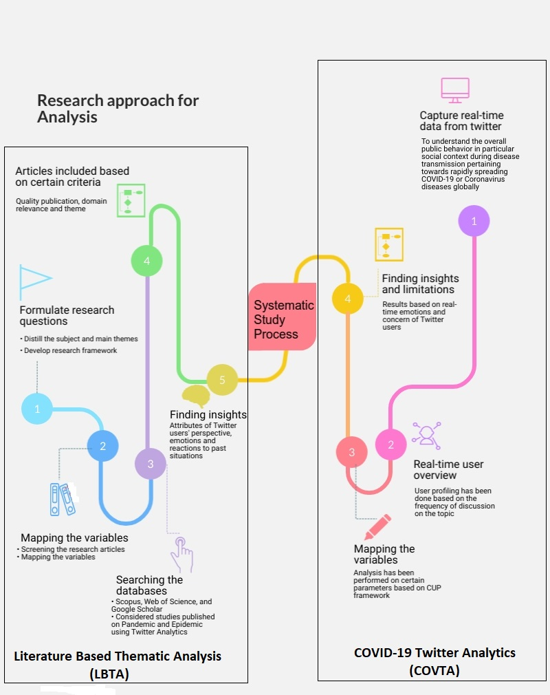

Extraction of Relevant Articles
Various academic paper databases have been used to extract papers with a clear focus on understanding the COVID-19 situation. After using multiple sources, we eventually extracted a good number of papers till March 2020. Two major search words were used during the search on different databases: 'Pandemic' and 'Epidemic'. After a preliminary search on google scholar, we selected a total of 3,456 articles. Considering the volume of academic articles, we finally selected articles based on the type of publication journal only. In the second round of investigation, 792 articles were selected. The third step of the work consisted of using another filter (Twitter analytics) to screen the articles further. Figure 2 provides more details on the selection of final articles. Following the basic screening of research articles, obtained only 127 articles, and the final number was reached using abstract screening on these articles. Through Twitter Analytics or Text Mining (the adopted methodology) (Lipizzi, 2016), we were, therefore, able to select all the articles had cited for past pandemic or epidemic scenarios.
Figure 2: Selection method of academic articles
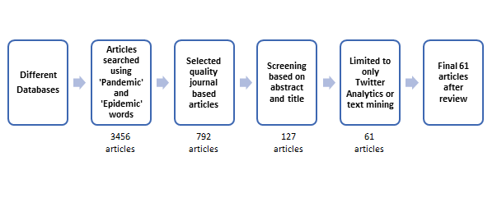

Twitter Analytics Process
Twitter analytics (TA) will help to understand the emotions and concerns of different users in the Covid-19 crisis. Twitter is an online mediated communication tool (Al-Yafi et al., 2018; Sunday and Vera, 2018) and an effective tool for identifying the user emotional behavior (Brandt et al., 2017) and examining the user interests (Feng et al., 2015) and knowledge sharing (Leonardi, 2017). It will be the right approach to use Twitter analytics for COVID-19 to understand the emotional behavior of users. The CUP framework (Fan and Gordon, 2014) has been used to perform Twitter analytics in this study. The CUP framework has three major processes: capturing tweets, understanding the data, and presenting the results.

Tracing of Tweets
The data has been extracted from Twitter using Tweepy API in a specific time framework from January 25, 2020 to April 4, 2020. During this period, approximately 80,420 tweets were extracted using two hashtags, namely "Coronavirus' and 'COVID-19'. We noticed the existence of multiple tweets with low-quality information or less helpful information concerning the coronavirus situation. So, after doing the initial screening of such tweets, we obtained 58,320 final tweets, all of which were used to perform the final analysis on different parameters under Twitter Analytics (TA).

Findings and Results
The results and findings of this study were further divided into two significant sub-sections based on the type of analysis performed. In the first subsection of the findings, a detailed thematic analysis was presented based on the literature review, followed by Twitter analytics in the second sub-section of the study. Based on the similarity of the words, the clustering was perfomed in order to fetch the data from the different databases. So, by the process of clustering, the data will generate some specific groups based on similary or dissimarlity and further assignment each object to its closest medoid (Mostafa, 2019). In addition to clustering, the network analysis provided the network (twitter handle) density of the nodes that are highly conncted to each other on the Twitter or the density of handle is very high in nature compare to other handles. So, the network analysis is applied to select a specific dataset on twitter and create a certain range to measure the centrality, density and modularity of the data (Grandjean, 2016)

Insights from thematic analysis
Various academic articles were extracted from different databases using the search string, as mentioned in table 1. A total of 61 articles were extracted from Web of Science, Scopus, Taylor & Francis, and further analyzed based on the type of pandemic and epidemic situation cited in the paper.
Table 1: Data extraction details

Database | Search String Used
Web of Science | TOPIC: (Pandemic) AND TOPIC: (Epidemic), TOPIC: (Pandemic) AND TOPIC: (Social media), TOPIC: (Epidemic) AND TOPIC: (Social media)
Scopus | (TITLE-ABS-KEY (Pandemic) AND TITLE-ABS-KEY (Epidemic)), (TITLE-ABS-KEY(Pandemic) AND TITLE-ABS-KEY (Twitter)), (TITLE-ABS-KEY (Epidemic) AND TITLE-ABS-KEY (Twitter))
Taylor and Francis online | [All: Pandemic] AND [All: Epidemic], [All: Pandemic] AND [All: Twitter], [All: Epidemic] AND [All: Twitter]

RQ1: What are the various sentiments shown by the general public towards the COVID-19 pandemic across multiple geographies?
Figure 2 explains the number of instances for the recorded pandemics according to the type of situation. These pandemics include Flu Epidemic, Ebola Epidemic, Zika Epidemic, Dengue, Chikungunya, Diphtheria, H1N1 Flu, HIV Epidemic, and Measles. Figure 3 explains the distribution of type of flu (in numbers across various years) wherein figure 4 describe the distribution of specific fluw from duration prespective (in years) of pandemics or epidemics in respect to the current situation. These two figures examine the historical evidence mentioned in the research articles by using the text mining method. They then showcase a substantial amount of insights about each crisis. The maximum number of research articles have been found to relate to the Flu epidemic scenario, followed by those on the Zika virus epidemic and finally those concerning the Ebola epidemic. All the studies have been performed between 2009 to 2020.
Figure 3: Distribution of types of Flu (number)

Figure 4: Distribution of Flu (years)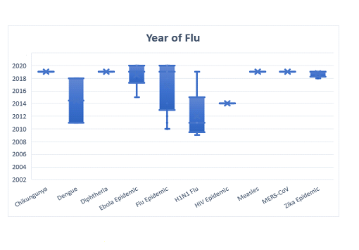
RQ2: How does previous literature investigate the sentiment of the general public towards pandemics?
The current study has focused on analyzing the emotions and concerns of people in already published academic studies and comparing findings with results from the current Covid-19 context. Our investigation went through several processes, including a word cloud analysis to understand the frequency of words related to the topics under study. The word cloud analysis revealed the significant words with high frequency: information, social, media, health, and influenza. Moreover, the word frequency enabled us to detect the important words translating a negative and positive intention or internal emotion. Figure 5 presents the results of the word cloud analysis based on the traditional academic literature (Boon-Itt & Skunkan, 2020). In word cloud, the whole analysis is based on the frequency of one specific word (unigram) in the mining text and display their frequencies through the word cloud representation. The words, such as positive, accessed, prevention, and value, featured among the top positive ones in the word cloud analysis.
During the word cloud analysis, negative words with high frequency appeared in greater numbers than positive words with high frequency. In contrast, outbreak, influenza, infectious, epidemic, virus, infection, and transmission pertained to the top negative words. Therefore, it can be concluded that, according to the previous literature, the public expressed negative feelings about different pandemics or epidemics at a specific point in time. .
Figure 5: Word cloud analysis – LBTA
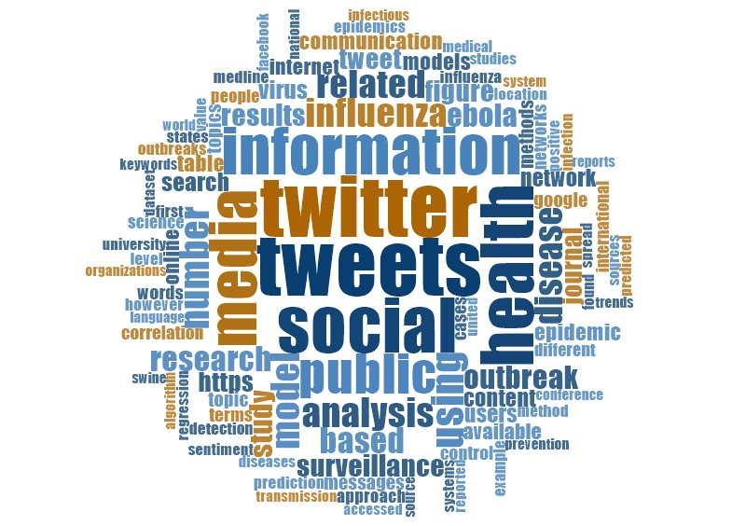
Table 2 depicts that the major available academic research on the flu epidemic. To the best of our knowledge, the classification presented in Table 2 is exhaustive; the first column represents the type of flu studied, followed by the most frequent constructs used in the study, the research methodology used, and the size of the samples. On the other hand, Table 2 provides further details about 61 articles based on the type of flu per article.
Table 2: Flu-specific classification of literature
Type of Flu | Author(s) | Constructs Used for Results | Research Methodology | Sample Size
Dengue | Gomide et al. (2011) | Volume, location, time and public perception | Sentiment analysis | 493,102 tweets
 | Kraemer et al. (2018) | Disease dynamics, Gravity model, Human  mobility, Radiation model | Spatiotemporal analysis | Tweets
Chikungunya | Rocklöv et al. (2019) | Air passenger, virus transmission | Quasi real-time, geolocated Twitter activity data and computed mobility patterns of users. | Tweets
Ebola Epidemic | Odlum & Yoon (2015) |  | Content analysis, NLP | 54 million tweets
 | Tully et al. (2018) | Non-profit organizations, communication, organization, news media, influencers | Qualitative textual analysis | Tweets from non-profits
 | Joshi et al. (2020) | Public health & symptoms | SVM and SVM-Perf | Tweets from December 2011 to December 2014
 | Roy et al. (2020a) | Figure of blame, government, health communication, outbreak | Inductive thematic  analysis approach | Twitter and Facebook
 | Roy et al. (2020b) | Epidemic management, African Cup of Nation, soccer | Qualitative thematic and frame analysis | Facebook and Twitter
 | Guidry et al. (2020) | Communications, the larger ecological context, and the associated risk perception | Quantitative content analysis | 700 Pinterest posts & tweets
 | Bempong et al. (2019) | Big data, mHealth, modelling, novel technologies and remote-sensing technologies | Systematic Literature Review | 82 research articles
Flu Epidemic | Baker et al. (2020) | Valid category (influenza signs) and invalid category (other category) tweets | Data mining SVM, Naive Bayes (NB), K-nearest neighbor and Decision Tree | 54,065 tweets
 | Hellsten & Leydesdorff (2020) | Social media debate | Social network analysis and semantic  network analysis | 72,077 tweets
 | Hellsten et al. (2019) | Stakeholder’s participation | Social network analysis and semantic  network analysis | 2,139 Twitter messages
 | Huang et al. (2013) | Co-location and social tie | Cosine similarity, standard deviation metrics, dynamic Bayesian Network | 35.3 million tweets
 | Wakamiya et al. (2019) | Social media, infodemiology;  infoveillance | Machine learning and natural language processing | Tweets
 | Deiner et al. (2019) |  | Temporal search and scan analysis of Google searches | 135 candidates’ tweets
 | Rubin (2019) | Newspapers, Internet, Deception, Disinformation, automation, education, regulation | Literature review | Conceptual framework
 | Diaz-Aviles et al. (2010) | Tweets related to medical conditions | Personalized Tweet Ranking algorithm for Epidemic Intelligence, semantic analysis | 7,710,231 tweets
 | Zadeh et al. (2019) | Public health, Social media, Behavioural analytics, Location analytics | Big Data technologies | Twitter data
 | Glowacki et al. (2019) | Food safety and illness | Text analysis and content analysis | 13,000 tweets
 | Wegrzyn-Wolska et al. (2013) |  | Text mining, social network analysis | 100,000 tweets
 | Lamb et al. (2013) | Word classes used | NLP | 1.8 billion tweets
 | Alessa & Faezipour (2019) | Social networking site posts on well being | Sentiment analysis (text classification, mapping, and linear regression) | 8,400,000 tweets
 | Wakamiya et al. (2018) | Patient, urban areas, rural areas, information | Natural Language Processing Module | 7 million influenza-related tweets
 | Xue et al. (2019) | Preventive measures, control measures, departments | SVR for prediction | Twitter data
 | Hu et al. (2018) | Public health | Artificial tree algorithm | CDC data set and Twitter data set.
 | Barros, Duggan, & Rebholz-Schuhmann (2020) | Diseases, Medical Conditions, and Health Topics | Systematic Literature Review | 162 research articles
 | Wang et al. (2020) | Flu prediction | PDE model | Geotagged Twitter streaming data
 | Aramaki, Maskawa, & Morita (2011) |  | Machine learning, SVM, text mining | 300 million tweets
 | Devika, Sinduja, & Subramaniyaswamy (2019) |  | Text ranking, min-cut algorithm, SVM | 800 tweets
 | Santos & Matos (2014) | Flu indicator tweets | Naïve Bayes Classifiers | 2,704 tweets
 | Kallur et al. (2020) | Healthcare provider, alternative medicine  provider, company, media, or professional society | Least mean scores based on GQS | Youtube videos from 28 January to 5 February 2017
 | Molaei et al. (2019) | Contagious disease prediction | Nonlinear methods including ARX, ARMAX, NARX, DeepMLP, CNN | Tweets and Centers for Disease Control and Prevention (CDC) data
 | Samaras et al. (2020) | Social media, precision, severe | ARIMA method | Google and Twitter
 | Li et al. (2020) | Sentiments, Media attitudes, Range of influence and dissemination, Media credibility and influence, Netizen attitudes and influence | SIR virus propagation model, Social network analysis, Complex system simulation | China's Sina Weibo
 | Culotta (2010) |  | Text mining, Regression | 574,643 tweets
 | Sadilek, Kautz, & Silenzio (2012) | Negatively and positively weighted features | SVM, tokenization | 16 million tweets
 | Achrekar et al. (2011) |  | Correlation and auto-regression with exogenous inputs | 4.7 million tweets
 | Li & Cardie (2013) | Flu indicator keywords such as influenza | Unsupervised Bayesian algorithm basedon a 4 phase Markov Network | 3.6 million tweets
 | Ng (2014) | Flu indicator terms and emoticons | Correlation | 1,055,460 tweets
 | Broniatowski, Paul, & Dredze (2013) | Categorization of tweets based on health data | Supervised classification model, time series analysis | 0.3 billion tweets
H1N1 Flu | Chew & Eysenbach (2010) | Tweet categorizations Resource, personal experience, personal opinion and interest, jokes/ parody, marketing, spam | Info-veillance using twitter data analysis and survey | 2 million tweets
 | Ahmed et al. (2019) | Emotion and feeling, health related information, general commentary and resources, | Thematic analysis | 214,784 tweets
 | Lampos & Cristianini (2010) |  | Textual analysis | 26.8 million tweets
 | Szomszor et al., (2010) |  | Correlation | 3 million tweets
 | Signorini et al., (2011) |  | Bayesian classifiers, SVM | 5,150,863 tweets
HIV Epidemic | Young et al., (2014) |  | Binomial regression | 553,186,061 tweets
Measles | Meadows et al. (2019) | Health beliefs and vaccine attitudes | Descriptive statistics (frequencies and percentages) | 3,000 tweets systematically selected
 | Tang et al. (2018) | Public, social media, communication | Semantic network  analysis | Twitter discussion  before, during, and after the outbreak
MERS-CoV | Yoo & Choi (2019) | Social networking sites,  social media, health  information, predictor, psychological factors | Hierarchical regression  analyses | Web survey of South Korean adults
Zika epidemic | Khatua et al. (2019) | Patient symptoms | Word embedding method | 0.095 million tweets
 | Bora et al. (2018) | Informative, misleading, and personal experience videos | Case study | 101 videos from Youtube
 | Daughton & Paul (2019) | Linguistic and psychological inquiry | Keyword filtering and machine learning classification | 29,386 tweets
 | Nolasco et al. (2020) | Technology, influence, humans, articles | Topic modelling algorithms | Twitter datasets of Zika related posts
 | Wirz et al. (2018) | Blame, GE mosquitoes, SARF | Combined machine learning with human coding to analyse and sentiment analysis | Facebook and Twitter
 | Darrow et al. (2018) | Zika Knowledge, Attitudes, and beliefs | Survey | 139 students’ tweets
 | Mamidi et al. (2019) | Public sentiment | Machine learning techniques and algorithms | 48,734 tweets
 | Masri et al. (2019) | Disease surveillance and Disease forecasting | Cloudberry, Time-series analysis | 874 million tweets
 | Gallivan et al. (2019) | behaviour and intention | Netnography and chi-square tests | 15,818 tweets
Diphtheria | Porat et al. (2019) | Policy, misinformation | Correlation | 722, 974 tweets

Insights from Twitter Analytics
In this sub-section, COVTA has been performed using the CUP framework (Fan and Gordon, 2014) in three steps, i.e., capture the data, understand the data through different analyses, and present the results. Figure 6 has provided the complete details about the CUP framework that was used for COVTA with each step description. We retrieved Twitter data in different periods to grasp the change in emotions with time, if any. We then established scores to quantify our conclusion.
Figure 6: CUP Framework - COVTA
CAPTURE
UNDERSTAND
PRESENT
Real- time Presentation
Visibility
Information Flow
DATA CLEANING
Removed low quality and less-information on COVID-19 tweets

DATE EXTRACTION
Extracted data from Twitter using Tweepy API from January, 2019 to December, 2019

DATA STEMMING
Reduced the word to its word root for analysis purpose
- Descriptive Analysis
- Content Analysis
- Network Analysis
Naïve Bayes Algorithm

After screening, a total of 58,320 tweets concerning 'COVID-19' or 'Coronavirus' were finally retained using Tweepy API from January 25, 2020 to April 4, 2020. Figure 6 presents details of the analysis performed under COVTA in three major steps. The first step of the CUP framework consisted of extracting, cleaning, and stemming data using capture. Step 2 analyzed the data at three levels: descriptive analysis, content analysis, and network analysis.
RQ3: What are the emergent topics and themes highlighting the general public's sentiment towards COVID-19?
Twitter content regarding the Covid-19 was studied by measuring the user frequency on tweets under descriptive analysis. Based on user frequency, hashtags were selected to perform further content analysis and network analysis. Figure 7 describes the words cloud analysis of COVTA by using tweets by different users. The word cloud analysis disclosed different positive outcomes through words such as health, government, information, social, weather, pollution, believe, unintentional, gracious, support, happy, accept, thank (Boon-Itt & Skunkan, 2020). In contrast, negative words included discrepancy, contagious, sad, crisis, emergency, pandemic, clueless. Word cloud analysis showed a marked disparity between the emotions and concerns of people during the COVID-19 crisis and people's feelings during past pandemic and epidemic outbreaks. In the current Covid-19 times, people's behavior has shifted from negative (according to the literature review) to neutral. The cloud analysis indicated that words like positive, increased, information, media, and discrepancy are being more frequently used, which suggests that social media is the main source of information and that misinformation or discrepancy in information may experience changes according to such media sources.
Figure 7: Word cloud analysis of COVTA
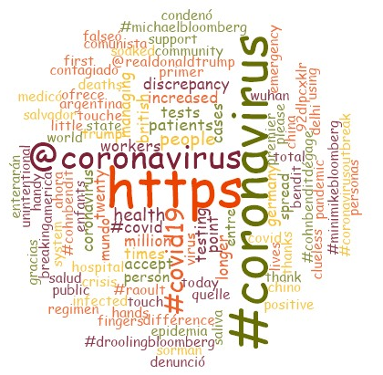
The word cloud analysis displayed few words, like information, social, health, and public, and the results from the literature review looked similar to those of the word cloud analysis.
COVTA user frequency shows information that is similar to those of the actual scenario. A full understanding of the user behavior required a review of user frequency based on the words that are being frequently used in people's tweets. Based on the time frame, the tweets were divided into three categories. In the first place, user frequency was investigated from January 25, 2020 to February 14, 2020. In this period, London appeared as the area with the highest number of tweets about coronavirus or COVID-19, followed by France and Madrid, as indicated by Figure 8. During the same period, the number of Covid-19 cases rose in Europe. As per WHO data (Organization, 2020c), the first case of coronavirus in Europe was discovered on January 24, 2020, and thereafter French officials announced three confirmed cases. So, the high user frequency during this period seemed to map the facts.
Figure 8: User frequency based on location from January 25, 2020 to February 14, 2020
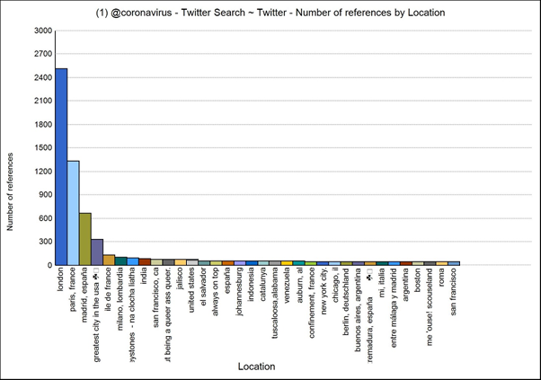
Following the verification of user frequency, cluster analysis relied on the same data for the time mentioned above period. It showed that people from different parts of the World are expressing themselves on social media. We observed that clustering is analogous to the spread of COVID-19, which means that expressing their feelings did so only if they had faced similar types of crises in terms of quantum and severity. The data presents the clustering of users based on their feelings, emotions, and concerns. All the clusters prove the coding similarity index based on Pearson's correlation coefficient.
From February 15, 2020 to March 14, 2020, user frequency was examined in various locations. This accounted for the second step of the process. As shown in Figure 9, the United Kingdom (UK) produced the highest number of tweets pertaining to the coronavirus or COVID-19, followed by India—with Delhi (Capital of India) in the first row. COVTA user frequency describes insights similar to the actual scenario, mapping the occurrence of the first coronavirus case confirmed on January 30, 2020 by the WHO (Organization, 2020c).
Figure 9: User frequency of tweets per location from February 15, 2020 to March 14, 2020
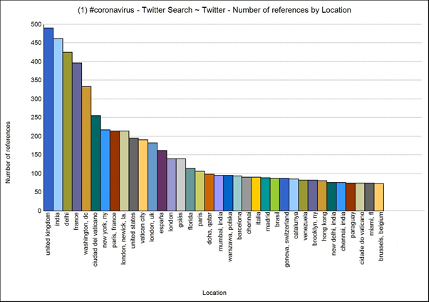
The data describes the cluster analysis as conducted between February 15, 2020, and March 14, 2020, and it shows that people from different parts of the World tend to express similar emotions and concerns.

In the last step of the process between March 15, 2020 and April 4, 2020, user frequency was reviewed based on locations. As indicated in Figure 10, Florida (USA) recorded the highest number of tweets on coronavirus or COVID-19, followed by Los Angeles and New York. The COVTA user frequency evidenced similarities with the actual scenario, and major coronavirus cases were recorded during this period in Florida, Miami, and other parts of the United States (Organization, 2020c).
Figure 10: User frequency based on locations from March 15, 2020 to April 4, 2020
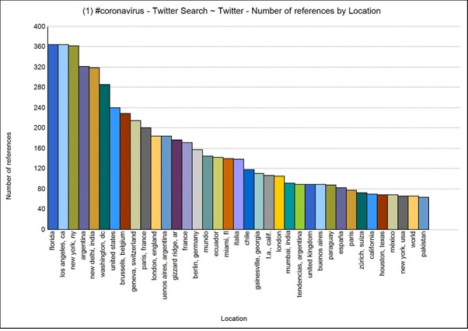
The further analysis presents results from the cluster analysis conducted from March 15, 2020 to April 4, 2020. Such clusters show similarities in people's emotions and concerns.
During the content analysis of COVTA, the sentiments of people as expressed in the selected tweets were examined using the Naïve Bayes Algorithm. People's perception was underscored through a user classification and classified their feelings into negative, positive, neutral, and mixed feelings. Figure 11 describes the sentiment analysis based on the polarity of emotions and feelings. Sentiment analysis showed a maximum number of neutral, positive, and mixed sentiments, and fewer users expressed negative feelings. Moreover, it disclosed a high propensity of optimistic sentiments (a high number of tweets with neutral and mixed sentiments) and a behavioral shift from negative to optimistic sentiments.
Figure 11: User sentiment analysis
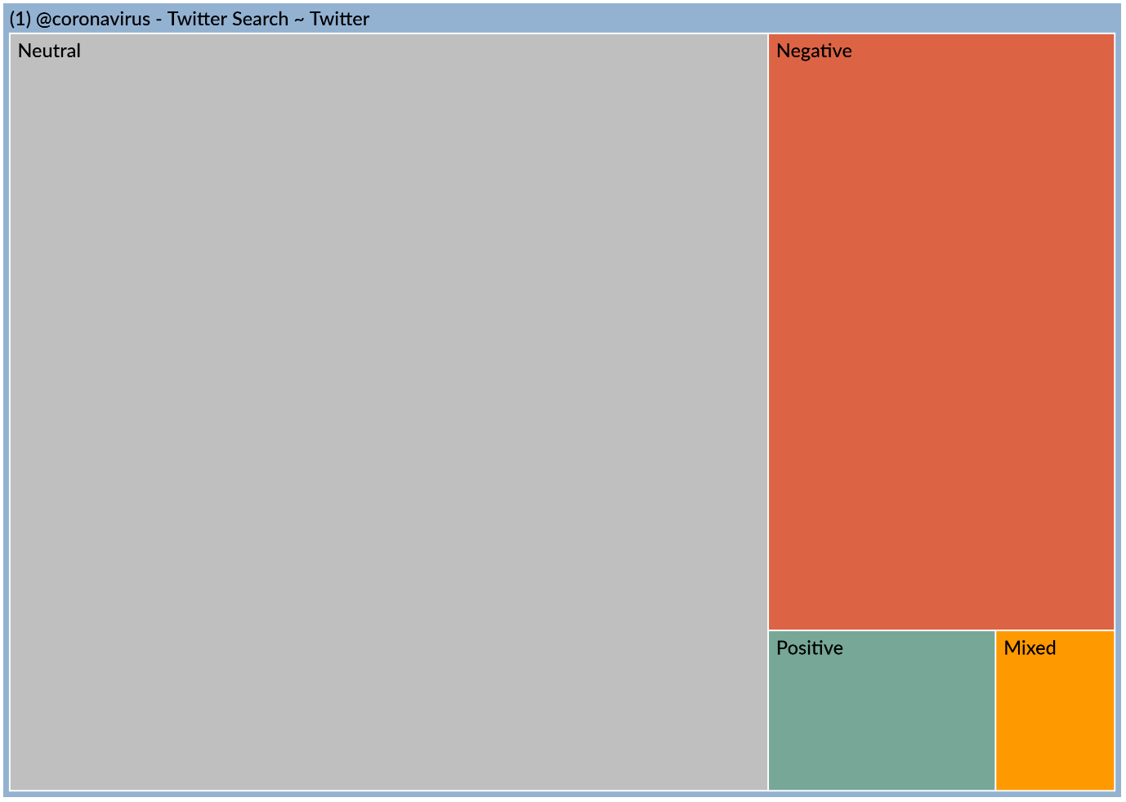
Next, the various types of sentiments were classified to understand the different emotions carried along. Figure 12 presents the related network diagram based on the outcome of the user sentiment analysis.
Figure 12: Network diagram based on user sentiments
The network analysis shows that there are eleven common codes between positive and negative sentiments, and they have a relationship with each other. However, all the codes show positive and moderately positive sentiment in these codes by different user handles. The frequency of hashtag and word cloud analysis provides deep insights into the frequently used words related to positive and negative sentiments.
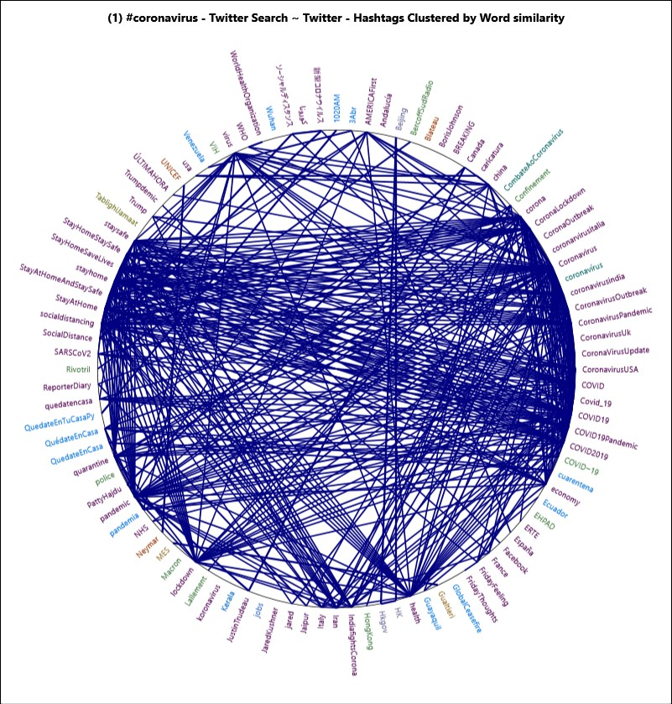
The diagram, as mentioned above, shows the major words expressing positive and negative feelings as indicated by the sentiments analysis. The same sentiments led to positive and negative emotions, but also neutral feelings for some cases. Further, the word-tree analysis was performed based on the top three positive and negative words to understand the sentiments of people.
Researchers have investigated online reviews to observe user sentiments (Joseph et al., 2017). The study also processes the sentiments of people through the extracted tweets. It provides negative and positive verbatim based on the sentiment analysis. Very positive sentiments are related to health and economy, and it expresses the people feeling through the posting during the COVID-19 situation. Very negative sentiments refer to lockdown, about pandemic and breaking of virus that emphasize the polarity scoring to understand people's emotions better.
The word-tree analysis relied on people's top positive and negative emotions, as it appeared from the network analysis of sentiments. The said network analysis highlighted top negative-emotion words such as positive, health, and economy and top positive emotion words such as breaking, pandemic, and lockdown. The word-tree analysis shows the verbatim of users based on user frequency. The emotional state expressed through postings contributes to understanding how people feel during the COVID-19 situation. Strong emotions are generally expressed by means of though words (adjectives, superlatives, etc.): "these dark days, let's stay positive"; "to keep them informed & stay positive"; "The UK is not testing its health" (with health-related terms); "facts and the device of health"; and "health professionals are worth more than," etc. User verbatim may also rely on economic terms, such as: "lives are as normal and their economy"; "save lives and economy"; and "prioritize people's lives than the economy." A critical remark is that health-related terms typically express neutral emotions, whereas economic terms express mixed and positive emotions in COVID-19. Negative emotions have also been observed, which was expressed through concepts like breaking, pandemic, and lockdown. Terms related to "breaking" include "another virus breaks out" and "time of exercises to avoid," while those related to "pandemic" include "any knowledge over handling pandemic," "severe seasonal influenza or pandemic," and "human can be blamed for the natural pandemic." The "lockdown" has been expressed through expressions such as "fewer people than an indefinite lockdown," "lockdown is better to save peoples," and "cases decreases because of a city lockdown." Expressions of negative emotions look not very negative by nature, as they show more mixed or neutral behavior towards COVID-19, with some degree of hope. Text content with polarity scoring in terms of sentiments helps better understand people's emotions and concerns. So, the various performed analyses (thematic analysis, content analysis, and sentiment analysis) show a strong shift in people's emotions over the years. Through COVTA, it appeared that people are more optimistic about the current COVID-19 situation.

Discussion
Pandemics have generated considerable interest among researchers across the World, as shown in Figure 1 and Table 1. Researchers have extensively used data from Twitter to study various aspects of pandemics such as public perception, emotions, feelings, communication, health information, etc., as illustrated in Table 2. It should be noted that social media analytics has already been used to study people's negative emotions (Tsugawa et al., 2015; Chaudhary et al., 2013). LBTA performed on research articles show that communities worldwide have always expressed their concerns for multiple pandemic and epidemic outbreaks, especially different types of flu, as depicted in Figures 3 and 4. The word cloud analysis (Figure 5) of past research showed that people's sentiments during pandemics are majorly negative. Communications are mostly concerned with viruses, infections, epidemics, and the seriousness of the disease. As a result, people's emotions in such circumstances are generally negative.
Interestingly, according to the outcome of the word cloud analysis conducted for COVTA based on Twitter data between January 25, 2020, and April 4, 2020, people's emotions witnessed a significant change compared to the emotions expressed during past pandemics (from 2011 to 2019). Despite variations in emotions from negative (sad, crises) to neutral and positive (gracious, positive, pollution, thank, accept, support), noted an increased frequency of comforting words, as shown by the outcomes of the word cloud analysis. Moreover, the presence of words like information and discrepancy in information indicates that social media has emerged as a prominent source of information. However, the prospects for social media information being different from reality cannot be ignored.
Based on user frequency in different time periods and locations, it is established that people tweet more on COVID 19 when they are affected the most (Figures 8, 9, and 10). For example, between January 25, 2020 and Februray14, 2020, people from London tweeted the most on COVID 19 (Figure 8), whereas very few people from India tweeted on the pandemic. People from the United Kingdom, India, and France communicated the most on COVID 19 on Twitter from February 15 to March 14, 2020 (Figure 9). Similarly, from March 15 to April 4, 2020, people from Florida, Los Angeles, and New York (USA) used Twitter to express themselves on the pandemic (figure 10). The cluster analysis conducted on tweets for different time periods revealed a fascinating discovery: people with similar situations express somewhat similar emotions all over the World.
Sentiment analysis performed on tweets related to COVID 19 under COVTA classifies emotions into four categories, namely positive, negative, mixed, and neutral. Figure 11 shows that the propensity of such tweets to be non-negative, as they rather portray neutral, positive, and mixed emotions. The network diagram (Figure 12) based on emotions suggests that positive and neutral sentiments are connected. This also proves that over the years, Twitter-based expressions of emotions about epidemics have mellowed. Network analysis shows positive emotions (terms related to health and the economy are the top positive words) and mixed and neutral emotions. Terms such as "breaking," "pandemic," "lockdown" are the top words expressing negative emotions. The word-tree analysis (based on the world cloud results) gives further insights into emotions through user verbatim. For example, the user verbatim for positive emotions during the Covid-19 pandemic indicates that people are trying to remain positive. Verbatim for health shows mixed emotions as people are concerned about their health and, at the same time, are grateful to health workers. Verbatim for economy indicates that people are giving preference to lives rather than to the economy. Verbatim of top positive, mixed, and neutral emotions further strengthen our finding that the sentiments towards COVID 19 are predominantly positive, mixed, and neutral.

Theoretical and Practical Implications
This study provides new insights into the sentiments of people on pandemics. And better still, it contributes to the general research methodology, relying on a thematic analysis of past studies and Twitter analytics on current data. The study suggests that Twitter data can be used for a better understanding of public sentiments on outbreaks. This can be used to gauge public sentiment in future researches.
The pandemic has not only medical consequences, but also impacts people on a social and psychological level. The findings demonstrate that people reach out to social media to express themselves and to acquire information. This paper makes a theoretical contribution to the literature on social-techno realm during pandemic using twitter analytics. Twitter reflects the real time concerns of social media users and the social media platform is helpful to understand the psychological health of the users. Our findings that people are more expressive when they are the most affected and people across the World go through similar emotions while dealing with similar situations facilitate further discussions on mental and emotional health during the pandemic and the measures to deal with it. It also offers deliberations on how social media can be a powerful communication medium and a tool to provide social support to the needy during emergencies or pandemics. Yang et al. (2020) found out that social support reduces negative emotions, anxiety, and depression. In contrast, physical distance is recommended in Covid-19 situations; the importance of social support through social media for mental well-being offers some reprieve. The importance of mental well-being cannot be ignored, as World health organization prioritized mental well-being (Adhanom, 2020). The United Nations has particularly emphasized the collective approach by the society to take care of mental well-being (Nations, 2022). An international commission on global mental health is being set up by Lancet (Kola, 2020; The Lancet 2020). As our findings suggest, social media could be the most potent medium to measure people's emotional and mental well-being. Real-time screening and assessing the people's emotions during a pandemic can put health agencies in order; their planning and responses could be need-based. This can also improve trust between the health care agencies and the people.
Even though social media data helps monitor mental and emotional health during pandemics, our findings have important implications. From a theoretical point of view, the findings have enriched the RPA – COV model by identifying that people's emotions towards pandemics are changing and showing a tendency for more positive emotions. This research aims to advance knowledge of the emotions of the people during pandemics and the role of social media in effective communication (Oh et al., 2020; El-Awaisi et al., 2020) during pandemics.
There is a serious need to apprehend the sentiment of people to deal with the connected socioeconomic factors. This would help craft better solutions and policies to combat this global crisis. All through COVID-19, people from the UK, France, London, Paris, Spain, Italy, India, and the USA mostly expressed their concerns on health, test, economy, support, information, etc.. They were gracious, thankful, and hopeful. Past studies revealed that sentiments of people during Chikungunya, Dengue, Diphtheria, Ebola, Flu, HIV, Measles, Zika breakdown from the year 2002 to 2018 were mostly negative. This is contrary to the sentiments expressed during COVID-19. This suggests that the people stayed hopeful in the course of unprecedented health emergencies. People expressed gratitude towards health workers, police, community efforts, and other frontline workers. However, few keywords such as breaking, contagious, emergency, crises, lockdown, pandemic reported negative sentiments during COVID-19. However, positive sentiments overshadowed the negative sentiments. The study captured manifestations of people during COVID-19 and showed the change of public sentiments over the years towards pandemics.
This is probably the first in-depth study of people's sentiments on pandemics, including the current Covid-19 outbreak. The findings of this study should serve as a starting block for developing strategies to deal with future infectious disease outbreaks. The study shows that people express their feelings and emotions (fear, hope, worry, etc.) by posting on Twitter. Health officials may rely on such information to better take care of people's physical and mental health during epidemics or pandemics. For instance, they can use these findings to formulate strategies that can help to reduce negative emotions among the population concerned. Several researchers (Geßler, Nezlek, & Schütz, 2020; 2019; Moroń and Biolik-Moroń, 2021; Hodzic et al., 2018; Elsotouhy et al., 2021) stated that emotional intelligence of a person can predict his or her mental health. Hence health officials can also offer emotional intelligence training to tone down negative emotions. Such findings are useful not only to health professionals but also to policymakers and other stakeholders in outbreaks. Stakeholders and health officials can access the information and sentiments shared on Twitter in real-time, and accordingly, take preventive measures to better combat pandemics. Of course, this study can be of interest to researchers as well.

Conclusion
This study has shown that, over the years, people's sentiments on pandemics as shared on Twitter are changing. Based on the LBTA and COVTA, The study considered 61 research articles published on pandemics, coupled with data from Twitter (for LBTA). A total of 58,320 tweets on COVID 19 was considered for COVTA. Big data analytics techniques were used for Twitter postings, while thematic analysis was performed on published papers to understand people's sentiments on pandemics. Only tweets posted between January 25, 2020 and April 4, 2020, were taken into account for this study. Future studies may consider analyzing Twitter content on COVID 19 for a more extended period to improve the results. People may react differently on Twitter as compared to real-life circumstances. Hence, this could be the limitation of the study. However, the benefit of employing Twitter analytics is that it evades the biases of the researcher/interviewer.
Overall, the complete analysis posits that people's sentiments towards pandemics have changed over ten years. Following a sentiment analysis for COVID 19 clearly shows a high propensity for optimistic sentiments (high number of tweets with neutral and mixed sentiments). It suggests that people are concerned about their health but are optimistic and show immense gratitude towards frontline workers.

References

- Achrekar, H., Gandhe, A., Lazarus, R., Yu, S. H., & Liu, B. (2011, April). Predicting flu trends using twitter data. In 2011 IEEE conference on computer communications workshops (INFOCOM WKSHPS) (pp. 702-707). IEEE.
- Ghebreyesus, T. A. (2020). Addressing mental health needs: an integral part of COVID‐19 response. World psychiatry, 19(2), 129.
- Ahmed, W. (2018). Using Twitter data to provide qualitative insights into pandemics and epidemics (Doctoral dissertation, University of Sheffield).
- Ahmed, W., Bath, P. A., Sbaffi, L., & Demartini, G. (2018, March). Measuring the effect of public health campaigns on Twitter: the case of World Autism Awareness Day. In International Conference on Information (pp. 10-16). Springer, Cham.
- Ahmed, W., Bath, P. A., Sbaffi, L., & Demartini, G. (2019). Novel insights into views towards H1N1 during the 2009 Pandemic: a thematic analysis of Twitter data. Health Information & Libraries Journal, 36(1), 60-72.
- Ahmed, W., Bath, P. A., Sbaffi, L., & Demartini, G. (2019). Novel insights into views towards H1N1 during the 2009 Pandemic: a thematic analysis of Twitter data. Health Information & Libraries Journal, 36(1), 60-72.
- Alessa, A., & Faezipour, M. (2019). Preliminary Flu Outbreak Prediction Using Twitter Posts Classification and Linear Regression With Historical Centers for Disease Control and Prevention Reports: Prediction Framework Study. JMIR public health and surveillance, 5(2), e12383.
- Alonso-Muñoz, L., Marcos-García, S., & Casero-Ripollés, A. (2017). Political leaders in (inter) action. Twitter as a strategic communication tool in electoral campaigns. Trípodos, (39), 71-90.
- Alsudais, K., & Corso, A. (2015). GIS, big data, and a tweet corpus operationalized via natural language processing.
- Al-Yafi, K., El-Masri, M., & Tsai, R. (2018). The effects of using social network sites on academic performance: the case of Qatar. Journal of Enterprise Information Management.
- Aramaki, E., Maskawa, S., & Morita, M. (2011, July). Twitter catches the flu: detecting influenza epidemics using Twitter. In Proceedings of the conference on empirical methods in natural language processing (pp. 1568-1576). Association for Computational Linguistics.
- Baker, Q. B., Shatnawi, F., Rawashdeh, S., Al-Smadi, M., & Jararweh, Y. (2020). Detecting Epidemic Diseases Using Sentiment Analysis of Arabic Tweets. Journal of Universal Computer Science, 26(1), 50-70.
- Barros, J. M., Duggan, J., & Rebholz-Schuhmann, D. (2020). The Application of Internet-Based Sources for Public Health Surveillance (Infoveillance): Systematic Review. Journal of Medical Internet Research, 22(3), e13680.
- Bempong, N. E., De Castañeda, R. R., Schütte, S., Bolon, I., Keiser, O., Escher, G., & Flahault, A. (2019). Precision Global Health–The case of Ebola: a scoping review. Journal of global health, 9(1).
- Bendler, J., Ratku, A., & Neumann, D. (2014). Crime mapping through geo-spatial social media activity.
- Boon-Itt, S., & Skunkan, Y. (2020). Public perception of the COVID-19 pandemic on Twitter: sentiment analysis and topic modeling study. JMIR Public Health and Surveillance, 6(4), e21978.
- Bora, K., Das, D., Barman, B., & Borah, P. (2018). Are internet videos useful sources of information during global public health emergencies? A case study of YouTube videos during the 2015–16 Zika virus pandemic. Pathogens and global health, 112(6), 320-328.
- Brandt, T., Bendler, J., & Neumann, D. (2017). Social media analytics and value creation in urban smart tourism ecosystems. Information & Management, 54(6), 703-713.
- Braun, V., & Clarke, V. (2006). Using thematic analysis in psychology. Qualitative research in psychology. Qualitative Research in Psychology, 3(2), 77-101.
- Broniatowski, D. A., Paul, M. J., & Dredze, M. (2013). National and local influenza surveillance through Twitter: an analysis of the 2012-2013 influenza epidemic. PloS one, 8(12).
- Chew, C., & Eysenbach, G. (2010). Pandemics in the age of Twitter: content analysis of Tweets during the 2009 H1N1 outbreak. PloS one, 5(11).
- Culotta, A. (2010, July). Towards detecting influenza epidemics by analyzing Twitter messages. In Proceedings of the first workshop on social media analytics (pp. 115-122).
- Darrow, W., Bhatt, C., Rene, C., & Thomas, L. (2018). Zika virus awareness and prevention practices Among University students in Miami: fall 2016. Health Education & Behavior, 45(6), 967-976.
- Daughton, A. R., & Paul, M. J. (2019). Identifying protective health behaviors on Twitter: observational study of travel advisories and Zika virus. Journal of medical Internet research, 21(5), e13090.
- De Choudhury, M., Gamon, M., Counts, S., & Horvitz, E. (2013, June). Predicting depression via social media. In Seventh international AAAI conference on weblogs and social media.
- Deiner, M. S., McLeod, S. D., Wong, J., Chodosh, J., Lietman, T. M., & Porco, T. C. (2019). Google Searches and Detection of Conjunctivitis Epidemics Worldwide. Ophthalmology, 126(9), 1219-1229.
- Devika, R., Sinduja, S., & Subramaniyaswamy, V. (2019). A Novel Method to Detect Public Health in Online Social Network Using Graph-based Algorithm. EAI Endorsed Transactions on Pervasive Health and Technology, 5(18).
- Diaz-Aviles, E., Stewart, A., Velasco, E., Denecke, K., & Nejdl, W. (2012, May). Epidemic Intelligence for the Crowd, by the Crowd. In Sixth International AAAI Conference on Weblogs and Social Media.
- El-Awaisi, A., O’Carroll, V., Koraysh, S., Koummich, S., & Huber, M. (2020). Perceptions of who is in the healthcare team? A content analysis of social media posts during COVID-19 pandemic. Journal of Interprofessional Care, 34(5), 622-632.
- Elsotouhy, M., Jain, G., & Shrivastava, A. (2021). Disaster Management during Pandemic: A Big Data-Centric Approach. International Journal of Innovation and Technology Management, 2140003.
- Fan, W., & Gordon, M. D. (2014). The power of social media analytics. Communications of the ACM, 57(6), 74-81.
- Feng, H., Tian, J., Wang, H. J., & Li, M. (2015). Personalized recommendations based on time-weighted overlapping community detection. Information & Management, 52(7), 789-800.
- Gallivan, M., Oppenheim, B., & Madhav, N. K. (2019). Using social media to estimate Zika's impact on tourism:# babymoon, 2014-2017. PloS one, 14(2).
- Georgiadou, E., Angelopoulos, S., & Drake, H. (2020). Big data analytics and international negotiations: Sentiment analysis of Brexit negotiating outcomes. International Journal of Information Management, 51, 102048.
- Geßler, S., Nezlek, J. B., & Schütz, A. (2021). Training emotional intelligence: Does training in basic emotional abilities help people to improve higher emotional abilities?. The Journal of Positive Psychology, 16(4), 455-464.
- Gill, A. Q., Alam, S. L., & Eustace, J. (2014, January). Using social architecture to analyzing online social network use in emergency management. In 20th Americas Conference on Information Systems, AMCIS 2014.
- Glowacki, E. M., Glowacki, J. B., Chung, A. D., & Wilcox, G. B. (2019). Reactions to foodborne Escherichia coli outbreaks: A text-mining analysis of the public's response. American journal of infection control, 47(10), 1280-1282.
- Godes, D., & Mayzlin, D. (2004). Using online conversations to study word-of-mouth communication. Marketing science, 23(4), 545-560.
- Golder, S. A., & Macy, M. W. (2011). Diurnal and seasonal mood vary with work, sleep, and daylength across diverse cultures. Science, 333(6051), 1878-1881.
- Gomide, J., Veloso, A., Meira Jr, W., Almeida, V., Benevenuto, F., Ferraz, F., & Teixeira, M. (2011, June). Dengue surveillance based on a computational model of spatio-temporal locality of Twitter. In Proceedings of the 3rd international web science conference (pp. 1-8).
- Grandjean, M. (2016). A social network analysis of Twitter: Mapping the digital humanities community. Cogent Arts & Humanities, 3(1), 1171458.
- Guidry, J. P., Meganck, S. L., Perrin, P. B., Messner, M., Lovari, A., & Carlyle, K. E. (2020). # Ebola: Tweeting and Pinning an Epidemic. Atlantic Journal of Communication, 1-14.
- Hamouda, M. (2018). Understanding social media advertising effect on consumers’ responses. Journal of Enterprise Information Management.
- Hashimy, L., Treiblmaier, H., & Jain, G. (2021). Distributed ledger technology as a catalyst for open innovation adoption among small and medium-sized enterprises. The Journal of High Technology Management Research, 32(1), 100405.
- Hellsten, I., & Leydesdorff, L. (2020). Automated analysis of actor–topic networks on twitter: New approaches to the analysis of socio‐semantic networks. Journal of the Association for Information Science and Technology, 71(1), 3-15.
- Hellsten, I., Jacobs, S., & Wonneberger, A. (2019). Active and passive stakeholders in issue arenas: A communication network approach to the bird flu debate on Twitter. Public Relations Review, 45(1), 35-48.
- Higgins, T. (2020). Coronavirus pandemic could inflict emotional trauma and PTSD on an unprecedented scale, scientists warn. Retrieved April 14, 2020, from https://www.who.int/docs/default-source/coronaviruse/situation-reports/20200127-sitrep-7-2019--ncov.pdf?sfvrsn=98ef79f5_2
- Ho, C. S., Chee, C. Y., & Ho, R. C. (2020). Mental Health Strategies to Combat the Psychological Impact of COVID-19 Beyond Paranoia and Panic. Ann Acad Med Singapore, 49(1), 1-3.
- Hodžić, V., Triaud, A. H., Anderson, D. R., Bouchy, F., Cameron, A. C., Delrez, L., ... & West, R. (2018). WASP-128b: a transiting brown dwarf in the dynamical-tide regime. Monthly Notices of the Royal Astronomical Society, 481(4), 5091-5097.
- Hu, H., Wang, H., Wang, F., Langley, D., Avram, A., & Liu, M. (2018). Prediction of influenza-like illness based on the improved artificial tree algorithm and artificial neural network. Scientific reports, 8(1), 1-8.
- Huang, J., Zhao, H., & Zhang, J. (2013, August). Detecting flu transmission by social sensor in China. In 2013 IEEE International Conference on Green Computing and Communications and IEEE Internet of Things and IEEE Cyber, Physical and Social Computing (pp. 1242-1247). IEEE.
- Hutto, C. J., & Gilbert, E. (2014, May). Vader: A parsimonious rule-based model for sentiment analysis of social media text. In Eighth international AAAI conference on weblogs and social media.
- Ji, X., Chun, S. A., Wei, Z., & Geller, J. (2015). Twitter sentiment classification for measuring public health concerns. Social Network Analysis and Mining, 5(1), 13.
- Jones, L., Brown, D., & Palumbo, D. (2020). Coronavirus: A visual guide to the economic impact. BBC News, 28.
- Joshi, A., Sparks, R., Karimi, S., Yan, S. L. J., Chughtai, A. A., Paris, C., & MacIntyre, C. R. (2020). Automated monitoring of tweets for early detection of the 2014 Ebola epidemic. PloS one, 15(3), e0230322.
- Jovanoski, D., Pachovski, V., & Nakov, P. (2015, September). Sentiment analysis in Twitter for Macedonian. In Proceedings of the International Conference Recent Advances in Natural Language Processing (pp. 249-257).
- Kallur, A., Albalbissi, A., Carillo-Martin, I., Boonpheng, B., Kallur, L., Kherallah, Y., ... & Reddy, K. (2020). Doctor YouTube’s opinion on seasonal influenza: A critical appraisal of the information available to patients. Digital health, 6, 2055207620906968.
- Kecmanovic, J. (2020). A psychologist’s science-based tips for emotional resilience during the coronavirus crisis. Retrieved April 14, 2020, from https://www.washingtonpost.com/lifestyle/wellness/anxiety-coronavirus-mental-wellness-tips/2020/03/16/f187faf2-67b8-11ea-9923-57073adce27c_story.html (Accessed: 14 April, 2020).
- Khatua, A., Khatua, A., & Cambria, E. (2019). A tale of two epidemics: Contextual Word2Vec for classifying twitter streams during outbreaks. Information Processing & Management, 56(1), 247-257.
- KIM, Y. S., Choi, K. S., & Natali, F. (2016). Extending the network: The influence of offline friendship on Twitter network. AIS.
- Kola, L. (2020). Global mental health and COVID-19. The Lancet Psychiatry, 7(8), 655–657. https://doi.org/10.1016/S2215-0366(20)30235-2
- Kostkova, P., Szomszor, M., & St. Louis, C. (2014). # swineflu: The use of twitter as an early warning and risk communication tool in the 2009 swine flu pandemic. ACM Transactions on Management Information Systems (TMIS), 5(2), 1-25.
- Kostkova, P., Szomszor, M., & St. Louis, C. (2014). # swineflu: The use of twitter as an early warning and risk communication tool in the 2009 swine flu pandemic. ACM Transactions on Management Information Systems (TMIS), 5(2), 1-25.
- Kraemer, M. U., Bisanzio, D., Reiner, R. C., Zakar, R., Hawkins, J. B., Freifeld, C. C., ... & Perkins, T. A. (2018). Inferences about spatiotemporal variation in dengue virus transmission are sensitive to assumptions about human mobility: a case study using geolocated tweets from Lahore, Pakistan. EPJ Data Science, 7(1), 16.
- Kuckartz, U. (2019). Qualitative text analysis: A systematic approach. In Compendium for Early Career Researchers in Mathematics Education (pp. 181-197). Springer, Cham.
- Lamb, A., Paul, M., & Dredze, M. (2013, June). Separating fact from fear: Tracking flu infections on twitter. In Proceedings of the 2013 Conference of the North American Chapter of the Association for Computational Linguistics: Human Language Technologies (pp. 789-795).
- Lampos, V., & Cristianini, N. (2010, June). Tracking the flu pandemic by monitoring the social web. In 2010 2nd international workshop on cognitive information processing (pp. 411-416). IEEE.
- Leonardi, P. M. (2017). The social media revolution: Sharing and learning in the age of leaky knowledge. Information and Organization, 27(1), 47-59.
- Li, J., & Cardie, C. (2013). Early stage influenza detection from twitter. arXiv preprint arXiv:1309.7340.
- Li, S., Liu, Z., & Li, Y. (2020). Temporal and spatial evolution of online public sentiment on emergencies. Information Processing & Management, 57(2), 102177.
- Li, Y., Pan, Q., Yang, T., Wang, S., Tang, J., & Cambria, E. (2017). Learning word representations for sentiment analysis. Cognitive Computation, 9(6), 843-851.
- Lipizzi, C., Dessavre, D. G., Iandoli, L., & Marquez, J. E. R. (2016). Towards computational discourse analysis: A methodology for mining twitter backchanneling conversations. Computers in Human Behavior, 64, 782-792.
- Lischke, L., Hoffmann, J., Krüger, R., Bader, P., Wozniak, P. W., & Schmidt, A. (2017, May). Towards Interaction Techniques for Social Media Data Exploration on Large High-Resolution Displays. In Proceedings of the 2017 CHI Conference Extended Abstracts on Human Factors in Computing Systems (pp. 2752-2759).
- Liu, F. (2015). Retransmitting Messages Online in Evolving Disasters: A Scenario Simulation.
- Mamidi, R., Miller, M., Banerjee, T., Romine, W., & Sheth, A. (2019). Identifying Key Topics Bearing Negative Sentiment on Twitter: Insights Concerning the 2015-2016 Zika Epidemic. JMIR public health and surveillance, 5(2), e11036.
- Masri, S., Jia, J., Li, C., Zhou, G., Lee, M. C., Yan, G., & Wu, J. (2019). Use of Twitter data to improve Zika virus surveillance in the United States during the 2016 epidemic. BMC public health, 19(1), 761.
- McClellan, C., Ali, M. M., Mutter, R., Kroutil, L., & Landwehr, J. (2017). Using social media to monitor mental health discussions− evidence from Twitter. Journal of the American Medical Informatics Association, 24(3), 496-502.
- Meadows, C. Z., Tang, L., & Liu, W. (2019). Twitter message types, health beliefs, and vaccine attitudes during the 2015 measles outbreak in California. American journal of infection control, 47(11), 1314-1318.
- Min, H., Peng, Y., Shoss, M., & Yang, B. (2021). Using machine learning to investigate the public’s emotional responses to work from home during the COVID-19 pandemic. Journal of Applied Psychology, 106(2), 214.
- Mirbabaie, M., Ehnis, C., Stieglitz, S., & Bunker, D. (2014, December). Communication roles in public events. In Working Conference on Information Systems and Organizations (pp. 207-218). Springer, Berlin, Heidelberg.
- Molaei, S., Khansari, M., Veisi, H., & Salehi, M. (2019). Predicting the spread of influenza epidemics by analyzing twitter messages. Health and Technology, 9(4), 517-532.
- Moreau, N., Roy, M., Wilson, A., & Atlani Duault, L. (2020). “Life is more important than football”: Comparative analysis of Tweets and Facebook comments regarding the cancellation of the 2015 African Cup of Nations in Morocco. International Review for the Sociology of Sport, 1012690219899610.
- Moroń, M. and Biolik-Moroń, M., 2021. Trait emotional intelligence and emotional experiences during the COVID-19 pandemic outbreak in Poland: A daily diary study. Personality and Individual Differences, 168, p.110348.
- Mostafa, M. M. (2019). Clustering halal food consumers: A Twitter sentiment analysis. International Journal of Market Research, 61(3), 320-337.
- Mukherjee, S. (2017). Emerging infectious diseases: epidemiological perspective. Indian journal of dermatology, 62(5), 459.
- Ng, K. W. (2014). The use of Twitter to predict the level of influenza activity in the United States. NAVAL POSTGRADUATE SCHOOL MONTEREY CA.
- Nguyen, T. H., & Shirai, K. (2015, July). Topic modeling based sentiment analysis on social media for stock market prediction. In Proceedings of the 53rd Annual Meeting of the Association for Computational Linguistics and the 7th International Joint Conference on Natural Language Processing (Volume 1: Long Papers) (pp. 1354-1364).
- Ni, M. Y., Yang, L., Leung, C. M., Li, N., Yao, X. I., Wang, Y., ... & Liao, Q. (2020). Mental health, risk factors, and social media use during the COVID-19 epidemic and cordon sanitaire among the community and health professionals in Wuhan, China: cross-sectional survey. JMIR mental health, 7(5), e19009.
- Nolasco, D., & Oliveira, J. (2020). Mining social influence in science and vice-versa: A topic correlation approach. International Journal of Information Management, 51, 102017.
- Odoom, R., Anning-Dorson, T., & Acheampong, G. (2017). Antecedents of social media usage and performance benefits in small-and medium-sized enterprises (SMEs). Journal of Enterprise Information Management.
- Oh, S. H., Lee, S. Y., & Han, C. (2021). The effects of social media use on preventive behaviors during infectious disease outbreaks: The mediating role of self-relevant emotions and public risk perception. Health communication, 36(8), 972-981.
- Organization, W. H. (2020a). Novel Coronavirus(2019-nCoV) Situation Report - 1. Retrieved April 14, 2020, from https://www.who.int/docs/default-source/coronaviruse/situation-reports/20200127-sitrep-7-2019--ncov.pdf?sfvrsn=98ef79f5_2
- Organization, W. H. (2020b). Novel Coronavirus(2019-nCoV) Situation Report - 7. Retrieved April 14, 2020, from https://www.who.int/docs/default-source/coronaviruse/situation-reports/20200127-sitrep-7-2019--ncov.pdf?sfvrsn=98ef79f5_2
- Organization, W. H. (2020c). Novel Coronavirus(2019-nCoV) Situation Report - 78. Retrieved April 14, 2020, from https://www.who.int/docs/default-source/coronaviruse/situation-reports/20200127-sitrep-7-2019--ncov.pdf?sfvrsn=98ef79f5_2
- Organization, W. H. (2020d). Novel Coronavirus(2019-nCoV) Situation Report - 83. Retrieved April 14, 2020, from https://www.who.int/docs/default-source/coronaviruse/situation-reports/20200127-sitrep-7-2019--ncov.pdf?sfvrsn=98ef79f5_2
- Oyeyemi, S. O., Gabarron, E., & Wynn, R. (2014). Ebola, Twitter, and misinformation: a dangerous combination?. Bmj, 349, g6178.
- Porat, T., Garaizar, P., Ferrero, M., Jones, H., Ashworth, M., & Vadillo, M. A. (2019). Content and source analysis of popular tweets following a recent case of diphtheria in Spain. European journal of public health, 29(1), 117-122.
- Rathore, A. K., Kar, A. K., & Ilavarasan, P. V. (2017). Social media analytics: Literature review and directions for future research. Decision Analysis, 14(4), 229-249.
- Rocklöv, J., Tozan, Y., Ramadona, A., Sewe, M. O., Sudre, B., Garrido, J., ... & Semenza, J. C. (2019). Using big data to monitor the introduction and spread of Chikungunya, Europe, 2017. Emerging infectious diseases, 25(6), 1041.
- Roy, M., Moreau, N., Rousseau, C., Mercier, A., Wilson, A., & Atlani-Duault, L. (2020a). Ebola and localized blame on social media: analysis of Twitter and Facebook conversations during the 2014–2015 Ebola epidemic. Culture, Medicine, and Psychiatry, 44(1), 56-79.
- Roy, S., Suman, B. K., Chandra, J., & Dandapat, S. K. (2020b). Forecasting the Future: Leveraging RNN based Feature Concatenation for Tweet Outbreak Prediction. In Proceedings of the 7th ACM IKDD CoDS and 25th COMAD (pp. 219-223).
- Rubin, V. L. (2019). Disinformation and misinformation triangle. Journal of Documentation.
- Sachs, J. D., Horton, R., Bagenal, J., Amor, Y. B., Caman, O. K., & Lafortune, G. (2020). The lancet COVID-19 commission. The Lancet, 396(10249), 454-455.
- Sadilek, A., Kautz, H., & Silenzio, V. (2012, May). Modeling spread of disease from social interactions. In Sixth International AAAI Conference on Weblogs and Social Media.
- Samaras, L., García-Barriocanal, E., & Sicilia, M. A. (2020). comparing Social media and Google to detect and predict severe epidemics. Scientific Reports, 10(1), 1-11.
- Santos, J. C., & Matos, S. (2014). Analysing Twitter and web queries for flu trend prediction. Theoretical Biology and Medical Modelling, 11(S1), S6.
- Signorini, A., Segre, A. M., & Polgreen, P. M. (2011). The use of Twitter to track levels of disease activity and public concern in the US during the influenza A H1N1 pandemic. PloS one, 6(5).
- Sinnenberg, L., Buttenheim, A. M., Padrez, K., Mancheno, C., Ungar, L., & Merchant, R. M. (2017). Twitter as a tool for health research: a systematic review. American journal of public health, 107(1), e1-e8.
- Sodhi, M. S., & Tang, C. S. (2018). Corporate social sustainability in supply chains: a thematic analysis of the literature. International Journal of Production Research, 56(1-2), 882-901.
- Stokes, C., & Senkbeil, J. C. (2017). Facebook and Twitter, communication and shelter, and the 2011 Tuscaloosa tornado. Disasters, 41(1), 194-208.
- Sunday, C. E., & Vera, C. C. E. (2018). Examining information and communication technology (ICT) adoption in SMEs. Journal of Enterprise Information Management.
- Szomszor, M., Kostkova, P., & De Quincey, E. (2010, December). # Swineflu: Twitter predicts swine flu outbreak in 2009. In International conference on electronic healthcare (pp. 18-26). Springer, Berlin, Heidelberg.
- Tang, L., Bie, B., & Zhi, D. (2018). Tweeting about measles during stages of an outbreak: A semantic network approach to the framing of an emerging infectious disease. American journal of infection control, 46(12), 1375-1380.
- Taylor, L. H., Latham, S. M., & Woolhouse, M. E. (2001). Risk factors for human disease emergence. Philosophical Transactions of the Royal Society of London. Series B: Biological Sciences, 356(1411), 983-989.
- Lancet, T. (2020). COVID-19: The worst may be yet to come. Lancet (London, England), 396(10244), 71.
- Tricco, A. C., Zarin, W., Lillie, E., Pham, B., & Straus, S. E. (2017). Utility of social media and crowd-sourced data for pharmacovigilance: a scoping review protocol. BMJ open, 7(1), e013474.
- Tsugawa, S., Kikuchi, Y., Kishino, F., Nakajima, K., Itoh, Y., & Ohsaki, H. (2015, April). Recognizing depression from twitter activity. In Proceedings of the 33rd annual ACM conference on human factors in computing systems (pp. 3187-3196).
- Tully, M., Dalrymple, K. E., & Young, R. (2019). Contextualizing Nonprofits’ Use of Links on Twitter During the West African Ebola Virus Epidemic. Communication Studies, 70(3), 313-331.
- Nations, U., 2022. UNSDG | Policy Brief: COVID-19 and the Need for Action on Mental Health. [online] Unsdg.un.org. Available at: <https://unsdg.un.org/resources/policy-brief-covid-19-and-need-action-mental-health> [Accessed 16 February 2022].
- Vaismoradi, M., Jones, J., Turunen, H., & Snelgrove, S. (2016). Theme development in qualitative content analysis and thematic analysis.
- van Gorp, A. F., Pogrebnyakov, N., & Maldonado, E. A. (2015, May). Just Keep Tweeting: Emergency Responder's Social Media Use Before and During Emergencies. In ECIS.
- Wakamiya, S., Kawai, Y., & Aramaki, E. (2018). Twitter-based influenza detection after flu peak via tweets with indirect information: text mining study. JMIR public health and surveillance, 4(3), e65.
- Wakamiya, S., Morita, M., Kano, Y., Ohkuma, T., & Aramaki, E. (2019). Tweet classification toward Twitter-based disease surveillance: new data, methods, and evaluations. Journal of medical Internet research, 21(2), e12783.
- Wang, Y., Xu, K., Kang, Y., Wang, H., Wang, F., & Avram, A. (2020). Regional Influenza Prediction with Sampling Twitter Data and PDE Model. International journal of environmental research and public health, 17(3), 678.
- Wegrzyn-Wolska, K., Bougueroua, L., & Dziczkowski, G. (2013). Infodemiology by Tweet Mining Methods. Stud. Inform. Univ., 11(3), 65-79.
- Wekerle, C., Vakili, N., Stewart, S. H., & Black, T. (2018). The utility of Twitter as a tool for increasing reach of research on sexual violence. Child abuse & neglect, 85, 220-228.
- Wirz, C. D., Xenos, M. A., Brossard, D., Scheufele, D., Chung, J. H., & Massarani, L. (2018). Rethinking social amplification of risk: Social media and Zika in three languages. Risk Analysis, 38(12), 2599-2624.
- Xue, H., Bai, Y., Hu, H., & Liang, H. (2019). Regional level influenza study based on Twitter and machine learning method. PloS one, 14(4).
- Yoo, W., & Choi, D. H. (2019). Predictors of expressing and receiving information on social networking sites during MERS-CoV outbreak in South Korea. Journal of Risk Research, 1-16.
- Young, S. D., Rivers, C., & Lewis, B. (2014). Methods of using real-time social media technologies for detection and remote monitoring of HIV outcomes. Preventive medicine, 63, 112-115.
- Zadeh, A. H., Zolbanin, H. M., Sharda, R., & Delen, D. (2019). Social media for nowcasting flu activity: Spatio-temporal big data analysis. Information Systems Frontiers, 21(4), 743-760.
- Zeng, D., Chen, H., Lusch, R., & Li, S. H. (2010). Social media analytics and intelligence. IEEE Intelligent Systems, 25(6), 13-16.

