Research priorities regarding the use of bisphosphonates for osteoporosis: a UK priority setting exercise
Corresponding Author:
Dr. Zoe Paskins, School of Medicine, Keele University, David Weatherall Building, Newcastle-under-Lyme, UK, ST5 5BG and Haywood Academic Rheumatology Centre, Haywood Hospital, High Lane, Burslem, Stoke-on-Trent ST6 7AG. 0000-0002-7783-2986
z.paskins@keele.ac.uk, 01782 733975
Author information:
Dr Alice Moult, School of Medicine, Keele University, Newcastle-under-Lyme, ST5 5BG, UK 0000-0002-9424-5660
Dr. Nadia Corp, School of Medicine, Keele University, Newcastle-under-Lyme, ST5 5BG, UK 0000-0002-6758-9513
Dr Anastasios Bastounis, PhD, Faculty of Medicine & Health Sciences, University of Nottingham, City Hospital, Nottingham NG5 1PB, UK 0000-0001-5861-9373
Ms Sarah Davis, School of Health and Related Research (ScHARR), Regent Court, 30 Regent Street, University of Sheffield, Sheffield, S1 4DA, UK 0000-0002-6609-4287
Dr Melanie Jay Narayanasamy, Nottingham University Business School, University of Nottingham, Nottingham, NG8 1BB, UK 0000-0003-3483-0777
Jill Griffin, Royal Osteoporosis Society (ROS), St James House, The Square, Lower Bristol Road, BA2 3BH, UK.
Prof. Neil Gittoes, Centre for Endocrinology, Diabetes and Metabolism, Institute of Metabolism and Systems Research, University of Birmingham, Birmingham, UK 0000-0001-5963-214X
Prof. Jo Leonardi-Bee, Centre for Evidence Based Healthcare, Faculty of Medicine & Health Sciences, University of Nottingham, Nottingham, NG5 1PB, UK 0000-0003-0893-6068
Dr. Tessa Langley, Faculty of Medicine & Health Sciences, University of Nottingham, Nottingham, NG5 1PB, UK 0000-0001-9560-1148
Dr. Simon Bishop, Nottingham University Business School, University of Nottingham, Nottingham, NG8 1BB,UK 0000-0001-8527-7081
Prof. Opinder Sahota, Department of Healthcare of Older People, Nottingham University Hospitals NHS Trust, Nottingham, NG5 1PB, UK 0000-0003-0055-7637

Acknowledgments
This study is funded by the National Institute for Health and Care Research (NIHR), [HTA NIHR127550]. ZP is funded by the NIHR, Clinician Scientist Award (CS-2018-18-ST2-010)/NIHR Academy. The views expressed are those of the author(s) and not necessarily those of the National Health Service, the NIHR, or the Department of Health and Social Care. The authors acknowledge the help and support of Caroline Sangan, Beth Jones from the Royal Osteoporosis Society, Rachael Taylor who is study coordinator for the Blast Off study, and Alicia Bratt and Lizzie Cottrell from Keele Impact Accelerator Unit.

Word Count 3195
Mini Abstract
Using James Lind Alliance methodology, this study reports prioritised topics of importance to stakeholders in the research of bisphosphonate treatment in osteoporosis. The priorities address how to better implement guidelines to address the care gap, understanding patient factors influencing treatment selection and effectiveness, and how to optimise long-term care.

Abstract
Purpose
Worldwide, many people who would benefit from osteoporosis drugs are not offered or receiving them, resulting in an osteoporosis care gap. Adherence with bisphosphonates is particularly low. This study aimed to identify stakeholder research priorities relating to bisphosphonate treatment regimens for prevention of osteoporotic fractures.

Methods
A three-step approach based on the James Lind Alliance methodology for identification and prioritisation of research questions was used. Research uncertainties were gathered from a large programme of related research studies about bisphosphonate regimens and from recent published international clinical guidelines. Clinical and public stakeholders refined the list of uncertainties into research questions. The third step prioritised the questions using a modified nominal group technique.
Results
In total, 34 draft uncertainties were finalised into 33 research questions by stakeholders. The top 10 includes questions relating to: which people should be offered intravenous bisphosphonates first-line (1); optimal duration of treatment (2); the role of bone turnover markers in treatment breaks (3); support patients need for medicines optimisation (4); support primary care practitioners need regarding bisphosphonates (5); comparing zoledronate given in community vs hospital settings (6); ensuring quality standards are met (7); the long-term model of care (8); best bisphosphonate for people aged under 50 (9); and, supporting patient decision-making about bisphosphonates (10).
Conclusion
This study reports, for the first time, topics of importance to stakeholders in the research of bisphosphonate osteoporosis treatment regimens. These findings have implications for research into implementation to address the care gap and education of healthcare professionals.

Keywords: bisphosphonates; osteoporosis; research priorities; stakeholder
Introduction
Osteoporosis is a disease that is characterised by skeletal fragility and changes in bone microarchitecture resulting in increased risk of fractures with no or low trauma [1]. The management and care of people with low trauma or fragility fractures results in a considerable societal economic burden; the annual cost in the UK alone is £4.4billion [2] Furthermore, the personal impact of fragility fractures is considerable, with potential deleterious effects on physical and psychological health, ability to live independently, and increased risk of death [3]. Many fractures are potentially preventable, with appropriate cost effective and clinically effective drug treatments such as bisphosphonates the mainstay of treatment for osteoporosis.

There are several different bisphosphonates; some are administered orally, others intravenously. A variety of regimes in terms of dose frequency also exists [4]. A network meta-analysis demonstrated that bisphosphonate treatment reduces the risk of fragility fracture by 33%–54% [5]. The success of treatment depends on patients initiating (starting), executing (or implementing—taking correctly) and persisting (continuing) medication; collectively these processes are described as adherence. Adherence with osteoporosis medications is notoriously poor and reported to be worse than adherence in other long-term conditions[5] . Oral bisphosphonate persistence rates at 1 year are commonly estimated between 16% and 60%, with different reporting measures partly explaining the wide variation observed across studies [5]. Worldwide, many people who would benefit from osteoporosis drugs are not receiving them, and this care gap has been described as an ‘osteoporosis crisis’ [6].

To enhance adherence to bisphosphonates, and thus contribute to addressing the osteoporosis care gap, it is important to understand perspectives of all relevant stakeholders in relation to the use of these drugs. There are many possible research agendas to pursue and traditionally health research priorities have been identified by researchers. However, patient and public involvement in research, including the prioritisation of research agendas, is now well established [7-13]. Involving patients and the public ensures that research is grounded in patient relevance, research questions are meaningful, and important research topics are identified that researchers may not have previously considered [14]. Over the last decade, a number of initiatives such as INVOLVE, part of the National Institute for Health and Care Research (NIHR), have been established to facilitate and promote active public involvement in all aspects of research, including priority setting. The James Lind Alliance (JLA) was formed in 2004 and aimed to bring patients and clinicians together in a new way to identify and address important uncertainties about the effects of care and treatments[15].

Despite the apparent revolution in patient engagement, evidence suggests the mismatch between the research conducted and the research which patients want, persists [8]. A previous report commissioned by the JLA established that most charitable funders in the UK funded research in a responsive mode, with only a minority funding research that met pre-identified priorities [15]. With respect to bisphosphonates as a treatment for osteoporosis, no studies have investigated the research priorities of stakeholders. Paskins et al (2017) conducted the first national study of public and patient research priorities in osteoporosis and fracture.[17] Participants were asked to indicate their top priority for research across 40 different research items. ‘Having easy access to advice and information from health professionals’ was the number one priority followed by ‘understanding the safety and benefit of osteoporosis drug treatments ‘ as the second research priority area. However, a need was identified for more refinement to translate this research focus into specific research questions. This paper aims to address this gap by conducting a research prioritisation exercise to understand priorities relating to bisphosphonate treatment regimens for prevention of osteoporotic fracture in adults.

Methods
We used a three-step approach based on the James Lind Alliance (JLA) methodology for identification and prioritisation of research questions. [18] An overview of the methods is shown in Figure 1. This prioritisation study did not require ethics approval as per the JLA guidance.
Step 1: Gathering uncertainties.
Uncertainties were gathered from the ‘Bisphosphonate aLternAtive regimenS for the prevenTion of Osteoporotic Fragility Fractures’ (Blast Off) study findings and existing published research recommendations. The Blast Off study consisted of six discrete individual research studies conducted May 2019 and February 2022, which all relate to the experience, effectiveness and cost-effectiveness of different bisphosphonate regimens; this study determined our scope which was specifically about bisphosphonates and not about other drugs. [19] Three studies were qualitative in design: a systematic review of existing qualitative research to determine acceptability of bisphosphonates among patients, clinicians, managers and payers; [20] an interview study with 78 patients receiving different bisphosphonate regimens[21]; and an interview study with 23 clinicians.[19] In addition, two systematic reviews were conducted to review the clinical effectiveness of and adherence with different bisphosphonate regimens [22, 23], and a health economic study was conducted to assess cost-effectiveness and identify the key uncertainties in the existing evidence [19]. Over four group meetings, the research team reviewed and discussed the findings of these studies and generated a list of potential arising uncertainties. Over this period, research findings were discussed with a patient advisory group to further inform the process.
Separately, a systematic search of relevant electronic databases and websites of professional organisations was conducted to identify research recommendations highlighted within recent clinical guidelines. Databases searched included Pubmed, Googlescholar, Epistemonikos, NICE, SIGN, Guidelines International Network, Guidelines.co.uk and TRIP database. Inclusion criteria were i) international guideline from non-Low- or Middle-Income Country (LMIC); ii) about osteoporosis (including glucocorticoid osteoporosis) iii) published since 2016 iv) developed on behalf of a professional organisation. Exclusion criteria were: guideline about osteoporosis only in the context of another specific health condition. Attempts were made to translate guidelines not in the English language. Relevant sections on recommendations for research were extracted and a list of research recommendations produced. Subsequently, research recommendations were considered as in- or out-of-scope initially by two members of the study team (ZP, NC), and then approved by the whole team, with in scope recommendations defined as relating to the use of bisphosphonates.
Step 2: Processing and refining uncertainties
Using stakeholder input, we refined the list of uncertainties into research questions. One three-hour stakeholder meeting was convened, with patients and carers, clinicians (medical and non-medical) and academics to include representatives from primary and secondary care. Potential participants were invited from the Royal Osteoporosis Society Effectiveness Working Group of the Bone Research Academy, Nottingham Osteoporosis Patient Support group and clinical networks of the study team. We recorded the professional role and sex of attendees, but we did not collect data on age or ethnicity. The uncertainties and research recommendations from guidelines (outputs from step 1), as derived by the research team were circulated to attendees before the meeting. In the meeting, within small groups, the uncertainties were discussed and refined, with some uncertainties combined as appropriate. Each uncertainty was refined into a research question with particular attention to defining the population and setting, intervention, comparison, and outcomes of interest [24]. Attendees and study team members had the opportunity to suggest additional uncertainties during this process. The uncertainties were also categorised into groups.
To validate that the uncertainties were true research questions and not already answered, a search was subsequently conducted of the Cochrane Database of Systematic Reviews, PubMed and references of NICE guidelines, SIGN clinical guidelines, NOGG guidelines and Royal Osteoporosis Society guidance for any relevant published systematic reviews. If no systematic review was found to exist, the research question proceeded to Step 3. Research questions that had arisen from published guideline research recommendations, or from the Blast Off systematic reviews or economic analysis were assumed to be unanswered and did not undergo validation.
Step 3: Prioritisation
A full day online workshop was convened in February 2022, aiming for between 12-30 participants to include a mix of patients, carers, and primary and secondary care clinicians. Potential participants were invited as per the Step 2 workshop. In addition, the workshop was advertised via authors’ Twitter accounts, and via the Keele Research User Group to particularly target lay, non-medical and primary care representatives. People were allocated on a first come, first served basis with the aim of achieving a balance of attendees across professional and lay groups. Study team members attended and acted as facilitators but did not vote or discuss ranking. Information on participant interests and disclosures was collected and reviewed to ensure balance across the group. Participants were sent the research questions in advance and asked to rank their top twenty questions before the workshop. Participants were permitted to send in pre-ranking if interested but unable to attend the workshop. In the workshop, an adapted nominal group technique was used. As per updated JLA guidance for online workshops, a 4-step approach was used (removing a 5th plenary step which has been difficult to operationalise online) [25]. The workshop started with a plenary session to introduce the task and explain the background. Thereafter, four small groups compared and discussed their initial pre-workshop rankings. After a break the same groups then produced their own combined ranking of at least the top twenty questions. The ranking of the four small groups was then combined and shared with the group in a plenary session. Finally, a second round of group prioritisation took place, to revise the shared ranking, in new small groups. These small group rankings were combined, reviewed, and agreed as the final prioritised list.

Patient and public involvement
Members of the Nottingham Royal Osteoporosis Society Support Group were involved in a series of meetings to discuss the design of the Blast Off research programme and confirmed that understanding acceptability of bisphosphonates from a range of perspectives was important. A Patient Advisory Group (PAG) helped the study team identify the research uncertainties emerging from Blast Off and public contributors were involved in both stakeholder groups (Step 2 and 3).

Results
Step 1: Gathering uncertainties.
The study team and patient advisory group identified 22 uncertainties from the Blast Off programme. Eleven uncertainties were informed by the empirical qualitative research, nine by the qualitative systematic review, 11 by the systematic reviews and meta-analyses and seven by the health economic analysis. The PAG talked about the importance of outcomes other than fracture, for example meeting people’s information needs. They discussed and particularly informed uncertainties relating to how patients could be supported to make decisions, how treatment could be made easier and how effectiveness could be monitored.
Sixty-nine potentially relevant clinical guidelines were identified, including seven articles in German and Spanish which were translated (Figure 1, Supplementary Data). After screening using our inclusion and exclusion criteria, 28 articles were excluded including six articles in Chinese or French. Of the remaining 41 articles, 17 included relevant research recommendations. The full list of guidelines identified is included in Supplementary Data. Supplementary Table 1 details the findings relating to research recommendations in existing guidelines. Nineteen uncertainties were informed by research recommendations from the clinical guidelines; nine of these overlapped with Blast Off uncertainties with 10 additional new uncertainties. In addition, the clinical guideline research recommendations highlighted populations in need of specific study including: men; people without BMD-defined osteoporosis; frail older adults; those with cognitive impairment; and those with glucocorticoid-induced osteoporosis.
In total, 34 draft uncertainties, were submitted to Workshop 1 for discussion and refinement (Supplementary Table 2).
Step 2: Processing and refining uncertainties
Eleven people attended Workshop 1. Characteristics of those attending are listed in Table 1. Supplementary Table 2 details the nature of the original uncertainty or research recommendation (before the workshop), its source (i.e., which Blast Off Research Study or which guideline), questions for discussion in the meeting and the refined research question following the meeting. The group was asked to consider the specific populations highlighted in the research recommendations when rewording and refining all the research uncertainties; from discussion younger adults emerged as a further group where further research was needed. Following the workshop the uncertainties and research recommendations were finalised into 33 distinct research questions. The origins of these recommendations are shown in Figure 2. Twelve questions needed to undergo verification searches to validate that the uncertainties were true research questions and not already answered. No systematic reviews pertaining to those questions were identified, so these were verified as true uncertainties (Supplementary Data Table 2).

Step 3: Prioritisation
Thirty-three questions went forward for prioritisation, organised into five categories relating to: patient factors and patient support; clinical support and policy; safety; effectiveness; and delivery (See pre-workshop ranking exercise in Supplementary Data). Twenty people attended workshop 2 with a further individual (a GP) submitting individual rankings for consideration in the first small group work without attending. Characteristics of attendees are shown in Table 1; there were more public contributors than clinicians and a mix of medical and non-medical, speciality and primary care clinicians.
The final top 10 priorities are shown in Figure 3. The top 10 includes questions relating to: which people should be offered intravenous bisphosphonates first line (1); optimal duration of treatment (2); the role of bone turnover markers in treatment breaks (3); support patients need for medicines optimisation (4); support primary care practitioners need regarding bisphosphonates (5); comparing effectiveness and safety of zoledronate given in community vs hospital settings (6); ensuring quality standards are met (7); the long-term model of care (8); best bisphosphonate for people aged < 50 (9); and, supporting people with osteoporosis to make decisions about bisphosphonates (10).
Research questions 11-20 were also ranked (full questions available in Supplementary Data Figures 2).Questions ranked 11-20 relate to: how to define, monitor and explain treatment effectiveness (11); how to identify people who will have difficulty continuing or taking oral treatment (12); the optimum frequency of zoledronate (13); effectiveness of lowering the dose as an alternative to treatment breaks (14); incidence and risk factors for osteonecrosis of the jaw and atypical femur fracture (15); best bisphosphonate for people with cognitive impairment (16); resources or incentives for primary care which might optimise bisphosphonate use (17); defining and manging treatment failure (18); comparing zoledronate vs alendronate in people with high fracture risk (19); best bisphosphonate for people with low BMI or kidney impairment (20).
The remainder questions were unranked. Unranked questions were agreed based on the cumulation of all groups ranking in the first session of the workshop (Supplementary Figure 3).

Discussion
This study reports, for the first time, topics of importance to stakeholders in the research of bisphosphonate treatment regimens for the prevention of osteoporotic fracture in adults, refining previously identified priority areas into specific questions. We identified a number of previously undescribed priority areas relating to bisphosphonates regimens for people with osteoporosis, including research into the best regimen for people aged under 50, and research comparing the safety, clinical and cost effectiveness of intravenous treatment given in peoples’ homes vs hospital. Furthermore, there was also a particular call to research patient factors influencing treatment selection and effectiveness, highlighting the importance of this research being underpinned by the ethos of personalised care.
The top research priority ‘Which people with osteoporosis should be offered intravenous bisphosphonates first line to optimise medicine effectiveness for the prevention of osteoporotic fractures?’ could be influenced by a range of different patient factors, which in turn would influence treatment selection and effectiveness. Patients are typically not given a choice between oral or intravenous bisphosphonates [21]. Whilst clinicians may choose to offer intravenous bisphosphonates based on tolerability and safety issues, more empirical evidence is needed which specifically investigates which patients would benefit most from first line intravenous treatment. Published research recommendations and previous prioritisation exercises largely focus on safety and optimal duration of drug treatment [26-28] both of which were included within the top 10 research priorities identified in this study. However, the top 10 list also highlights the importance of developing a long-term model of care, providing more support for ongoing medicines optimisation, and researching the role of monitoring (bone turnover markers). These areas have been highlighted in a recent rapid realist review exploring the effective characteristics of interventions to support medicines optimisation in osteoporosis, which identified a need for a person-centred model of long-term care for osteoporosis [29]; interestingly this review also highlighted the need for and role of providing primary care practitioners with decisional support to improve patient outcomes – also highlighted in our top ten. The question relating to ensuring quality standards are met highlights the importance of knowledge mobilisation and applied health services research which addresses barriers to implementation of clinical guidelines.
The previous prioritisation exercise in this area identified that ‘having easy access to advice and information from health professionals’ was the highest rating research priority [17]. Our top 10 includes the more specific question ‘supporting people with osteoporosis to make decisions about taking bisphosphonates’. Our preceding qualitative research identified that people reported the benefits of bisphosphonates to be ambiguous; previous research studies have investigated the role of decision support in osteoporosis and ongoing development work and trials will hopefully provide further evidence to support this area over the coming years [30,31].
Our findings highlight the importance of conducting priority setting exercises that involve all stakeholders, and to not solely focus on guideline recommendations. Of the top 10 identified research priorities in this study, only three were derived from guideline recommendations (Research priority 2,3 and 9 relating to the optimal duration of treatment with bisphosphonates, the role of bone turnover markers in determining the duration of treatment breaks and the best bisphosphonate choice and frequency for people aged under 50). Particularly novel questions relate to the use of zoledronate in the community and supporting primary care decision making. Nine of the 19 recommendations informed by clinical guidelines were unranked; research has shown that most guidelines do not include the views of public and patients [32] and, when mentioned, their views were only conceptualised as a preference for one medication over another.
Whilst our study provided important insights, it is subject to some limitations. Patient and caregiver responses within the workshops may have been influenced by the presence of healthcare professionals. Furthermore, the stakeholders involved might not be entirely representative of the wider population. The study may not have adequately represented underserved populations and stakeholders’ ethnicity data was not collected; this may have affected the final questions prioritised. Employing survey methods may have identified a more representative sample of stakeholders, however, qualitative research to inform priority setting is well-established and useful [33] and in this instance provided space for stakeholders to share their experiences with the research team. Finally, our literature search (guided by the James Lind method) only included recommendations from published guidelines, meaning we did not include research gaps identified or discussed in editorials, perspectives, or narrative reviews.
The strengths of our study included the comprehensive guideline search which ensured existing, relevant, published research recommendations were included and discussed when gathering uncertainties to discuss within the workshops. The depth of research in the Blast Off study was also a strength, particularly the qualitative interview study which included in-depth rich descriptions from 78 patients receiving bisphosphonate regimens.
Conclusions
In summary, this prioritisation exercise highlights the importance of including stakeholders when setting research priorities and provides a more in-depth understanding of the priorities of stakeholders in bisphosphonate regimens. Whilst some research priorities, such as supporting people with osteoporosis to make decisions about their treatment are being addressed, the findings illustrate a need for further research to address the issues relating to patient factors influencing treatment selection and effectiveness, and how to optimise long-term care. In addition, these findings have implications for research into implementation to address the care gap and education of healthcare professionals.

Statements and Declarations
Funding
This study is funded by the National Institute for Health and Care Research (NIHR), [HTA NIHR127550]. ZP is funded by the NIHR, Clinician Scientist Award (CS-2018-18-ST2-010)/NIHR Academy. The views expressed are those of the author(s) and not necessarily those of the National Health Service, the NIHR, or the Department of Health and Social Care.
Conflicts of interest
ZP, AM, NC,AB, MN, JG, NG, JLB, TL, SB, OS declare that they have no conflicts of interest. SD reports a grant from Roche Diagnostics to her employing institution to fund research into the cost-effectiveness of using a biomarker to monitor response to treatment with antifracture medication.

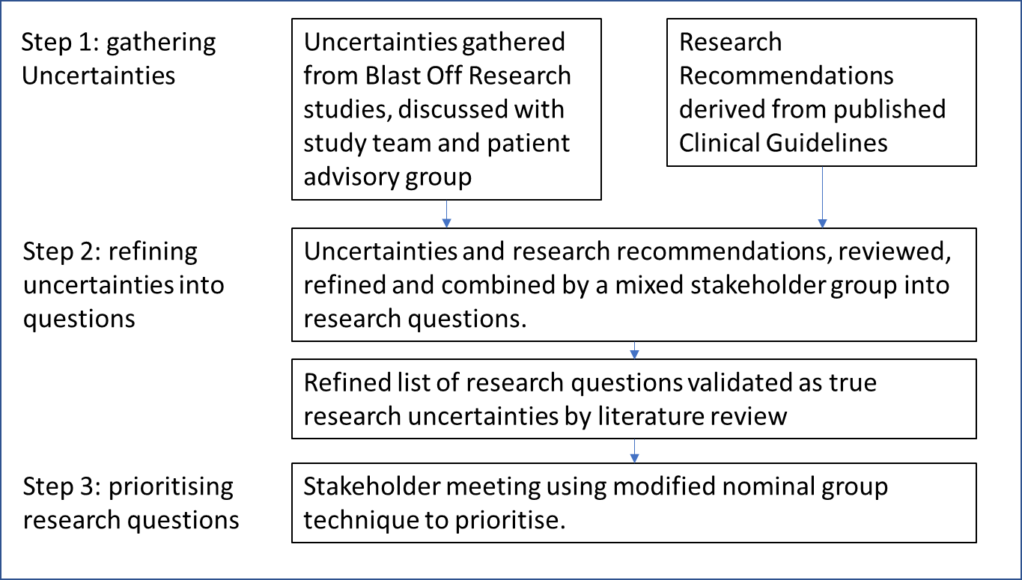
Figure 1: Overview of methods

Table 1: Characteristics of workshop attendees
Characteristics of participants | Workshop 1  N (%) | Workshop 2  N (%)
Healthcare professionals  Female  Secondary Care Doctor  Nurse/ Allied Health Professional  Primary care clinicians | 5 (42%)  2(40%)  5 (100%)  0  0 | 8 (40%)  5 (63%)  4 (50%)  2 (25%)  2 (25%)
Public Contributor  Female  Patient representative  Carer | 7 (58%)  5 (71%)  6 (86%)  1 (14%) | 12 (60%)  10 (83%)  12 (100%)  0
Total number | 12 | 20

Figure 2: Origin of final research questions
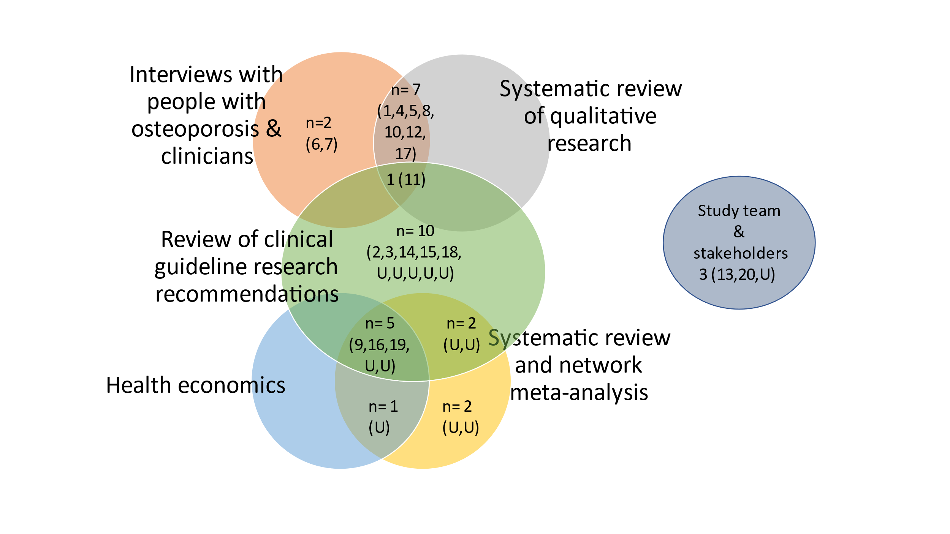
N = number of research questions. (ranking, U = unranked)
Figure 3: Finalised Top 10 Research priorities
- Which people with osteoporosis should be offered intravenous bisphosphonates first line to optimise medicine effectiveness?
- What is the optimal duration of treatment with bisphosphonates for people with osteoporosis?
- What is the role of bone turnover markers in determining the duration of treatment breaks in people with osteoporosis?
- What healthcare support do people with osteoporosis receiving bisphosphonates need for medicines optimisation?
- How can primary care practitioners be supported to make decisions about bisphosphonates with people with osteoporosis?
- What is the comparable safety, clinical and cost effectiveness of zoledronate administered in community (homes or primary care setting) vs in hospital for people with osteoporosis?
- How do we ensure quality standards are met for people with osteoporosis receiving bisphosphonates?
- What is the long-term model of care for people taking oral bisphosphonates in primary care?
- What is the best bisphosphonate choice and frequency for people aged under 50 with osteoporosis?
- How can people with osteoporosis be supported to make decisions about taking bisphosphonates?

References

[1] Cooper C, Campion G, Melton LJ. Hip fractures in the elderly: a world-wide projection. Osteoporos Int (1992) 2:285–9
[2] National Osteoporosis Society. NHS RightCare scenario: the variation between sub-optimal and optimal pathways, (2017): 1–16.
[3] Harvey N., Dennison, E. & Cooper, C. Osteoporosis: impact on health and economics. Nat Rev Rheumatol 6, 99–105 (2010).
[4] National Institute for Health Care Excellence. Bisphosphonates for treating osteoporosis, Technology appraisal guidance (TA46) NICE Guidance, (2017).
[5] Hiligsmann M, Cornelissen D, Vrijens B, et al. Determinants, consequences and potential solutions to poor adherence to antiosteoporosis treatment: results of an expert group meeting organized by the European Society for clinical and economic aspects of osteoporosis, osteoarthritis and musculoskeletal diseases (ESCEO) and the International osteoporosis Foundation (IOF). Osteoporos Int (2019);30:2155–65.
[6] Khosla S, Shane E. A crisis in the treatment of osteoporosis. J Bone Miner Res (2016) ;31:1485–7
[7] de Wit MP, Berlo SE, Aanerud GJ, Aletaha D, Bijlsma JW, Croucher L, Da Silva JA, Glusing B, Gossec L, Hewlett S, Jongkees M, Magnusson D, Scholte-Voshaar M, Richards P, Ziegler C, Abma TA (2011) European league against rheumatism recommendations for the inclusion of patient representatives in scientific projects. Ann Rheum Dis 70:722–726
[8] Crowe S, Fenton M, Hall M, Cowan K, Chalmers I (2015) Patients’, clinicians’ and the research communities’ priorities for treatment research: there is an important mismatch. Research Involvement and Engagement 1:1
[9] Hernlund E, Svedbom A, Ivergård M, Compston J, Cooper C, Stenmark J, McCloskey EV, Jönsson B, Kanis JA (2013) Arch Osteoporos (2017) 12: 45 Page 7 of 8 45 Osteoporosis in the European Union: medical management, epidemiology and economic burden. Arch Osteoporos 8:136
[10] Cooper C (1997) The crippling consequences of fractures and their impact on quality of life. Am J Med 103:S12–S19
[11] Cochrane methods Priority Setting (2015) Top tips for research priority setting. Available at http://methods.cochrane.org/ prioritysetting/top-tips-research-priority-setting-cochrane-vienna2015-workshop
[12] Mahmood W, Jinks C, Jayakumar P, Gwilym S, Paskins Z (2016) 115 public priority setting for research in osteoporosis. Rheumatology 55:i109–i110
[13] Jinks C, Carter P, Rhodes C, Taylor R, Beech R, Dziedzic K, Blackburn S, Hughes R, Ong BN (2016) Patient and public involvement in primary care research-an example of ensuring its sustainability. Research Involvement and Engagement 2:1
[14]Chalmers I, Bracken MB, Djulbegovic B, Garattini S, Grant J, Gülmezoglu AM, Howells DW, Ioannidis JP, Oliver S (2014) How to increase value and reduce waste when research priorities are set. Lancet 383:156–165
[15] Partridge N, Scadding J (2004) The James Lind Alliance: patients and clinicians should jointly identify their priorities for clinical trials. Lancet 364:1923–1924
[16] Staley K, Hanley B (2008) Scoping research priority setting (and the presence of PPI in priority setting) with UK clinical research organisations and funders
[17] Paskins Z., Jinks, C., Mahmood, W., Jayakumar, P., Sangan, C. B., Belcher, J., & Gwilym, S. (2017). Public priorities for osteoporosis and fracture research: results from a general population survey. Archives of osteoporosis, 12(1), 1-8.
[18] Cowan K, Oliver S; James Lind Alliance (JLA) Guidebook, Chapter 1 The James Lind Alliance Guidebook Version 9. 2020. Available online: https://www.jla.nihr.ac.uk/jla-guidebook/downloads/JLA-Guidebook-V9-download-March-2020.pdf.
[19] Sahota O, Narayanasamy M, Bastounis A, Paskins Z, Bishop S, Langley T, Gittoes N, Davis S, Bailey A, Holmes M, Leonardi-Bee J. BLAST-OFF : Bisphosphonate aLternAtive regimenS for the prevenTion of Osteoporotic Fragility Fractures; A Mixed Methods Study NIHR HTA report (2022)
[20] Paskins Z, Crawford-Manning F, Cottrell E, et al. Acceptability of bisphosphonates among patients, clinicians and managers: a systematic review and framework synthesis. BMJ Open (2020);10:e040634. doi: 10.1136/bmjopen-2020-040634
[21] Narayanasamy, M. et al, Acceptability and engagement amongst patients on oral and intravenous bisphosphonates for the treatment of osteoporosis in older adults, Age and Ageing Age and Ageing, Volume 51, Issue 11, November 2022, afac255, https://doi.org/10.1093/ageing/afac255
[22] Bastounis A, Langley T, Davis S, et al. Assessing the Effectiveness of Bisphosphonates for the Prevention of Fragility Fractures: An Updated Systematic Review and Network Meta-Analyses. JBMR Plus. (2022) ;6(5):e10620. Published (2022) Mar 25. doi:10.1002/jbm4.
[23] Bastounis, A., Langley, T., Davis, S. et al. Comparing medication adherence in patients receiving bisphosphonates for preventing fragility fractures: a comprehensive systematic review and network meta-analysis. Osteoporos Int 33, 1223–1233 (2022). https://doi.org/10.1007/s00198-022-06350-w
[24] Richardson M S, Wilson M C, Nishikawa J, et al; The well-built clinical question: a key to evidence-based decisions. (1995);123:A12. doi:10.7326/ACPJC-1995-123-3-A12
[25] Cowan K, Oliver S, James Lind Alliance (JLA) Guidebook, Chapter 7 Report on JLA PSP online priority setting workshop
[26] National Institute for Health and Care Excellence (2008) Alendronate, etidronate, risedronate, raloxifene and strontium ranelate for the primary prevention of osteoporotic fragility fractures in postmenopausal women. TAG 160
[27] National Institute for Health and Care Excellence (2008) Alendronate, etidronate, risedronate, raloxifene, strontium ranelate and teriparatide for the secondary prevention of osteoporotic fragility fractures in postmenopausal women. TAG 161
[28] Grossman JM, Gordon R, Ranganath VK, Deal C, Caplan L, Chen W, Curtis JR, Furst DE, McMahon M, Patkar NM (2010) American College of Rheumatology (2010) recommendations for the prevention and treatment of glucocorticoid-induced osteoporosis. Arthritis care & research 62:1515–1526
[29] Paskins Z, Babatunde O, Sturrock A, Toh L S, Horne R, Maidment I,, on behalf of the Effectiveness Working Group of the Royal Osteoporosis Society Osteoporosis and Bone Research Academy, Supporting patients to get the best from their osteoporosis treatment: a rapid realist review. In press Osteoporosis International
[30] Paskins Z, Bullock L, Crawford-Manning F, et al. Improving uptake of Fracture Prevention drug treatments: a protocol for Development of a consultation intervention (iFraP-D) BMJ Open (2021);11:e048811. doi: 10.1136/bmjopen-2021-048811
[31] Cornelissen, D., Boonen, A., Evers, S. et al. Improvement of osteoporosis Care Organized by Nurses: ICON study - Protocol of a quasi-experimental study to assess the (cost)-effectiveness of combining a decision aid with motivational interviewing for improving medication persistence in patients with a recent fracture being treated at the fracture liaison service BMC Musculoskelet Disord 22, 913 (2021). https://doi.org/10.1186/s12891-021-04743-2
[32] Sale J, Marwah, A, Naeem, F et al. Evidence of patient beliefs, values, and preferences is not provided in osteoporosis clinical practice guidelines. Osteoporos Int 30, 1325–1337 (2019). https://doi.org/10.1007/s00198-019-04913-y
[33] Hawarden A, Jinks C, Mahmood W, Bullock L, Blackburn S, Gwilym S, Paskins Z. Public priorities for osteoporosis and fracture research: results from a focus group study. Arch Osteoporos.( 2020) Jun 16;15(1):89. doi: 10.1007/s11657-020-00766-9. PMID: 32548718; PMCID: PMC7297850.

A further GP provided ranking in advance of the meeting but did not attend

