Daily pain severity but not vertebral fractures is associated with lower physical activity in postmenopausal women with back pain
Gallin Montgomery¹, Jon H Tobias^{2,3}, Zoe Paskins^{4,5}, Tarnjit K Khera², Cameron J Huggins⁶, Sarah J Allison^{7,8}, Daniel Abasolo⁶, Emma M Clark², Alex Ireland¹
1 Musculoskeletal Science and Sports Medicine Research Centre, Manchester Metropolitan University, Manchester, UK
2 Musculoskeletal Research Unit, Translational Health Sciences, Bristol Medical School, University of Bristol, Bristol, UK
3 MRC Integrative Epidemiology Unit, Bristol Medical School, University of Bristol, Bristol, UK.
4 School of Medicine, Keele University, Staffordshire, UK
5 Haywood Academic Rheumatology Centre, Midlands Partnership NHS Foundation Trust, Stoke-on-Trent
6 Centre for Biomedical Engineering, School of Mechanical Engineering Sciences, Faculty of Engineering and Physical Sciences, University of Surrey, Guildford, United Kingdom
7 School of Health and Life Sciences, Teesside University, Teesside, UK
8 School of Bioscience & Medicine, University of Surrey, Guildford UK

Running head: Back pain, vertebral fractures and physical activity in postmenopausal women

Keywords: osteoporosis, accelerometry, spine, walking
Corresponding Author: Dr Alex Ireland, Manchester Metropolitan University, John Dalton Building, Chester Street, Manchester, M1 5GD. a.ireland@mmu.ac.uk. +44 (0)161 247 1987.

Abstract (150 words)
Back pain lifetime incidence is 60-70%, whilst 12-20% of older women have vertebral fractures (VFs), often with back pain. We aimed to provide objective evidence, currently lacking, regarding whether back pain and VFs affect physical activity (PA).
We recruited 69 women with recent back pain (age 74.5±5.4y). Low (0.5<g<1.0), medium (1.0≤g<1.5) and high-impact (g≥1.5) PA and walking time were measured (100Hz for 7-days, hip-worn accelerometer). Linear mixed-effects models assessed associations between self-reported pain and PA, and group differences (VFs from spine radiographs/no-VF) in PA.
Higher daily pain was associated with reduced low (β=-0.12, 95%CI -0.22 to -0.03, p=0.013) and medium-impact PA (β=-0.11, -0.21 to -0.01, p=0.041), but not high-impact PA or walking time (p>0.11). VFs were not associated with PA (all p>0.2).
Higher daily pain levels but not VFs were associated with reduced low and medium-impact PA, which could increase sarcopenia and falls risk in older women with back pain.

Introduction
Low back pain is the leading cause of disability worldwide (Vos et al., 2012), with a lifetime prevalence of 60-70% in industrialised countries. It is widely known that low back pain can influence activities of daily living (Grabovac & Dorner, 2019), and that a graded increase in pain is associated with greater restrictions on daily life activities such as walking for individuals with a lumbar disc herniation (Kose, Tastan, Temiz, Sari, & Izci, 2019). Impaired mobility in individuals with low back pain appears multifactorial, with potential contributors including impaired neuromuscular control, muscle weakness, altered posture and gait in addition to avoidance of further pain (Hammill, Beazell, & Hart, 2008). Physical activity (PA) is important for many health outcomes including all-cause mortality, physical function (Lee et al., 2012; Warburton & Bredin, 2019), mental health (Rebar et al., 2015), sarcopenia (Meier & Lee, 2020; Steffl et al., 2017) and bone strength (Hannam et al., 2017; Jain & Vokes, 2019; Johansson, Nordström, & Nordström, 2015). Results of objective measures of PA in individuals with back pain are mixed and largely assessed in younger individuals, although deficits in PA appear evident in those with a higher level of disability (Lin et al., 2011). Prevalence of low back pain is greater in women than men (Cassidy, Carroll, & Côté, 1998), therefore associations between back pain and PA may contribute to lower PA observed in older women (Caspersen, Pereira, & Curran, 2000).
Back pain can be caused by several problems including myofascial dysfunction or trauma, degeneration of the intervertebral disc or facet joints, or by fractures within the vertebral body. Vertebral fractures (VFs) are present in 12-20% of older women, and are the most common type of osteoporotic fracture within the older population (O'Neill et al., 1996). Although VF incidence in men and women is similar in midlife, the age-related increase in women is greater such that over the age of 70 VD incidence is around twice that in men (O'Neill et al., 1996). Individuals with VFs are at one of the highest risks of future fracture (Ismail et al., 2001; Kaptoge et al., 2004), and VFs are associated with increased mortality (Kado et al., 1999), morbidity (Hasserius, Karlsson, Jónsson, Redlund-Johnell, & Johnell, 2005) and reduced quality of life (Adachi et al., 2002). Over 50% of individuals with VFs have back pain (Society, 2014), which is qualitatively different to that in individuals with back pain due to degenerative change (Clark, Gooberman-Hill, & Peters, 2016) being more commonly described as crushing pain. In addition, back pain in individuals with VFs is more commonly relieved by lying down (Clark et al., 2016), which may lead to lower levels of PA. For these reasons, confounding effects of back pain reduce our ability to assess the independent impact of VFs on health and function.
The structural changes associated with VF including reduced thoracic space (Silverman, 1992) likely limit the ability of individuals to engage in PA, particularly vigorous activities known to be beneficial for bone strength (Hannam et al., 2017). Alterations in spine biomechanics resulting from VFs may have other consequences impacting on function, including impaired postural balance (Greig, Bennell, Briggs, Wark, & Hodges, 2007). Identifying consequences of VF independent of back pain is essential in developing successful strategies for improving functional outcomes in these individuals. However, whilst a number of studies using self-reported questionnaires have identified difficulties in walking and lower PA in individuals with a VF (Al-Sari, Tobias, & Clark, 2018), it is unclear whether this deficit is exaggerated compared with those with back pain due to other causes. Moreover, self-reported PA measures have poor agreement and evidence of bias when compared to objective accelerometry measures (Skender et al., 2016), which have not previously been applied to study PA in individuals with VFs.
Therefore, we aimed to measure objectively and compare habitual PA levels in individuals with different levels of back pain, and between those individuals with and without VF. We hypothesised that daily pain levels would be negatively associated with PA. In addition, it was also hypothesised that PA would be lower in individuals with VFs.

Methods
Study design
The Physical Activity in Individuals with Back Pain and Vertebral Fractures (PAVE) study was a nested case control study recruited from the Vfrac study (Khera et al., 2022), a cohort of older women from Bristol and Stoke-on-Trent, UK. Inclusion study for Vfrac were women ≥65 years of age (65.4 to 96.8 years), with self-reported back pain in the preceding four months, recruited via general practices. Additional exclusion criteria were having had a full spinal X-ray in the previous 4 months or being considered unsuitable for participation by their general practitioner (GP) e.g due to being housebound, recent bereavement, cognitive impairment or being near end of life. Invitation packs were sent by the participant’s GP,and those willing to participate were asked to complete a baseline questionnaire with information on demographics, socioeconomic status, traditional osteoporosis risk factors, back pain, quality of life, medication use, healthcare utilisation and comorbidity, along with a consent form and contact details which were sent to the study team. A study team member then checked eligibility and if eligible, participants were booked in for a physical examination, and a spinal radiograph. Vfrac participants provided written consent agreeing to be contacted about additional research studies and were therefore invited to participate in the PAVE study. PA was recorded with a hip-worn Actigraph wGT3X-BT accelerometer which was worn for 7 days, and self-reported pain measures were recorded for each day of PA measurement.
Ethics approval was obtained for Vfrac from the West of Scotland REC 3 18/WS/0061, IRAS ID 239418 and for PAVE from the Cambridgeshire and Hertfordshire REC, IRAS ID 257356.
Accelerometry
All participants were provided with an Actigraph wGT3X-BT accelerometer attached to an elasticated belt (Actigraph, Pensacola, CA, USA). Participants were given written and verbal instructions (via telephone) to wear the accelerometer over the right hip and to wear it for seven days during waking hours, except when bathing/showering/swimming. A short self-completion questionnaire was given to all participants to record brief daily details of their wear time and severity and causes of pain throughout the seven days of accelerometer wear. After 7 days, the participants returned the accelerometer and questionnaire to the PAVE study team via post.
Accelerations were recorded at 100 Hz for 7 days. Raw vertical acceleration data were extracted using ActiLife software (ActiLife 6 Data Analysis Software, Actigraph, Pensacola, CA, USA) and saved as CSV files. CSV files were read into and processed using MATLAB software (MATLAB R2019a, Mathworks, Cambridge, UK). Data analysis was conducted using previously published methods (Deere et al., 2016). Briefly, data were visually inspected and cleaned for non-wear and artefacts. Periods of primarily inverted accelerations highlighted instances where the monitor had been placed upside down, these were identified and corrected. Non-wear periods were identified as sustained periods of zero readings of > 20 minutes in duration, which were then removed from the analysis. Data from 4 minutes at the start and end of each period of wear time were removed to eliminate the acceleration artefacts from positioning the monitor and removing the monitor from the body. Participants were required to have a minimum of 6 hours of wear time per day across 7 days. Individual isolated instances of high acceleration >2 g during periods of low level activity were assumed to be artefacts as they were not consistent with high impact activity with multiple high accelerations. These artefacts were removed from the analysis.
Other established accelerometry assessments classify physical activity intensity using counts per minute thresholds. However, these measures combine movement frequency and magnitude of acceleration such that a small number of vigorous movements will be evaluated as equivalent to a large number of moderate movements. Whilst this may be relevant for aspects of health such as energy expenditure, for others such as muscle and particularly bone health effects of physical activity are intensity-specific (Hannam et al., 2017; Hartley et al., 2018). Therefore we identified and grouped individual impacts according to their intensity, as we have previously applied in a large group of older women (Deere et al., 2016; Hannam et al., 2016). Acceleration peaks were identified and expressed in g, where g indicated units greater than 1 g, which was a constant due to gravity. The number of acceleration peaks per week grouped into low (0.5<g<1.0), medium (1.0≤g<1.5) and high impact (g≥1.5) bands. Acceleration peaks below 0.5 g were categorised as sedentary activity and were not used in the analysis. The acceleration bands were developed due to previous findings that showed that older participants were unlikely to experience accelerations above 2.1 g (Deere et al., 2016; Tobias et al., 2014).
Development and application of a machine learning classifier for walking behaviour
A pre-trained binary machine learning k-Nearest Neighbours (k-NN) classifier was developed to predict when each participant was walking or stationary whilst wearing the accelerometer. The classifier was developed, tested, and trained using accelerometery data from eighty postmenopausal women who performed incremental shuttle tests, both on a treadmill and on a track. The testing of this classifier produced a leave-one-out validation accuracy of 99.61%. The cleaned accelerometery data were pre-processed by down-sampling to 50 Hz, filtered using a high pass filter and segmented into 2-second samples with 50% overlap. The samples were then processed into 18 features and combined into a single feature set, which included features from simple statistics, linear and non-linear digital signal processing. The resulting feature set was used as an input to the binary machine learning classifier, a k-NN classification algorithm and Manhattan distance measure. The classifier produced an output of either ‘Walking’ or ‘Stationary’ for every 1-second of the cleaned data. The percentage walking time for each participant was then calculated for the entire 7-day wear time, resulting in a weekly percentage walking time (Huggins et al., 2022).
Pain measurements
Sensory, affective and evaluative pain were assessed using a McGill questionnaire and each was calculated as a McGill pain score (Melzack, 1975). Briefly, sensory pain was described as crushing, heavy, dull, aching, sharp, gnawing, stinging, tingling and burning. Affective pain was described as tiring. Evaluative pain was described as annoying, intense, unbearable and excruciating (Melzack, 1975). Pain location was also classified by the site of back pain as thoracic, waist area, low back/buttock or multiple sites using a pain map (Clark et al., 2010). In the Vfrac questionnaire (Khera et al., 2019), participants were asked: “How does your back pain change with activity – generally my back is better with activity” and “How does your back pain change with activity – generally my back pain builds with activity”. From their answers to these questions, participants were classified as those whose back pain increased, decreased or remained unchanged with activity.
PAVE participants were given an additional short self-completion questionnaire to record brief details of their accelerometer wear time and the severity and causes of pain. They were asked to complete this daily throughout the seven days of accelerometer wear. Daily pain severity during the accelerometer wear period was recorded using a ten-point Likert scale. Average daily pain levels were calculated for each participant as an average of these daily pain recordings.
Radiographs
Participants were assessed for the presence of osteoporotic VFs on lateral thoracic and lateral lumbar radiographs by EC utilising the Algorithm-Based Qualitative (ABQ) approach (Jiang, Eastell, Barrington, & Ferrar, 2004; Khera et al., 2019). Radiographs were categorised into those with no fracture and those with fracture. Number of fractures were also noted.

Sample size
Recruitment of 170 individuals (85 with VFs and 85 without) would provide 90% statistical power to detect a 0.5 SD group difference (two-tailed analysis) in PA at an alpha level of 0.05. We aimed to recruit 200 individuals (100 each group) to ensure sufficient study power allowing for a low rate of loss of complete data (up to 17%) as found in previous cross-sectional studies in postmenopausal women (Hannam et al., 2017). This cohort size would also give high power (>99%) to detect a moderate (r = 0.3) linear correlation between daily pain and PA (two-tailed analysis) across the whole cohort.
Statistical analyses
Statistical analysis completed using R version 3.6.2. (R Foundation for Statistical Computing, v3.6.2, Vienna, Austria) using packages nlme and emmeans. Differences in cohort characteristics between individuals with and without VFs were assessed by Fisher’s exact test, χ2 tests and t-tests for binary, categorical and continuous variables respectively, and Mann-Witney test where data were not normally distributed. Linear mixed effects models were used to examine associations between average daily pain for each participant during accelerometer wear (exposure) with weekly low, medium, and high impacts and percentage walking time (outcomes). In addition, similar analyses were used to assess associations between the reported pain on any given day (exposure) and daily low, medium, and high impacts (outcomes), for which participant ID was included as a random effect. Associations between presence of VF as a binary exposure (yes/no) and weekly low, medium, and high impacts and percentage walking time (outcomes) were also examined. Furthermore, weekly low, medium, and high impacts and percentage walking time (outcomes) were compared between groups based on site of back pain (thoracic, waist area, low back/buttock and multiple sites), for associations with different dimensions of McGill pain scores (sensory, affective and evaluative) and for associations with perceived changes in back pain due to activity. In all cases except percentage walking time, analyses were initially adjusted for participant wear time (Model 1) and then in additional models for age (Model 2). Finally, to assess the independence of associations between pain/VF and PA outcomes analyses for pain were further adjusted for VF status and vice versa (Model 3). To meet assumptions of normality of residuals, PA data were root-transformed. The association between walking activity from the machine learning algorithm and low impact activity were assessed using Pearson correlation.

Results
Of the 466 invitations that were sent to potential participants (195 to individuals with VFs and 271 to those with no VFs), 99 were recruited whilst complete data from 69 participants were available to be used in the final analyses (Figure 1). Table 1 shows the characteristics of participants according to presence or absence of VF. There was no difference in age, height, weight or average daily pain, although directions of association were as expected.
The accelerometer impacts in low, medium and high impact bands for individuals with VFs and back pain control participants are detailed in Table 2. There was no difference in time worn between the two groups.
Association between back pain and PA
For all participants in minimally-adjusted Model 1, higher average daily pain levels were associated with lower low (standardised regression coefficient β – indicating change in outcome in SD per unit change in pain = -0.17, 95%CI -0.27 to -0.06, p = 0.013) and medium impact activity (β = -0.14, 95%CI -0.24 to -0.03, p = 0.011). There was weaker evidence of a similar association with high impact activity (β = -0.11, 95%CI -0.22 to 0.00, p = 0.058) but not with percentage walking time (β = -0.06, 95%CI -0.17 to 0.05, p = 0.272) (Table 3 and Figure 2). In a separate analysis, our novel method of identifying walking activity from accelerometry using machine learning algorithms showed a moderate association with low impact activity (r = 0.35, 95%CI 0.07 to 0.51, p = 0.004) (Figure 3).
There was attenuation of associations after adjustment for age in Model 2; whilst associations with low and medium impacts were still evident, there was little evidence for associations with high impact activity (β = -0.08, 95%CI -0.19 to 0.02, p = 0.131). Further adjustment for presence of VF in Model 3 had no substantial effect on associations.
Within-participant variation in pain was examined to assess whether individuals did less PA on days where they had higher pain levels (Table 3). There was no association between daily pain level and low (β = 0.02, 95%CI -0.03 to 0.06, p = 0.448), medium (β = -0.00, 95%CI -0.05 to 0.04, p = 0.922) or high impact PA (β = 0.00, 95%CI -0.06 to 0.06, p = 0.975).
Differences in PA between individuals with and without VFs were also examined (table 3). There was no evidence of differences in PA in individuals with VF for low impacts (β = -0.26, 95%CI -0.75 to 0.22, p = 0.294), medium impacts (β = -0.11, 95%CI -0.60 to 0.38, p = 0.665), high impacts ((β = 0.15, 95%CI -0.36 to 0.66, p = 0.561), or percentage walking time (β = 0.27, 95%CI -0.23 to 0.76, p = 0.296). This lack of association was not substantially altered after adjustment for age or weekly pain level.
In additional analyses, associations between detailed features of pain and PA outcomes were examined. There was little evidence of association between site at which participants reported experiencing pain (thoracic, waist area, low back/buttock and multiple sites) and any PA outcome in any model (all p > 0.2, Table 3). Similarly, there was little evidence of associations between participants’ reported changes in pain due to PA and any PA outcome (all p > 0.2, Table 3). Whilst McGill sensory pain score was positively associated with low impact PA (β = 0.26, 95%CI 0.03 to 0.50, p = 0.033) and weakly with % walking time in Model 1 (β = 0.24, 95%CI 0.00 to 0.48, p = 0.056), this was completely attenuated by adjustment for age (Table 3). The McGill affective pain score was not associated with any PA outcome in any model (all p > 0.1). The McGill evaluative pain score had similar inverse associations with percentage walking time in all models (Model 3 β = -0.27, 95%CI -0.53 to -0.01, p = 0.046), but was not associated with other PA outcomes (all p > 0.5).

Discussion
This study examined associations between back pain severity and PA, and between VF and PA in a small sample of older women. We measured low-impact, medium-impact and high-impact PA using accelerometry data and developed a novel machine learning classifier to estimate walking behaviour. Challenges caused by the COVID-19 pandemic led to lower participant numbers and reduced study power to detect associations. Average daily pain levels were associated with reduced low and medium impact activity, but not high impact activity or walking time. There was no evidence for an association between reported pain on any given day and daily PA. Objective walking, low, medium and high impact PA levels were similar in individuals with back pain and VF compared to individuals with back pain without VF. In more detailed analysis of pain characteristics, higher evaluative pain scores were associated with a lower percentage of time spent walking.
Comparison with previous findings
To the best of our knowledge, this is the first study to investigate associations between back pain and objective measures of PA in older individuals. Examination of associations between detailed pain characteristics such as pain location and type, and PA is also novel. These results are consistent with previous research showing reductions in PA with higher levels of pain related disability in individuals with a mean age of 45-50 years (Lin et al., 2011). In contrast, previous work found no evidence of an association between the level of back pain experienced and both light and moderate to vigorous objective PA in younger males and females with low back pain (Carvalho et al., 2017; Hendrick et al., 2011; Leininger et al., 2017). One previous accelerometer-based study identified an average increase in PA (counts per day) in individuals with low back pain one year after the development of symptoms coinciding with a reduced pain intensity (Bousema, Verbunt, Seelen, Vlaeyen, & Knottnerus, 2007). In addition, severity of back pain time has shown no association with self-reported walking in a number of previous studies (Fernando, Filho, & Barbosa, 2020) and our novel objective estimations of walking time are in line with these findings. Whilst our walking time data were positively associated with low impact activity, the effect size of the association was only moderate. This can be explained by other types of low impact activity such as housework and stair negotiation which would not be characterised as walking. Interestingly, all participants displayed lower levels of low (-39% and -18%), medium (-32% and -15%) and high impact activity (-29% and -24% for VF and back pain vs back pain only groups respectively) when compared to a similar cohort of postmenopausal women (mean age 76.8 years vs 74.5 years in the current study, median height 1.59 m vs 1.61 m in the current study, median weight 67 kg vs 67 kg in the current study) without any back pain symptoms with the same methods of assessment (Hannam et al., 2017). This might suggest that back pain of any aetiology could be associated with reduced PA.
Our findings show similar PA levels in individuals with and without fractures, and are in agreement with previous literature based on self-reported data (Mikkilä, Calogiuri, Emaus, & Morseth, 2019). People with VFs have reported lower physical performance (self-reported mobility and activities of daily living) when compared to control participants (Al-Sari et al., 2018). The presence of a VF has been associated with further functional limitations than the effect of either back pain or VF alone (Edmond, Kiel, Samelson, Kelly-Hayes, & Felson, 2005). When considering that individuals with VF reported a 27% increase in difficulty in undertaking ambulatory activities, it might be expected that this could influence walking and low impact PA. Research has also highlighted that often, measures of pain are not included and that higher levels of pain could substantially influence PA levels (Al-Sari et al., 2018). The presence of a single vertebral deformity has also shown no association with physical function (Jinbayashi et al., 2002) and activities of daily living when controlled for back pain (Huang, Ross, & Wasnich, 1996), which could both influence PA levels. Multiple vertebral deformities are associated with decreased physical function, even when controlled for back pain symptoms (Jinbayashi et al., 2002). Therefore, it is plausible that effects of VF on physical activity may be more pronounced in individuals with multiple VFs. The current study only had two participants with multiple VFs, which may help to explain the lack of observed associations between VF and PA. Larger studies assessing PA and VF should also consider assessment of the contribution of pain to any observed associations, in addition to the effects of multiple VFs on PA.
Explanation of findings
Pain has been reported to be the main barrier to PA in people with back pain (Boutevillain, Dupeyron, Rouch, Richard, & Coudeyre, 2017). This may help to explain why higher levels of pain were linked to reduced low and moderate PA levels in our results. In addition, greater sedentary behaviour is a known risk factor for lower back pain (Citko, Górski, Marcinowicz, & Górska, 2018). Individuals with greater sedentary behaviour also experience increased muscular atrophy and lower levels of muscle strength, these could adversely affect the stability of the spine and exacerbate existing lower back pain issues (Alsufiany et al., 2020). These issues in turn could also further reduce PA levels.
Certain types of back pain are known to cause avoidance of PA due to fear of pain (Keen et al., 1999; Marshall, Schabrun, & Knox, 2017; Schaller, Exner, Schroeer, Kleineke, & Sauzet, 2017), and have been linked with a sedentary lifestyle (Sribastav et al., 2018). We observed associations between evaluative pain and walking time but not low impact activity. This could indicate avoidance of more voluntary PA such as recreational walking or commuting by walking, whereas other daily activity is maintained. Whilst there is limited information on associations between pain type and function in individuals with back pain, evaluative pain in post hip-fracture patients is associated with impaired ability to complete activities of daily living (Campos, Liebano, Lima, & Perracini, 2020). However, previous work has identified other activities such as gardening being perceived as potentially harmful activities in individuals with back pain whereas walking activities are perceived as low risk of harm (Leeuw, Goossens, van Breukelen, Boersma, & Vlaeyen, 2007). Therefore, the relationship between evaluative pain and walking activities requires further investigation. Our data show that some individuals presented relatively low pain levels despite the presence of a VF. As pain due to VF may be shorter in duration and is less likely to radiate to the legs, this may have less of an effect on overall PA than lower back pain from degeneration (Clark et al., 2016).
Implications of findings
Back pain is the highest contributor to global disability (Hoy et al., 2014), and older women with back pain have greater risk of all-cause mortality, cardiovascular mortality and cancer mortality (Roseen et al., 2019), as well as obesity (Nieminen, Pyysalo, & Kankaanpää, 2021) and sarcopenia (Tanishima, Hagino, Matsumoto, Tanimura, & Nagashima, 2017). Therefore, reduced PA in older women with back pain may contribute to these health impairments. Additionally, the median number of high impacts were 29% (VF and back pain) and 24% (back pain only) lower than reported in a similar aged female population (Hannam et al., 2017). This may also infer a greater risk of reduced lower limb bone strength for both individuals with VF and those with back pain only, although this would need further investigation.
It must be acknowledged that back pain from VFs and back pain from degenerative changes are fundamentally different, with VF related back pain easing when lying down, for example (Clark et al., 2016). However, higher average daily pain appears to be associated with reduced low and medium PA irrespective of the presence of a VF. This has key implications for the management of pain symptoms when it comes to the promotion of a physically active lifestyle with these populations. Pharmacological interventions have had mixed results in the management of back pain symptoms (Maher, Underwood, & Buchbinder, 2017), whereas targeted exercise therapies such as stretching or muscle strengthening activities are an effective treatment for low back pain symptoms and have been reported to decrease pain and improve physical function (Hayden, van Tulder, Malmivaara, & Koes, 2005). This may require extra support in helping individuals circumvent barriers that prevent them from PA (Marshall et al., 2017; Schaller et al., 2017). In addition, cognitive behaviour therapy can be used in individuals with chronic pain in order to target effects of evaluative pain on function (Makris, Abrams, Gurland, & Reid, 2014).
Strengths and limitations of study
This is the first study to assess objective PA data with a population of older women with back pain, some of whom had VFs. In addition, application of a classifier developed to identify walking behaviour from accelerometer data is also novel. Despite our small sample size, we confirmed that back pain is associated with reduced PA. A primary aim of our study was to examine associations between VFs and PA, but effects of the Covid-19 pandemic meant that we only recruited 24 participants with VFs. This was exacerbated by the age of our population, as the vast majority were over 70 and considered ‘clinically vulnerable’ by UK government guidance. This meant that our study only achieved sufficient power to detect large effects (88% power to detect 0.8 SD group difference). The dropout rate due to incomplete data was much higher than our previous studies, which might relate to the remote nature of the data collection. In addition, non-random dropout may have introduced bias into our sample limiting generalisability of the results. The small sample size also did not allow us to explore the role of potential mediating factors such as body size. The accelerometry data collected provide reliable, detailed information of different intensities of PA during daily living. However, some popular activities such as cycling and swimming would have not been captured due to participants having to remove the accelerometer or the lack of impact activity. In addition, the act of wearing an accelerometer may influence an individual’s engagement in PA whether consciously or subconsciously. The inclusion of a group without back pain would have allowed us to assess the extent of PA deficits attributable to increased back pain in relation to typical activity levels. Whilst overall pain levels were assessed during the period of accelerometer data collection, questionnaire-based data on pain characteristics such location and type were collected on average several weeks beforehand in tandem with scanning sessions. Therefore, given weekly variability in reported pain in our study participants with back pain (Jamison, Raymond, Slawsby, McHugo, & Baird, 2006), future studies should ensure to collect all pain-related data concurrently with outcome assessments.
Conclusions
Greater average daily pain was associated with lower levels of low and medium PA but not high impact activity or walking time in older women with back pain. In exploratory assessments of associations between detailed characterisation of pain and PA, we observed lower levels of walking in individuals with higher evaluative pain. Lower levels of PA in older women with higher average daily pain may contribute to their increased risk of all-cause mortality, sarcopenia and future fractures. These results support the need for approaches aiming to increase PA in older women with back pain, such as targeted exercises.
Acknowledgements: This study was funded by a New Investigator Grant from the Royal Osteoporosis Society (reference number 398). ZP is funded by the National Institute for Health and Care Research (NIHR), Clinician Scientist Award (CS-2018-18-ST2-010)/NIHR Academy. The views expressed are those of the authors and not necessarily those of the National Health Service, the NIHR, or the Department of Health & Social Care.

References
Adachi, J. D., Ioannidis, G., Olszynski, W. P., Brown, J. P., Hanley, D. A., Sebaldt, R. J., . . . Goldsmith, C. H. (2002). The impact of incident vertebral and non-vertebral fractures on health related quality of life in postmenopausal women. BMC Musculoskelet Disord, 3, 11. doi:10.1186/1471-2474-3-11
Al-Sari, U. A., Tobias, J. H., & Clark, E. M. (2018). Self-reported everyday physical activities in older people with osteoporotic vertebral fractures: a systematic review and meta-analysis. Osteoporos Int, 29(1), 19-29. doi:10.1007/s00198-017-4287-6
Alsufiany, M. B., Lohman, E. B., Daher, N. S., Gang, G. R., Shallan, A. I., & Jaber, H. M. (2020). Non-specific chronic low back pain and physical activity: A comparison of postural control and hip muscle isometric strength: A cross-sectional study. Medicine (Baltimore), 99(5), e18544. doi:10.1097/MD.0000000000018544
Bousema, E. J., Verbunt, J. A., Seelen, H. A. M., Vlaeyen, J. W. S., & Knottnerus, A. J. (2007). Disuse and physical deconditioning in the first year after the onset of back pain. Pain, 130(3), 279-286. doi:10.1016/j.pain.2007.03.024
Boutevillain, L., Dupeyron, A., Rouch, C., Richard, E., & Coudeyre, E. (2017). Facilitators and barriers to physical activity in people with chronic low back pain: A qualitative study. PLoS One, 12(7), e0179826. doi:10.1371/journal.pone.0179826
Campos, H. L. M., Liebano, R. E., Lima, C. A., & Perracini, M. R. (2020). Multidimensional investigation of chronic pain experience and physical functioning following hip fracture surgery: clinical implications. Br J Pain, 14(1), 5-13. doi:10.1177/2049463719861994
Carvalho, F. A., Maher, C. G., Franco, M. R., Morelhão, P. K., Oliveira, C. B., Silva, F. G., & Pinto, R. Z. (2017). Fear of Movement Is Not Associated With Objective and Subjective Physical Activity Levels in Chronic Nonspecific Low Back Pain. Arch Phys Med Rehabil, 98(1), 96-104. doi:10.1016/j.apmr.2016.09.115
Caspersen, C. J., Pereira, M. A., & Curran, K. M. (2000). Changes in physical activity patterns in the United States, by sex and cross-sectional age. Med Sci Sports Exerc, 32(9), 1601-1609.
Cassidy, J. D., Carroll, L. J., & Côté, P. (1998). The Saskatchewan health and back pain survey. The prevalence of low back pain and related disability in Saskatchewan adults. Spine (Phila Pa 1976), 23(17), 1860-1866; discussion 1867. doi:10.1097/00007632-199809010-00012
Citko, A., Górski, S., Marcinowicz, L., & Górska, A. (2018). Sedentary Lifestyle and Nonspecific Low Back Pain in Medical Personnel in North-East Poland. Biomed Res Int, 2018, 1965807. doi:10.1155/2018/1965807
Clark, E. M., Gooberman-Hill, R., & Peters, T. J. (2016). Using self-reports of pain and other variables to distinguish between older women with back pain due to vertebral fractures and those with back pain due to degenerative changes. Osteoporos Int, 27(4), 1459-1467. doi:10.1007/s00198-015-3397-2
Clark, E. M., Hutchinson, A. P., McCloskey, E. V., Stone, M. D., Martin, J. C., Bhalla, A. K., & Tobias, J. H. (2010). Lateral back pain identifies prevalent vertebral fractures in post-menopausal women: cross-sectional analysis of a primary care-based cohort. Rheumatology (Oxford), 49(3), 505-512. doi:10.1093/rheumatology/kep414
Deere, K. C., Hannam, K., Coulson, J., Ireland, A., McPhee, J. S., Moss, C., . . . Tobias, J. H. (2016). Quantifying Habitual Levels of Physical Activity According to Impact in Older People: Accelerometry Protocol for the VIBE Study. J Aging Phys Act, 24(2), 290-295. doi:10.1123/japa.2015-0066
Edmond, S. L., Kiel, D. P., Samelson, E. J., Kelly-Hayes, M., & Felson, D. T. (2005). Vertebral deformity, back symptoms, and functional limitations among older women: the Framingham Study. Osteoporos Int, 16(9), 1086-1095. doi:10.1007/s00198-004-1815-y
Fernando, L., Filho, S., & Barbosa, M. (2020). The Influence of Clinical,
Functional, and Psychosocial Factors on Walking Time in Individuals With
Chronic Low Back Pain. Journal of Manipulative & Physiological Therapeutics, 43, 331-338.
Grabovac, I., & Dorner, T. E. (2019). Association between low back pain and various everyday performances : Activities of daily living, ability to work and sexual function. Wien Klin Wochenschr, 131(21-22), 541-549. doi:10.1007/s00508-019-01542-7
Greig, A. M., Bennell, K. L., Briggs, A. M., Wark, J. D., & Hodges, P. W. (2007). Balance impairment is related to vertebral fracture rather than thoracic kyphosis in individuals with osteoporosis. Osteoporos Int, 18(4), 543-551. doi:10.1007/s00198-006-0277-9
Hammill, R. R., Beazell, J. R., & Hart, J. M. (2008). Neuromuscular consequences of low back pain and core dysfunction. Clin Sports Med, 27(3), 449-462, ix. doi:10.1016/j.csm.2008.02.005
Hannam, K., Deere, K. C., Hartley, A., Al-Sari, U. A., Clark, E. M., Fraser, W. D., & Tobias, J. H. (2017). Habitual levels of higher, but not medium or low, impact physical activity are positively related to lower limb bone strength in older women: findings from a population-based study using accelerometers to classify impact magnitude. Osteoporos Int, 28(10), 2813-2822. doi:10.1007/s00198-016-3863-5
Hannam, K., Deere, K. C., Hartley, A., Clark, E. M., Coulson, J., Ireland, A., . . . Tobias, J. H. (2016). A novel accelerometer-based method to describe day-to-day exposure to potentially osteogenic vertical impacts in older adults: findings from a multi-cohort study. Osteoporos Int, 28(3), 1001-1011. doi:10.1007/s00198-016-3810-5
Hartley, A., Gregson, C. L., Hannam, K., Deere, K. C., Clark, E. M., & Tobias, J. H. (2018). Sarcopenia is negatively related to high gravitational impacts achieved from day-to-day physical activity. J Gerontol A Biol Sci Med Sci, 73(5), 652-659. doi:10.1093/gerona/glx223
Hasserius, R., Karlsson, M. K., Jónsson, B., Redlund-Johnell, I., & Johnell, O. (2005). Long-term morbidity and mortality after a clinically diagnosed vertebral fracture in the elderly--a 12- and 22-year follow-up of 257 patients. Calcif Tissue Int, 76(4), 235-242. doi:10.1007/s00223-004-2222-2
Hayden, J. A., van Tulder, M. W., Malmivaara, A., & Koes, B. W. (2005). Exercise therapy for treatment of non-specific low back pain. Cochrane Database Syst Rev(3), CD000335. doi:10.1002/14651858.CD000335.pub2
Hendrick, P., Milosavljevic, S., Hale, L., Hurley, D. A., McDonough, S., Ryan, B., & Baxter, G. D. (2011). The relationship between physical activity and low back pain outcomes: a systematic review of observational studies. Eur Spine J, 20(3), 464-474. doi:10.1007/s00586-010-1616-2
Hoy, D., March, L., Brooks, P., Blyth, F., Woolf, A., Bain, C., . . . Buchbinder, R. (2014). The global burden of low back pain: estimates from the Global Burden of Disease 2010 study. Ann Rheum Dis, 73(6), 968-974. doi:10.1136/annrheumdis-2013-204428
Huang, C., Ross, P. D., & Wasnich, R. D. (1996). Vertebral fracture and other predictors of physical impairment and health care utilization. Arch Intern Med, 156(21), 2469-2475.
Huggins, C. J., Clarke, R., Abasolo, D., Gil-Rey, E., Tobias, J. H., Deere, K., & Allison, S. J. (2022). Machine Learning Models for Weight-Bearing Activity Type Recognition Based on Accelerometry in Postmenopausal Women. Sensors (Basel), 22(23). doi:10.3390/s22239176
Ismail, A. A., Cockerill, W., Cooper, C., Finn, J. D., Abendroth, K., Parisi, G., . . . O'Neill, T. W. (2001). Prevalent vertebral deformity predicts incident hip though not distal forearm fracture: results from the European Prospective Osteoporosis Study. Osteoporos Int, 12(2), 85-90.
Jain, R. K., & Vokes, T. (2019). Physical activity as measured by accelerometer in NHANES 2005-2006 is associated with better bone density and trabecular bone score in older adults. Arch Osteoporos, 14(1), 29. doi:10.1007/s11657-019-0583-4
Jamison, R. N., Raymond, S. A., Slawsby, E. A., McHugo, G. J., & Baird, J. C. (2006). Pain assessment in patients with low back pain: comparison of weekly recall and momentary electronic data. J Pain, 7(3), 192-199. doi:10.1016/j.jpain.2005.10.006
Jiang, G., Eastell, R., Barrington, N. A., & Ferrar, L. (2004). Comparison of methods for the visual identification of prevalent vertebral fracture in osteoporosis. Osteoporos Int, 15(11), 887-896. doi:10.1007/s00198-004-1626-1
Jinbayashi, H., Aoyagi, K., Ross, P. D., Ito, M., Shindo, H., & Takemoto, T. (2002). Prevalence of vertebral deformity and its associations with physical impairment among Japanese women: The Hizen-Oshima Study. Osteoporos Int, 13(9), 723-730. doi:10.1007/s001980200099
Johansson, J., Nordström, A., & Nordström, P. (2015). Objectively measured physical activity is associated with parameters of bone in 70-year-old men and women. Bone, 81, 72-79. doi:10.1016/j.bone.2015.07.001
Kado, D. M., Browner, W. S., Palermo, L., Nevitt, M. C., Genant, H. K., & Cummings, S. R. (1999). Vertebral fractures and mortality in older women: a prospective study. Study of Osteoporotic Fractures Research Group. Arch Intern Med, 159(11), 1215-1220. doi:10.1001/archinte.159.11.1215
Kaptoge, S., Armbrecht, G., Felsenberg, D., Lunt, M., O'Neill, T. W., Silman, A. J., . . . Group, E. S. (2004). When should the doctor order a spine X-ray? Identifying vertebral fractures for osteoporosis care: results from the European Prospective Osteoporosis Study (EPOS). J Bone Miner Res, 19(12), 1982-1993. doi:10.1359/JBMR.040901
Keen, S., Dowell, A. C., Hurst, K., Klaber Moffett, J. A., Tovey, P., & Williams, R. (1999). Individuals with low back pain: how do they view physical activity? Fam Pract, 16(1), 39-45. doi:10.1093/fampra/16.1.39
Khera, T. K., Burston, A., Davis, S., Drew, S., Gooberman-Hill, R., Paskins, Z., . . . Clark, E. M. (2019). An observational cohort study to produce and evaluate an improved tool to screen older women with back pain for osteoporotic vertebral fractures (Vfrac): study protocol. Arch Osteoporos, 14(1), 11. doi:10.1007/s11657-019-0558-5
Khera, T. K., Hunt, L. P., Davis, S., Gooberman-Hill, R., Thom, H., Xu, Y., . . . Clark, E. M. (2022). A clinical tool to identify older women with back pain at high risk of osteoporotic vertebral fractures (Vfrac): a population-based cohort study with exploratory economic evaluation. Age Ageing, 51(3). doi:10.1093/ageing/afac031
Kose, G., Tastan, S., Temiz, N. C., Sari, M., & Izci, Y. (2019). The Effect of Low Back Pain on Daily Activities and Sleep Quality in Patients With Lumbar Disc Herniation: A Pilot Study. J Neurosci Nurs, 51(4), 184-189. doi:10.1097/JNN.0000000000000446
Lee, I. M., Shiroma, E. J., Lobelo, F., Puska, P., Blair, S. N., Katzmarzyk, P. T., & Group, L. P. A. S. W. (2012). Effect of physical inactivity on major non-communicable diseases worldwide: an analysis of burden of disease and life expectancy. Lancet, 380(9838), 219-229. doi:10.1016/S0140-6736(12)61031-9
Leeuw, M., Goossens, M. E., van Breukelen, G. J., Boersma, K., & Vlaeyen, J. W. (2007). Measuring perceived harmfulness of physical activities in patients with chronic low back pain: the Photograph Series of Daily Activities--short electronic version. J Pain, 8(11), 840-849. doi:10.1016/j.jpain.2007.05.013
Leininger, B., Schulz, C., Gao, Z., Bronfort, G., Evans, R., Pope, Z., . . . Haas, M. (2017). Accelerometer-Determined Physical Activity and Clinical Low Back Pain Measures in Adolescents With Chronic or Subacute Recurrent Low Back Pain. J Orthop Sports Phys Ther, 47(10), 769-774. doi:10.2519/jospt.2017.7345
Lin, C. W., McAuley, J. H., Macedo, L., Barnett, D. C., Smeets, R. J., & Verbunt, J. A. (2011). Relationship between physical activity and disability in low back pain: a systematic review and meta-analysis. Pain, 152(3), 607-613. doi:10.1016/j.pain.2010.11.034
Maher, C., Underwood, M., & Buchbinder, R. (2017). Non-specific low back pain. Lancet, 389(10070), 736-747. doi:10.1016/S0140-6736(16)30970-9
Makris, U. E., Abrams, R. C., Gurland, B., & Reid, M. C. (2014). Management of persistent pain in the older patient: a clinical review. JAMA, 312(8), 825-836. doi:10.1001/jama.2014.9405
Marshall, P. W. M., Schabrun, S., & Knox, M. F. (2017). Physical activity and the mediating effect of fear, depression, anxiety, and catastrophizing on pain related disability in people with chronic low back pain. PLoS One, 12(7), e0180788. doi:10.1371/journal.pone.0180788
Meier, N. F., & Lee, D. C. (2020). Physical activity and sarcopenia in older adults. Aging Clin Exp Res, 32(9), 1675-1687. doi:10.1007/s40520-019-01371-8
Melzack, R. (1975). The McGill Pain Questionnaire: major properties and scoring methods. Pain, 1(3), 277-299. doi:10.1016/0304-3959(75)90044-5
Mikkilä, S., Calogiuri, G., Emaus, N., & Morseth, B. (2019). A cross-sectional and 6-year follow-up study of associations between leisure time physical activity and vertebral fracture in adults. BMC Musculoskelet Disord, 20(1), 435. doi:10.1186/s12891-019-2821-8
Nieminen, L. K., Pyysalo, L. M., & Kankaanpää, M. J. (2021). Prognostic factors for pain chronicity in low back pain: a systematic review. Pain Rep, 6(1), e919. doi:10.1097/PR9.0000000000000919
O'Neill, T. W., Felsenberg, D., Varlow, J., Cooper, C., Kanis, J. A., & Silman, A. J. (1996). The prevalence of vertebral deformity in european men and women: the European Vertebral Osteoporosis Study. J Bone Miner Res, 11(7), 1010-1018. doi:10.1002/jbmr.5650110719
Rebar, A. L., Stanton, R., Geard, D., Short, C., Duncan, M. J., & Vandelanotte, C. (2015). A meta-meta-analysis of the effect of physical activity on depression and anxiety in non-clinical adult populations. Health Psychol Rev, 9(3), 366-378. doi:10.1080/17437199.2015.1022901
Roseen, E. J., LaValley, M. P., Li, S., Saper, R. B., Felson, D. T., Fredman, L., & Fractures, S. o. O. (2019). Association of Back Pain with All-Cause and Cause-Specific Mortality Among Older Women: a Cohort Study. J Gen Intern Med, 34(1), 90-97. doi:10.1007/s11606-018-4680-7
Schaller, A., Exner, A. K., Schroeer, S., Kleineke, V., & Sauzet, O. (2017). Barriers to Physical Activity in Low Back Pain Patients following Rehabilitation: A Secondary Analysis of a Randomized Controlled Trial. Biomed Res Int, 2017, 6925079. doi:10.1155/2017/6925079
Silverman, S. L. (1992). The clinical consequences of vertebral compression fracture. Bone, 13 Suppl 2, S27-31. doi:10.1016/8756-3282(92)90193-z
Skender, S., Ose, J., Chang-Claude, J., Paskow, M., Brühmann, B., Siegel, E. M., . . . Ulrich, C. M. (2016). Accelerometry and physical activity questionnaires - a systematic review. BMC Public Health, 16, 515. doi:10.1186/s12889-016-3172-0
Society, N. O. (2014). Life with Osteoporosis: the
untold story. Key findings from research into the realities of life with
osteoporosis. In N. O. Society (Ed.).
Sribastav, S. S., Long, J., He, P., He, W., Ye, F., Li, Z., . . . Zheng, Z. (2018). Risk Factors Associated with Pain Severity in Patients with Non-specific Low Back Pain in Southern China. Asian Spine J, 12(3), 533-543. doi:10.4184/asj.2018.12.3.533
Steffl, M., Bohannon, R. W., Sontakova, L., Tufano, J. J., Shiells, K., & Holmerova, I. (2017). Relationship between sarcopenia and physical activity in older people: a systematic review and meta-analysis. Clin Interv Aging, 12, 835-845. doi:10.2147/CIA.S132940
Tanishima, S., Hagino, H., Matsumoto, H., Tanimura, C., & Nagashima, H. (2017). Association between sarcopenia and low back pain in local residents prospective cohort study from the GAINA study. BMC Musculoskelet Disord, 18(1), 452. doi:10.1186/s12891-017-1807-7
Tobias, J. H., Gould, V., Brunton, L., Deere, K., Rittweger, J., Lipperts, M., & Grimm, B. (2014). Physical Activity and Bone: May the Force be with You. Front Endocrinol (Lausanne), 5, 20. doi:10.3389/fendo.2014.00020
Vos, T., Flaxman, A. D., Naghavi, M., Lozano, R., Michaud, C., Ezzati, M., . . . Memish, Z. A. (2012). Years lived with disability (YLDs) for 1160 sequelae of 289 diseases and injuries 1990-2010: a systematic analysis for the Global Burden of Disease Study 2010. Lancet, 380(9859), 2163-2196. doi:10.1016/S0140-6736(12)61729-2
Warburton, D. E. R., & Bredin, S. S. D. (2019). Health Benefits of Physical Activity: A Strengths-Based Approach. J Clin Med, 8(12). doi:10.3390/jcm8122044

Table 1. Participant characteristics presented as means and SD
 | Back pain and vertebral fracture (n = 24) | Back pain and no vertebral fracture (n = 45) | p value
Age (years) | 75.9 (6.0) | 73.7 (5.0) | 0.139
Height (m) | 1.57 (0.08) | 1.60 (0.05) | 0.064
Weight (kg) | 67.6 (15.4) | 73.7 (18.6) | 0.159
Average daily pain | 4.1 (2.5) | 3.7 (2.0) | 0.463
Pain Site (n) |  |  | 0.515
Thoracic | 3 | 1
Waist area | 4 | 7
Low back/buttock | 3 | 7
Multiple | 14 | 29
McGill Pain Score
Sensory Pain | 2.3 (1.0) | 2.3 (1.0) | 0.857
Affective Pain | 0.6 (0.5) | 0.4 (0.5) | 0.132
Evaluative Pain | 0.7 (0.9) | 0.8 (0.9) | 0.618
Back pain due to activity (n) |  |  | 0.615
Better | 6 | 16
No change | 4 | 7
Worse | 14 | 21
Non vertebral fracture back pain (n = 44) for pain site, McGill pain score and back pain due to activity.
p values are presented for group differences.

Table 2. Accelerometer impacts across acceleration bands and average daily pain for vertebral fracture and control back pain participants
 | Number of Vertical Impacts
 | Back pain and vertebral fracture (n = 24) |  |  |  |  |  |  | Back pain and no vertebral fracture (n = 45)
Impact Band | Median |  | 25th |  | 75th |  |  |  | Median |  | 25th |  | 75th
Low (0.5<g<1.0) | 5385 |  | 1513 |  | 15576.2 |  |  |  | 7267 |  | 3619 |  | 13869
Medium (1.0≤ g<1.5) | 233.5 |  | 55 |  | 691 |  |  |  | 292 |  | 109.2 |  | 769.5
High (≥1.5 g) | 30 |  | 14.25 |  | 67.75 |  |  |  | 32 |  | 12 |  | 123
Weekly walking time (%) | 14.2 |  | 8.4 |  | 19.8 |  |  |  | 12.2 |  | 7.8 |  | 16.8
Weekly wear time (mins) | 5525 |  | 5089 |  | 5839 |  |  |  | 5171 |  | 4738 |  | 5629

Table 3. Associations between pain and vertebral fracture (VF) exposures and PA outcomes. SRC –standardised regression coefficient. Model Adjustments - Model 1: participant wear time (except for % walking time, which was unadjusted, Model 2: Model 1 + age, Model 3: Model 3 + VF (for pain exposures) or weekly pain (for VF).
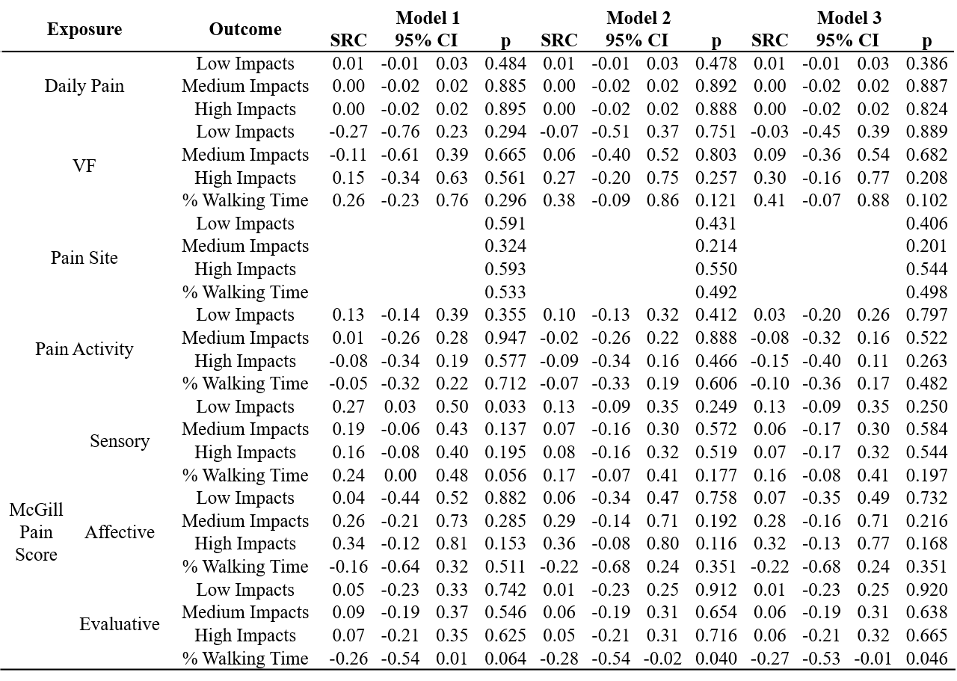

Figure 1
Flow diagram of participant recruitment
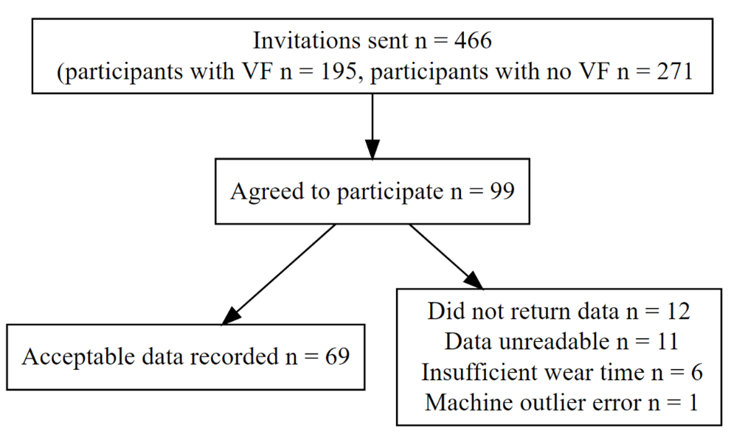

Figure 2.
Associations between average daily pain and PA outcomes, shown as standardised regression coefficients (indicating change in outcome in SD per one unit increment in average pain score) and 95% confidence intervals. Model 1 adjustments: wear time (except for walking time%, which is unadjusted), Model 2: Model 1 + age, Model 3: Model 2 + vertebral fracture.

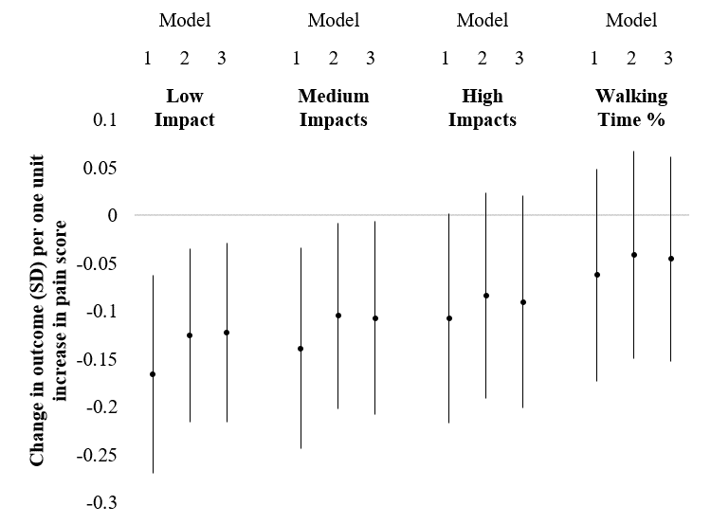

Figure 3.
The relationship between number of weekly low impacts and percentage walking time in all individuals, shown as Pearson correlation coefficient. Shaded area shows 95% confidence intervals.
