Transnational In-Group Solidarity Networks in the Case of
#Hellobrother

Abstract
This paper examines the dynamics of one hashtag, #hellobrother, shared on Twitter following the Christchurch terror attack on 15th March 2019. It was analysed as part of a larger study #Contesting Islamophobia: Representation and Appropriation in Mediated Activism which explores the potentials and limitations of counternarratives against Islamophobia on Twitter. Using three ‘trigger events’ (Awan, 2014), Brexit, the Christchurch terror attack, and the Covid pandemic as its starting point, the study analysed six weeks of tweets at different points in time. The data on #hellobrother demonstrates an affective response which, through the affordances of Twitter, gave rise to strong networks of transnational solidarity. It illustrates both the limitations of its potentially transient solidarities but also the capacity of social media to offer visibility to counternarratives, which at specific moments, following specific events can become normative.
Keywords: Islamophobia, Twitter, hellobrother, Christchurch terror attack, affect

#Hellobrother Örneğinde Ulusötesi İç Grup Dayanışma Ağları

Öz
Bu çalışma, 15 Mart 2019'da meydana gelen Christchurch terör saldırısının ardından Twitter'da paylaşılan #hellobrother etiketi etrafındaki dinamikleri incelemektedir. Çalışma, İslamofobiye karşı karşıt anlatıları araştıran ve Twitter'daki potansiyelleri ile sınırlılıklarını keşfetmeyi hedefleyen daha geniş kapsamlı #Contesting Islamophobia: Representation and Appropriation in Mediated Activism adlı çalışmanın bir parçası olarak ele alınmıştır. Çalışmada Awan (2014) tarafından tanımlanan üç 'tetikleyici olayı' - Brexit, Christchurch terör saldırısı ve Covid pandemisi - başlangıç noktası olarak ele almış, farklı zaman dilimlerinde altı haftalık tweet verisini analiz etmiştir. #hellobrother etiketiyle ilgili veriler, duygusal bir tepkiyi göstererek Twitter'ın imkanları aracılığıyla güçlü uluslararası dayanışma ağlarının oluşumuna zemin hazırlamıştır. Bu durum, potansiyel olarak geçici dayanışma biçimlerinin içsel sınırlarını sadece belirtmekle kalmaz, aynı zamanda sosyal medyanın, belirli anlarda belirli olaylara yönelik olarak karşı anlatılara görünürlük sağlama yeteneğini vurgular. Bu anlar, belirli olaylara ilişkin takip eden özel zaman dilimlerinde normatif özellikler kazanabilir.

Anahtar Kelimeler: İslamofobi, Twitter, hellobrother, Christchurch terör saldırısı, etki

Introduction
This paper examines the dynamics of one hashtag shared on Twitter following the Christchurch terror attack on 15th March 2019. It was analysed as part of a larger study #Contesting Islamophobia: Representation and Appropriation in Mediated Activism which explores the potentials and limitations of counternarratives against Islamophobia on Twitter. Using three ‘trigger events’ (Awan, 2014), Brexit, the Christchurch terror attack, and the Covid pandemic as its starting point, the study analysed six weeks of tweets at different points in time. For the Christchurch attack, this was for a month after the attack, then for a week at three months then six months later. In general, we noticed a demise in the use of hashtags across our datasets except for descriptive use (#Brexit, #Christchurch terror attack,) so the formation of #hellobrother was significant (see Table 1). Largely, in contrast to the other datasets, we also found evidence of strong networks of transnational solidarity in the #hellobrother hashtag.
Literature Review
Hashtags have been widely discussed as having the potential ‘to create collective conversations in times of crisis, conflicts, and controversies, they also mark and declare identities in distinction to other groups and opinions’ (Giglietto & Lee, 2017 cited in Evolvi, 2019: 387). Our own previous analysis of the #stopislam showed how this went viral on Twitter due to people sharing opposition to its original negative intention (Poole et al, 2019). In this way it was ‘hijacked’ to counter dominant ideas about Islam and terrorism (see also Jackson and Foucault-Welles’s 2015 study of the hashtag #myNYPD). Many theorists have shown how the architecture of Twitter along with its political economy (which rewards sensational and emotional content), allows for counter-publics to form (Fraser, 1990). These studies show how hashtags can be used as an ideological and organising tool for harnessing collective power in racial politics, providing alternative frames to mainstream discourse (Evolvi, 2019; Jackson and Foucault-Welles, 2015, 2016).
#hellobrother gained traction following a campaign by TRT World Citizen (Turkish public service broadcaster) to highlight the kindness of the first victim of the terror attack (Daoud Nabi) who opened the door of Al Noor mosque to the terrorist with the words ‘hello brother’. The aim was, in their words, to ‘continue the conversation he never had chance to finish’ and ‘spread hope, unity and love’. The larger dataset on Christchurch included over 3 million tweets, largely shared in the first 24 hours after the attack, (which was also the case with #hellobrother, see Figure 1) by high profile figures such as politicians and celebrities offering condolences. We describe these as affective solidarities (Papacharissi, 2014; Poole et al, 2023) in that they are mobilized through an outpouring of collective emotion and support. However, they were also limited, and criticized by other tweeters for their ‘non-performativity’ (Ahmed, 2004 NP), by their transience, quickly disappearing to give way to more critical (right-wing) debates around gun laws and censorship. In this article, we adopt a broad definition of solidarity to be inclusive but also to recognize its multiple dimensions, building on an argument we have made elsewhere (Poole et al, 2023). Social media platforms have been widely critiqued as providing a limited potential for solidarity due to ‘weak commitments’ underpinned by individualism and commerciality (see Nikunen, 2019). However, here we aim to show how, through this hashtag, Muslim voices were able to gain more centrality and visibility through transnational networks of connectivity to provide a counternarrative to stereotypical representations of Muslims as terrorists and construct an alternative discourse.
Figure 1. Timeline of the #hellobrother hashtag
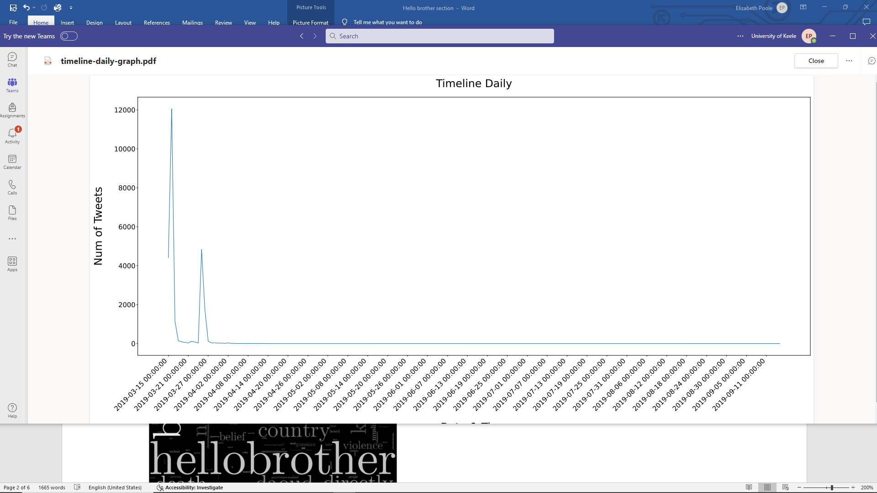
Methods
The project used a multi-method approach to analyse the content of tweets, including a big data analysis (25084 tweets in the month after the attack, 25476 in total), and a manual quantitative (1000 of the most shared tweets) and qualitative (top 50 shared tweets) content analysis. As well as being complementary, in some of the datasets we looked at, the methods complicated, in particular, the big data analysis (see Giraud et al, forthcoming). Big data studies have been criticized for their assumed accuracy and lack of transparency (Boyd and Crawford, 2012), triangulating methods allowed us to test the validity of our analysis. In the case of this dataset, due to its homogeneity, the approach consolidated and enriched the findings of each method. We used broad search terms to collect our initial data on Christchurch, (Christchurch or New Zealand) AND (Islam* or Muslim(s) or Moslem(s) or “Religion of Peace” or Terror* or Mosque(s). Our analysis of hashtags used in this dataset showed that #hellobrother was repeatedly used in relation to this event so we singled it out for analysis (Table 1).
Table 1: Hashtags of significance on Twitter after the Christchurch terror attack
Hashtag | Number
Christchurch | 475031
NewZealand | 130995
NewZealandshooting | 75441
christchurchmosqueattack | 74453
NewZealandterroristattack | 59595
peacefulmosques | 25904
hellobrother | 25476
NewZealandmosqueshooting | 24210
Islamophobia | 23123
Terrorism | 20252

Of the 25476 tweets, many were either Retweets (22803) or Quote tweets (1435), shared to show solidarity and circulate the story rather than add anything significant to the narrative. Figure 2 shows the most retweeted tweet in the dataset (8540 times at the time of capture). This image was retweeted often with only an emoji; the most frequently used emojis (crying, broken hearts, sad face) demonstrate an affective response: 😭❤️💔😢🙏🏼👇🙏😔.
Figure 2. Most retweeted tweet in #hellobrother
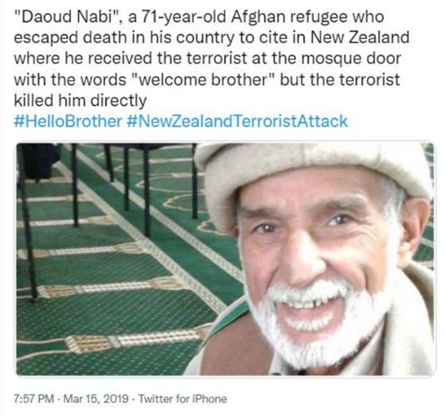
Figure 3 shows the keywords from the hashtag which clearly point to the circulation of the tweet shown in Figure 2.
Figure 3. Keywords
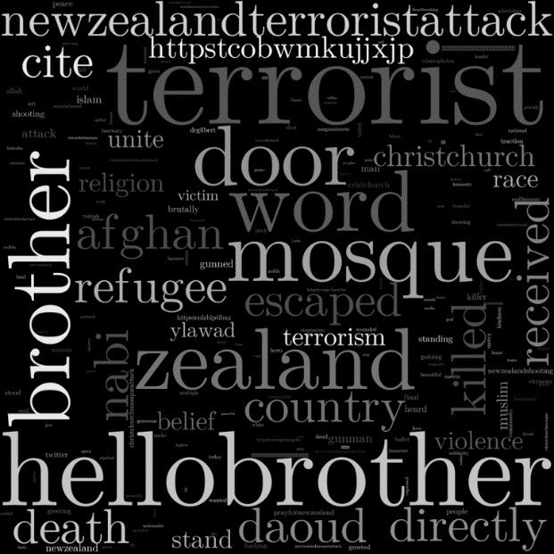

The second most retweeted tweet (6384) was from the Turkish footballer Mesut Ozil, who shared TRT’s video tribute to the Imam with the words ‘Terrorism has no religion’ and #hellobrother; with 26m followers, this also explains its traction (and the reason for the second peak in figure 1). Figure 4 also shows a frequently shared tweet (292), an illustration used by City News Toronto, with a significantly more open (ethnically) and younger figure which would appeal to a wider audience (the Indonesian artist, who shared in on Instagram, claims to have drawn it before an image of the victim was released). The network diagram shows the activity around the top retweeted tweets and how they are connected (Figure 5).
Figure 4. An illustration widely circulated with the #hellobrother
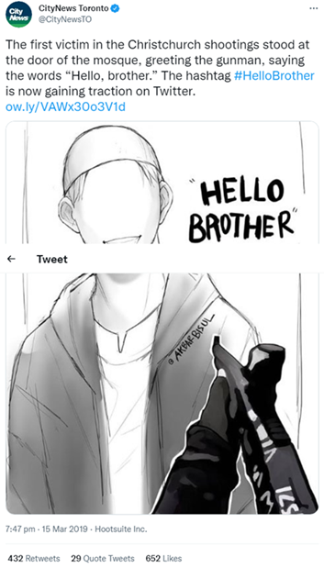
Image courtesy of Akbar Bisul
Figure 5. Retweet networks in #hellobrother
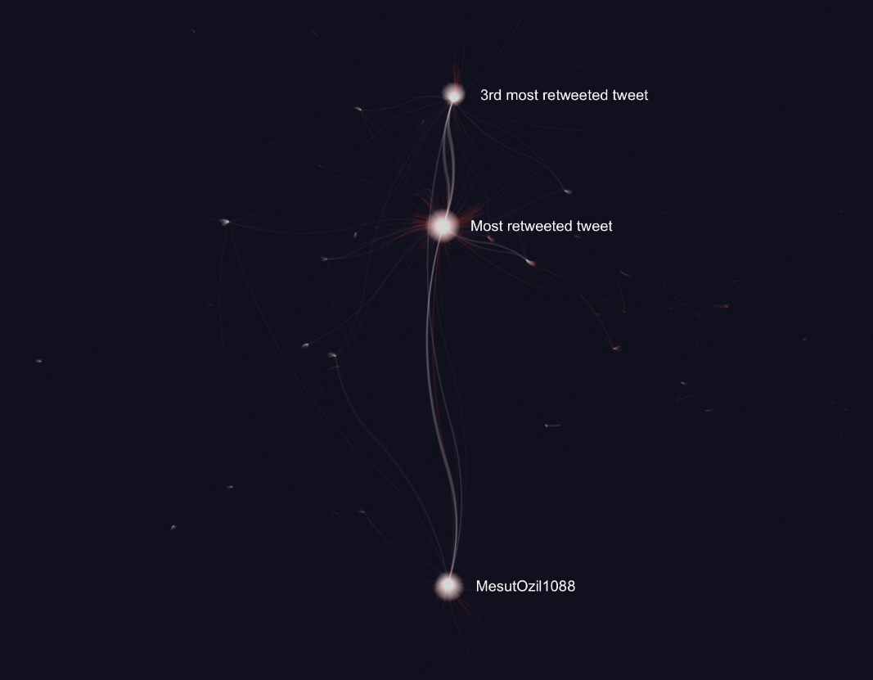
Key: White: Retweets, Red: Quote tweets
Where location can be identified (which is not always possible), this dataset shows more diversity than the others (particularly Brexit which is mostly British), as can be seen when compared to the larger Christchurch sample (see Table 2).
Table 2. Location of users in #hellobrother and the Christchurch terror attack
#hellobrother: Location | Number | Christchurch: Location  Sample 1: 15/3-15/4/19 | Number
Unknown | 9349 | Unknown | 1046489
Malaysia | 434 | United States | 31868
London, England | 253 | Malaysia | 26181
Indonesia | 252 | London, England | 21303
London | 138 | India | 17594
Saudi Arabia | 106 | Pakistan | 16500
Nigeria | 106 | London | 15313
Lagos, Nigeria | 97 | California, USA | 13419
Selangor, Malaysia | 85 | USA | 11029
UK | 82 | Canada | 11024
Nairobi, Kenya | 81 | Australia | 11023

The diversity of the dataset is also illustrated by the top users both by number of followers and those sharing the most original tweets. In the wider Christchurch dataset the top users by the number of their followers tended to be Western news organisations, politicians and celebrities but in this hashtag, as well as Mesut Ozil, there is an Egyptian footballer, a Malaysian politician, another Malaysian account, a Danish football supporter, and a Saudi consultant. Most of the top tweeters accounts have Arabic names (190 of the tweets are in Arabic). This is also evident in the manual content analysis of the 1000 most shared tweets, many are from the Middle East (particularly Saudi Arabia), there are a large number of Arabic tweets (96 non-English tweets out of the 1000 original tweets). There are a significantly higher number of (self-identified) Muslim accounts in the sample (38.3% compared to 3.5% in the Brexit sample). This is illustrative of the collective identities that coalesced around this hashtag, important in the way discourse is amplified on Twitter, through affective solidarities (see Richardson et al, forthcoming, for more discussion on these affective politics).
At this stage we were also able to measure support towards Muslims; 95.4% of these tweets are outwardly supportive to Muslims, significantly higher than the other datasets, demonstrating the collectivity of hashtag politics. This is further evident when examining the primary topic of tweets which comprised largely of condolences or tributes to victims (68.1%, see Table 3). This demonstrates the affective response which outweighs attention to political issues; only 3.8% of the tweets specifically point out Islamophobia as a primary issue. While the emotional tone therefore is sympathetic, the apolitical response is typical of reactions to terrorism which largely avoid addressing systemic issues. There is also little evidence of contestation in this dataset which had some success on Twitter in spreading a positive message about Islam. However, a number of tweets use the hashtags to give greater prominence/visibility to Islamic teachings, and proselytizing, (9.5%) further illustrating the appropriation of tweets for specific agendas. For example, the most shared URLs aim to show or teach about the religion such as Discoveritsbeauty, islamtomorrow.com and islamreligion.com

Table 3. Primary topics of tweets
 |  | Frequency | Percent | Valid Percent | Cumulative Percent
Valid | Condolences/support/tributes to Muslims | 681 | 68.1 | 68.1 | 68.1
 | Defending Muslims | 190 | 19.0 | 19.0 | 87.1
 | Global Politics/ Politics of RW terrorism | 89 | 8.9 | 8.9 | 96.0
 | Left wing politics | 32 | 3.2 | 3.2 | 99.2
 | Right wing politics | 6 | .6 | .6 | 99.8
 | Accusation of antisemitism | 2 | .2 | .2 | 100.0
 | Total | 1000 | 100.0 | 100.0

Conclusion
This article speaks to debates about hashtag politics which suggest that hashtags are instrumental devices around which counter-publics can form (Jackson and Foucault Welles, 2016). We have previously shown how counter-narratives can coalesce on social media platforms to challenge dominant negative media coverage of Islam (Poole et al, 2019). In comparison to other datasets in this project, this hashtag shows how social media can offer ‘potentials for identity negotiation, visibility and influence’ (Jackson and Foucault Welles, 2015: 399) and in this case allowed for the transnational expression of collective solidarities to form. However, this visibility did not expand significantly into the wider mainstream media. Through an analysis of worldwide mainstream media sources that used the hashtag (using the Nexis database) we found only 17 articles, only 8 from Western countries. It is, however, likely that some media organisations reported on the story without using the hashtag. While this would appear to reinforce arguments that social media solidarities are transient and therefore lacking in impact, we would argue that the data from the project overall shows how through different events, anti-Islamophobic counternarratives can be sustained and even become normative in the right conditions (see Poole et al, 2023).

References

Ahmed S. (2004). Declarations of whiteness: the non-performativity of anti-racism. Borderlands, 3(2). https://research.gold.ac.uk/id/eprint/13911/

Awan, I. (2014) Islamophobia and twitter: a typology of online hate against muslims on social media. Policy & Internet 6(2): 133–50
Boyd d., Crawford K. (2012). Critical questions for Big Data. Provocations for a cultural, technological, and scholarly phenomenon. Information, Communication & Society, 15(5), 662–679. https://doi.org/10.1080/1369118X.2012.678878

Evolvi, G. (2019) #Islamexit: inter-group antagonism on Twitter. Information, Communication & Society 22(3): 386-401
Fraser, N. (1990). Rethinking the public sphere: A contribution to the critique of actually existing
Democracy. Social Text 25/26: 56–80.
Giraud, E. H; Poole, E; Richardson, J.E and de Quincey, E. (in press). Learning from Hate: Developing diffractive approaches to big data for interdisciplinary research.

Jackson, S.J., & Foucault Welles, B (2015). Hijacking #myNYPD: social media dissent and networked counterpublics. Journal of Communication, 65(6), 932–952.

Jackson, S.J. and Foucault Welles, B. (2016) #Ferguson is everywhere: initiators in emerging counterpublic networks. Information, Communication & Society, 19(3): 397-418
Nikunen K. (2019). Media solidarities: Emotion, power and justice in the digital age. Sage.

Papacharissi, Z. (2014) Affective publics: sentiment, technology and politics. Oxford: Oxford University Press

Poole, E; Giraud, E, and De Quincey, E. (2019) Contesting #stopIslam: Examining the dynamics of anti-racist hashtag campaigns in contesting right wing populism, Open Library of Humanities, 5(1), 5. doi: https://doi.org/10.16995/olh.406

Poole, E; Giraud, E; Richardson, J and De Quincey, E. (2023) Expedient, affective, and sustained solidarities? mediated contestations of islamophobia in the case of brexit, the Christchurch terror attack, and the covid-19 pandemic, Social Media and Society https://doi.org/10.1177/20563051231199452

Richardson, J; Giraud, E; Poole, E and De Quincey, E. (2024) ‘Hypocrite!’ Affective and argumentative engagement on Twitter, following the Christchurch terrorist attack, Media, Culture and Society.

Endnotes The Christchurch terror attack took place in New Zealand and was committed by a white-supremacist terrorist who attacked two mosques killing 51 people and injuring 40. As well as posting a document online before the attack which demonstrates his hate for Muslims, he live streamed 17 minutes of the attack on Facebook before it was taken down.
https://www.keele.ac.uk/humanities/study/mcc/research/contestingislamophobia/
https://worldcitizen.trtworld.com/hello-brother/#:~:text=TRT%20World%20Citizen%20Hello%20Brother%20Campaign&text=The%20hashtag%20%23HelloBrother%20was%20born,had%20a%20chance%20to%20finish
Again, this confirms that most of the activity took place in the first month.
* includes any derivatives. Some of the search terms we used reflected the lexicon of far-right users after consultation with our advisory group.
We discuss this in Richardson et al, 2024.

