Forensic geoscience non-invasive detection and characterisation of underground clandestine complexes, bunkers, tunnels and firing ranges

Jamie K. Pringle^{1,2*}, Alastair Ruffell³, Peter Styles¹, Matt Stringfellow⁴, Ian G. Stimpson¹, Steven G. Banham^{1,5}, Kristopher D Wisniewski², Stephen Owen⁴, Luke Hobson¹ & James Thompson⁴

¹School of Geology, Geology & Environment, Keele University, Keele, Staffs, ST5 5BG, UK.
²School of Chemical & Physical Sciences, Keele University, Keele, Staffs, ST5 5BG, UK.
³School of the Natural Built Environment, Queens University, Belfast, N. Ireland, BT7 1NN, UK.
⁴RSK Geosciences, Part of RSK Environment Ltd, 18 Frogmore Road, Hemel Hempstead, HP3 9RT, UK.
⁵Department of Earth Science & Engineering, South Kensington Campus, Imperial College London, SW7 2AZ, UK.

Emails: j.k.pringle@keele.ac.uk ; a.ruffell@qub.ac.uk ; p.styles@keele.ac.uk ; MStringfellow@rsk.co.uk ; i.g.stimpson@keele.ac.uk ; s.banham@imperial.ac.uk ; k.d.wisniewski@keele.ac.uk ; SOwen@rsk.co.uk ; l.hobson@keele.ac.uk ; james.thompson@rsk.co.uk

*Corresponding author: Jamie Pringle (j.k.pringle@keele.ac.uk)

KEYWORDS: forensic science, geoscience, tunnel, bunker, EM, micro-gravity, resistivity, EM, magnetics, GPR

Abstract

Recent events in conflict zones have emphasized that the successful detection and characterisation of buried clandestine complexes, bunkers and tunnels is vitally important for forensic investigators globally, to reduce or solve criminal activities, address national security threats and avoid potential terrorist attacks. However, this can often prove very difficult, particularly in urban areas, with potentially both below-ground non target items and above-ground infrastructures present, that can interfere with detecting target(s).
Here we provide selected successful case studies where forensic geoscience techniques were used to detect and characterise buried clandestine complexes, bunkers and tunnels using different geophysical techniques. Generally, desktop studies assessing pre-existing information, including local geology, soils, historical/modern remote sensing, maps and photographs inform appropriate geophysical survey technique(s) selection. Subsequent near-surface geophysical techniques are then employed to produce accurate plans of sub-surface targets, with numerical modelling and correction for the interfering effects of above ground infrastructure, enabling the calibration of geophysical datasets to provide confidence in their respective interpretations.
All forensic investigations are, of course, unique to every site, and thus require an individual approach to their respective ground conditions. Investigations should be both phased and iterative, with techniques tailored to local conditions: the selection of geophysical method(s) is crucial to improve successful detection rates of such important buried targets.

Graphical abstract
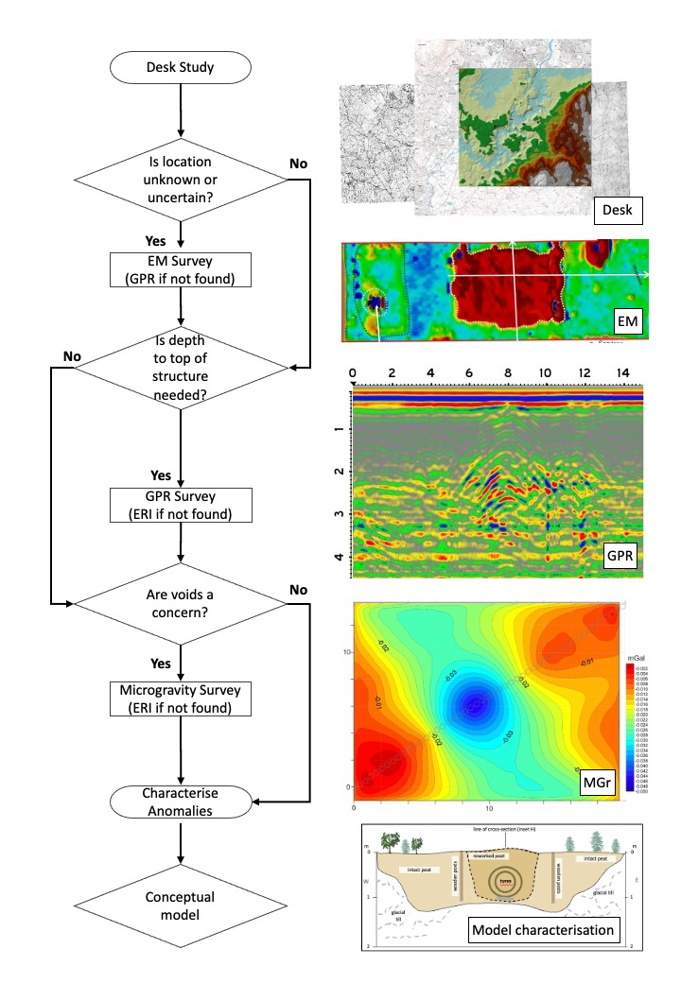

Highlights:
- Forensic search for underground complexes, bunkers and tunnels is difficult
- Forensic geophysics can be used to detect and characterise as part of phased investigations
- Geophysical technique(s) depend on target(s), depths below ground and background environment
- Case studies cover underground bunkers, tunnels and firing ranges detection
- Numerical modelling can also predict anomalies and calibrate geophysical datasets

Introduction

The non-invasive detection and characterisation of clandestine underground structures and covert underground complexes, bunkers and tunnels are of great interest to law enforcement, humanitarian investigations, forensic engineering, search and rescue teams, as well as national/international security forces. For law enforcement, the most recognised uses of tunnels are in smuggling of illegal goods, prisoner escapes and also covert activities such as illegal drug and explosives manufacture. Humanitarian issues concentrate on the illicit movement or secreting of people, especially human trafficking across international borders. For engineering, forensic investigations into tunnel and mine collapses are of paramount importance. The issues of smuggling (e.g. drugs, weapons, people, etc.) mix humanitarian with national security concerns to detection of military tunnelling – the latter of which is an extensive research topic in itself [1].

Most historical examples relate to either military campaigns or to defence (see [2]), with plentiful examples in the 20th Century such as: mining and underground dugouts and bunkers on the WW1 Western Front [3-5]; POW camp escape tunnels [6-7]; the Củ Chi tunnels in Vietnam in the 1970s [8] and under the demilitarised zone in the Korean peninsula [9]. In modern conflicts, military complex examples abound from Iraq and Afghanistan cave complexes, and specifically tunnels used by over 400 prisoners to escape from Sarposa Prison in Afghanistan in 2011 [10].

There are numerous detection methods described in the literature, indeed too many to describe in full here, but to summarise; best practice (see [11-12]) suggests following a phased-investigation approach, namely desktop studies assessing pre-existing target(s) information, including local geology, soils, historical/modern remote sensing, change detection analysis, contemporary and modern maps and photographs, before ground reconnaissance to inform appropriate geophysical survey technique(s) selection and then lastly intrusive investigations.

Whilst remote sensing has shown promise to detect such buried structures (see review in [11], and a Cyprus example in [13]), subsequent ground surveys using near-surface geophysical techniques have been shown to be more successful in the detection and characterisation of such sub-surface targets, even in difficult brownfield or urban sites. In comparison to conventional intrusive investigations, near-surface geophysical investigations can be collected across a relatively large area (100-1000 m³), under difficult conflict circumstances, by a relatively small team and in a shorter time frame, without having to disturb/destroy infrastructure or causing too much local public disturbance. The particular geophysical technique selected depends on the survey site itself, the target(s) size and depth below ground level (bgl) and what other non-target object(s) may be present. As would be expected, the deeper a subsurface target becomes, the progressively more difficult it is to detect and characterise them [14].

Shallow seismic methods, whilst relatively low resolution in comparison to other techniques, have been applied to detect voids in general, but have also been successfully used to detect bunkers and tunnels (see [10]). Microgravity surveys have been commonly used to detect both natural and man-made voids, mines and tunnels (e.g. [15]) but little has been published on their use for underground complexes. Electrical resistivity surveys have also been used to detect WW2 British resistance bunkers [5] and abandoned coal-mine access shafts (e.g. [16]), whilst Electro-Magnetic (EM) surveys have been used to detect WW1 underground bunkers on the Western Front [17], and tunnels along the south-west US border [18]. The less common utilised self-potential surveys techniques have also been demonstrated to detect water ingress down into access mineshafts, but data is relatively slow and difficult to collect [19]. Whilst depth-limited to commonly ~10m bgl, Ground Penetrating Radar (GPR) has been commonly used for such near-surface buried features, for example to detect and characterise unmarked cellars beneath commercial shop floors [20]. [21] provide useful insights into the use of GPR for clandestine tunnel detection and preventing non-target noise interference.

Numerical modelling can usefully calibrate the geophysical datasets collected and can provide estimates of anomaly causative void size, possible linings, depths and respective orientations, which can then provide confidence in geophysical dataset interpretations. For example, [21] numerically modelled seismic data to detect a tunnel on Rice University Campus (Houston, USA), and [19] modelled micro-gravity responses of an open, partially and filled scenarios of a successfully detected coal-mine vertical access shaft in Shropshire, UK.

In this paper through selected forensic case studies, using deliberately different geophysical techniques, to emphasise target and site uniqueness, we show how careful forensic geoscience site investigations successfully detected and characterised underground clandestine complexes, bunkers, tunnels and firing ranges.
Case Study 1: Micro-gravity survey to detect and characterise a Cold War era underground military complex

Background
ROTOR was an early warning air defence radar system built by the British Government in the 1950s, in response to the threat of Nuclear War with the USSR. As part of this system, an R3 style ROTOR bunker was built in 1953 beneath the RAF Troywood airbase, situated ~1 km SE from the town of St. Andrews, East Fife, Scotland [23]. This underground military complex was built in two levels covering 2,230 m² and incorporated Scotland’s command centre, radar, plotting rooms, mess and sleeping areas (Fig. 1). It is estimated that 45,000 Tns of concrete was used to construct the bunker, which has an outer 3 m thick concrete-reinforced shell with 2.5 cm-thick tungsten rods spaced every 15cm with an outer brick shell. It was subsequently privately purchased in 1993 and opened as a tourist attraction in 1994.

The client wished to quantify the geophysical footprint of the complex when locating similar underground complexes in other conflict areas.

Method
The site is open and grassy and is situated ~100m above sea level. The ground is composed of Devensian till soil overlying the Lower Carboniferous Anstruther Formation, which is a stratified mud-dominated sedimentary bedrock. There are above-ground structures, including the fake farmhouse which conceals the complex entrance, relict military vehicles and various metal fences (Fig. 1).

Due to the underground complex size and depth below ground level, this precluded EM, GPR and resistivity surveys to be undertaken. Magnetic surveys may have been useful here for comparison, but initial trial survey results were not good and thus a full microgravity survey was deemed optimal here.

The pre-planned 200 m² surveyed grid had 5 m spaced microgravity sample positions over the bunker itself and 10 m spaced sample positions away from the bunker to gain background gravity measurements. The survey week itself collected 166 sample positions and used a Scintrex™ CG-5 microgravimeter instrument. A Leica 1200 total station theodolite and RTK dGPS system was also used to accurately (+/-2mm) measure the relative spatial and height gravity sample positions, as well as the site and surrounding topography to generate a site digital elevation model. In certain survey areas, steep banks needed hand-dug sample positions to vertically level the microgravimeter. During the survey, 1,113 gravity readings were acquired with 45 s measurement durations, that were repeated three times at each station to gain average measurements. Usually longer measurement durations are used for gravity surveys but this was needed to cover the survey site, repeats and for quality control, 5% of stations were also resampled to ensure repeatability. Finally, hourly base station gravity observations were re-acquired to check diurnal Earth tide and to correct for instrument drift. Data quality was generally good despite the cold and windy weather during data collection, with average >0.1 SD of gravity readings collected. The microgravity data were corrected for earth tides and instrument drift, before being combined with survey data to adjust for relative sample position height variations, background topography and free-air corrections in Macro-enabled Microsoft Excel software. Finally a digitally-contoured Bouguer processed gravity dataset over the survey area was generated in MATLAB and SURFER software.

Results
The resulting processed microgravity 2D profile over the complex shows a clear and obvious microgravity low anomaly over the complex, with respect to background values, which is due to the low density anomaly associated with the void of the complexes (Fig. 1). Interestingly the relatively dense material used to construct the underground complex itself (as described above) had little effect on the anomaly. Two-dimensional numerical modelling Cooper™ grav2D software was also used over the complex centre to determine the likely position and depth of causative gravity anomalies (Fig. 1). Numerical modelling is useful to calibrate geophysical results for their likely causes with the caveat that there could be several potential non-unique solutions. Some prior knowledge needs to be known during this process.

The final microgravity low anomaly, quantifying the underground multi-level complex geophysical response, and 2D numerical model, were then provided to the client, to use for likely geophysical anomaly size and character caused by other underground complexes that forensic search investigators were seeking to identify in active conflict areas.

Case Discussion
A major advantage of gravity surveys, when compared to most other geophysical techniques, is that they are not depth limited, and therefore even deeply buried military complexes and bunkers, such as the one presented in this study, can still be detected. Successful observation depends on a range of variables: i) that a void presents a sufficiently large target anomaly in terms of size and contrast; a microgravity sample grid be gathered both over the immediate area, and beyond to measure the relative density contrasts; recording instruments are sensitive enough; and there are not significant above-ground structures which may interfere with the survey. Gravity surveys can still be collected adjacent and within above-ground structures if adjustments are made to gravity readings for the extra mass, but this process is lengthy and not straightforward (e.g. see [24]). These control studies are really useful to provide evidence of likely geophysical anomalies that are produced over such structures. However, microgravity surveys are arguably the slowest of the geophysical techniques to collect, are susceptible to local vibrations and bad weather causing data noise, need very accurate relative height measurements between sample stations and careful data processing to obtain good quality data.

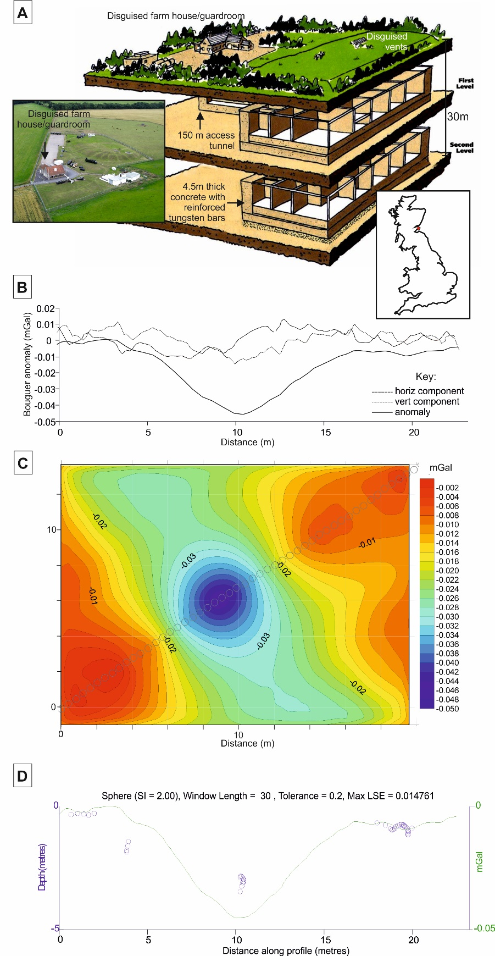
Fig. 1. Microgravity survey to identify an underground military complex. A: Modern site photograph and underground plan of RAF Troywood, showing the two level complex, access shaft, and above-ground disguised farm house/guard room and vents. B: Microgravity processed 2D profile across the complex, showing a relative gravity low and, C: processed microgravity grid showing obvious low Bouguer anomaly over the complex. D: 2D numerical gravity model across the bunker quantifying microgravity anomaly causative bodies.
Case study 2: Electro-magnetic survey to detect and characterise an underground WW2 public air-raid shelter/bunker

Background
During WWII, aerial attacks on the British Mainland were devasting and caused over 140,000 deaths [25], but in London this could have been far worse without the rapid construction of a variety of air-raid shelters. Different London Boroughs had individual policies that were sometimes at variance with the Government’s stance on avoiding deep underground shelters that may result in a bunker mentality and subsequent loss of productivity for the war effort [4].

The council client’s wish was to identify the location of a public air-raid shelter using geophysical methods as significant intrusive investigation were not desirable in these densely-populated urban areas. Using the results of the geophysical survey, a more targeted and less disruptive intrusive investigation could be carried out. The site was situated in a heavily developed built-up residential area, with properties ranging from three-storey brick-built flats to six-storey concrete block developments.

Methods
The area 1:50,000 scale geological map shows all investigated sites to have bedrock geology of London Clay with Cretaceous Chalk beneath, with at least 3 m of overlying made ground which contain a mixture of concrete debris, discarded smelted material and reworked clay. The site surface was an open grassy area with several metal inspection covers, surrounded by metal fences, tarmac paths, residential roads and significant residential multi-storey properties (Fig. 2).

Electrical resistivity surveys were not possible due to the surrounding roads and buildings, the urban site was too geophysically noisy for seismic surveys, and microgravity surveys would need to adjust for the extra gravitation mass of the surrounding above-ground buildings which would make the project too lengthy and costly for a commercial survey.. Instead, a phased TDEM and GPR survey approach was suggested to save both survey time and money, as these are relatively quick to acquire and should be less affected by above-ground conductive objects. A Geonics™ EM-61 ground conductivity meter in differential mode was used for this survey, being calibrated in a geophysically quiet area before being used to collect measurements approximately every 0.1m data on 1m-spaced lines in the 210 m² survey area. Data processing then integrated the collected EM dataset with dGPS positional information, removing isolated outlier data, particularly near the survey margins where conductive fences and parked cars were location, before finally a digital contoured surface grid was constructed and superimposed onto the basemap within Oasis Montaj v7. Software. Once the shelter was identified as an EM anomaly in the dataset, a series of targeted 400 MHz GPR 2D profiles were then acquired to identify the respective positions of the supporting air-raid shelter walls. 2D GPR profiles were processed by applying time zero, a band-pass filter and an exponential gain to enhance the signal at depth.

Results
The initial TDEM survey produced an obvious high-conductivity rectangular shaped anomaly, with respect to background values, over part of the survey area (Fig. 2). This was consistent with the presence of conductive reinforcing metal bars used commonly used in the construction of the roof in these types of air-raid shelter. Absence of these bars would otherwise likely generate a respective low conductive anomaly, with respect to background values.

The subsequent GPR 2D profiles showed roof-supporting walls were still in place at both the edges and within the shelter itself suggesting the roof was still intact, the depth to the roof was confirmed and the location of the shelter entrance on the northern side of the location (Fig. 2).

After the geophysical report was analysed, subsequent careful intrusive investigations, comprising targeted trial pits and concrete boring, confirmed the air-raid shelter position was causing the geophysical anomaly, the roof was indeed reinforced by metal rebars and the supporting shelter wall positions were correctly identified and still intact (see Ainsworth et al. 2018).

Case discussion
The multi-phased geophysical site investigation, initially collecting the bulk ground conductivity surveys to map the bunker extents, before the secondary GPR surveys located the roof-supporting walls and likely entrance, proved optimal to both rapidly detect and characterise the structure of this WW2-era underground public air-raid shelter. Such a multi-phased geophysical investigation phase is suggested to be best practice as others have evidenced (see, e.g. [11]) and was undertaken under fairly difficult survey conditions.

It should be noted that this study was very successful due to a lack of other similar-sized causative objects present onsite which would have interfered with results, was very shallowly buried, and there were not many above ground conductive objects that might have interfered with the survey itself, other than one parked car and metal fencing (Fig. 2). This may not be the case in other brownfield and urban sites of investigation, such as the [26] central London study.

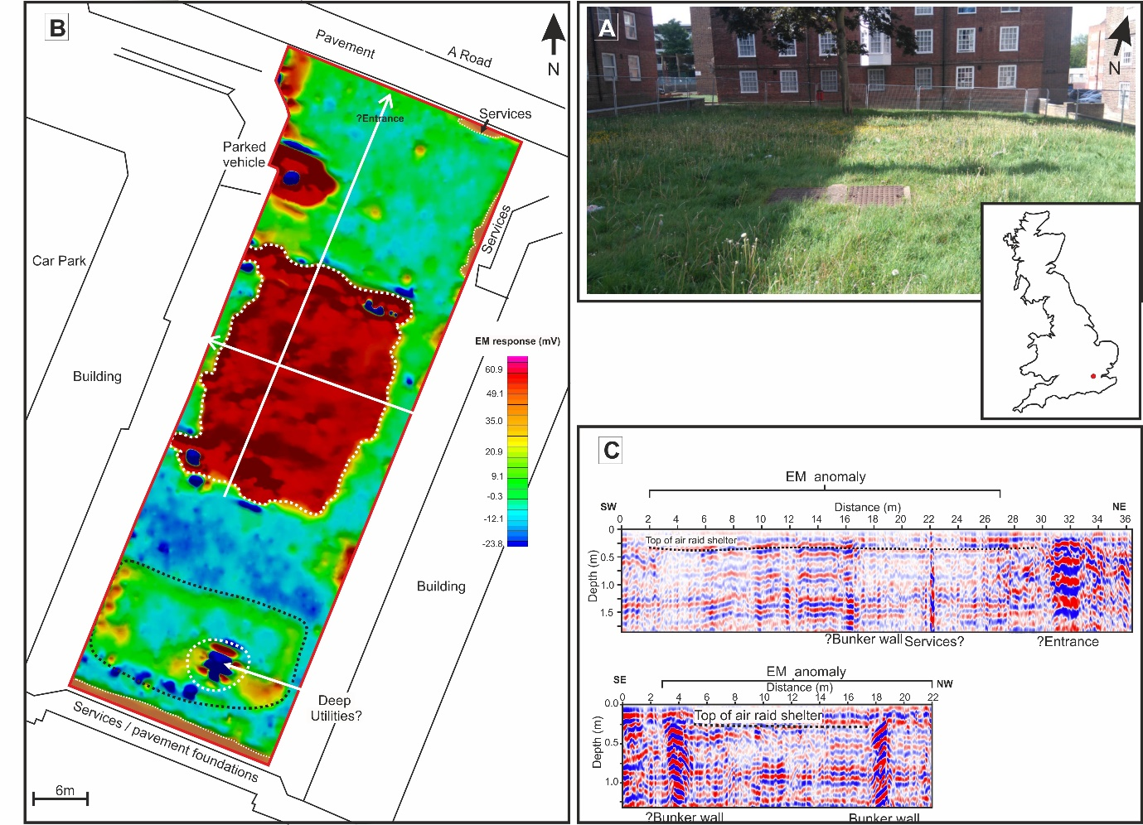
Fig. 2. EM/GPR survey to identify and characterise a WW2 underground air-raid shelter. A: Modern site photograph showing central area and surrounding residential developments (location map inset). B: EM61 processed results with relevant anomalies interpreted. C: Selected 2D 400 MHz GPR annotated profiles acquired (see B for respective locations). Adapted from [4].
Case study 3: Magnetic survey to detect and characterise an abandoned coal-mine access shaft

Background
An open, green field site in the Midlands, UK, had been earmarked as a potential housing development. The site 1:50,000 scale geological map shows the site to be underlain by Carboniferous Pennine Lower Coal measures of sedimentary mudstones, with overlying Quaternary clays, sands and gravels. However, the landowner was concerned about the risk presented by an historic coalmine access mineshaft within the site boundary, which was identified via the UK Coal Authority records.

The commercial client required a quick and accurate geophysical survey to locate the coal mineshaft, to confirm if it existed within the site boundary, as this would be a hazard for site development, and it was preferred that minimal intrusive work would be carried out.

Methods
A G858 Caesium vapor magnetic gradiometry survey, using vertically-orientated sensors collected 1s data on 1m-spaced lines was conducted. An Electro-magnetic (EM) conductivity FDEM GF Instrument CMD explorer system was also used, in vertical/high mode, to collect 2 m spaced data on 1m-spaced lines in two days over the 100 m x 70 m survey area due to the site urgency. Both instruments used Leica 1200 dGPS smartrover to spatially locate both geophysical surveys. After data collection, both datasets were processed (data spike removal including positional dropouts and other spurious values) before digitally contoured surfaces were generated in Oasis Montaj software.

Results
7 magnetic dipole and 6 low amplitude monopolar magnetic anomalies and 2 EM anomalies were identified within the survey area (Fig. 3), one of which was subsequently found to relate to the target mineshaft. The other anomalies are due to other non-target magnetic near-surface objects buried onsite, which is often the case in such environments [27]. To prioritise which anomalies should be investigated first, basic 2D numerical modelling of magnetic anomalies were undertaken, in order to quantify depth and size of causative objects.

After the geophysical report was analysed, subsequent careful intrusive investigations, using shallow mechanical excavation, confirmed the presence of the infilled mine access shaft at the large monopolar magnetic anomaly location identified in the survey data (Fig. 3). The intrusive investigations also confirmed that the other geophysical anomalies identified were not the result of previous mine workings.

Case discussion
Magnetic surveys often identify numerous non-target anomalies in survey areas, depending upon historical land use, above-ground metallic objects (if present) and also often have difficulty in calibrating magnetic instrumentation. However, as per the gravity methods shown in the initial case study, total field magnetic data is not depth limited, in contrast to other techniques, and can be numerically modelled to determine likely depth and size of causative objects as shown here and in other studies [28-29]. Magnetic gradiometer data collection is also more sensitive than total field data, avoids any potential magnetic field diurnal effects and thus does not require base station re-acquisitions. Whilst the approximate mine access shaft position was determined by records, these are often inaccurate (see [19]), and thus a rapid combined geophysical technique survey such as this is can rapidly determine its true position in the field.
Fig. 3. Magnetic survey to identify an infilled mine access shaft. A: Magnetic gradiometry processed data results, showing dipolar and monopolar magnetic anomalies (see key). B: Diagram showing likely magnetic causative body positions and respective depths below ground level (circles) and desk study identified shaft position (red). C: Photograph of successfully located infilled mine access shaft just to north of red position.
Case Study 4: Resistivity survey within an access shaft tunnel to detect and characterise a deeper tunnel

Background:
Coal seams in Apedale, Staffordshire, UK, were first mined commercially during the industrial revolution using drift and then deep mining techniques before switching to open cast mining. Mining ceased in 1996 and the old mines were landscaped to its present country park status. Part of the site was re-opened as a tourist mining museum, with mine accessed by inclined drifts, to shallow pillar and stall workings used to give underground mine tours.

The local mining museum client wished to reopen old workings in deeper seams for coal extraction on a charitable status, for use in their newly-installed steam train, as well as for potential train insurance liability for the underlying mine. An initial desk study suggested deeper target workings could be accessed from an accessible drift entrance, but there was uncertainty where this was. A geophysical survey was then suggested to non-intrusively locate where the deeper workings access was located.

Methods
A microgravity survey was attempted – both on the surface and within the No.4 adit, however, data corrections were found to be difficult, and the small target coal mine entrance could not be identified with certainty. EM surveys were also not optimal here due to the mining equipment on the surface. A GPR 2D profile was also collected down the inclined shaft but did not show any clear anomalies [16]. Finally, an electrical resistivity survey was therefore decided on, as an intact tunnel should be expressed as a highly resistive anomaly, as electrical currents find it more difficult to travel through air compared to soil and sediments.

A CAMPUS™ TIGRE system, with a 64-electrode array with 1 m spacings, was used for the single 2D resistivity profile within the access shaft (Fig.4), with basic surveying locating the survey from the entrance. Geotomo™ Res2Dinv v.3.4 data processing software then sequentially removed anomalous data points, a least-squares L1 normalised inversion algorithm then used for finite-difference numerical modelling, with the model run 5 times to give a reasonable RMS inversion model error (see [30]) and robust inversion option to reduce the effect of isolated anomalous data points, before model refinement using ½ cell spacing was used to reduce top-surface variations (Fig. 4).

Results
The resistivity 2D profile showed an obvious high resistivity (~1650 Ωm) anomaly ~24 m from the shaft entrance, with lower anomalies either side most probably due to modelling artefacts (Fig. 4).

After the geophysical report was analysed, subsequent careful intrusive investigations at the resistivity anomalous position excavating friable sand for ~6m below the entrance tunnel, before successfully locating and breaking through to the underlying open coal mine targeted tunnel. This deeper tunnel was then progressively physically excavated to the surface over several months, before being remade and made safe as a surface entrance for the deeper coal-mine workings (see [16]).

Case discussion
Geophysical surveys collected within confined spaces, such as the mine access tunnel in this case study or within manmade infrastructure, are challenging, not just for the surveying teams to design and acquire, but also to process and interpret the resulting data collected (see [31]). A difficult data processing example would be micro-gravity surveys acquired within buildings need to adjust for the extra building mass as [24] documented. An equally challenging interpretation example would be locating an unmarked cellar beneath a shop floor with previous building foundations ranging from Roman-era to present as [20] documented. Technique selection was shown to be key here – unsuccessful geophysical techniques trialled in this case study are detailed in [16]. However, in-mine surveys to look for deeper mine tunnels, previous mine workings and other hazards are actually fairly common in conventional exploration mining [15]: this case study is similar to Case Study 2 (above, WW2 air-raid shelters), in adopting the iterative approach of trial and error with eventual success.

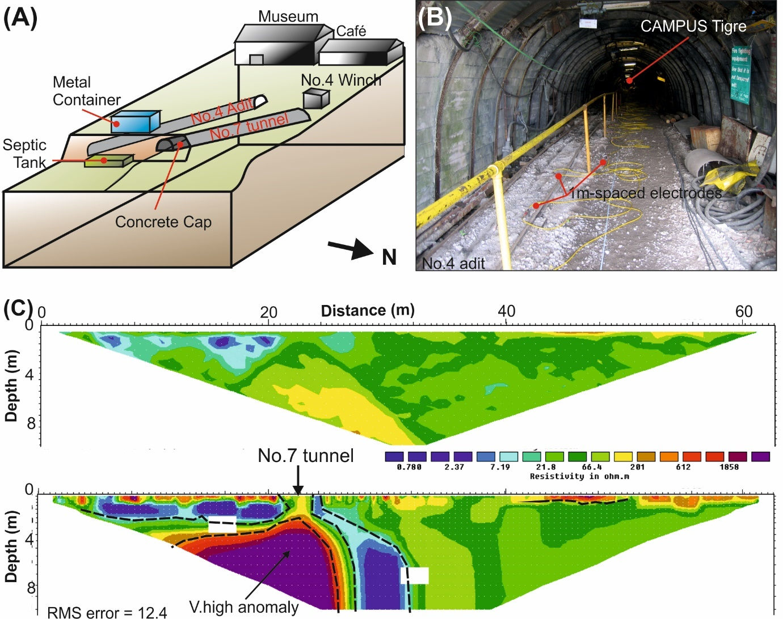
Fig. 4. Electrical resistivity survey within an access shaft adit to detect a deeper tunnel. A: site schematic showing the target No.7 tunnel located beneath No.4 access adit according to mine plans. B: Photograph showing the resistivity profile being collected. C: Resistivity 2D profile showing (top) collected data and (bottom) inverted data, with a clear high resistivity anomaly, sandwiched between low resistivity anomalies likely due to inversion modelling affects. The high resistivity anomaly was subsequently confirmed to be caused by the discovered target tunnel 7m below the access shaft tunnel. Modified from [16].

Case Study 5. GPR survey to detect a covert underground firing range

Background
The Provisional Irish Republican Army (PIRA) were a proscribed paramilitary force in the time of the Troubles - 1968/69 to 1986 [32], with the aim of reunification with the Republic of Ireland. The force used guerrilla tactics (including ambush shootings), requiring familiarity in the use of small arms. To secretly conduct this training PIRA constructed tube ranges known as improvised ranges [33], with a trench lined with vehicle tyres and covered. Some were 25 m in length, others 100 m. Tube ranges had an outer zone with a firing bay, ricochet/backsplash prevention and 12v battery lighting: some even doubled as briefing rooms and equipped with comfort facilities. These needed covert locations in uninhabited areas with easily-excavated (‘diggable’ – see [12]) superficial or bedrock geology. In the Irish border area there is low inhabitation, forests with tracks and operationally useful as PIRA could relocate across the border, requiring any law enforcement activities to be coordinated by both authorities. The tube ranges needed to be located, found and rendered non-operational by authorities.

The 1985 forensic search using remote sensing and ground searches were analysed by military data specialists to establish a 100 km² search area, with numerous vegetation anomalies, thermal hotspots and potential range access routes identified. Subsequent low frequency GPR surveys were conducted over selected sites, with one confirmed to be a long tube range (Fig. 5).

A modern retrospective desktop study, using available aerial imagery, geology/soil data, topography/past Ordnance Survey maps and original search data, will be analysed with the aim to construct an optimised phased workflow to identify these covert underground firing range target sites.

Methods
The Carboniferous resistant bedrock in the area formed a ~300m plateau, dissected by NE-SW orientated low scarp slopes, overlain by peat areas surrounding glacial drumlins. Analysis of map data showed the extent of peat and gravel tracks (Fig. 5). The 1985 originally collected 50m and 80m long 100 MHz 2D GPR profiles were re-processed in MalaVisionTM software using automatic gain control (AGC) and 1D trace averaging with no background removal.

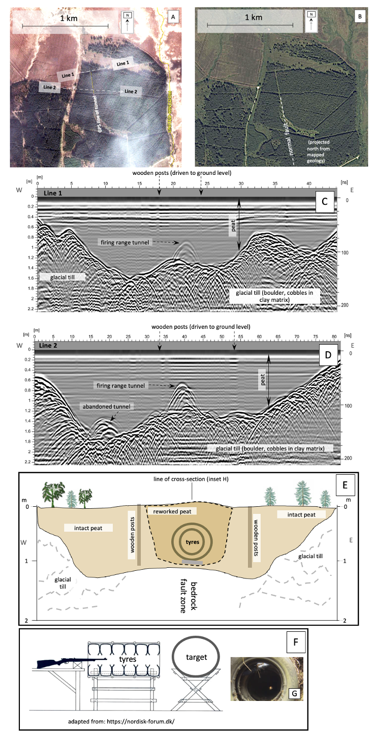
Fig. 5. Remote sensing and GPR data to locate a covert PIRA firing range. A: 2011 Copernicus image, showing position of 100 MHz GPR profiles (C, D); B: 2021 Apple maps aerial image © 2012–2021, after TomTom/OpenStreetMaps at https://www.apple.com/legal/internet-services/maps/terms-en.html; C,D: 100 MHz processed 2D GPR profile (location in A & B); E: conceptual 2D model of the tube range, combining GPR data with bedrock mapping; F: schematic 2D tube firing range, modified after nordisk-forum.de; G (inset on F): uncovered tube range tyres, from - https://www.rte.ie/archives/2022/0308/1285222-ira-training-camp/

Results
The tube range re-processed GPR survey data showed peat present down to 2 m bgl, with underlying palaeotopography mimicking the broad, N-S valley with the stream/waterfall to the east. Combining datasets allowed the palaeovalley and past valley stream positions to be identified, these infilled linear peat areas being advantageous and diggable tube range construction (Fig. 5).

Whilst this was a retrospective study, the analysis of remote sensing datasets allows rapid prioritisation of ground teams to focus search efforts on selected sites which, with careful geophysical surveys, GPR in this case, can detect the locations of the targeted underground firing ranges.

Case Discussion
The PIRA decision to choose the tube range site included geopolitical (the presence of, and proximity to, the Irish Border); behavioural (covert, remote location, possibly with sympathetic local people and some vehicle access) and the practical (easily diggable ground). Diggable sites were critical, as the north – south orientation of the tube range, on a moderate incline (north to south) followed a linear depression coincident with a bedrock normal fault, which was naturally infilled by ~2 m thick of peaty sediments. Detecting such underground covert facilities continues to be challenging as [34] document. The firing position was located at the southern end of the range, up-slope – probably allowing infiltrating groundwater to flow away from the storage area and the main access. In times of waterlogging of the downslope, northern end, the firing target could be moved closer, or a new temporary target installed. The level of engineering, with such geotechnical parameters used, installation of shoring posts and selection of geological location was highly sophisticated. Other such covert ranges and storage depots have been shown to be geologically controlled (see [2]) and thus should be considered by forensic search teams when locating search areas.

Discussion

The selected case studies presented illustrate how a thorough desk study, appropriate geophysical survey design and often repeated phases of multi-technique data collection, processing, interpretation and sometimes numerical modelling can maximise the chances of successful detection and characterisation of buried infrastructures that are summarised in Table 1. Forensic investigators looking for such covert facilities could relatively rapidly detect and characterise a range of clandestine buried infrastructure, such as these, which would greatly assist law enforcement, and national security agencies in providing evidence in hostile conflicts and for both civil and criminal prosecutions if deemed relevant.

Searching for similar buried targets are undertaken fairly commonly in other applied science areas, for example: civil engineering studies monitoring existing infrastructure or to assess potential infrastructure building sites for hazards; mining engineering looking for relict mine workings and access shafts; brownfield site development to detect and characterise cleared building foundations and infrastructure; historic (unmarked) landfill locations/remediations; environmental contamination investigations and archaeological investigations for relict conflict and habitation structures. Geophysical search investigations are therefore not novel but already proven techniques and, whilst often used for clandestine burial detection to detect isolated forensic objects (see [11]) and those hidden within built structures (see [31]), geophysical surveys have not been as applied to the detection of buried forensic targets as shown in this paper as much as they should be.

However, there are plenty of other noteworthy forensic case study examples where geophysical technique selection, survey design or interpretation was poorly applied, sub-optimal or shouldn’t have been applied. These include the ‘Gold Train’ Polish search using GPR/ERT surveys which were poorly designed and collected ([35] Pasierb & Nawrocki, 2020) and [28] had difficulty interpreting geophysical survey datasets to try to characterise WW2 German defensive sites on the Normandy coast which had been extensively bombed prior to the 1944 Allied invasion.

Case study | Target(s) & depth bgl (m) | Geophysical detection technique(s) | Survey Result | Survey technique advantage(s) | Survey technique Disadvantage(s)
CS1 | Military complex, 2 levels down to 30m bgl & 2,230 m² | Micro-gravity | Microgravity low anomaly detected & numerically modelled | Large target, microgravity not depth limited | Relatively slow to acquire (1 week) and gravity data processing takes time
CS2 | Public air-raid shelter/bunker <2m bgl & 910 m² | EM61 and then GPR | Conductivity high anomaly and GPR identified reinforced roof and surrounding wall positions | Rapid survey (2 days) to detecting and characterise structure | Susceptible to above-ground conductive object(s) and non-target buried object(s)
CS3 | Vertical mine access metallic shaft 1+m bgl & ~5m² diameter & | Magnetic and EM | Magnetic / conductive anomalies identified shaft position | Rapid survey (1 day) to detect metallic and conductive access shaft | Susceptible to above-ground conductive object(s) and non-target buried object(s)
CS4 | Below-ground access tunnel 7+m below to deeper mine adit | Resistivity | Very high resistivity anomaly detected deeper mine adit | Rapid survey (1 day) to detect target tunnel air-void below access tunnel, other techniques not successful | Difficult to collect and to obtain equivalent probe contact resistances
CS5 | Covert PIRA firing range 2+m bgl & 50m – 100m long | Remote sensing & GPR | Survey sites identified, GPR located firing ranges | Remote sensing data efficient to analyse. Rapid survey (1 day) GPR data collection | Expertise needed to undertake remote sensing data analysis. GPR depth limited to max. 10m bgl.
[10] Sloan et al. 2015 | Tunnel test 1.8 m² & Sarposa Prison escape tunnel 1m² | Shallow seismic | Both tunnel locations Identified | Rapid survey (1 day) as vehicle-towed streamer, flat ground & weight drop source | Can’t be undertaken in geophysically noisy sites and expertise required to data process & interpret.
Table 1. Summary of selected case studies presented in this paper published seismic case study using geophysical method not shown here.

For relatively deeply buried targets beyond 50 m below ground level, microgravity and potentially magnetic surface surveys could be used to detect and characterise them, as seismic surveys, as evidenced by [10] (see Table 1), and potentially self-potential which maps water current flow that may ingress into these systems (see [19]) that are both not presented here. Other methods of geophysical detection for relatively deep targets, or in urban areas with significant above-ground structures utilise instruments within shallow-boreholes to detect deeply-buried targets, which include magnetic, seismic and GPR cross-borehole techniques to locate forensic objects of interest, the most high profile being UXOs and buried foundations such as piles and sheet piles. Significant above-ground vegetation or steep terrain may make these surveys very difficult, for example above the Củ Chi tunnel and complex system in Vietnam ([8]).

For shallow-buried targets, there are a wealth of geophysical technique(s) and survey equipment configuration(s) that could be used; deliberately different techniques have been showcased in the case studies included in this paper, and there is no single approach that is applicable for all forensic searches of the stated forensic underground complexes, bunkers and tunnel targets. Generally EM can fairly rapidly survey search areas and identify sub-areas for follow-up, more high resolution search technique(s) such as the case study 2 mass bunker example. UAV drones with geophysical instruments have also shown recent promise for forensic target detection on land [36] and under water [37] but payload and survey time remain an issue. If a large metallic/conductive object is present then magnetic surveys could work to detect them, although this technique is affected by above-ground metallic objects that may be present within/adjacent to the search area. Electrical resistivity 2D profiles can determine depth and size of causative resistive/conductive bodies but are relatively slow to acquire and needs likely targets to be on the profile such as the case study 4 tunnel example. If buried forensic targets are less than 10 m bgl then GPR could be used, although this would depend on the soil type(s), the survey area size, any noise sources that [21] summarize, and any presence of non-target object(s) that may make it difficult to determine which geophysical anomaly is the target.

Numerical modelling has been shown by this and other studies to be extremely useful, not only to predict the likely geophysical anomalies that would be recorded from causative forensic search targets (see, e.g. [19]), but also to calibrate the resulting geophysical datasets acquired, and thus allow search teams to prioritise anomalies to be intrusively investigated, such as the mine access shaft case study 3.

Any search survey site will have a unique site history, perhaps with other detectable non-target objects that may be geophysically detected, different bedrock/soil and ground conditions that will cause different geophysical results, as well as the background environment, above-ground objects and engineered structures, which may also interfere with the forensic search surveys. Nevertheless, a workflow has been generated for such underground targets of interest that may be useful for forensic search investigators, but it should be emphasised that this is not exhaustive and should be modified for each search environment. The methods described here are selective, based on equipment availability, operator experience and operational requirements. The latter constrain what land ownership access permissions are required, dependent on local laws and whether such non-intrusive surveys are (for example) hazard mapping, forensic search or historical/archaeological enquiries. Consideration should also be made for legal constraints on site – for instance, in the UK, the Ancient Monuments and Archaeological Areas Act 1979 requires a licence for geophysical surveys conducted over scheduled monuments and other protected places.

Of course, geophysical methods can also be used as a deterrent for criminal and military activities. For example, seismic monitoring technologies have been applied around US Army forward operating bases and theatre internment facilities overseas since before the 2005 Iraq War ([34]. Other researchers have used geophysics to detect tunnels being dug by WW2 POW camp internees (see [6-7]) and for illegal drug imports along the south-west US-Mexico border [18].
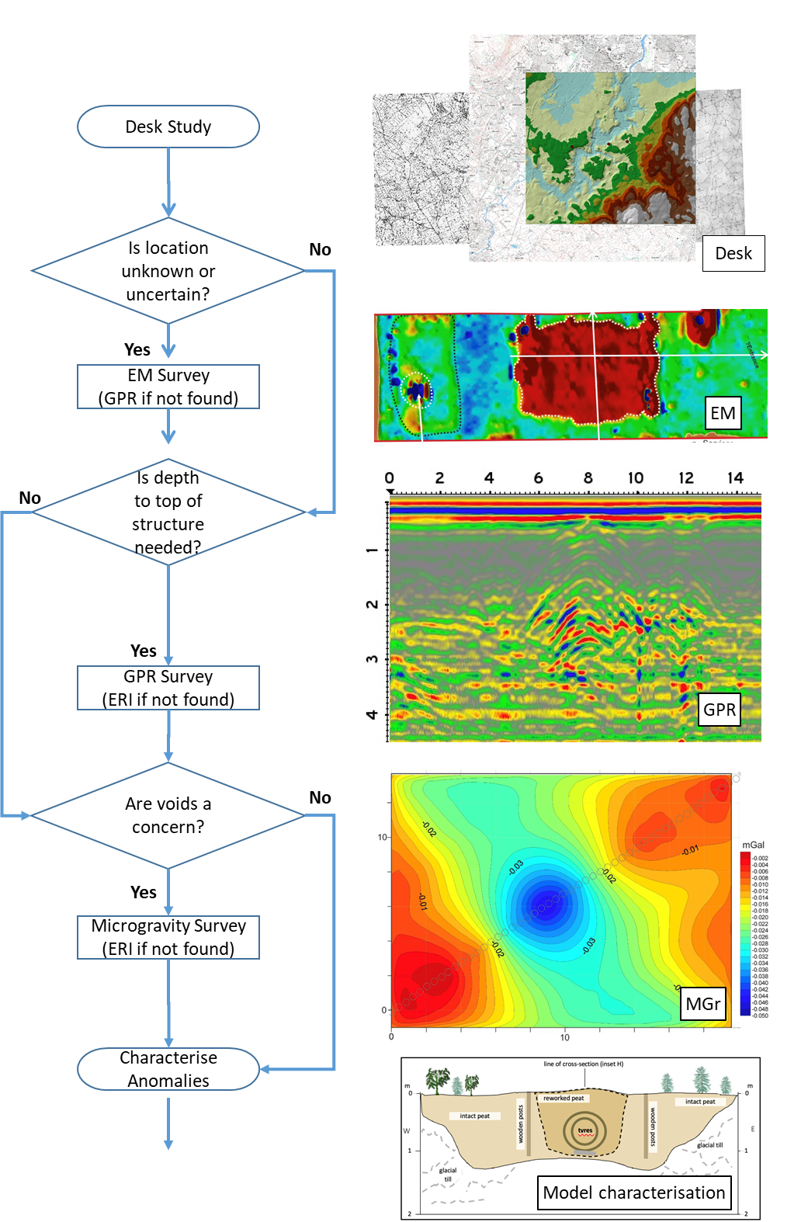
Fig. 6. Suggested workflows for forensic geophysical surveys to detect and characterise underground complexes, bunkers, tunnels and other area of interest.

Conclusions

From the case studies presented here and from published literature, it is evident that best practice in the detection and characterisation of underground complexes, bunkers, tunnels are covert firing ranges is best achieved through multi-phased forensic investigation using all information available and careful selection of non-invasive geophysical technique(s), followed by numerical modelling and careful intrusive investigations to confirm results. All ground surveys are limited, whether it be in penetration depth below ground level, affected by above-ground structures in urban areas or the difficulty in separating target(s) from non-target buried anomalies. However, the knowledge provided here can be used to assist law enforcement agencies and their associated specialised search teams, humanitarian investigations, forensic engineering, search and rescue teams and national/international security to identify and characterisation of such difficult to locate infrastructure.

Acknowledgements

Sam Toon and Malcolm Wright are acknowledged for assistance with case study 1 site data collection and QINETIQ are thanked for providing project funding. The Metropolitan Housing Trust are thanked for permission to publish data for case study 2 and Dr Mike Still of Dartford Borough Museum kindly provided information on London air raid shelters. Harworth Estates are thanked for permission to publish data for case study 3. The Apedale Heritage Trust are thanked for allowing site access and providing logistical support for case study 4.
References

[1] Ulmer, D.S. 2008. Shaping Operational Design: A Counter to the Growing Trend of Underground Facilities and Tunnel Warfare. Air Command and Staff College. Biblioscholar, Libristo, Poland. 44pp.

[2] Rose, E.P.F, Ehlen, J. & Lawrence, U.L. 2019. Military use of geologists and geology: a historical overview and introduction. In: Rose, Ehlen & Lawrence (Eds.), Military aspects of geology: fortification, excavation and terrain evaluation. Geological Society Special Publication 473, 1-30. https://doi.org/10.1144/SP473.15

[3] Doyle, P., P. Barton, M. S. Rosenbaum, J. Vandewalle, and K. Jacobs. 2002. Geoenvironmental Implications of Military Mining in Flanders, Belgium, 1914-1917. Environmental Geology (43) 57–71. https://doi.org/10.1007/S00254-002-0642-8

[4] Ainsworth, J.T.R., Pringle, J.K., Doyle, P., Stringfellow, M., Roberts, D., Wisniewski, K.D., Stimpson, I.G. & Goodwin, J. 2018. Geophysical investigations of WW2 UK air-raid shelters. Journal of Conflict Archaeology, 13, 167-197. https://doi.org/10.1080/15740773.2018.1583472

[5] Carr, S., Pringle, J.K., Doyle, P., Wisniewski, K.D. & Stimpson, I.G. 2020. ‘Scallywag Bunkers’: Geophysical Investigations of WW2 Auxiliary Unit Operational Bases (OBs) in the UK. Journal of Conflict Archaeology, 15, 4-31. https://doi.org/10.1080/15740773.2020.1822102

[6] Pringle, J.K., Doyle, P. & Babits, L.E. 2007. Multi-disciplinary investigations at Stalag Luft III Allied Prisoner of War camp, the site of the 1944 ‘Great Escape’, Zagan, Western Poland. Geoarchaeology, 22(7). 729-746. http://doi.org/10.1002/gea.20184

[7] Rees-Hughes, L., Pringle, J.K., Russill, N., Wisniewski, K., Doyle, P. 2016. Multidisciplinary investigations at P.O.W. Camp 198, Bridgend, S. Wales: Site of a mass escape in March 1945. Journal of Conflict Archaeology, 11, 166-191. http://dx.doi.org/10.1080/15740773.2017.1357900

[8] Olson, K.R. & Morton, L. W. 2017. Why were the soil tunnels of Củ Chi and Iron Triangle in Vietnam so resilient? Open Journal of Soil Science, 7, 34-51. https://doi.org/10.4236/ojss.2017.72003

[9] Butler, D.K. 2008. Detection and characterization of subsurface cavities, tunnels and abandoned mines. Applied Geophysics Consultancy, LLC. Available online at: https://www.agc-llc.net/ICEEG_Paper_2008.pdf Last accessed: 28.12.2023.

[10] Sloan, S.D., Peterie, S.L., Miller, R.D., Ivanov, J., Schwenk, J.T. & McKenna, J.R. 2015. Detecting clandestine tunnels using near-surface seismic techniques. Geophysics, 80, EN15-EN135. http://doi.org/10.1190/GEO2014-0529.1

[11] Pringle, J.K., Ruffell, A., Jervis, J.R. Donnelly, L., McKinley, J., Hansen, J., Morgan, R., Pirrie, D. & Harrison, M. 2012a. The use of geoscience methods for terrestrial forensic searches. Earth Science Reviews, 114(1-2), 108-123. http://dx.doi.org/10.1016/j.earscirev.2012.05.006

[12] Donnelly. L. & Harrison, M. 2013. Geomorphological and geoforensic interpretation of maps, aerial imagery, conditions of diggability and the colour-coded RAG prioritization system in searches for criminal burials. In: Geological Society of London Special Publication, 384, 173–194. https://doi.org/10.1144/SP384.10

[13] Melillos, G., Agapiou, A., Themistocleous, K., Michaelidees, S., Papadavid, G. & Hadjimitsis, D.G. 2019. Field spectroscopy for the detection of underground military structures. European Journal of Remote Sensing, 52, 385-399. https://doi.org/10.1080/22797254.2019.1625075

[14] Usher, C., Stringfellow, M. & Grossey, T. 2023. Good practice guide to using geophysics in ground investigation. A client's guide (C812), CIRIA Report. ISBN: 978-0-86017-956-6. Available online at: https://www.ciria.org/ItemDetail?iProductCode=C812D&Category=DOWNLOAD&WebsiteKey=3f18c87a-d62b-4eca-8ef4-9b09309c1c91

[15] Styles, P., Toon, S., Thomas, E. & Skittrall, M. 2006. Microgravity as a tool for the detection, characterization and prediction of geohazard posed by abandoned mining cavities. First Break, 24, 51-60.

[16] Banham, S.G. & Pringle, J.K. 2011. Geophysical and intrusive site investigations to detect an abandoned coal-mine access shaft, Apedale, Staffordshire, UK. Near Surface Geophysics, 9, 483-496. http://doi.org/10.3997/1873-0604.2011028

[17] Gheyle, W., Saey, T., Van Hollebeeke, Y. van, Verplaetse, S., Note, N. et al. 2016. Historical aerial photography and multi-receiver EMI soil sensing, complementing techniques for the study of a Great War conflict landscape. Archaeological Prospection, 23, 149-164. https://doi.org/10.1002/arp.1534

[18] Llopis, J.L., Dunbar, J.B., Wakeley, L.D., Corcoran, M.K. & Butler, D.K. 2005. Tunnel detection along the SW U.S. border. 18th EEGS Symposium on the Application of Geophysics to Engineering and Environmental Problems, Apr 2005, cp-183-00046. https://doi.org/10.3997/2214-4609-pdb.183.430-443

[19] Pringle, J.K., Stimpson, I.G., Toon, S.M., Caunt, S., Lane, V.S., Husband, C.R., Jones, G.M., Cassidy, N.J. & Styles, P. 2008. Geophysical characterisation of derelict coalmine workings and mineshaft detection: a case study from Shrewsbury, UK. Near Surface Geophysics, 6, 185-194. http://doi.org/10.3997/1873-0604.2008014

[20] Pringle, J.K., Lenham, J.W. & Reynolds, J.M. 2009. GPR investigations to characterise Medieval and Roman foundations under existing shop premises: a case study from Chester, Cheshire, UK. Near Surface Geophysics, 7, 93-100. http://doi.org/10.3997/1873-0604.2008042

[21] Diamanti, N., & Annan, A.P. 2019. Understanding the use of GPR for assessing clandestine tunnel detection. The Leading Edge, 453-459. https://doi.org/10.1190/tle38060453.1

[22] Jiang, W., Zelt, C.A. & Zhang, J. 2020. Detecting an underground tunnel by applying joint traveltime and waveform inversion. Journal of Applied Geophysics, 174, 103957. https://doi.org/10.1016/j.jappgeo.2020.103957

[23] Secret Bunker, 2023. Available online at: https://secretbunker.co.uk/ Last Accessed: 29.12.23.

[24] Panisova, J., Pastea, R., Papco, J. & Frastia, M. 2012. The calculation of building corrections in microgravity surveys using close range photogrammetry. Near Surface Geophysics, 10, 391-399. http://doi.org/10.3997/1873-0604.2012034

[25] Collier, B. 1957. The Defence of the United Kingdom. London: HMSO.

[26] Dick, H.C., Pringle, J.K., Sloane, B., Carver, J., Haffenden, A., Porter, S., K. Wisniewski, Roberts, D. & Cassidy, N.J. 2015. Detecting and characterising of Black Death burials by multi-proxy geophysical methods. Journal of Archaeological Science, 59, 132-141. http://dx.doi.org/10.1016/j.jas.2015.04.010

[27] Jiracek, G.R. 1990. Near-surface and topographic distortions in electromagnetic induction. Surveys in Geophysics, 11, 163-203.

[28] Gaffney, C., Gater, J., Saunders, T. & Adcock, J. 2004. D-Day: geophysical investigation of a World War II German site in Normandy, France. Archaeological Prospection, 11, 121-128. https://doi.org/10.1002/arp.233

[29] Masters & Stichelbaut, B. 2009. From the air to beneath the soil – revealing and mapping Great War trenches at Ploegsteert (Comines-Warneton), Belgium. Archaeological Prospection, 16, 279-285. http://doi.org/10.1002/arp.357

[30] Loke M.H. and Barker R.D. 1996. Rapid least-squares inversion of apparent resistivity pseudosections using a quasi-Newton method. Geophysical Prospection 44, 131–152.

[31] Ruffell, A., Pringle, J.K. & Forbes, S. 2014. Search protocols for hidden forensic objects beneath floors and within walls. Forensic Science International, 237, 137-145. http://doi.org/10.1016/j.forsciint.2013.12.036

[32] Jackson, B.A. 2005. Provisional Irish Republican Army. In: Jackson, B.A., Baker, J.C., Cragin, K., Parachini, J., Truilillo, H.R. & Chalk, P. (Eds.) Aptitude for Destruction, RAND Corporation, Santa Monica, USA. pp. 93-139. https://www.rand.org/pubs/monographs/MG332.html

[33] Ministry of Defence, 2012. Handbook of Defence Land Ranges Safety, Volume 3. Joint Service Publication, 65pp. Available online at: https://www.gov.uk/government/publications/dsa03-ome-part-3-ranges Las accessed: 28.12.2023.

[34] Tucker, R.E., McKenna, J.R., Mckenna, M.H. & Mattice, M.S. 2007. Detecting underground penetration attempts at secure facilities. US Army Engineering School, Fort Leonard Wood, MO, US, ADA596633. Available online at: https://apps.dtic.mil/sti/citations/ADA596633 Last accessed: 28.12.2023.

[35] Pasierb, B. & Nawrocki, W. 2019. Not only the ‘Gold Train’ – the ‘Underground Town’ of Riese (Poland) – the ambiguity of interpretation ERT and GPR methods. Archaeological Prospection, 27, 361-375. https://doi.org/10.1002/arp.1779

[36] Kolster, M.E., Wigh, M.D., da Silva, E.L.S., Vilhelmsen, T.B., Dossing, A. 2022. High-speed magnetic surveying for Unexploded Ordnance using UAV systems. Remote Sensing, 14, 1134. https://doi.org/10.3390/rs14051134

[37] Ruffell, A., Lally, A. Rocke, B. 2021. Dronar—Geoforensic search sonar from a drone. Forensic Sciences, 1, 202–212. https://doi.org/10.3390/forensicsci1030018

